Name: Joaquim Miguel Conceição Espada

Login: con0004

Date: 16th November of 2016

Report of measuring

Title: Data transmission with Fiber Optic

Task: Using Fiber Optic technology and protocol C-Kermit download a file from the server and upload another file to the server. As transmission technology should be used a fiber optic media converter.

Scheme:

Optical Swicth
PC client
PC Server
PC cliente
PC Server
converver
converver
converver
converver

Illustration 1: Scheme for measurement

Introduction to problematics:
The main objective of this experiment is to transfer data among a client and a server using fiber optics technology.
The needed hardware is the following list : at least two desktops computers (one is the client and the other is the server), fiber optic media converter and a optical switch. The needed software is a Linux distribution with Kermit installed.

Elaboration:

Fiber optics Communication
Fiber-optic communication is a way of transmitting information from one place to another by sending pulses of light through an optical fiber. The light forms an electromagnetic carrier wave that is modulated to carry information.
Fiber optics (optical fibers) are long, thin strands of very pure glass about the size of a human hair. They are arranged in bundles called optical cables and used to transmit signals over long distances (hundreds of kilometers).
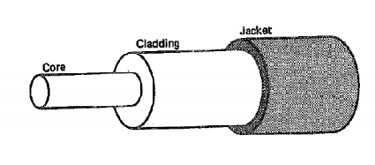Illustration 2: Fiber Optics Composition

Types of Optical Fiber
There are two kinds of fiber optics:
- Multi mode
- Single Mode

Multi mode
Multi-mode optical fiber is a type of optical fiber mostly used for communication over short distances, such as within a building or on a campus. Multi mode optical fiber is less expensive than that for single-mode fiber. Typical transmission speed and distance limits are 100 Mbit/s for distances up to 2 km, 1 Gbit/s up to 1000 m, and 10 Gbit/s up to 550 m. The LED light sources are used with multi-mode fiber to produce a range of wavelengths and these each propagate at different speeds allowing multiple light signals at the same time.
A typical Multi mode optical fiber has a core diameter between 50 µm and 125 µm and a cladding diameter of 125 µm.

Single mode
Single mode optical fiber is a type of optical fiber mostly used for communication over longs distances, such as between buildings, supports distances of hundreds of kilometers. Single mode optical fiber is more expensive than that multi mode fiber, usually the core of the Single mode fiber is made of glass and the core of Multi mode fiber is made of plastic. Single mode fiber uses expensive laser light, the signal of light is this kind of fiber is only one.
A typical single mode optical fiber has a core diameter between 8 and 10.5 µm and a cladding diameter of 125 µm.
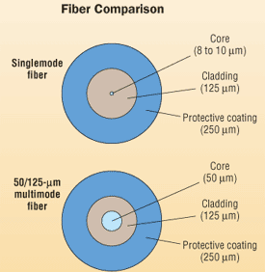Illustration 3: Comparison between Single and Multimode Fiber

Advantages of Optic Fiber:
- Immunity to Electromagnetic Interference
- Data Security
- Non Conductive Cables
- Eliminating Spark Hazards
- Easy installation
- High Bandwidth Over Long Distance
- Experiment

Disadvantages of Optic Fiber:
- Cost
- Fragile
- Protection

Problems with Optic Fiber

Dispersion
Dispersion represents the fact that different colors or wavelengths travel at different speeds, even within the same mode.
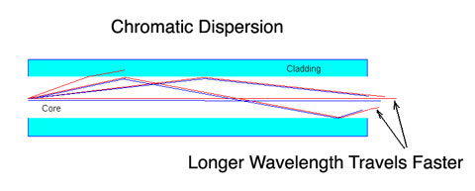Illustration 4: Chromatic Dispersion

Attenuation
Fiber attenuation, which necessitates the use of amplification systems, is caused by a combination of material absorption, Rayleigh scattering, Mie scattering, and connection losses. Although material absorption for pure silica is only around 0.03 dB/km (modern fiber has attenuation around 0.3 dB/km), impurities in the original optical fibers caused attenuation of about 1000 dB/km.
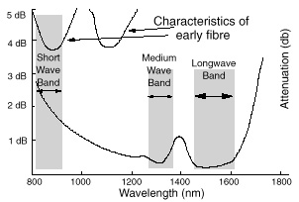Illustration 5: Attenuation Graphic

Experimental Part
Measurement Steps:
- Connect the usb fiber optics media converter to the computer;
- Stop service network manager
  - student@eb215-desktop:~$ sudo -i
  - root@eb215-desktop:~# stop network-manager
- Up the interface links
  - root@eb215-desktop:~# ip link set dev eth0 up
  - root@eb215-desktop:~# ip link set dev eth1 up
- Add ip to interface eth1
  - root@eb215-desktop:~# ip address add 10.0.0.11/24 dev eth1
- Generate Random file to uploaded or download from the server
  - dd if=/dev/urandom of=test11.bin bs=100M count =1
- Start Kermit-C
Setting up Kermit-C as Client
(/root/) C-Kermit>set network type tcp/ip
(/root/) C-Kermit>set tcp reverse-dns-lookup off
(/root/) C-Kermit>set host 10.0.0.11 10015

Setting up Kermit-C as Server
(/root/) C-Kermit>set network type tcp/ip
(/root/) C-Kermit>set tcp reverse-dns-lookup off
(/root/) C-Kermit>set host * 10015

Receive File
Server Computer
(/root/) C-Kermit>send file100M.bin

Client computer
(/root/) C-Kermit>receive
(/root/) C-Kermit>statistics /verbose

total file characters : 104857600
elapsed time : 00:00:03 (3.394 sec)
effective data rate : 30895246 cps = 247161968 bps = 235.712021 Mbps
Send File
Client Computer
(/root/) C-Kermit> receive

Client computer
(/root/) C-Kermit>send test11.bin

total file characters : 104857600
elapsed time : 00:00:04 (4.115 sec)
effective data rate : 25479346 cps = 203834768 bps = 194.391983 Mbps
Observations :
The kind of optic fiber used in the experiment was multi-mode fiber. There was a short distance (1 meter) between the computers and the main switch. The theoretical speed of multi-mode fiber at this distance is between 100Mbit/second and 10Gbit/second. The measurement download speed was 235.712021 Mbps and the upload speed was 194.391983 Mbps, this speed are in between the previous statement. There are a few factors that can affect the speed of transmission like the computer, tp-link optical switch and fiber optic cable.

Conclusion
After studying Fiber Optics Communications I realized that was the fastest by far technology that we studied.
Fiber Optics are divided in two kinds Multi mode and Single Mode. The Multi mode fiber is used in short distances, it's cheaper than Single mode, the core is made of plastic and carrier is generated by LED light. Regarding Single mode fiber, this is used in long distances, it's more expensive than multi-mode, the core is made of glass and the carrier is generated using Laser light.
Usually Multi-mode fiber as superior core diameter.
Multi-mode fiber is more suitable to use inside builds while Sing-mode should be used to connect buildings.

References:
- https://en.wikipedia.org/wiki/Multi-mode_optical_fiber
- https://en.wikipedia.org/wiki/Single-mode_optical_fiber#Characteristics
- https://en.wikipedia.org/wiki/Fiber-optic_communication
- https://www.utdallas.edu/~torlak/courses/ee4367/lectures/FIBEROPTICS.pdf
- http://www.doc.ic.ac.uk/~nd/surprise_97/journal/vol4/sm27/adv.html
- http://services.eng.uts.edu.au/~akadi/ite/major_assignments/barber/advdisad.htm

