Name: Joaquim Miguel Conceição Espada

Login: con0004

Date: 24th October of 2016

Theoretical and Measuring report

Title: Data transmission with Power line technology

Task: Using Power line technology and protocol C-Kermit download a file from the server, rename it, upload it back and recover statistics.

Scheme:

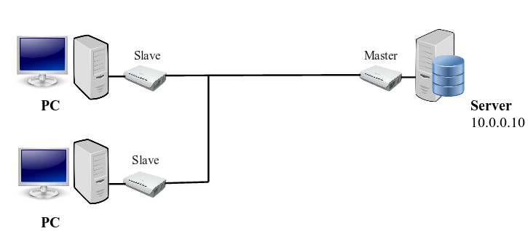
Illustration 1: Class Power-line scheme

Introduction to problematics:

The main objective of this experiment is to transfer data among a client and a server using a power line as well power line modems and take some measurements. In addition a comparison with ADSL and VDSL will be made.
The needed hardware is the following list : two desktops computers (one is the client and the other is the server), power line modems, Ethernet cable and remote usb to Ethernet device. The needed software is a Linux distribution with Kermit installed.

Elaboration:

Initial Concepts

Direct Current (DC)

Direct current (DC) is the unidirectional flow of electric charge. Direct current is produced by sources such as batteries, power supplies, thermocouples, solar cells, or dynamos.

Alternating Current (AC)

Alternating current (AC), is an electric current in which the flow of electric charge periodically reverses direction. AC is the form in which electric power is delivered to businesses and residences, and it is the form of electric power that consumers typically use when they plug their appliances.

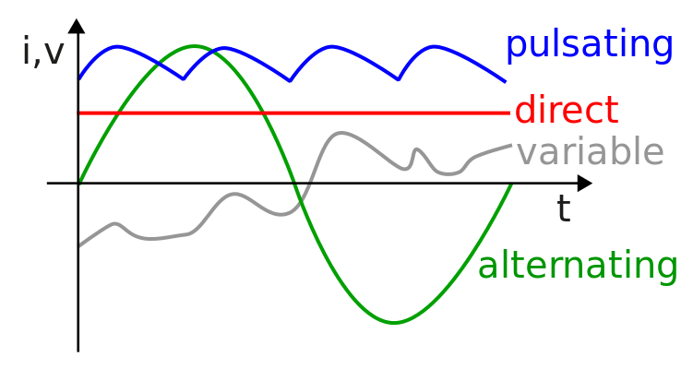Illustration 2: Comparison graph AC VS DC current

Note:
In this graph the Direct Current is represented by the red line, the Alternating Current bye the green one. Regarding the axis the vertical axis represents current or voltages while the horizontal axes measures time.

Power-line Communicatin (PLC)
Power-line communication is a communication protocol that uses electrical grid to simultaneously carry both data, and Alternating Current (AC) . In this case the carrier is electrical AC current and the network cables is the electrical grid.
It is also known as power-line digital subscriber line (PDSL). The power-line communication uses the modulation techniques Orthogonal frequency-division multiplexing (OFDM) similar to the technology found in DSL modems.

Types of PLC
There are two main types of PLC :
- Narrow band PLC (low frequency / high voltage / long distances)
  - Narrowband in-house applications: where household wiring is used for low bit rate services like home automation and intercoms.
  - Narrowband outdoor applications. These are mainly used by the utility companies for automatic meter reading and remote surveillance and control.
- Broad band PLC (high frequency /low voltage / short distances)
  - Broadband In-house mains power wiring can be used for high speed data transmission for home networking.
  - Broadband over Power Line: outdoor mains power wiring can be used to offer broadband internet access.

Narrow Band
Narrow band PLC works at lower frequencies (3-500 kHz), lower data rates (up to 100s of kbps), and has longer range (up to several kilometers), which can be extended using repeaters. Narrow band uses high voltages.
Recently, Narrow bands had been receiving widespread attention due to its applications regarding Smart Grid.

Broad band PLC
Broad band PLC works at higher frequencies (1.8-250 MHz), high data rates (up to 100s of Mbps) and is used in shorter-range applications. Broad band uses low voltages.
It is mainly used in short distances and for Internet distribution and home networking. With its high data rates and no additional wiring, broadband PLC is seen as an exciting and effective technology for multimedia distribution within homes.

Orthogonal frequency-division multiplexing (OFDM)

Orthogonal frequency division multiplexing (OFDM) is a technique for a digital multi-carrier modulation using many closely spaced sub-carriers - a previously modulated signal modulated into another signal of higher frequency and bandwidth.
The available range of frequencies on the electrical subsystem (4.3 MHz to 20.9 MHz) is split into 84 separate carriers. OFDM sends packets of data simultaneously along several of the carrier frequencies, allowing for increased speed and reliability.
If noise or a surge in power usage disrupts one of the frequencies, the chip will sense it and switch that data to another carrier. This rate-adaptive technique allows to maintain an Ethernet-class connection throughout the power-line network without losing any data.
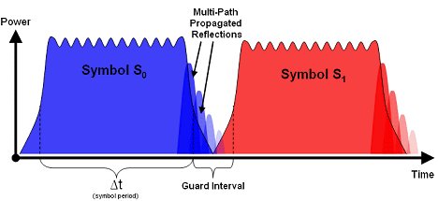Illustration 3: ODFM Frequency Spectrum

Experiment

Setting up the scheme

- Connect the power-line modem to the computer through a USB to Ethernet adapter and to the power socket;

testing connection with server
student@eb215-desktop:~$ ping 10.0.0.10

Setting up Client Kermit

student@eb215-desktop:~$ sudo -i // entering root user
(/root/) C-Kermit>set network type tcp/ip //setting up commucation protocol
(/root/) C-Kermit>set tcp reverse-dns-lookup off //shutting off dns name resolution
(/root/) C-Kermit>set host 10.0.0.10 10014 // the last two digits correspond to the pc number
Trying 10.0.0.10... (OK)
Negotiations.. (OK)

Receiving File

Client Computer
(/root/) C-Kermit>receive

Server
(/root/) C-Kermit>send file100M.bin

Statistics of downloading the file

total file characters : 104857600
elapsed time : 00:02:32 (152.270 sec)
effective data rate : 688628 cps

Sending File

Client Computer
(/root/) C-Kermit> mv file100M.bin con0004.bin //Changing file name to con0004.bin
(/root/) C-Kermit> send con0004.bin

Server
(/root/) C-Kermit>receive

Statistics of sending the file

total file characters : 104857600
elapsed time : 00:00:42 (41.749 sec)
effective data rate : 2511634 cps

Comparison Power-line VS ADSL

Power-line VS ADSL Downloading File

 | Elapsed time | Effective data rate | Total file characters
Power-line | 00:02:32 (152.270 sec) | 688628 cps | 104857600
ADLS | 00:00:25 (25.181 sec) | 416418 cps | 10485760

After analyzing the data I concluded that :

- For the ADSL to download a 100 Mega Byte file would take approximately 251.181 seconds.

- For the Power-line to download a 10 Mega Byte file would take approximately 15.27 seconds

- The power-line was almost two times faster than the ADSL

Power-line VS ADSL Uploading the File

 | Elapsed time | Effective data rate | Total file characters
Power-line | 00:00:42 (41.749 sec) | 2511634 cps | 104857600
ADLS | 00:01:39 (98.923 sec) | 105999 cps | 10485760

After analyzing the data I concluded that :

- For the ADSL to upload a 100 Mega Byte file would take approximately 251.181 seconds.

- For the Power-line to upload a 10 Mega Byte file would take approximately 15.27 seconds

- The power-line was almost twenty four times faster than the ADSL

Observation : The retrieved data sample is very low to take viable statistical conclusion the sample for each type of modem and upstream/downstream test would need to be at least thirty, that way a probability density function graph could be generated. The calculation there I made were going to the the same but the values would the means of elapsed times and data rates.
The justification for the previous statement is the following : there are several aspects that could interfere with the measurements like the category of cable, the number of requests simultaneously to the server, the occupation of the server … .
Thats why we need more measurements to have more precise conclusions.

Conclusion:

After the class and analyzing the data I concluded that power-line technologies can obtain much higher speeds regarding downstream and upstream than ADSL and analog modems, according with the retrieved data . Regarding the modulation technique used OFDM is very similar to DMT where the only difference is number of sub channels and range of frequencies. The main advantages that I spotted were the modems power-lines where easier to manage because they do everything automatically and power-line technologies uses the electrical grid to carry data instead than digital subscriber line or analog line.

References:
- Ing. Pavel Nevlud lectures
- https://en.wikipedia.org/wiki/Direct_current
- https://en.wikipedia.org/wiki/Alternating_current
- https://en.wikipedia.org/wiki/Power-line_communication
- http://computer.howstuffworks.com/power-network2.htm

