Name: Joaquim Miguel Conceição Espada

Login: con0004

Date: 8th November of 2016

Report of measuring

Title: Data transmission with Wireless technology

Task: Using wireless technology and protocol C-Kermit download a file from the server, rename it and upload it back to the server.

Scheme:
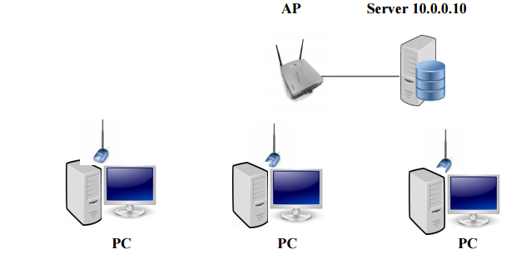Illustration 1: Scheme wireless comunication between computers and a server

Introduction to problematics:

The main objective of this experiment is to transfer data among a client and a server using wireless technology.
The needed hardware is the following list : at two desktops computers (one is the client and the other is the server), usb wireless antenna, and one Access Point. The needed software is a Linux distribution with Kermit installed.

Elaboration:

Initial Concepts

Wireless Network

A wireless local-area network (LAN) uses radio waves to connect devices such as laptops to the Internet and to your business network and its applications. When you connect a laptop to a WiFi hotspot at a cafe, hotel, airport lounge, or other public place, you're connecting to that business's wireless network.
A few advantages of using wireless networks:
- Convenience. Access your network resources from any location within your wireless network's coverage area.
- Mobility.
- Easy setup. You don't have to string cables, so installation can be quick and cost-effective.
- Expandable. You can easily expand wireless networks with existing equipment, while a wired network might require additional wiring.
- Security. Advances in wireless networks provide robust security protections.
- Cost. Because wireless networks eliminate or reduce wiring costs, they can cost less to operate than wired networks.

A few constraint of using wireless networks:
- Physical Obstructions
- Network Range and distance between devices
- Channels overlap
- Network usage and load
- Low quality antennas
- Signal reflection

IEEE 802.11

IEEE 802.11 is a set of media access control (MAC) and physical layer (PHY) specifications for implementing wireless local area network (WLAN) computer communication in the 900 MHz and 2.4, 3.6, 5, and 60 GHz frequency bands. They are created and maintained by the Institute of Electrical and Electronics Engineers (IEEE) LAN/MAN Standards Committee (IEEE 802).

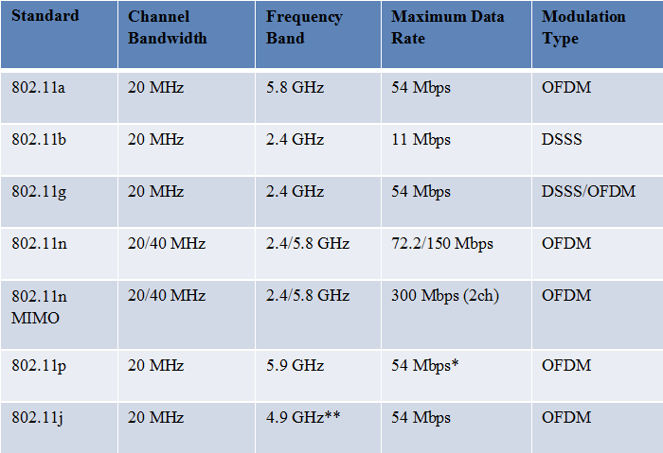Table 1: Table with the protocol family 802.11

Range

The 5 GHz band has a shorter range compared to a 2.4 GHz band because in radio frequencies, the
higher the frequency the shorter its range. In other words, if you are using a lower frequency like
the 2.4 GHz, the distance it will cover will be greater than the 5 GHz band.

Speed

The 5 GHz has a wider wireless spectrum available compared to the 2.4 GHz, which leads significantly better performance as the 5 GHz is commonly used for usage that requires uninterrupted throughput. That is why it is recommended for media streaming and transferring music, pictures, an video throughout your home network.

Experiment

Measurement Steps:
- Connect the usb antenna to the computer;
- Using network manager connect to the network “DataTrans”
- Test connectivity with server, send a ping to 10.0.0.10
- Get Information from wireless: channel, frequency, bit rate, Link Quality;
- Start Kermit-C

Setting up Kermit-C
(/root/) C-Kermit>set network type tcp/ip
(/root/) C-Kermit>set tcp reverse-dns-lookup off
(/root/) C-Kermit>set hp?No keywords match - "hp"
(/root/) C-Kermit>set host 10.0.0.10 10011
Trying 10.0.0.10... (OK)
Negotiations.. (OK)

Wireless Information
root@eb215-desktop:~# iwconfig

SSID:"DataTrans"
Frequency:2.472 GHz
Channel : 13
Access Point: 54:75:D0:A4:D0:8
Bit Rate:72.2 Mbps
Link Quality=100/100 Signal level=100/100 Noise level=0/100

Receive File
Server Computer
(/root/) C-Kermit>send file100M.bin

Client computer
(/root/) C-Kermit>receive
(/root/) C-Kermit>statistics /verbose

total file characters : 104857600
elapsed time : 00:00:18 (18.027 sec)
effective data rate : 5816786 cps = 46534288 bsp = 44.378555 Mbps

Send File
Client Computer
(/root/) C-Kermit> receive

Client computer
(/root/) C-Kermit>mv file100M.bin con0004.bin
(/root/) C-Kermit>send con0004.bin

total file characters : 104857600
elapsed time : 00:00:21 (20.682 sec)
effective data rate : 5070045 cps = 40560360 bps = 38.681374 Mbps

Observations :
The antenna connected to the computer had the theoretical speed of 150 Mbps and the access point antennas could transmit until 300 Mbps of speed also theoretical. But this kind of devices usually have 50% throughput meaning that the speeds of transmission would be half. The download speed of the 100 Mb was 44.378555 Mbps and the upload speed was 38.681374 Mbps. This speeds means that when I downloaded and uploaded the file the network wasn't being overloaded by traffic and perhaps that the throughput of the access point is higher than 50%.

Conclusion
After studying the wireless topic I concluded that higher frequencies have shorter range and low frequency have bigger range. Regarding the speed higher frequencies can achieve better performance, being great for streaming and sharing multimedia. But for a regular user a lower frequencies are better because of the higher range. Usually higher frequencies have lot of channels and dont get so much interferences.
There are other factor that can affect the wireless network's as the physical obstacles, signal reflection, antennas quality and number of users.
Regarding the experimental part of the class I concluded that when I was uploading and downloading the file were few users using the network.

References:
- https://en.wikipedia.org/wiki/IEEE_802.11
- http://www.cisco.com/cisco/web/solutions/small_business/resource_center/articles/work_from_anywhere/what_is_a_wireless_network/index.html
- http://www.4gon.co.uk/solutions/technical_factors_affecting_wireless_performance.php
- http://www.linksys.com/us/support-article?articleNum=134478

