Name: Joaquim Miguel Conceição Espada

Login: con0004

Date: 20th September of 2016

Report of measuring

Title: Data transmission with xDSL technology

Task: Using xDSL technology and protocol C-Kermit download a file from the server, rename it and upload it back.

Scheme:

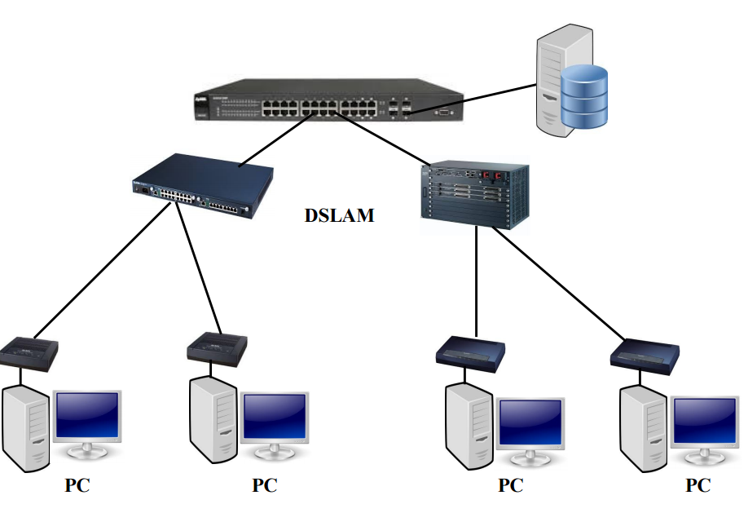
Illustration 1: Scheme about xDSL network

Introduction to problematics:

The main objective of this experiment is to transfer data among a client and a server using DSL line with ADL/VDSL Modems.
The needed hardware is the following list : two desktops computers (one is the client and the other is the server), xDSL modems, one Ethernet switch, DSLAM, Ethernet cables,voice cables and remote usb to Ethernet device. The needed software is a Linux distribution with Kermit installed.

Elaboration:

Initial Concepts

Digital subscriber line (DSL)

DLS is a family of technology that are used to transmit digital data over voice cables. There are three main types of DSL:
- ADSL → Asymmetric digital subscriber line
- SDSL → Symmetric digital subscriber line
- VDSL → Very-high-bit-rate digital subscriber line

Asymmetric digital subscriber line (ADSL)

ADSL is a type of DSL that enables faster data transmission over voice cables rather than analog modems.In ADSL the bandwidth and bit rate are asymmetric, meaning that downstream speed is much higher than upstream speed. It was the most commonly installed DSL technology, for Internet access.
In the image in the bottom is represented the Spectrum used in ADSL. The DMT modulation in this case consist of 20 carriers constructing the upstream stream band and 221 carriers constructing the downstream band. In each of sub channels QAM modulation is used.

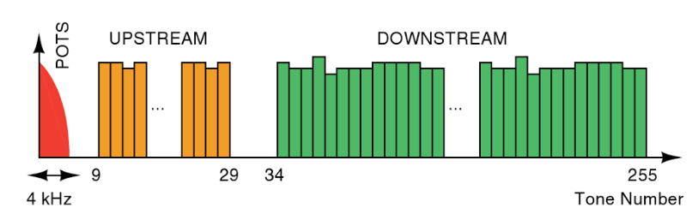
Illustration 2: Spectrum of DMT modulation of ADSL modem
Table with ADSL Rates

Version | Common name | Downstream rate | Upstream rate | Approved in
ADSL | ADSL | 8.0 Mbit/s | 1.0 Mbit/s | 1998
ADSL | ADSL Lite (G.lite) | 1.5 Mbit/s | 0.5 Mbit/s | 1999-07
ADSL | ADSL (G.dmt) | 8.0 Mbit/s | 1.3 Mbit/s | 1999-07
ADSL | ADSL over POTS | 12.0 Mbit/s | 1.3 Mbit/s | 2001
ADSL | ADSL over ISDN | 12.0 Mbit/s | 1.8 Mbit/s | 2005
ADSL2 | RE-ADSL2 | 5.0 Mbit/s | 0.8 Mbit/s | 2002-07
ADSL2 | ADSL2 | 12.0 Mbit/s | 1.3 Mbit/s | 2002-07
ADSL2 | ADSL2 | 12.0 Mbit/s | 3.5 Mbit/s | 2002-07
ADSL2 | splitterless ADSL2 | 1.5 Mbit/s | 0.5 Mbit/s | 2002-07
ADSL2+ | ADSL2+ | 24.0 Mbit/s | 1.4 Mbit/s | 2003-05
ADSL2+ | ADSL2+M | 24.0 Mbit/s | 3.3 Mbit/s | 2008

Symmetric digital subscriber line (SDSL)

The SDL can be viewed as the opposite of the ADLS regarding the bandwidth and bit rate because they are symmetric. Meaning that upstream speed is bigger than the download stream.

Very-high-bit-rate digital subscriber line (VDSL)

VDSL is a digital subscriber line (DSL) technologies providing data transmission faster than ADSL downstream and upstream. VDSL can support applications as high-definition television, telephone services (voice over IP) and general Internet access, over a single connection. In the bottom image is represented the frequency plan used in VDLS version 2 that can use frequency bands up to 35 MHz. We can see a few familiarities with the ADSL DMT modulation . The biggest difference is that it uses techniques such as the fast Fourier transform (FFT) to modulate data on up to 4,096 sub carriers in a full-rate VDSL implementation, creating a large number of transmissions in which the sub channels have to be processed in parallel.

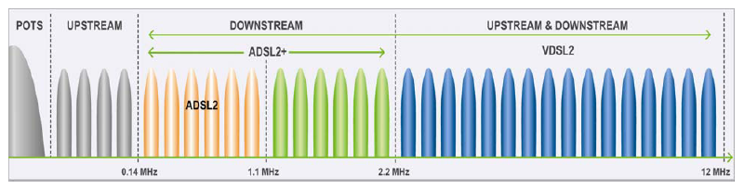
Illustration 3: Frequency plan for VDSL2

Table with VDSL Rates

Version | Standard name | Common name | Downstream rate | Upstream rate | Approved on
VDSL | ITU G.993.1 | VDSL | 55 Mbit/s | 3 Mbit/s | 2001-11-29
VDSL2 | ITU G.993.2 | VDSL2 | 100 Mbit/s | 100 Mbit/s | 2006-02-17
VDSL2 | ITU G.993.2  Amendment 1 (11/15) | VDSL2 Annex Q  VPlus/35b | 300 Mbit/s | 100 Mbit/s | 2015-11-06

Discrete multi tone (DMT)

Discrete multi-tone (DMT) is a method of separating a Digital Subscriber Line (DSL) signal so that the usable frequency range is separated into 256 frequency bands (or channels) of 4.3125 KHz each. Within each channel, modulation uses quadrature amplitude modulation (QAM). The DMT modulation constantly shifts signals between different channels,searching for the best channels for transmission and reception.

Quadrature amplitude modulation (QAM)

The QAM changes the amplitudes of two sinusoidal carriers depending on the digital sequence that must me transited. One carrier is modulated using PSK (phase-shift keying) and other using ASK (amplitude-shift keying). The modulated waves are summed and then the final waveform is a combination of both.

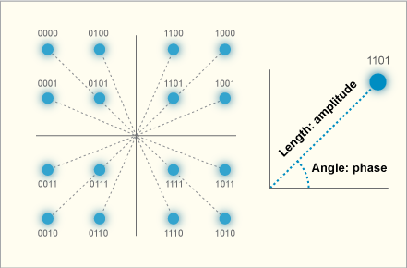
Illustration 4: QAM 16 Constellation

Experiment

Setting up the scheme

- Connect to modem ADSL/VDSL to the computer through a USB to Ethernet adapter and to the power socket;
- Connect to modem ADSL/VDSL to the digital subscriber line via voice cable;
- Connect Ethernet cable from Ethernet Switch port number x (computer number) to the DSLAM;
- Connect the previously configured server to the Ethernet Switch.

Setting up a few configurations
student@eb215-desktop:~$ sudo -i // entering root mode
root@eb215-desktop:~# ip a // command to check ip of USB to Ethernet adapter
student@eb215-desktop:~$ stop network-manager // stopping network-manager process
student@eb215-desktop:~$ ip link set dev eth1 up //turning on interface eth1
student@eb215-desktop:~$ dhcclient eth1
student@eb215-desktop:~$ ping 10.0.0.10 //testing connection with server

Setting up Client Kermit

student@eb215-desktop:~$ sudo -i // entering root user
(/root/) C-Kermit>set network type tcp/ip //setting up commucation protocol
(/root/) C-Kermit>set tcp reverse-dns-lookup off //shutting off dns name resolution
(/root/) C-Kermit>set host 10.0.0.10 10011 // the last two digits correspond to the pc number
Trying 10.0.0.10... (OK)
Negotiations.. (OK)

Receiving File

Client Computer
(/root/) C-Kermit>receive

Server
(/root/) C-Kermit>send file10M.bin

Statistics of downloading the file

total file characters : 10485760
elapsed time : 00:00:25 (25.181 sec)
effective data rate : 416418 cps

Sending File

Client Computer
(/root/) C-Kermit> mv file10M.bin con0004.bin //Changing file name to con0004.bin
(/root/) C-Kermit> send con0004.bin

Server
(/root/) C-Kermit>receive

Statistics of sending the file

total file characters : 10485760
elapsed time : 00:01:39 (98.923 sec)
effective data rate : 105999 cps

Observation : In this measurement I was using one ADSL modem. After analyzing the statistics provided by Kermit about the sending and receiving of a 10 Mega Byte binary file I could conclude that the downstream rate is higher than upstream rate. The download speed was almost four times faster than the upload speed proving that theoretical information about ADSL modems is right.

Getting information about transmission rate at ADSL/VDSL modem

student@eb215-desktop:~$ telnet 10.1.4.1 // accessing the modem via telnet protocol
Password: *****
Select option 24 then 8
adsl1> wan adsl chandata // command to check the channel data

Information
DSL standard: ADSL2+ Mode
near-end bit rate: 4093 kbps
far-end bit rate: 1021 kbps

Conclusion:

After the class I concluded that xDSL technologies can obtain much higher speeds regarding downstream and upstream than analog modems. VDSL/ADSL can be viewed has multiple analogue modems working at the same time.
There are three main types of xDSL modems: ADSL, SDSL and VDSL. The difference between ADSL and SDLS is that ADSL modems have a higher downstream rate than upstream rate. VDSL technology obtain higher speeds up and downstream than the ADSL and SDSL. ADSL and VDSL uses DMT modulation and in each sub channel is modulated using QAM. SDSL has 4096 sub channels while ADSL only has 255.
Regarding the experimental part the theoretical information about ADSL has been proven as true. After compiling the statistics about the download and upload of 10 Mega Byte binary file I concluded that The download speed was almost four times faster than the upload speed.
During the experiment were a few setbacks regarding the voice and Ethernet cables but that was solved quickly by changing them.

References:
- Ing. Pavel Nevlud lectures
- http://computer.howstuffworks.com/vdsl4.htm
- https://en.wikipedia.org/wiki/Very-high-bit-rate_digital_subscriber_line
- https://en.wikipedia.org/wiki/Asymmetric_digital_subscriber_line
- https://en.wikipedia.org/wiki/Digital_subscriber_line
- https://en.wikipedia.org/wiki/Symmetric_digital_subscriber_line
- https://books.google.de/books?id=H9FhS828SfEC&pg=PA21&dq=DMT+Modulation&hl=pt-PT&sa=X&redir_esc=y#v=onepage&q=VDSL%20Modulation&f=false
- http://www.eetimes.com/document.asp?doc_id=1277797

