|  |  |  |  |
| --- | --- | --- | --- |
| Study ID | DW10 | Initial NIHSS (affected arm) | 2 |
| Age | 71 | Sex | Female |
| ICH Location | Right lobar | Patient location | ICU |
| Hospital day | 0 | Mechanical ventilation | No |
| Delirium status | No | 3-month mRS | 4 |

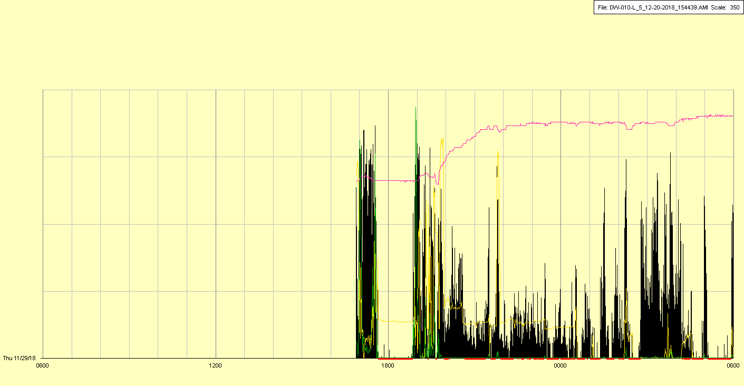

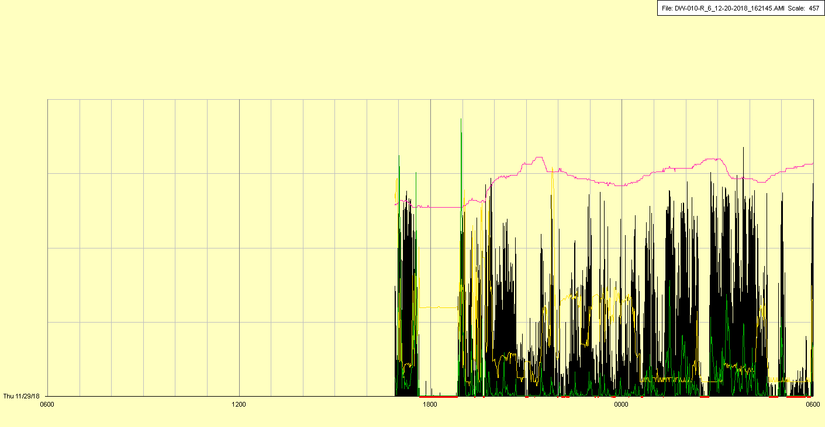

|  |  |  |  |
| --- | --- | --- | --- |
| Study ID | DW10 | Initial NIHSS (affected arm) | 2 |
| Age | 71 | Sex | Female |
| ICH Location | Right lobar | Patient location | ICU |
| Hospital day | 1 | Mechanical ventilation | No |
| Delirium status | Yes | 3-month mRS | 4 |

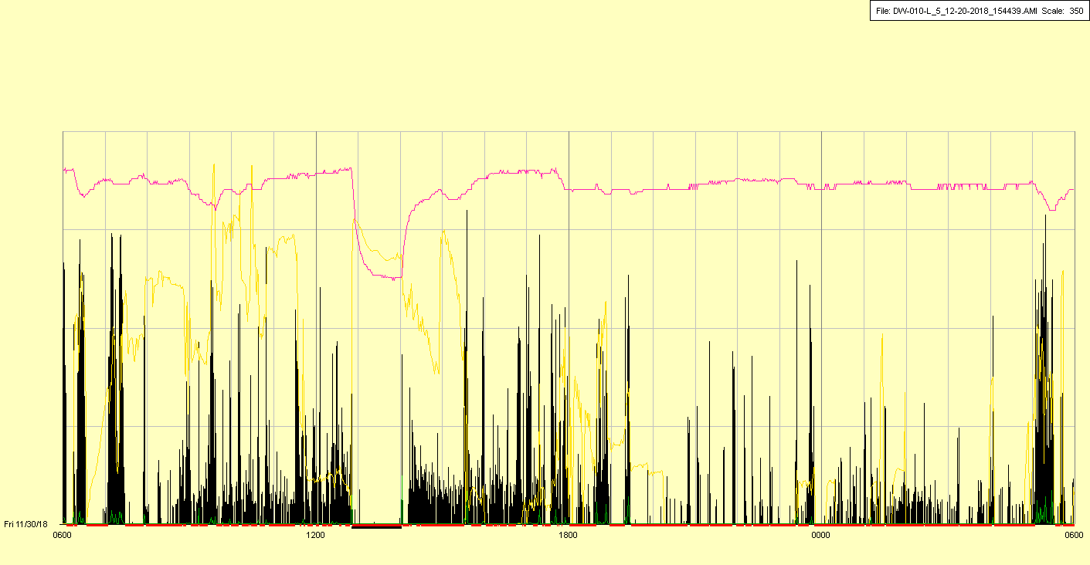

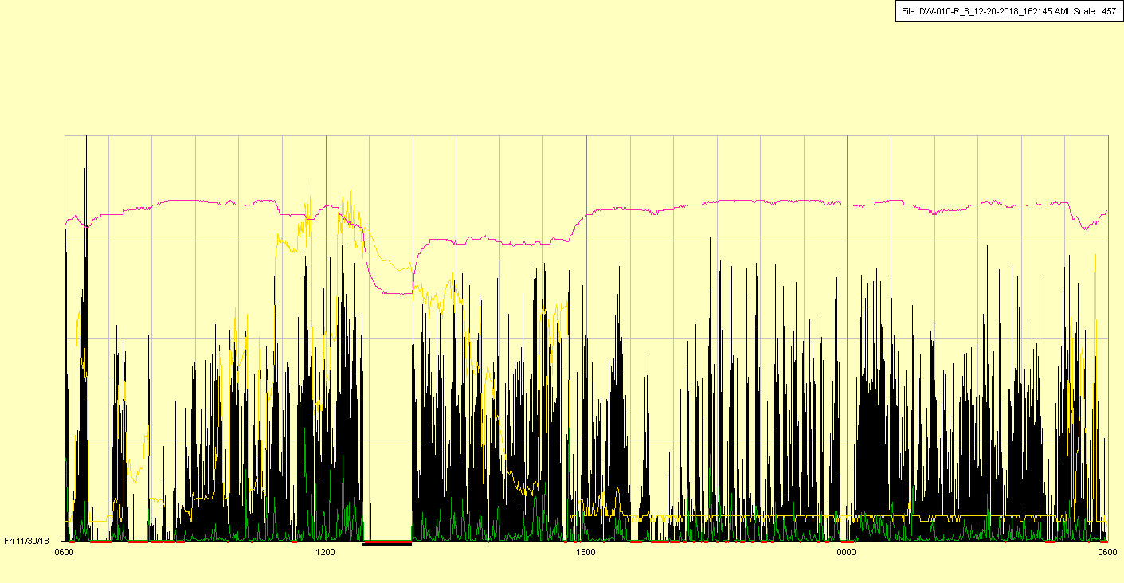

|  |  |  |  |
| --- | --- | --- | --- |
| Study ID | DW10 | Initial NIHSS (affected arm) | 2 |
| Age | 71 | Sex | Female |
| ICH Location | Right lobar | Patient location | ICU |
| Hospital day | 2 | Mechanical ventilation | No |
| Delirium status | Yes | 3-month mRS | 4 |

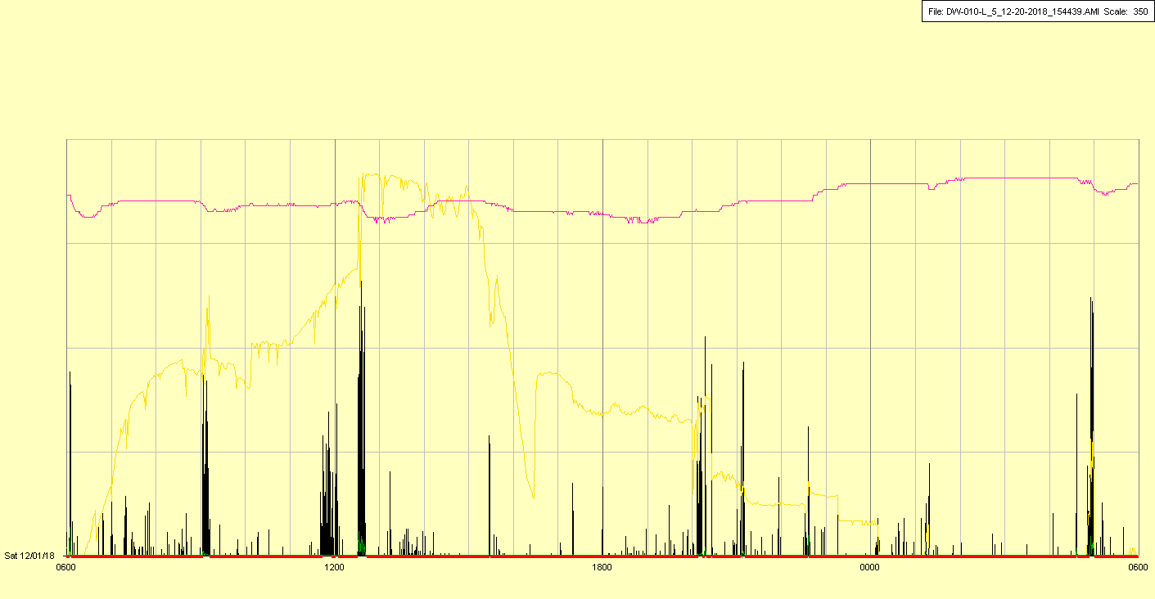

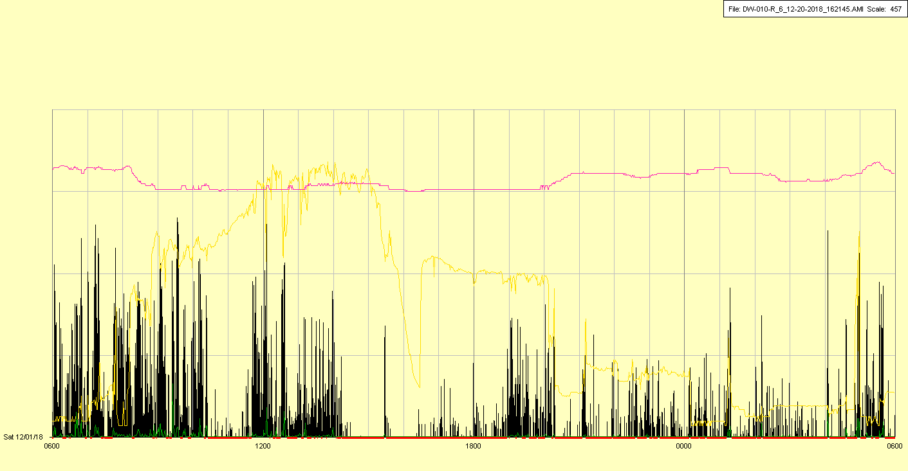

|  |  |  |  |
| --- | --- | --- | --- |
| Study ID | DW10 | Initial NIHSS (affected arm) | 2 |
| Age | 71 | Sex | Female |
| ICH Location | Right lobar | Patient location | ICU |
| Hospital day | 3 | Mechanical ventilation | No |
| Delirium status | Yes | 3-month mRS | 4 |

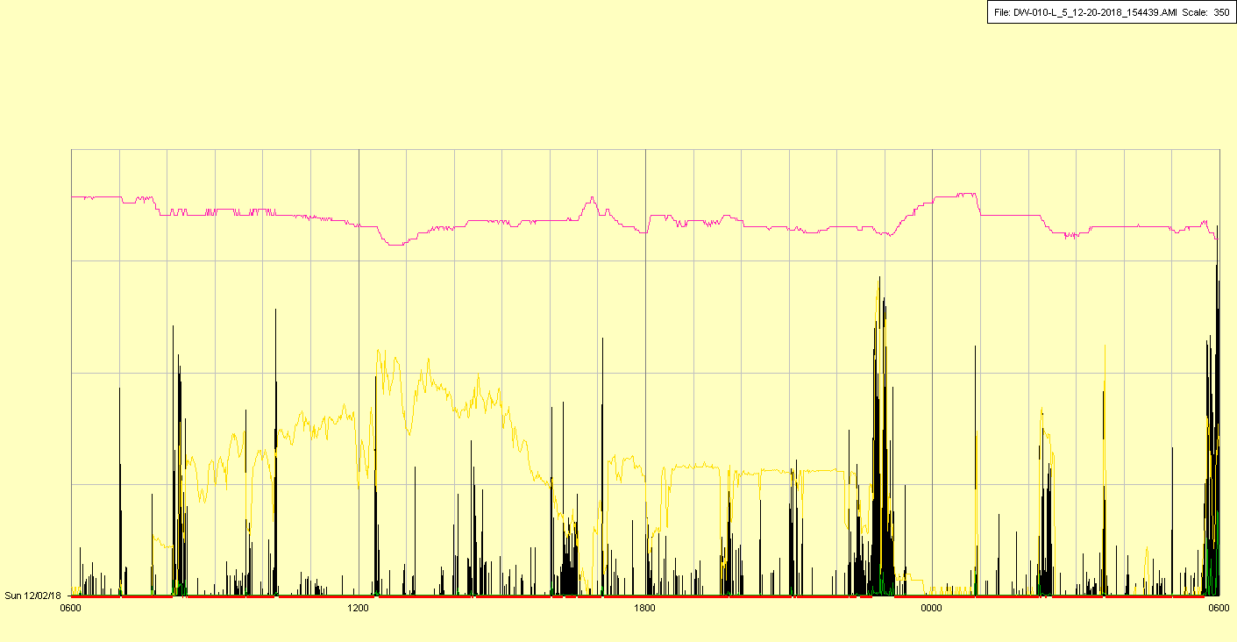

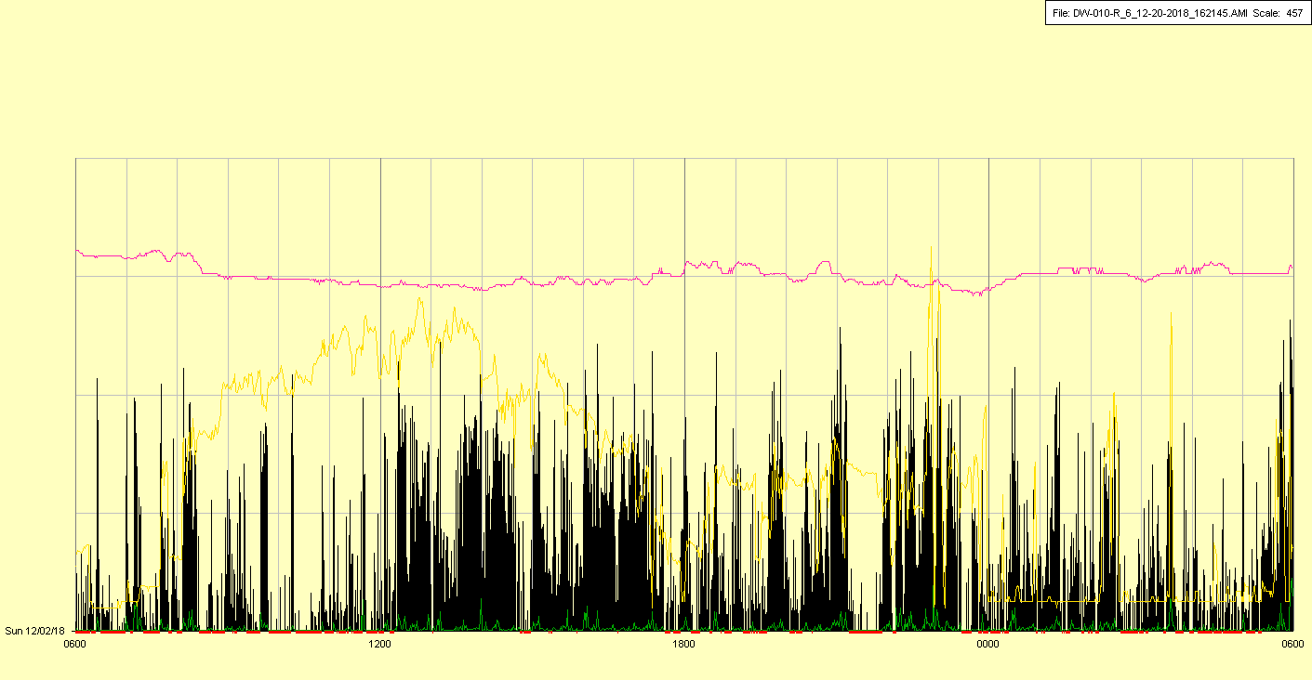

|  |  |  |  |
| --- | --- | --- | --- |
| Study ID | DW10 | Initial NIHSS (affected arm) | 2 |
| Age | 71 | Sex | Female |
| ICH Location | Right lobar | Patient location | ICU |
| Hospital day | 4 | Mechanical ventilation | No |
| Delirium status | Yes | 3-month mRS | 4 |

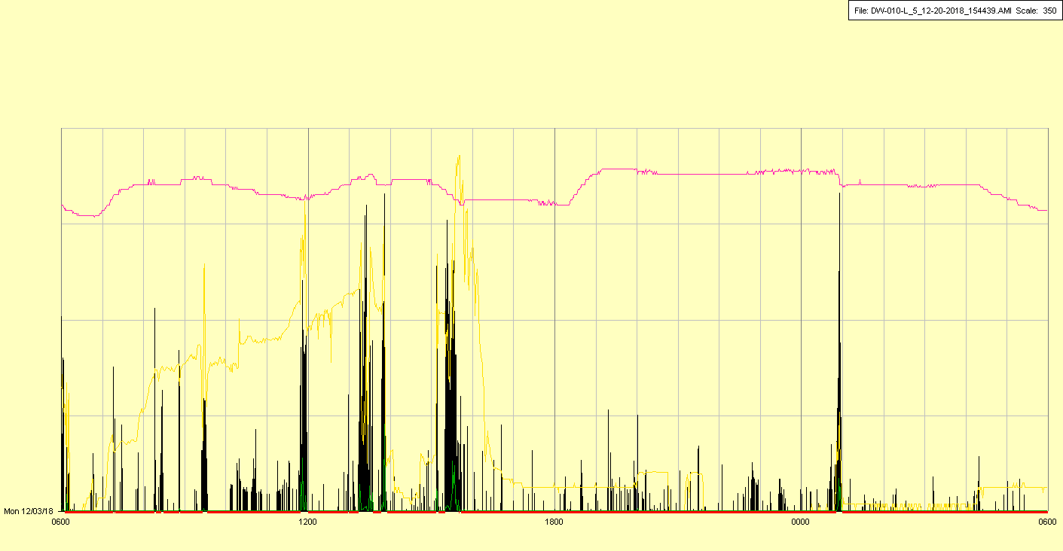

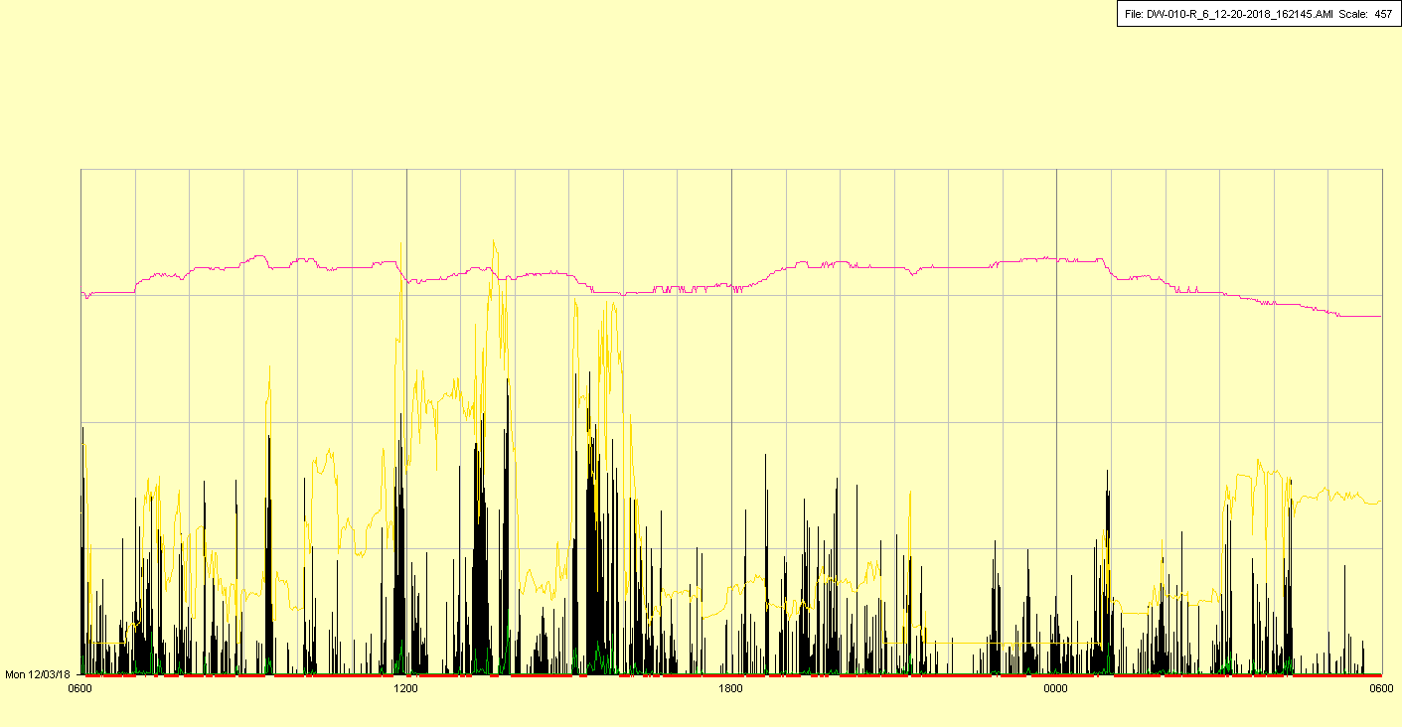

|  |  |  |  |
| --- | --- | --- | --- |
| Study ID | DW10 | Initial NIHSS (affected arm) | 2 |
| Age | 71 | Sex | Female |
| ICH Location | Right lobar | Patient location | ICU |
| Hospital day | 5 | Mechanical ventilation | No🡪Yes |
| Delirium status | Yes | 3-month mRS | 4 |

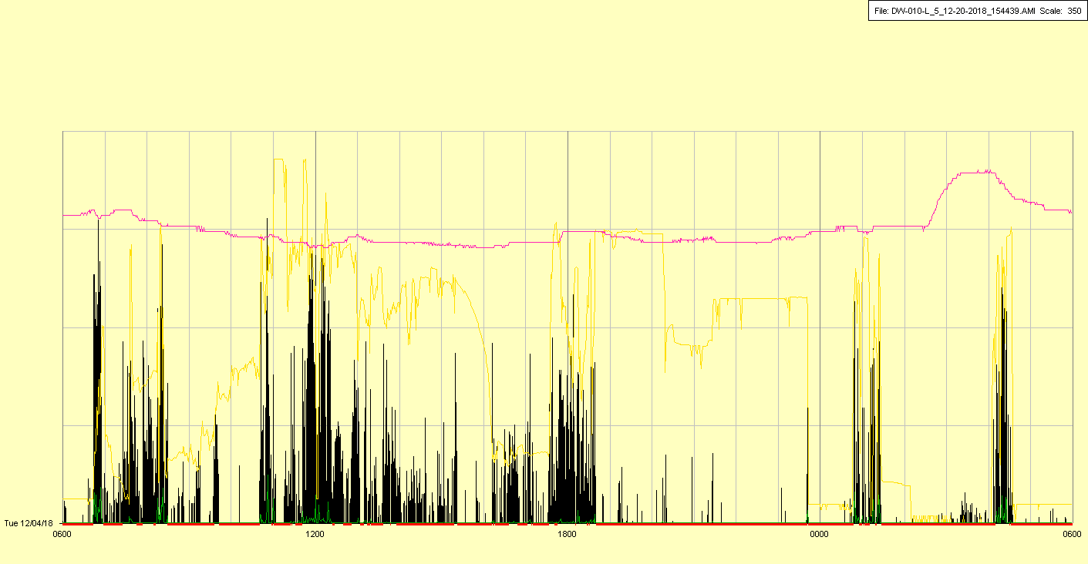

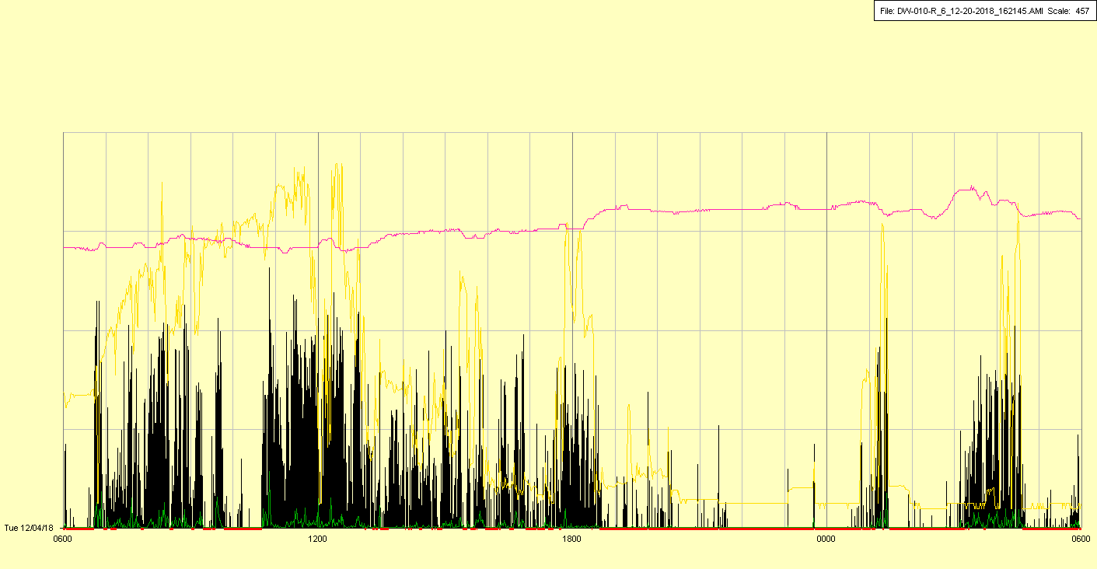

Intubated in evening

|  |  |  |  |
| --- | --- | --- | --- |
| Study ID | DW10 | Initial NIHSS (affected arm) | 2 |
| Age | 71 | Sex | Female |
| ICH Location | Right lobar | Patient location | ICU |
| Hospital day | 6 | Mechanical ventilation | Yes |
| Delirium status | No | 3-month mRS | 4 |

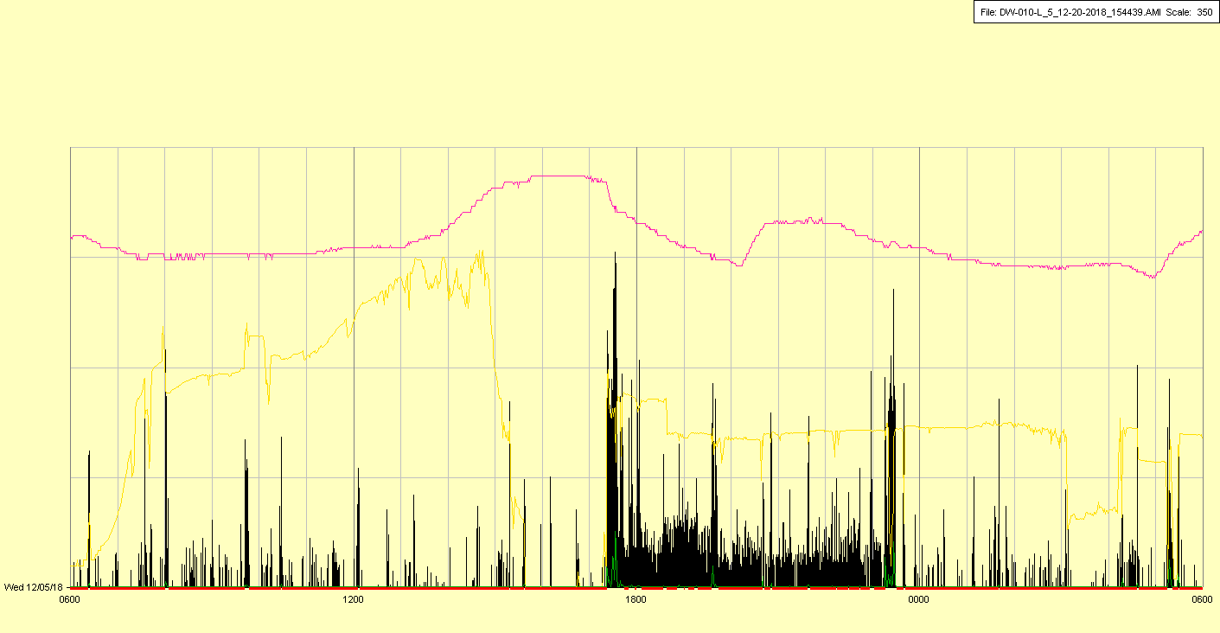

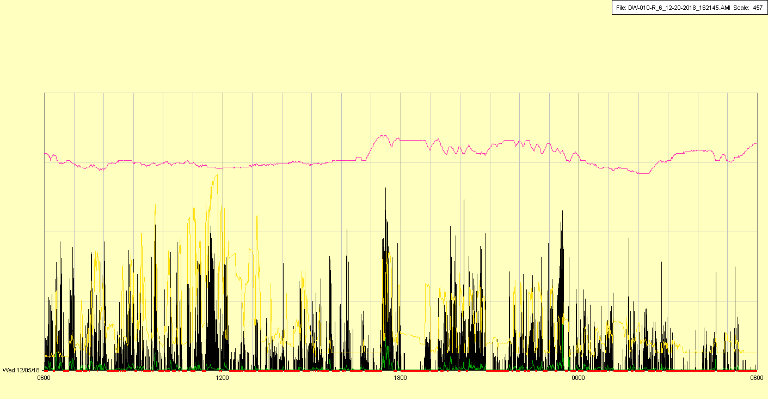

|  |  |  |  |
| --- | --- | --- | --- |
| Study ID | DW10 | Initial NIHSS (affected arm) | 2 |
| Age | 71 | Sex | Female |
| ICH Location | Right lobar | Patient location | ICU |
| Hospital day | 7 | Mechanical ventilation | Yes |
| Delirium status | Yes | 3-month mRS | 4 |

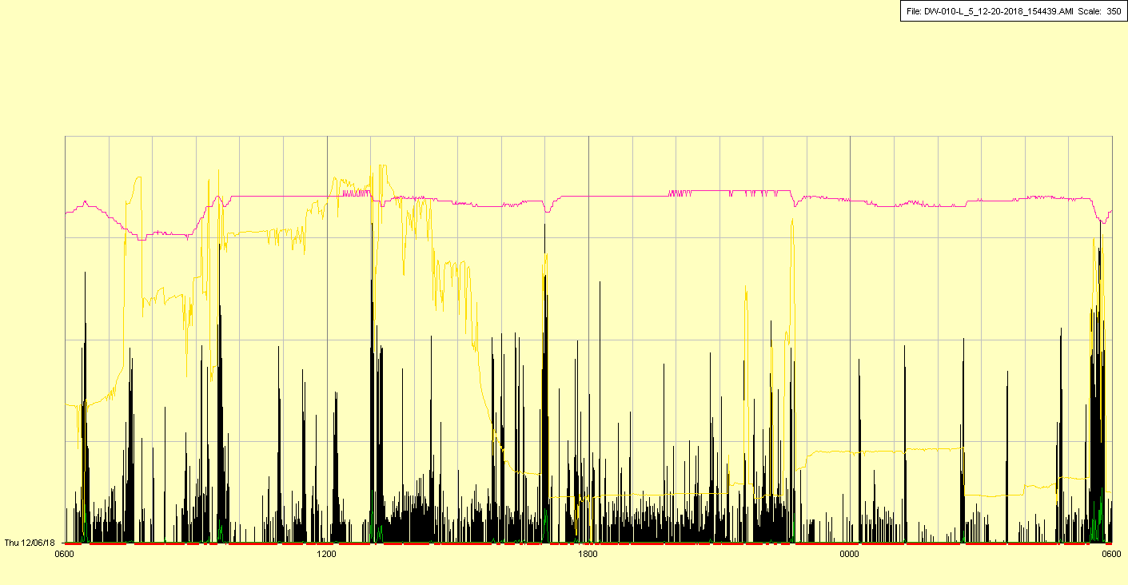

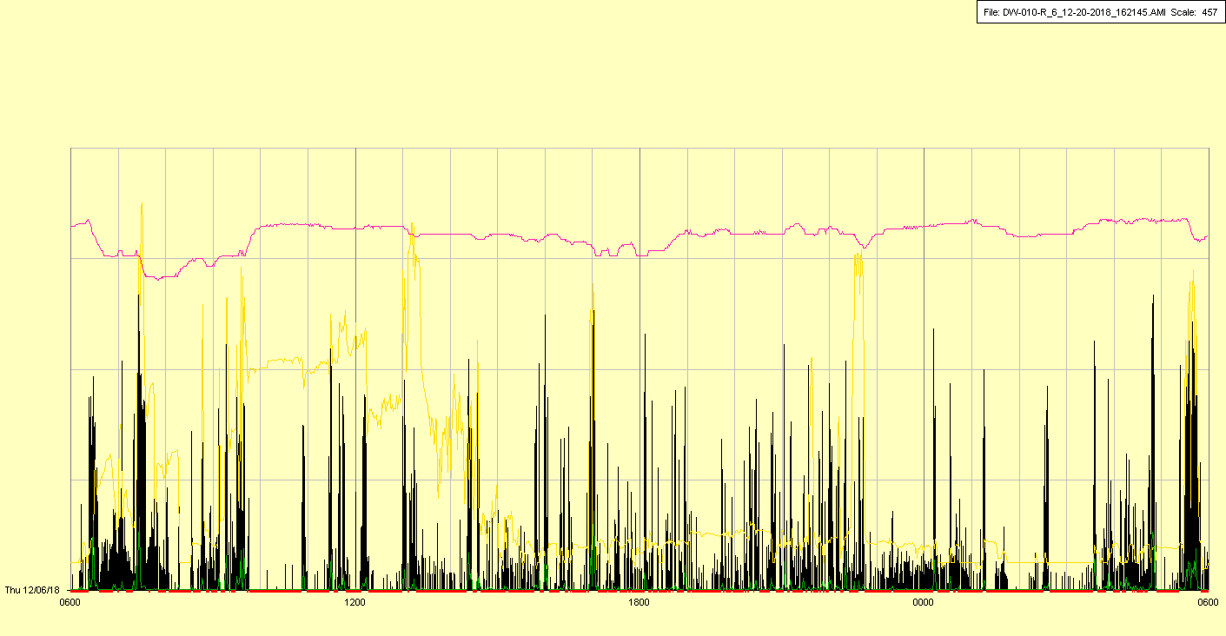

|  |  |  |  |
| --- | --- | --- | --- |
| Study ID | DW10 | Initial NIHSS (affected arm) | 2 |
| Age | 71 | Sex | Female |
| ICH Location | Right lobar | Patient location | ICU |
| Hospital day | 8 | Mechanical ventilation | Yes |
| Delirium status | Yes | 3-month mRS | 4 |

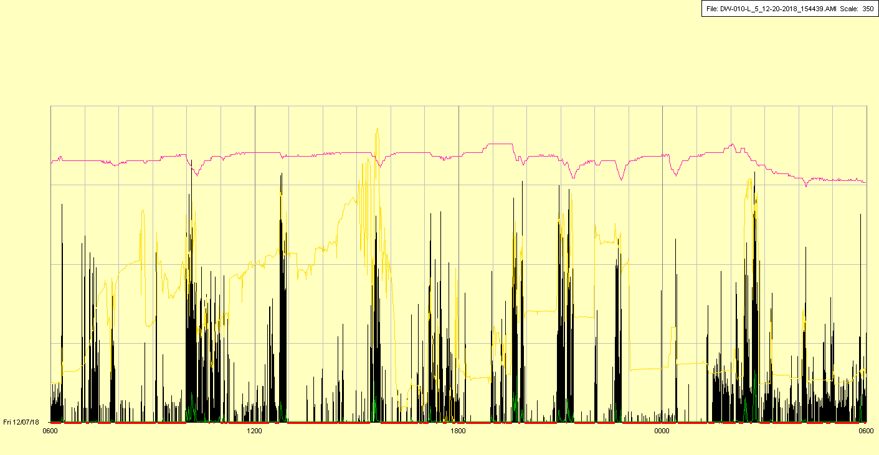

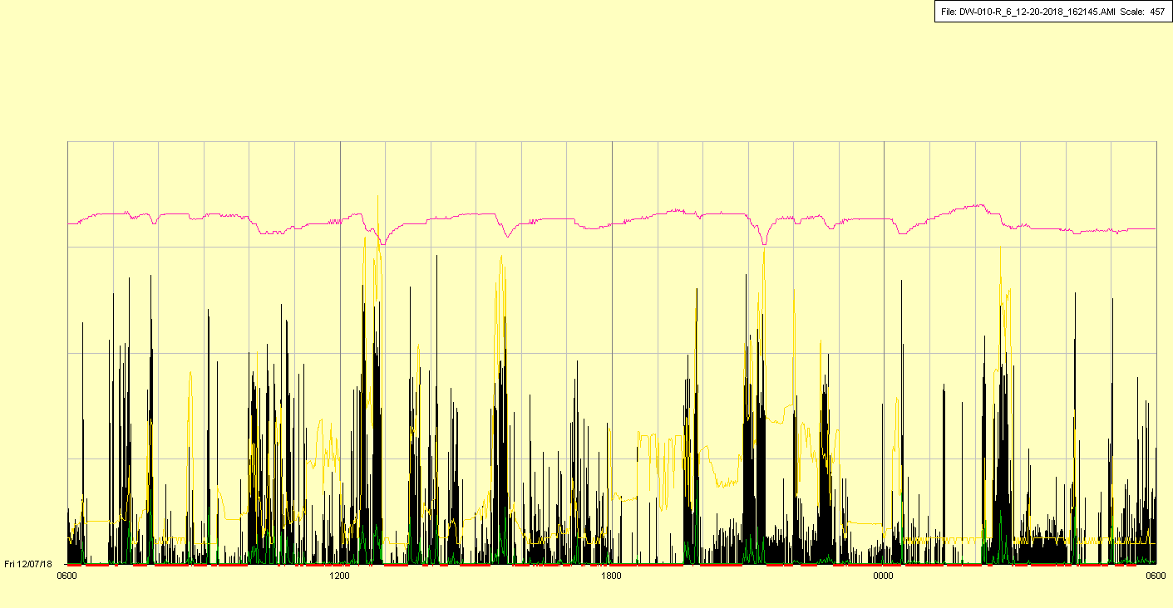

|  |  |  |  |
| --- | --- | --- | --- |
| Study ID | DW10 | Initial NIHSS (affected arm) | 2 |
| Age | 71 | Sex | Female |
| ICH Location | Right lobar | Patient location | ICU |
| Hospital day | 9 | Mechanical ventilation | Yes |
| Delirium status | Yes | 3-month mRS | 4 |

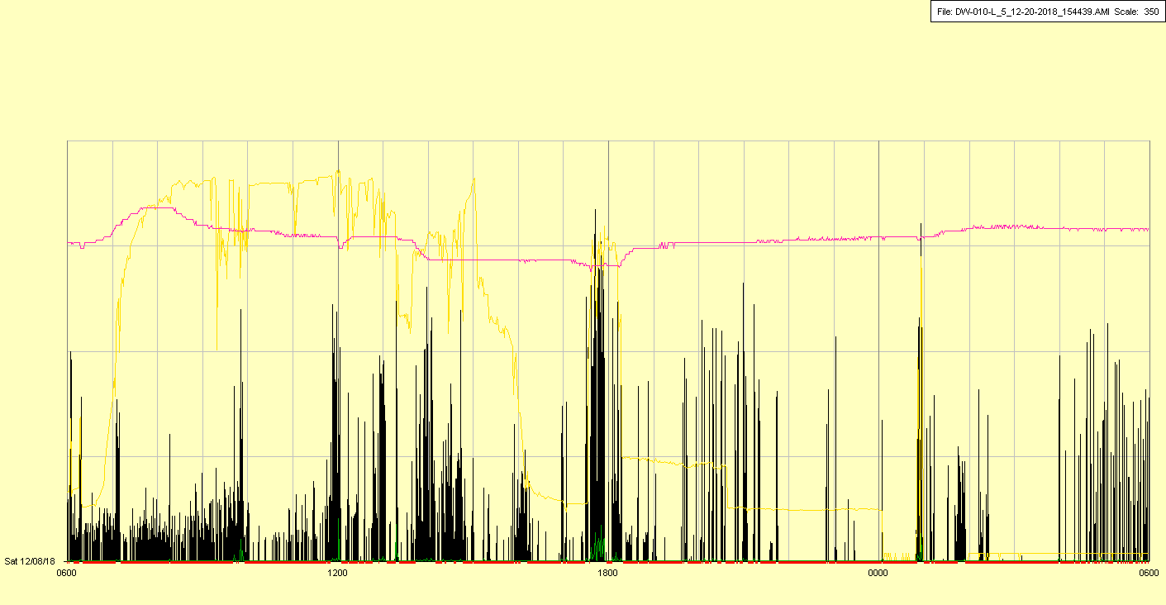

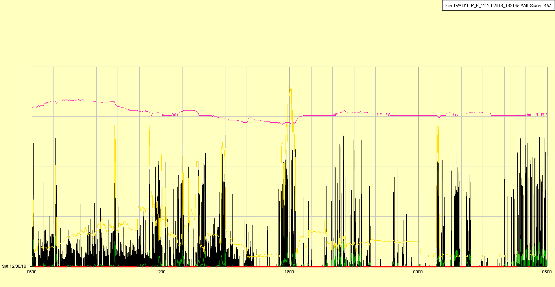

|  |  |  |  |
| --- | --- | --- | --- |
| Study ID | DW10 | Initial NIHSS (affected arm) | 2 |
| Age | 71 | Sex | Female |
| ICH Location | Right lobar | Patient location | ICU |
| Hospital day | 10 | Mechanical ventilation | Yes |
| Delirium status | Yes | 3-month mRS | 4 |

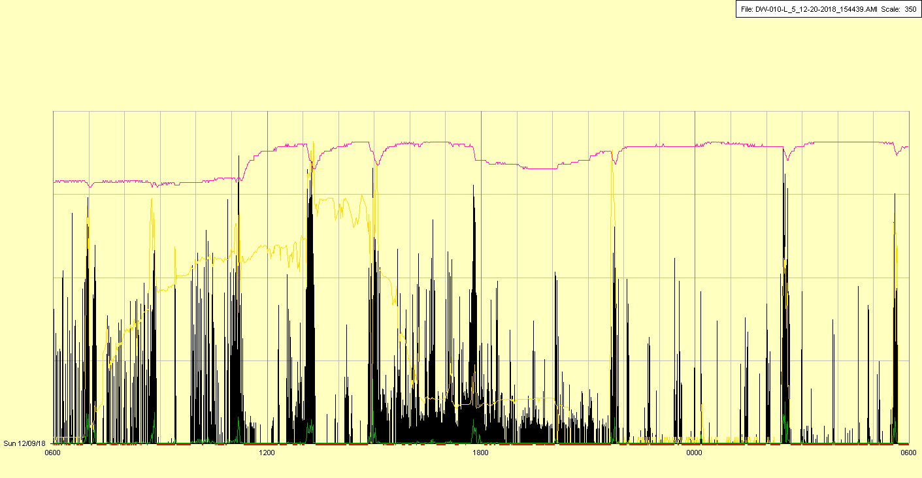

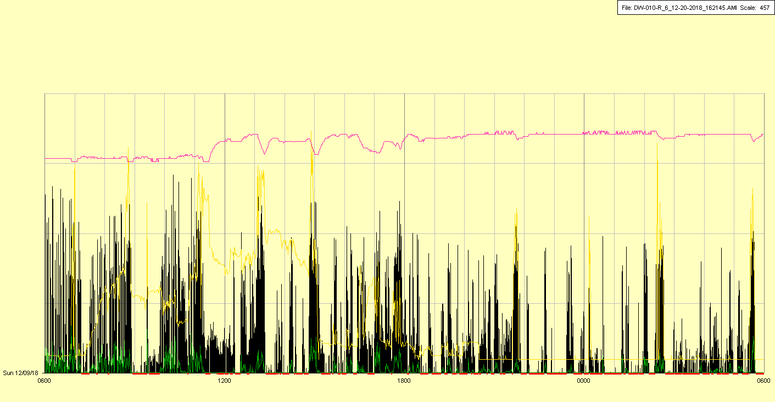

|  |  |  |  |
| --- | --- | --- | --- |
| Study ID | DW10 | Initial NIHSS (affected arm) | 2 |
| Age | 71 | Sex | Female |
| ICH Location | Right lobar | Patient location | ICU |
| Hospital day | 11 | Mechanical ventilation | Yes |
| Delirium status | Yes | 3-month mRS | 4 |

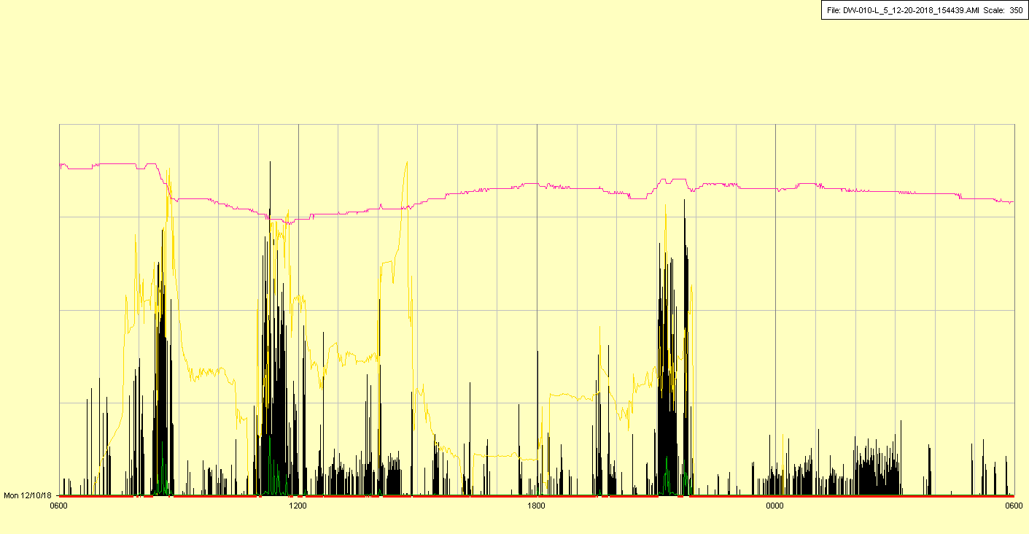

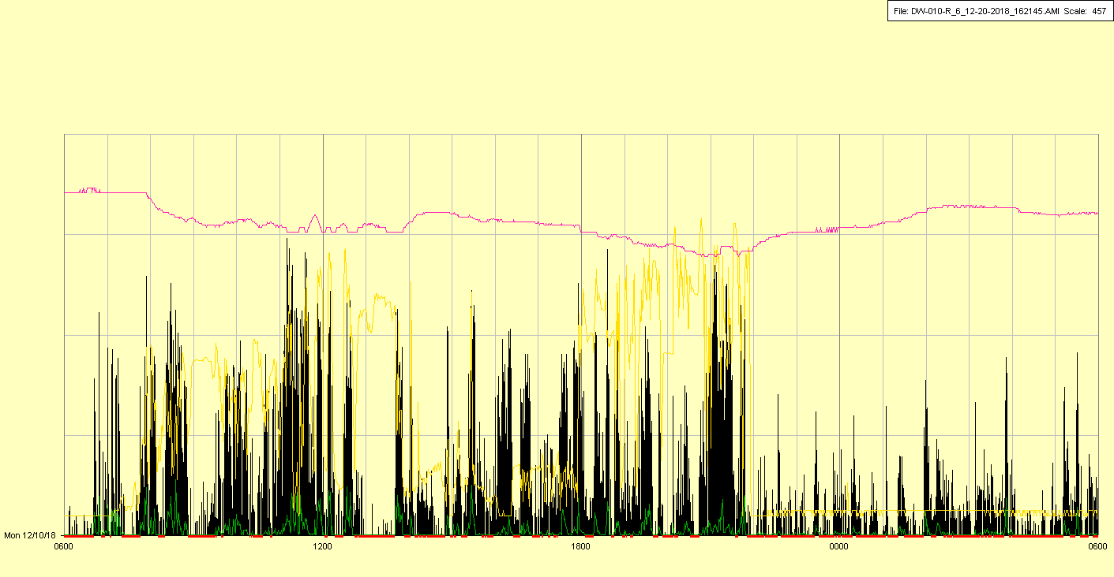

|  |  |  |  |
| --- | --- | --- | --- |
| Study ID | DW10 | Initial NIHSS (affected arm) | 2 |
| Age | 71 | Sex | Female |
| ICH Location | Right lobar | Patient location | ICU |
| Hospital day | 12 | Mechanical ventilation | Yes |
| Delirium status | Yes | 3-month mRS | 4 |

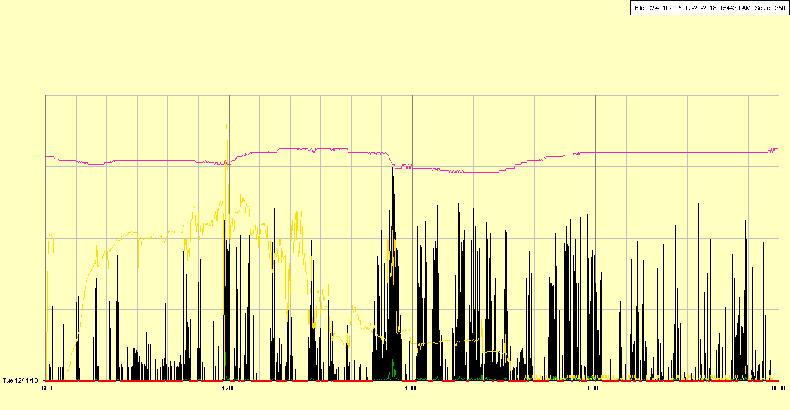

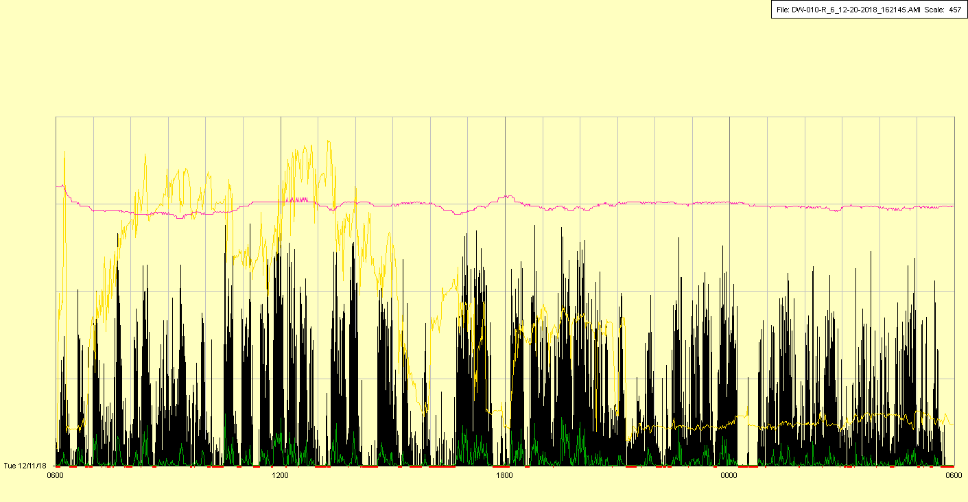

|  |  |  |  |
| --- | --- | --- | --- |
| Study ID | DW10 | Initial NIHSS (affected arm) | 2 |
| Age | 71 | Sex | Female |
| ICH Location | Right lobar | Patient location | ICU |
| Hospital day | 13 | Mechanical ventilation | Yes |
| Delirium status | No | 3-month mRS | 4 |

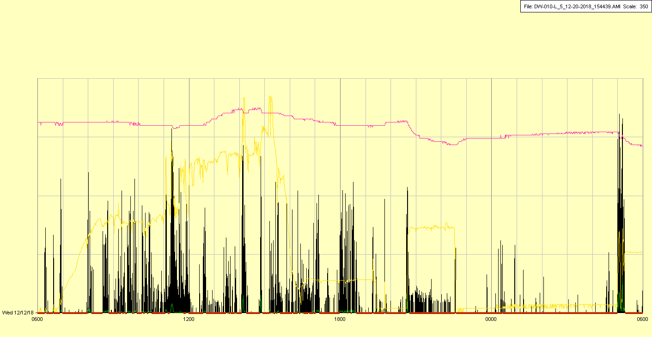

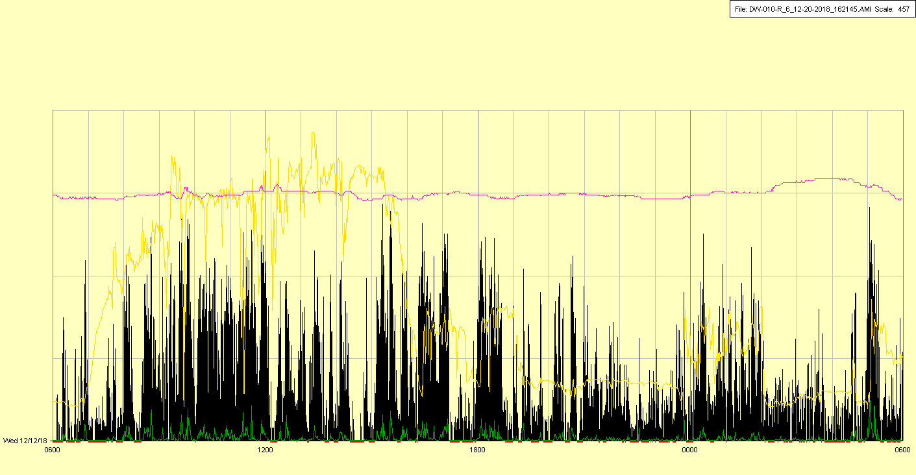

|  |  |  |  |
| --- | --- | --- | --- |
| Study ID | DW10 | Initial NIHSS (affected arm) | 2 |
| Age | 71 | Sex | Female |
| ICH Location | Right lobar | Patient location | ICU |
| Hospital day | 14 | Mechanical ventilation | Yes |
| Delirium status | No | 3-month mRS | 4 |

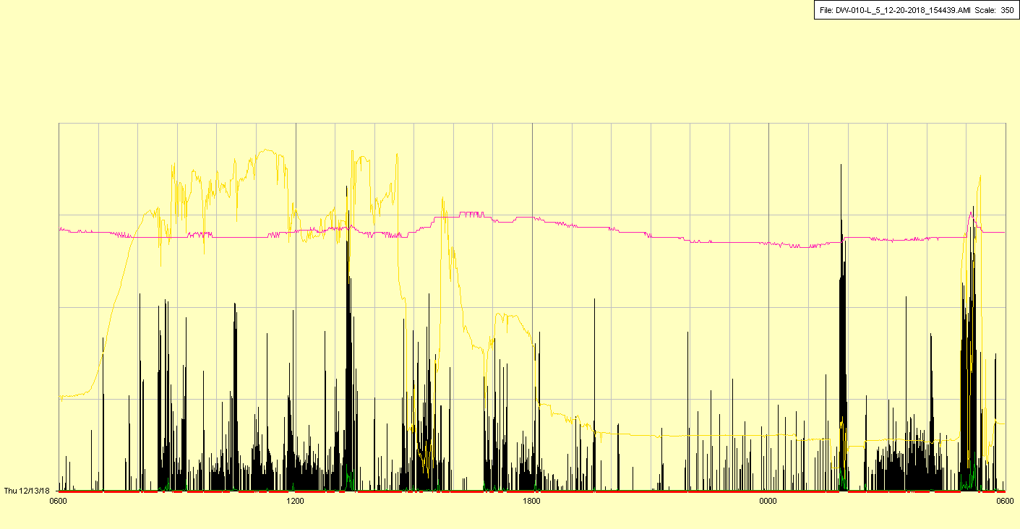

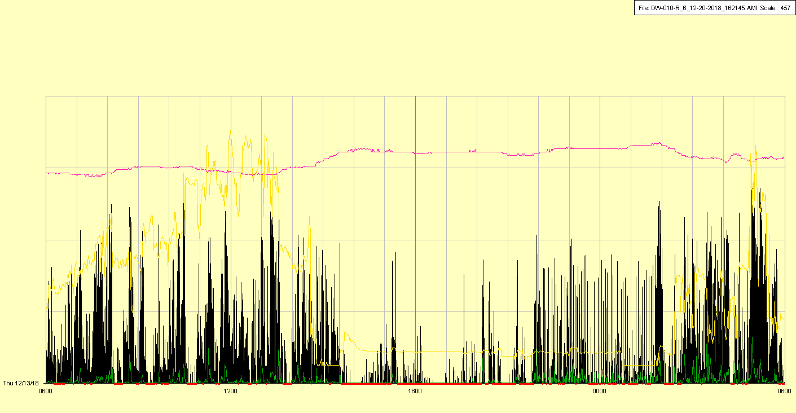

|  |  |  |  |
| --- | --- | --- | --- |
| Study ID | DW10 | Initial NIHSS (affected arm) | 2 |
| Age | 71 | Sex | Female |
| ICH Location | Right lobar | Patient location | ICU |
| Hospital day | 15 | Mechanical ventilation | Yes🡪No |
| Delirium status | Yes | 3-month mRS | 4 |

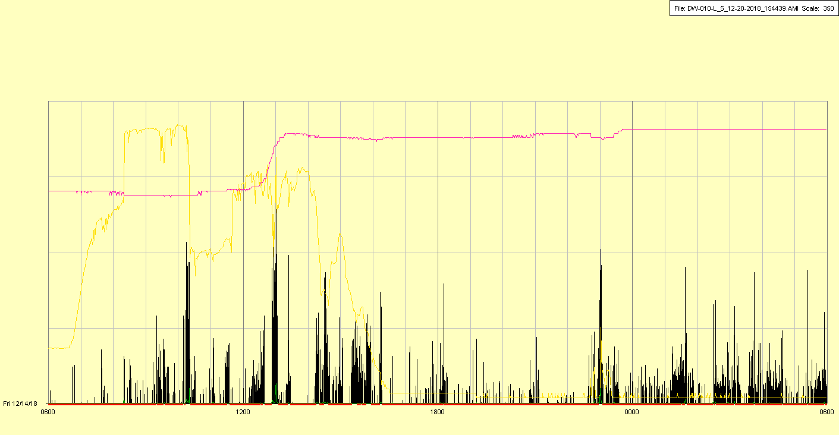

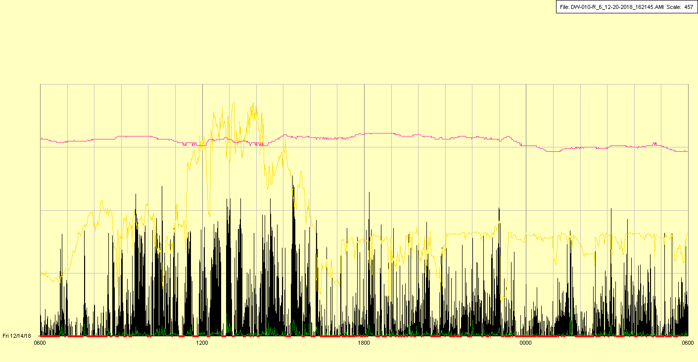

Extubated in late morning

|  |  |  |  |
| --- | --- | --- | --- |
| Study ID | DW10 | Initial NIHSS (affected arm) | 2 |
| Age | 71 | Sex | Female |
| ICH Location | Right lobar | Patient location | ICU |
| Hospital day | 16 | Mechanical ventilation | No |
| Delirium status | No | 3-month mRS | 4 |

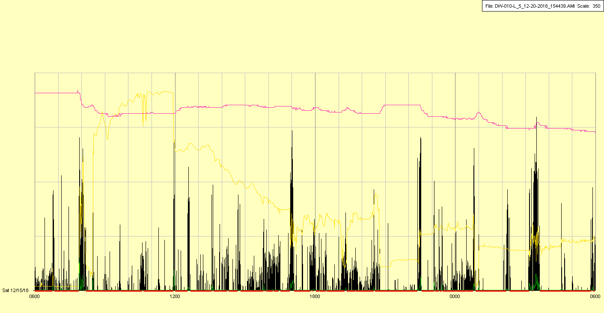

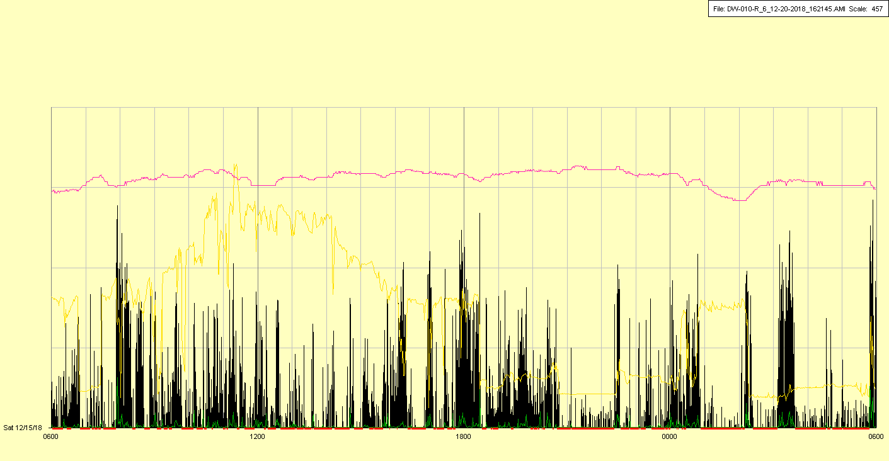

|  |  |  |  |
| --- | --- | --- | --- |
| Study ID | DW10 | Initial NIHSS (affected arm) | 2 |
| Age | 71 | Sex | Female |
| ICH Location | Right lobar | Patient location | ICU |
| Hospital day | 17 | Mechanical ventilation | No |
| Delirium status | Yes | 3-month mRS | 4 |

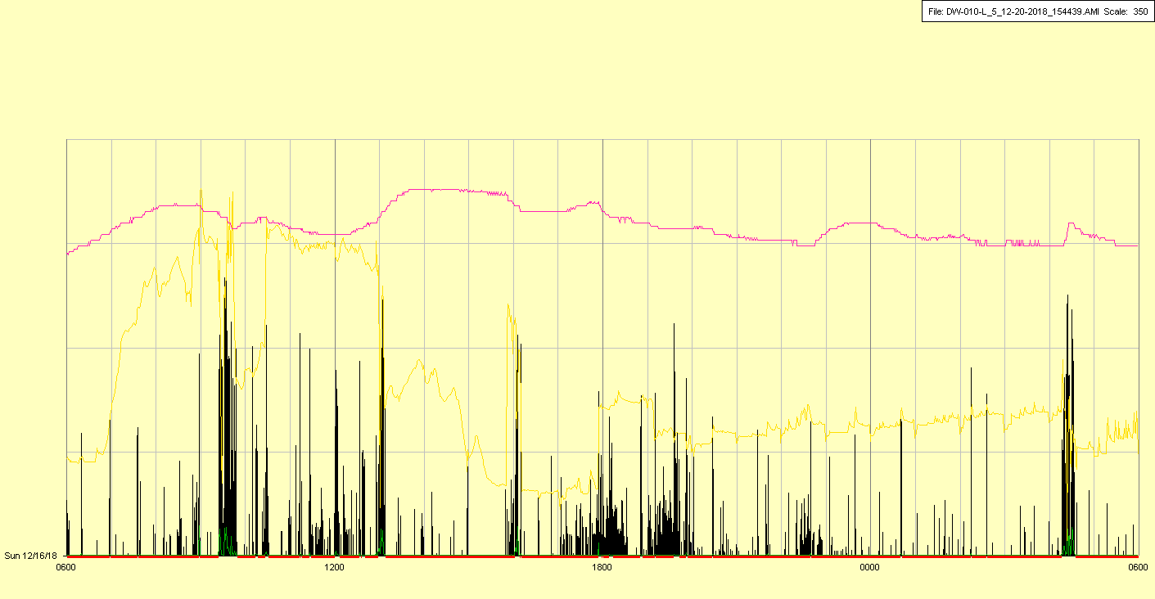

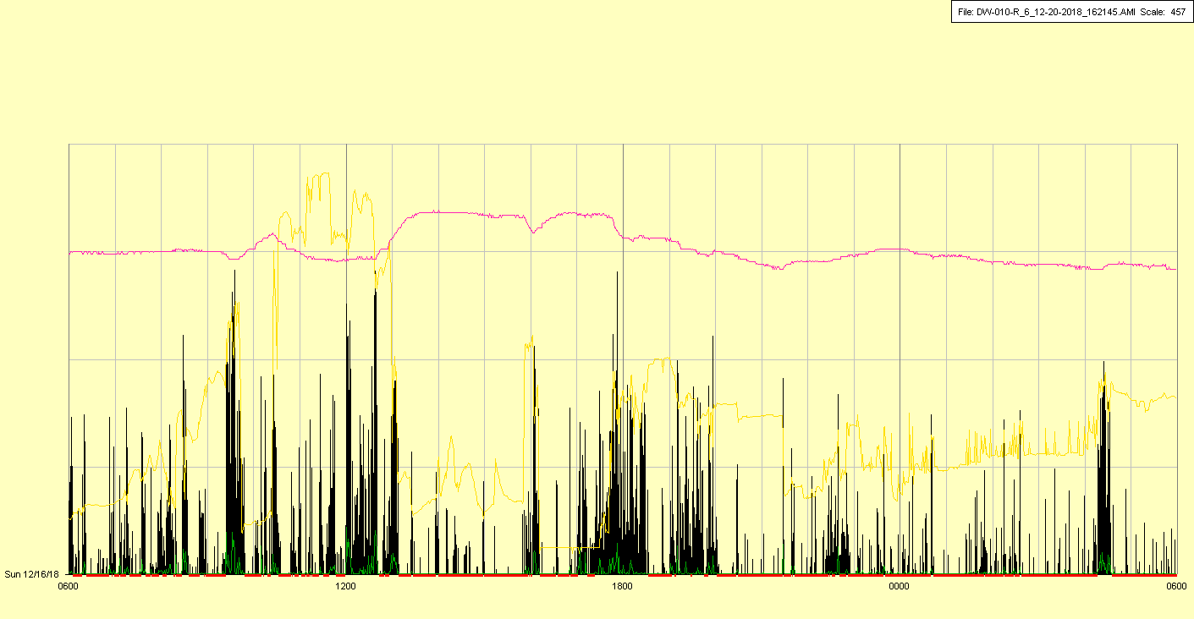

|  |  |  |  |
| --- | --- | --- | --- |
| Study ID | DW10 | Initial NIHSS (affected arm) | 2 |
| Age | 71 | Sex | Female |
| ICH Location | Right lobar | Patient location | ICU |
| Hospital day | 18 | Mechanical ventilation | No |
| Delirium status | No | 3-month mRS | 4 |

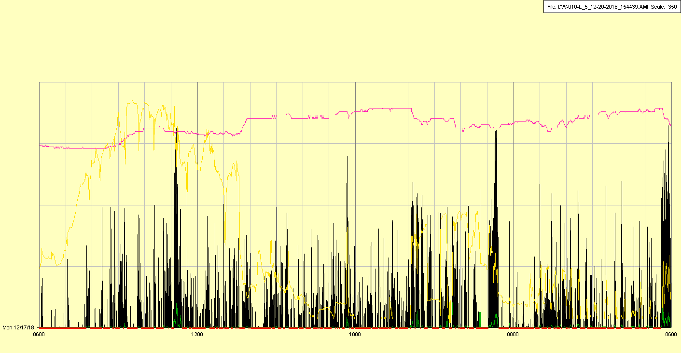

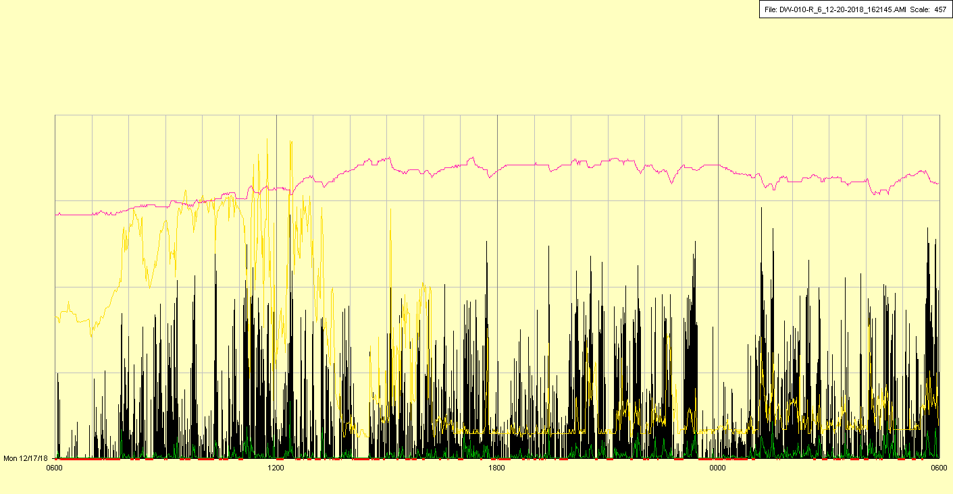

|  |  |  |  |
| --- | --- | --- | --- |
| Study ID | DW10 | Initial NIHSS (affected arm) | 2 |
| Age | 71 | Sex | Female |
| ICH Location | Right lobar | Patient location | ICU |
| Hospital day | 19 | Mechanical ventilation | No |
| Delirium status | Yes | 3-month mRS | 4 |

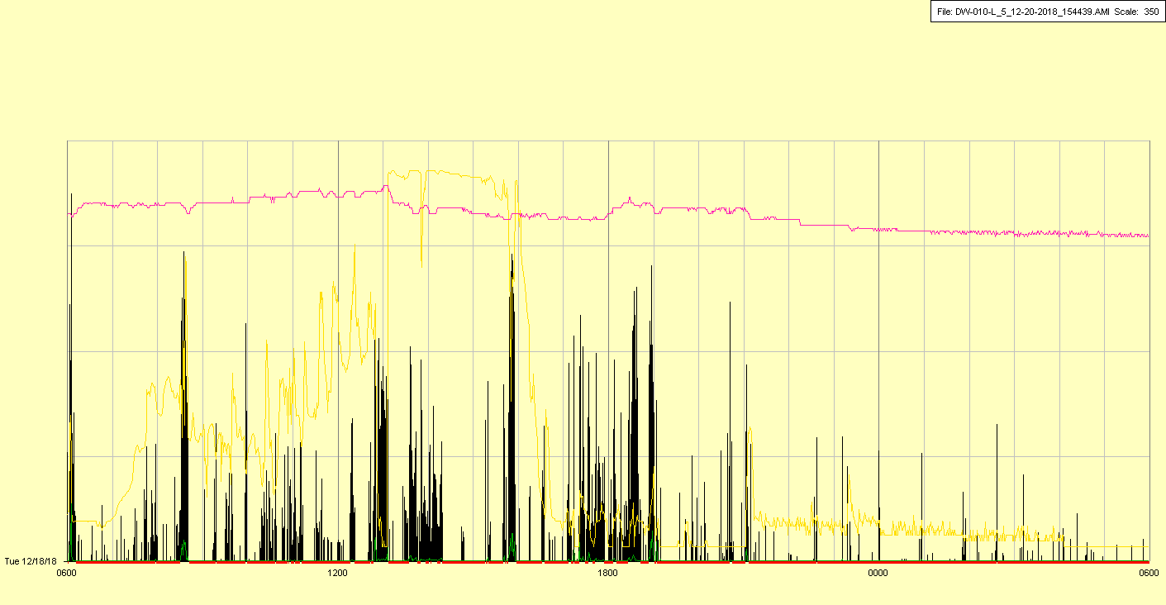

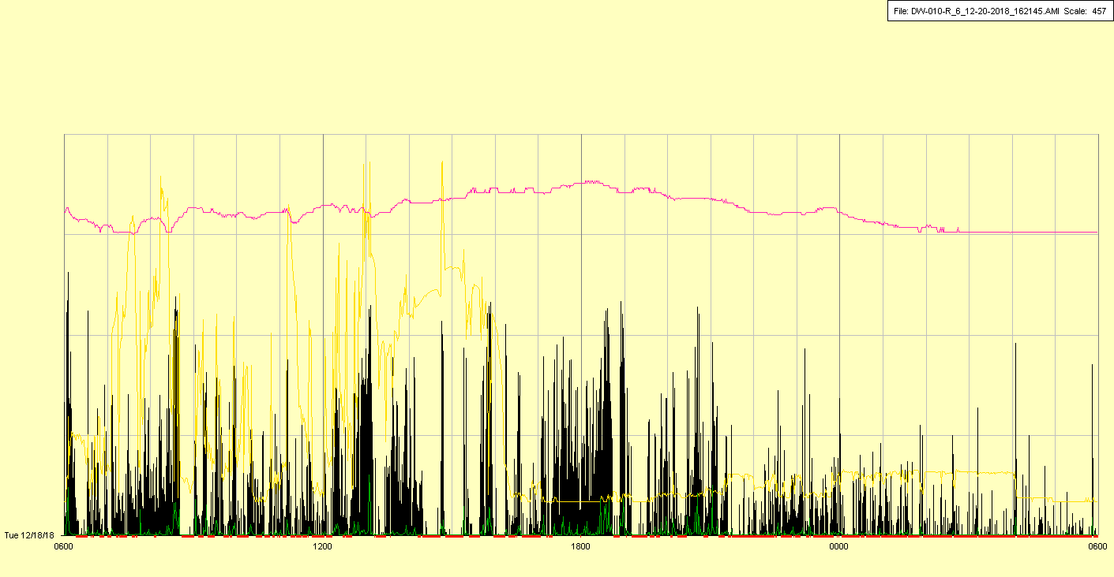

|  |  |  |  |
| --- | --- | --- | --- |
| Study ID | DW10 | Initial NIHSS (affected arm) | 2 |
| Age | 71 | Sex | Female |
| ICH Location | Right lobar | Patient location | ICU |
| Hospital day | 20 | Mechanical ventilation | No |
| Delirium status | No | 3-month mRS | 4 |

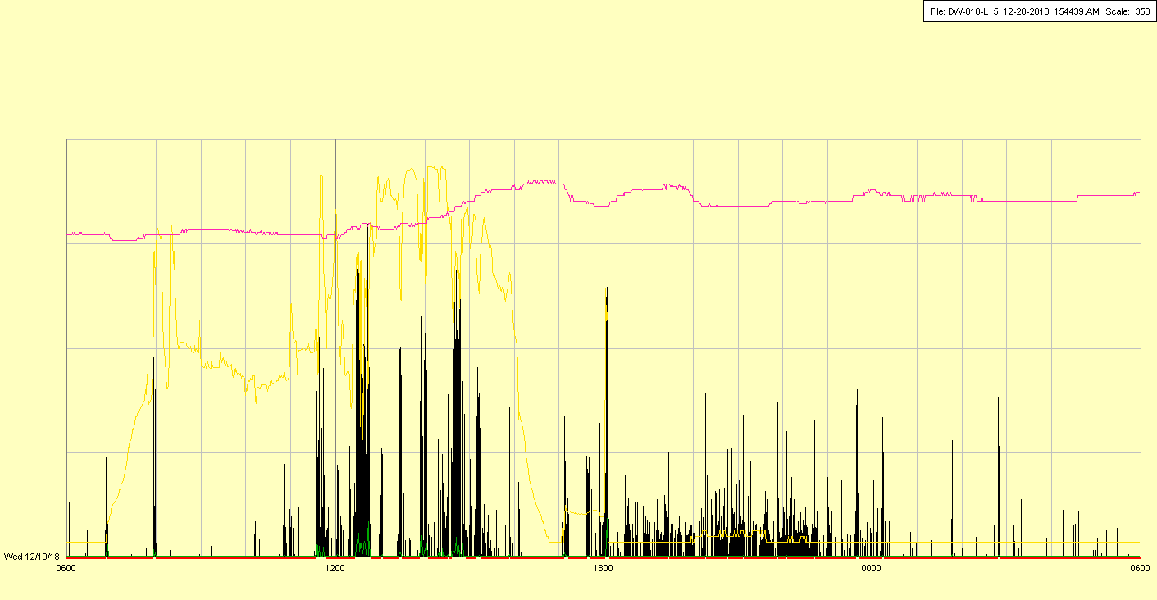

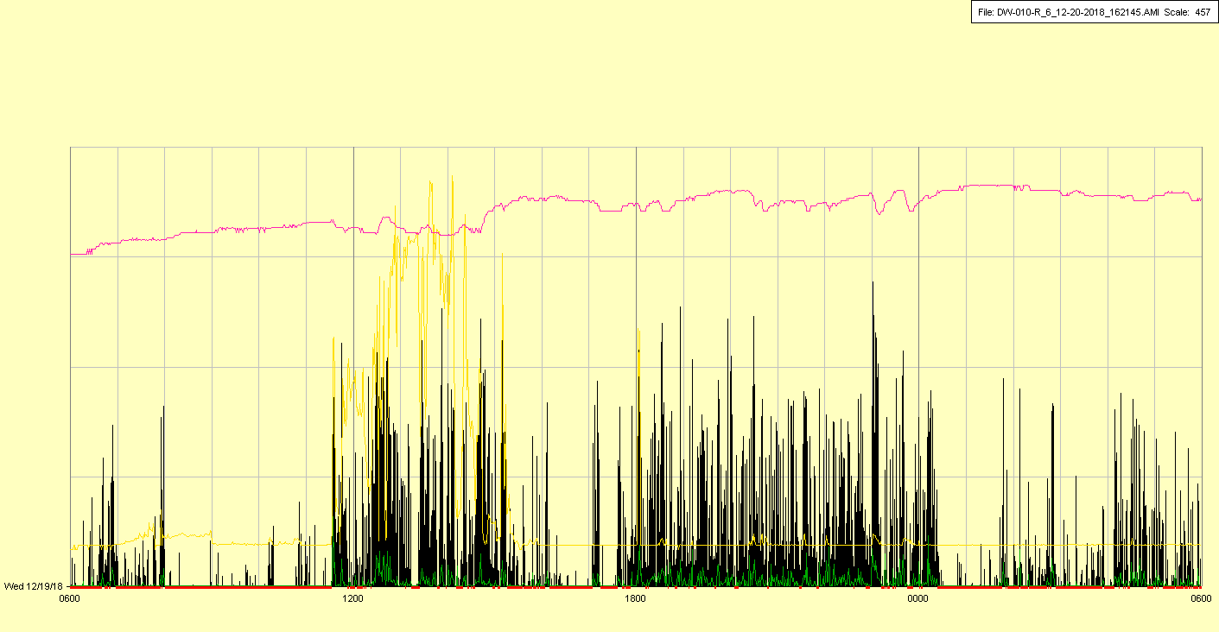

|  |  |  |  |
| --- | --- | --- | --- |
| Study ID | DW10 | Initial NIHSS (affected arm) | 2 |
| Age | 71 | Sex | Female |
| ICH Location | Right lobar | Patient location | ICU |
| Hospital day | 21 | Mechanical ventilation | No |
| Delirium status | No | 3-month mRS | 4 |

