|  |  |  |  |
| --- | --- | --- | --- |
| Study ID | DW11 | Initial NIHSS (affected arm) | 2 |
| Age | 76 | Sex | Female |
| ICH Location | Left deep | Patient location | ICU |
| Hospital day | 0 | Mechanical ventilation | No |
| Delirium status | Yes | 3-month mRS | 4 |

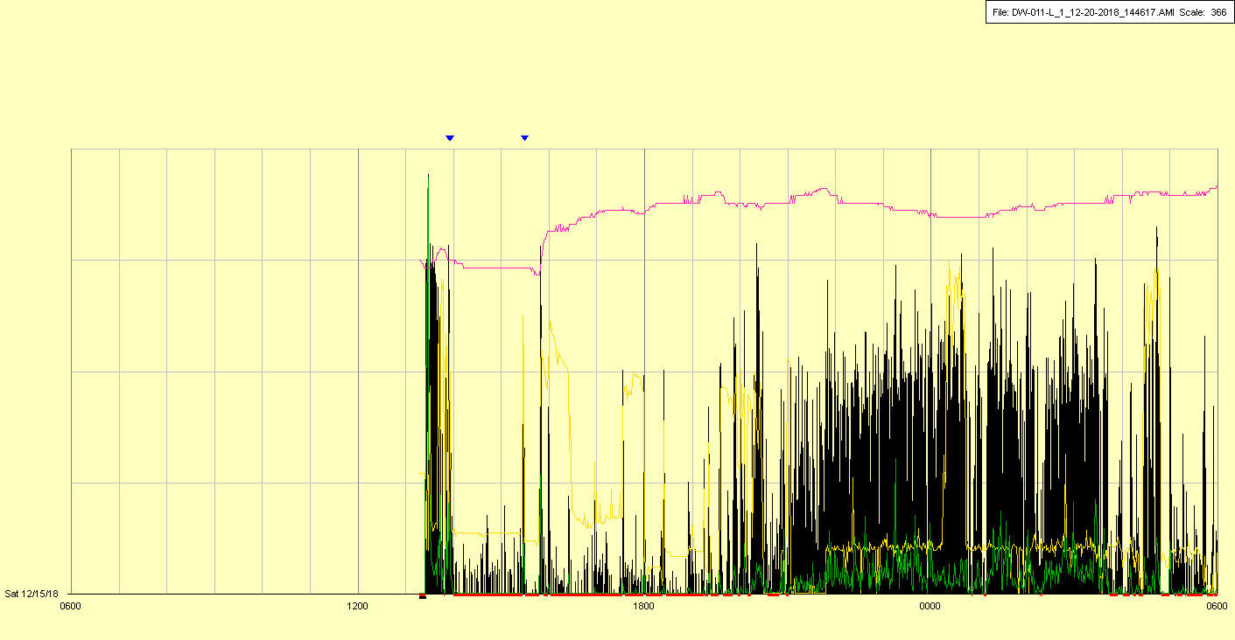

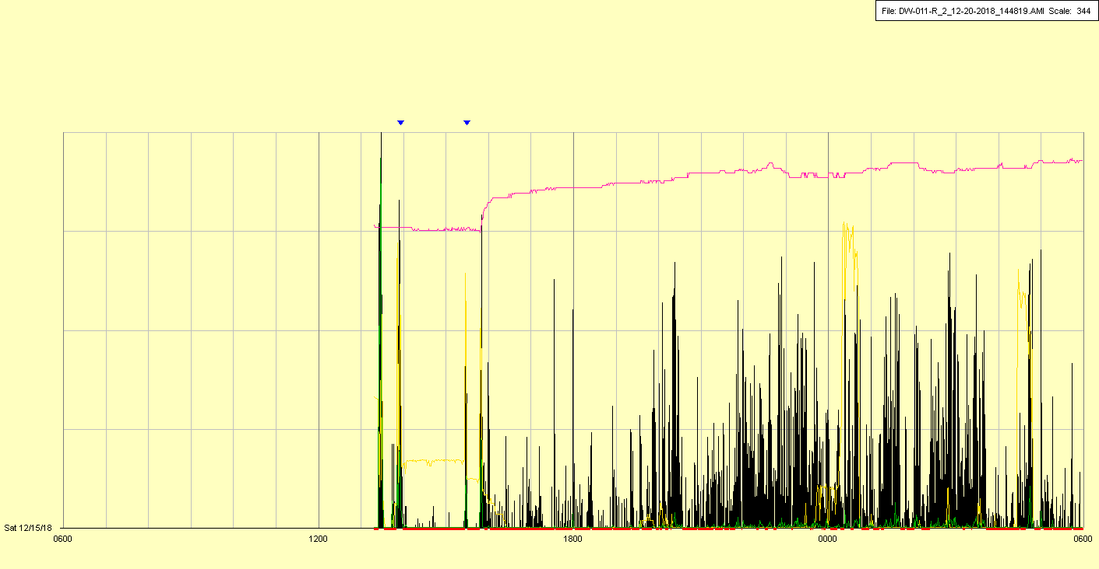

|  |  |  |  |
| --- | --- | --- | --- |
| Study ID | DW11 | Initial NIHSS (affected arm) | 2 |
| Age | 76 | Sex | Female |
| ICH Location | Left deep | Patient location | ICU |
| Hospital day | 1 | Mechanical ventilation | No |
| Delirium status | Yes | 3-month mRS | 4 |

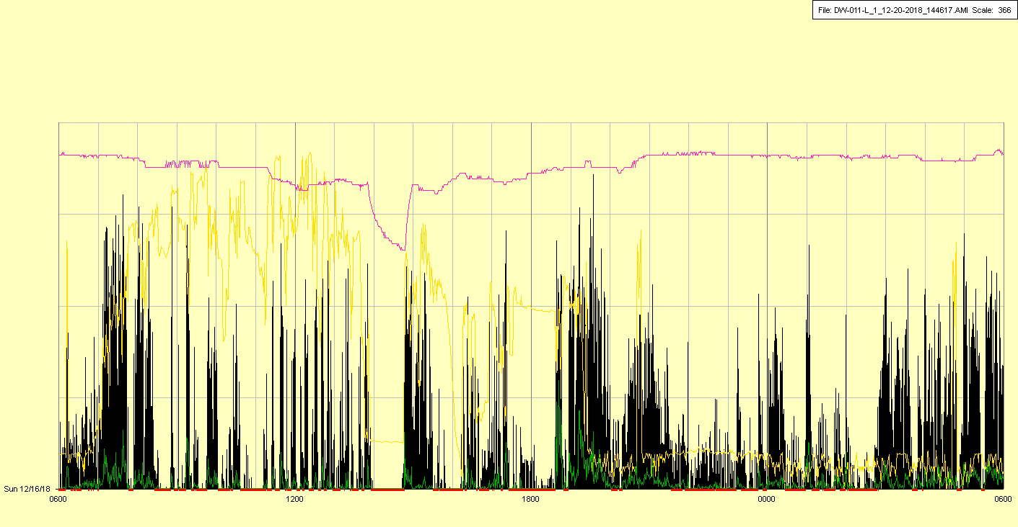

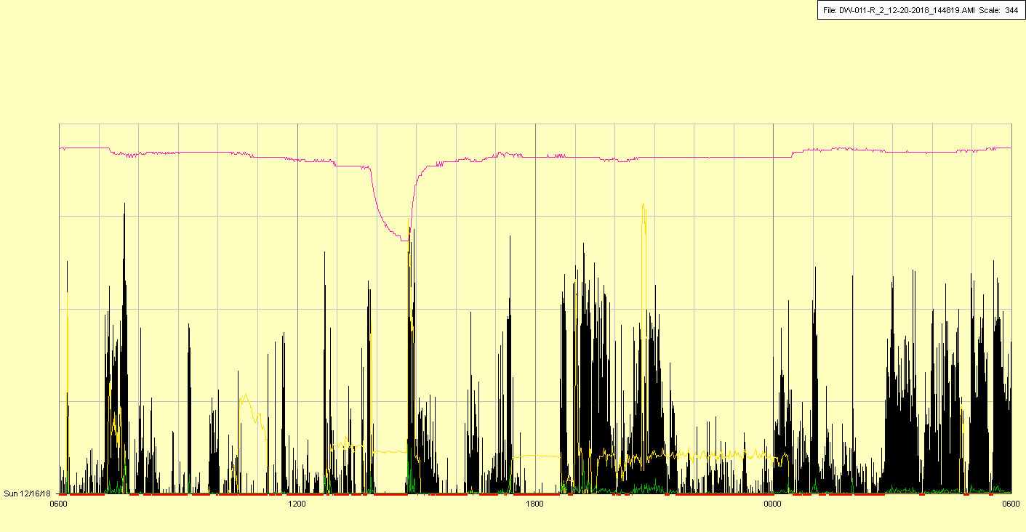

|  |  |  |  |
| --- | --- | --- | --- |
| Study ID | DW11 | Initial NIHSS (affected arm) | 2 |
| Age | 76 | Sex | Female |
| ICH Location | Left deep | Patient location | ICU |
| Hospital day | 2 | Mechanical ventilation | No |
| Delirium status | Yes | 3-month mRS | 4 |

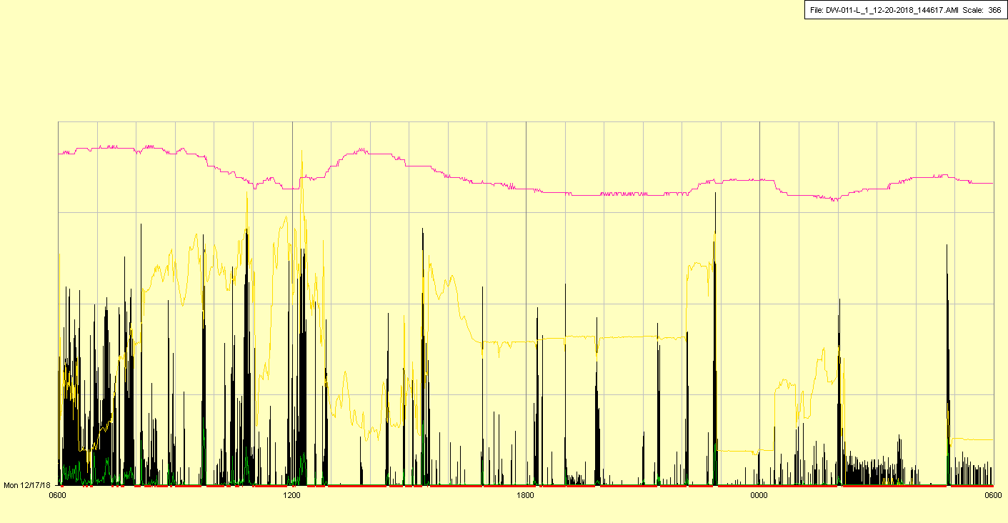

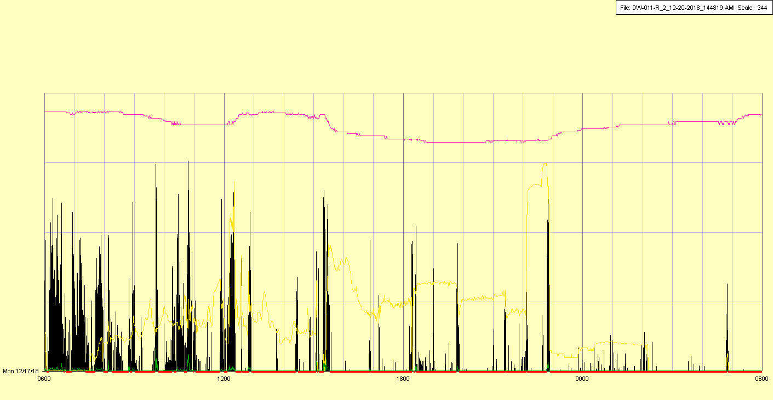

|  |  |  |  |
| --- | --- | --- | --- |
| Study ID | DW11 | Initial NIHSS (affected arm) | 2 |
| Age | 76 | Sex | Female |
| ICH Location | Left deep | Patient location | ICU |
| Hospital day | 3 | Mechanical ventilation | No |
| Delirium status | No | 3-month mRS | 4 |

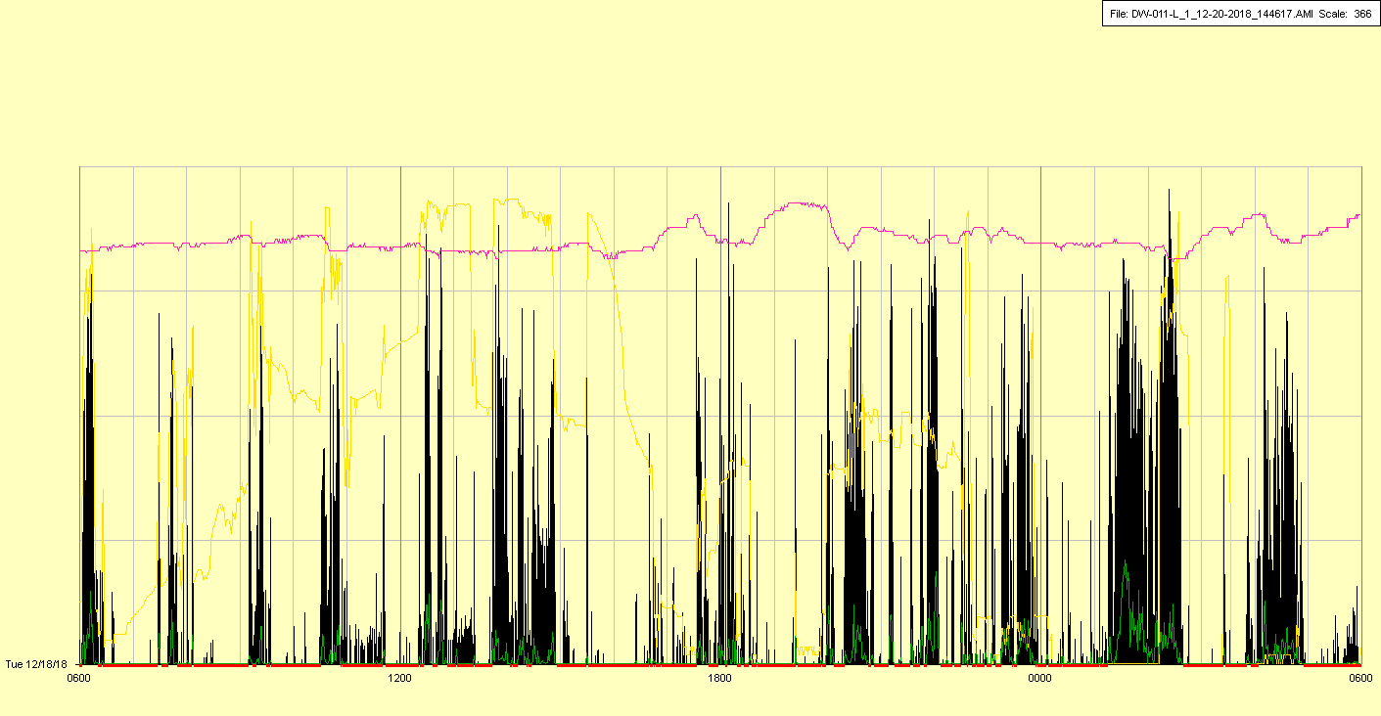

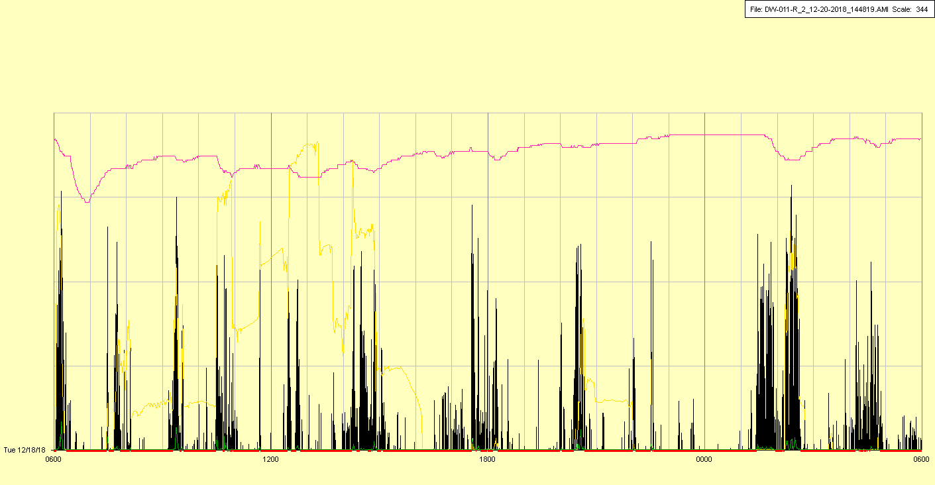

|  |  |  |  |
| --- | --- | --- | --- |
| Study ID | DW11 | Initial NIHSS (affected arm) | 2 |
| Age | 76 | Sex | Female |
| ICH Location | Left deep | Patient location | Stroke Unit |
| Hospital day | 4 | Mechanical ventilation | No |
| Delirium status | Yes | 3-month mRS | 4 |

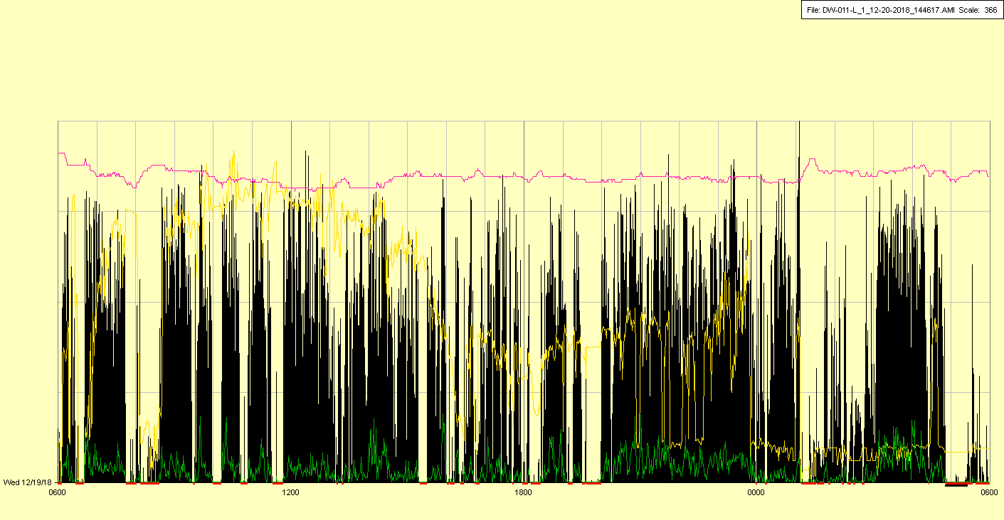

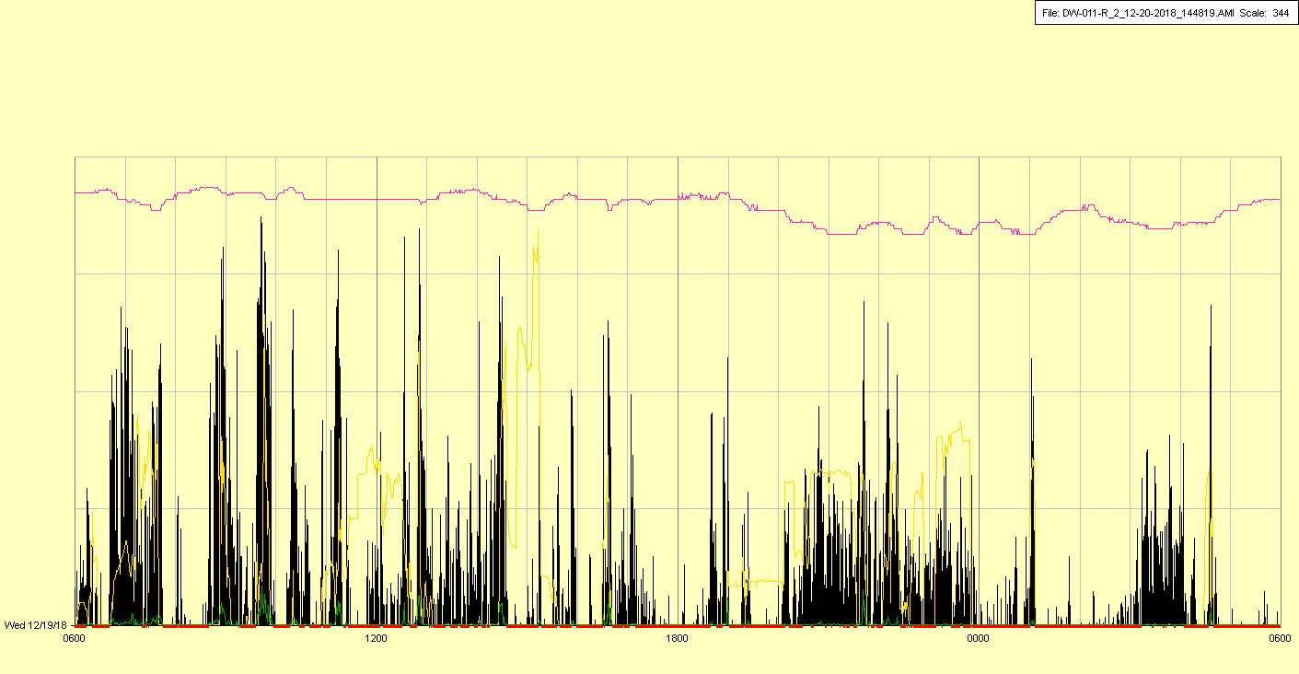

|  |  |  |  |
| --- | --- | --- | --- |
| Study ID | DW11 | Initial NIHSS (affected arm) | 2 |
| Age | 76 | Sex | Female |
| ICH Location | Left deep | Patient location | Stroke Unit |
| Hospital day | 5 | Mechanical ventilation | No |
| Delirium status | Yes | 3-month mRS | 4 |

