|  |  |  |  |
| --- | --- | --- | --- |
| Study ID | DW13 | Initial NIHSS (affected arm) | 3 |
| Age | 67 | Sex | Female |
| ICH Location | Right deep | Patient location | ICU |
| Hospital day | 1 | Mechanical ventilation | No |
| Delirium status | No (not assessed) | 3-month mRS |  |

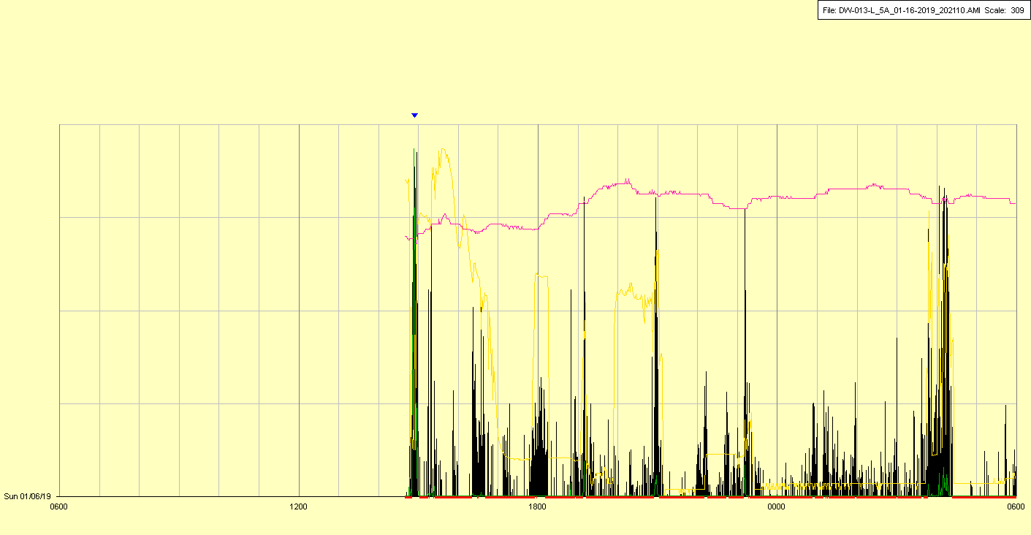

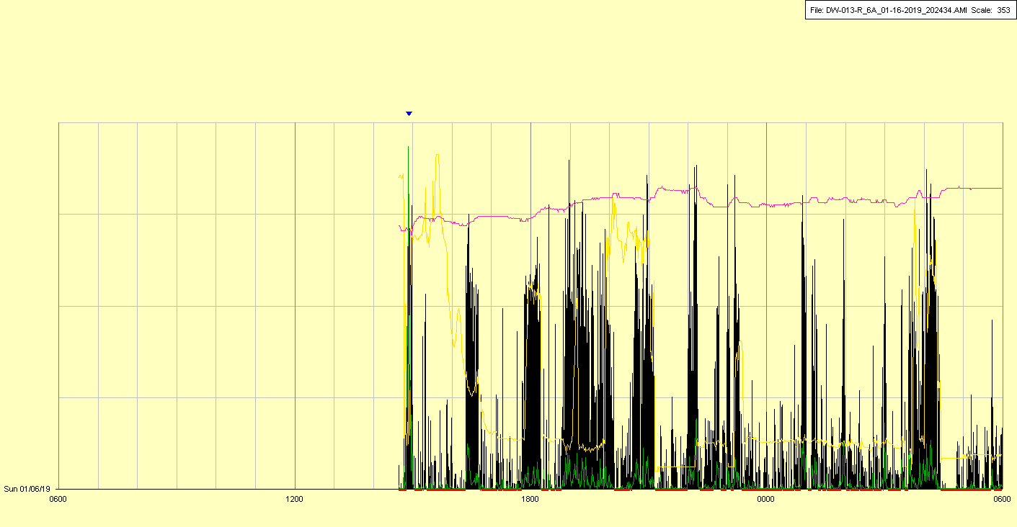

|  |  |  |  |
| --- | --- | --- | --- |
| Study ID | DW13 | Initial NIHSS (affected arm) | 3 |
| Age | 67 | Sex | Female |
| ICH Location | Right deep | Patient location | ICU |
| Hospital day | 2 | Mechanical ventilation | No |
| Delirium status | No | 3-month mRS |  |

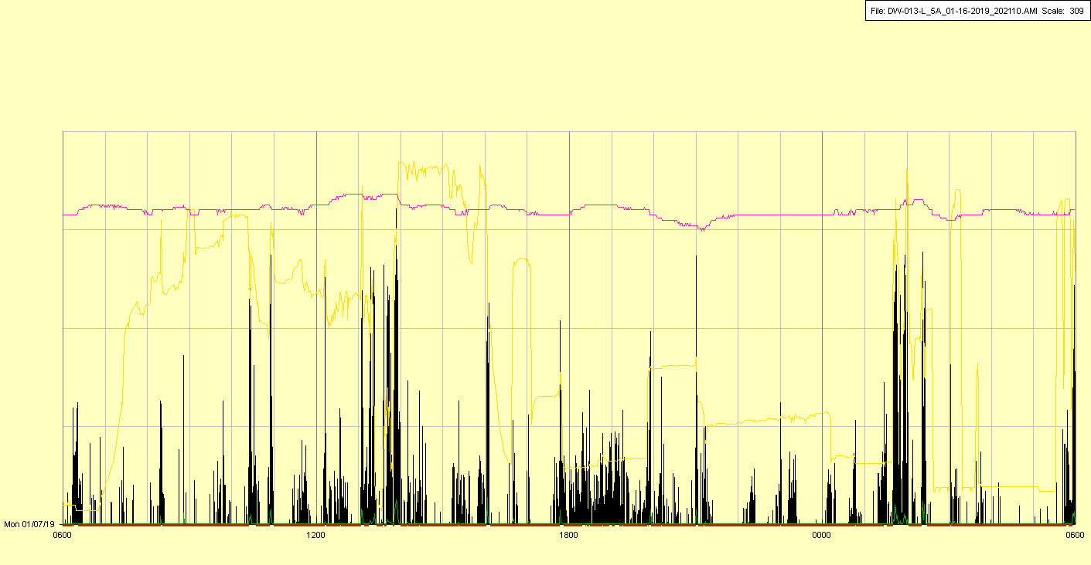

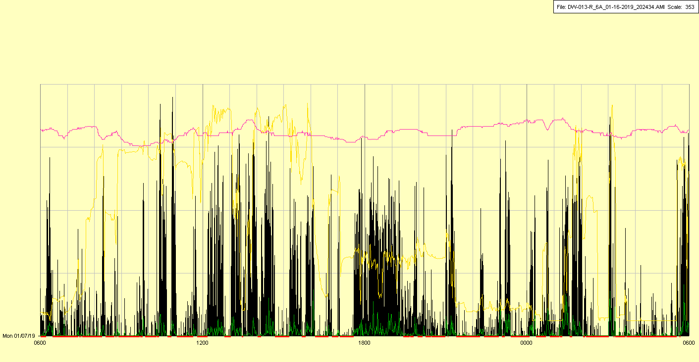

|  |  |  |  |
| --- | --- | --- | --- |
| Study ID | DW13 | Initial NIHSS (affected arm) | 3 |
| Age | 67 | Sex | Female |
| ICH Location | Right deep | Patient location | ICU |
| Hospital day | 3 | Mechanical ventilation | No |
| Delirium status | No | 3-month mRS |  |

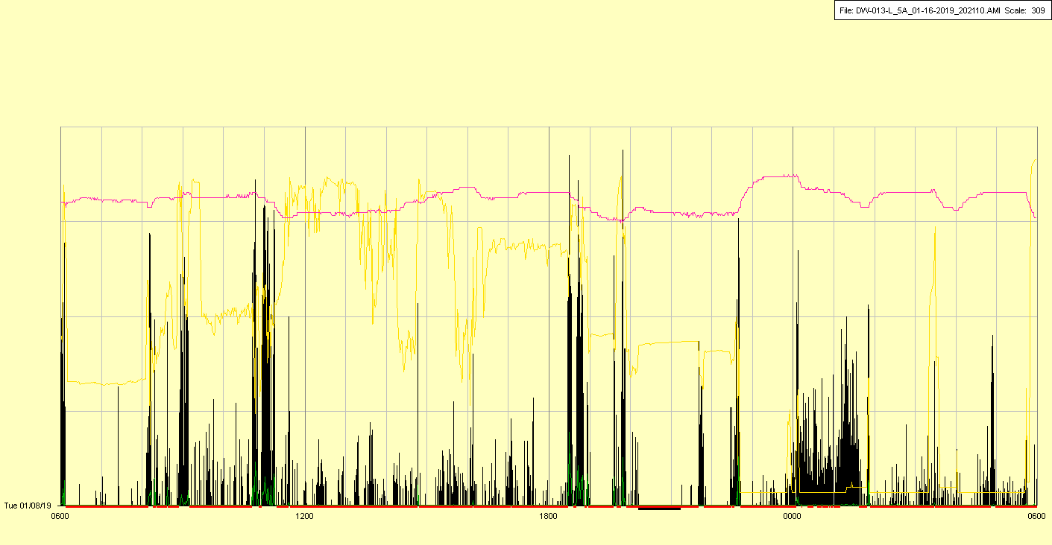

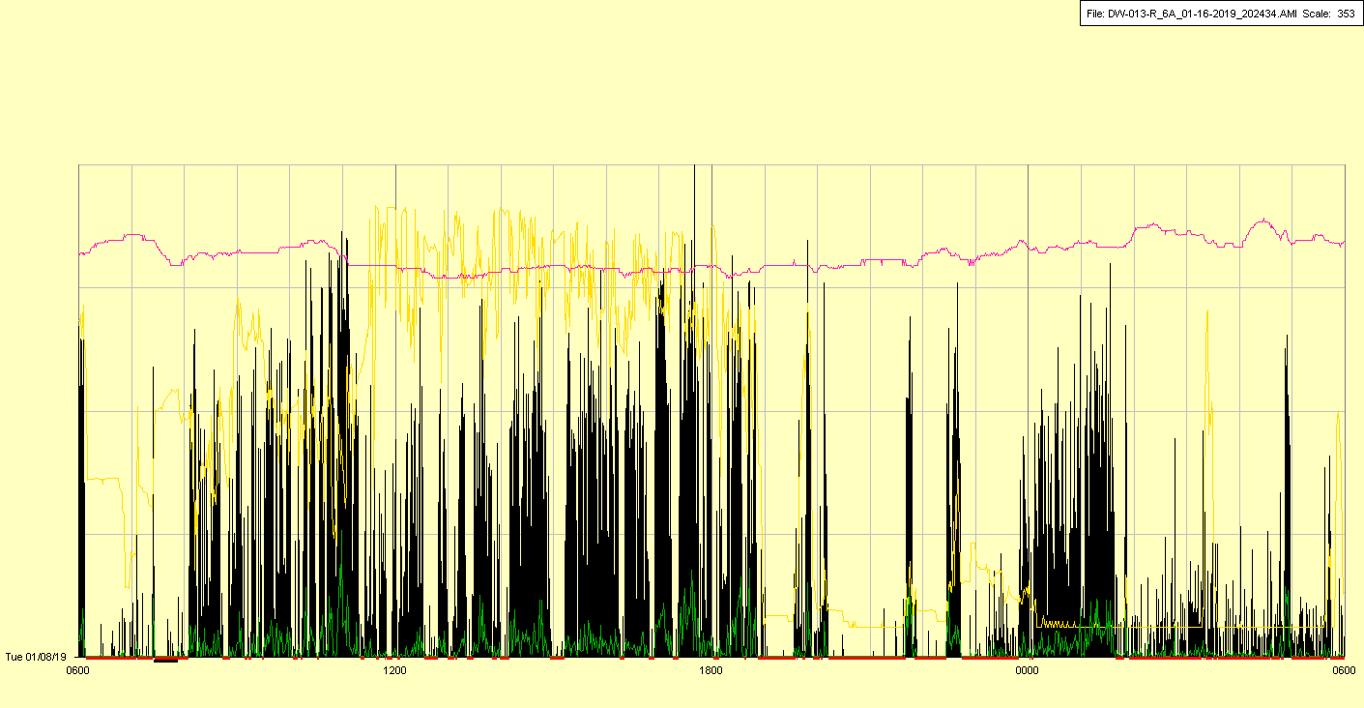

|  |  |  |  |
| --- | --- | --- | --- |
| Study ID | DW13 | Initial NIHSS (affected arm) | 3 |
| Age | 67 | Sex | Female |
| ICH Location | Right deep | Patient location | Stroke Unit |
| Hospital day | 4 | Mechanical ventilation | No |
| Delirium status | No | 3-month mRS |  |

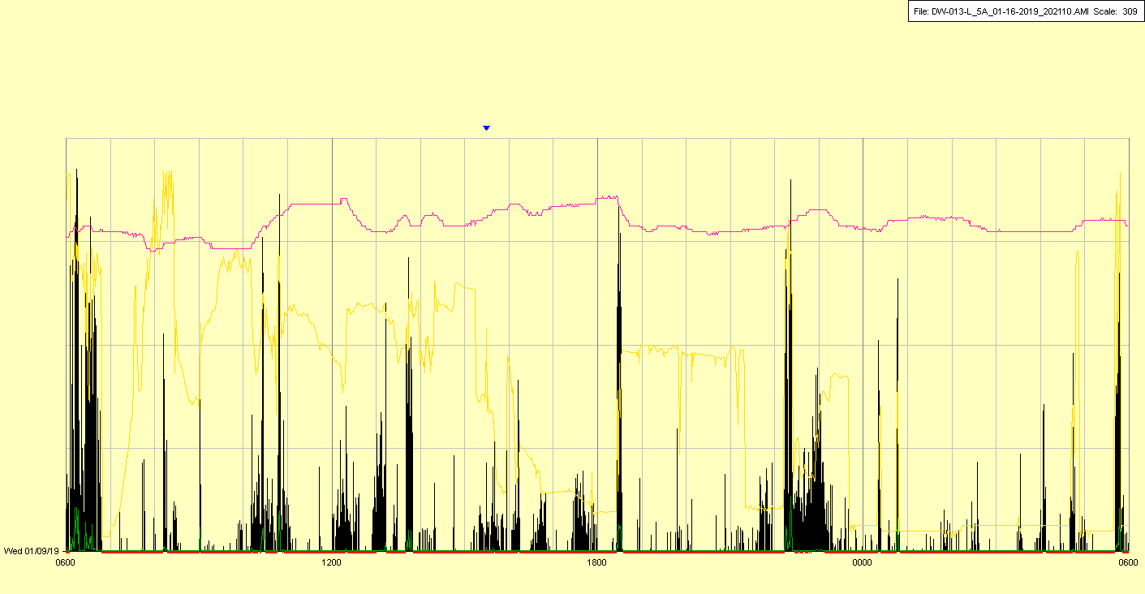

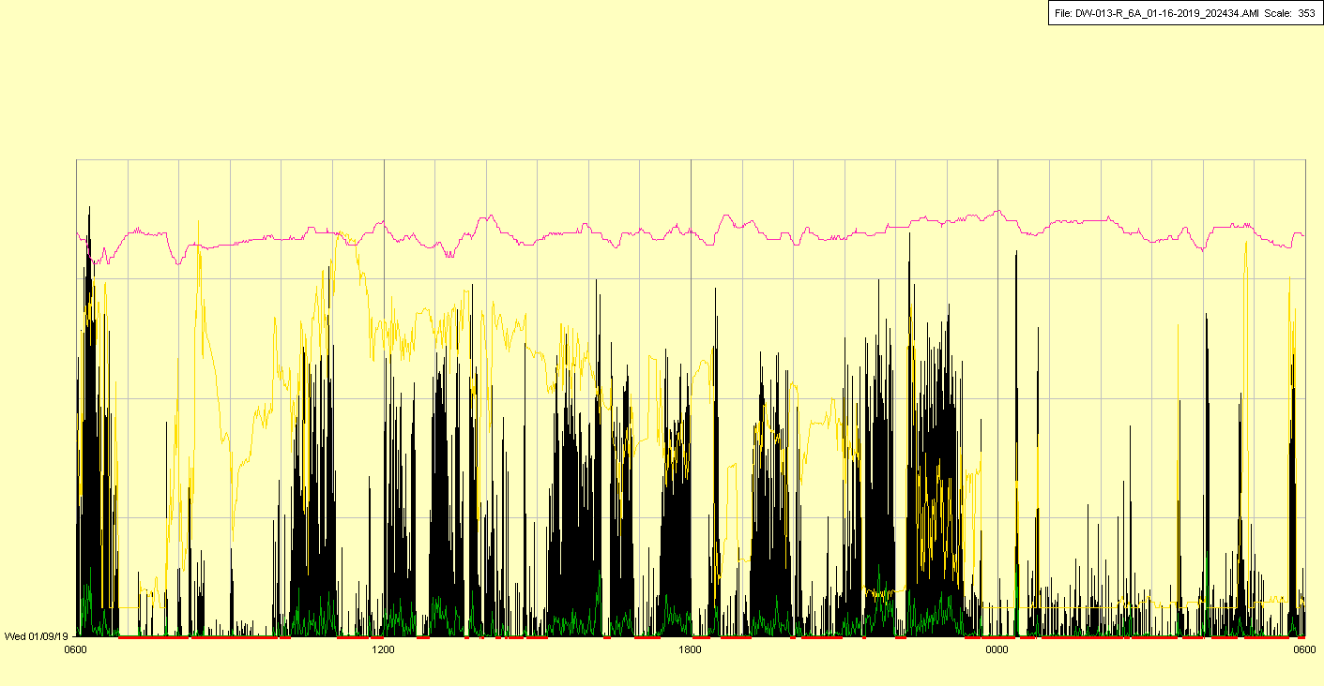

|  |  |  |  |
| --- | --- | --- | --- |
| Study ID | DW13 | Initial NIHSS (affected arm) | 3 |
| Age | 67 | Sex | Female |
| ICH Location | Right deep | Patient location | Stroke Unit |
| Hospital day | 5 | Mechanical ventilation | No |
| Delirium status | No | 3-month mRS |  |

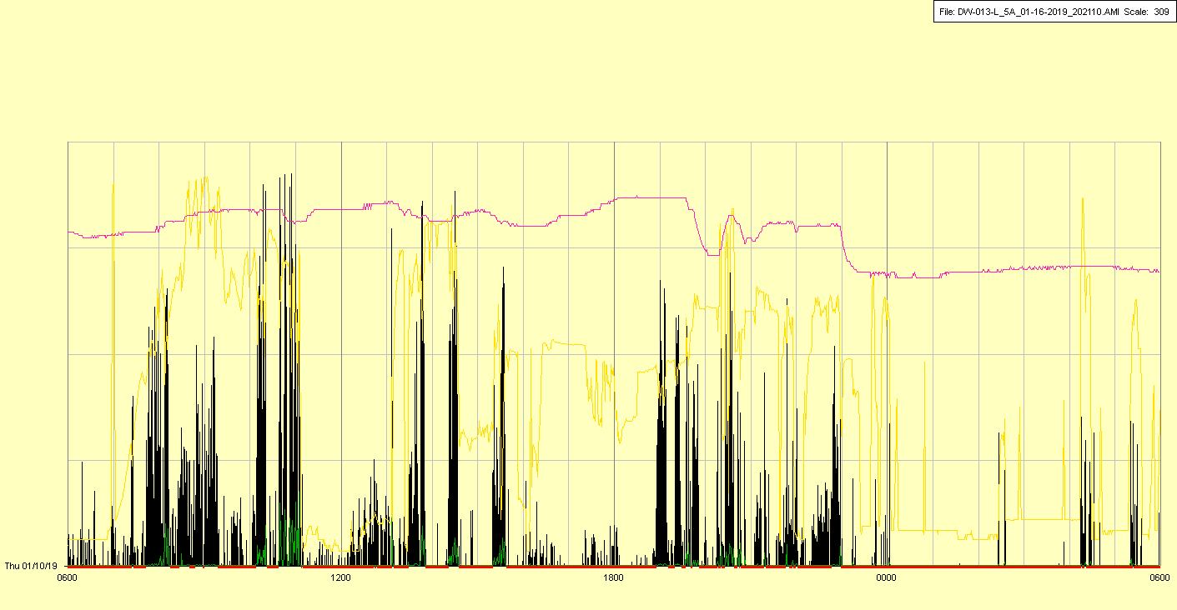

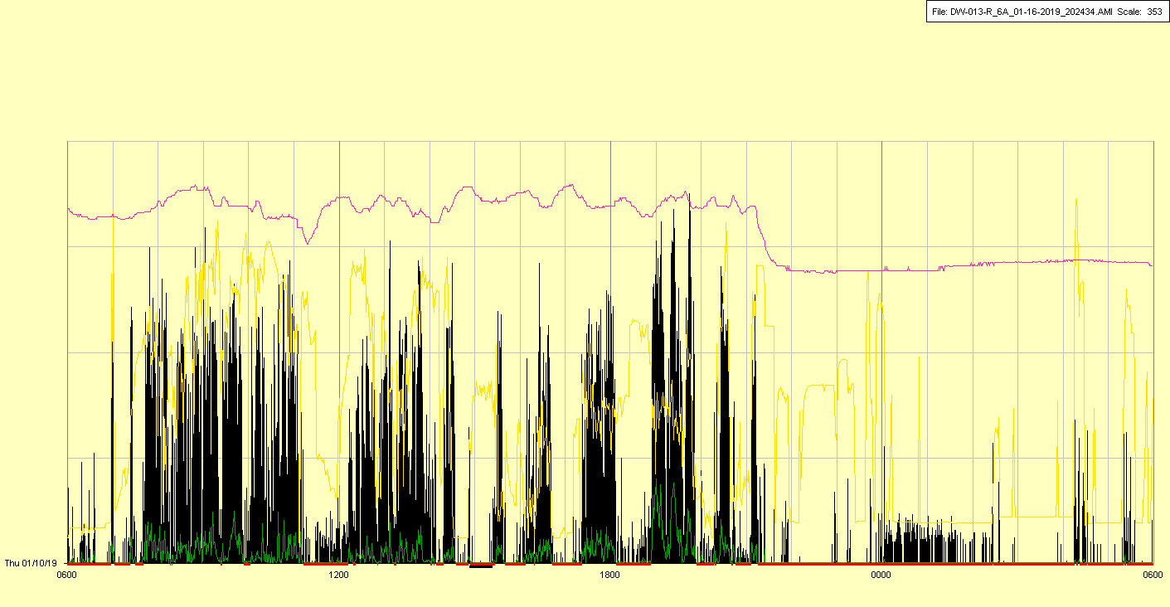

Watches off overnight (MRI?)

|  |  |  |  |
| --- | --- | --- | --- |
| Study ID | DW13 | Initial NIHSS (affected arm) | 3 |
| Age | 67 | Sex | Female |
| ICH Location | Right deep | Patient location | Stroke Unit |
| Hospital day | 6 | Mechanical ventilation | No |
| Delirium status | No | 3-month mRS |  |

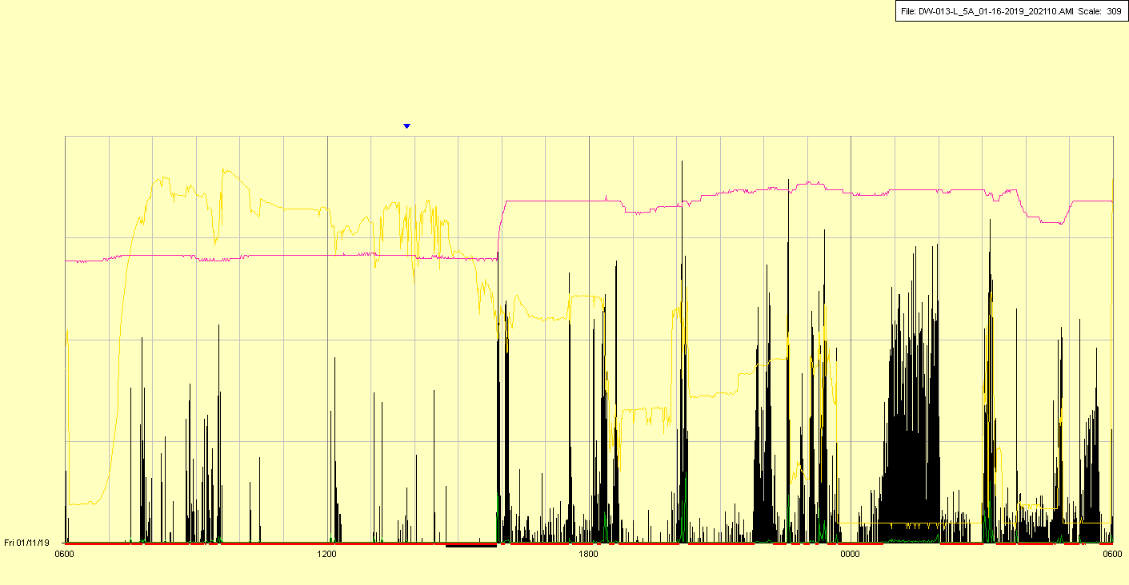

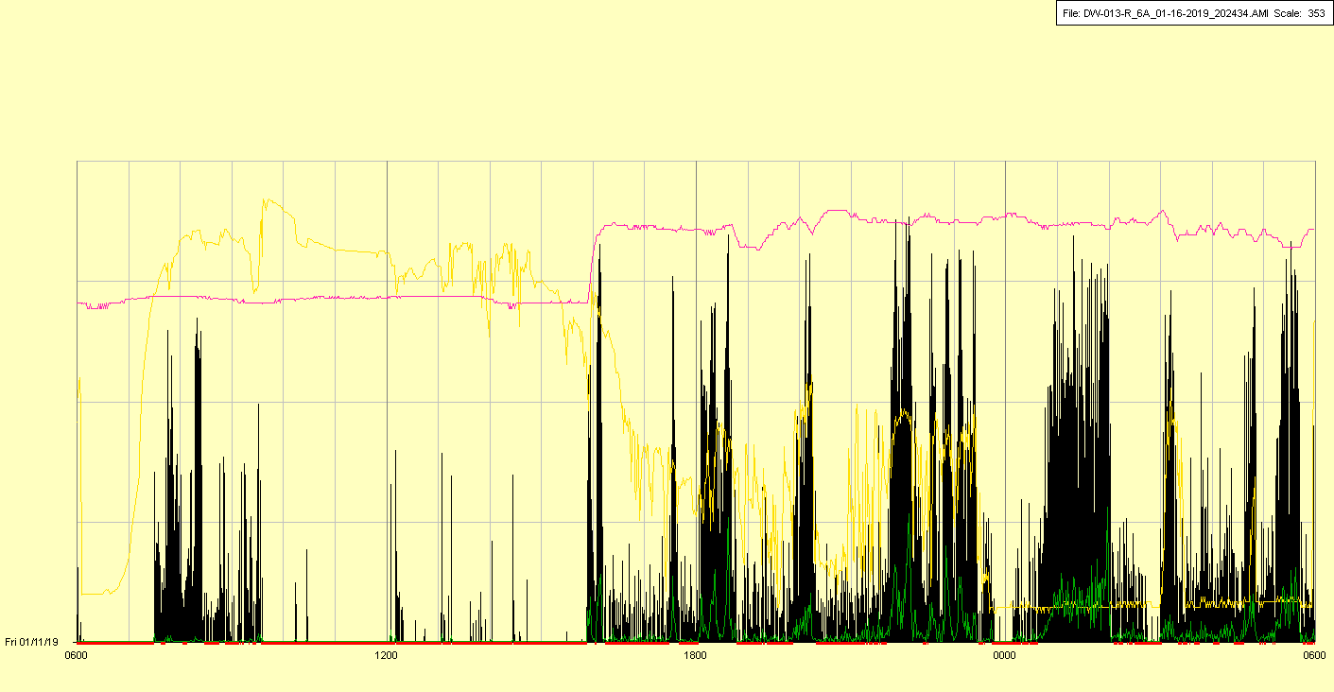

Watches not replaced until afternoon (unclear reason)

|  |  |  |  |
| --- | --- | --- | --- |
| Study ID | DW13 | Initial NIHSS (affected arm) | 3 |
| Age | 67 | Sex | Female |
| ICH Location | Right deep | Patient location | Stroke Unit |
| Hospital day | 7 | Mechanical ventilation | No |
| Delirium status | No (not assessed) | 3-month mRS |  |

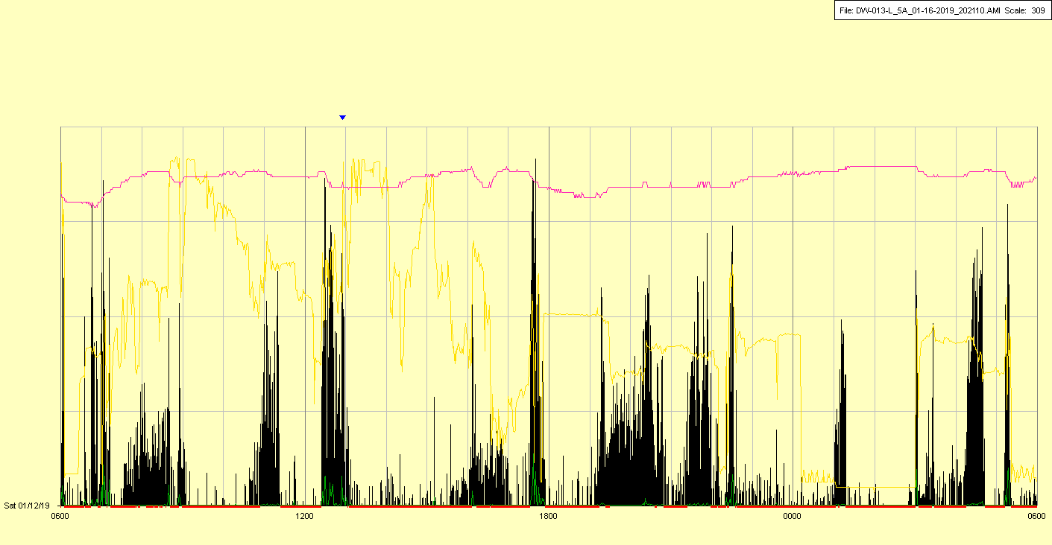

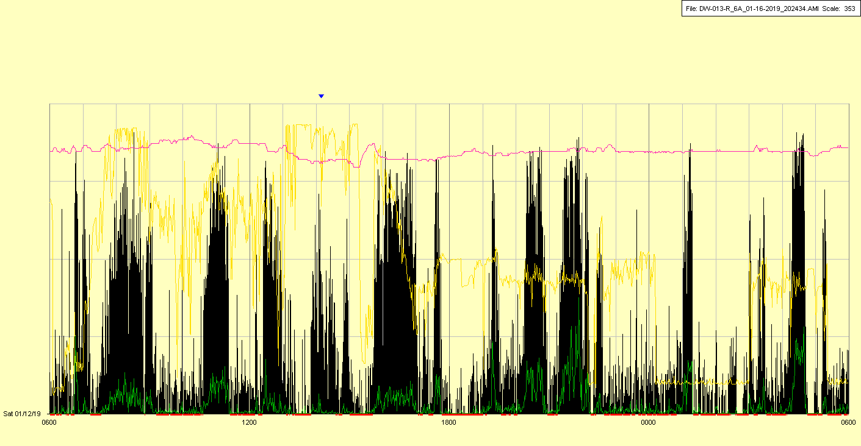

|  |  |  |  |
| --- | --- | --- | --- |
| Study ID | DW13 | Initial NIHSS (affected arm) | 3 |
| Age | 67 | Sex | Female |
| ICH Location | Right deep | Patient location | Stroke Unit |
| Hospital day | 8 | Mechanical ventilation | No |
| Delirium status | No (not assessed) | 3-month mRS |  |

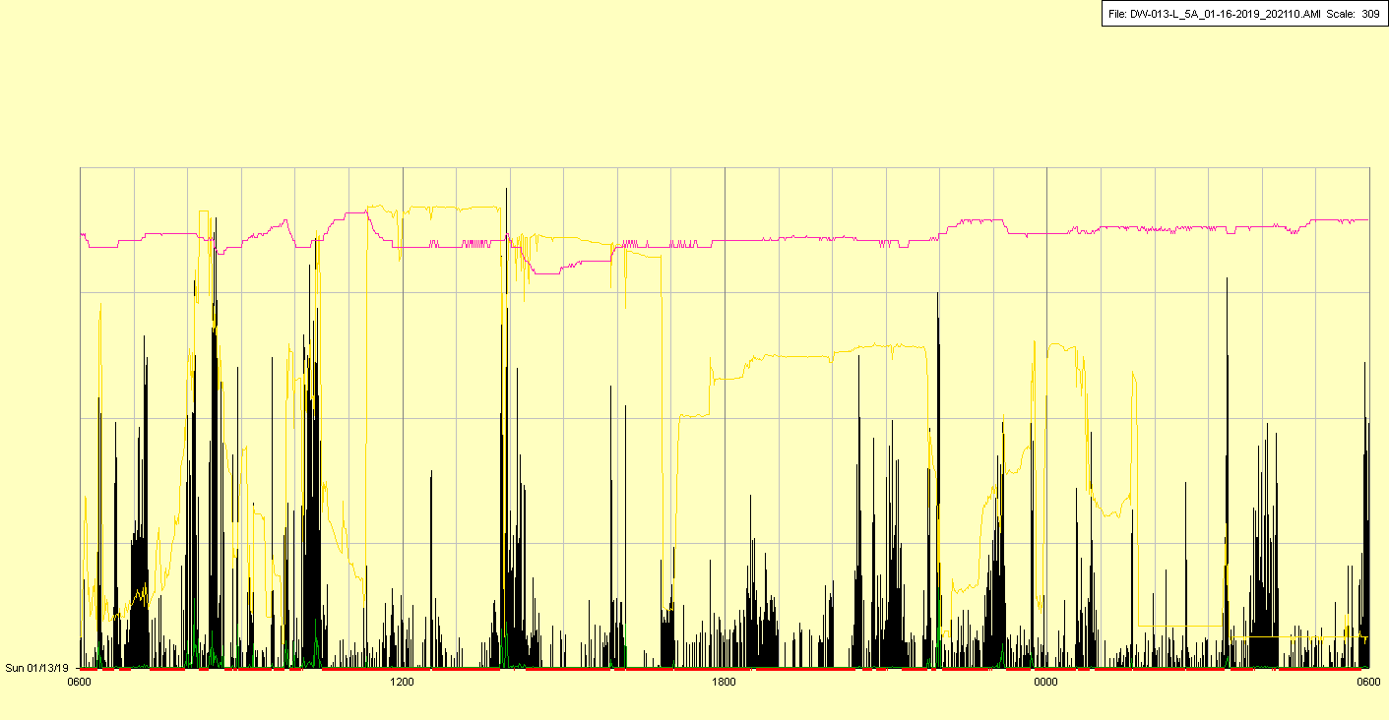

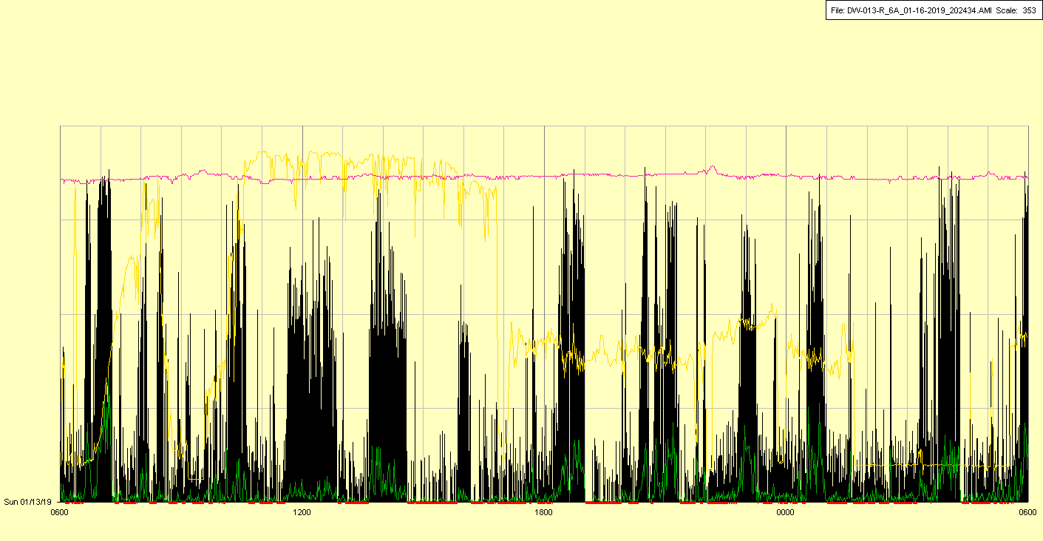

|  |  |  |  |
| --- | --- | --- | --- |
| Study ID | DW13 | Initial NIHSS (affected arm) | 3 |
| Age | 67 | Sex | Female |
| ICH Location | Right deep | Patient location | Stroke Unit |
| Hospital day | 9 | Mechanical ventilation | No |
| Delirium status | No | 3-month mRS |  |

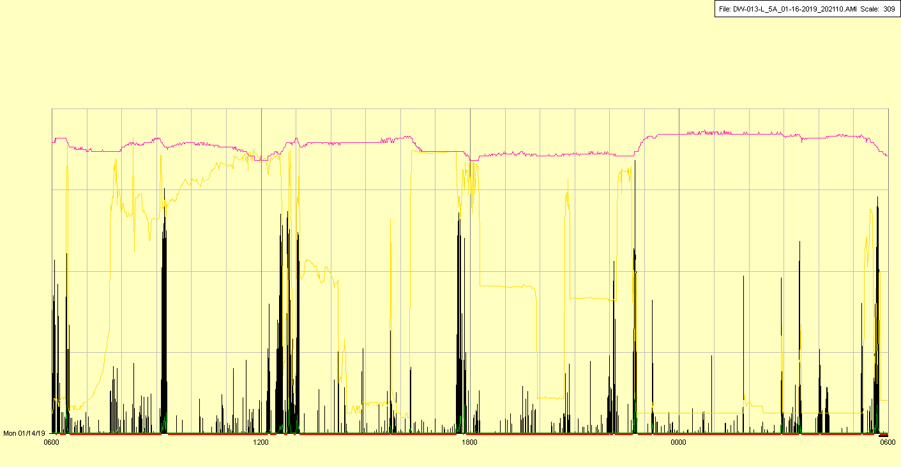

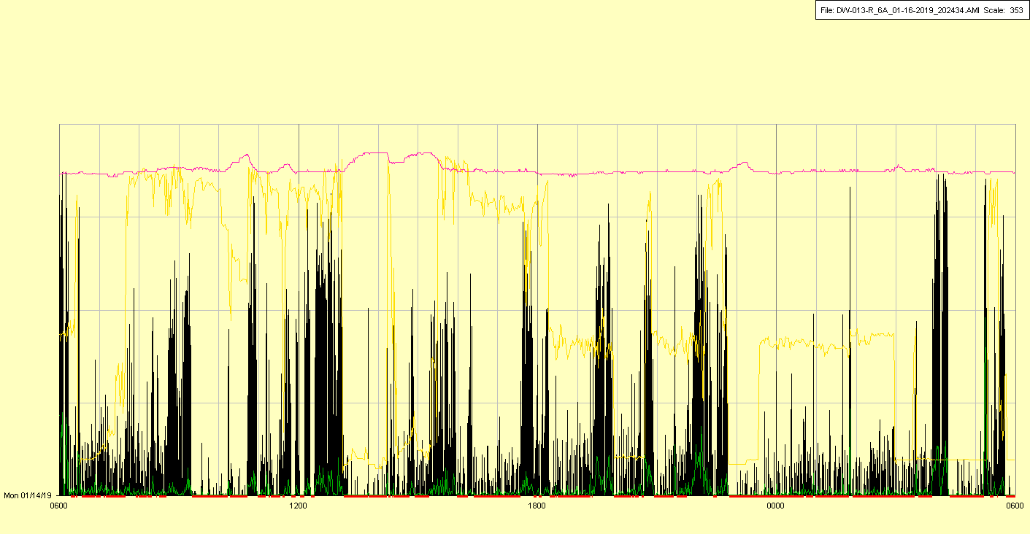

|  |  |  |  |
| --- | --- | --- | --- |
| Study ID | DW13 | Initial NIHSS (affected arm) | 3 |
| Age | 67 | Sex | Female |
| ICH Location | Right deep | Patient location | Stroke Unit |
| Hospital day | 10 | Mechanical ventilation | No |
| Delirium status | No | 3-month mRS |  |

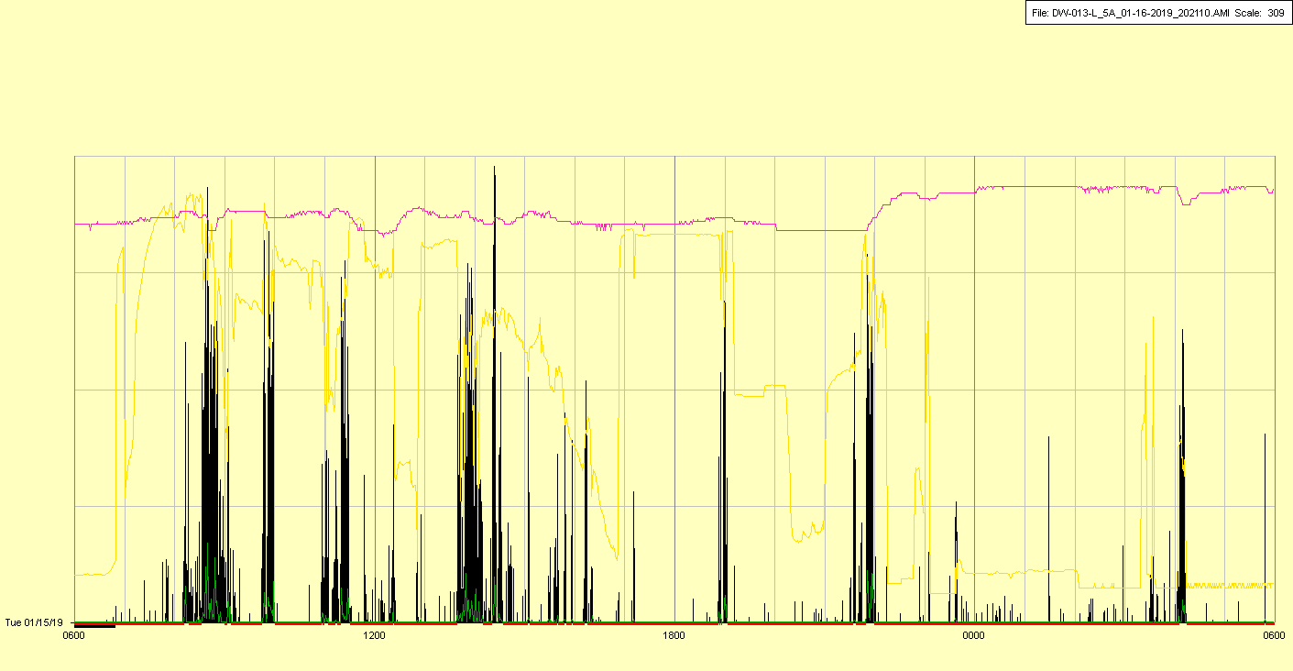

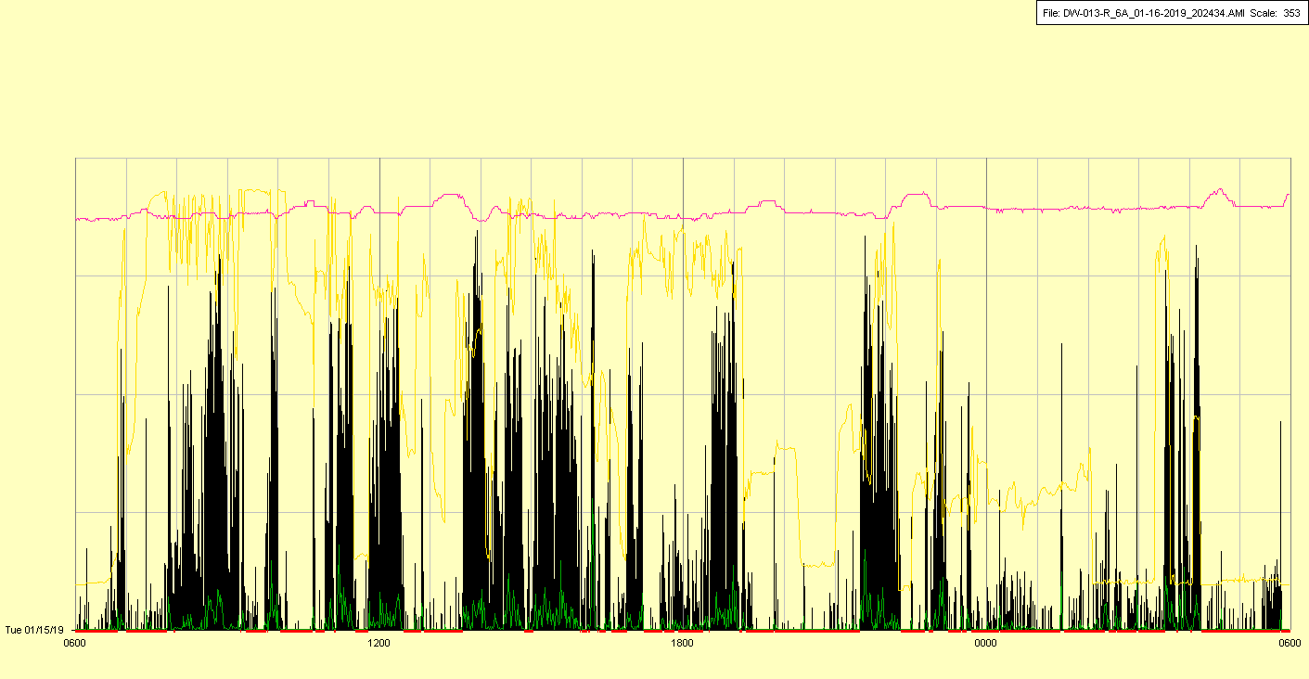

|  |  |  |  |
| --- | --- | --- | --- |
| Study ID | DW13 | Initial NIHSS (affected arm) | 3 |
| Age | 67 | Sex | Female |
| ICH Location | Right deep | Patient location | Stroke Unit |
| Hospital day | 11 | Mechanical ventilation | No |
| Delirium status | No | 3-month mRS |  |

