|  |  |  |  |
| --- | --- | --- | --- |
| Study ID | DW14 | Initial NIHSS (affected arm) | 4 |
| Age | 46 | Sex | Female |
| ICH Location | Right deep | Patient location | ICU |
| Hospital day | 1 | Mechanical ventilation | No |
| Delirium status | No | 3-month mRS |  |

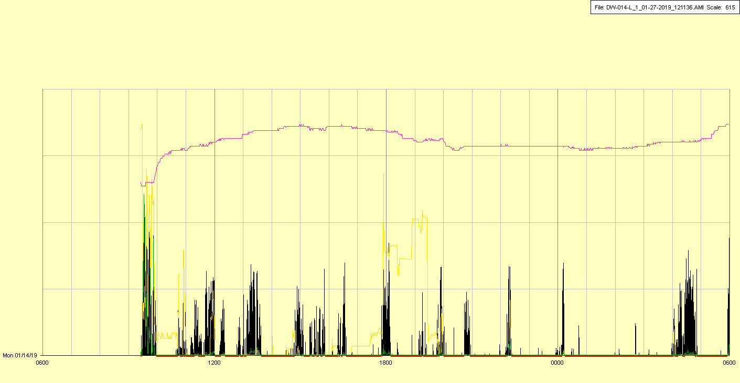

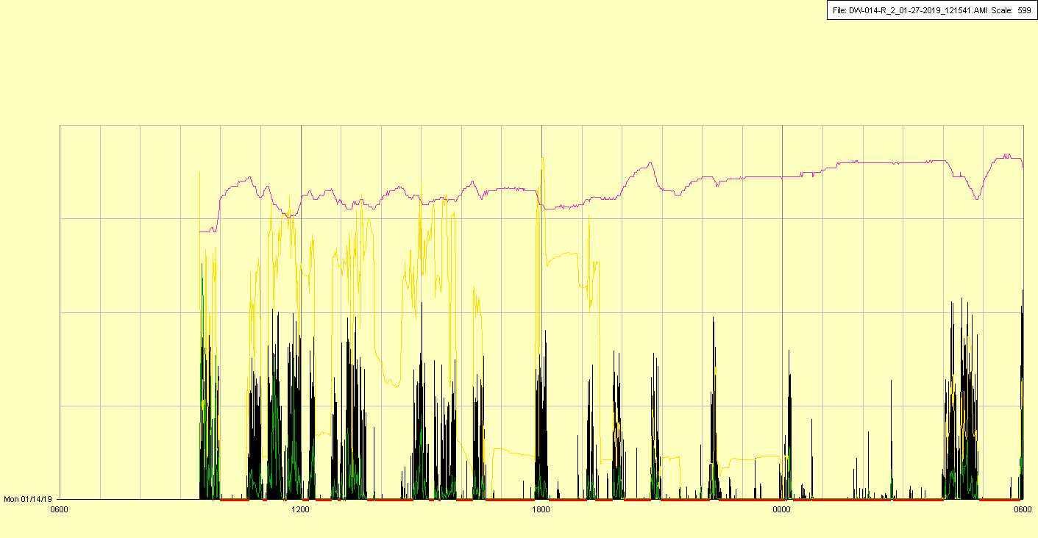

|  |  |  |  |
| --- | --- | --- | --- |
| Study ID | DW14 | Initial NIHSS (affected arm) | 4 |
| Age | 46 | Sex | Female |
| ICH Location | Right deep | Patient location | ICU |
| Hospital day | 2 | Mechanical ventilation | No |
| Delirium status | No | 3-month mRS |  |

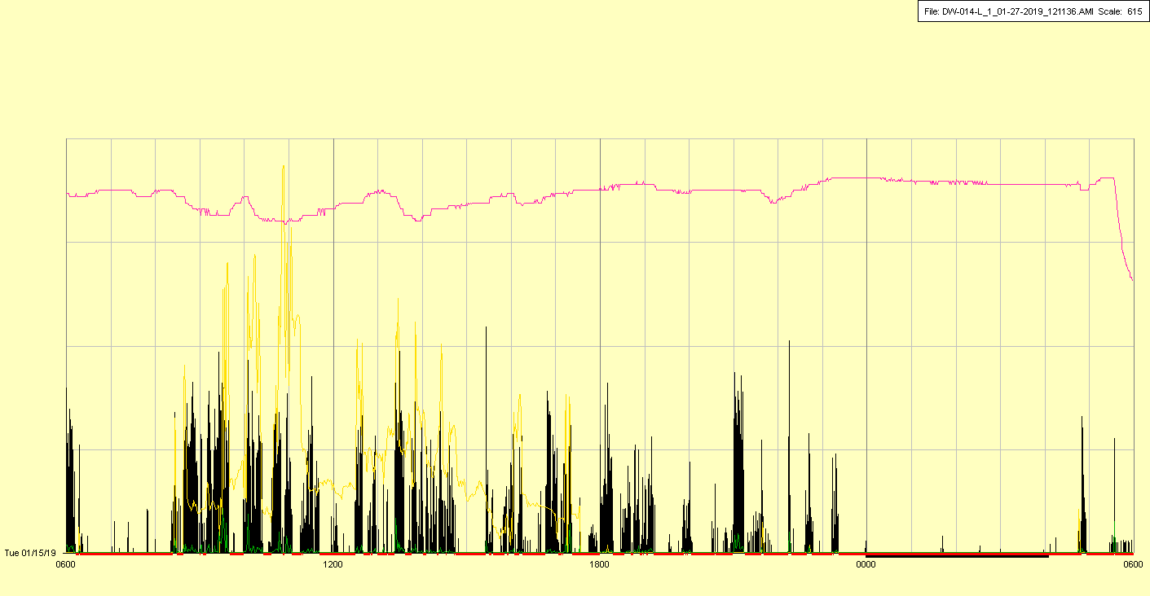

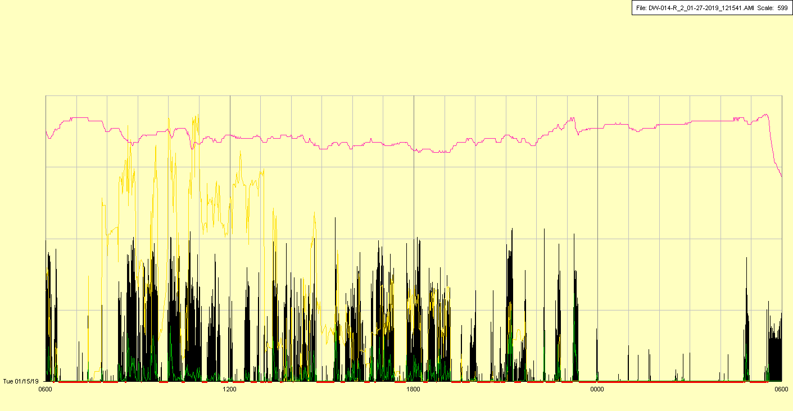

|  |  |  |  |
| --- | --- | --- | --- |
| Study ID | DW14 | Initial NIHSS (affected arm) | 4 |
| Age | 46 | Sex | Female |
| ICH Location | Right deep | Patient location | ICU |
| Hospital day | 3 | Mechanical ventilation | No |
| Delirium status | Yes | 3-month mRS |  |

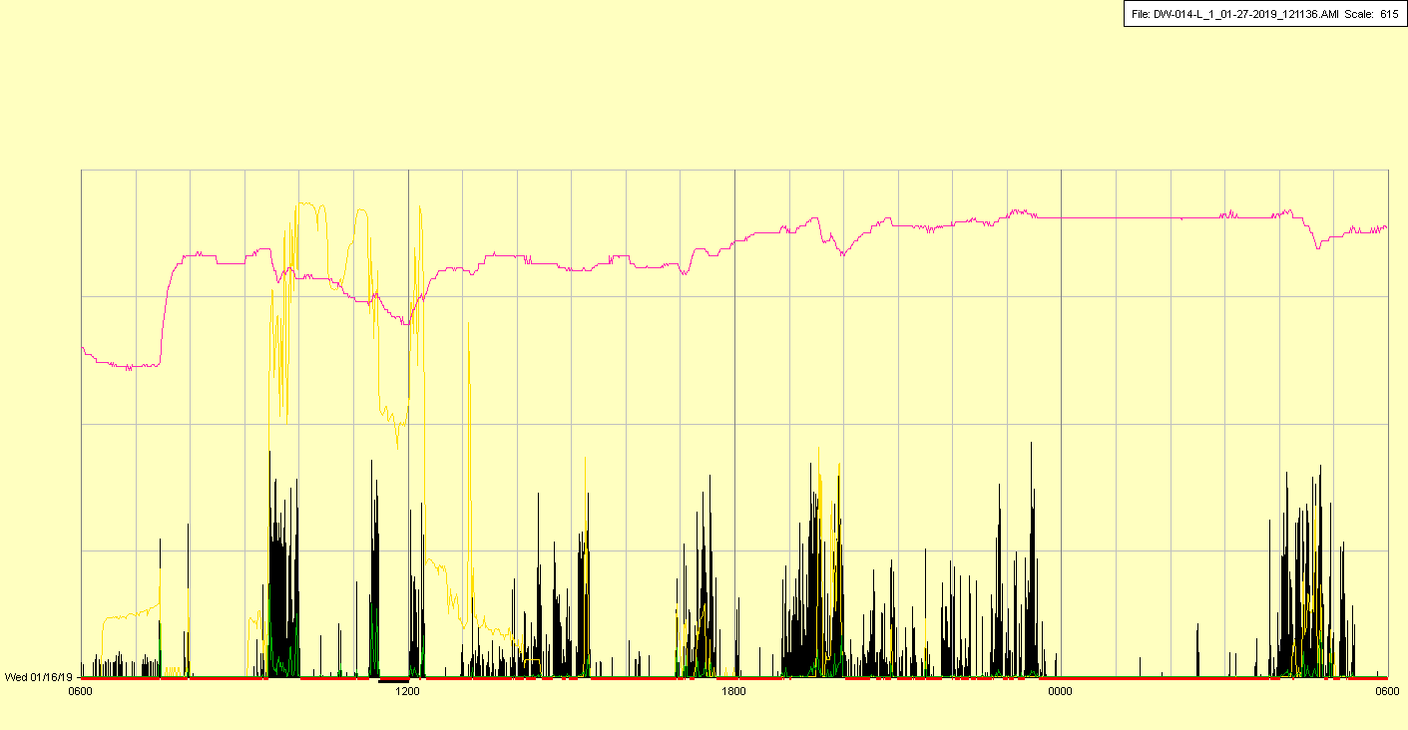

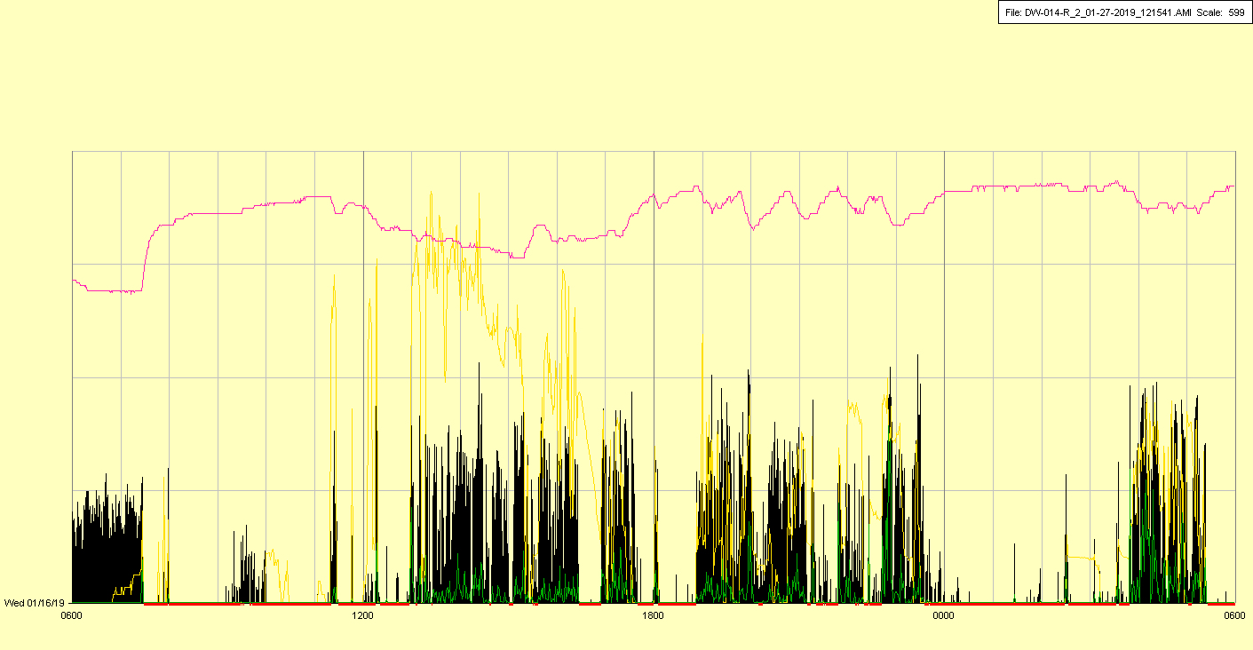

Watches off in early AM for MRI—please note error, watches initially put back on wrong sides (L on R and vice-versa), fixed at approximately 11:30 AM—raw data has not been cleaned

|  |  |  |  |
| --- | --- | --- | --- |
| Study ID | DW14 | Initial NIHSS (affected arm) | 4 |
| Age | 46 | Sex | Female |
| ICH Location | Right deep | Patient location | ICU |
| Hospital day | 4 | Mechanical ventilation | No |
| Delirium status | No | 3-month mRS |  |

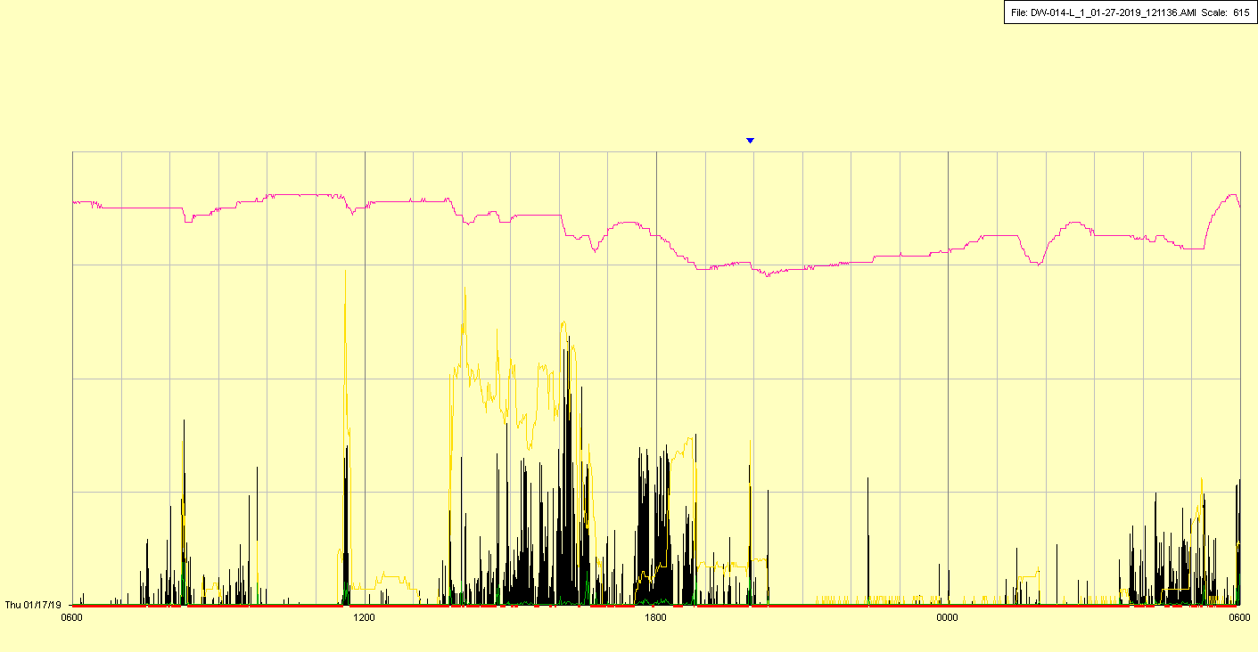

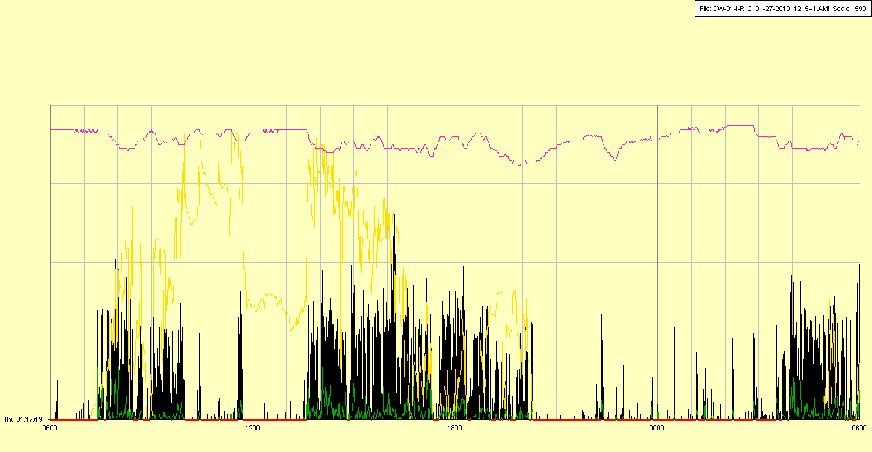

|  |  |  |  |
| --- | --- | --- | --- |
| Study ID | DW14 | Initial NIHSS (affected arm) | 4 |
| Age | 46 | Sex | Female |
| ICH Location | Right deep | Patient location | ICU |
| Hospital day | 5 | Mechanical ventilation | No |
| Delirium status | No | 3-month mRS |  |

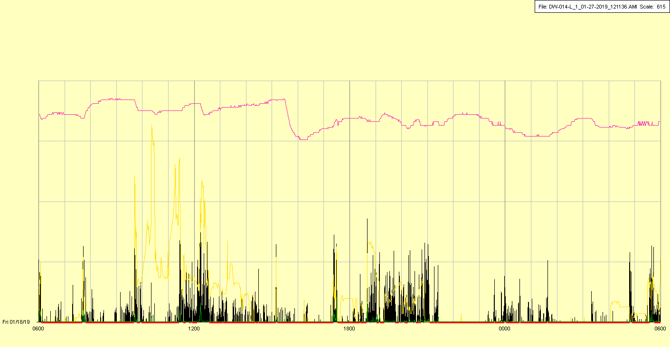

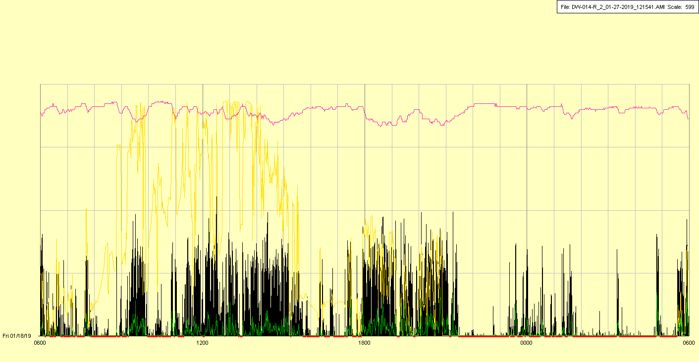

|  |  |  |  |
| --- | --- | --- | --- |
| Study ID | DW14 | Initial NIHSS (affected arm) | 4 |
| Age | 46 | Sex | Female |
| ICH Location | Right deep | Patient location | ICU |
| Hospital day | 6 | Mechanical ventilation | No |
| Delirium status | Yes | 3-month mRS |  |

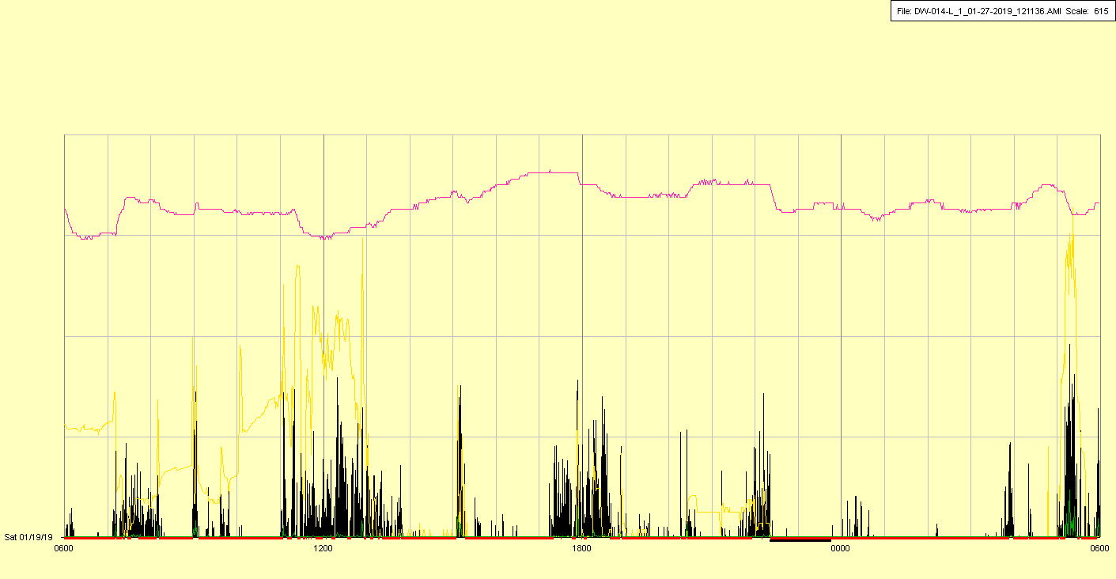

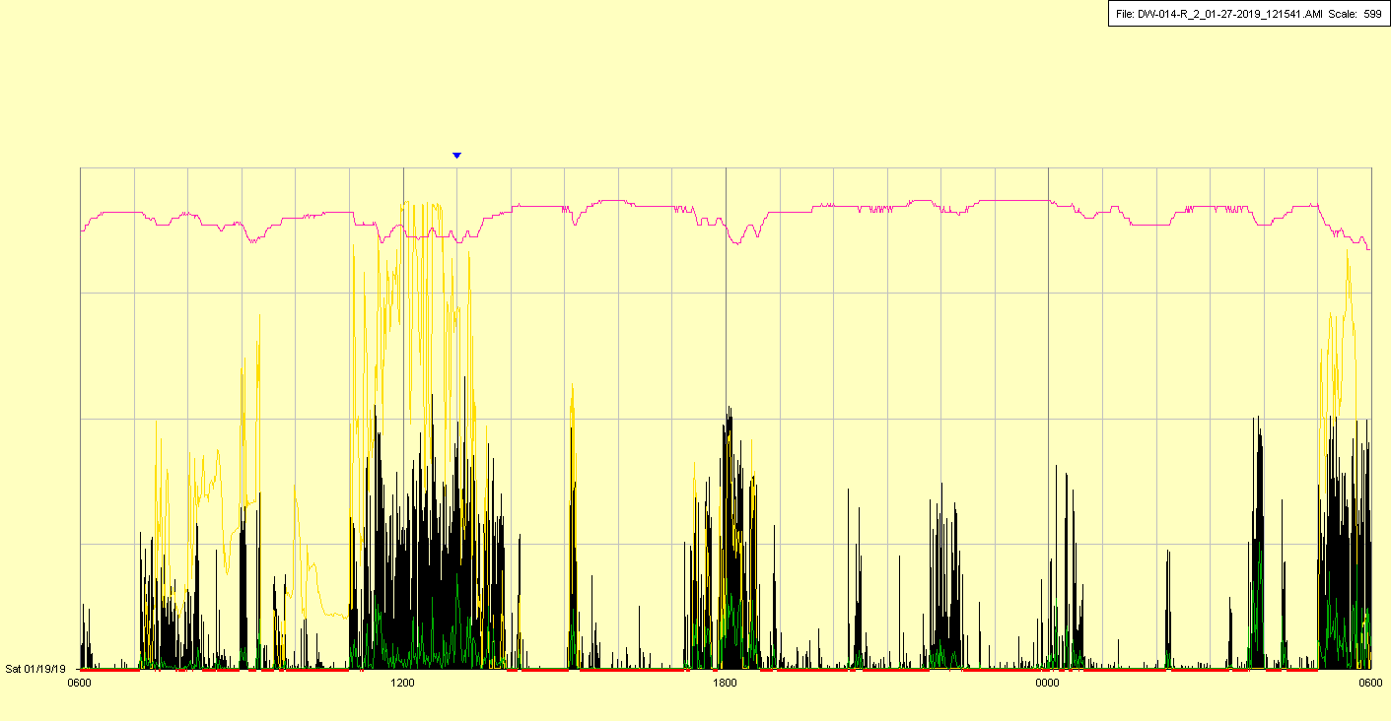

|  |  |  |  |
| --- | --- | --- | --- |
| Study ID | DW14 | Initial NIHSS (affected arm) | 4 |
| Age | 46 | Sex | Female |
| ICH Location | Right deep | Patient location | ICU |
| Hospital day | 7 | Mechanical ventilation | No |
| Delirium status | No | 3-month mRS |  |

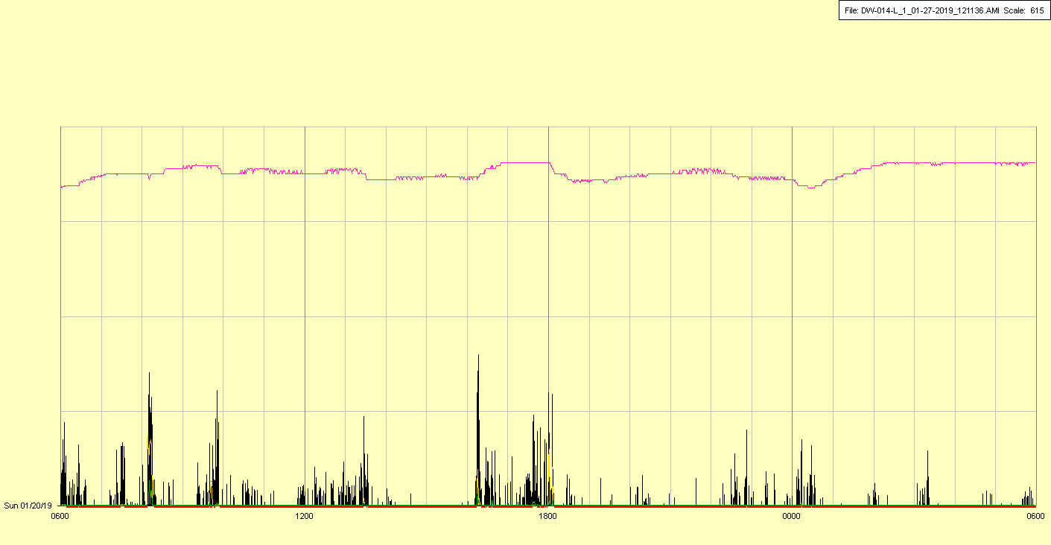

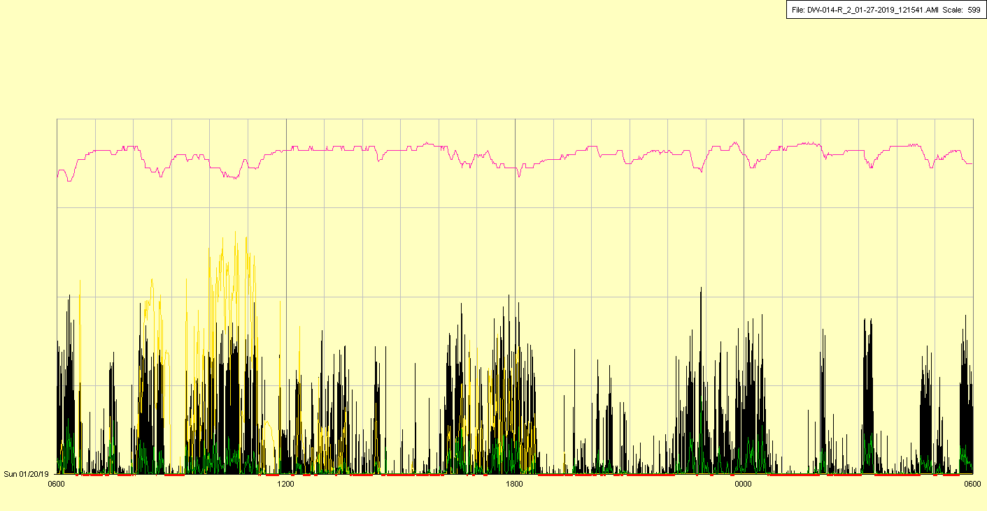

|  |  |  |  |
| --- | --- | --- | --- |
| Study ID | DW14 | Initial NIHSS (affected arm) | 4 |
| Age | 46 | Sex | Female |
| ICH Location | Right deep | Patient location | ICU |
| Hospital day | 8 | Mechanical ventilation | No |
| Delirium status | Yes | 3-month mRS |  |

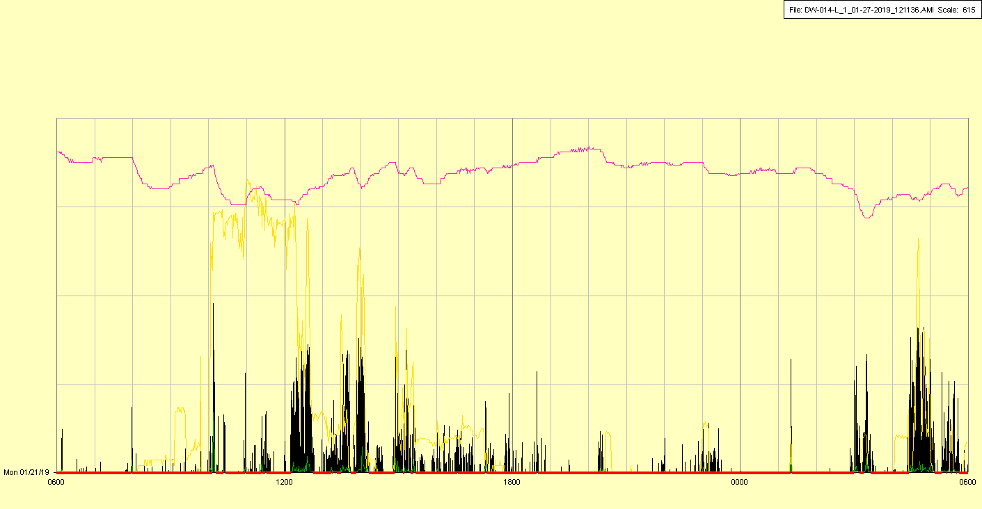

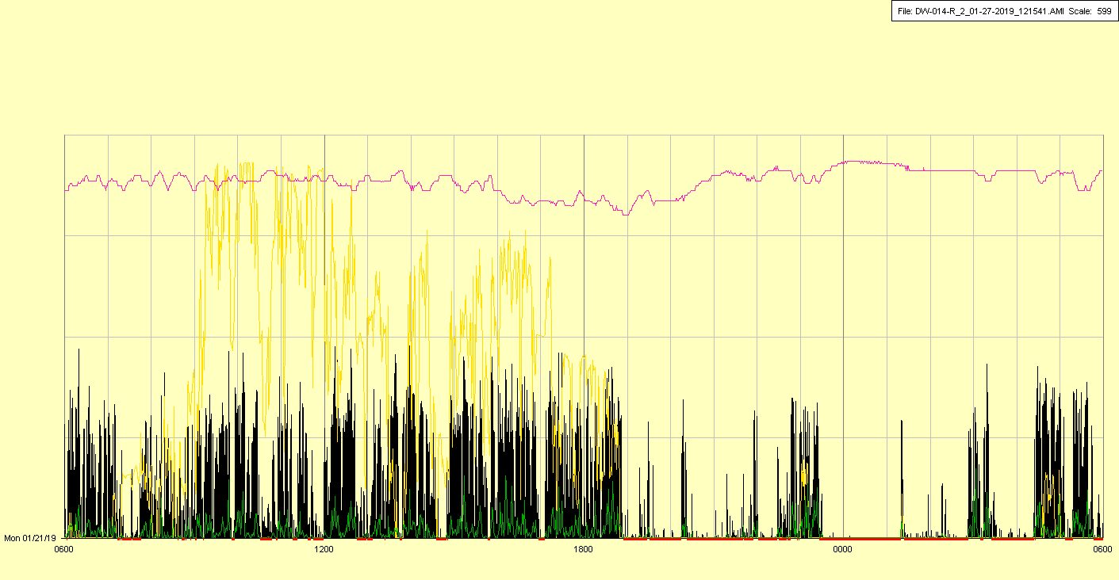

|  |  |  |  |
| --- | --- | --- | --- |
| Study ID | DW14 | Initial NIHSS (affected arm) | 4 |
| Age | 46 | Sex | Female |
| ICH Location | Right deep | Patient location | ICU |
| Hospital day | 9 | Mechanical ventilation | No |
| Delirium status | No | 3-month mRS |  |

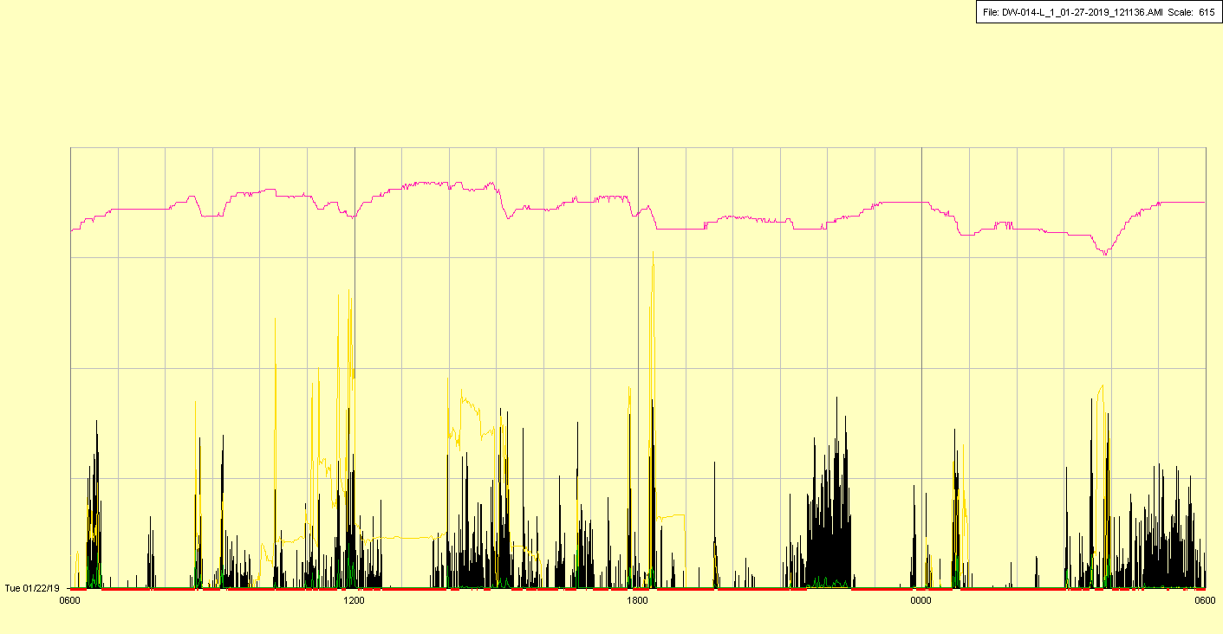

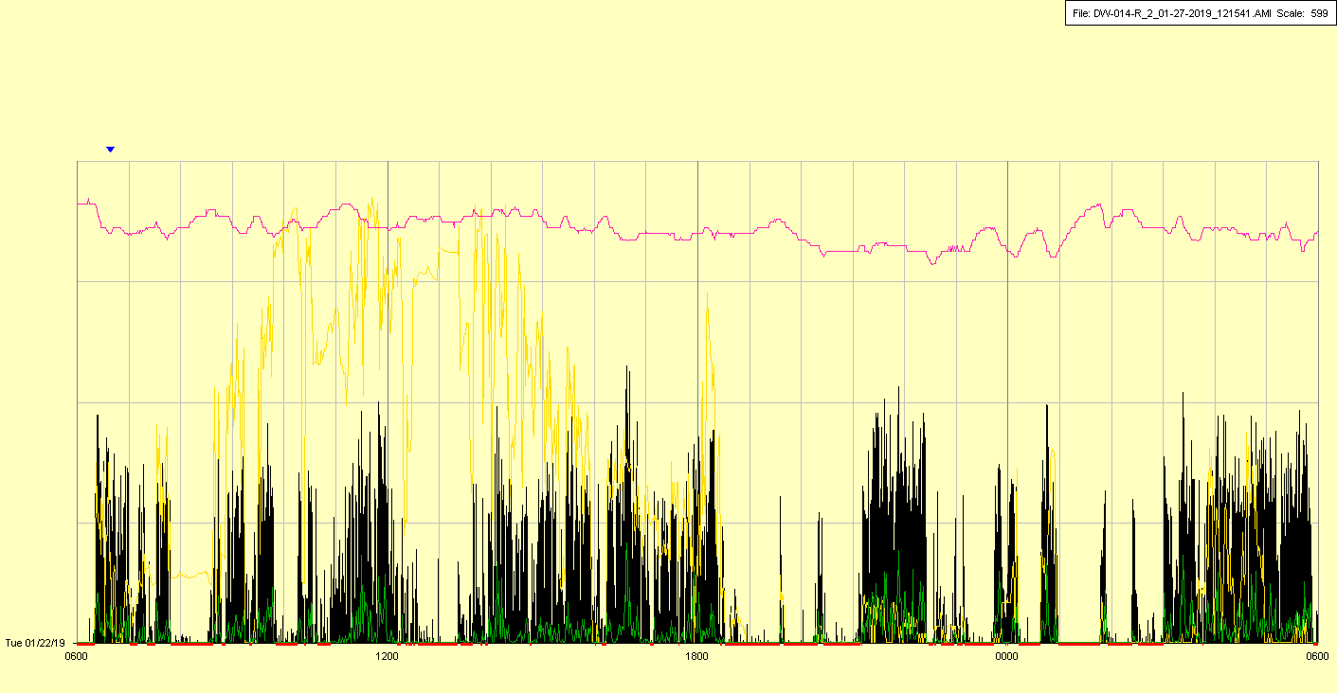

|  |  |  |  |
| --- | --- | --- | --- |
| Study ID | DW14 | Initial NIHSS (affected arm) | 4 |
| Age | 46 | Sex | Female |
| ICH Location | Right deep | Patient location | ICU |
| Hospital day | 10 | Mechanical ventilation | No |
| Delirium status | No | 3-month mRS |  |



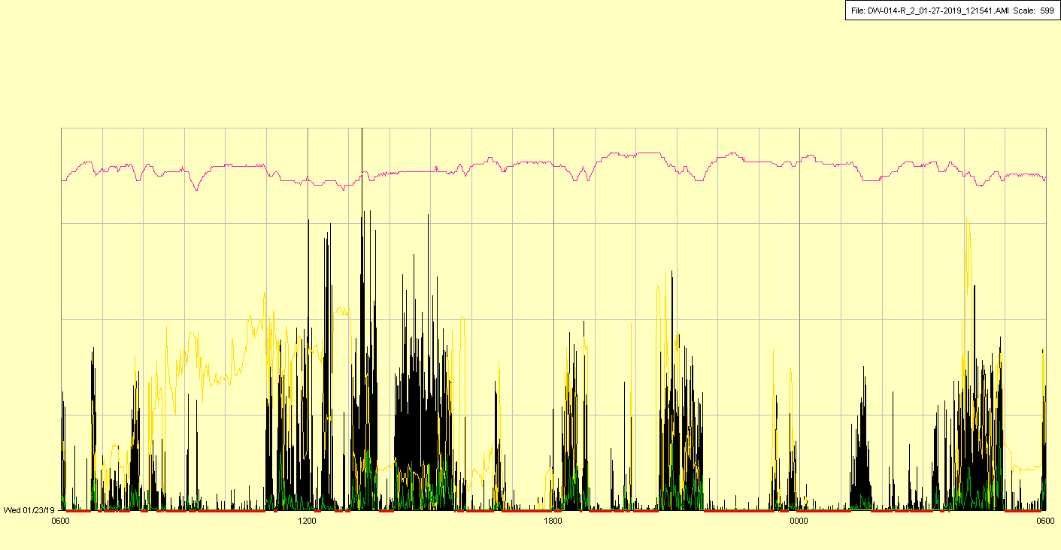

|  |  |  |  |
| --- | --- | --- | --- |
| Study ID | DW14 | Initial NIHSS (affected arm) | 4 |
| Age | 46 | Sex | Female |
| ICH Location | Right deep | Patient location | ICU |
| Hospital day | 11 | Mechanical ventilation | No |
| Delirium status | No | 3-month mRS |  |

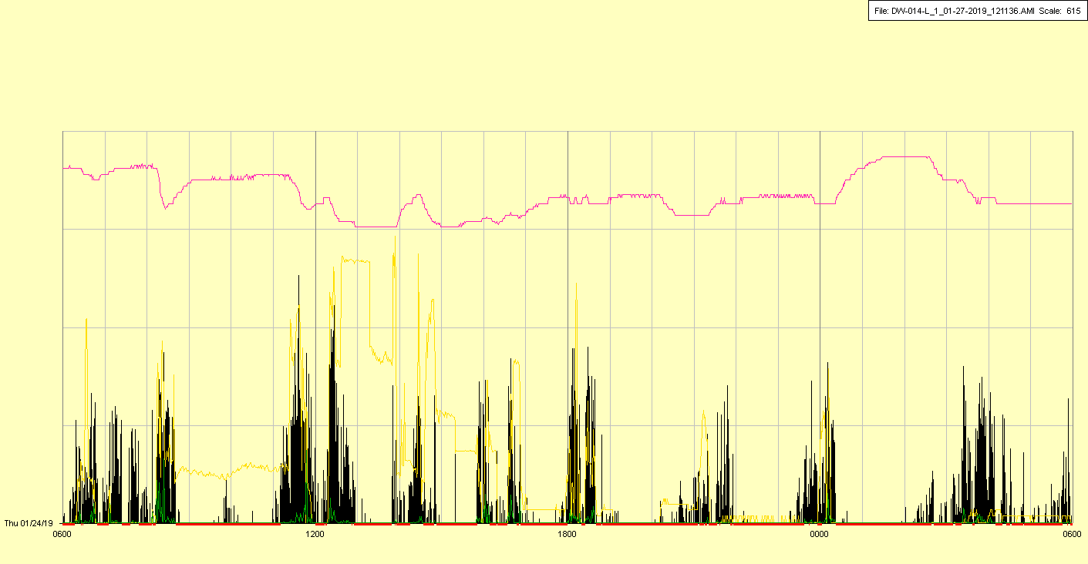

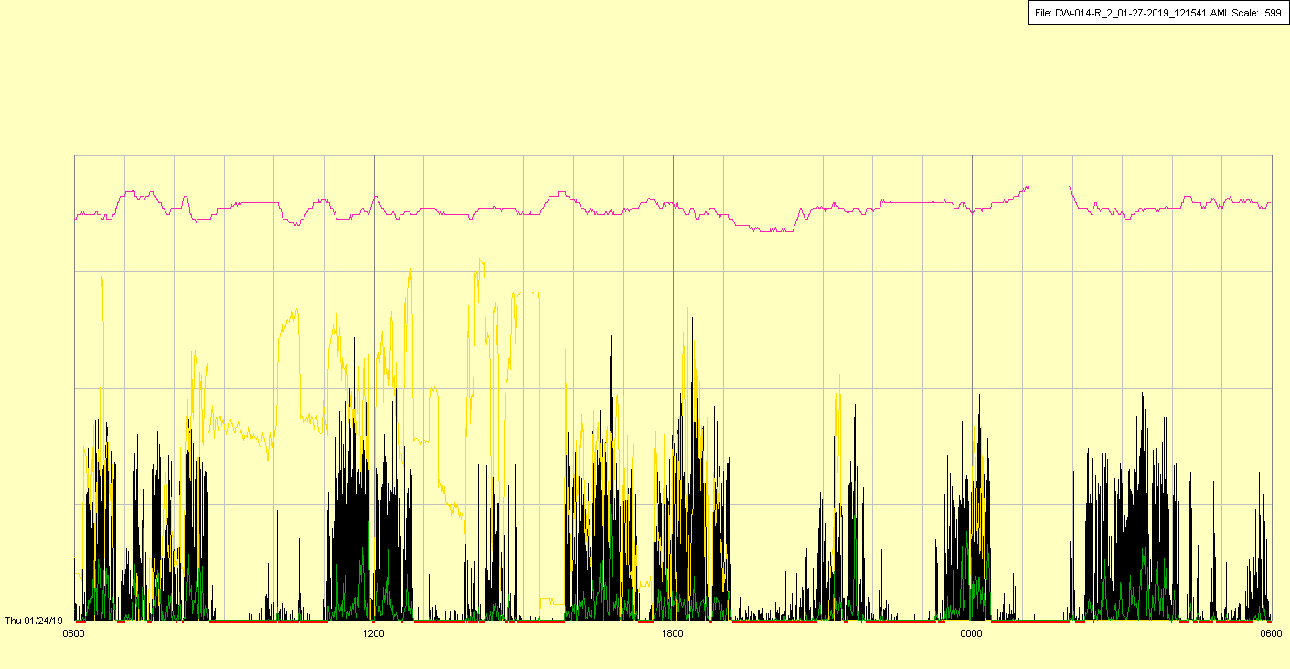

|  |  |  |  |
| --- | --- | --- | --- |
| Study ID | DW14 | Initial NIHSS (affected arm) | 4 |
| Age | 46 | Sex | Female |
| ICH Location | Right deep | Patient location | ICU |
| Hospital day | 12 | Mechanical ventilation | No |
| Delirium status | No | 3-month mRS |  |

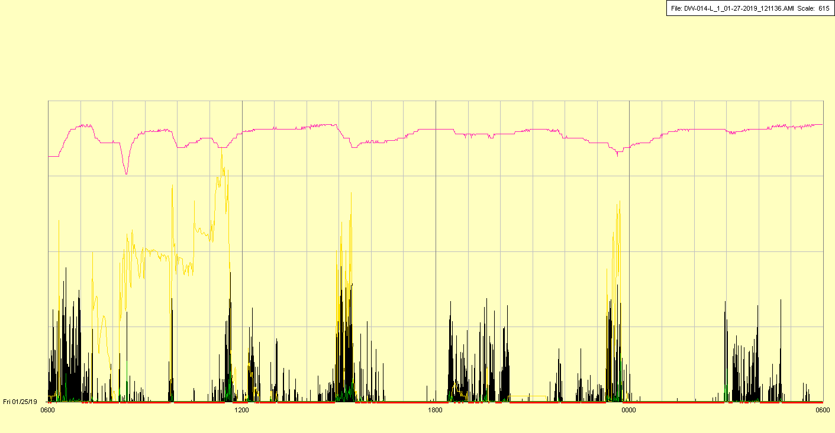

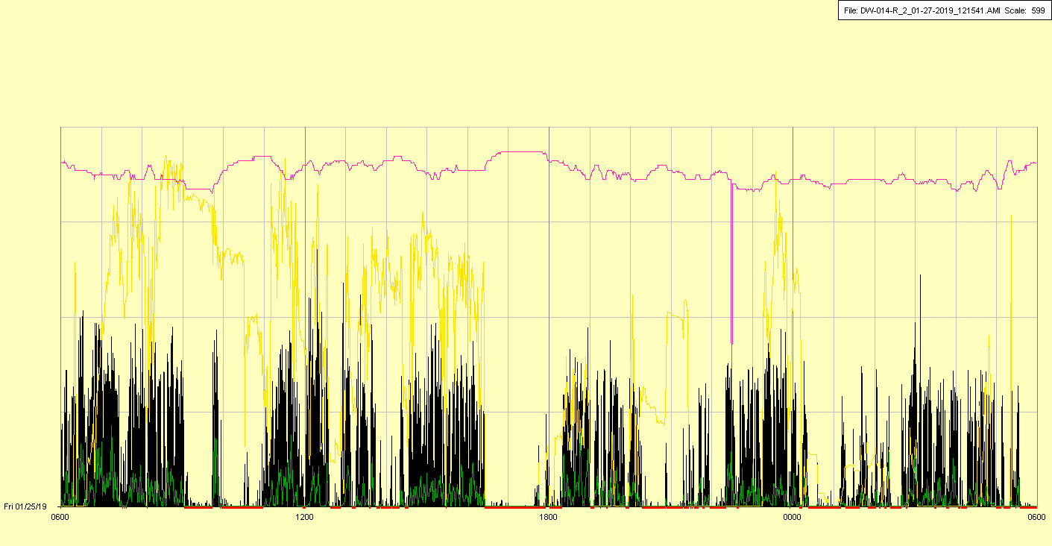

|  |  |  |  |
| --- | --- | --- | --- |
| Study ID | DW14 | Initial NIHSS (affected arm) | 4 |
| Age | 46 | Sex | Female |
| ICH Location | Right deep | Patient location | ICU |
| Hospital day | 13 | Mechanical ventilation | No |
| Delirium status | No | 3-month mRS |  |

