|  |  |  |  |
| --- | --- | --- | --- |
| Study ID | DW16 | Initial NIHSS (affected arm) | 4 |
| Age | 75 | Sex | Male |
| ICH Location | Right lobar | Patient location | NCCU |
| Hospital day | 1 | Mechanical ventilation | No |
| Delirium status | No | 3-month mRS | 6 |

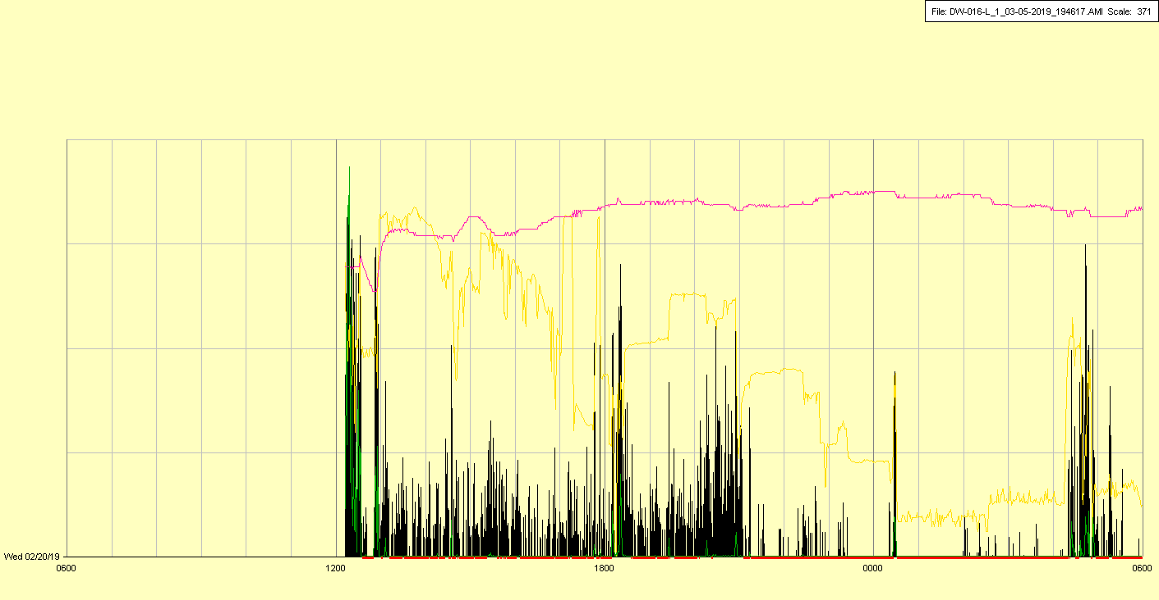

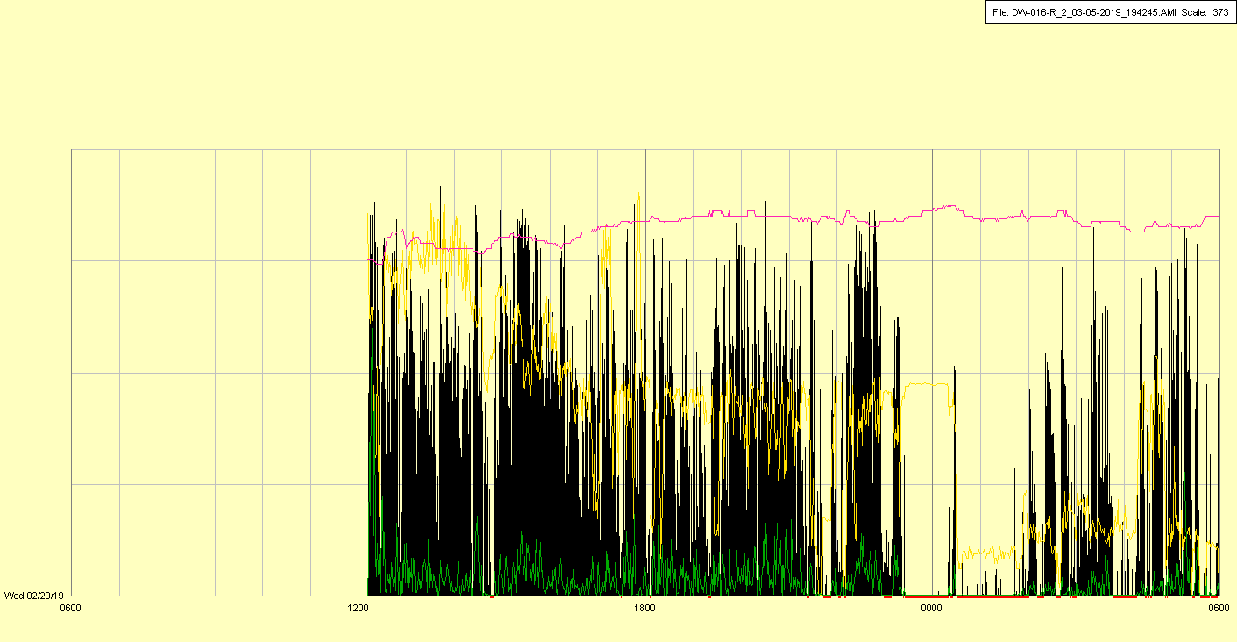

|  |  |  |  |
| --- | --- | --- | --- |
| Study ID | DW16 | Initial NIHSS (affected arm) | 4 |
| Age | 75 | Sex | Male |
| ICH Location | Right lobar | Patient location | NCCU |
| Hospital day | 2 | Mechanical ventilation | No |
| Delirium status | No | 3-month mRS | 6 |

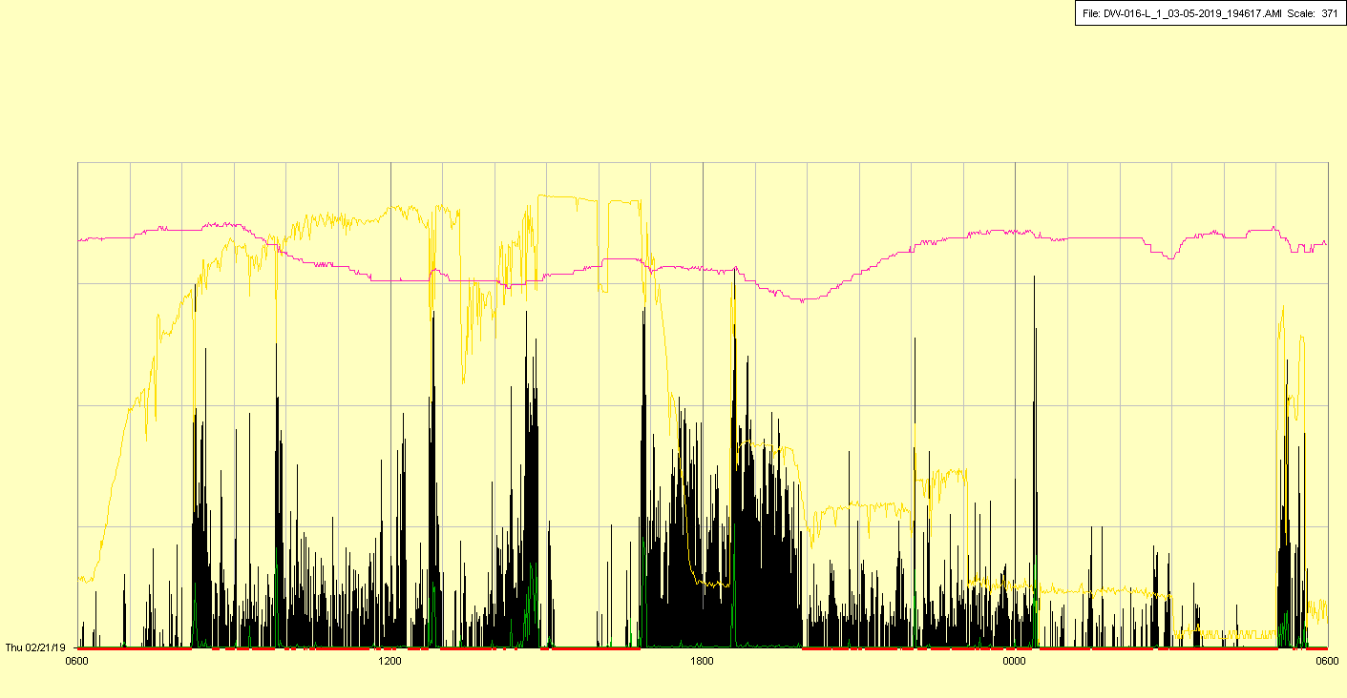

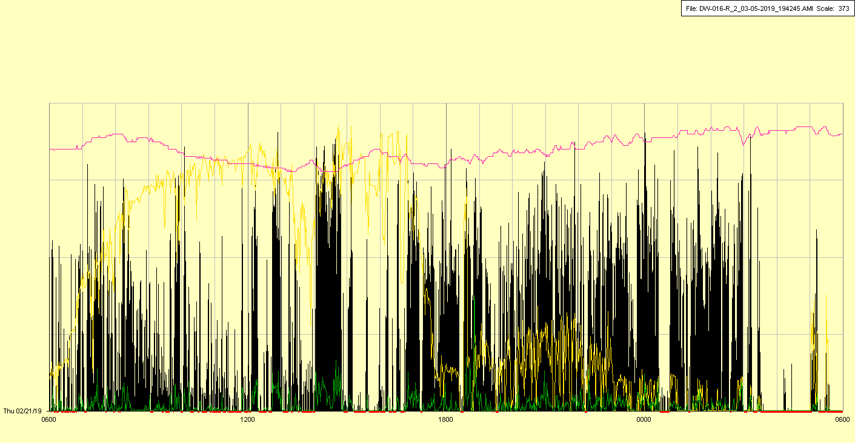

|  |  |  |  |
| --- | --- | --- | --- |
| Study ID | DW16 | Initial NIHSS (affected arm) | 4 |
| Age | 75 | Sex | Male |
| ICH Location | Right lobar | Patient location | NCCU |
| Hospital day | 3 | Mechanical ventilation | No |
| Delirium status | Yes | 3-month mRS | 6 |

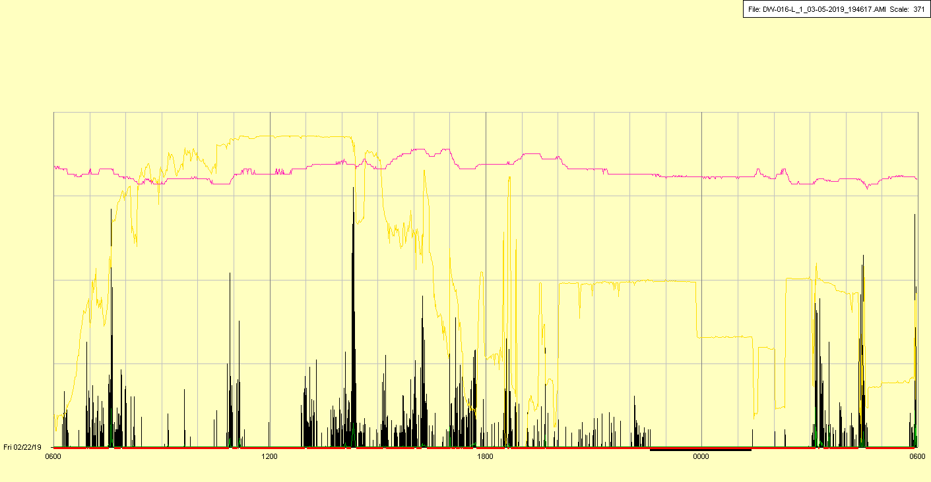

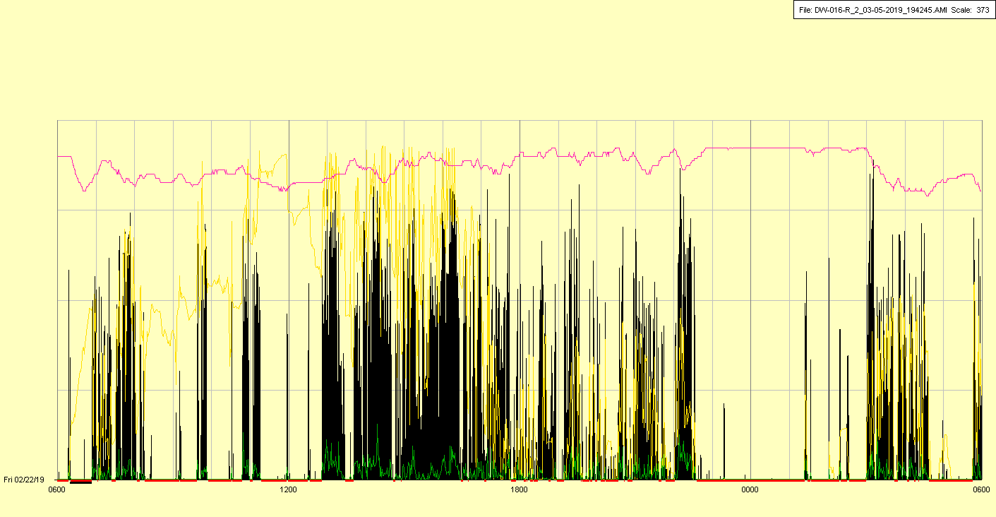

|  |  |  |  |
| --- | --- | --- | --- |
| Study ID | DW16 | Initial NIHSS (affected arm) | 4 |
| Age | 75 | Sex | Male |
| ICH Location | Right lobar | Patient location | NCCU |
| Hospital day | 4 | Mechanical ventilation | No |
| Delirium status | Yes | 3-month mRS | 6 |

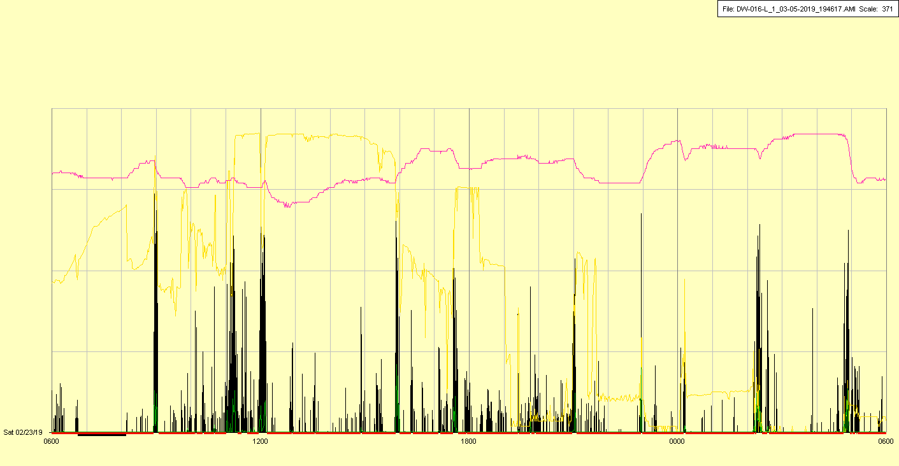

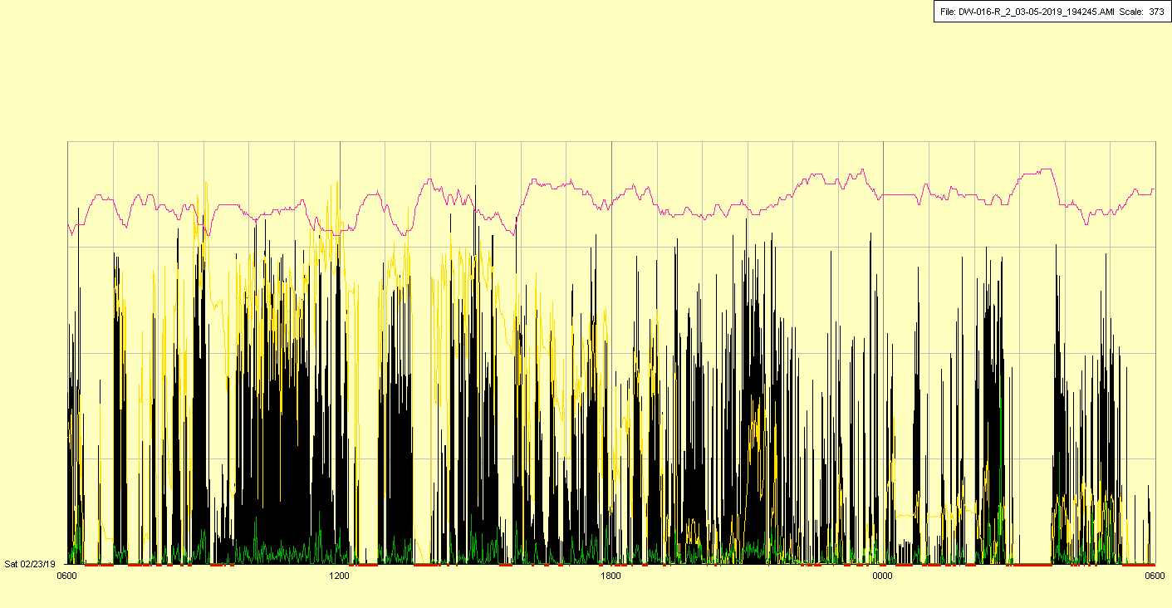

|  |  |  |  |
| --- | --- | --- | --- |
| Study ID | DW16 | Initial NIHSS (affected arm) | 4 |
| Age | 75 | Sex | Male |
| ICH Location | Right lobar | Patient location | NCCU |
| Hospital day | 5 | Mechanical ventilation | No |
| Delirium status | Yes | 3-month mRS | 6 |

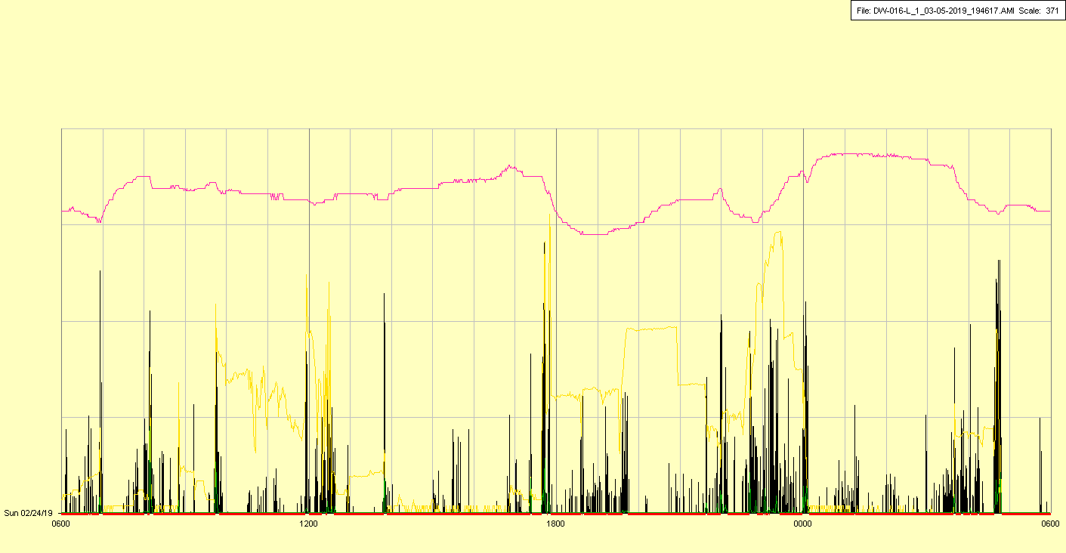

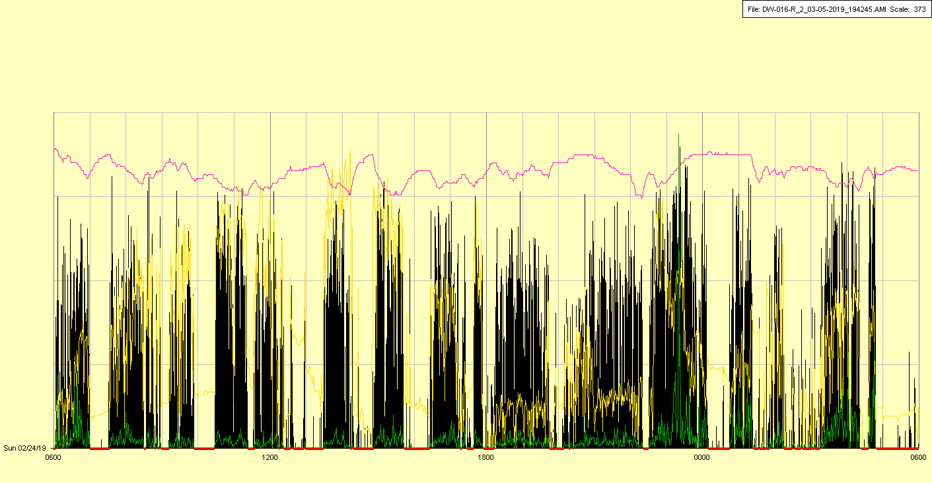

|  |  |  |  |
| --- | --- | --- | --- |
| Study ID | DW16 | Initial NIHSS (affected arm) | 4 |
| Age | 75 | Sex | Male |
| ICH Location | Right lobar | Patient location | NCCU |
| Hospital day | 6 | Mechanical ventilation | No |
| Delirium status | Yes | 3-month mRS | 6 |

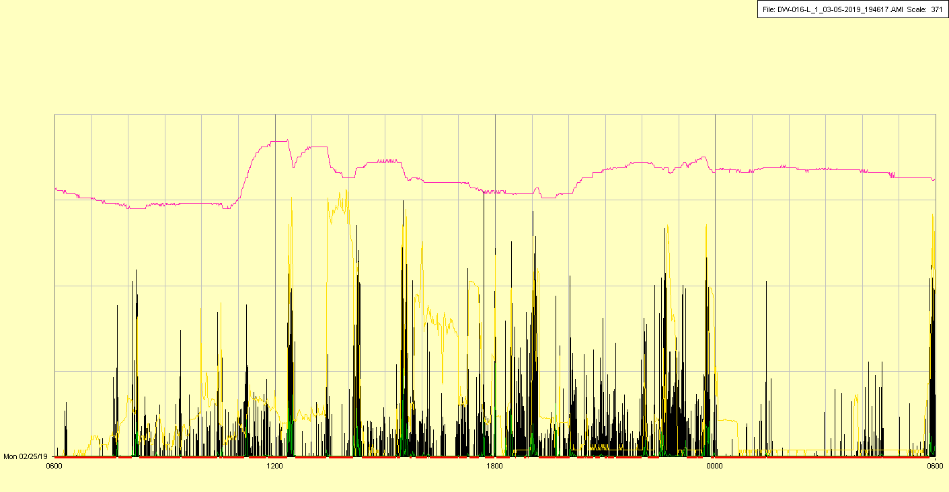

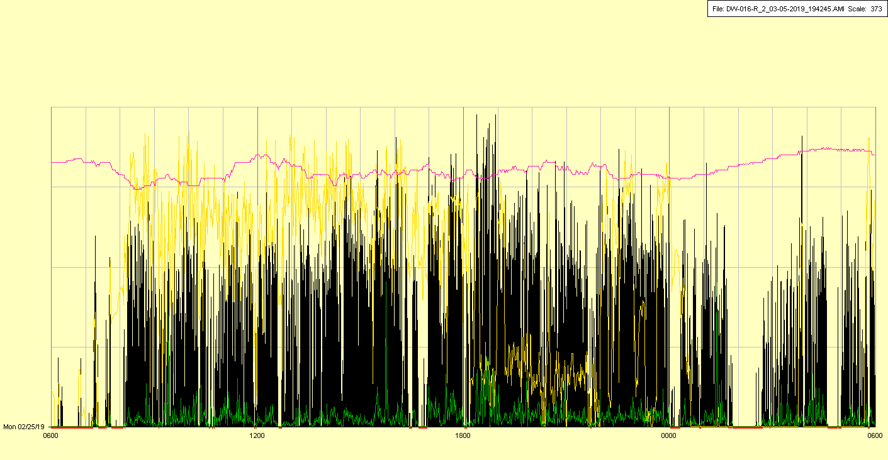

|  |  |  |  |
| --- | --- | --- | --- |
| Study ID | DW16 | Initial NIHSS (affected arm) | 4 |
| Age | 75 | Sex | Male |
| ICH Location | Right lobar | Patient location | NCCU |
| Hospital day | 7 | Mechanical ventilation | No |
| Delirium status | Yes | 3-month mRS | 6 |

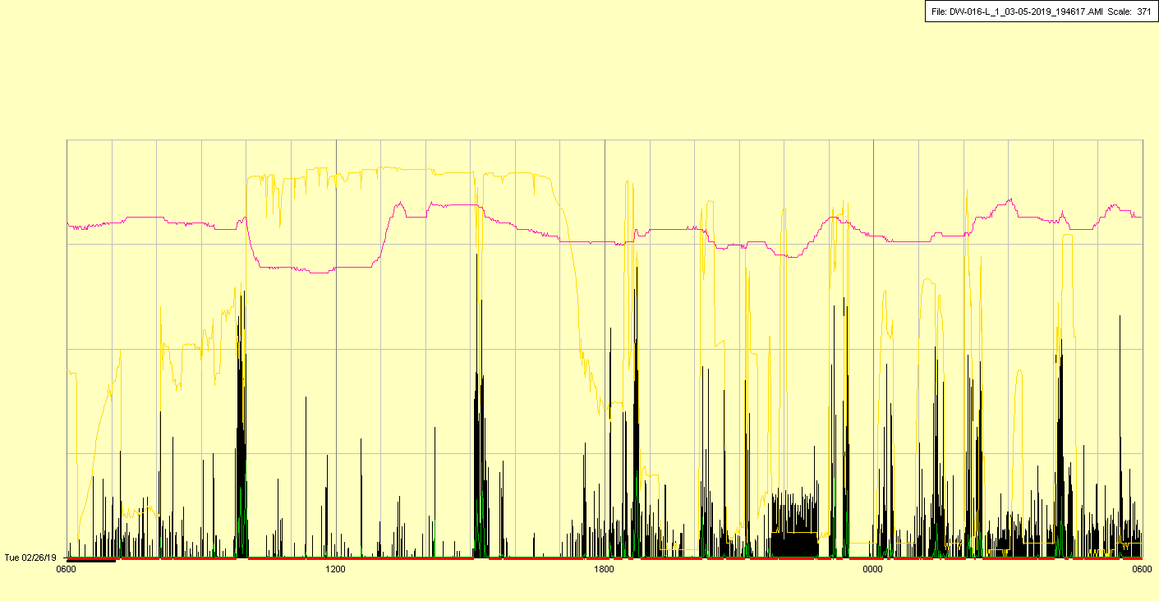

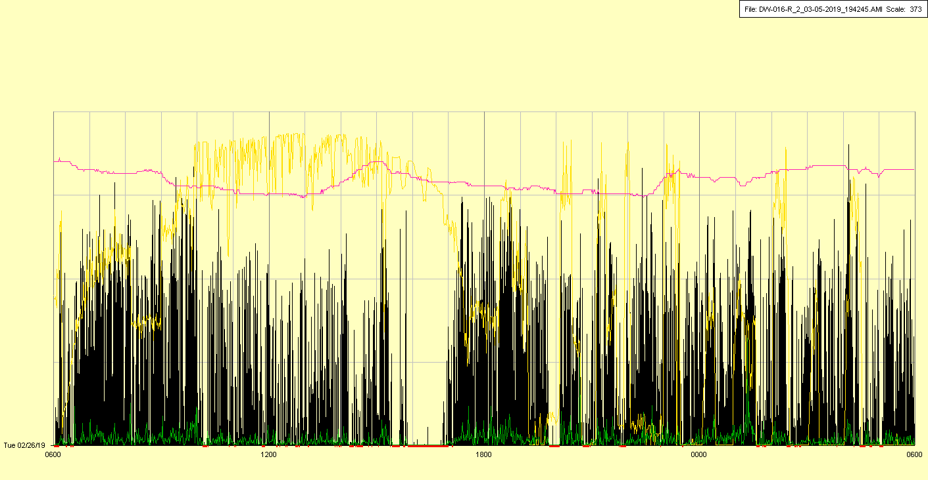

|  |  |  |  |
| --- | --- | --- | --- |
| Study ID | DW16 | Initial NIHSS (affected arm) | 4 |
| Age | 75 | Sex | Male |
| ICH Location | Right lobar | Patient location | NCCU |
| Hospital day | 8 | Mechanical ventilation | No |
| Delirium status | Yes | 3-month mRS | 6 |

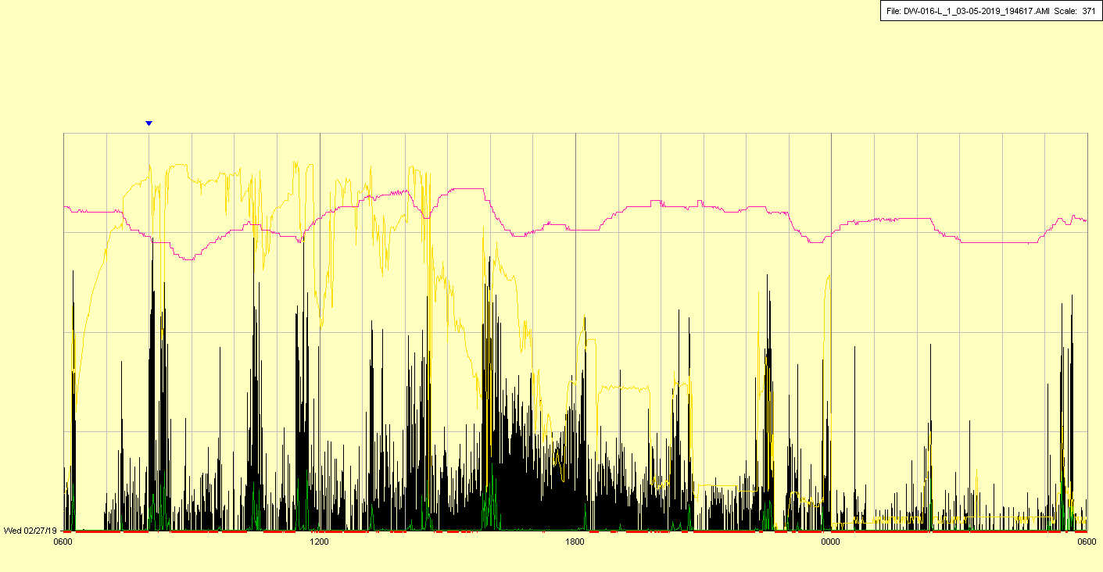

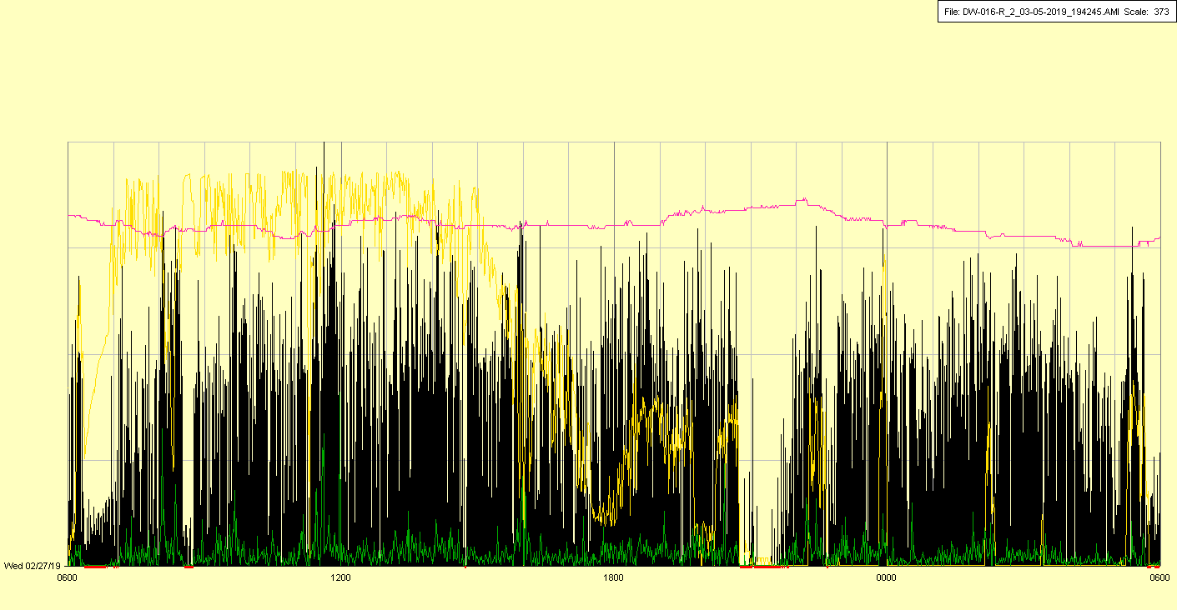

|  |  |  |  |
| --- | --- | --- | --- |
| Study ID | DW16 | Initial NIHSS (affected arm) | 4 |
| Age | 75 | Sex | Male |
| ICH Location | Right lobar | Patient location | NCCU 🡪 Stroke Unit |
| Hospital day | 9 | Mechanical ventilation | No |
| Delirium status | Yes | 3-month mRS | 6 |

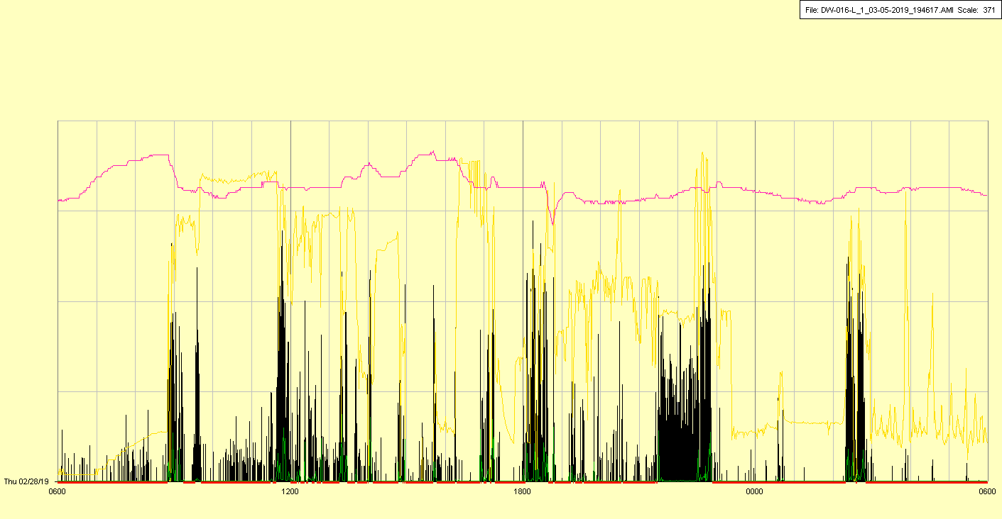

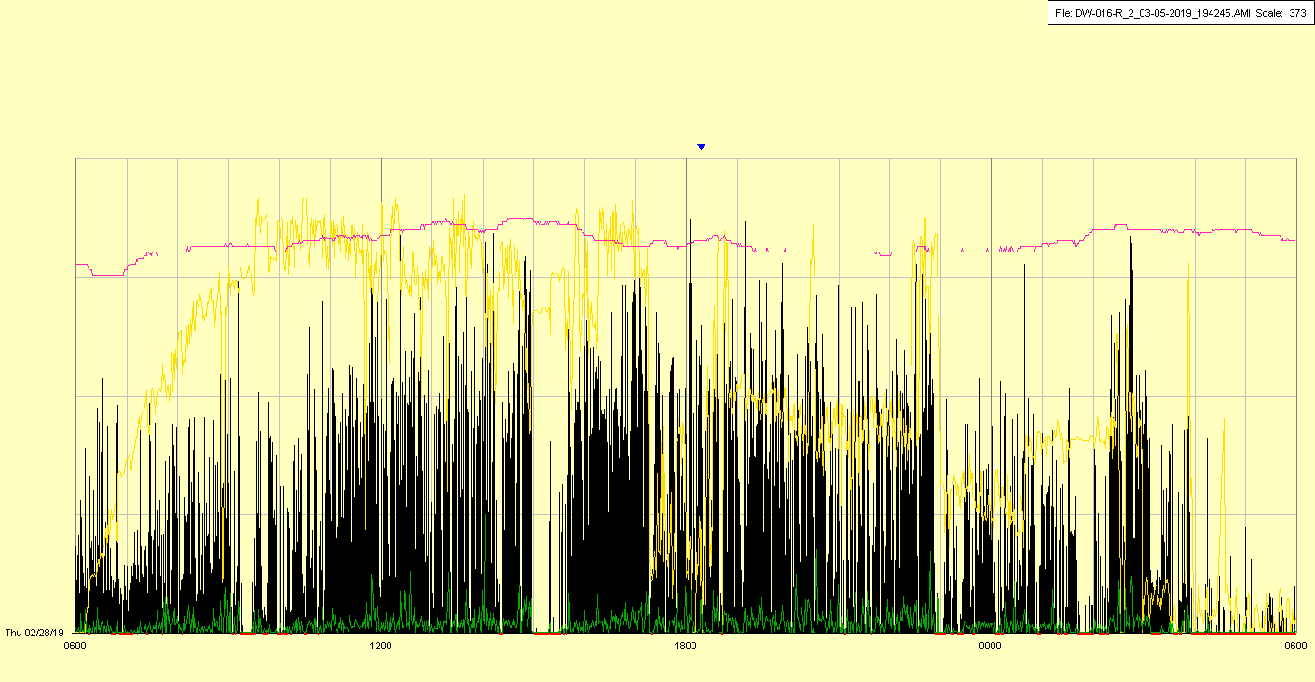

|  |  |  |  |
| --- | --- | --- | --- |
| Study ID | DW16 | Initial NIHSS (affected arm) | 4 |
| Age | 75 | Sex | Male |
| ICH Location | Right lobar | Patient location | Stroke Unit |
| Hospital day | 10 | Mechanical ventilation | No |
| Delirium status | Yes | 3-month mRS | 6 |

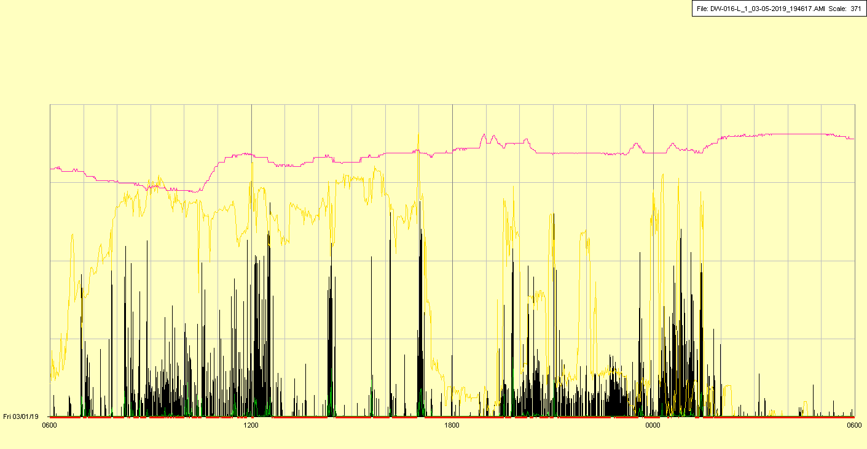

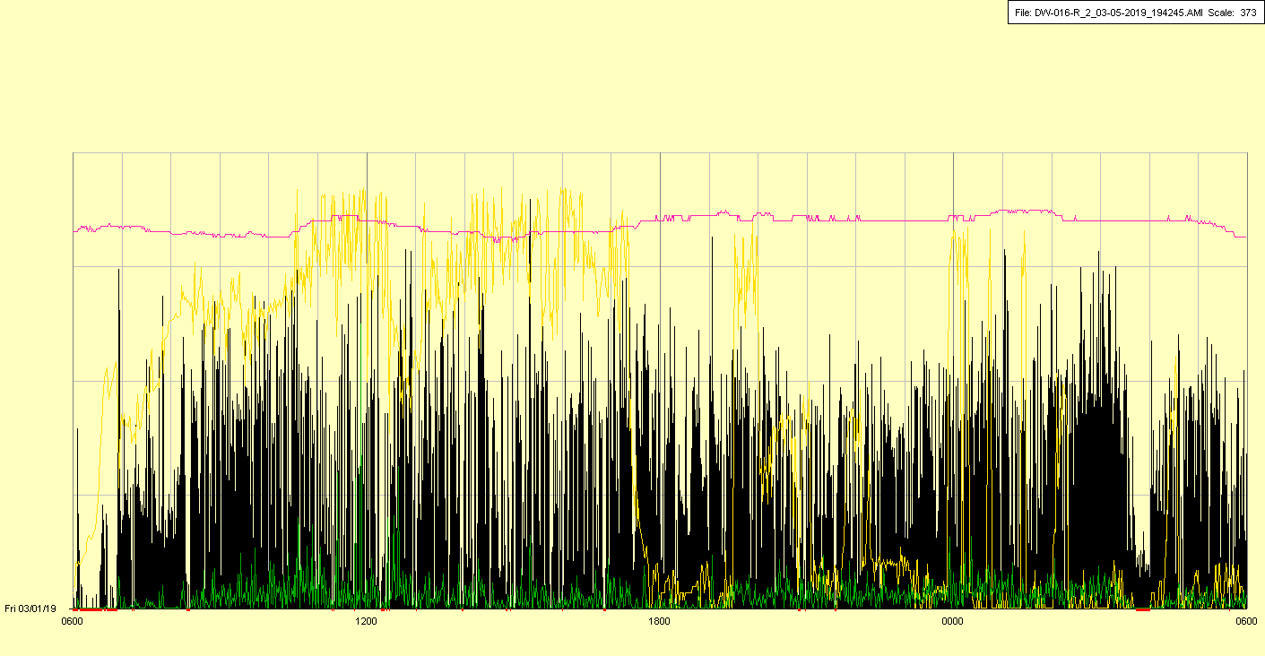

|  |  |  |  |
| --- | --- | --- | --- |
| Study ID | DW16 | Initial NIHSS (affected arm) | 4 |
| Age | 75 | Sex | Male |
| ICH Location | Right lobar | Patient location | Stroke Unit 🡪 NCCU |
| Hospital day | 11 | Mechanical ventilation | No |
| Delirium status | Yes | 3-month mRS | 6 |

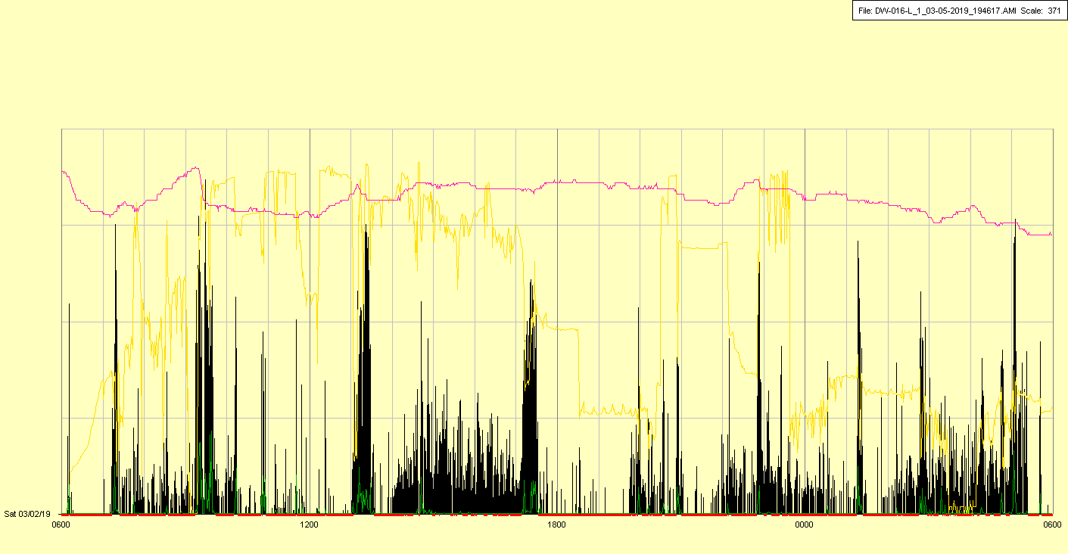

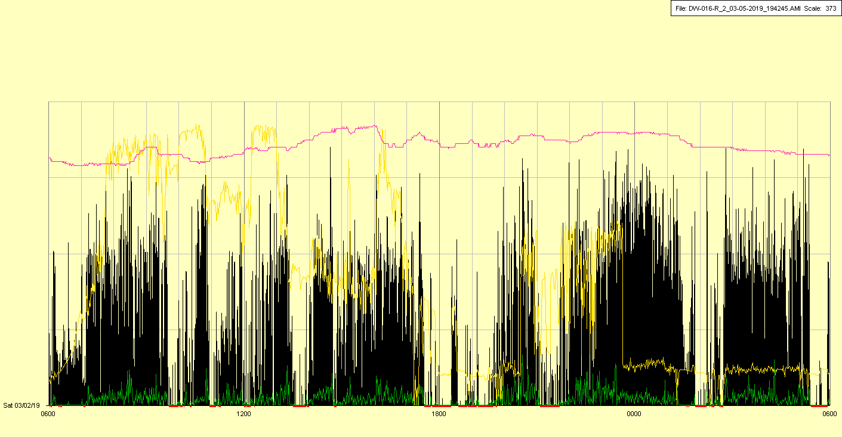

|  |  |  |  |
| --- | --- | --- | --- |
| Study ID | DW16 | Initial NIHSS (affected arm) | 4 |
| Age | 75 | Sex | Male |
| ICH Location | Right lobar | Patient location | NCCU |
| Hospital day | 12 | Mechanical ventilation | No |
| Delirium status | Yes | 3-month mRS | 6 |

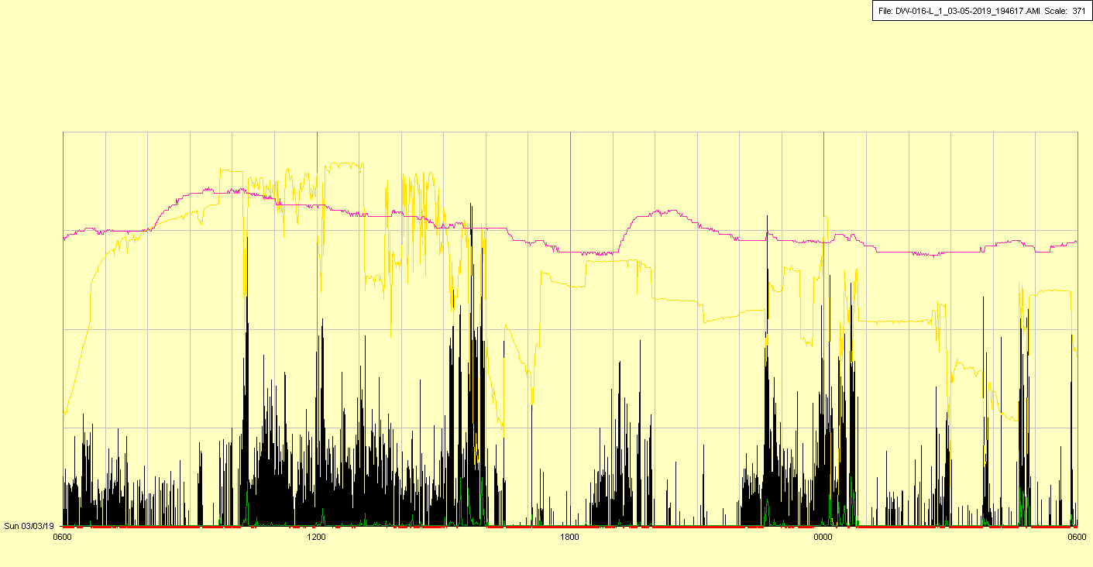

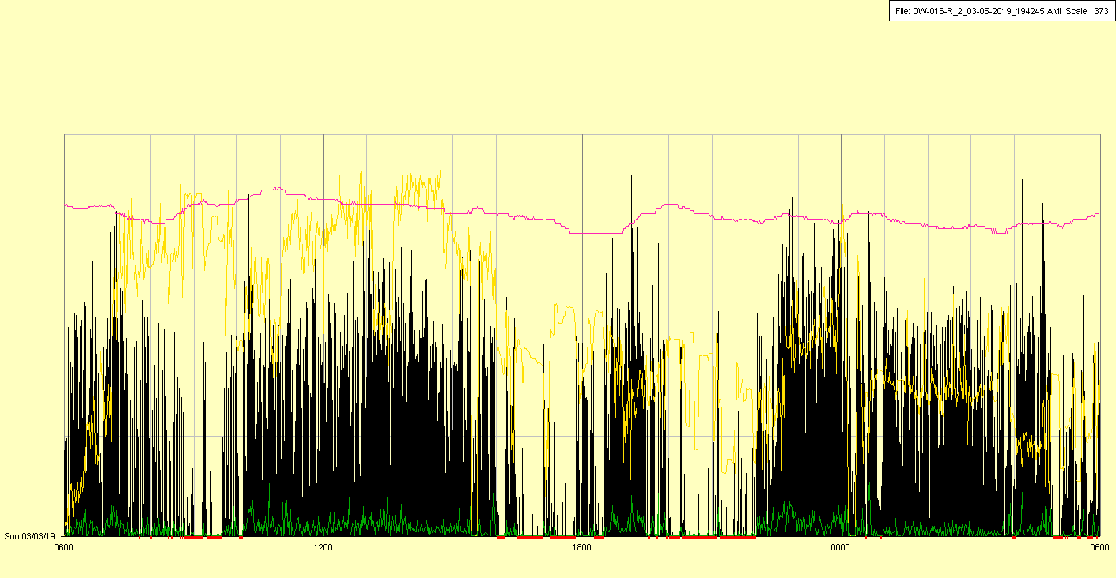

|  |  |  |  |
| --- | --- | --- | --- |
| Study ID | DW16 | Initial NIHSS (affected arm) | 4 |
| Age | 75 | Sex | Male |
| ICH Location | Right lobar | Patient location | NCCU |
| Hospital day | 13 | Mechanical ventilation | No |
| Delirium status | Yes | 3-month mRS | 6 |

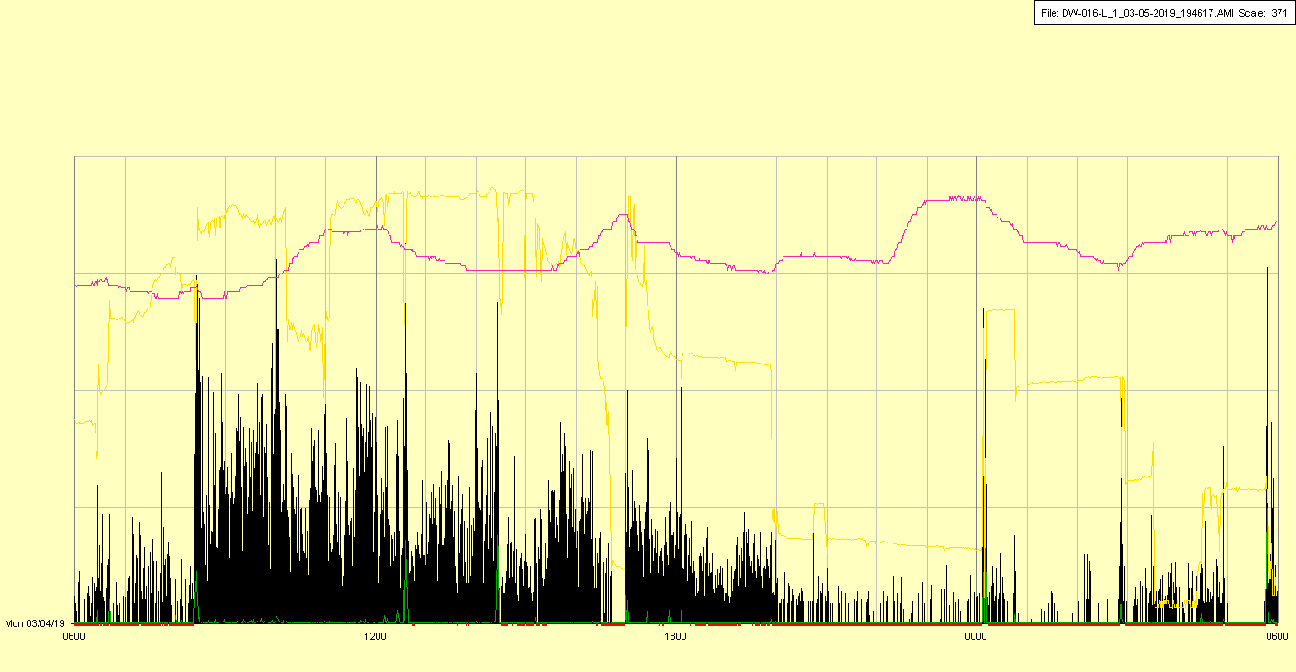

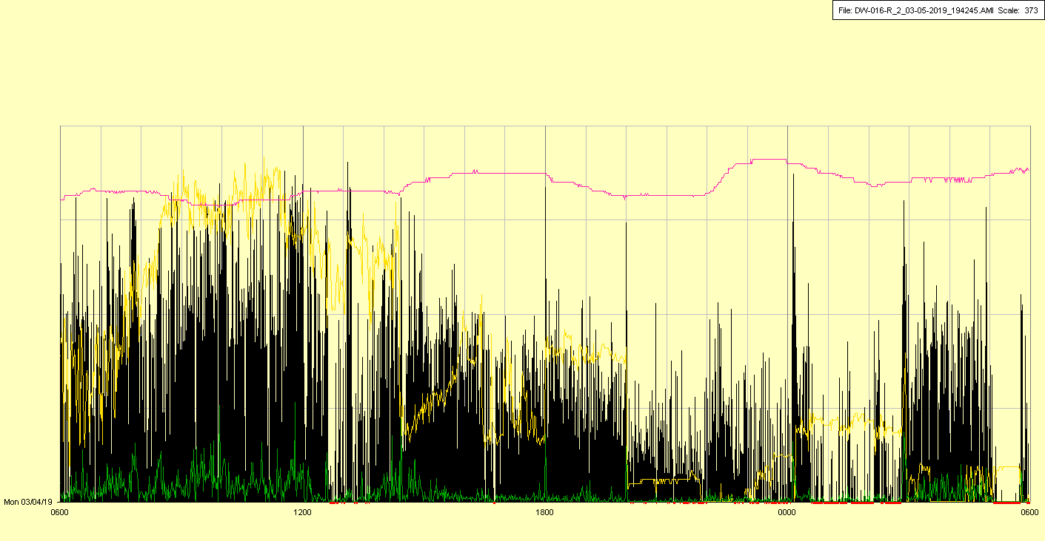

|  |  |  |  |
| --- | --- | --- | --- |
| Study ID | DW16 | Initial NIHSS (affected arm) | 4 |
| Age | 75 | Sex | Male |
| ICH Location | Right lobar | Patient location | NCCU |
| Hospital day | 14 | Mechanical ventilation | No |
| Delirium status | N/A | 3-month mRS | 6 |

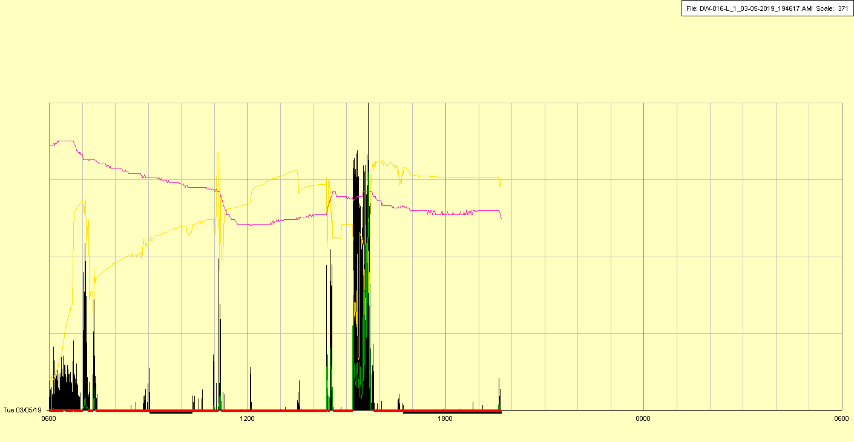

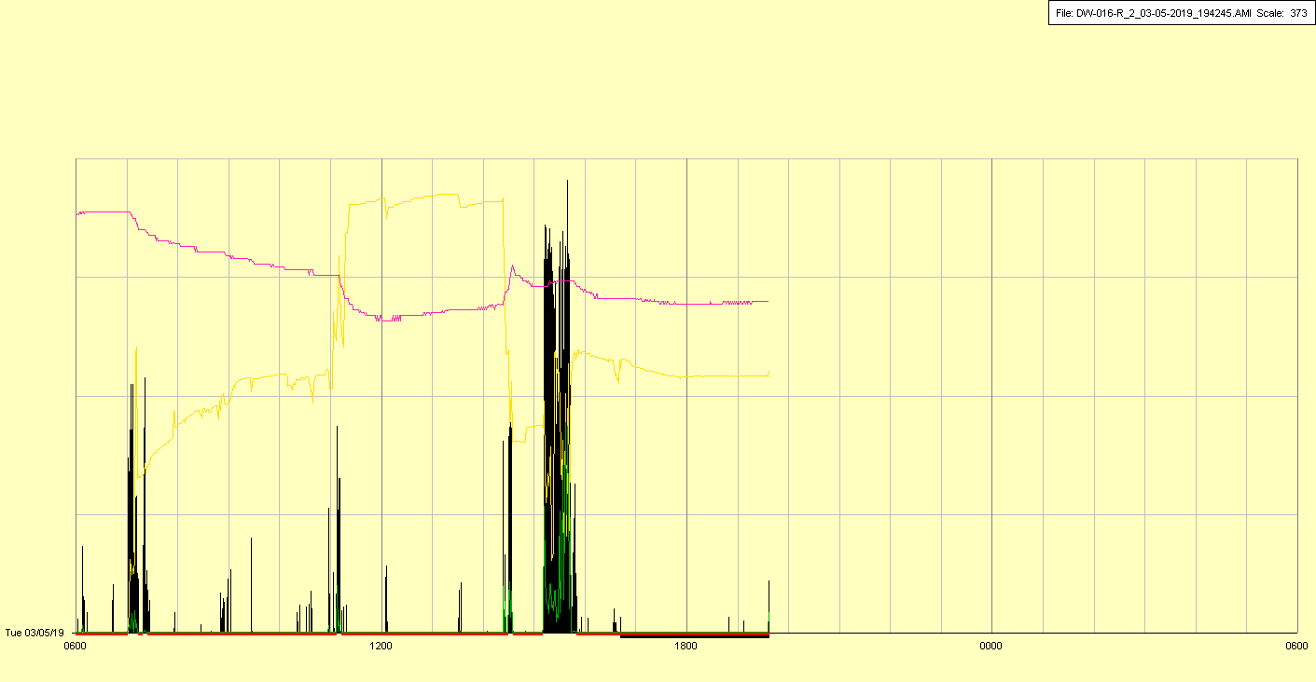

Patient died in early AM, watches taken off