|  |  |  |  |
| --- | --- | --- | --- |
| Study ID | DW17 | Initial NIHSS (affected arm) | 2 |
| Age | 75 | Sex | Female |
| ICH Location | Right lobar | Patient location | NCCU |
| Hospital day | 3 | Mechanical ventilation | Yes |
| Delirium status | Yes | 3-month mRS |  |

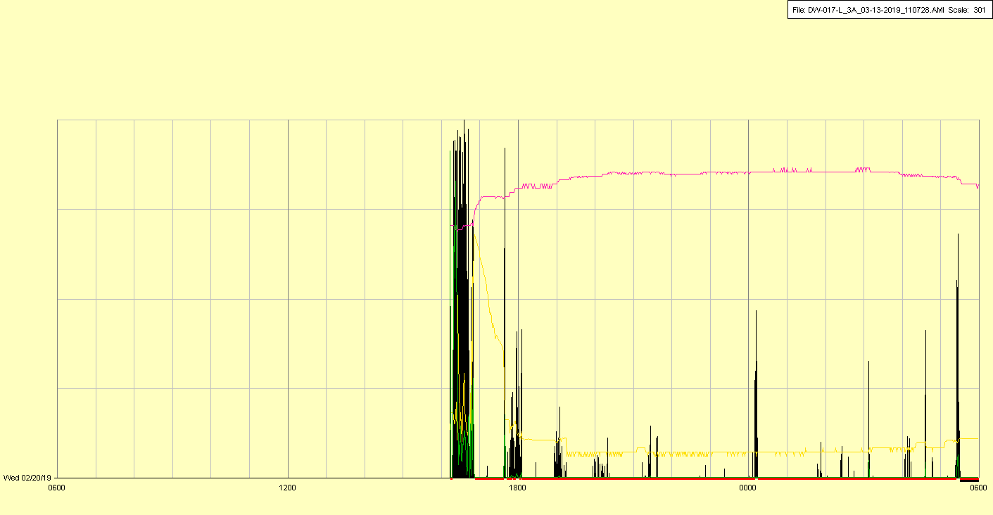

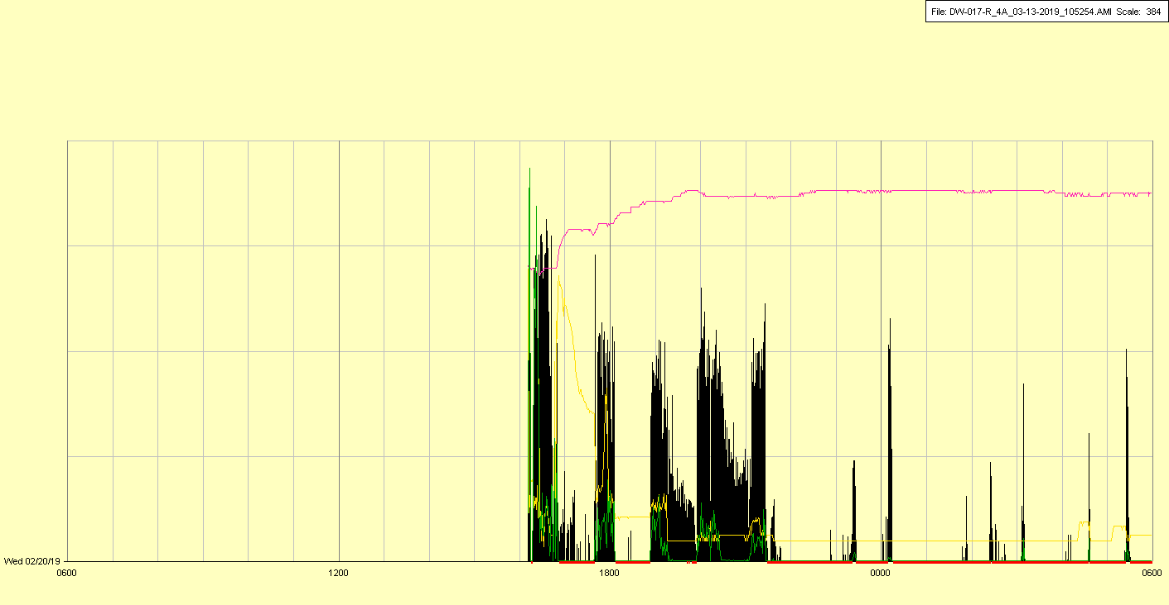

|  |  |  |  |
| --- | --- | --- | --- |
| Study ID | DW17 | Initial NIHSS (affected arm) | 2 |
| Age | 75 | Sex | Female |
| ICH Location | Right lobar | Patient location | NCCU |
| Hospital day | 4 | Mechanical ventilation | Yes |
| Delirium status | N/A - Coma | 3-month mRS |  |

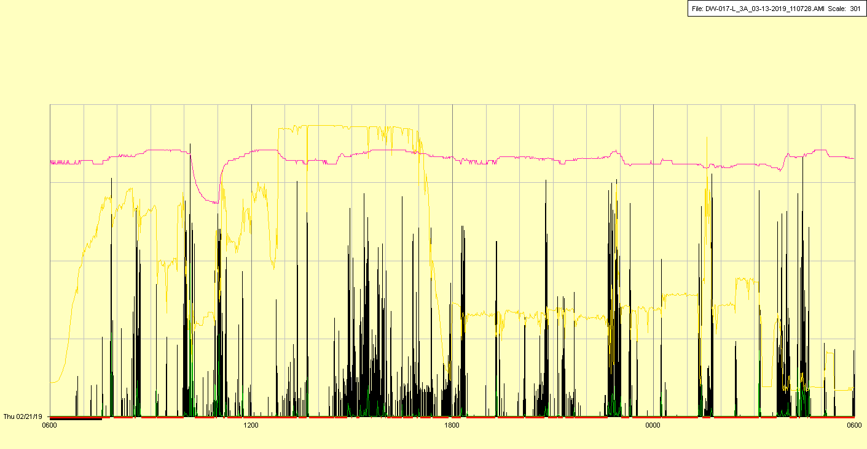

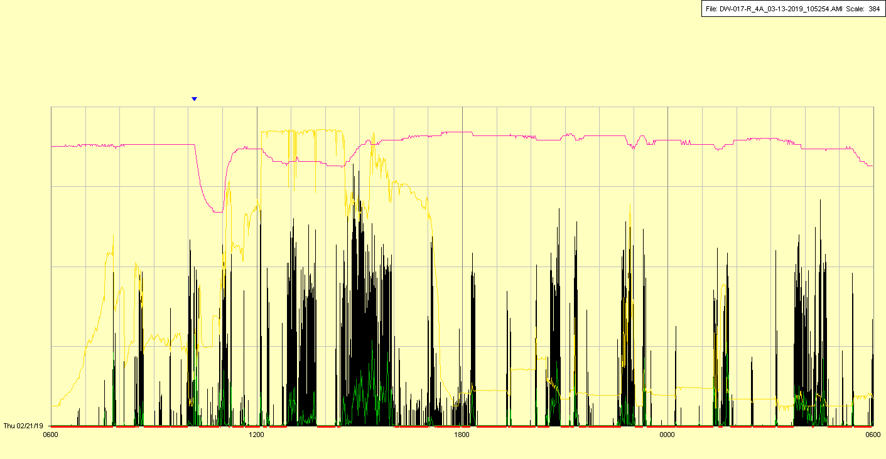

|  |  |  |  |
| --- | --- | --- | --- |
| Study ID | DW17 | Initial NIHSS (affected arm) | 2 |
| Age | 75 | Sex | Female |
| ICH Location | Right lobar | Patient location | NCCU |
| Hospital day | 5 | Mechanical ventilation | Yes |
| Delirium status | Yes | 3-month mRS |  |

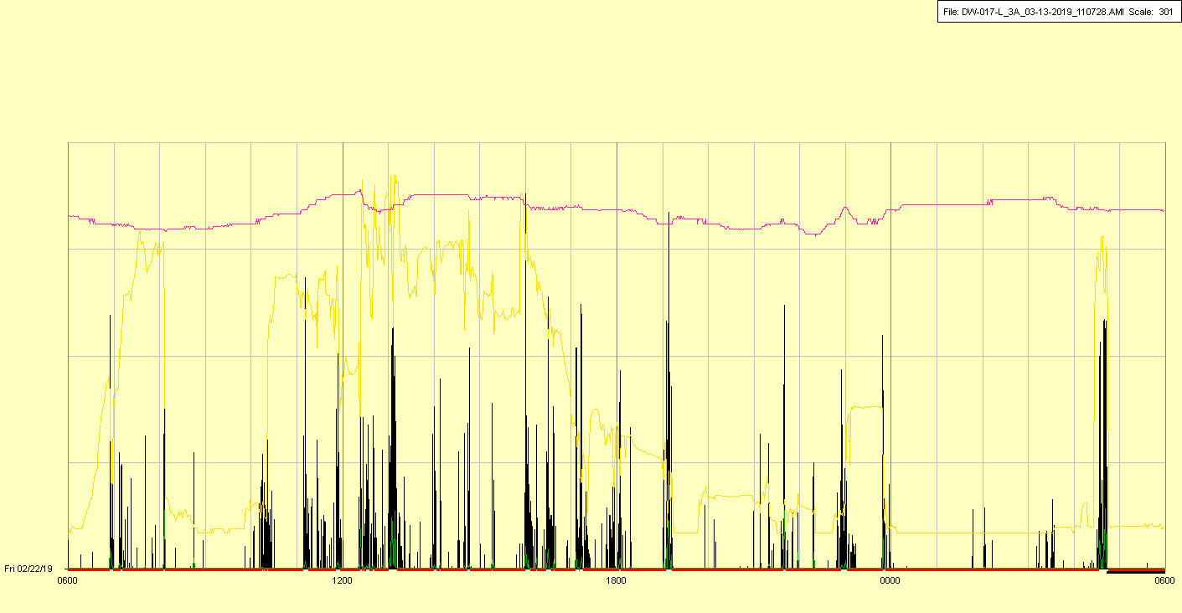

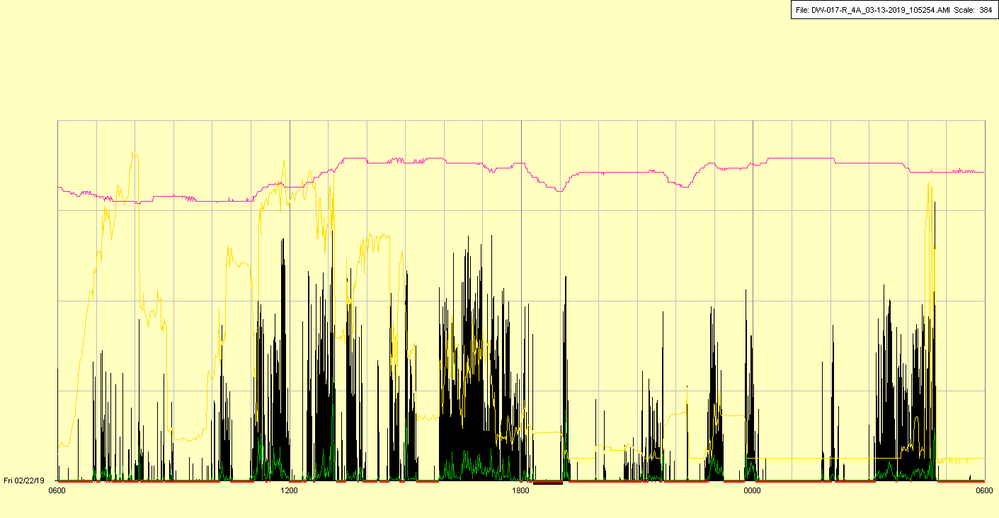

|  |  |  |  |
| --- | --- | --- | --- |
| Study ID | DW17 | Initial NIHSS (affected arm) | 2 |
| Age | 75 | Sex | Female |
| ICH Location | Right lobar | Patient location | NCCU |
| Hospital day | 6 | Mechanical ventilation | Yes |
| Delirium status | Yes | 3-month mRS |  |

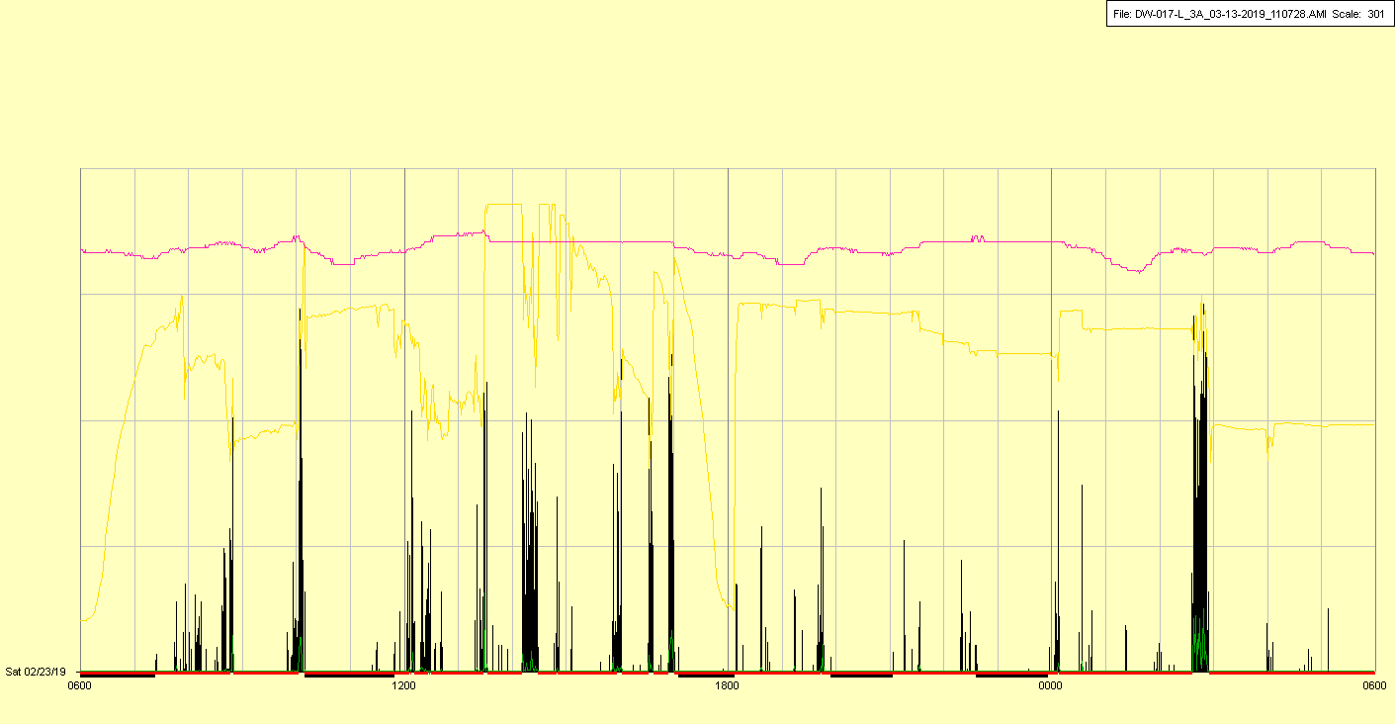

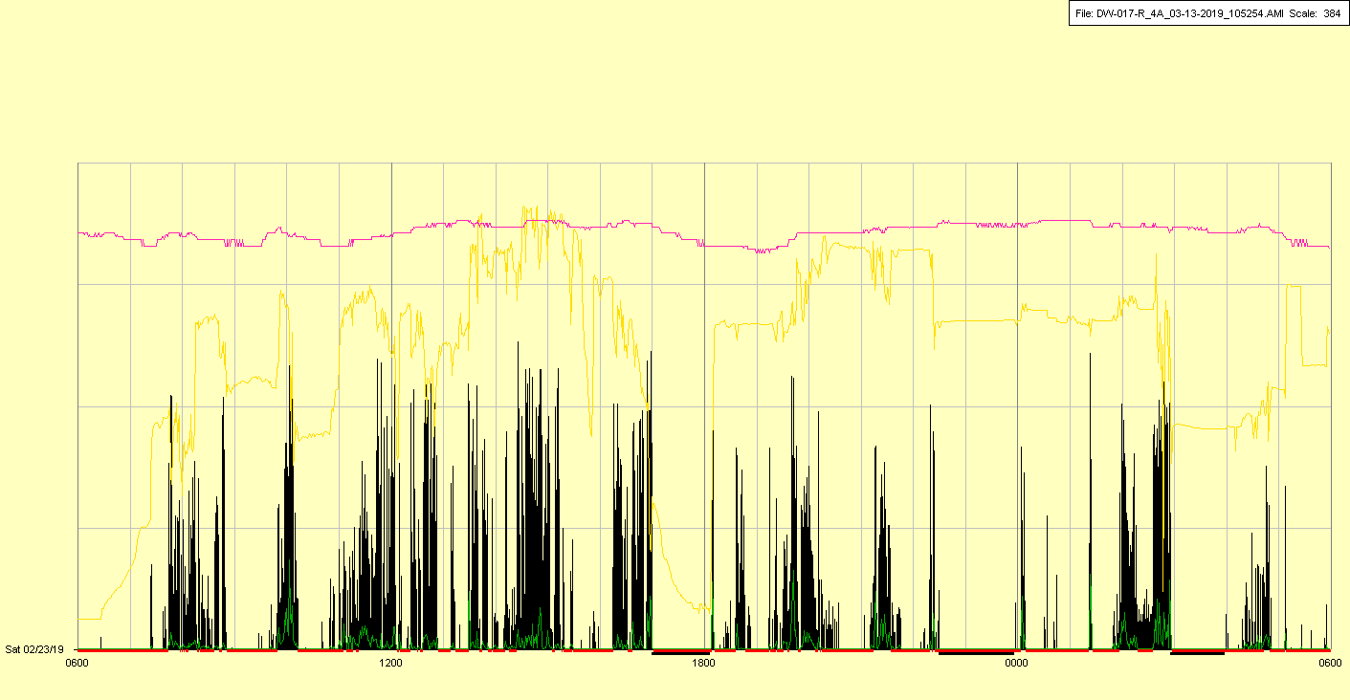

|  |  |  |  |
| --- | --- | --- | --- |
| Study ID | DW17 | Initial NIHSS (affected arm) | 2 |
| Age | 75 | Sex | Female |
| ICH Location | Right lobar | Patient location | NCCU |
| Hospital day | 7 | Mechanical ventilation | Yes |
| Delirium status | Yes | 3-month mRS |  |

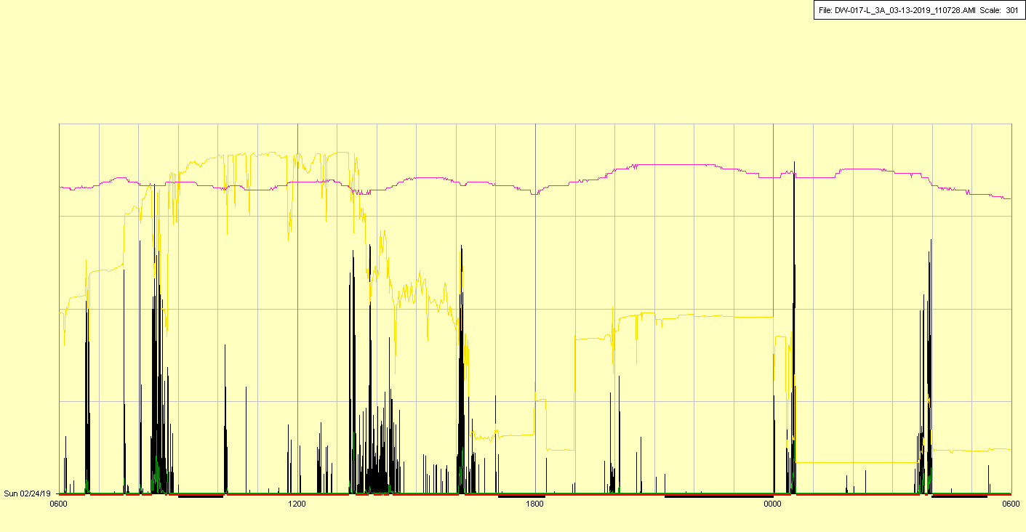

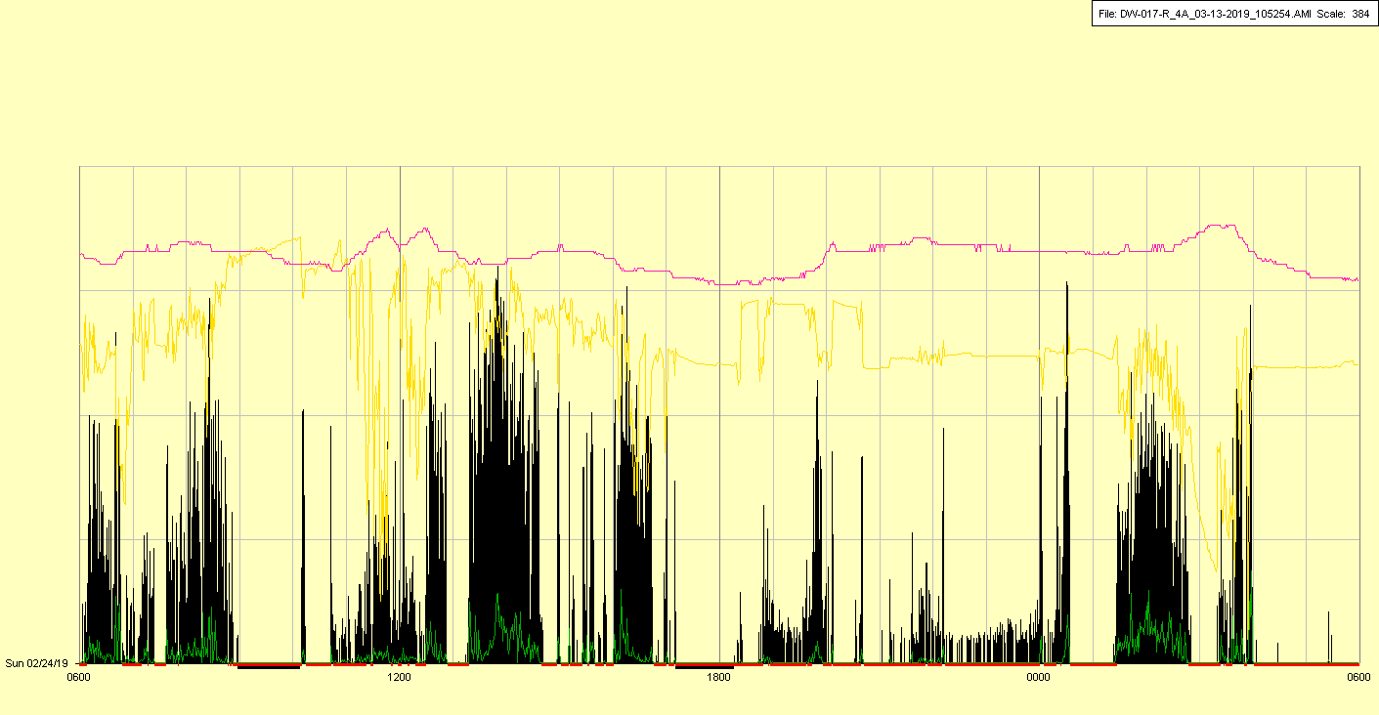

|  |  |  |  |
| --- | --- | --- | --- |
| Study ID | DW17 | Initial NIHSS (affected arm) | 2 |
| Age | 75 | Sex | Female |
| ICH Location | Right lobar | Patient location | NCCU |
| Hospital day | 8 | Mechanical ventilation | Yes |
| Delirium status | Yes | 3-month mRS |  |

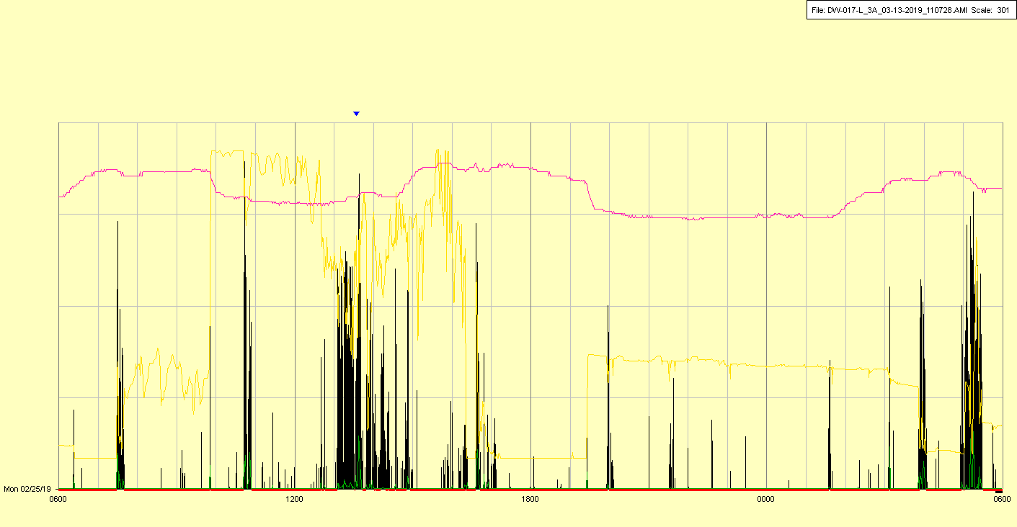

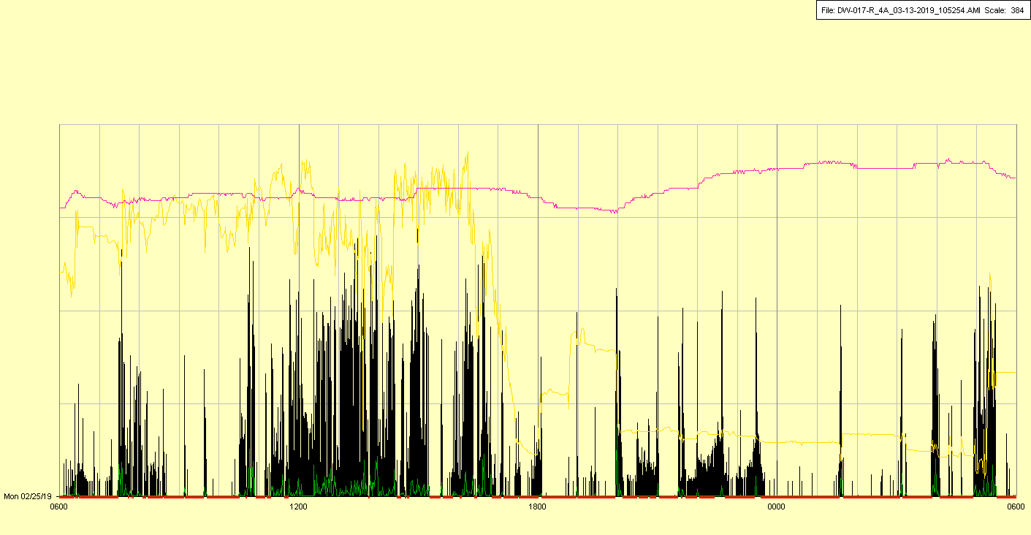

|  |  |  |  |
| --- | --- | --- | --- |
| Study ID | DW17 | Initial NIHSS (affected arm) | 2 |
| Age | 75 | Sex | Female |
| ICH Location | Right lobar | Patient location | NCCU |
| Hospital day | 9 | Mechanical ventilation | Yes |
| Delirium status | Yes | 3-month mRS |  |

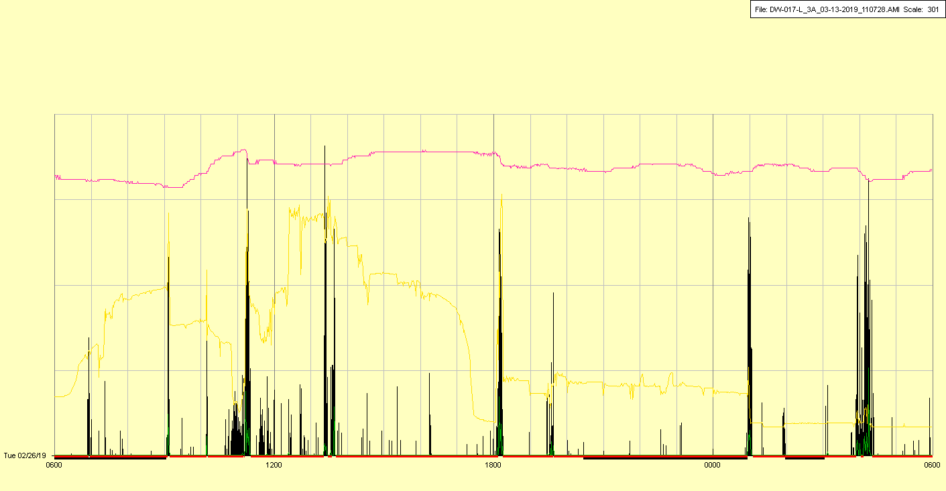

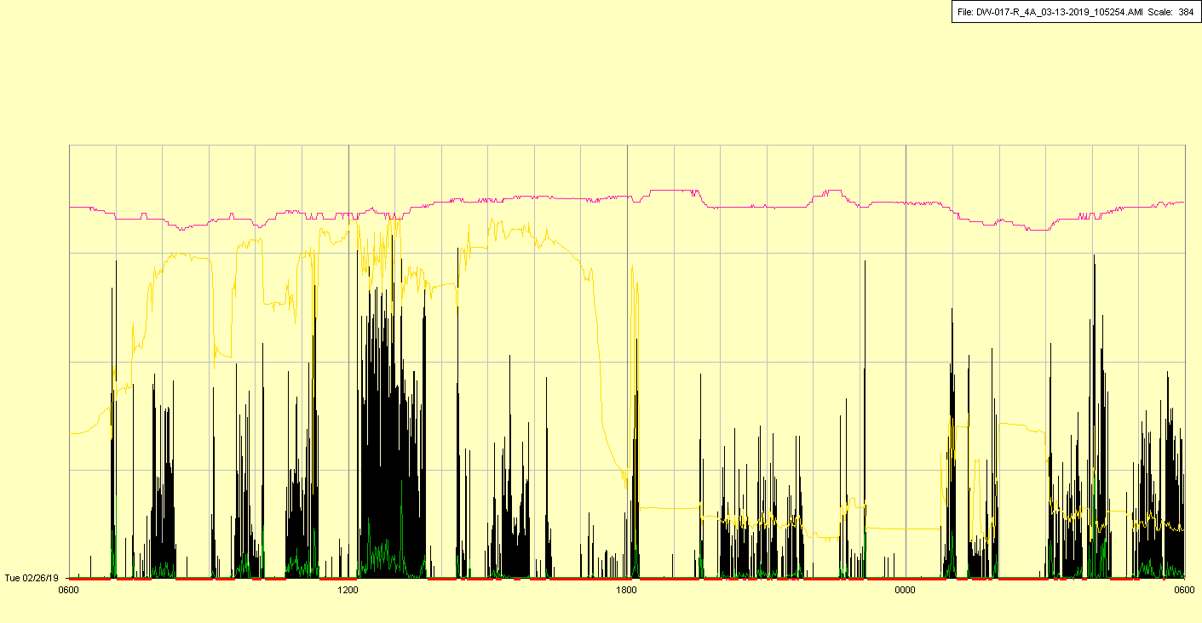

|  |  |  |  |
| --- | --- | --- | --- |
| Study ID | DW17 | Initial NIHSS (affected arm) | 2 |
| Age | 75 | Sex | Female |
| ICH Location | Right lobar | Patient location | NCCU |
| Hospital day | 10 | Mechanical ventilation | Yes |
| Delirium status | No | 3-month mRS |  |

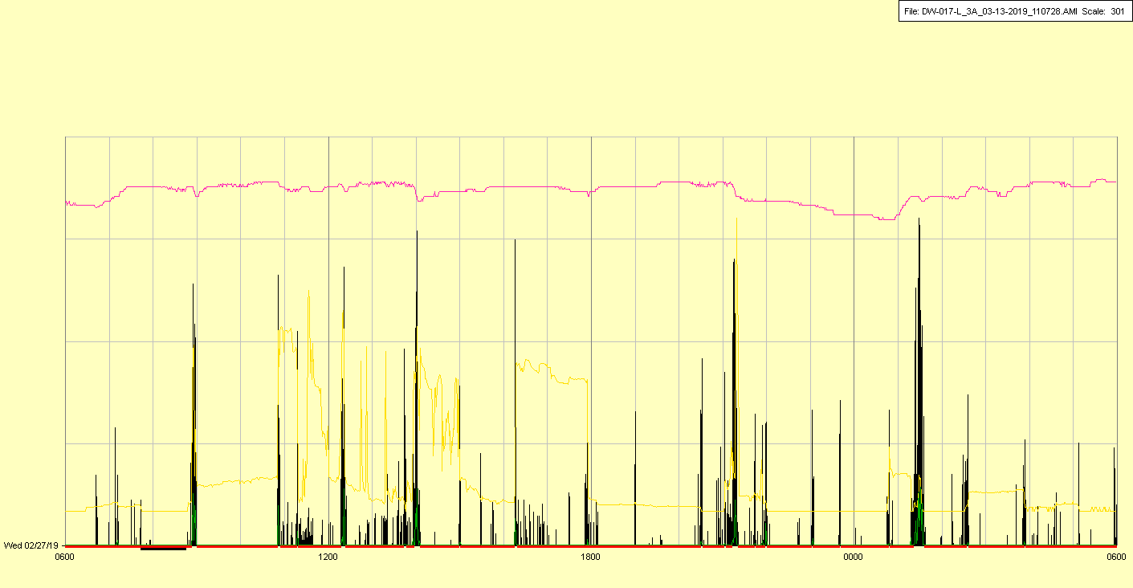

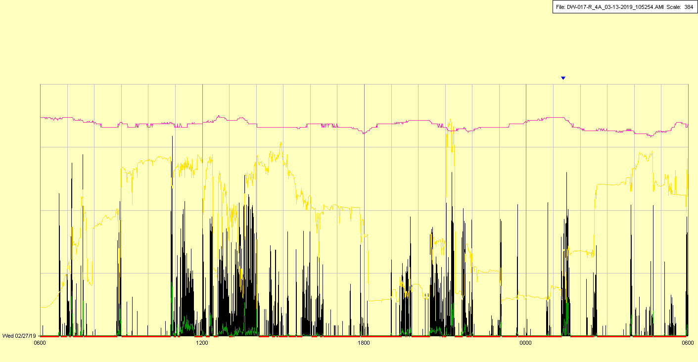

|  |  |  |  |
| --- | --- | --- | --- |
| Study ID | DW17 | Initial NIHSS (affected arm) | 2 |
| Age | 75 | Sex | Female |
| ICH Location | Right lobar | Patient location | NCCU |
| Hospital day | 11 | Mechanical ventilation | Yes |
| Delirium status | Yes | 3-month mRS |  |

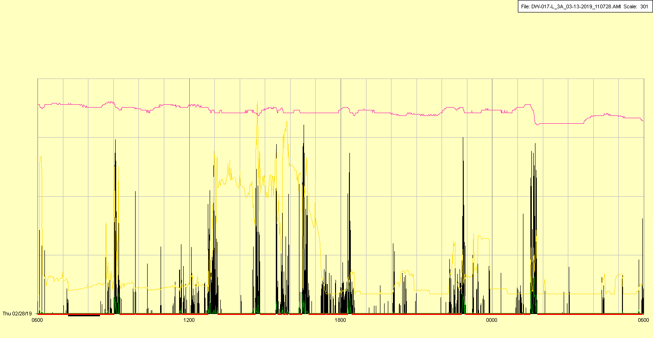

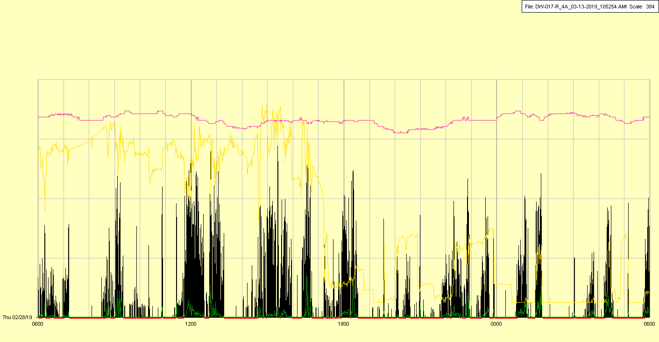

|  |  |  |  |
| --- | --- | --- | --- |
| Study ID | DW17 | Initial NIHSS (affected arm) | 2 |
| Age | 75 | Sex | Female |
| ICH Location | Right lobar | Patient location | NCCU |
| Hospital day | 12 | Mechanical ventilation | Yes |
| Delirium status | No | 3-month mRS |  |

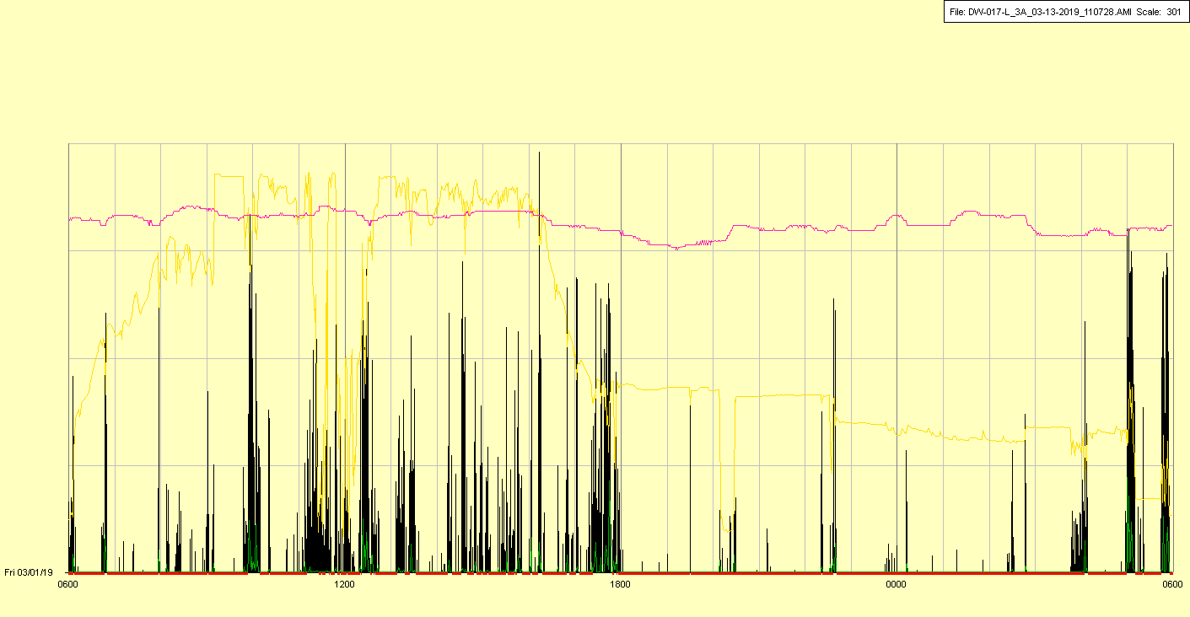

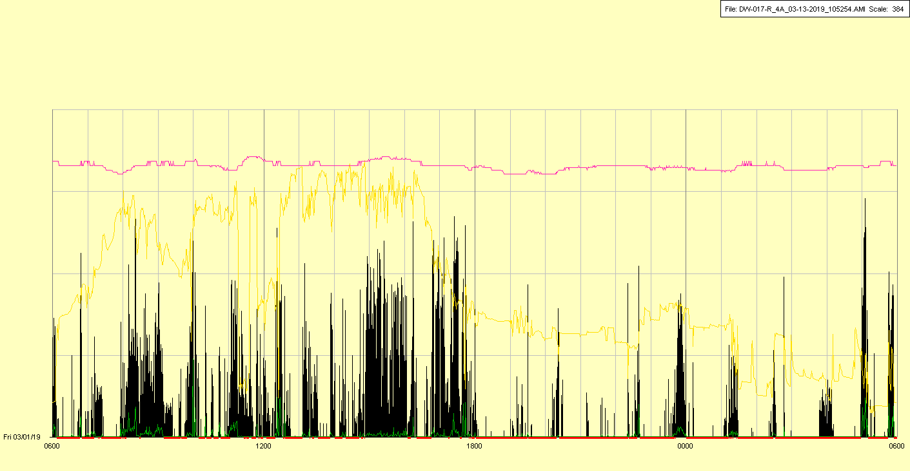

|  |  |  |  |
| --- | --- | --- | --- |
| Study ID | DW17 | Initial NIHSS (affected arm) | 2 |
| Age | 75 | Sex | Female |
| ICH Location | Right lobar | Patient location | NCCU |
| Hospital day | 13 | Mechanical ventilation | No (trach) |
| Delirium status | No | 3-month mRS |  |

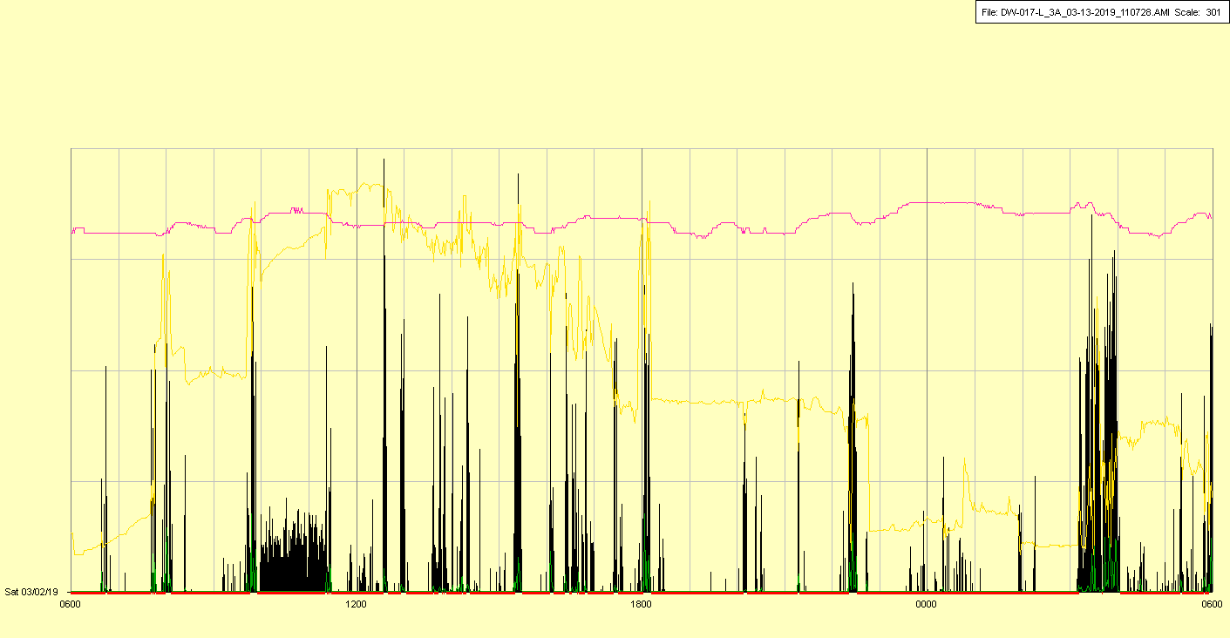

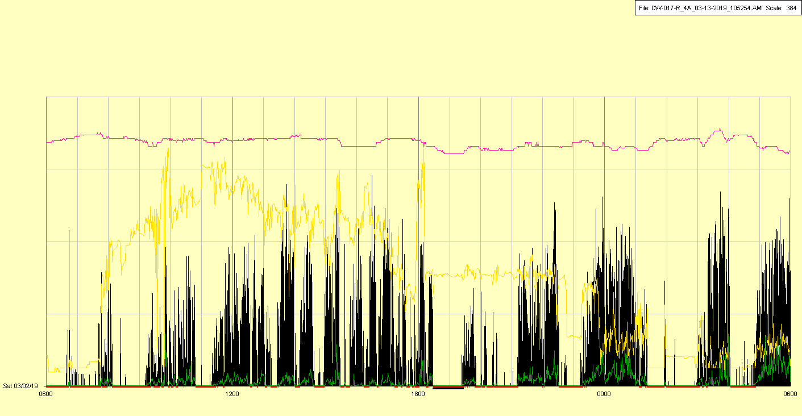

|  |  |  |  |
| --- | --- | --- | --- |
| Study ID | DW17 | Initial NIHSS (affected arm) | 2 |
| Age | 75 | Sex | Female |
| ICH Location | Right lobar | Patient location | NCCU |
| Hospital day | 14 | Mechanical ventilation | No (trach) |
| Delirium status | No | 3-month mRS |  |

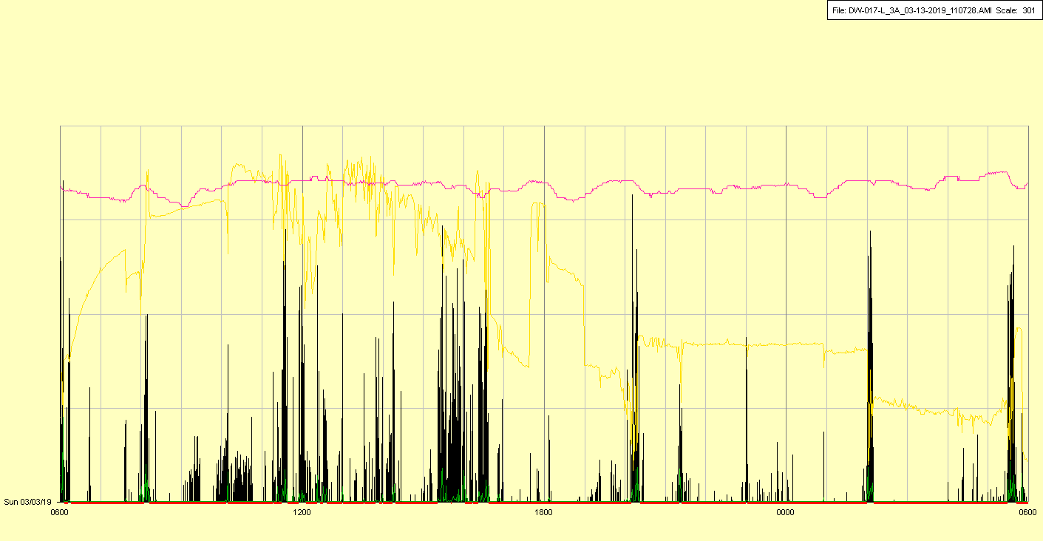

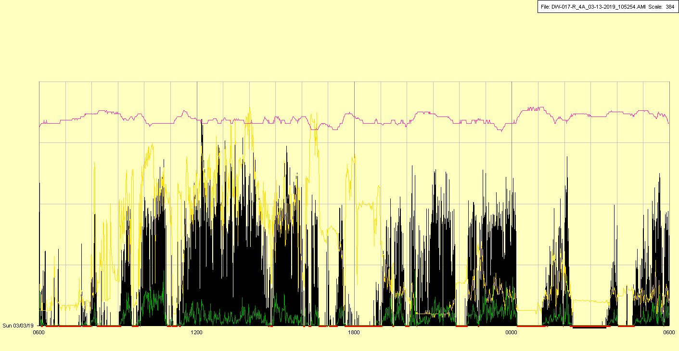

|  |  |  |  |
| --- | --- | --- | --- |
| Study ID | DW17 | Initial NIHSS (affected arm) | 2 |
| Age | 75 | Sex | Female |
| ICH Location | Right lobar | Patient location | NCCU |
| Hospital day | 15 | Mechanical ventilation | No (trach) |
| Delirium status | No | 3-month mRS |  |

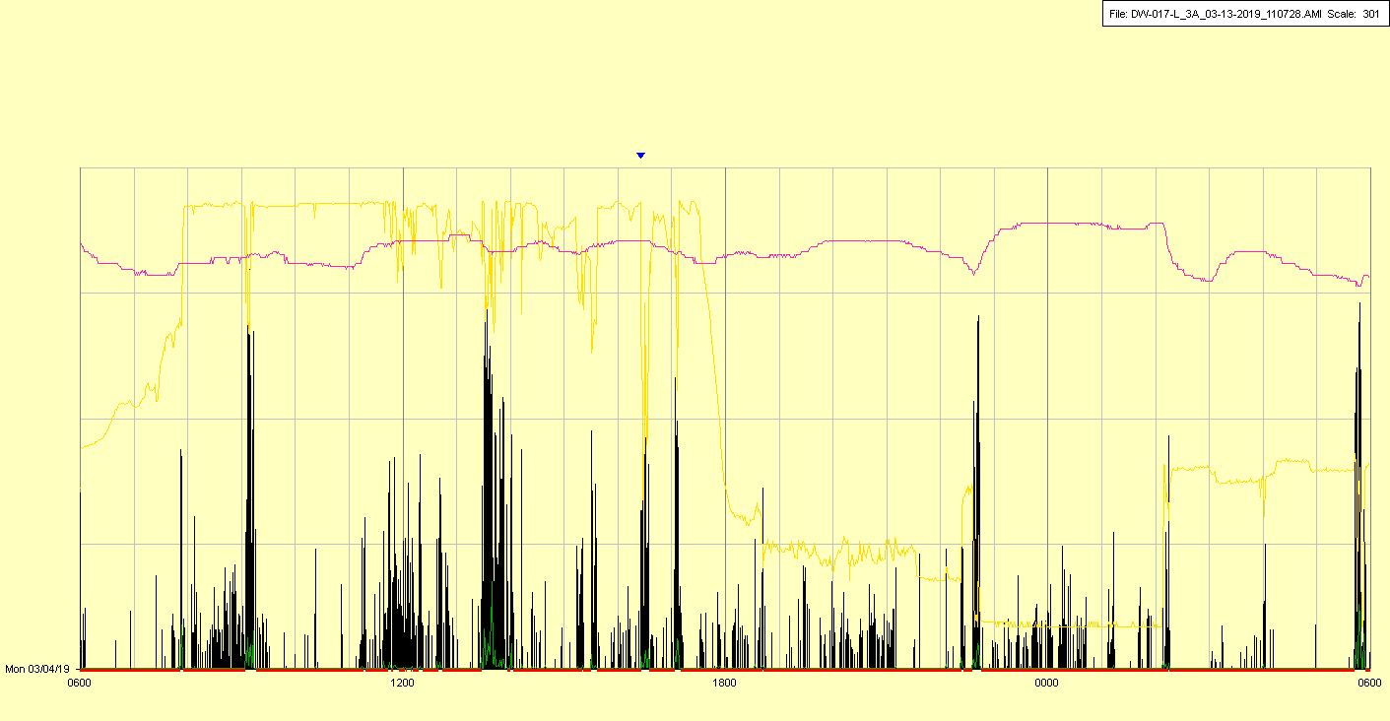

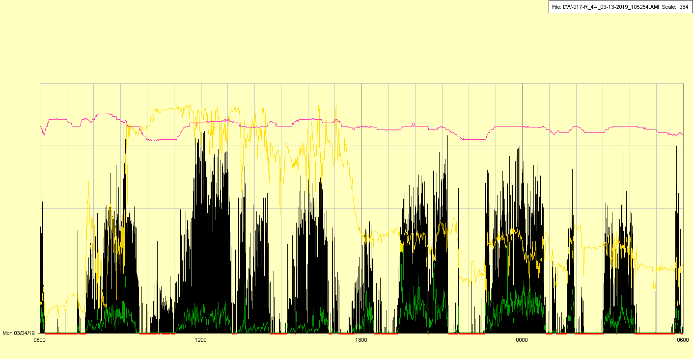

|  |  |  |  |
| --- | --- | --- | --- |
| Study ID | DW17 | Initial NIHSS (affected arm) | 2 |
| Age | 75 | Sex | Female |
| ICH Location | Right lobar | Patient location | NCCU |
| Hospital day | 16 | Mechanical ventilation | No (trach) |
| Delirium status | No | 3-month mRS |  |

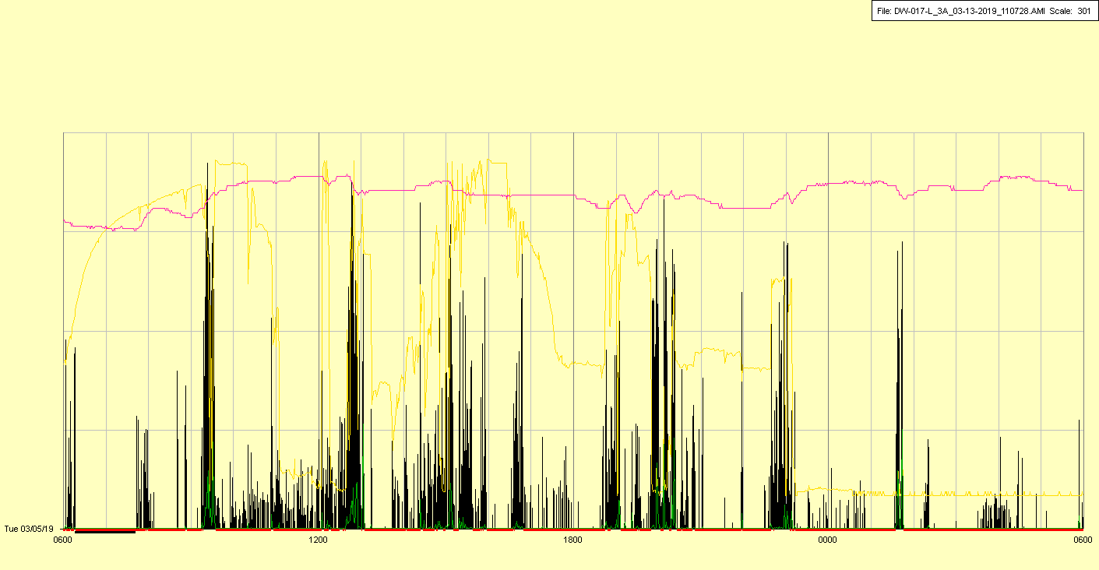

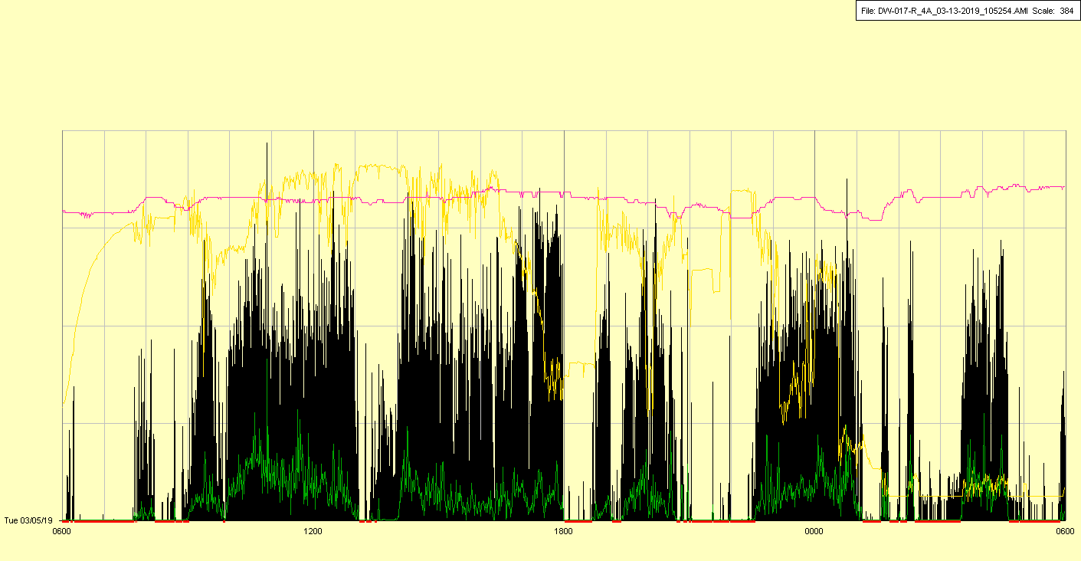

|  |  |  |  |
| --- | --- | --- | --- |
| Study ID | DW17 | Initial NIHSS (affected arm) | 2 |
| Age | 75 | Sex | Female |
| ICH Location | Right lobar | Patient location | NCCU |
| Hospital day | 17 | Mechanical ventilation | No (trach) |
| Delirium status | No | 3-month mRS |  |

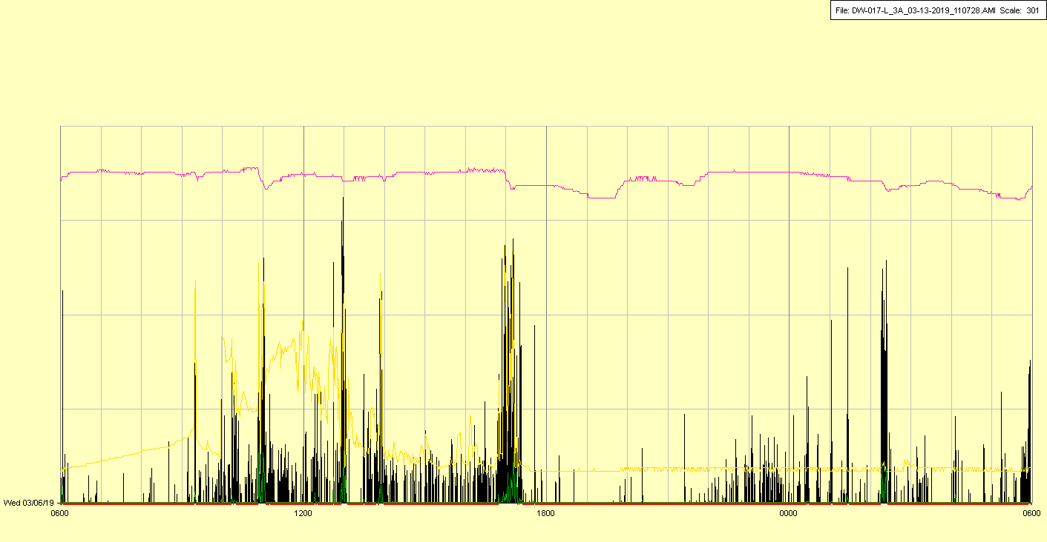

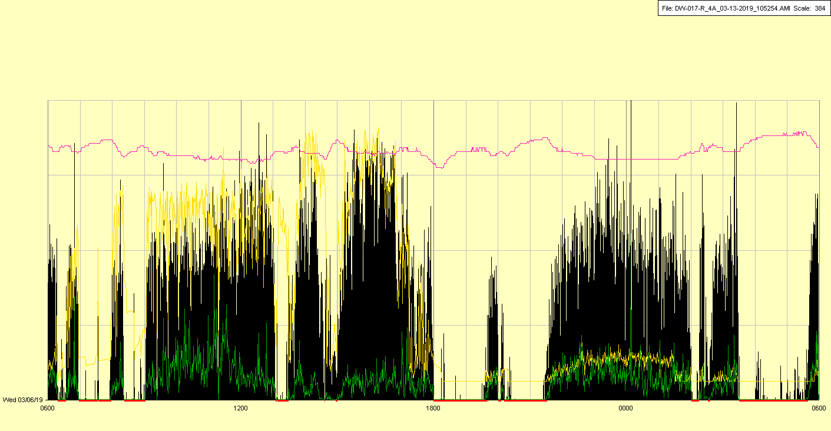

|  |  |  |  |
| --- | --- | --- | --- |
| Study ID | DW17 | Initial NIHSS (affected arm) | 2 |
| Age | 75 | Sex | Female |
| ICH Location | Right lobar | Patient location | NCCU 🡪 Stroke Unit |
| Hospital day | 18 | Mechanical ventilation | No (trach) |
| Delirium status | No | 3-month mRS |  |

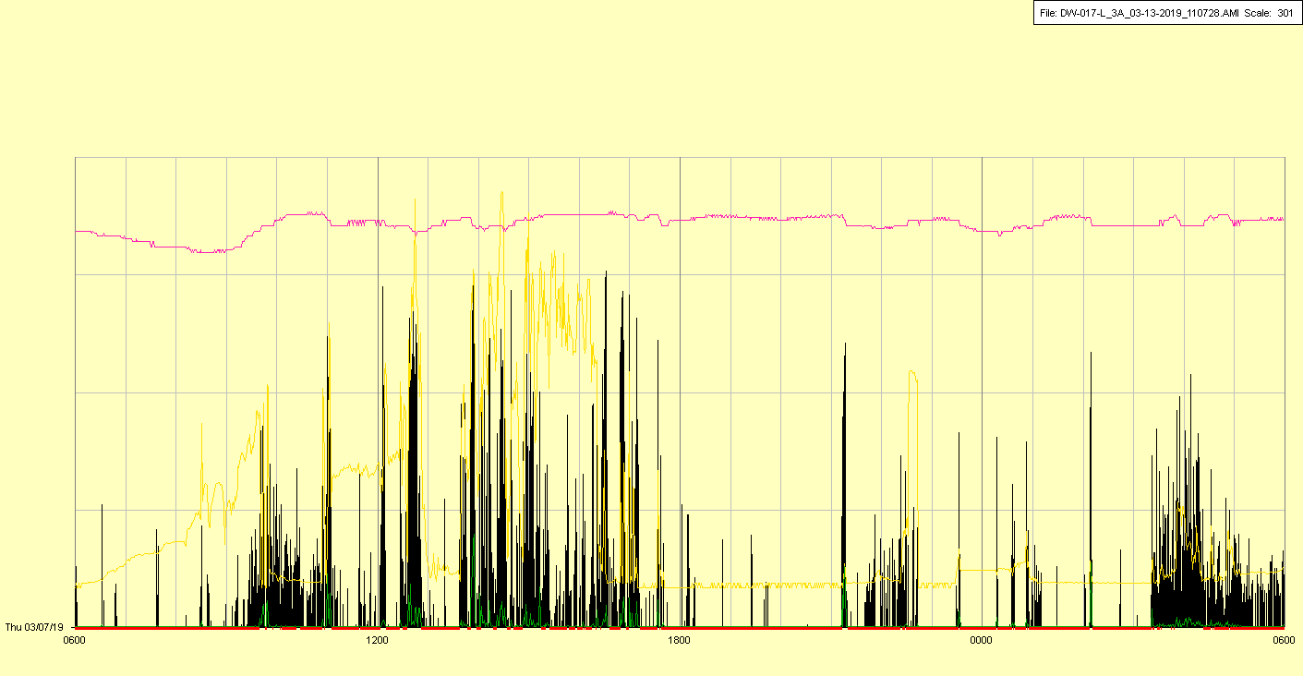

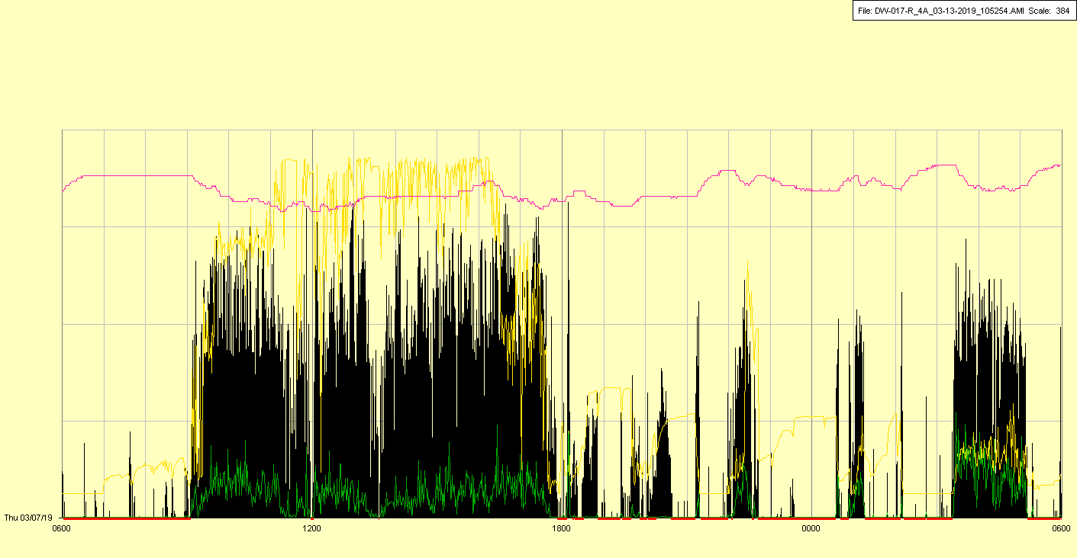

|  |  |  |  |
| --- | --- | --- | --- |
| Study ID | DW17 | Initial NIHSS (affected arm) | 2 |
| Age | 75 | Sex | Female |
| ICH Location | Right lobar | Patient location | Stroke Unit |
| Hospital day | 19 | Mechanical ventilation | No (trach) |
| Delirium status | No | 3-month mRS |  |

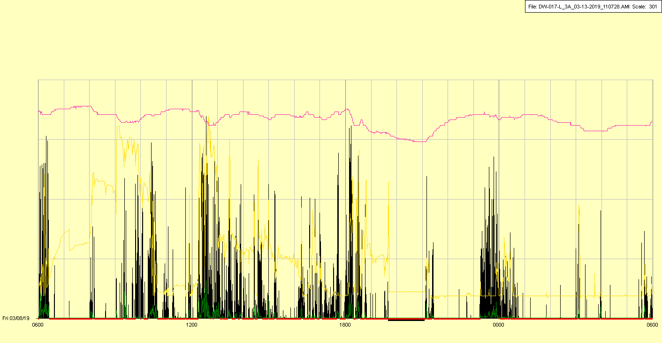

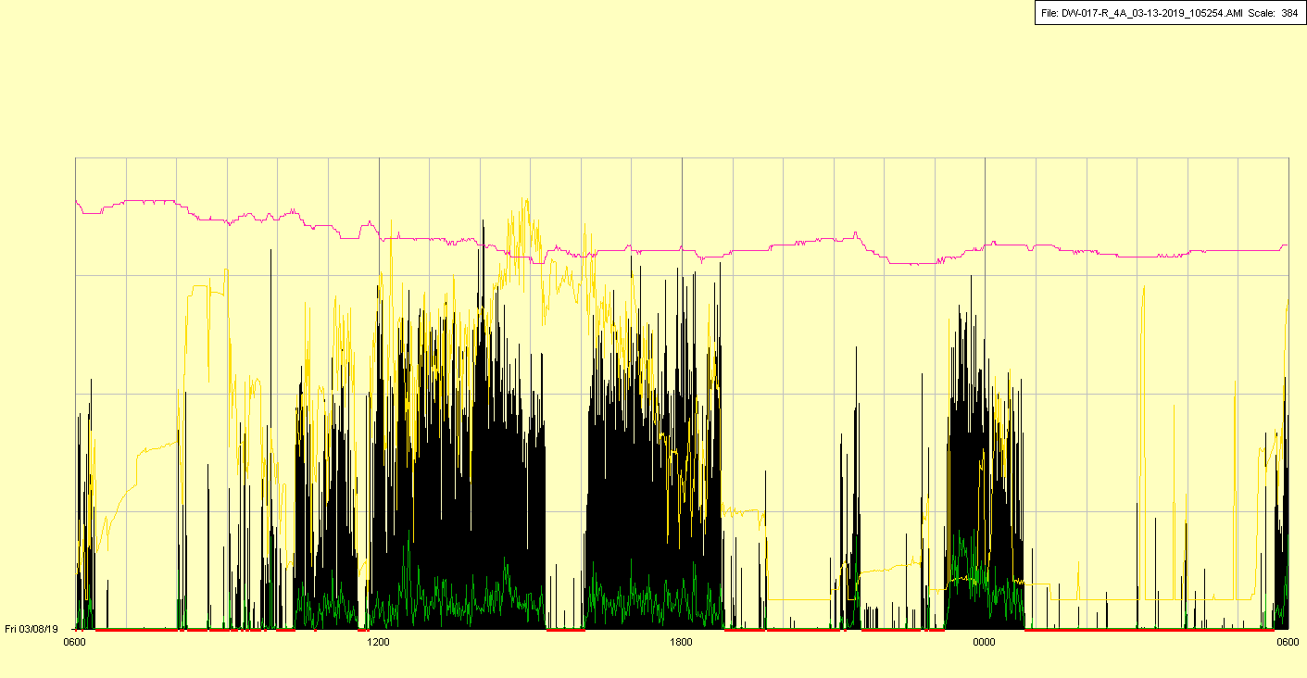

|  |  |  |  |
| --- | --- | --- | --- |
| Study ID | DW17 | Initial NIHSS (affected arm) | 2 |
| Age | 75 | Sex | Female |
| ICH Location | Right lobar | Patient location | Stroke Unit |
| Hospital day | 20 | Mechanical ventilation | No (trach) |
| Delirium status | No | 3-month mRS |  |

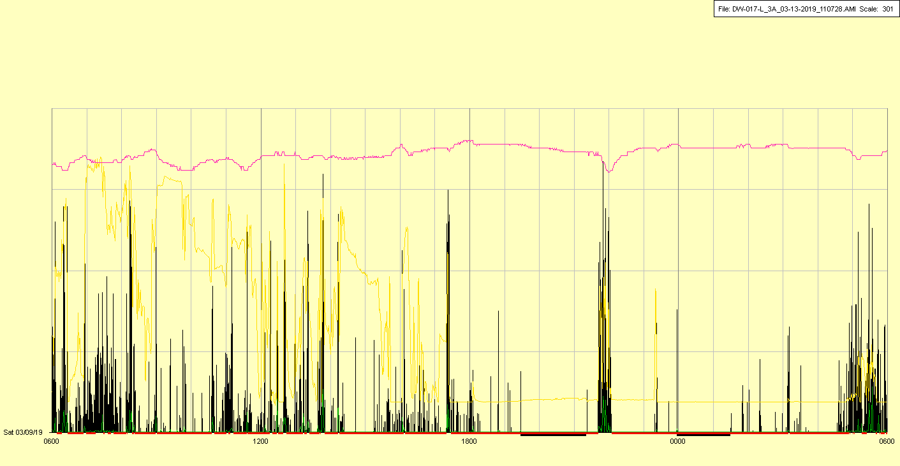

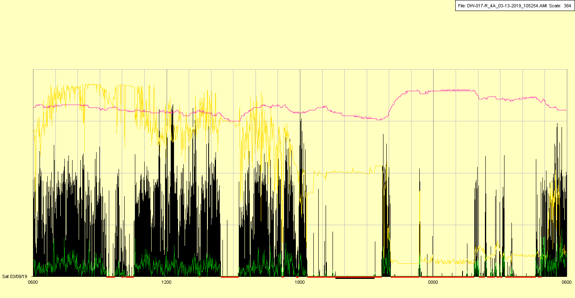

|  |  |  |  |
| --- | --- | --- | --- |
| Study ID | DW17 | Initial NIHSS (affected arm) | 2 |
| Age | 75 | Sex | Female |
| ICH Location | Right lobar | Patient location | Stroke Unit |
| Hospital day | 21 | Mechanical ventilation | No (trach) |
| Delirium status | No | 3-month mRS |  |

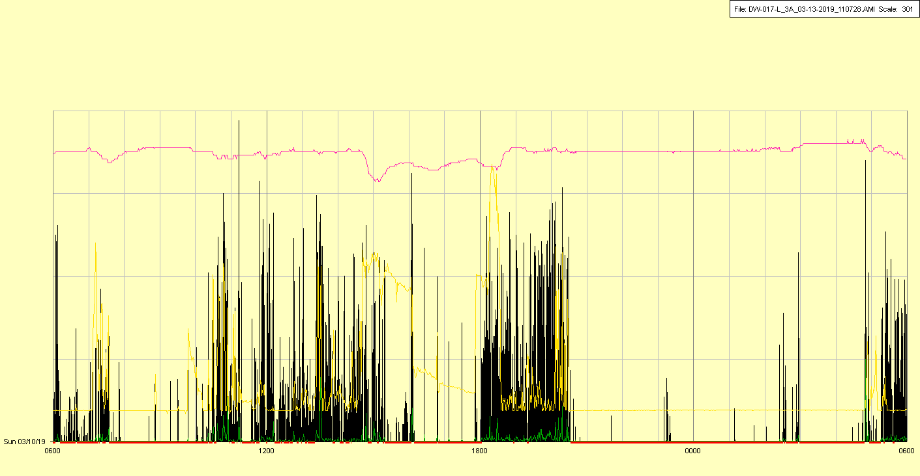

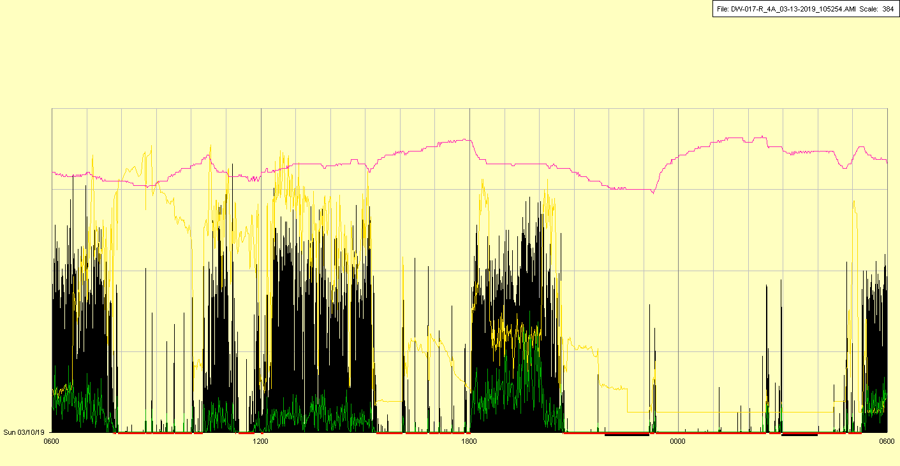

|  |  |  |  |
| --- | --- | --- | --- |
| Study ID | DW17 | Initial NIHSS (affected arm) | 2 |
| Age | 75 | Sex | Female |
| ICH Location | Right lobar | Patient location | Stroke Unit |
| Hospital day | 22 | Mechanical ventilation | No (trach) |
| Delirium status | No | 3-month mRS |  |

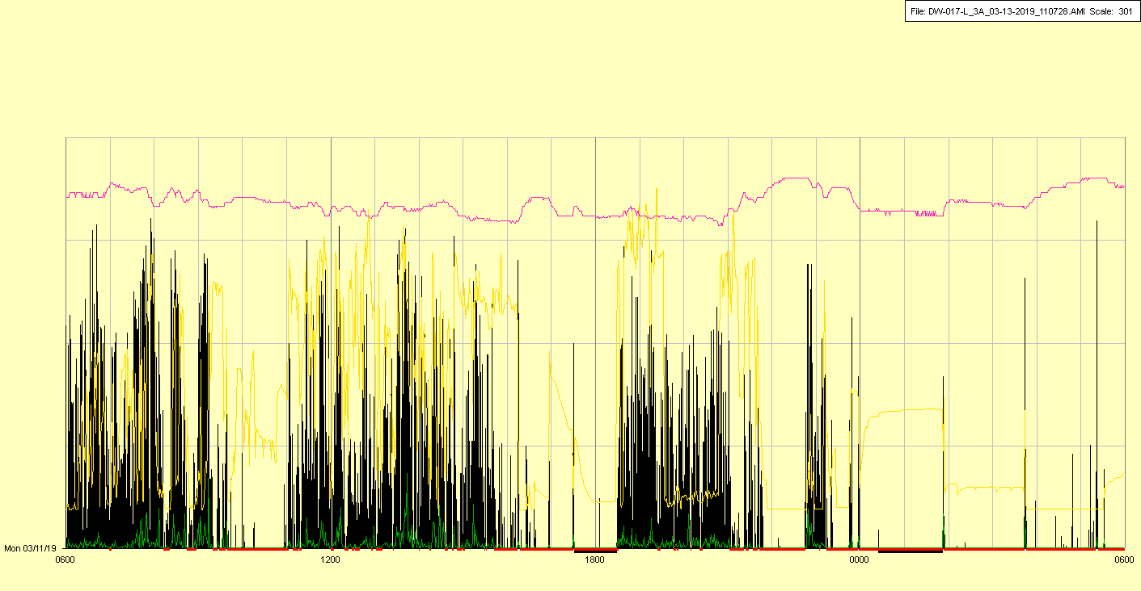

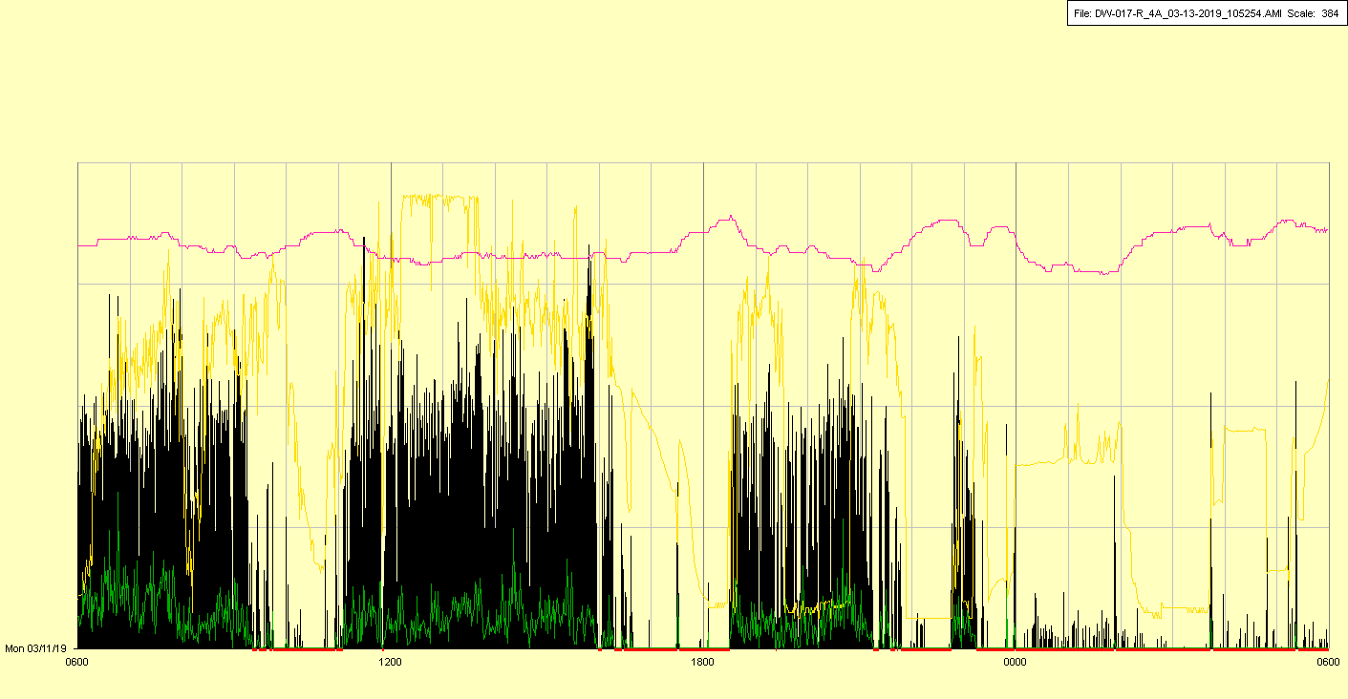

|  |  |  |  |
| --- | --- | --- | --- |
| Study ID | DW17 | Initial NIHSS (affected arm) | 2 |
| Age | 75 | Sex | Female |
| ICH Location | Right lobar | Patient location | Stroke Unit |
| Hospital day | 23 | Mechanical ventilation | No (trach) |
| Delirium status | No | 3-month mRS |  |

