|  |  |  |  |
| --- | --- | --- | --- |
| Study ID | DW2 | Initial NIHSS (affected arm) | 1 |
| Age | 71 | Sex | Male |
| ICH Location | Right lobar | Patient location | ICU |
| Hospital day | 1 | Mechanical ventilation | No |
| Delirium status | No | 3-month mRS |  |

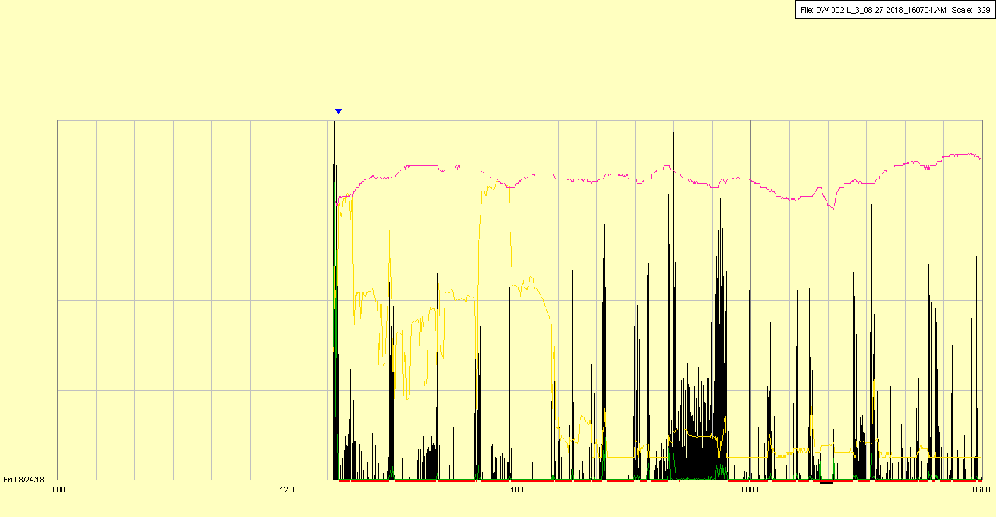

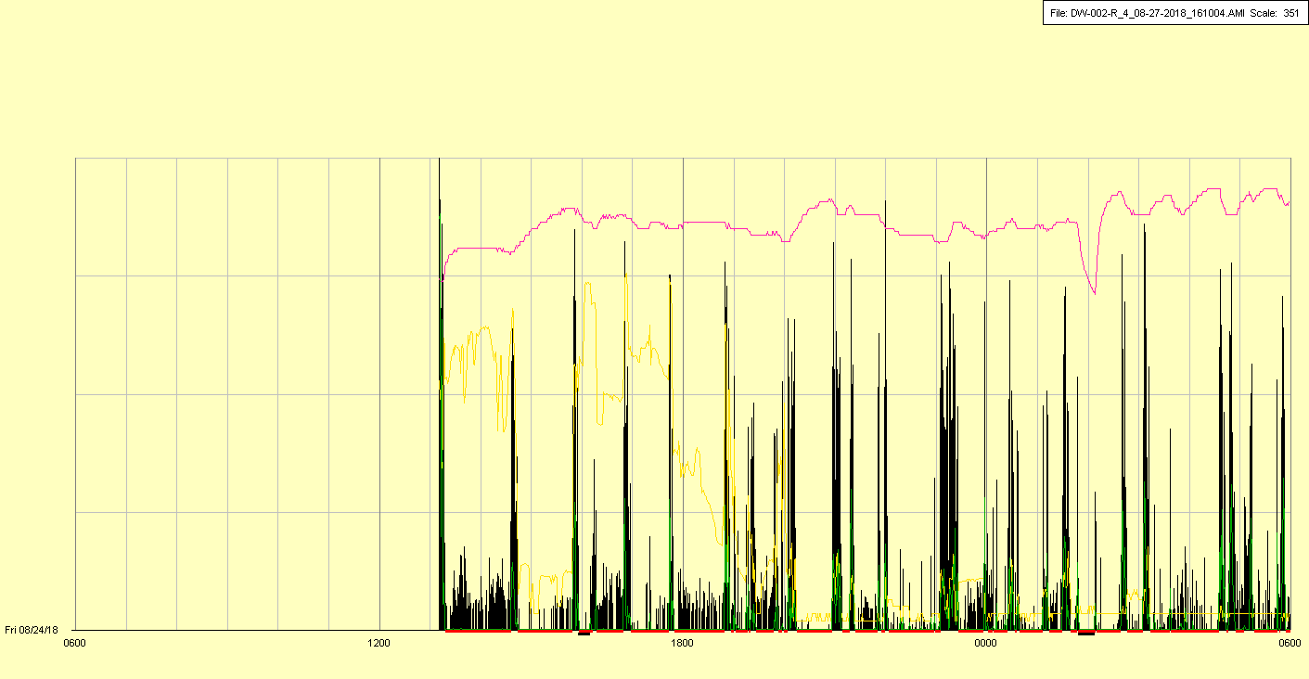

|  |  |  |  |
| --- | --- | --- | --- |
| Study ID | DW2 | Initial NIHSS (affected arm) | 1 |
| Age | 71 | Sex | Male |
| ICH Location | Right lobar | Patient location | ICU |
| Hospital day | 2 | Mechanical ventilation | No |
| Delirium status | No | 3-month mRS |  |

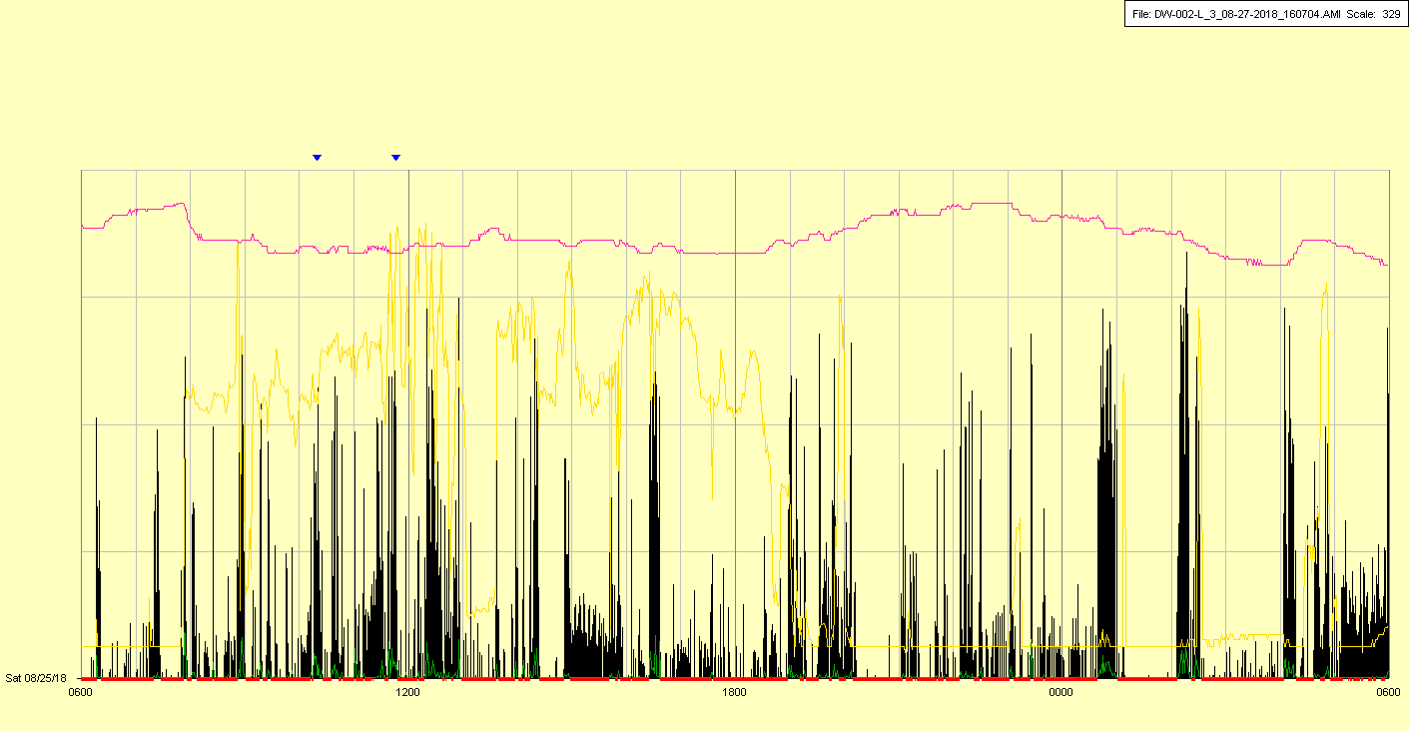

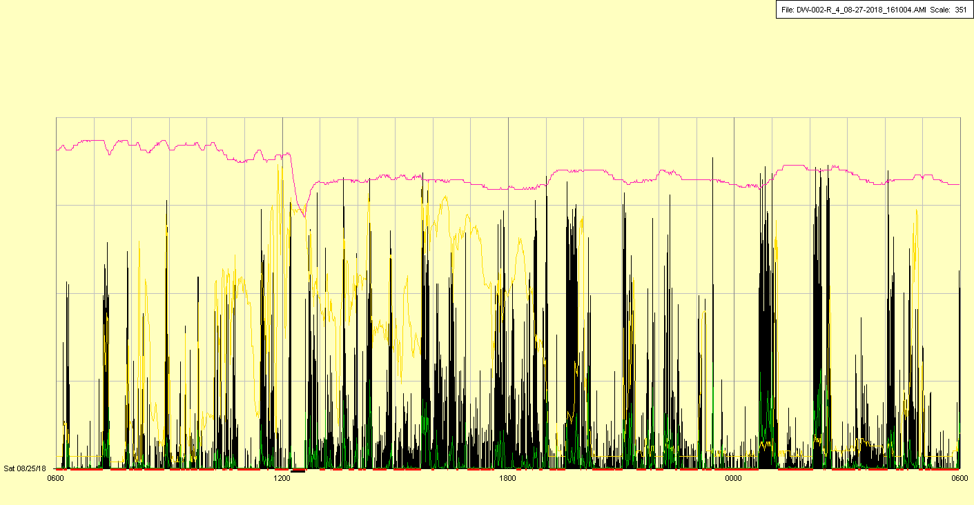

|  |  |  |  |
| --- | --- | --- | --- |
| Study ID | DW2 | Initial NIHSS (affected arm) | 1 |
| Age | 71 | Sex | Male |
| ICH Location | Right lobar | Patient location | ICU |
| Hospital day | 3 | Mechanical ventilation | No |
| Delirium status | No | 3-month mRS |  |

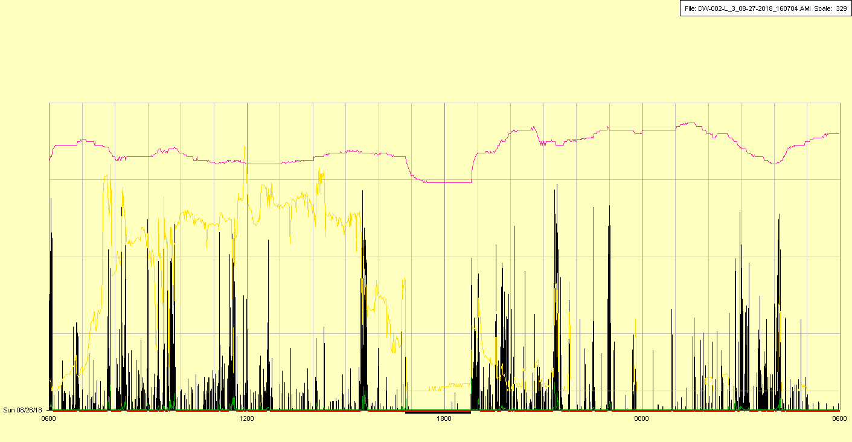

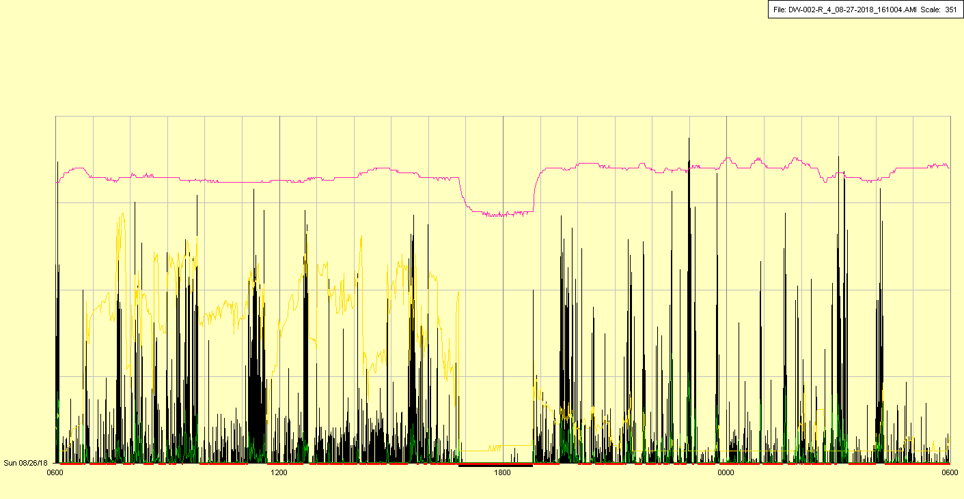

|  |  |  |  |
| --- | --- | --- | --- |
| Study ID | DW2 | Initial NIHSS (affected arm) | 1 |
| Age | 71 | Sex | Male |
| ICH Location | Right lobar | Patient location | Stroke Unit |
| Hospital day | 4 | Mechanical ventilation | No |
| Delirium status | No | 3-month mRS |  |

