|  |  |  |  |
| --- | --- | --- | --- |
| Study ID | DW20 | Initial NIHSS (affected arm) | 1 |
| Age | 84 | Sex | Male |
| ICH Location | Left lobar | Patient location | NCCU |
| Hospital day | 2 | Mechanical ventilation | No |
| Delirium status | Yes | 3-month mRS | 6 |

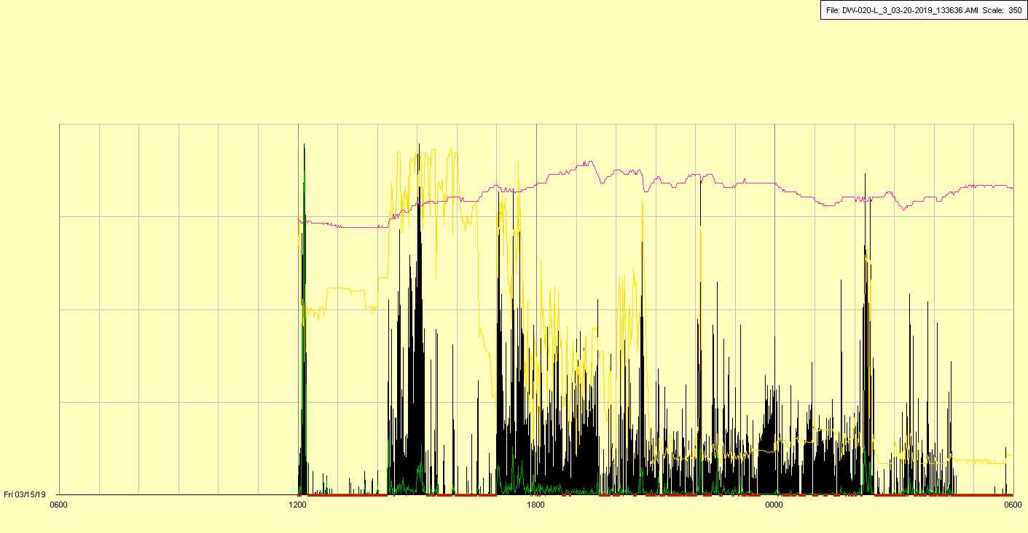

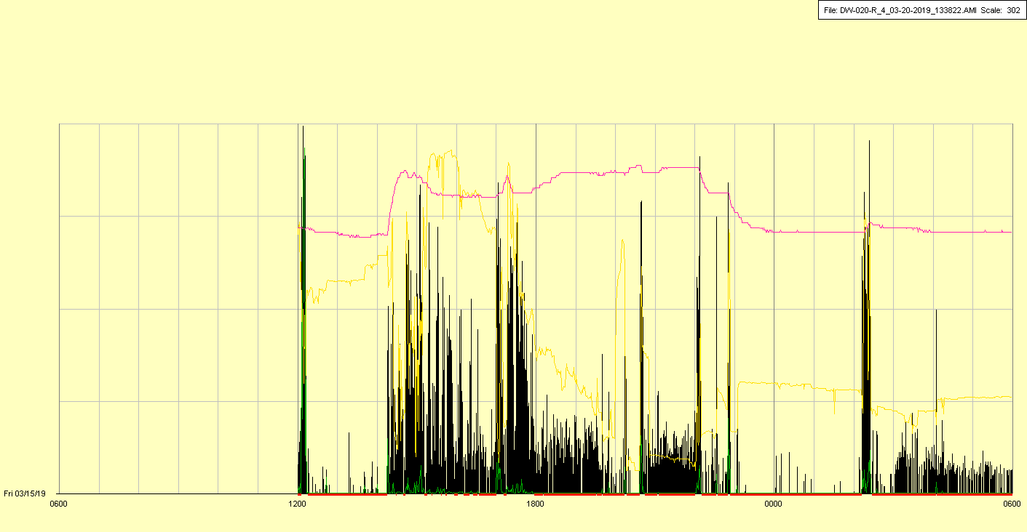

|  |  |  |  |
| --- | --- | --- | --- |
| Study ID | DW20 | Initial NIHSS (affected arm) | 1 |
| Age | 84 | Sex | Male |
| ICH Location | Left lobar | Patient location | NCCU |
| Hospital day | 3 | Mechanical ventilation | No |
| Delirium status | Yes | 3-month mRS | 6 |

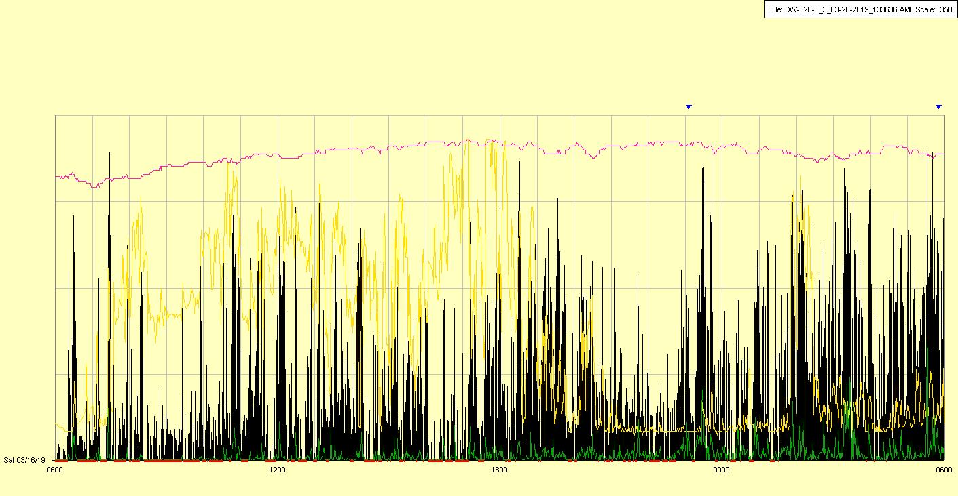

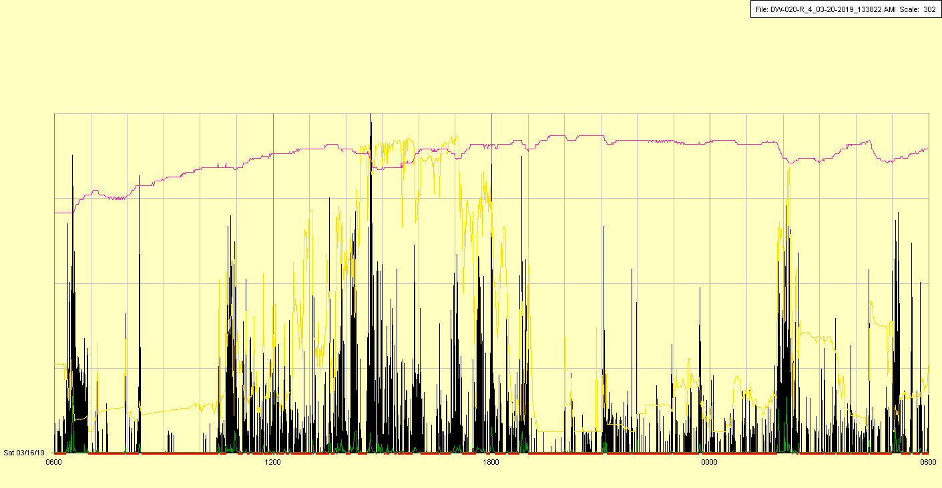

|  |  |  |  |
| --- | --- | --- | --- |
| Study ID | DW20 | Initial NIHSS (affected arm) | 1 |
| Age | 84 | Sex | Male |
| ICH Location | Left lobar | Patient location | NCCU |
| Hospital day | 4 | Mechanical ventilation | No |
| Delirium status | Yes | 3-month mRS | 6 |

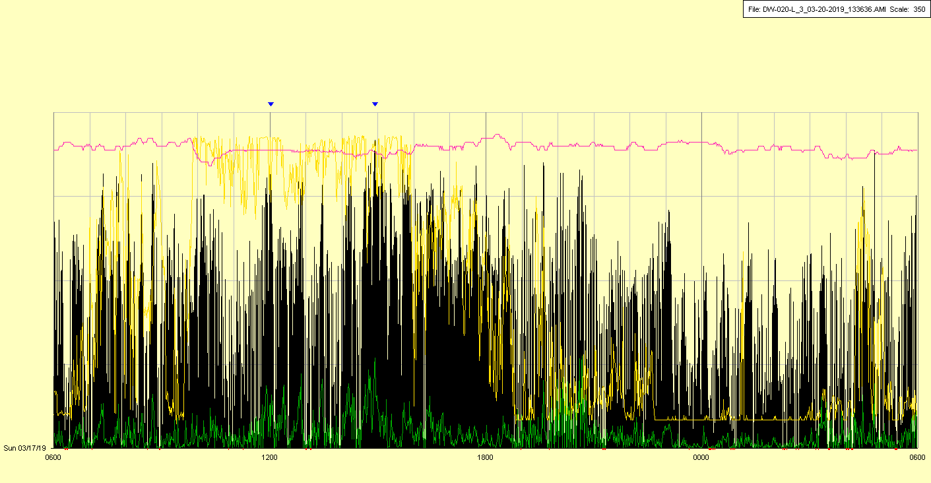

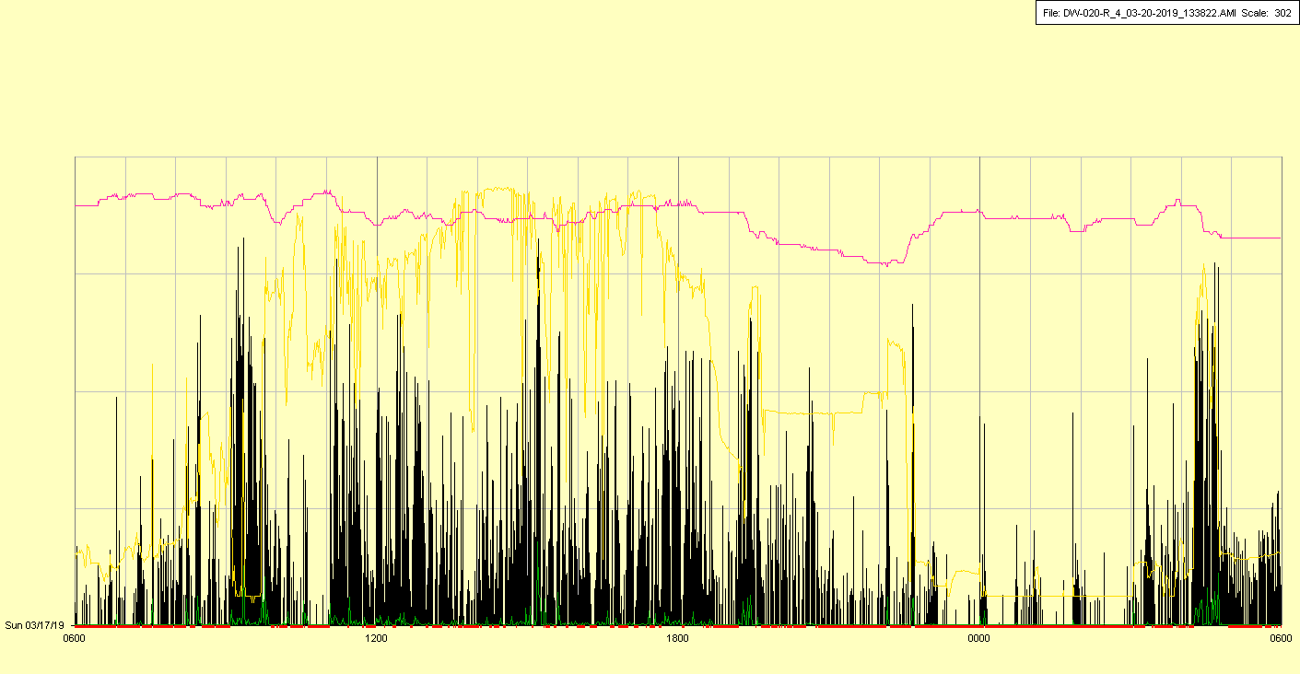

|  |  |  |  |
| --- | --- | --- | --- |
| Study ID | DW20 | Initial NIHSS (affected arm) | 1 |
| Age | 84 | Sex | Male |
| ICH Location | Left lobar | Patient location | NCCU |
| Hospital day | 5 | Mechanical ventilation | No |
| Delirium status | Yes | 3-month mRS | 6 |

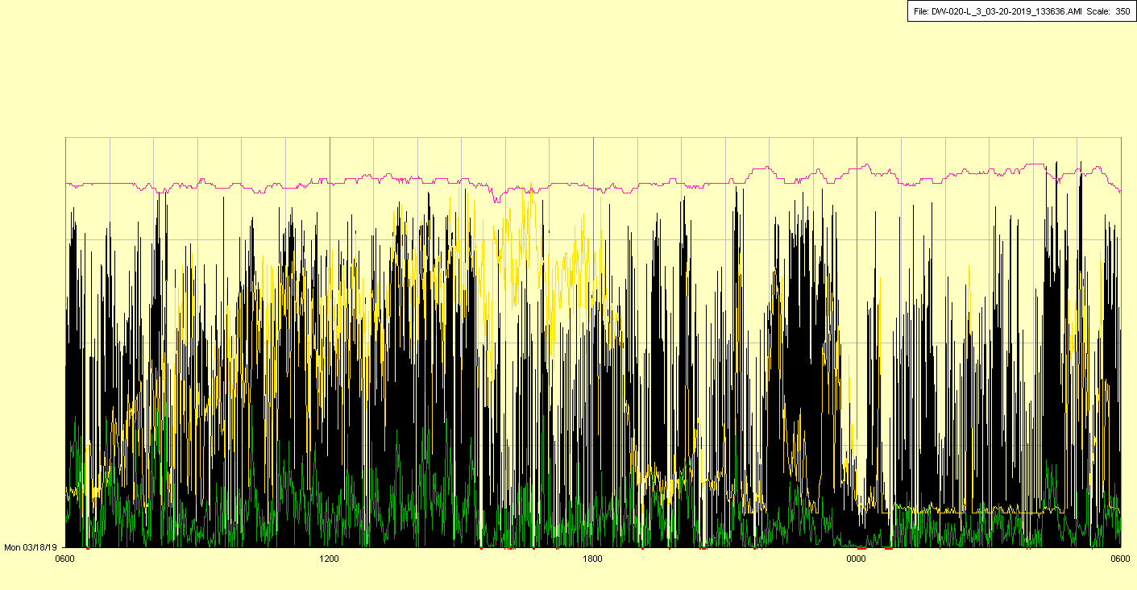

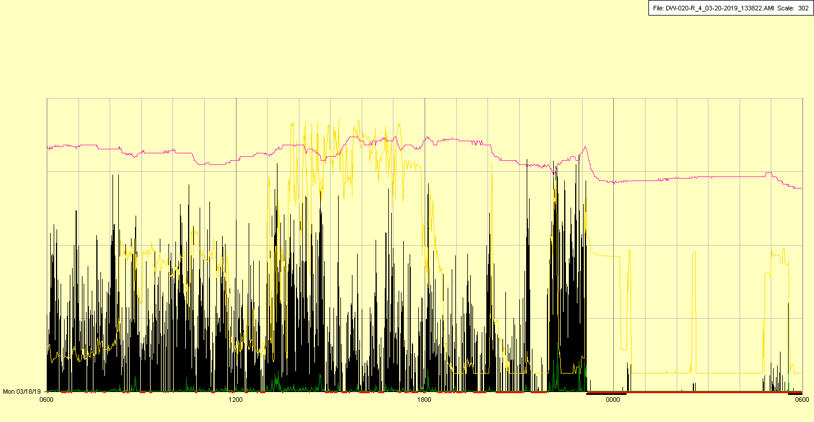

|  |  |  |  |
| --- | --- | --- | --- |
| Study ID | DW20 | Initial NIHSS (affected arm) | 1 |
| Age | 84 | Sex | Male |
| ICH Location | Left lobar | Patient location | NCCU |
| Hospital day | 6 | Mechanical ventilation | No |
| Delirium status | Yes | 3-month mRS | 6 |

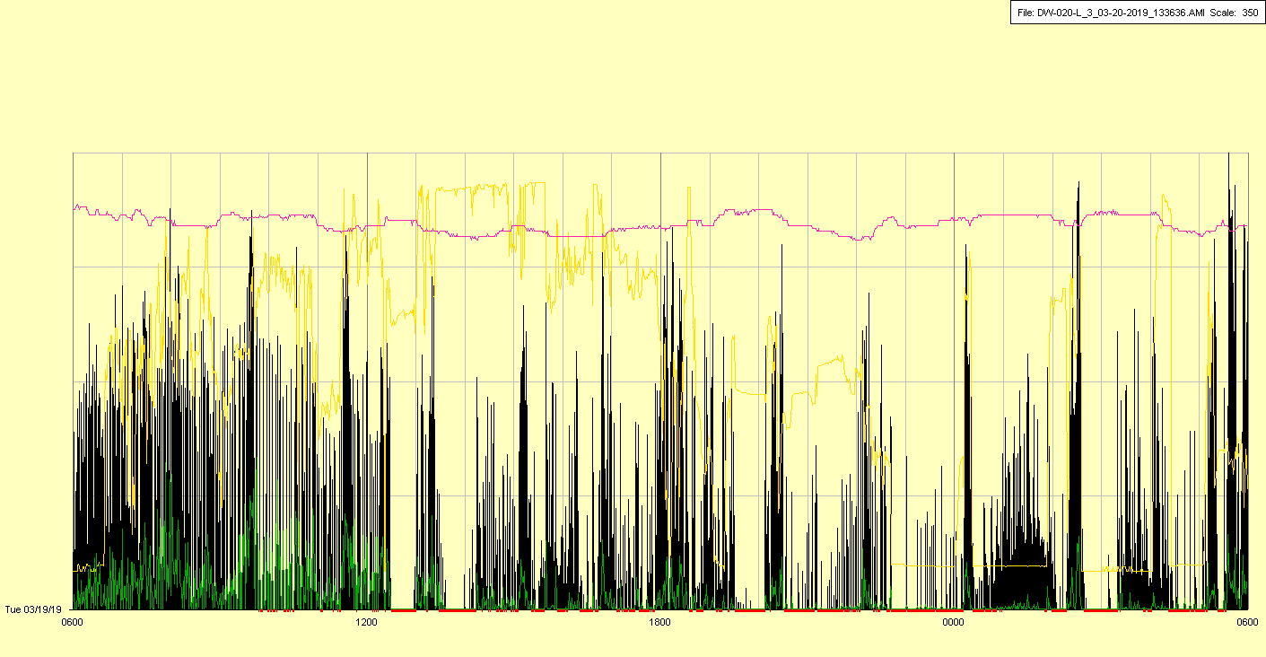

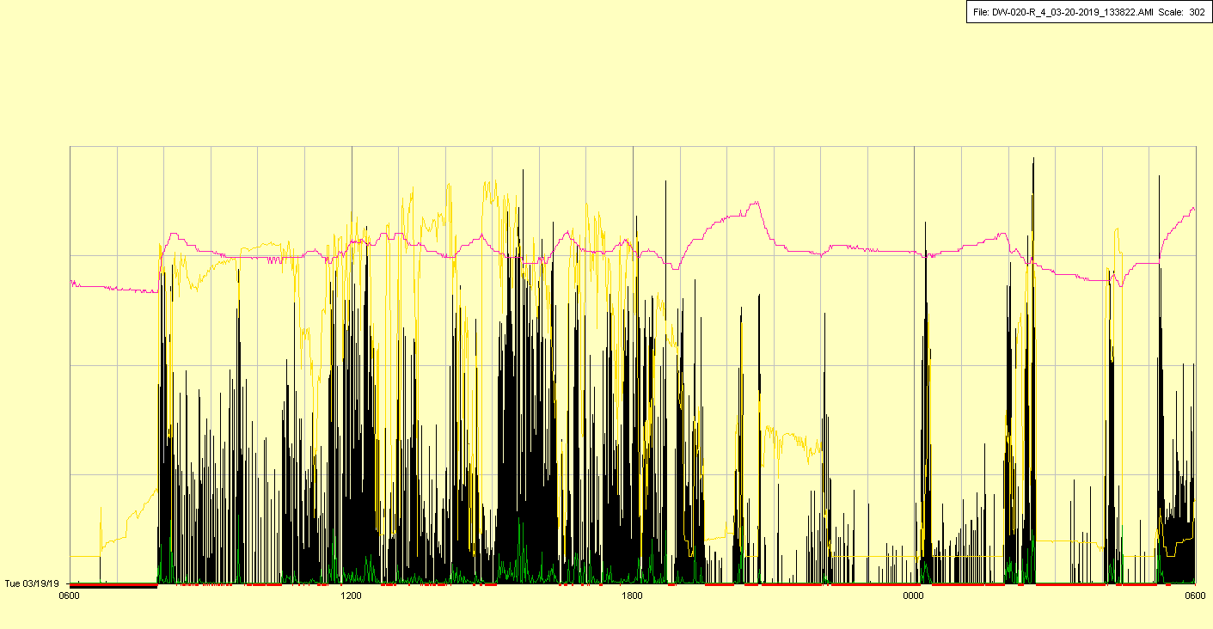

|  |  |  |  |
| --- | --- | --- | --- |
| Study ID | DW20 | Initial NIHSS (affected arm) | 1 |
| Age | 84 | Sex | Male |
| ICH Location | Left lobar | Patient location | NCCU |
| Hospital day | 7 | Mechanical ventilation | No |
| Delirium status | Yes | 3-month mRS | 6 |

