|  |  |  |  |
| --- | --- | --- | --- |
| Study ID | DW3 | Initial NIHSS (affected arm) | 4 |
| Age | 53 | Sex | Male |
| ICH Location | Right lobar | Patient location | ICU |
| Hospital day | 2 | Mechanical ventilation | Yes |
| Delirium status | No | 3-month mRS |  |

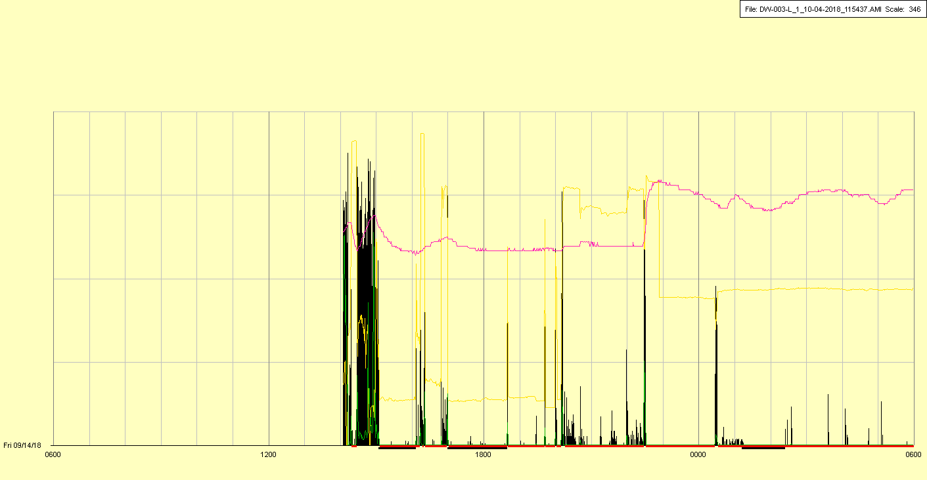

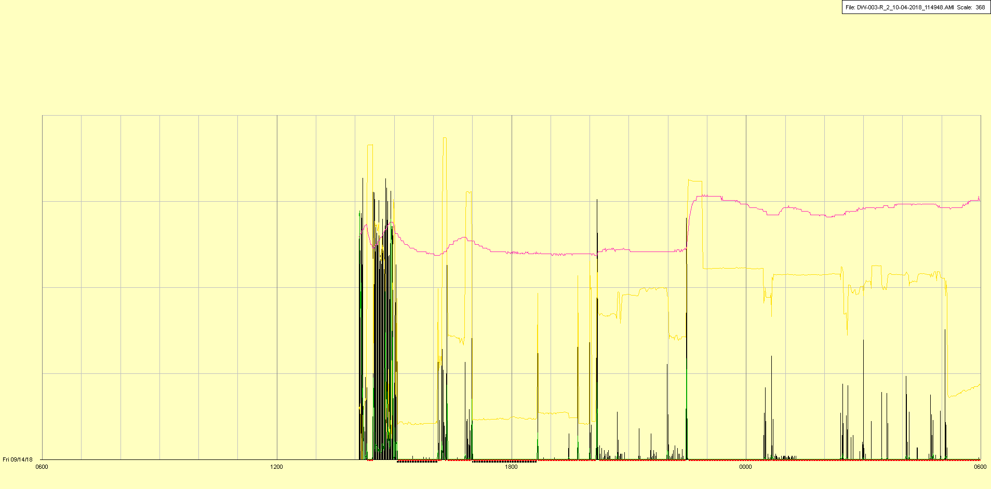

|  |  |  |  |
| --- | --- | --- | --- |
| Study ID | DW3 | Initial NIHSS (affected arm) | 4 |
| Age | 53 | Sex | Male |
| ICH Location | Right lobar | Patient location | ICU |
| Hospital day | 3 | Mechanical ventilation | Yes 🡪 No 🡪 Yes |
| Delirium status | No | 3-month mRS |  |

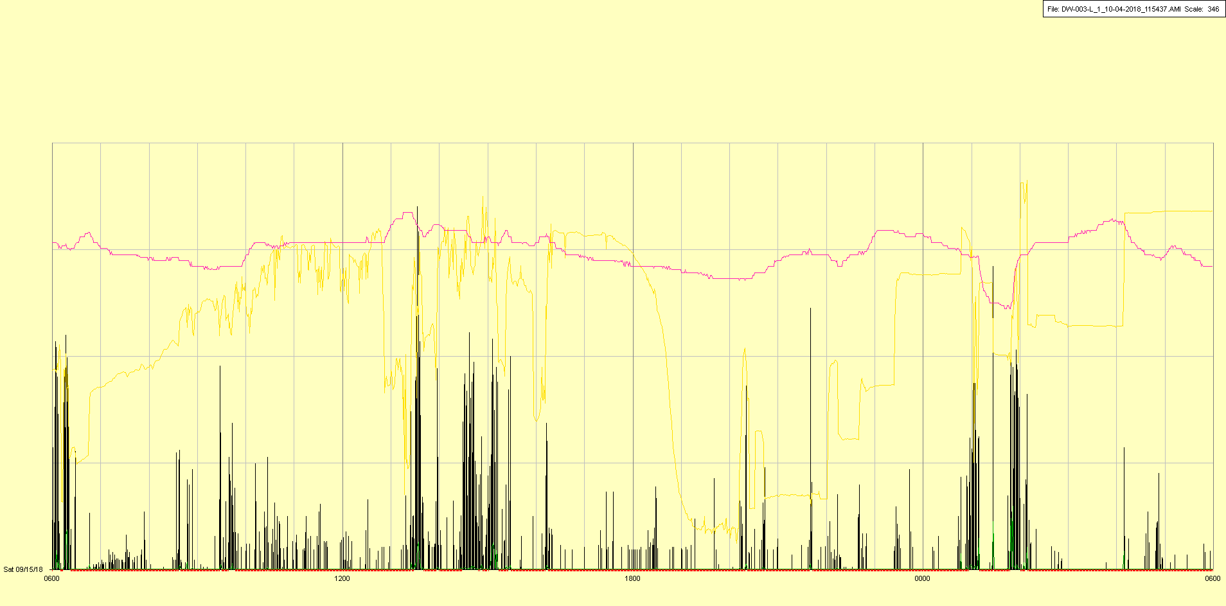

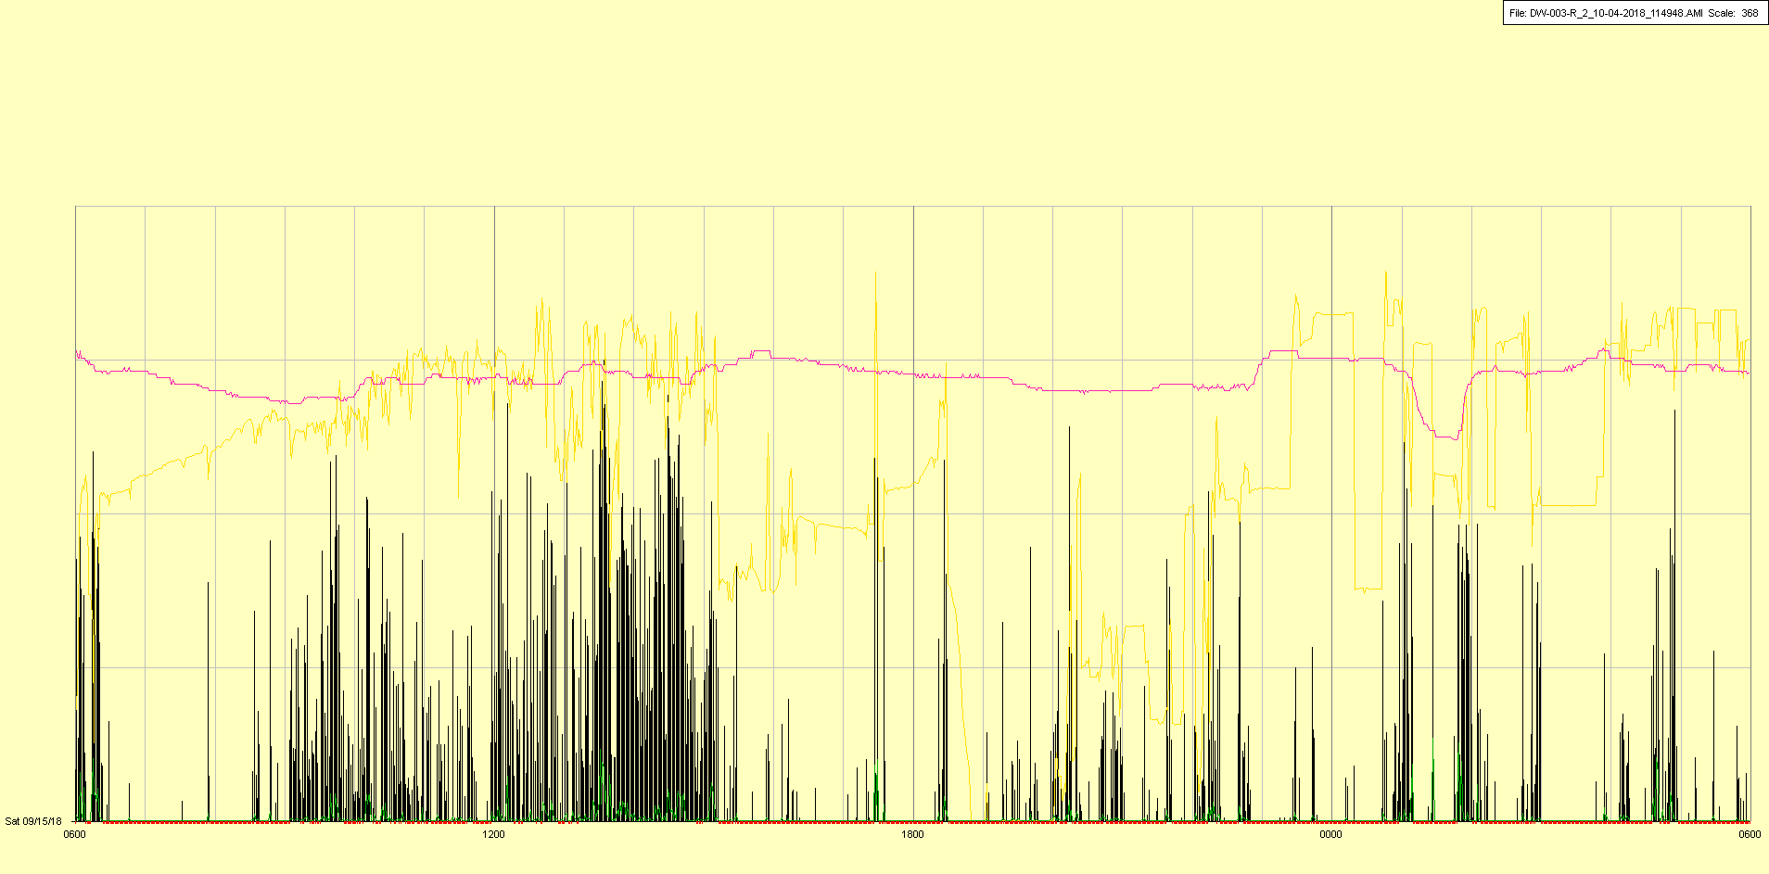

Extubated (off mechanical ventilation) in late morning, reintubated (back on mechanical ventilation) in afternoon

|  |  |  |  |
| --- | --- | --- | --- |
| Study ID | DW3 | Initial NIHSS (affected arm) | 4 |
| Age | 53 | Sex | Male |
| ICH Location | Right lobar | Patient location | ICU |
| Hospital day | 4 | Mechanical ventilation | Yes |
| Delirium status | No | 3-month mRS |  |

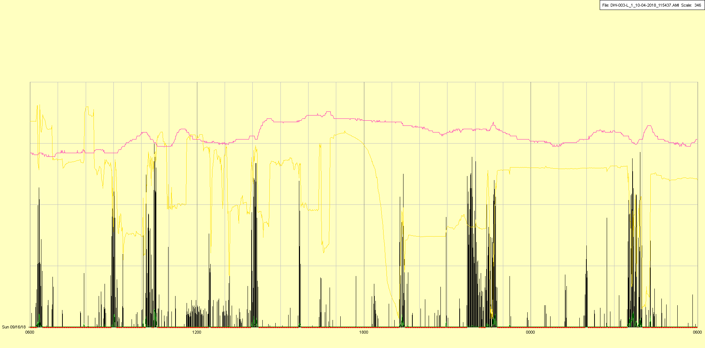

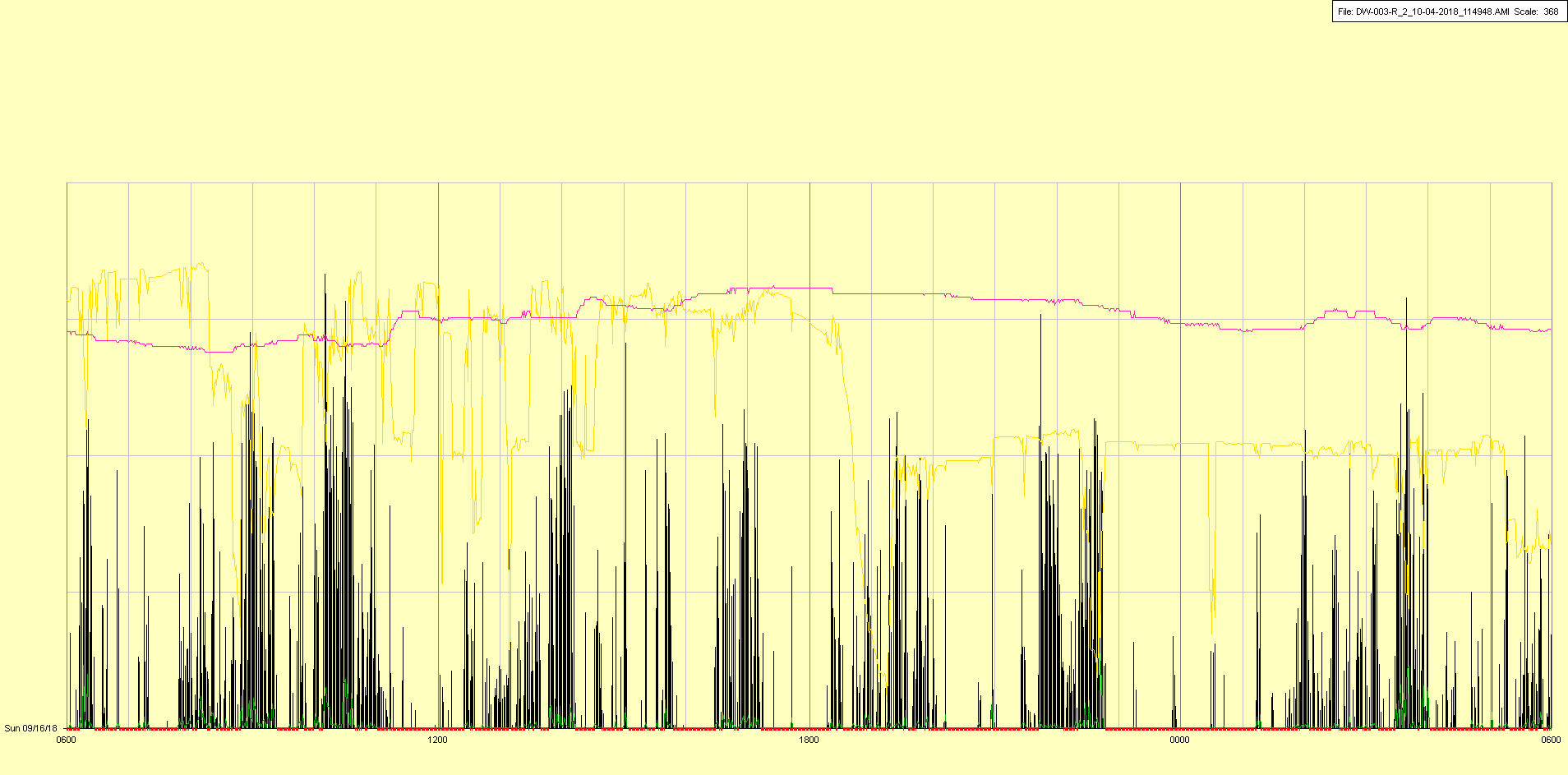

|  |  |  |  |
| --- | --- | --- | --- |
| Study ID | DW3 | Initial NIHSS (affected arm) | 4 |
| Age | 53 | Sex | Male |
| ICH Location | Right lobar | Patient location | ICU |
| Hospital day | 5 | Mechanical ventilation | Yes |
| Delirium status | No | 3-month mRS |  |

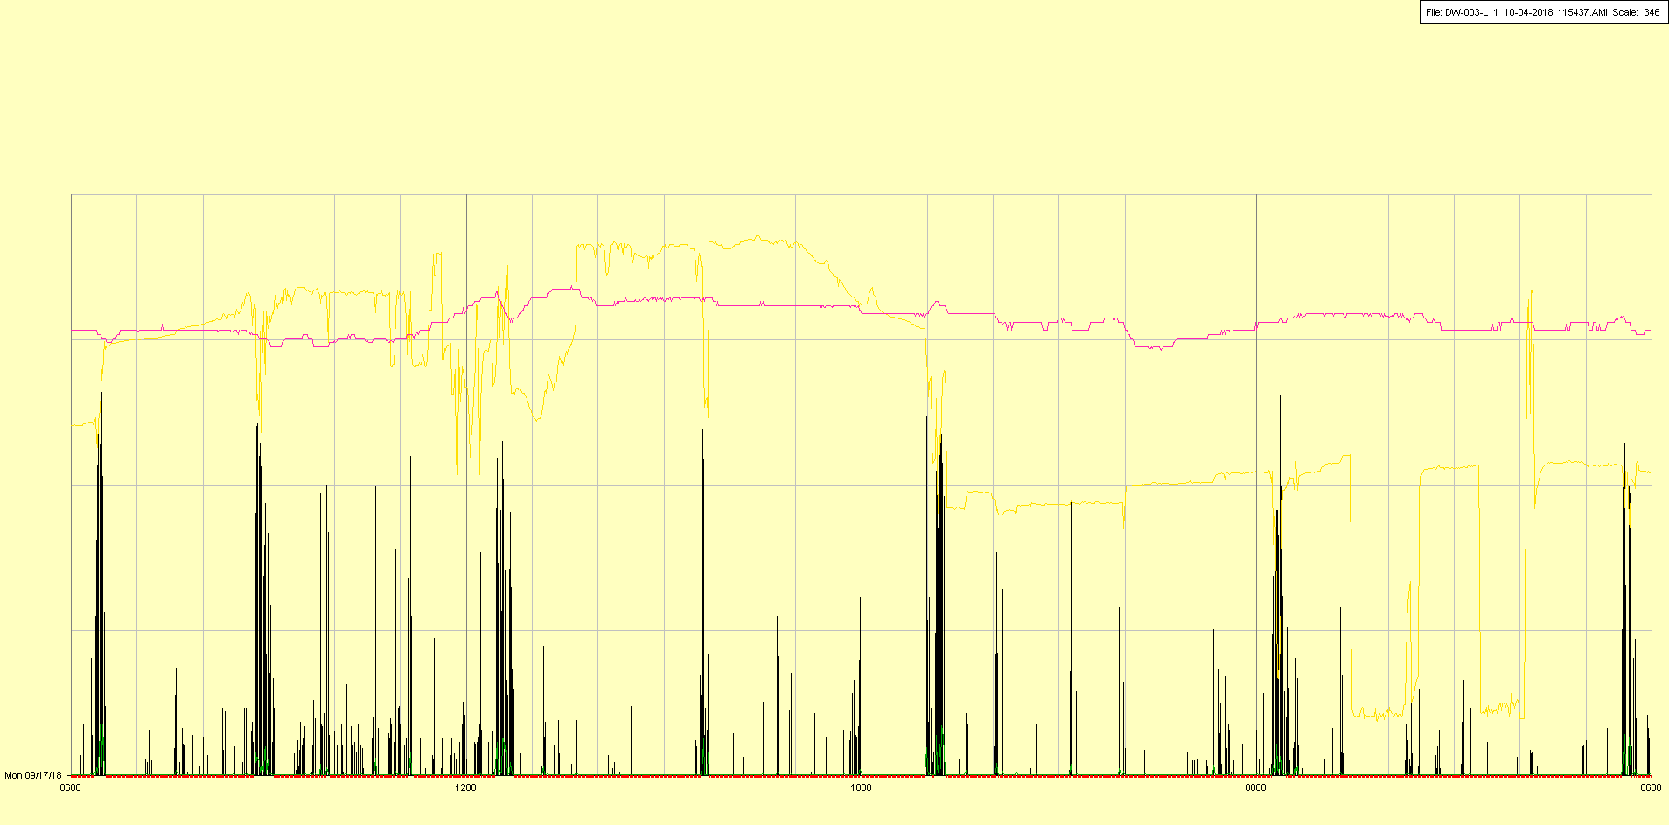

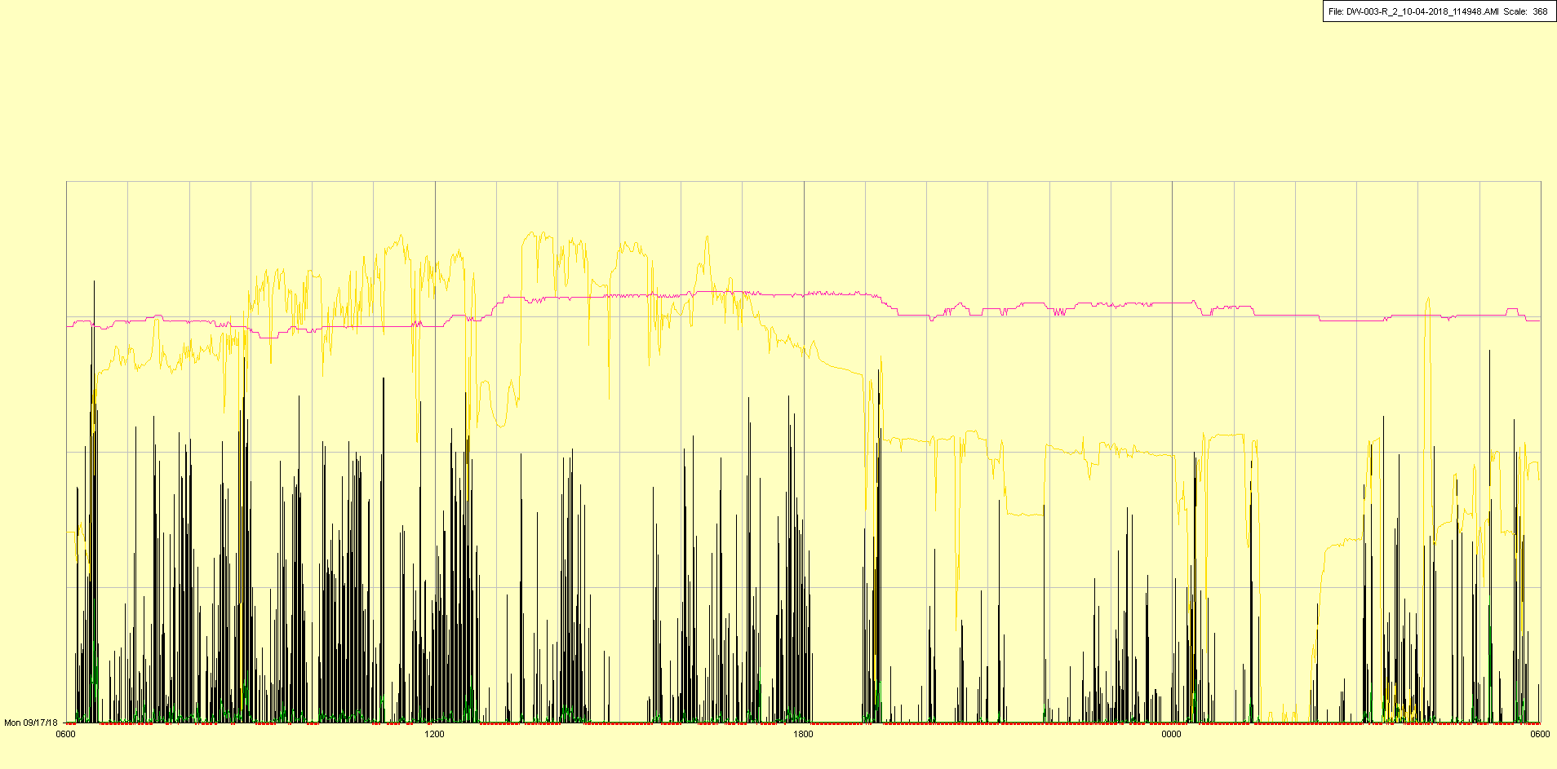

|  |  |  |  |
| --- | --- | --- | --- |
| Study ID | DW3 | Initial NIHSS (affected arm) | 4 |
| Age | 53 | Sex | Male |
| ICH Location | Right lobar | Patient location | ICU |
| Hospital day | 6 | Mechanical ventilation | Yes |
| Delirium status | No | 3-month mRS |  |

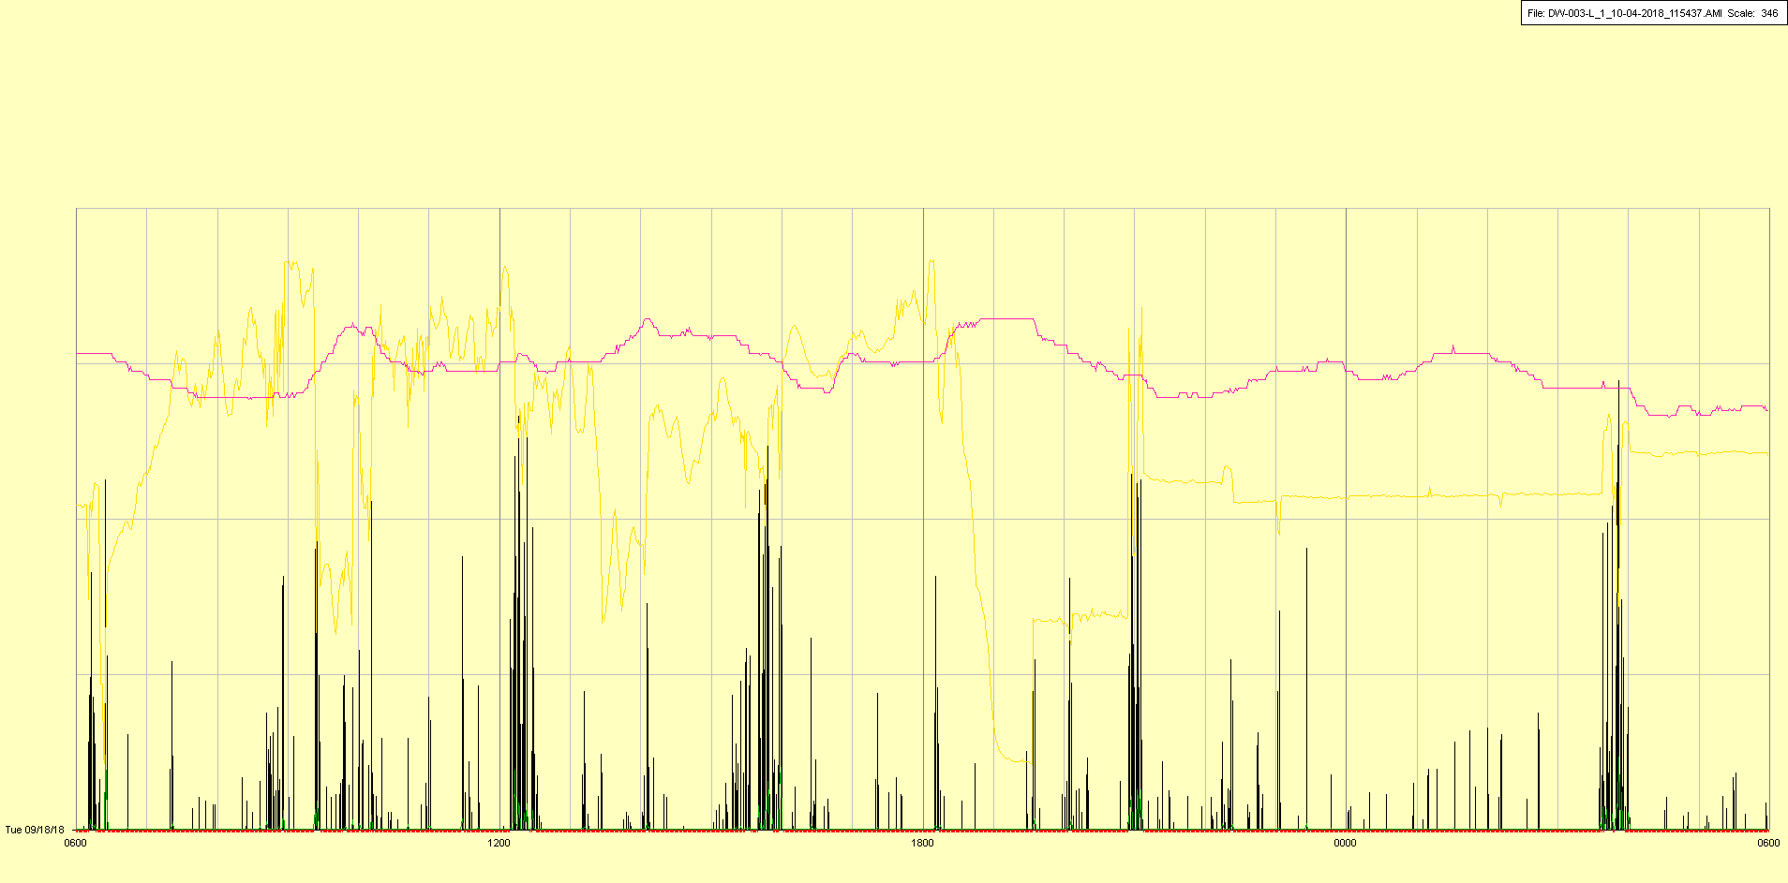

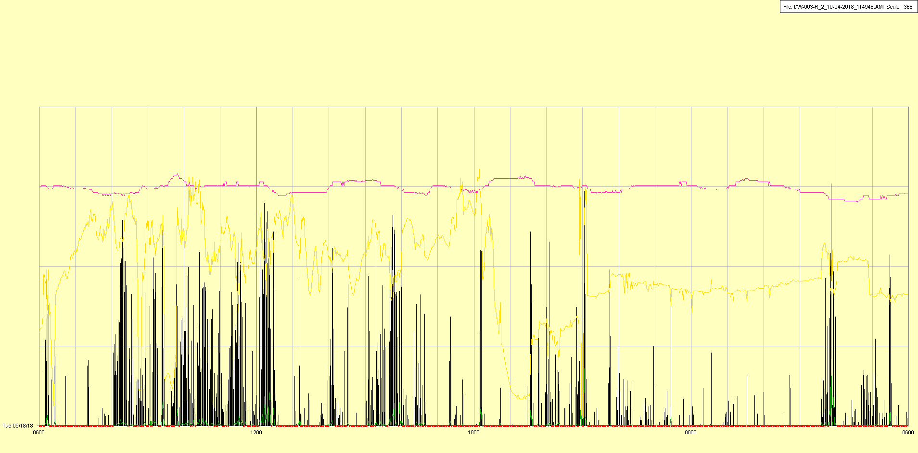

|  |  |  |  |
| --- | --- | --- | --- |
| Study ID | DW3 | Initial NIHSS (affected arm) | 4 |
| Age | 53 | Sex | Male |
| ICH Location | Right lobar | Patient location | ICU |
| Hospital day | 7 | Mechanical ventilation | Yes |
| Delirium status | No | 3-month mRS |  |

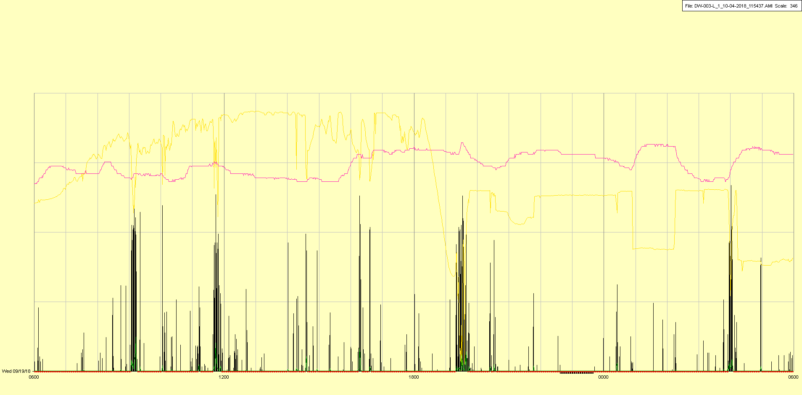

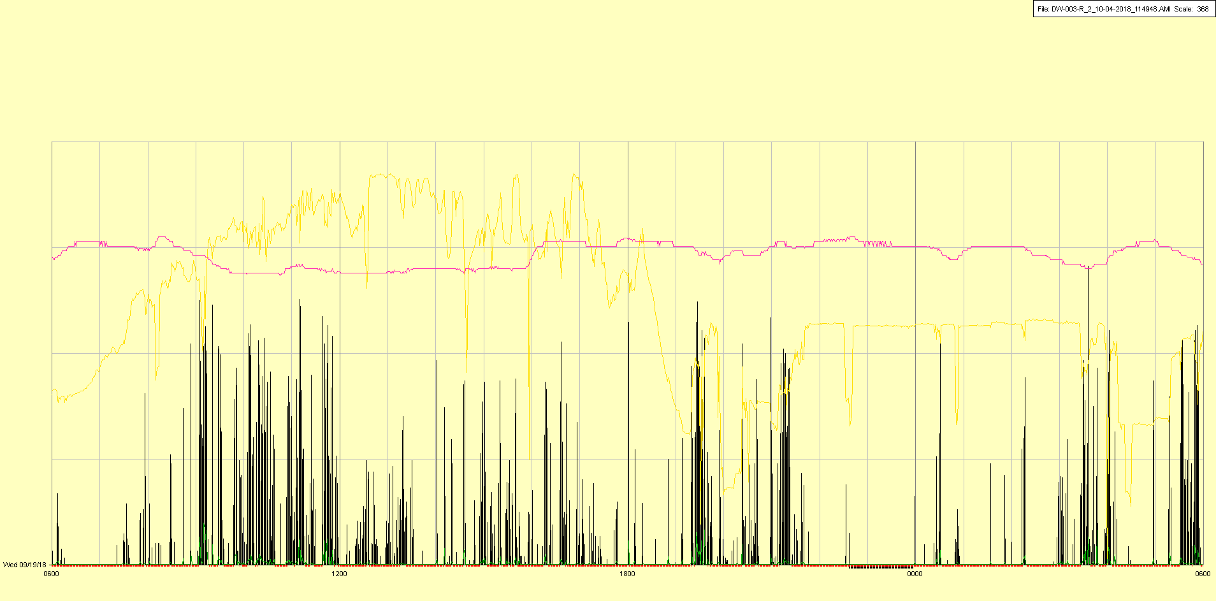

|  |  |  |  |
| --- | --- | --- | --- |
| Study ID | DW3 | Initial NIHSS (affected arm) | 4 |
| Age | 53 | Sex | Male |
| ICH Location | Right lobar | Patient location | ICU |
| Hospital day | 8 | Mechanical ventilation | Yes |
| Delirium status | No | 3-month mRS |  |

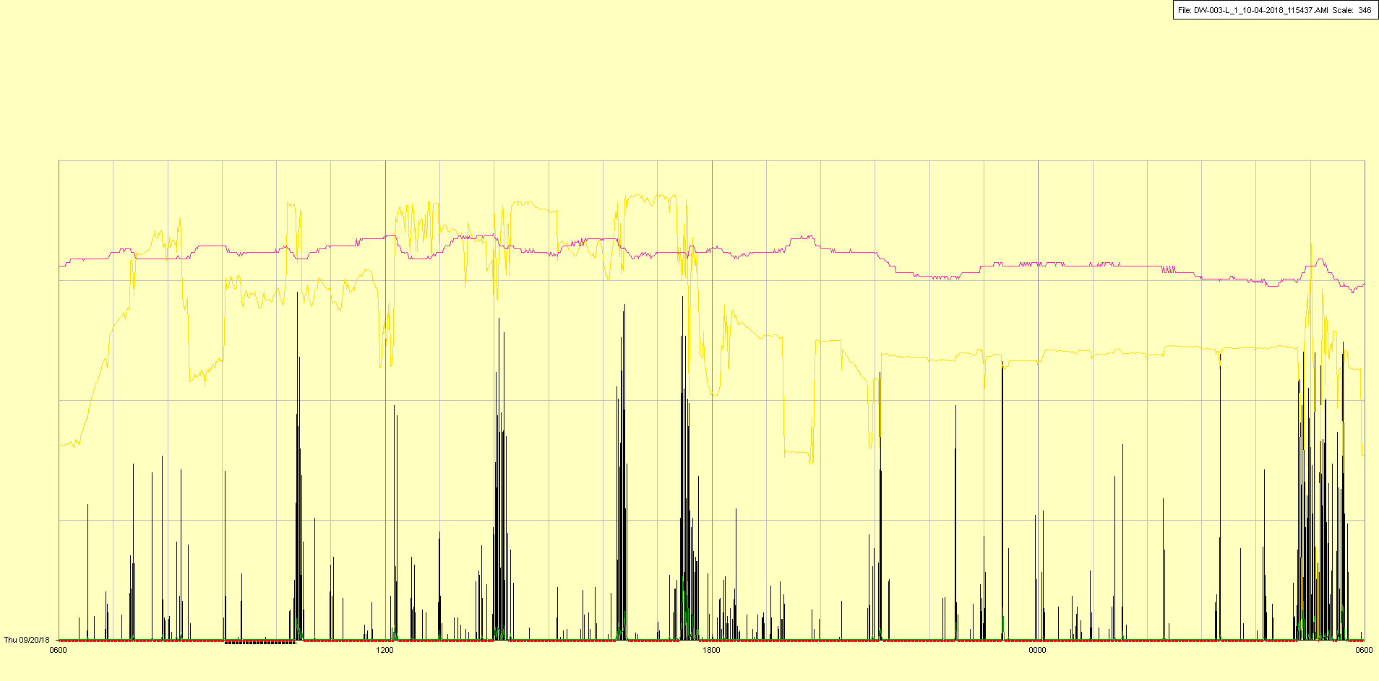

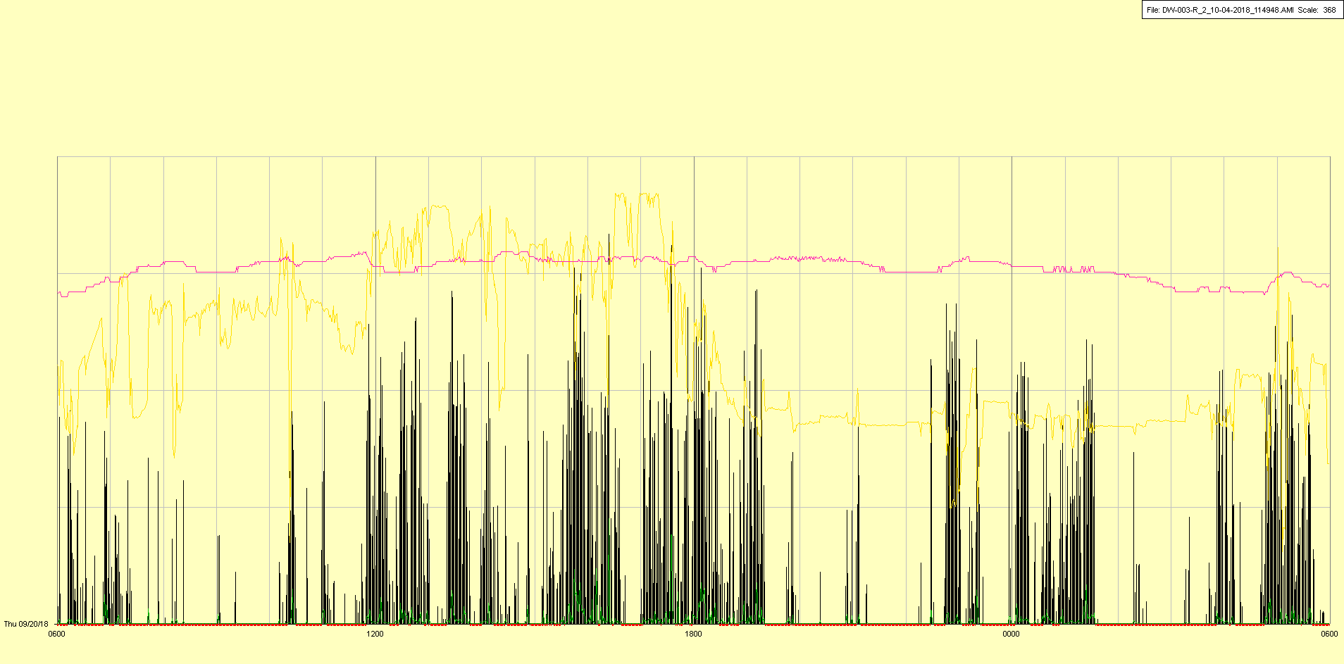

|  |  |  |  |
| --- | --- | --- | --- |
| Study ID | DW3 | Initial NIHSS (affected arm) | 4 |
| Age | 53 | Sex | Male |
| ICH Location | Right lobar | Patient location | ICU |
| Hospital day | 9 | Mechanical ventilation | Yes 🡪 No |
| Delirium status | No | 3-month mRS |  |

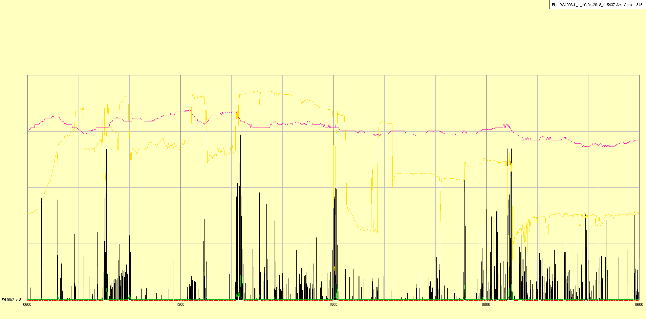

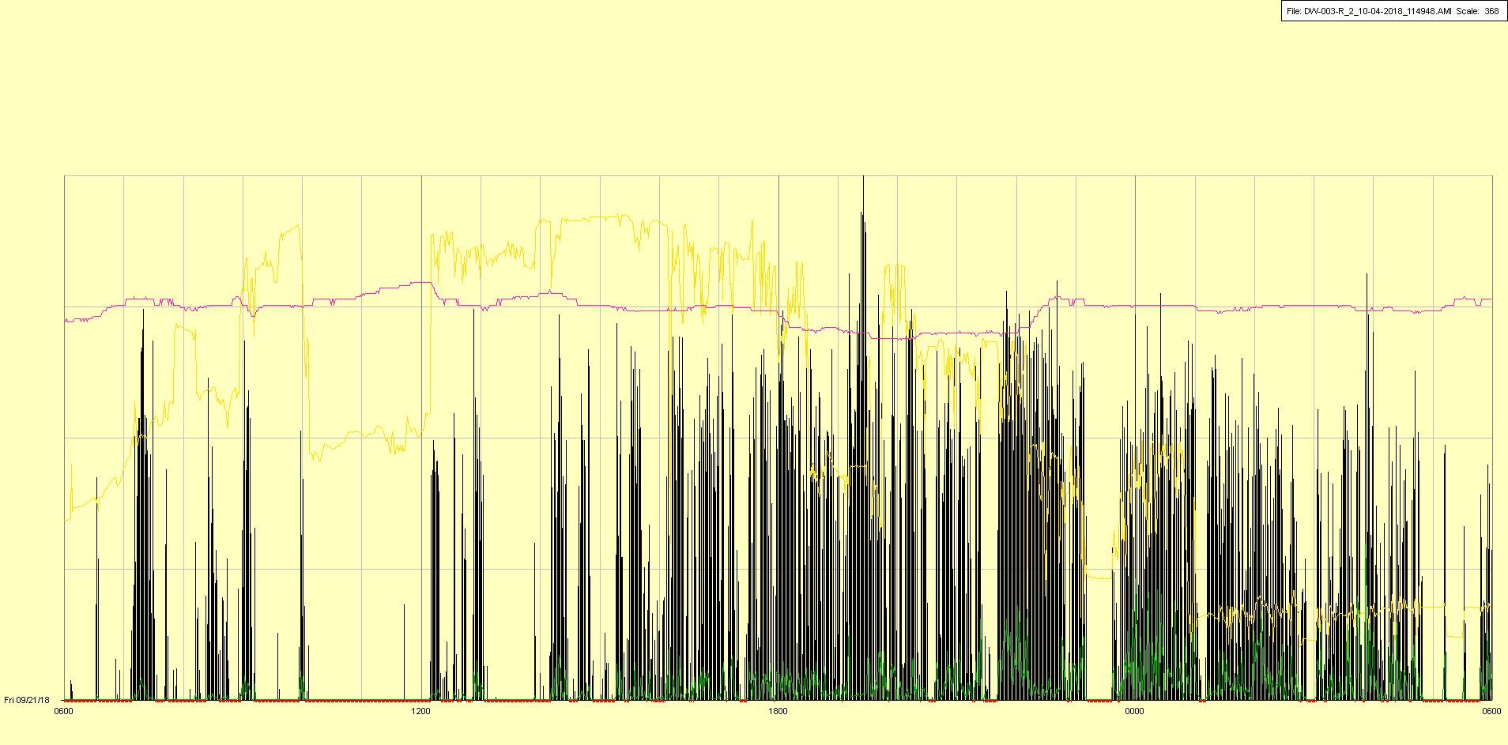

Extubated (off mechanical ventilation) in afternoon

|  |  |  |  |
| --- | --- | --- | --- |
| Study ID | DW3 | Initial NIHSS (affected arm) | 4 |
| Age | 53 | Sex | Male |
| ICH Location | Right lobar | Patient location | ICU |
| Hospital day | 10 | Mechanical ventilation | No |
| Delirium status | Yes | 3-month mRS |  |

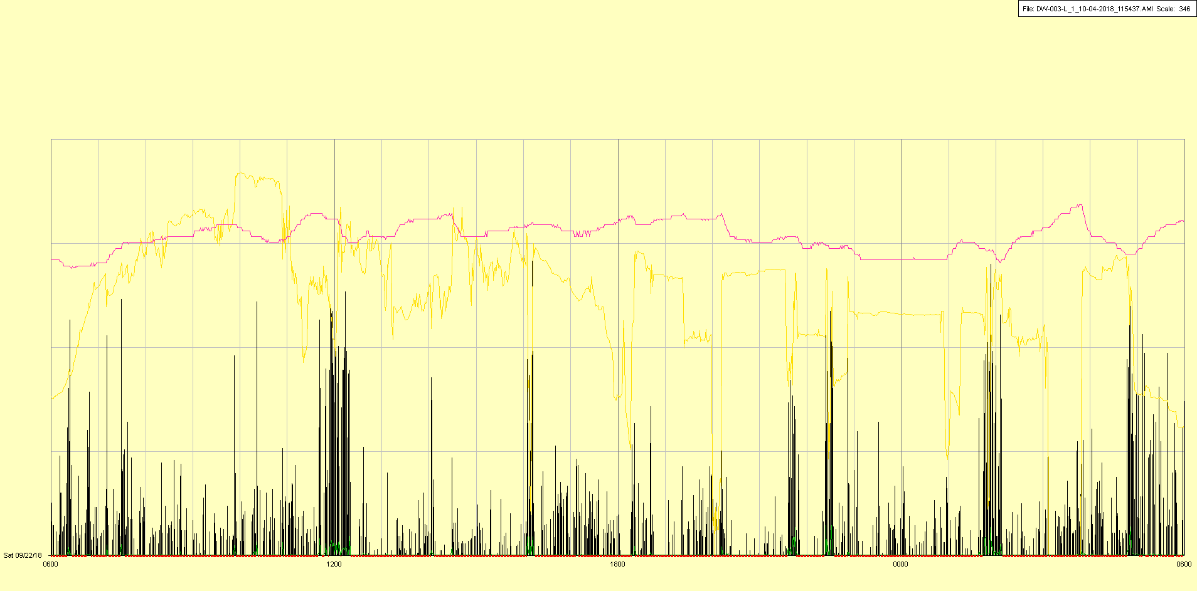

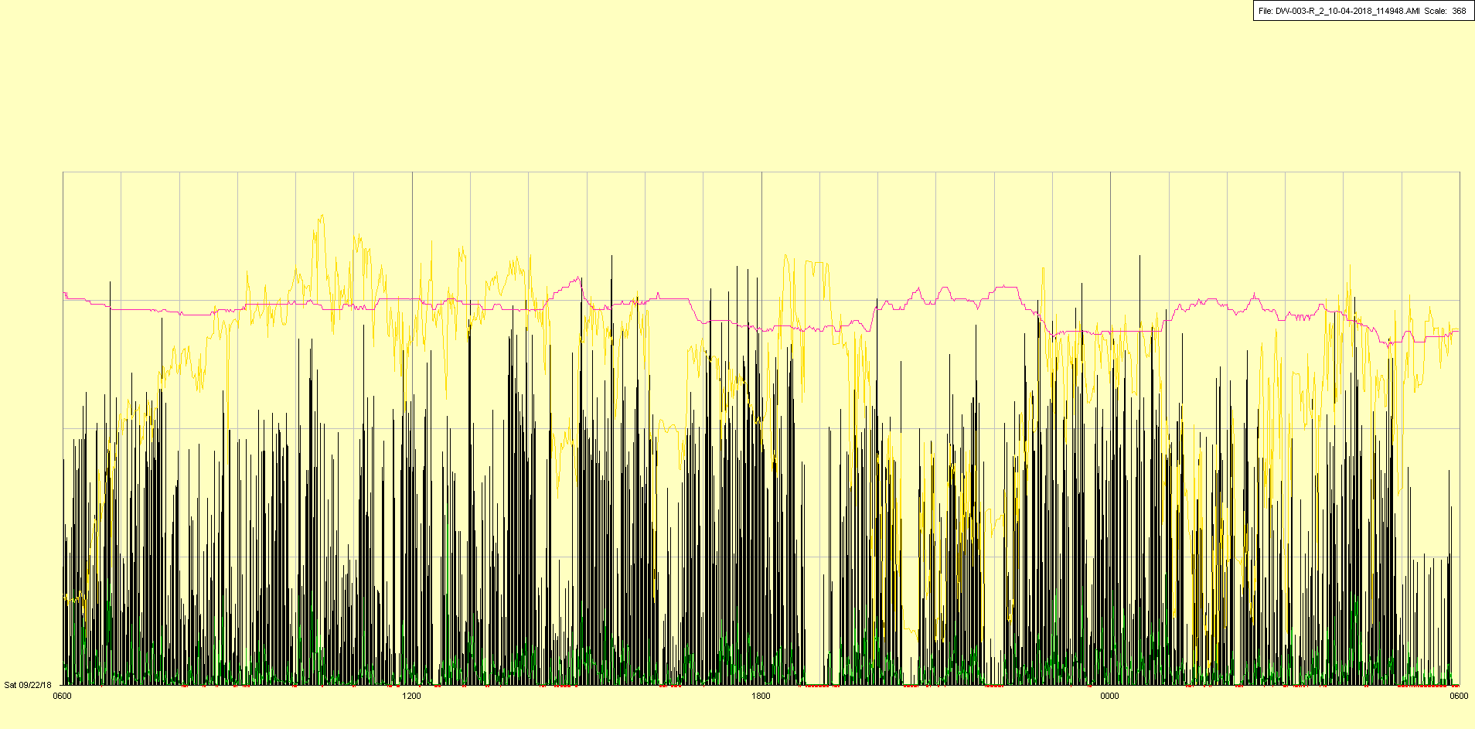

|  |  |  |  |
| --- | --- | --- | --- |
| Study ID | DW3 | Initial NIHSS (affected arm) | 4 |
| Age | 53 | Sex | Male |
| ICH Location | Right lobar | Patient location | ICU |
| Hospital day | 11 | Mechanical ventilation | No |
| Delirium status | Yes | 3-month mRS |  |

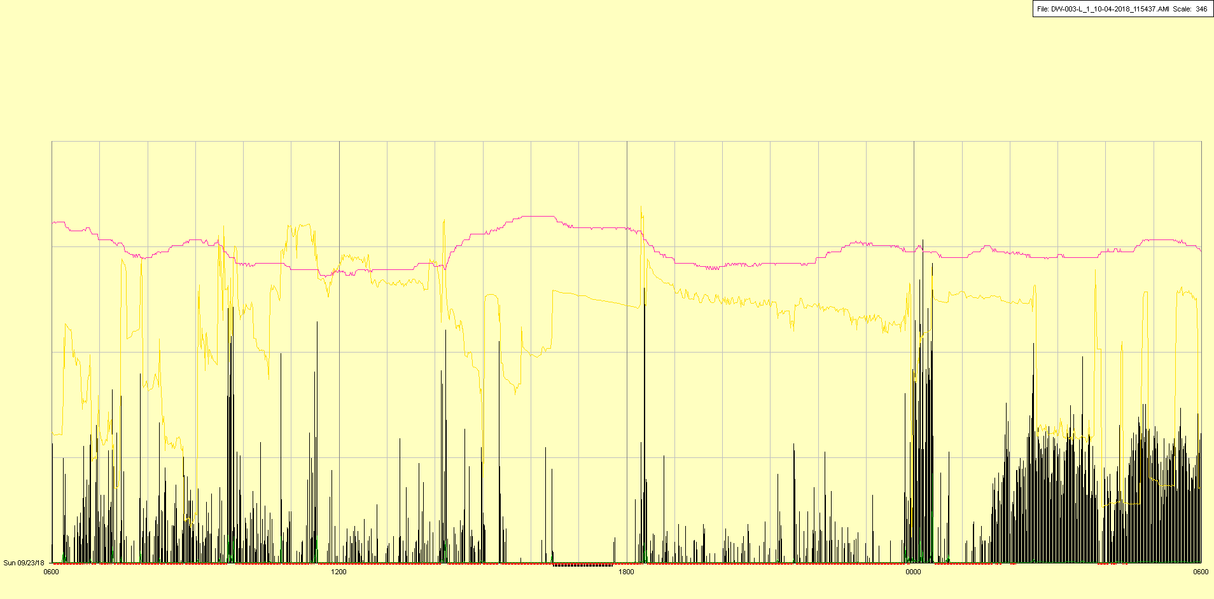

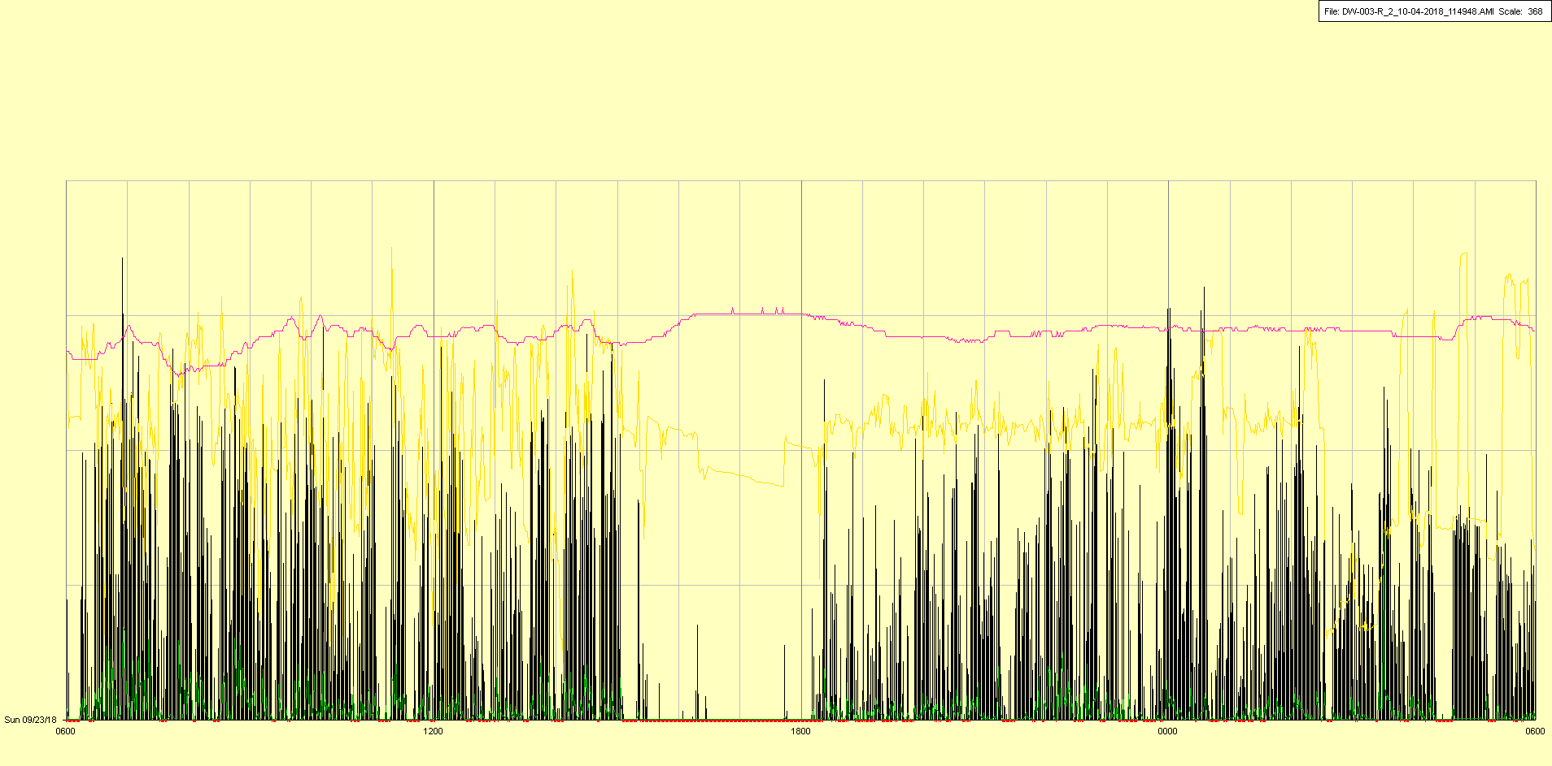

|  |  |  |  |
| --- | --- | --- | --- |
| Study ID | DW3 | Initial NIHSS (affected arm) | 4 |
| Age | 53 | Sex | Male |
| ICH Location | Right lobar | Patient location | ICU |
| Hospital day | 12 | Mechanical ventilation | No |
| Delirium status | Yes | 3-month mRS |  |

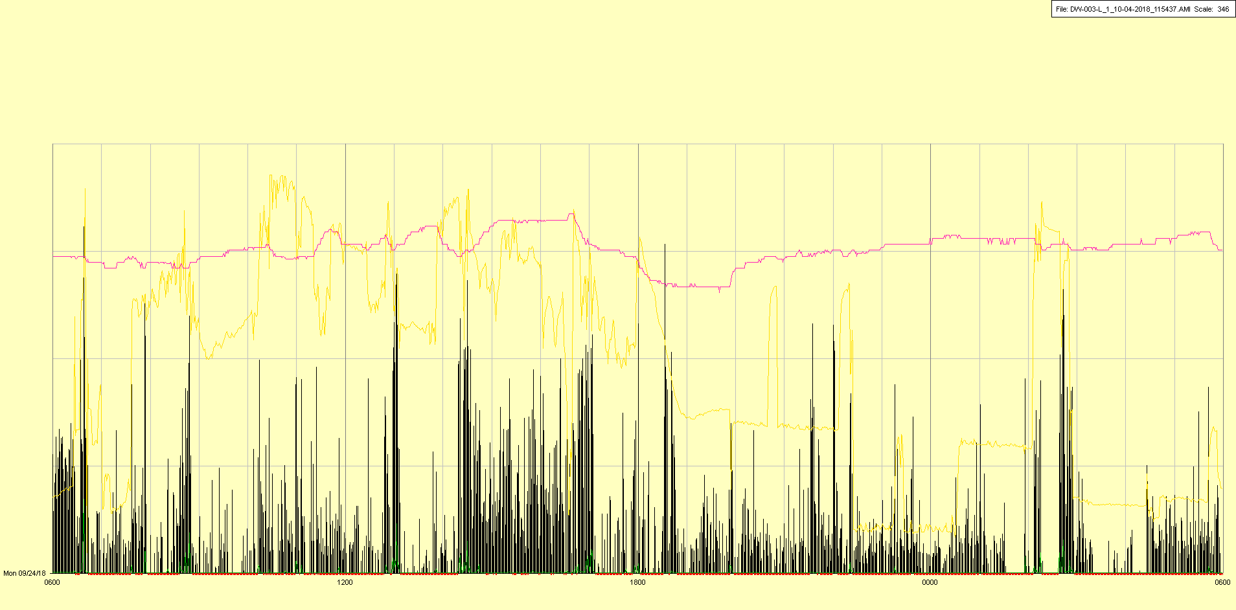

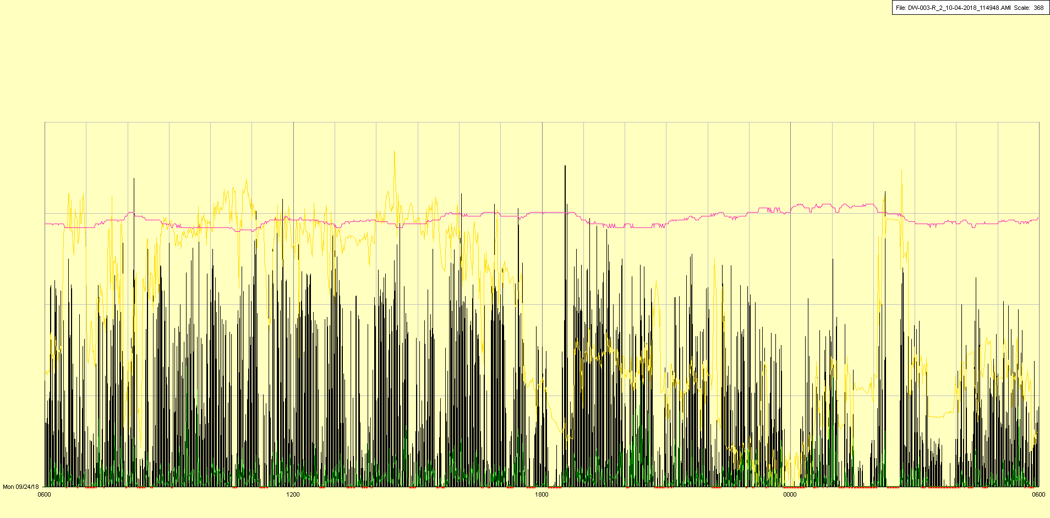

|  |  |  |  |
| --- | --- | --- | --- |
| Study ID | DW3 | Initial NIHSS (affected arm) | 4 |
| Age | 53 | Sex | Male |
| ICH Location | Right lobar | Patient location | ICU |
| Hospital day | 13 | Mechanical ventilation | No |
| Delirium status | Yes | 3-month mRS |  |

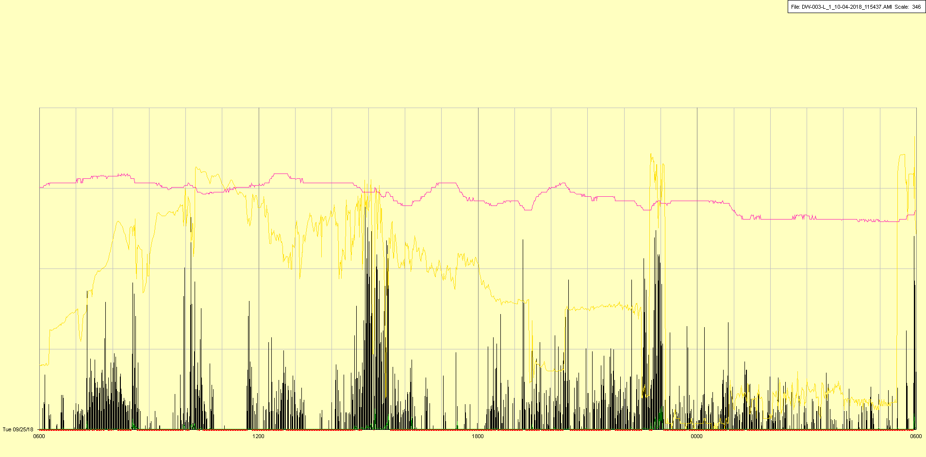

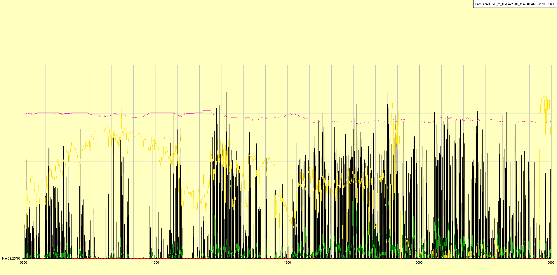

|  |  |  |  |
| --- | --- | --- | --- |
| Study ID | DW3 | Initial NIHSS (affected arm) | 4 |
| Age | 53 | Sex | Male |
| ICH Location | Right lobar | Patient location | ICU |
| Hospital day | 14 | Mechanical ventilation | No |
| Delirium status | Yes | 3-month mRS |  |

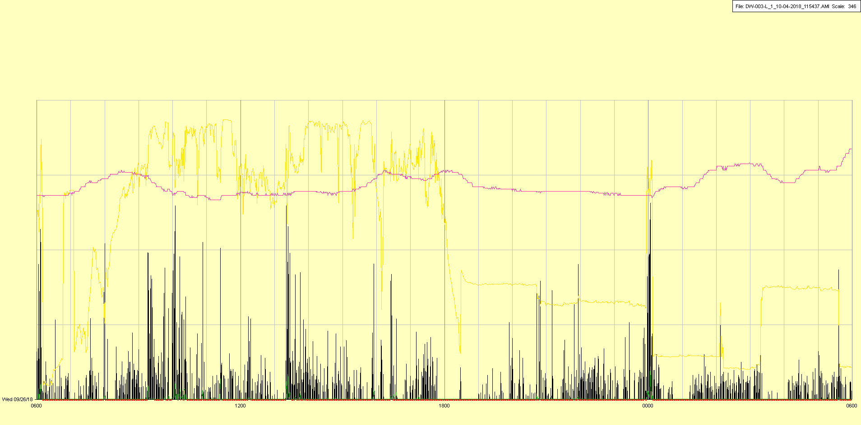

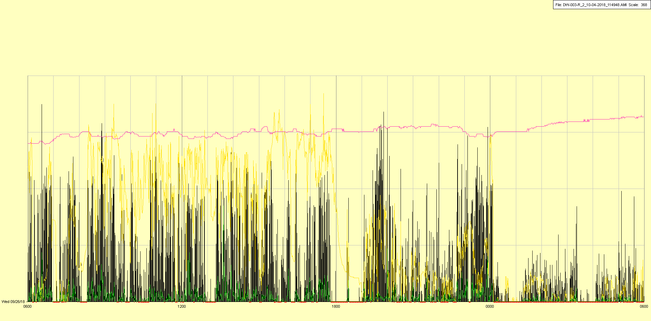

|  |  |  |  |
| --- | --- | --- | --- |
| Study ID | DW3 | Initial NIHSS (affected arm) | 4 |
| Age | 53 | Sex | Male |
| ICH Location | Right lobar | Patient location | ICU |
| Hospital day | 15 | Mechanical ventilation | No |
| Delirium status | Yes | 3-month mRS |  |

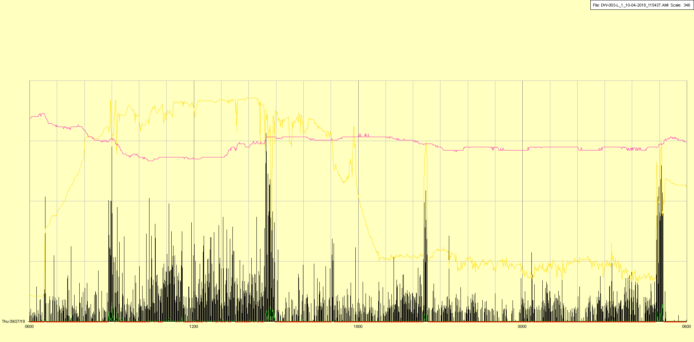

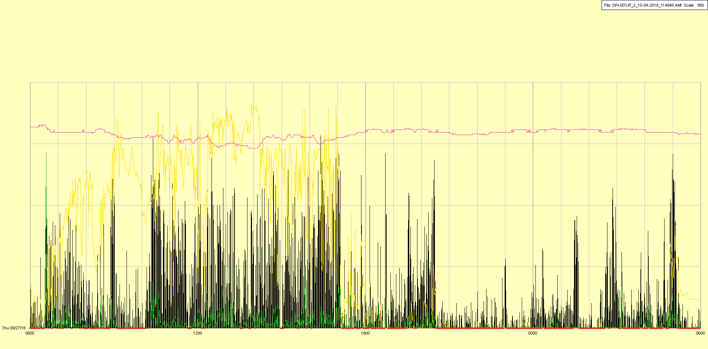

|  |  |  |  |
| --- | --- | --- | --- |
| Study ID | DW3 | Initial NIHSS (affected arm) | 4 |
| Age | 53 | Sex | Male |
| ICH Location | Right lobar | Patient location | ICU |
| Hospital day | 16 | Mechanical ventilation | No |
| Delirium status | Yes | 3-month mRS |  |

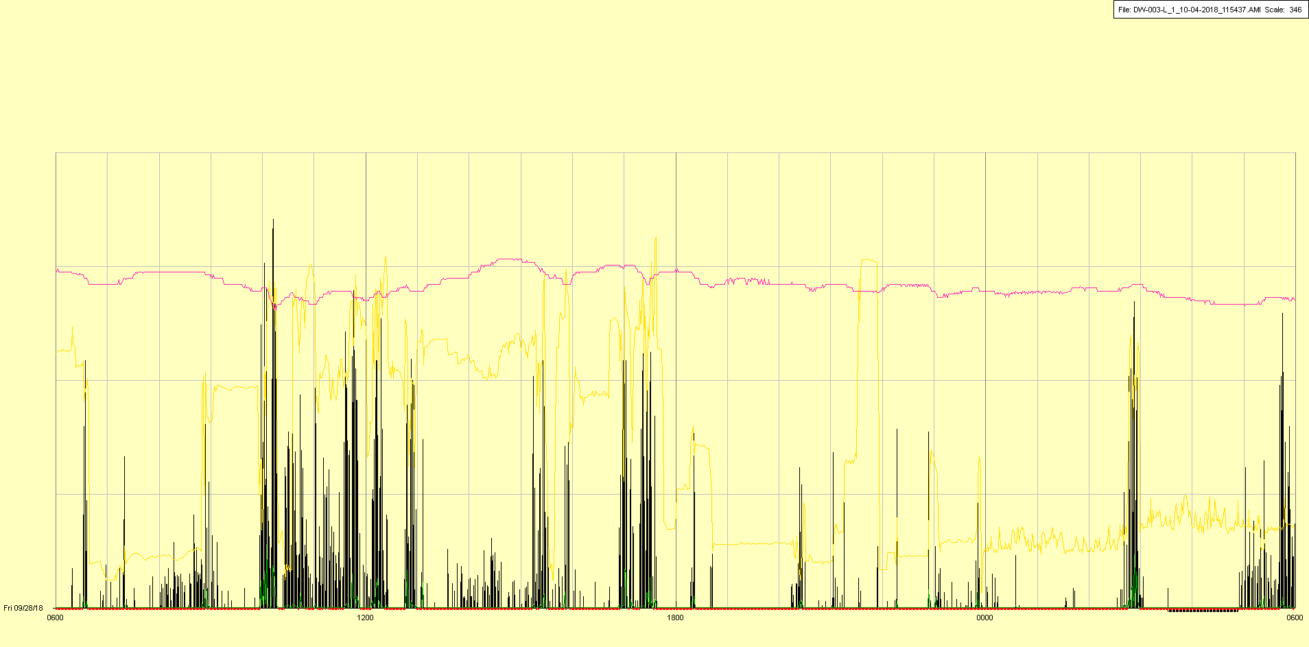

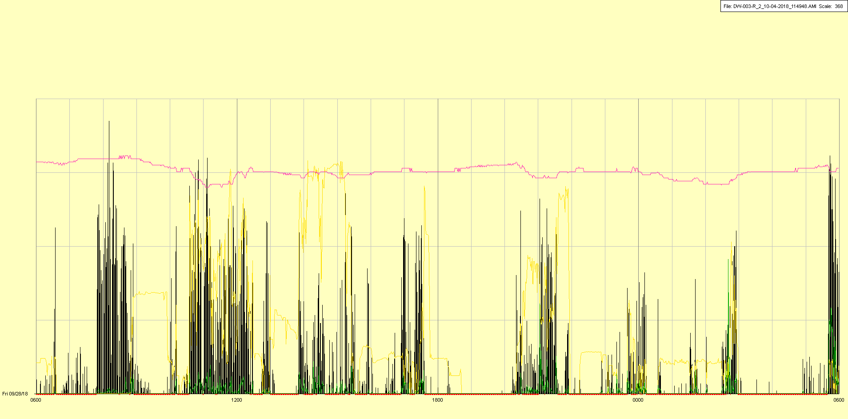

|  |  |  |  |
| --- | --- | --- | --- |
| Study ID | DW3 | Initial NIHSS (affected arm) | 4 |
| Age | 53 | Sex | Male |
| ICH Location | Right lobar | Patient location | Stroke Unit |
| Hospital day | 17 | Mechanical ventilation | No |
| Delirium status | No | 3-month mRS |  |

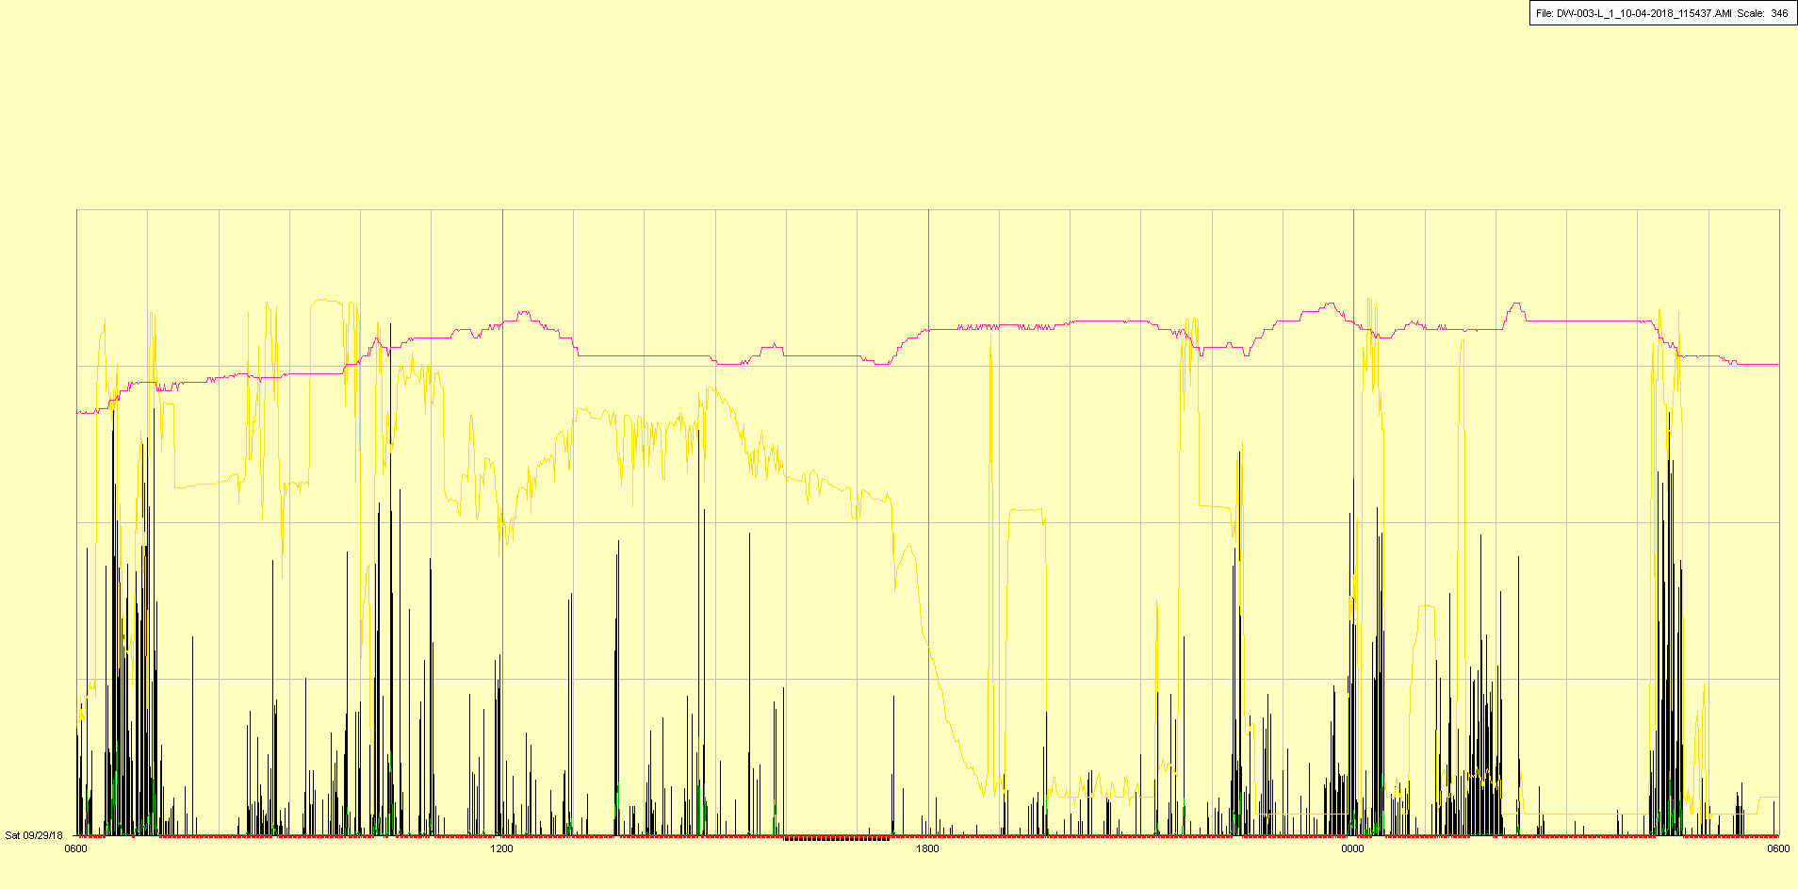

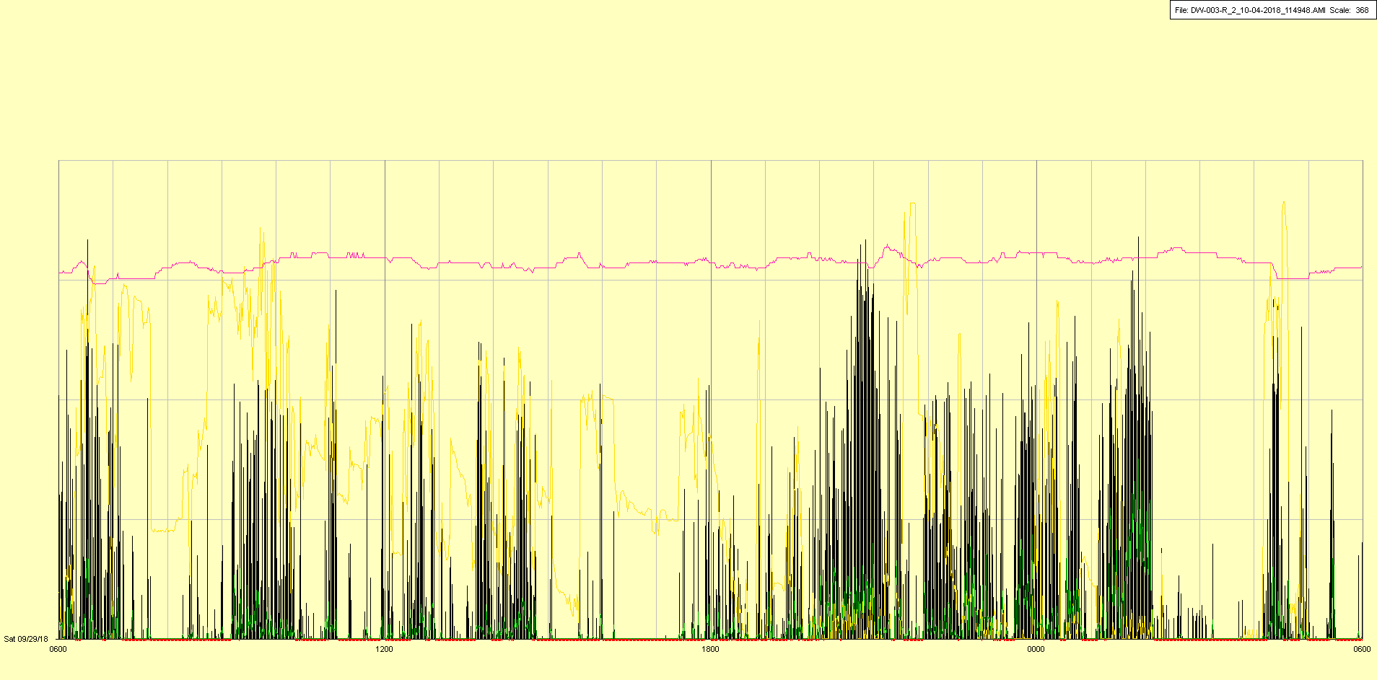

|  |  |  |  |
| --- | --- | --- | --- |
| Study ID | DW3 | Initial NIHSS (affected arm) | 4 |
| Age | 53 | Sex | Male |
| ICH Location | Right lobar | Patient location | Stroke Unit 🡪 ICU |
| Hospital day | 18 | Mechanical ventilation | No 🡪 Yes |
| Delirium status | No | 3-month mRS |  |

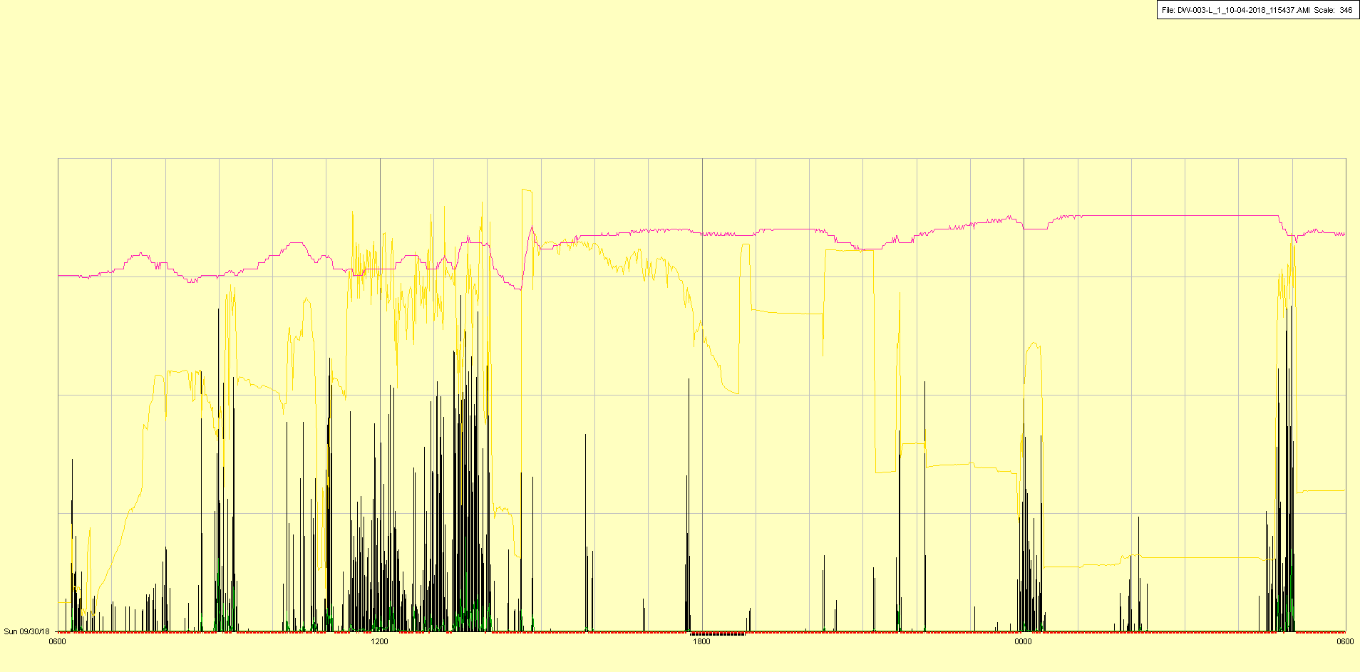

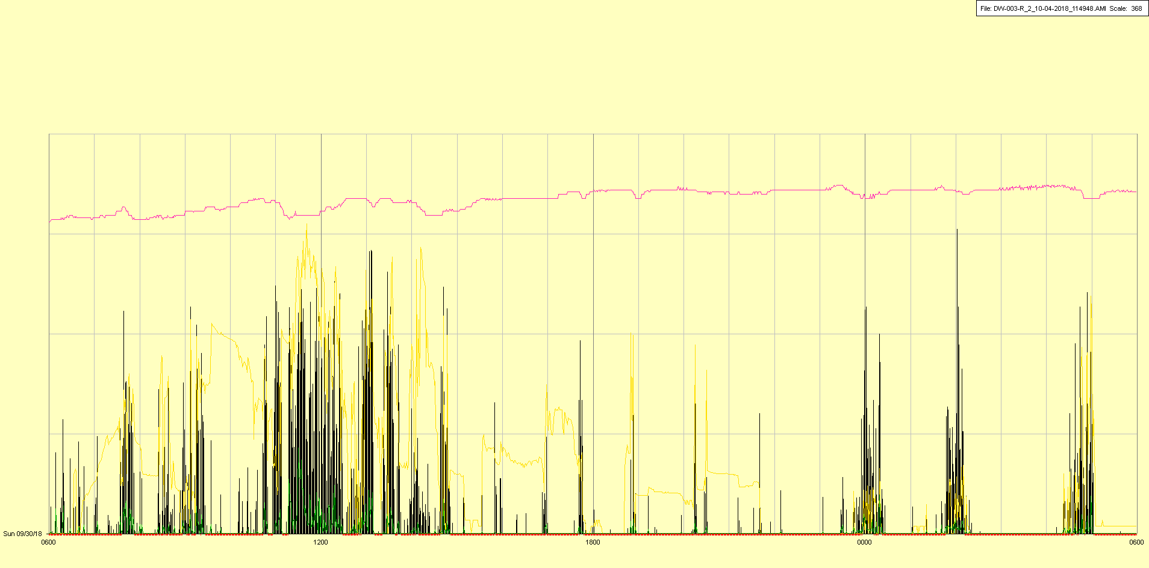

Intubated and transferred back to ICU due to epistaxis

|  |  |  |  |
| --- | --- | --- | --- |
| Study ID | DW3 | Initial NIHSS (affected arm) | 4 |
| Age | 53 | Sex | Male |
| ICH Location | Right lobar | Patient location | ICU |
| Hospital day | 19 | Mechanical ventilation | Yes |
| Delirium status | No | 3-month mRS |  |

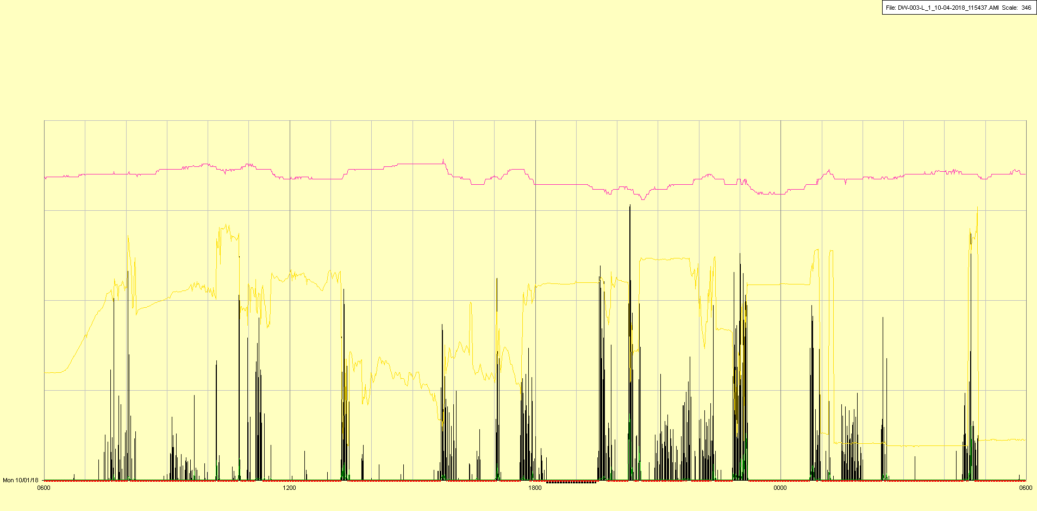

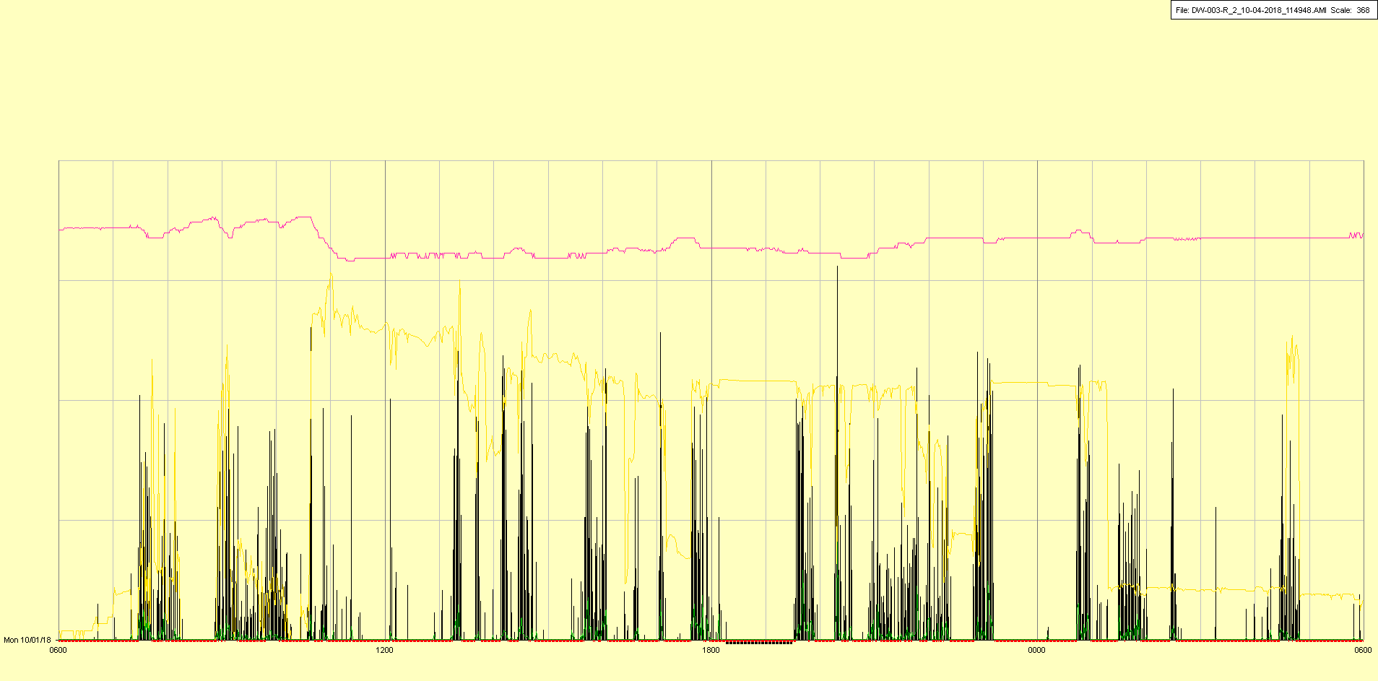

|  |  |  |  |
| --- | --- | --- | --- |
| Study ID | DW3 | Initial NIHSS (affected arm) | 4 |
| Age | 53 | Sex | Male |
| ICH Location | Right lobar | Patient location | ICU |
| Hospital day | 20 | Mechanical ventilation | Yes |
| Delirium status | No | 3-month mRS |  |

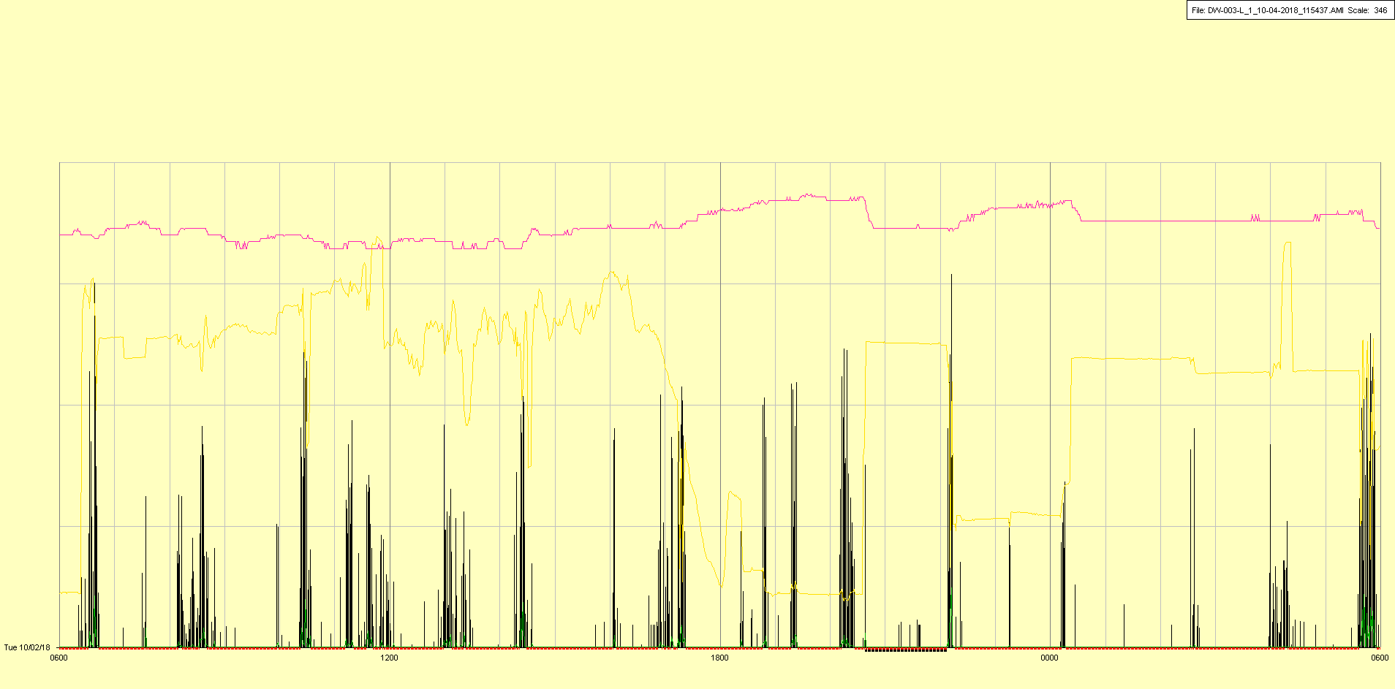

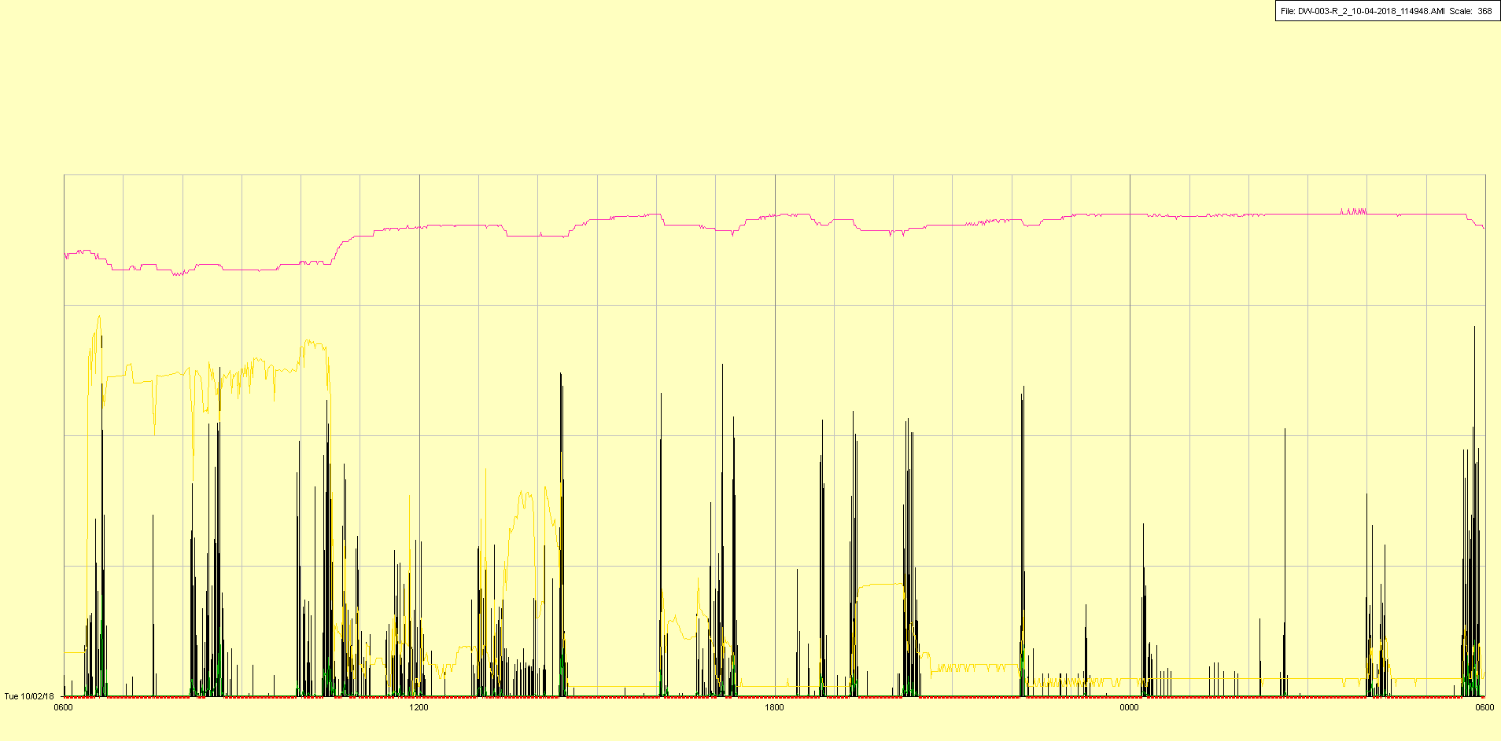

|  |  |  |  |
| --- | --- | --- | --- |
| Study ID | DW3 | Initial NIHSS (affected arm) | 4 |
| Age | 53 | Sex | Male |
| ICH Location | Right lobar | Patient location | ICU |
| Hospital day | 21 | Mechanical ventilation | Yes |
| Delirium status | No | 3-month mRS |  |

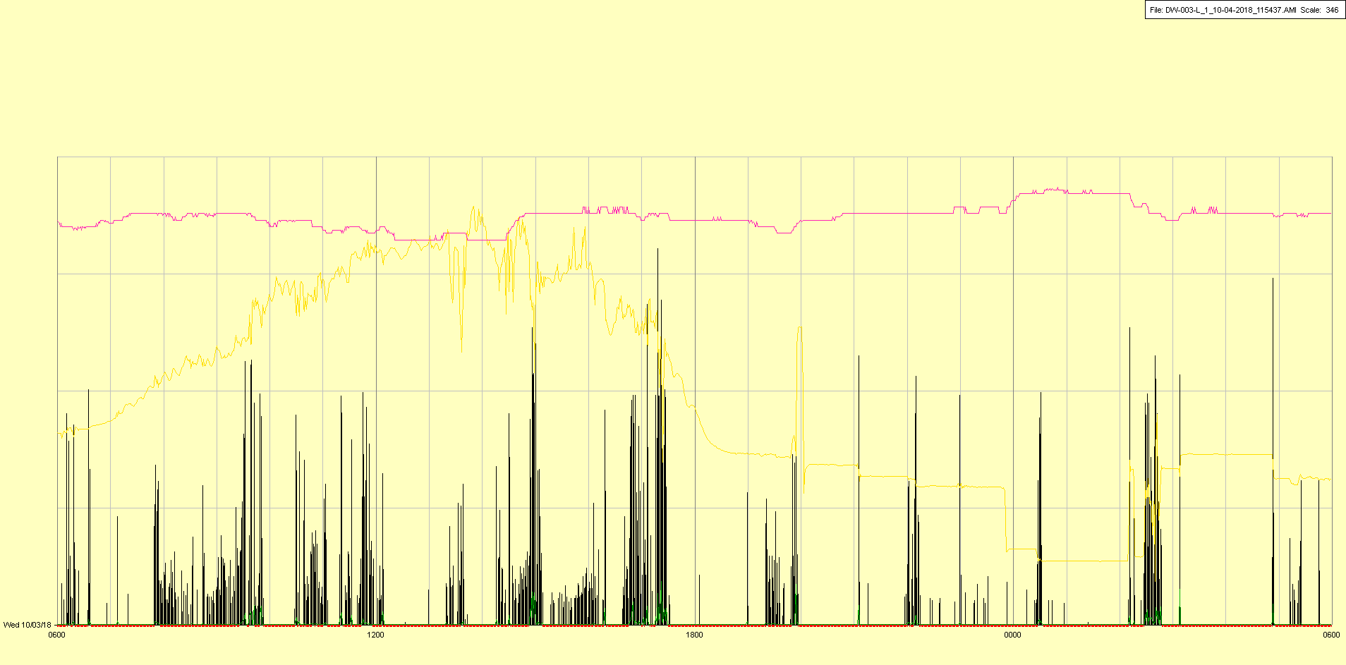

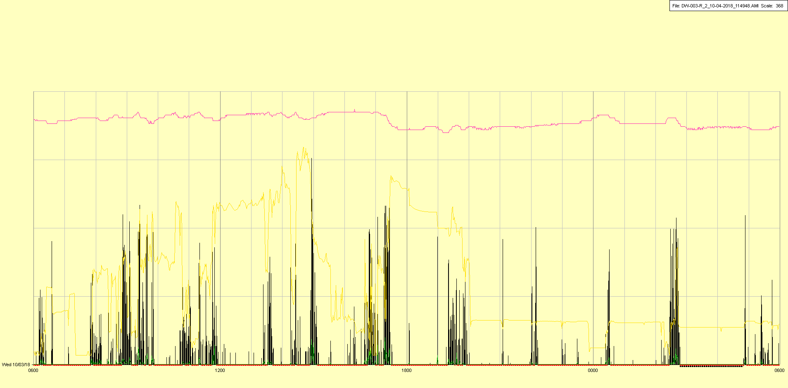

|  |  |  |  |
| --- | --- | --- | --- |
| Study ID | DW3 | Initial NIHSS (affected arm) | 4 |
| Age | 53 | Sex | Male |
| ICH Location | Right lobar | Patient location | ICU |
| Hospital day | 22 | Mechanical ventilation | Yes 🡪 No |
| Delirium status | No | 3-month mRS |  |

|  |
| --- |
|  |

Battery replaced in late AM (off time); extubated in early afternoon

|  |  |  |  |
| --- | --- | --- | --- |
| Study ID | DW3 | Initial NIHSS (affected arm) | 4 |
| Age | 53 | Sex | Male |
| ICH Location | Right lobar | Patient location | ICU |
| Hospital day | 23 | Mechanical ventilation | No |
| Delirium status | No | 3-month mRS |  |

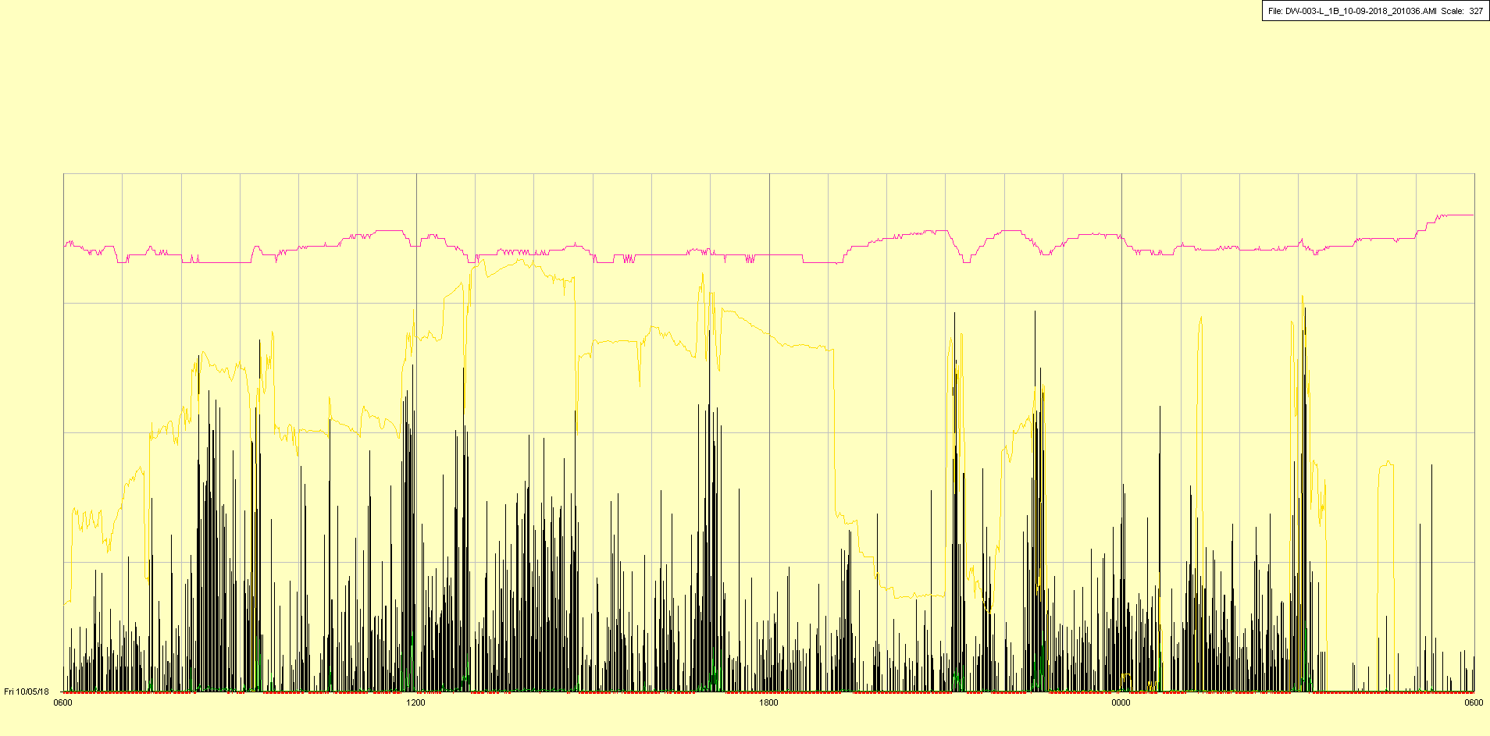

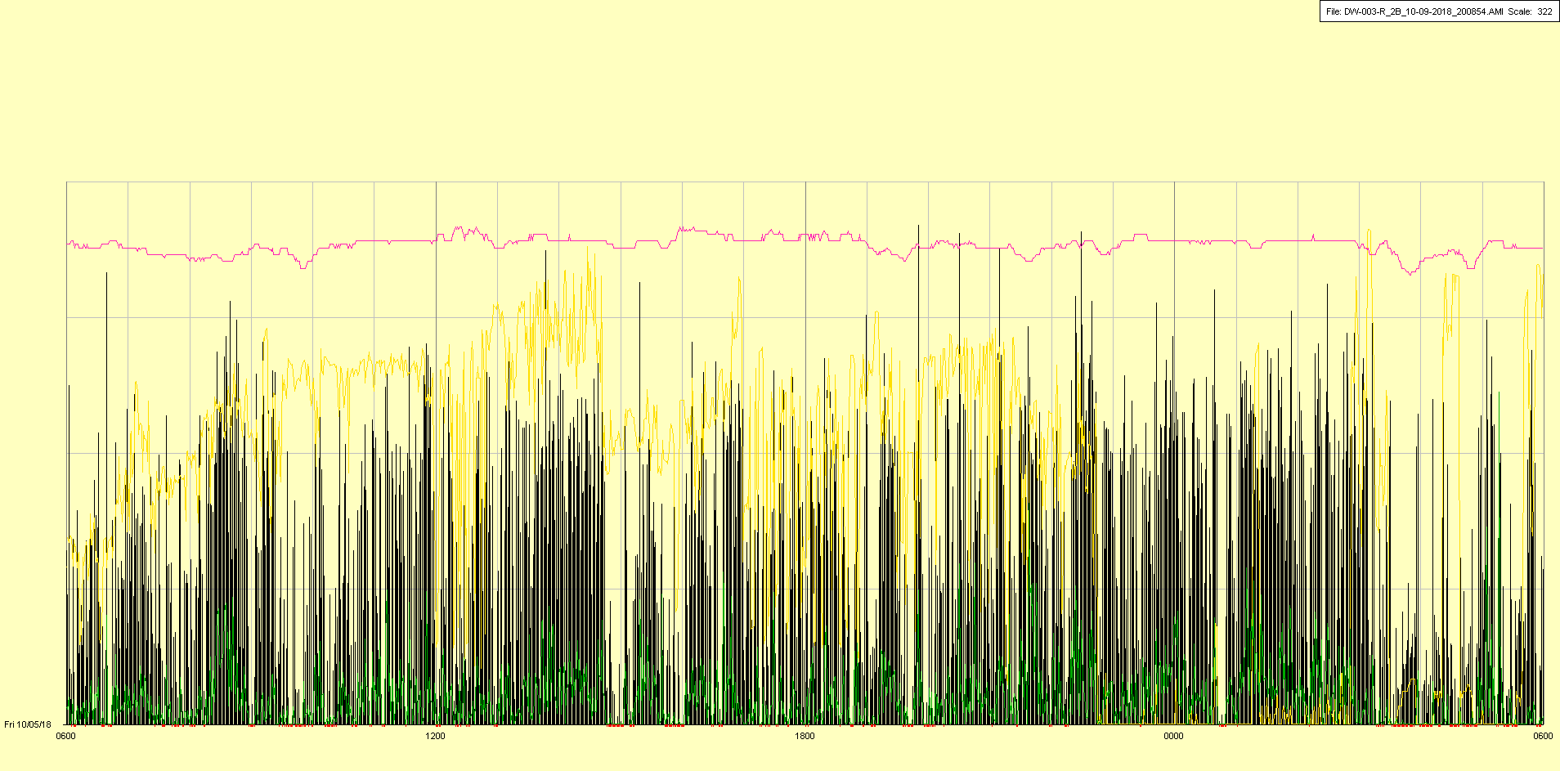

|  |  |  |  |
| --- | --- | --- | --- |
| Study ID | DW3 | Initial NIHSS (affected arm) | 4 |
| Age | 53 | Sex | Male |
| ICH Location | Right lobar | Patient location | Stroke Unit |
| Hospital day | 24 | Mechanical ventilation | No |
| Delirium status | No | 3-month mRS |  |

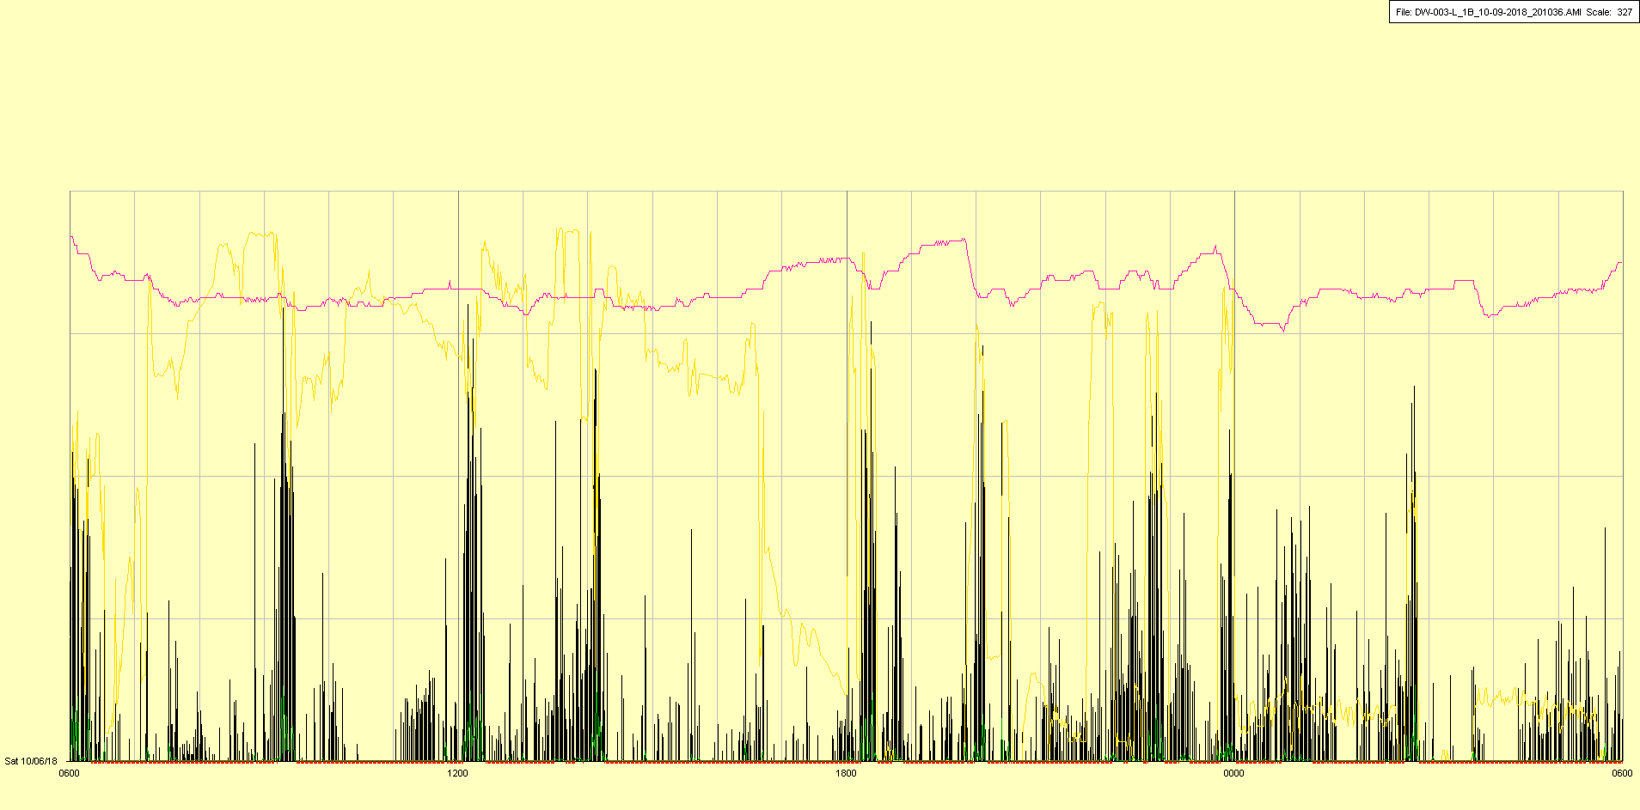

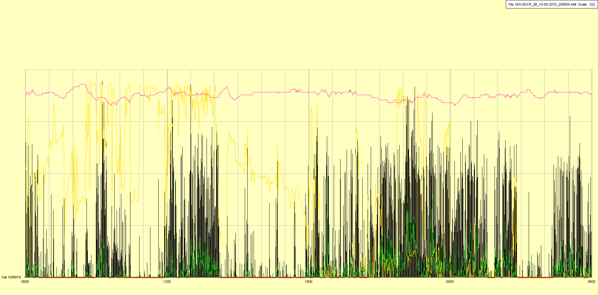

|  |  |  |  |
| --- | --- | --- | --- |
| Study ID | DW3 | Initial NIHSS (affected arm) | 4 |
| Age | 53 | Sex | Male |
| ICH Location | Right lobar | Patient location | Stroke Unit |
| Hospital day | 25 | Mechanical ventilation | No |
| Delirium status | No | 3-month mRS |  |

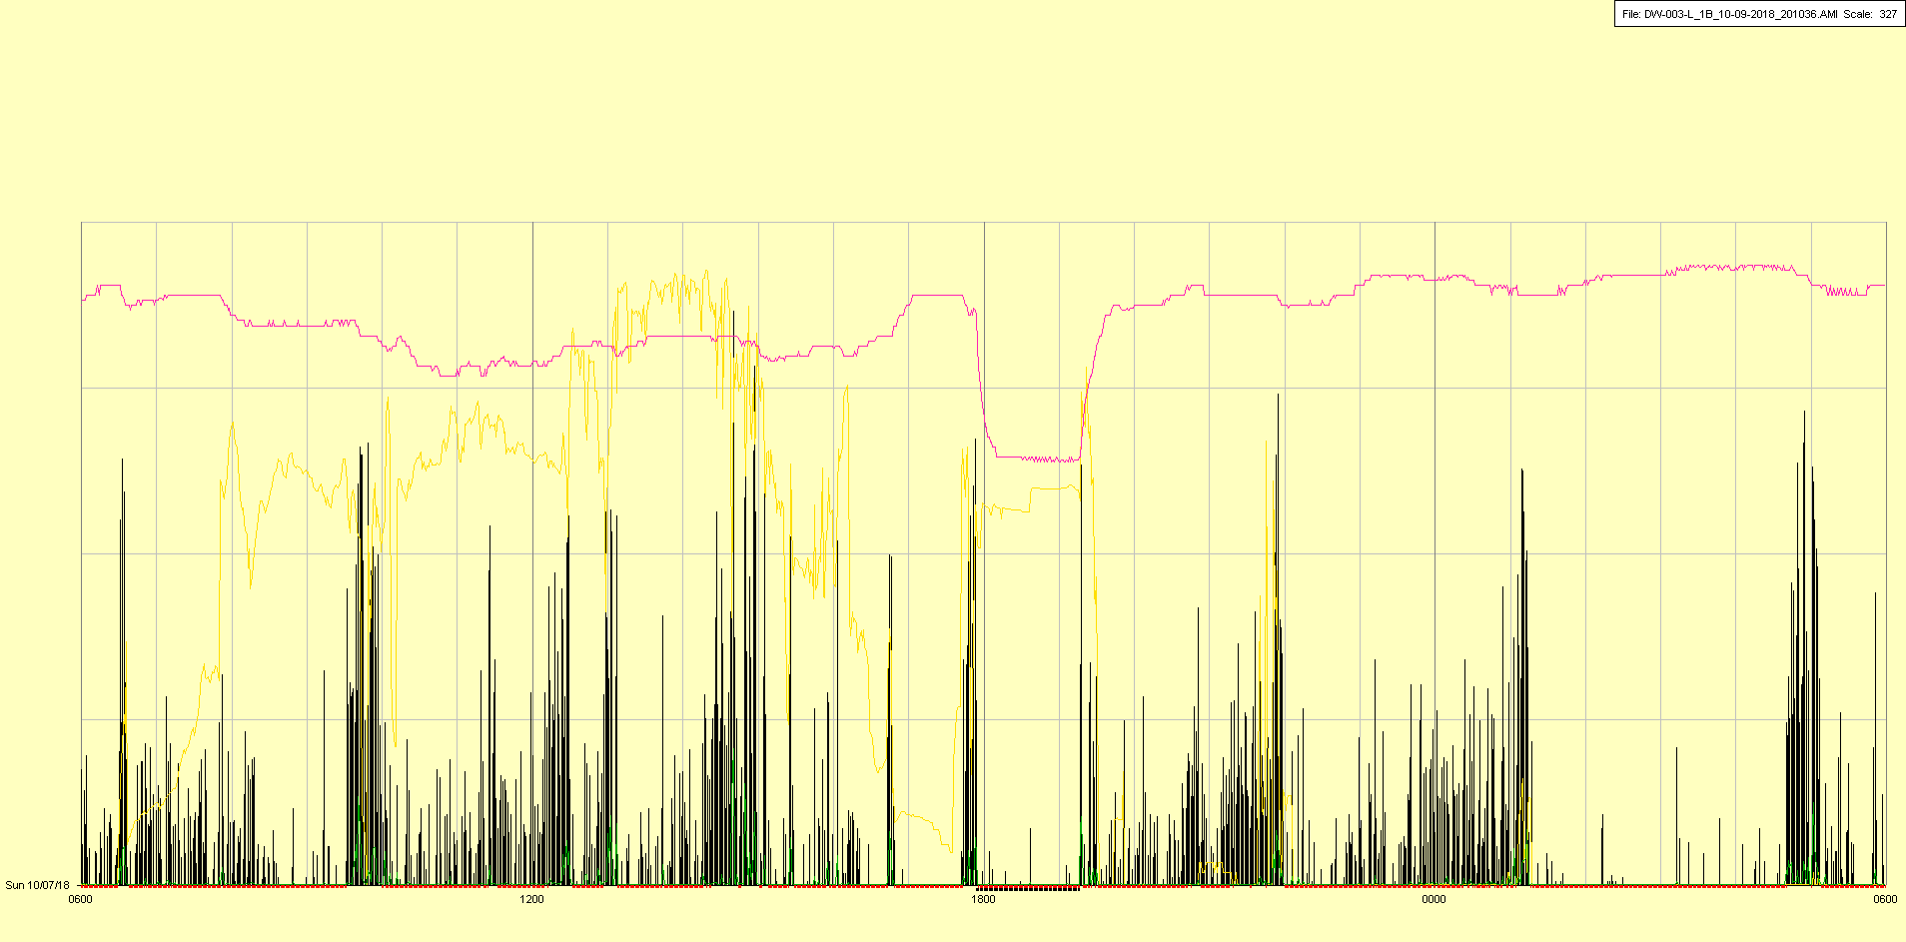

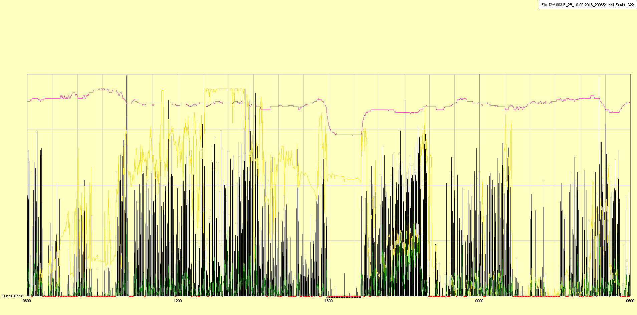

|  |  |  |  |
| --- | --- | --- | --- |
| Study ID | DW3 | Initial NIHSS (affected arm) | 4 |
| Age | 53 | Sex | Male |
| ICH Location | Right lobar | Patient location | Stroke Unit |
| Hospital day | 26 | Mechanical ventilation | No |
| Delirium status | No | 3-month mRS |  |

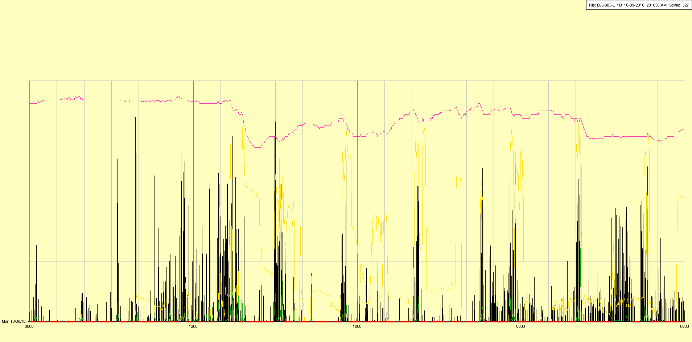

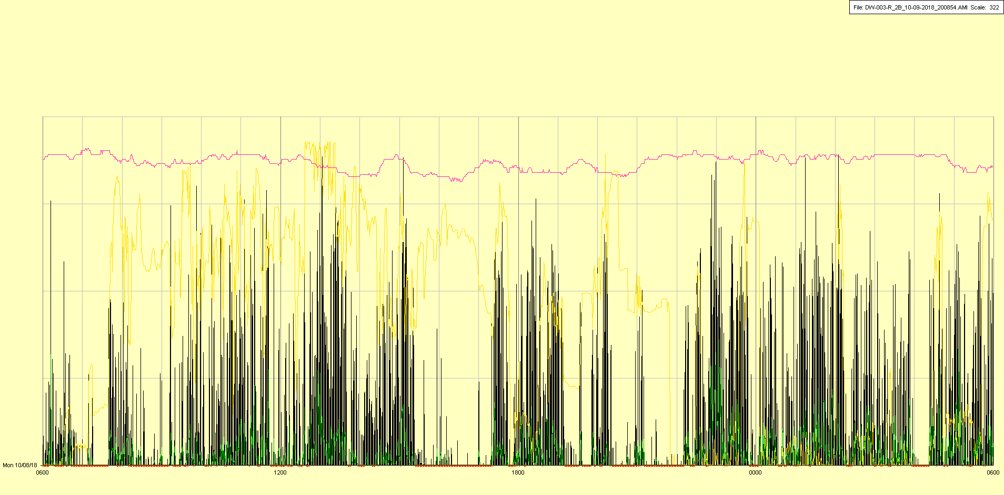

|  |  |  |  |
| --- | --- | --- | --- |
| Study ID | DW3 | Initial NIHSS (affected arm) | 4 |
| Age | 53 | Sex | Male |
| ICH Location | Right lobar | Patient location | Stroke Unit |
| Hospital day | 27 | Mechanical ventilation | No |
| Delirium status | No | 3-month mRS |  |

