|  |  |  |  |
| --- | --- | --- | --- |
| Study ID | DW4 | Initial NIHSS (affected arm) | 3 |
| Age | 67 | Sex | Male |
| ICH Location | Right deep | Patient location | Stroke Unit |
| Hospital day | 2 | Mechanical ventilation | No |
| Delirium status | No | 3-month mRS |  |

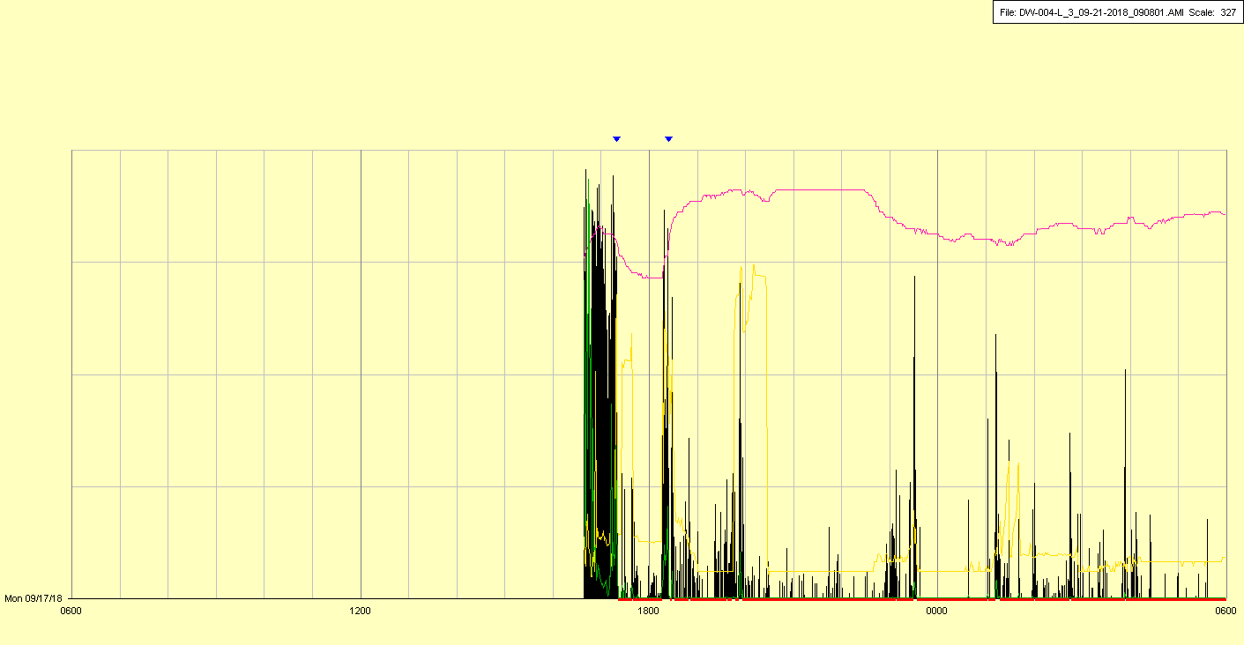

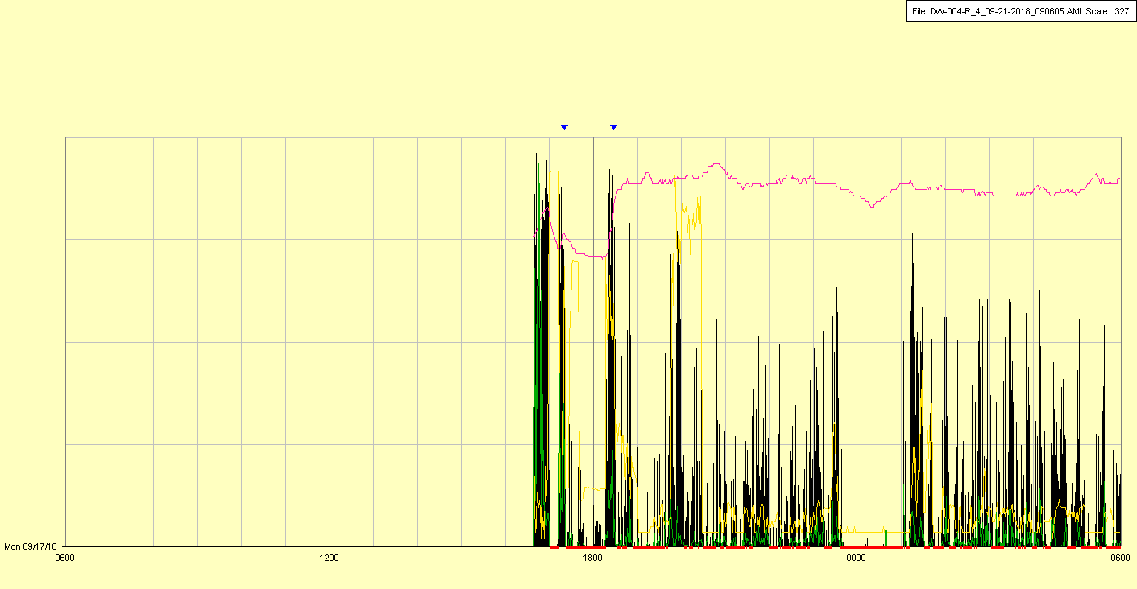

|  |  |  |  |
| --- | --- | --- | --- |
| Study ID | DW4 | Initial NIHSS (affected arm) | 3 |
| Age | 67 | Sex | Male |
| ICH Location | Right deep | Patient location | Stroke Unit |
| Hospital day | 3 | Mechanical ventilation | No |
| Delirium status | No | 3-month mRS |  |

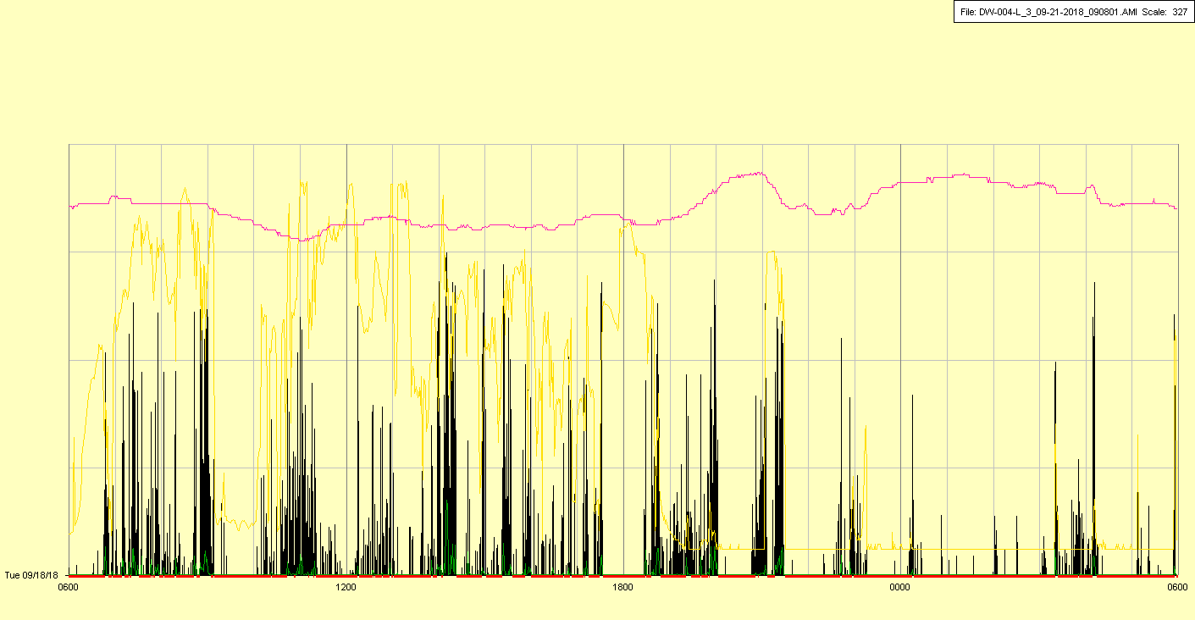

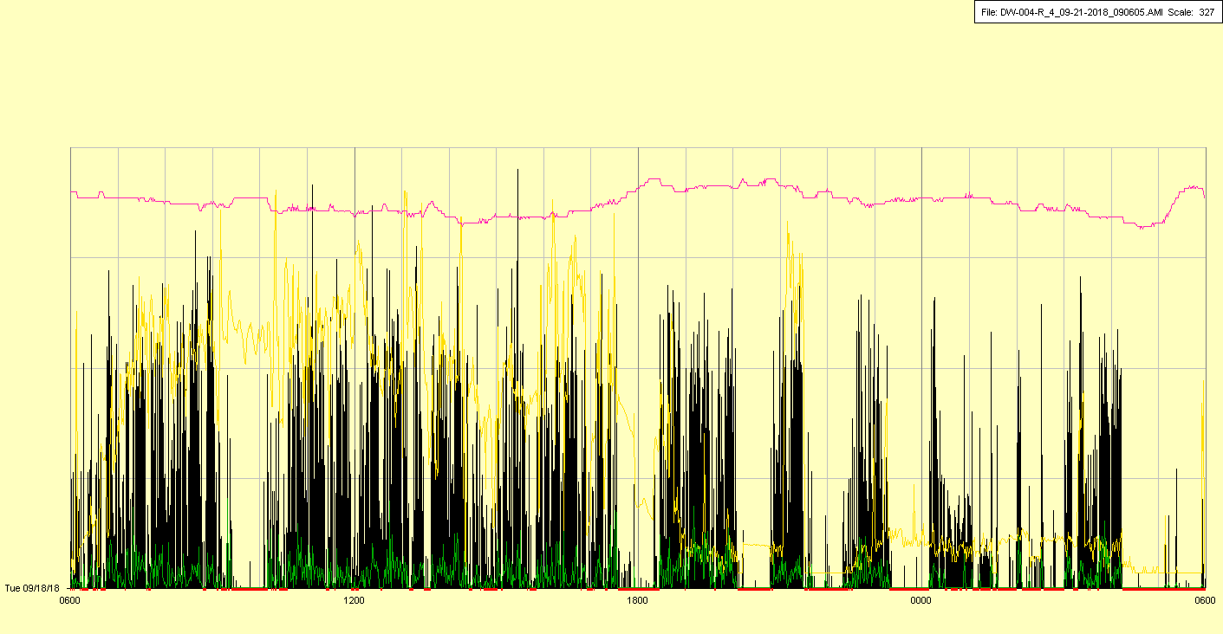

|  |  |  |  |
| --- | --- | --- | --- |
| Study ID | DW4 | Initial NIHSS (affected arm) | 3 |
| Age | 67 | Sex | Male |
| ICH Location | Right deep | Patient location | Stroke Unit |
| Hospital day | 4 | Mechanical ventilation | No |
| Delirium status | No | 3-month mRS |  |

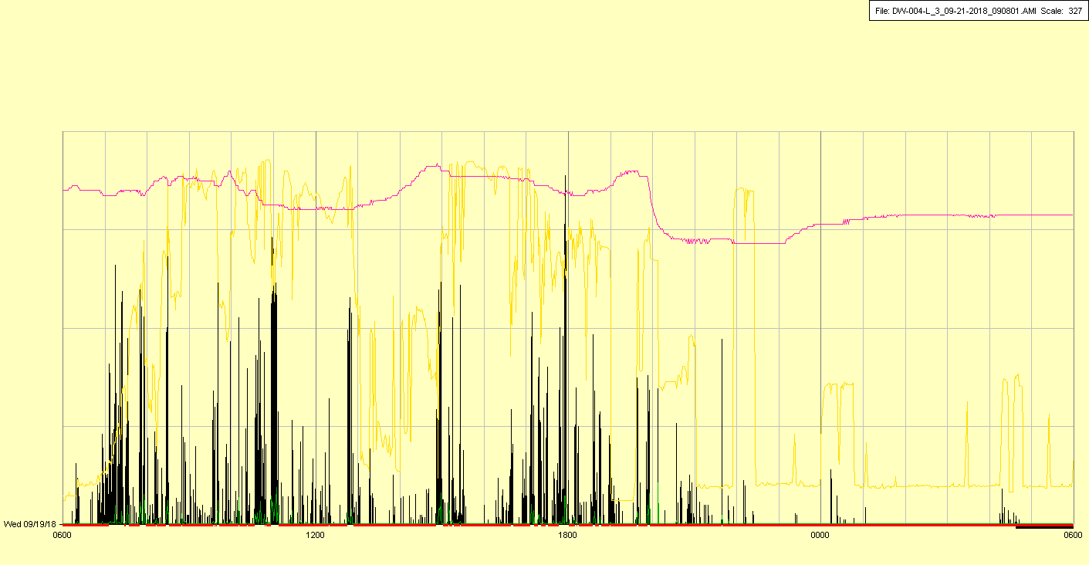

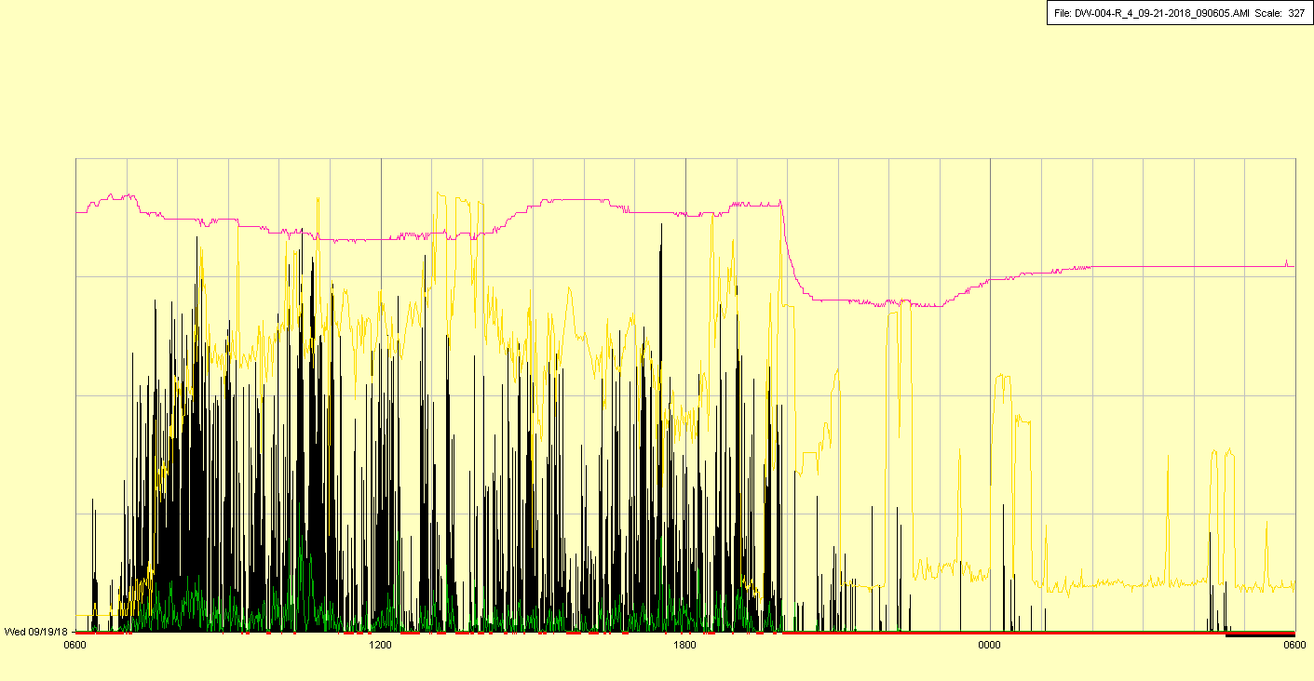

Taken off in late afternoon