|  |  |  |  |
| --- | --- | --- | --- |
| Study ID | DW5 | Initial NIHSS (affected arm) | 4 |
| Age | 78 | Sex | Male |
| ICH Location | Left hemispheric | Patient location | ICU |
| Hospital day | 2 | Mechanical ventilation | No |
| Delirium status | Yes | 3-month mRS |  |

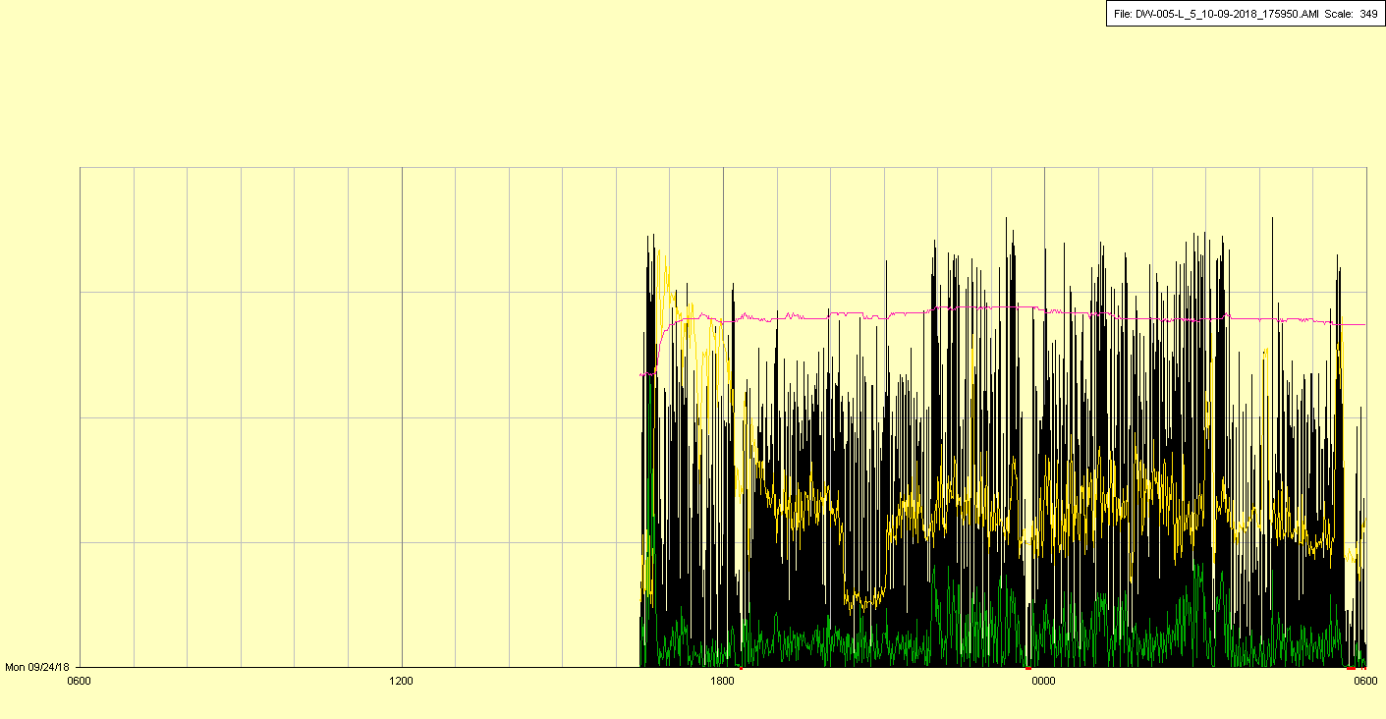

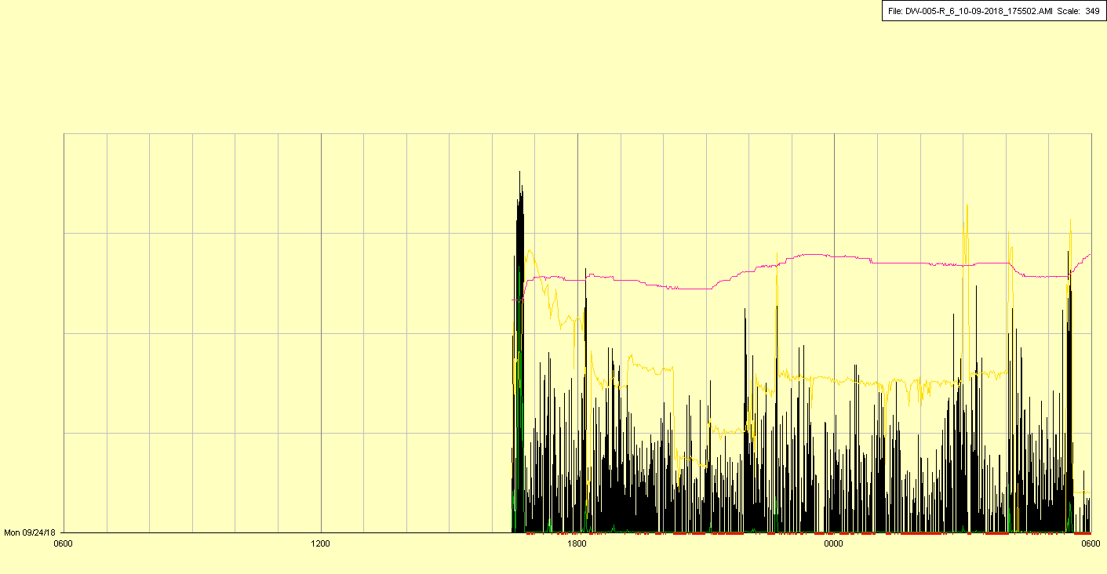

|  |  |  |  |
| --- | --- | --- | --- |
| Study ID | DW5 | Initial NIHSS (affected arm) | 4 |
| Age | 78 | Sex | Male |
| ICH Location | Left hemispheric | Patient location | ICU |
| Hospital day | 3 | Mechanical ventilation | No |
| Delirium status | Yes | 3-month mRS |  |

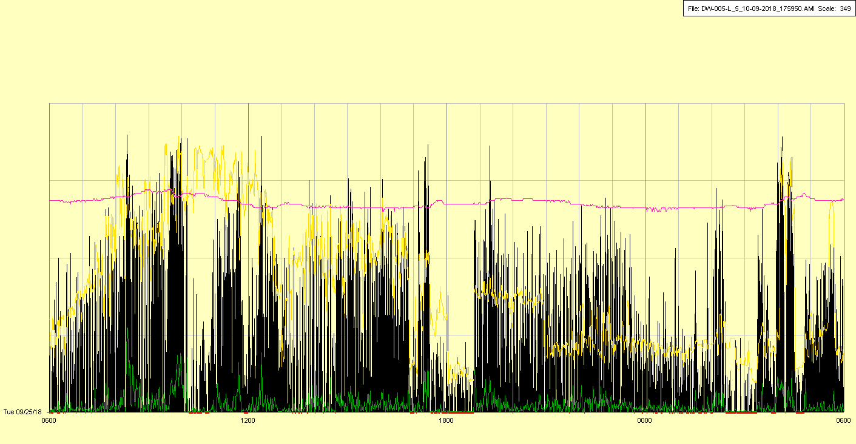

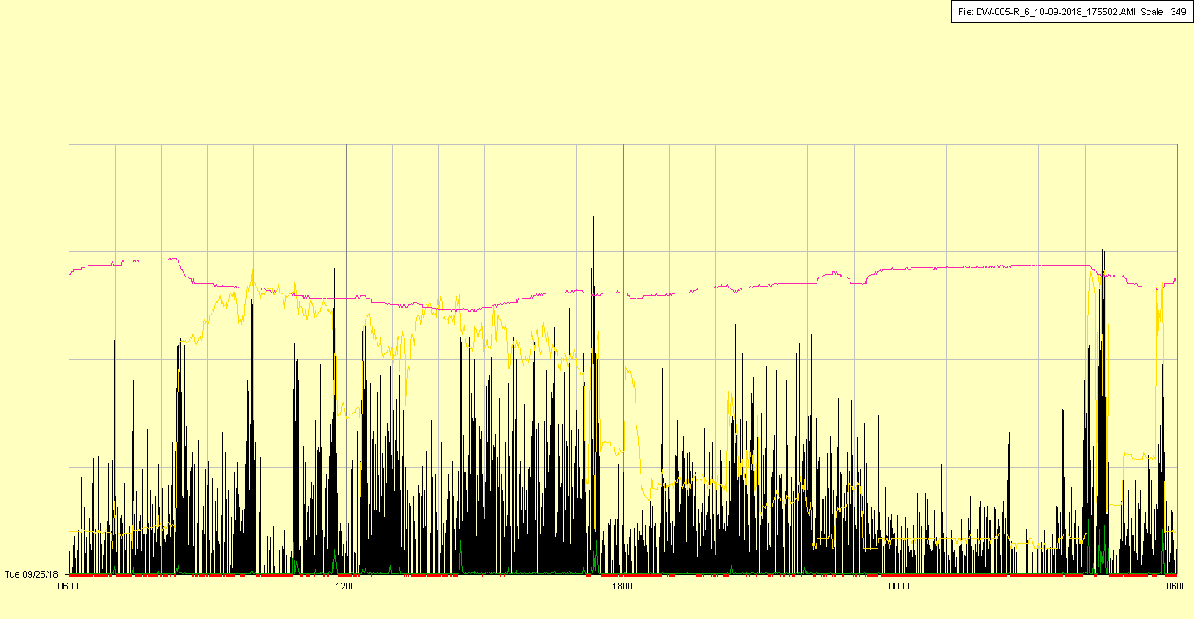

|  |  |  |  |
| --- | --- | --- | --- |
| Study ID | DW5 | Initial NIHSS (affected arm) | 4 |
| Age | 78 | Sex | Male |
| ICH Location | Left hemispheric | Patient location | ICU |
| Hospital day | 4 | Mechanical ventilation | No |
| Delirium status | Yes | 3-month mRS |  |

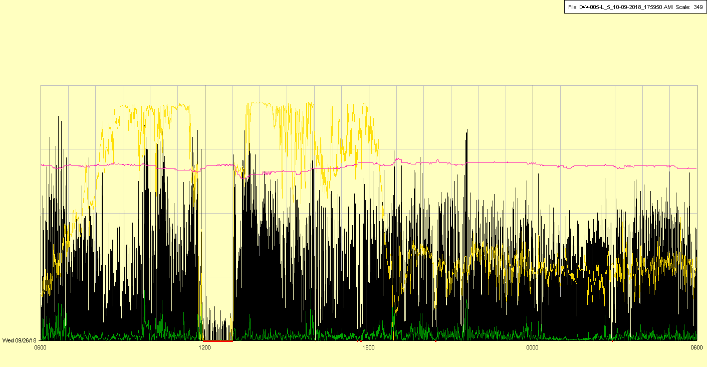

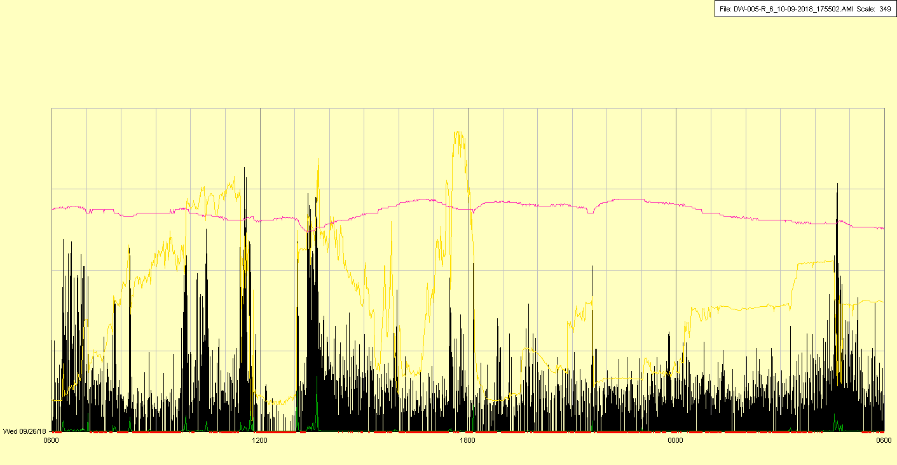

|  |  |  |  |
| --- | --- | --- | --- |
| Study ID | DW5 | Initial NIHSS (affected arm) | 4 |
| Age | 78 | Sex | Male |
| ICH Location | Left hemispheric | Patient location | ICU |
| Hospital day | 5 | Mechanical ventilation | No |
| Delirium status | Yes | 3-month mRS |  |

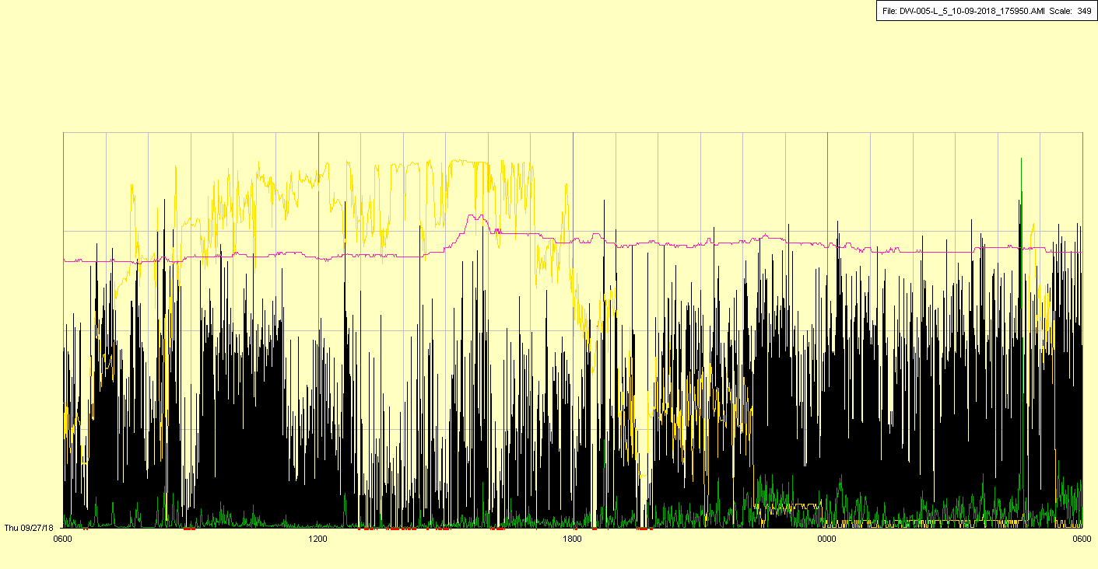

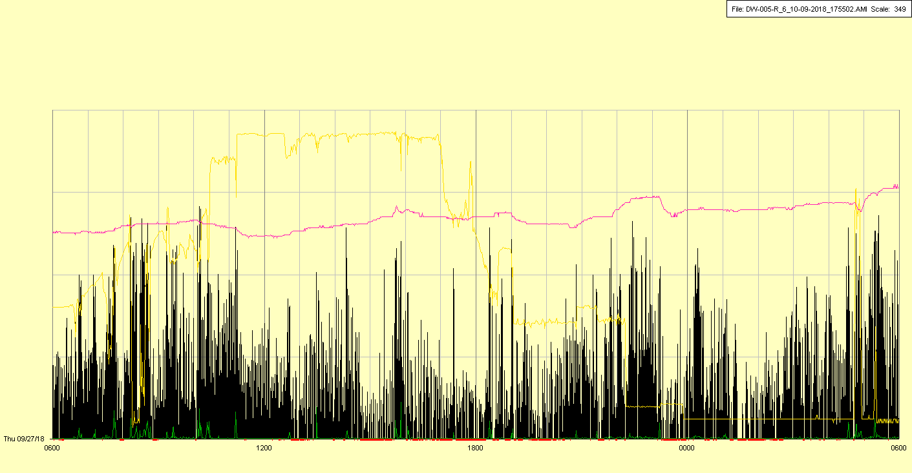

|  |  |  |  |
| --- | --- | --- | --- |
| Study ID | DW5 | Initial NIHSS (affected arm) | 4 |
| Age | 78 | Sex | Male |
| ICH Location | Left hemispheric | Patient location | ICU |
| Hospital day | 6 | Mechanical ventilation | No |
| Delirium status | Yes | 3-month mRS |  |

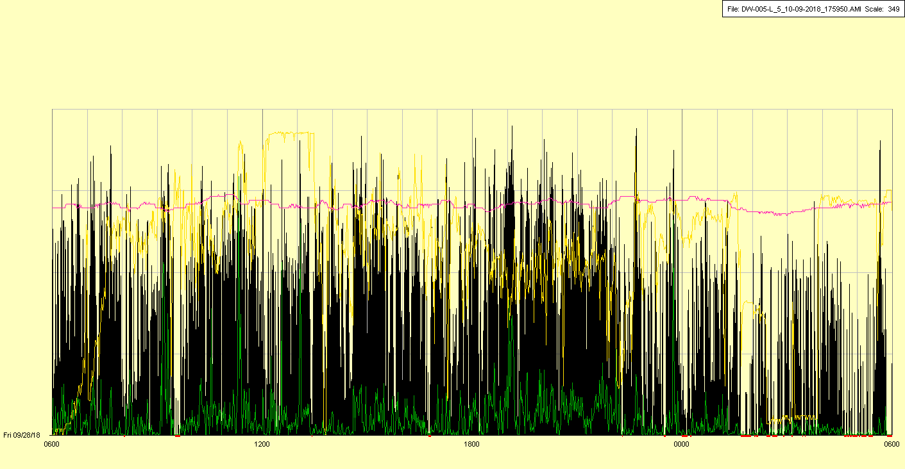

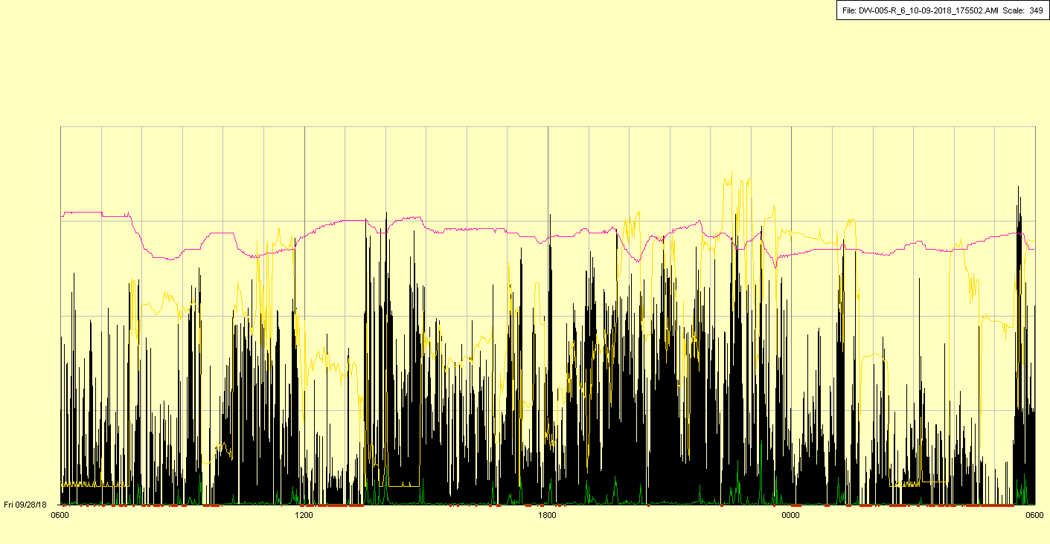

|  |  |  |  |
| --- | --- | --- | --- |
| Study ID | DW5 | Initial NIHSS (affected arm) | 4 |
| Age | 78 | Sex | Male |
| ICH Location | Left hemispheric | Patient location | ICU |
| Hospital day | 7 | Mechanical ventilation | Yes |
| Delirium status | Yes | 3-month mRS |  |

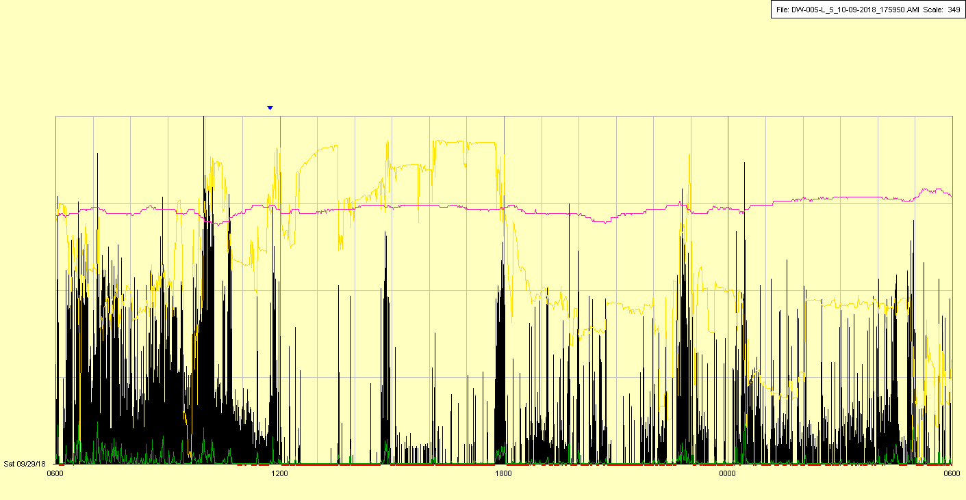

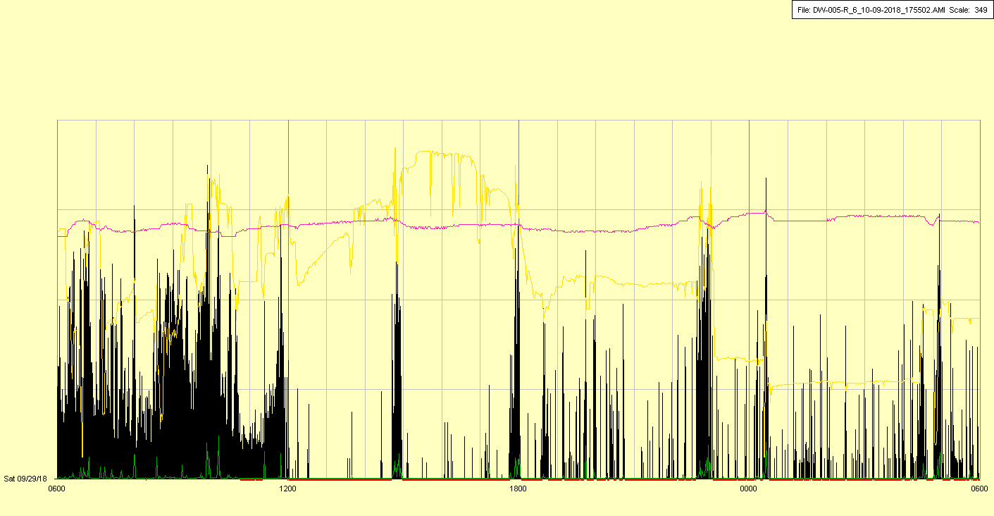

Intubation and mechanical ventilation beginning around noon

|  |  |  |  |
| --- | --- | --- | --- |
| Study ID | DW5 | Initial NIHSS (affected arm) | 4 |
| Age | 78 | Sex | Male |
| ICH Location | Left hemispheric | Patient location | ICU |
| Hospital day | 8 | Mechanical ventilation | Yes |
| Delirium status | Yes | 3-month mRS |  |

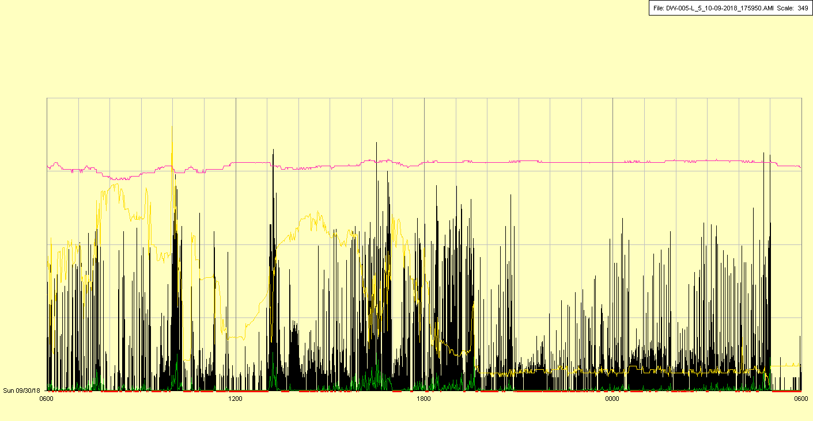

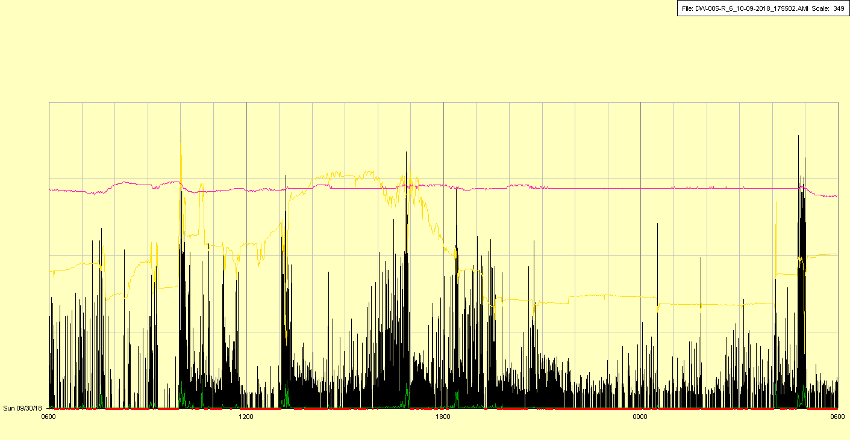

|  |  |  |  |
| --- | --- | --- | --- |
| Study ID | DW5 | Initial NIHSS (affected arm) | 4 |
| Age | 78 | Sex | Male |
| ICH Location | Left hemispheric | Patient location | ICU |
| Hospital day | 9 | Mechanical ventilation | Yes |
| Delirium status | Yes | 3-month mRS |  |

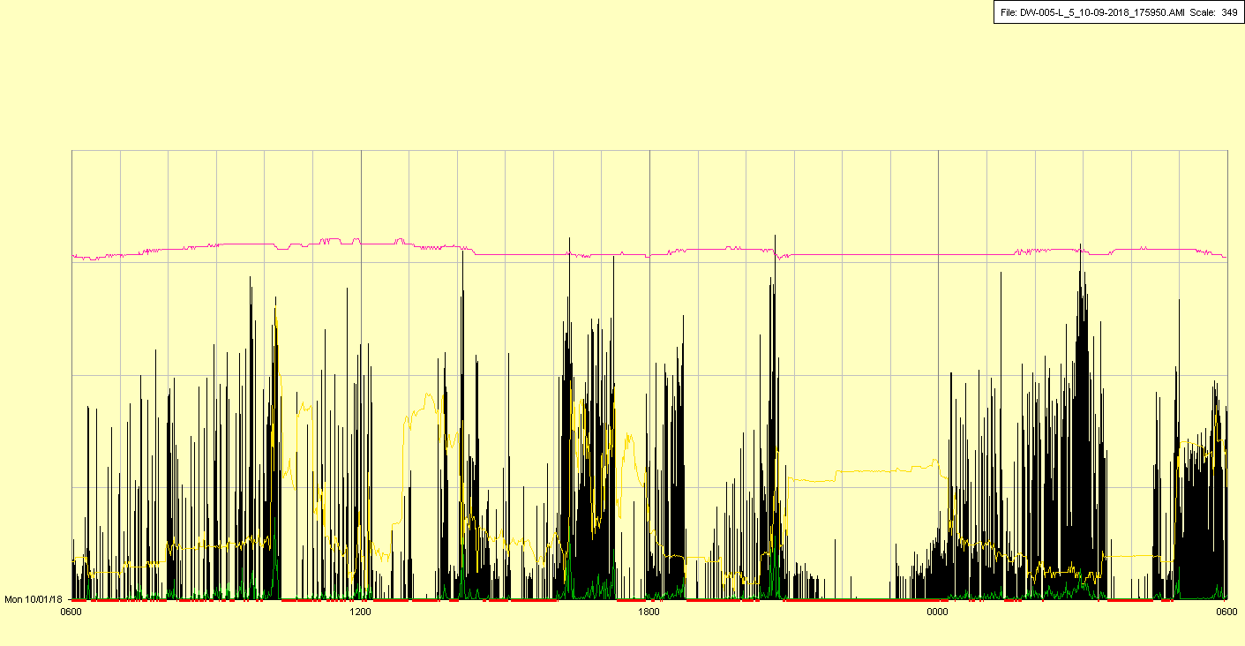

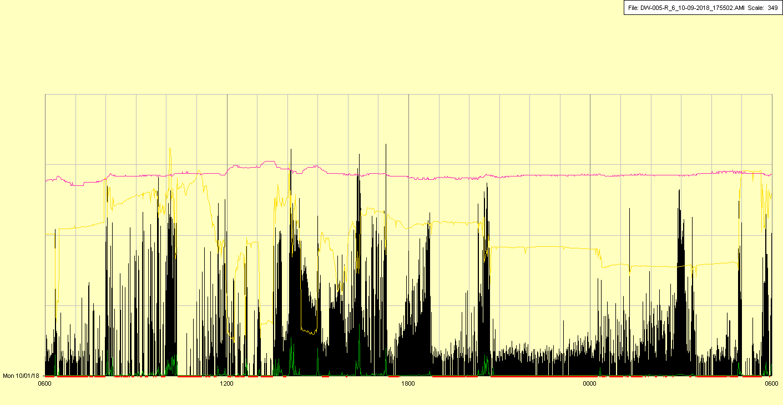

|  |  |  |  |
| --- | --- | --- | --- |
| Study ID | DW5 | Initial NIHSS (affected arm) | 4 |
| Age | 78 | Sex | Male |
| ICH Location | Left hemispheric | Patient location | ICU |
| Hospital day | 10 | Mechanical ventilation | Yes |
| Delirium status | Yes | 3-month mRS |  |

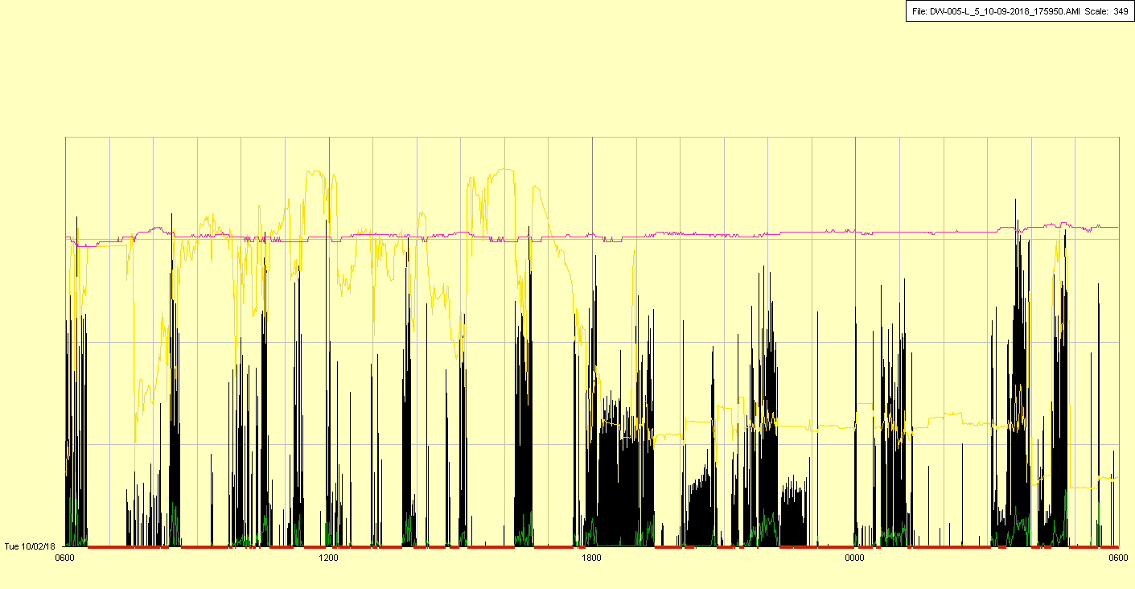

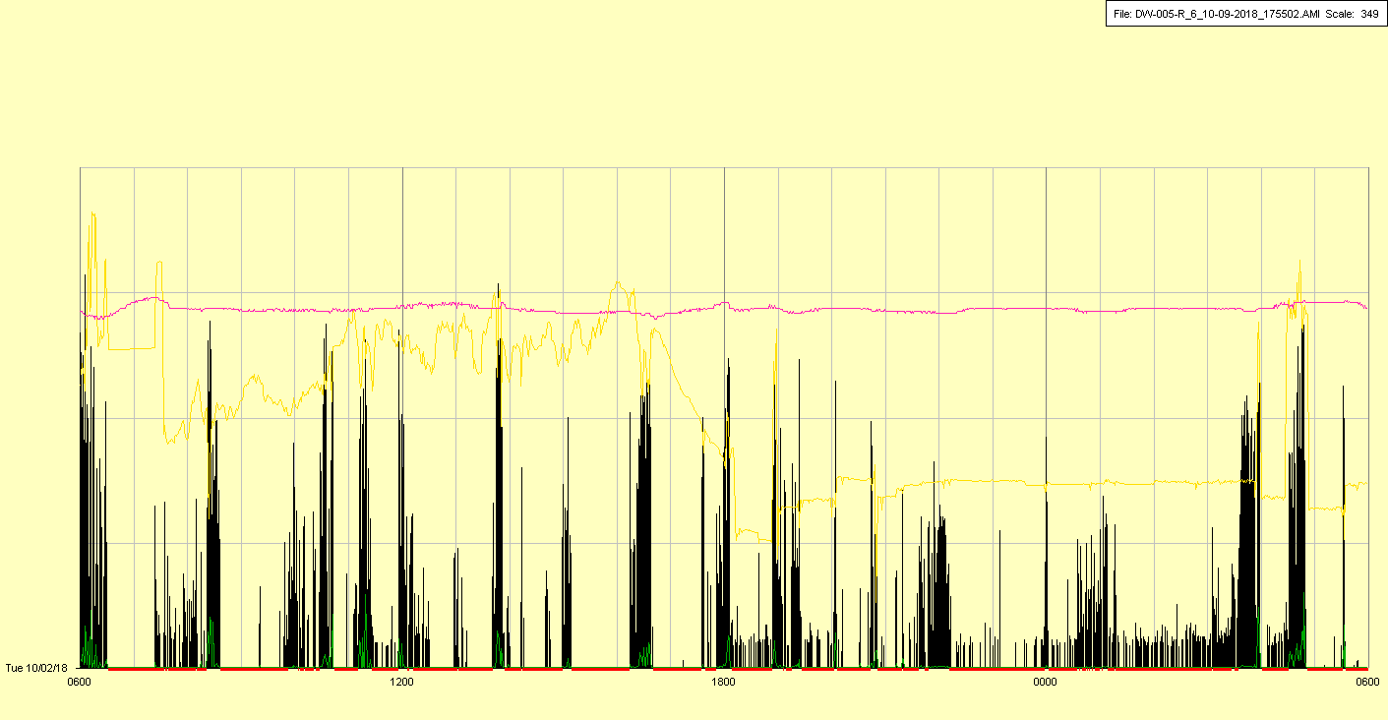

|  |  |  |  |
| --- | --- | --- | --- |
| Study ID | DW5 | Initial NIHSS (affected arm) | 4 |
| Age | 78 | Sex | Male |
| ICH Location | Left hemispheric | Patient location | ICU |
| Hospital day | 11 | Mechanical ventilation | Yes |
| Delirium status | Yes | 3-month mRS |  |

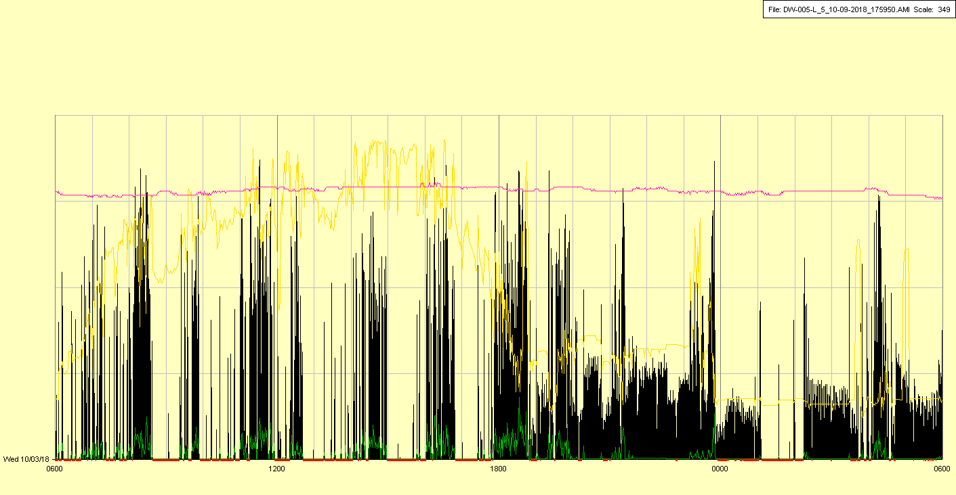

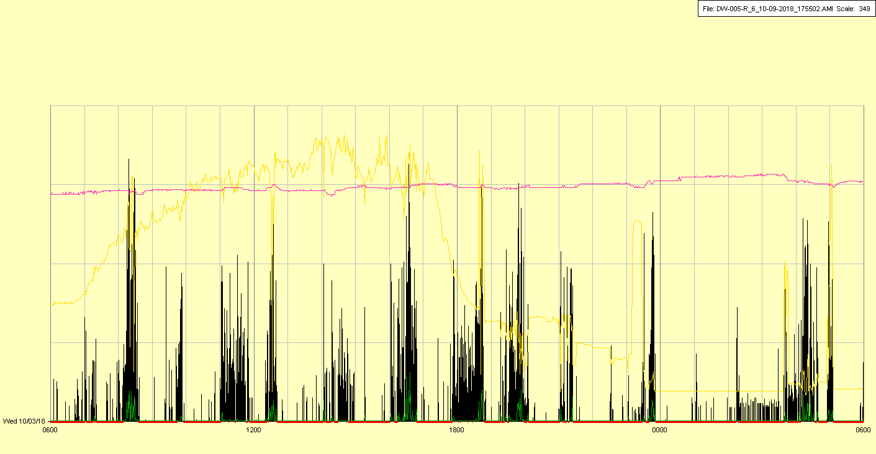

|  |  |  |  |
| --- | --- | --- | --- |
| Study ID | DW5 | Initial NIHSS (affected arm) | 4 |
| Age | 78 | Sex | Male |
| ICH Location | Left hemispheric | Patient location | ICU |
| Hospital day | 12 | Mechanical ventilation | Yes |
| Delirium status | Yes | 3-month mRS |  |

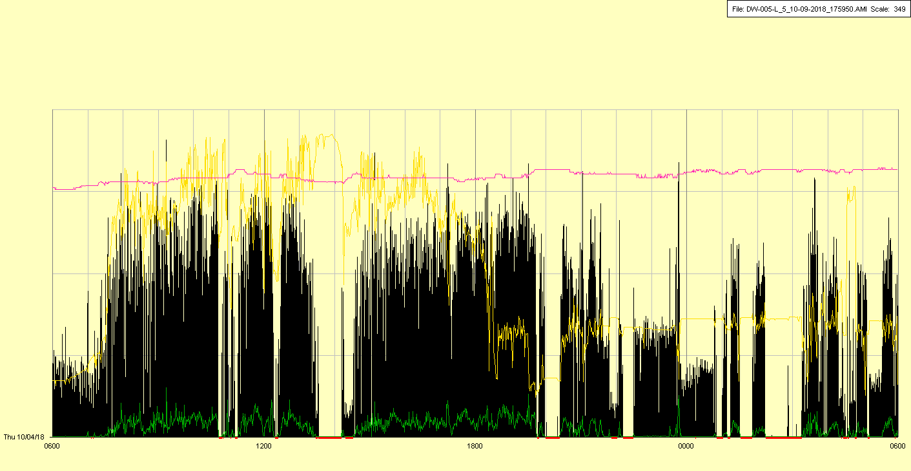

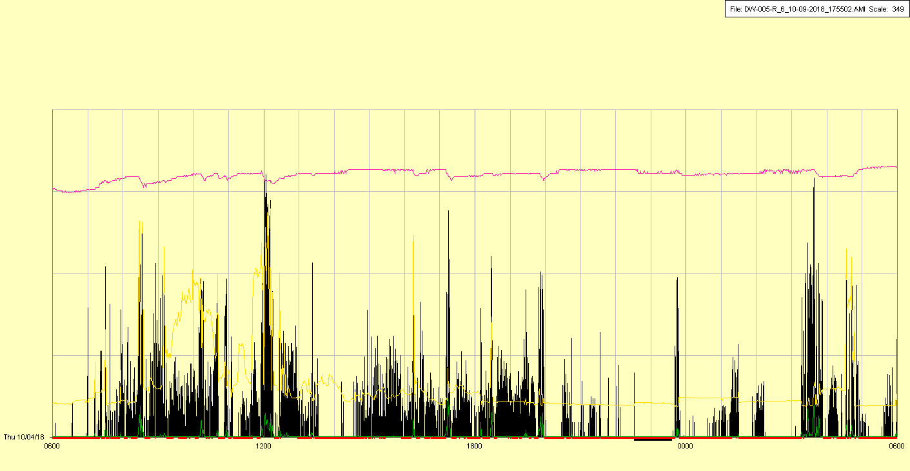

|  |  |  |  |
| --- | --- | --- | --- |
| Study ID | DW5 | Initial NIHSS (affected arm) | 4 |
| Age | 78 | Sex | Male |
| ICH Location | Left hemispheric | Patient location | ICU |
| Hospital day | 13 | Mechanical ventilation | Yes |
| Delirium status | Yes | 3-month mRS |  |

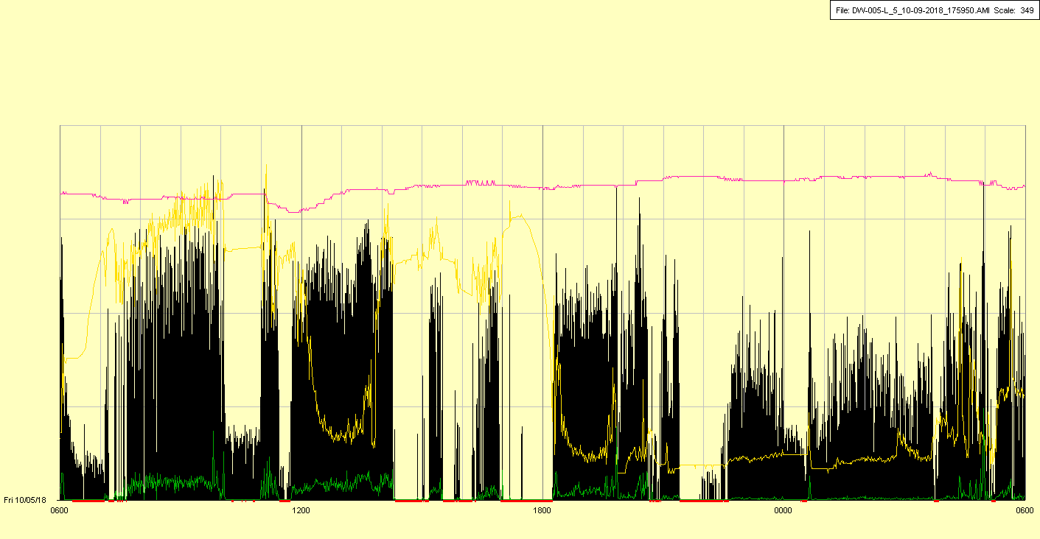

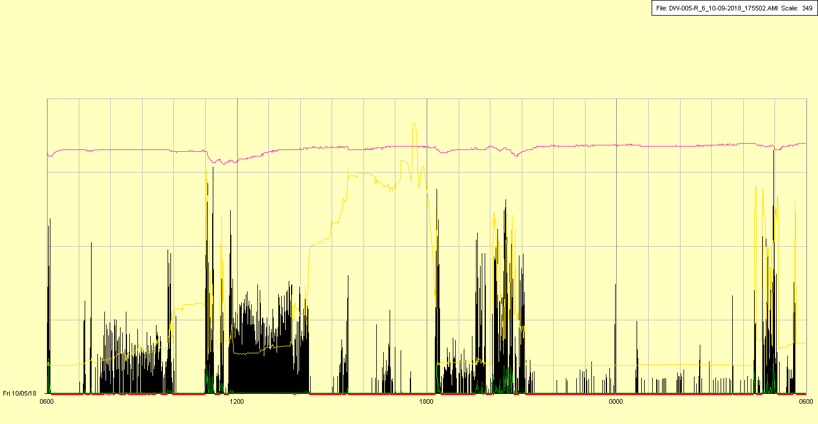

|  |  |  |  |
| --- | --- | --- | --- |
| Study ID | DW5 | Initial NIHSS (affected arm) | 4 |
| Age | 78 | Sex | Male |
| ICH Location | Left hemispheric | Patient location | ICU |
| Hospital day | 14 | Mechanical ventilation | Yes |
| Delirium status | N/A (Probable yes) | 3-month mRS |  |

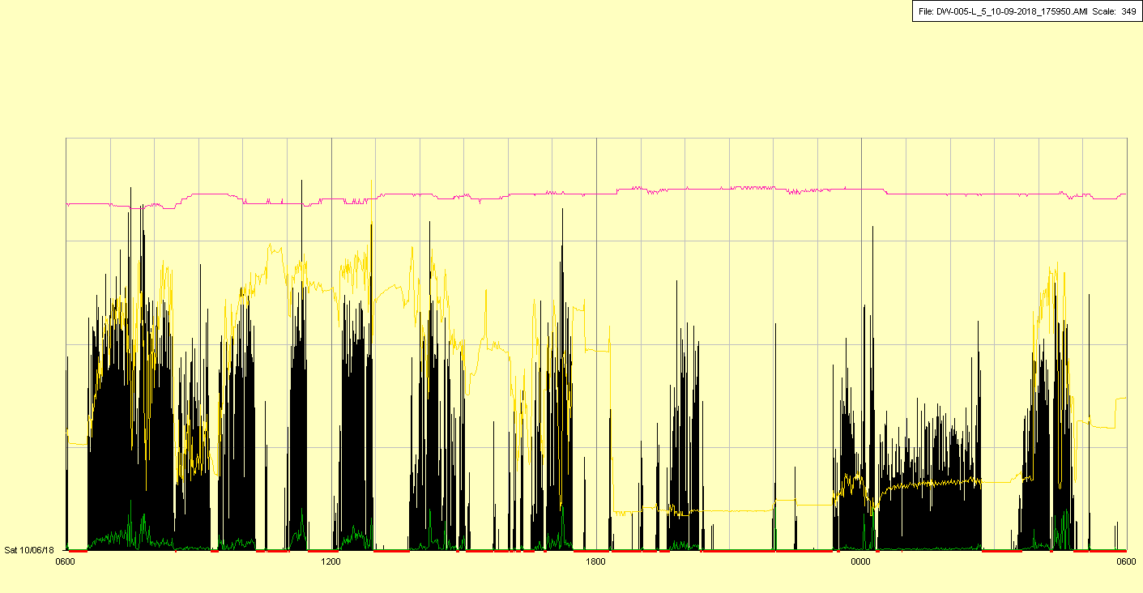

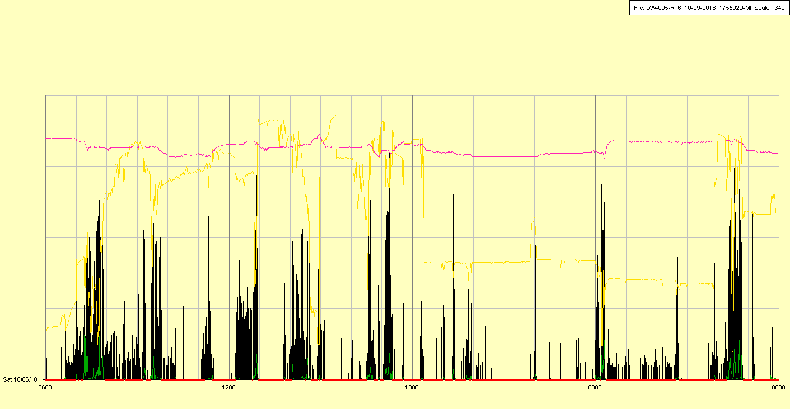

|  |  |  |  |
| --- | --- | --- | --- |
| Study ID | DW5 | Initial NIHSS (affected arm) | 4 |
| Age | 78 | Sex | Male |
| ICH Location | Left hemispheric | Patient location | ICU |
| Hospital day | 15 | Mechanical ventilation | Yes (briefly) |
| Delirium status | N/A (Probable yes) | 3-month mRS |  |

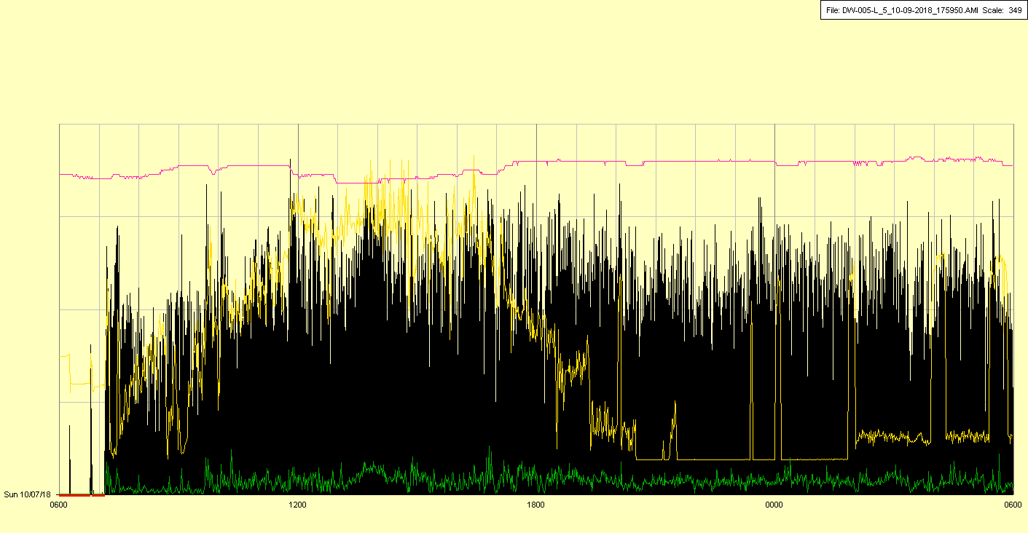

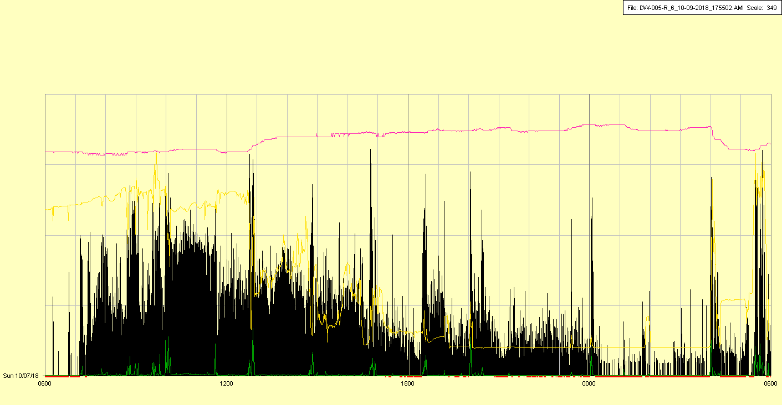

Extubated and off mechanical ventilation in AM

|  |  |  |  |
| --- | --- | --- | --- |
| Study ID | DW5 | Initial NIHSS (affected arm) | 4 |
| Age | 78 | Sex | Male |
| ICH Location | Left hemispheric | Patient location | ICU |
| Hospital day | 16 | Mechanical ventilation | No |
| Delirium status | No | 3-month mRS |  |

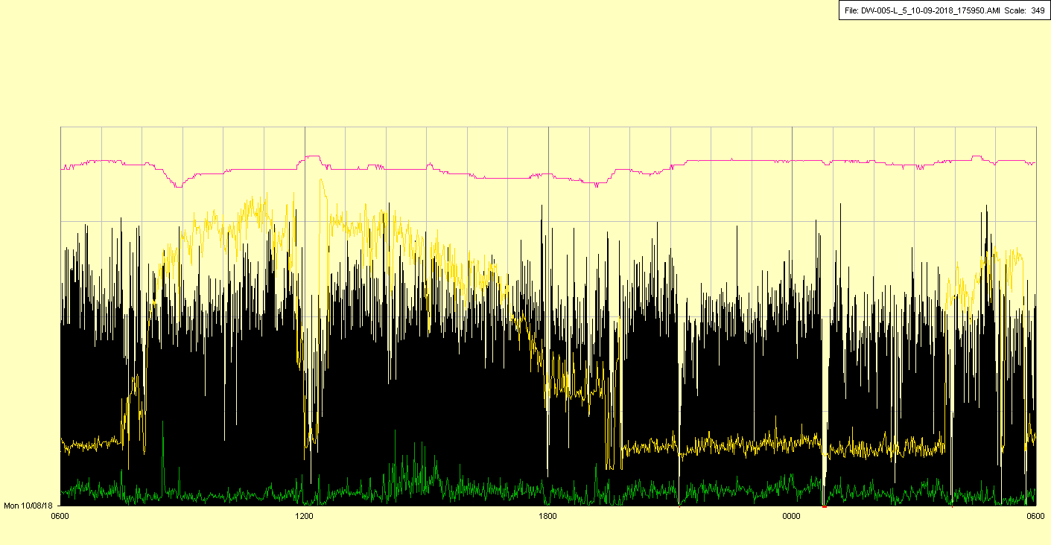

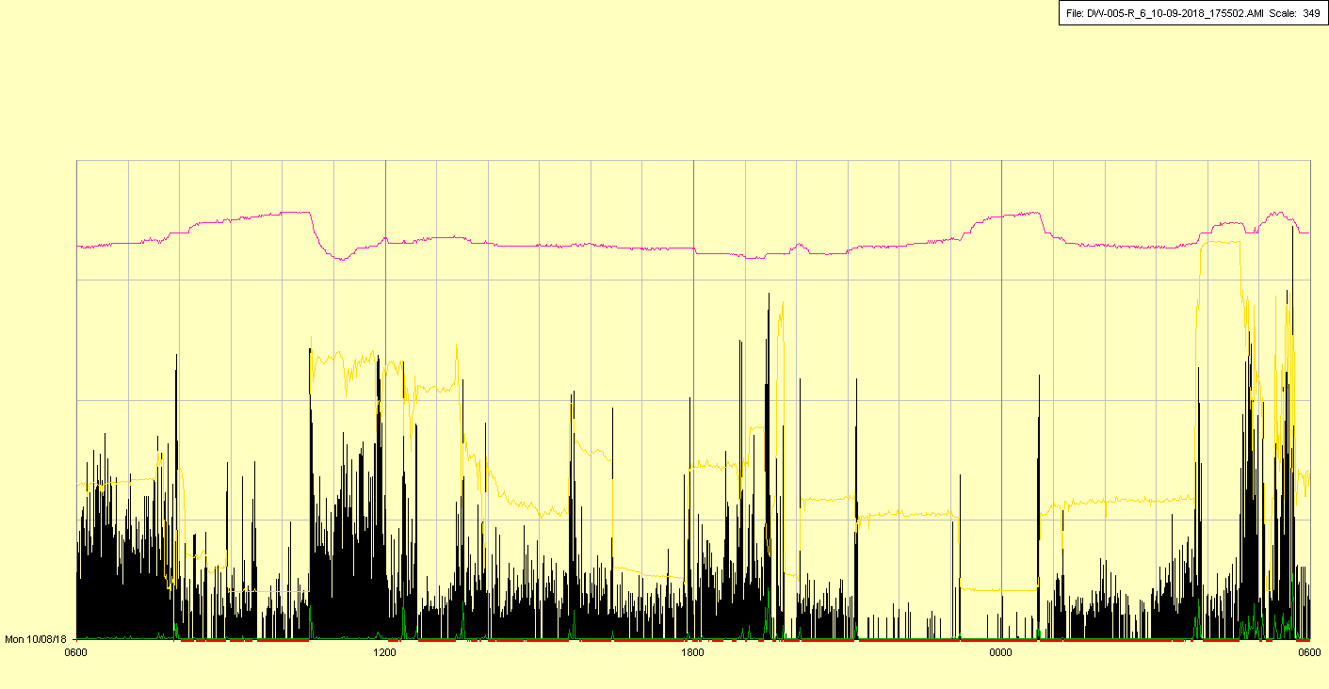

|  |  |  |  |
| --- | --- | --- | --- |
| Study ID | DW5 | Initial NIHSS (affected arm) | 4 |
| Age | 78 | Sex | Male |
| ICH Location | Left hemispheric | Patient location | ICU |
| Hospital day | 17 | Mechanical ventilation | No |
| Delirium status | Yes | 3-month mRS |  |

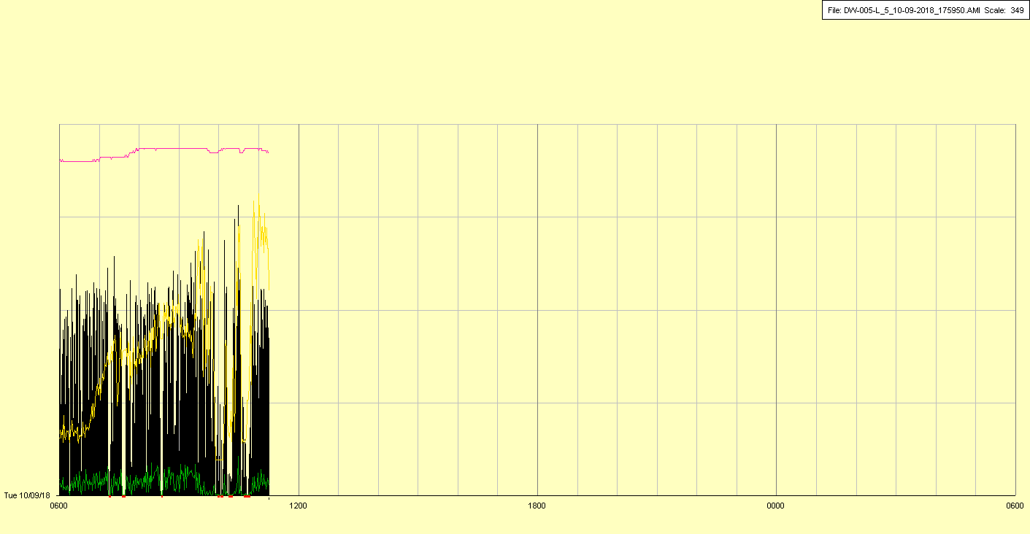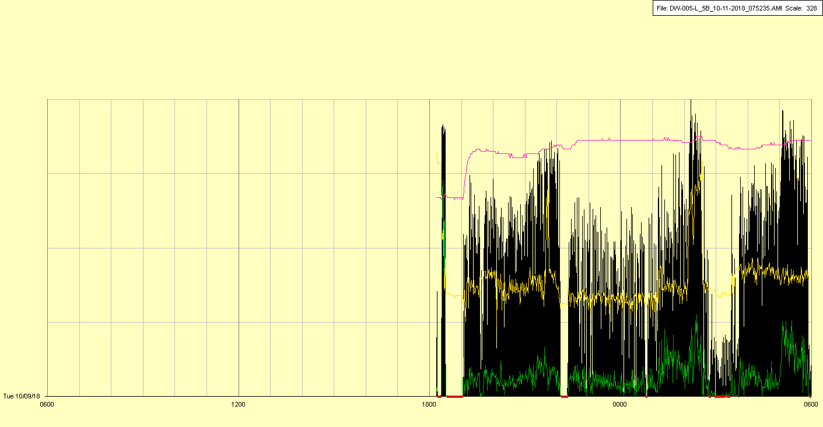

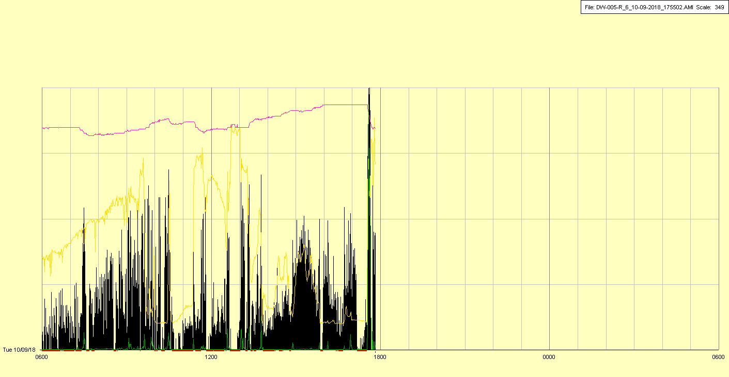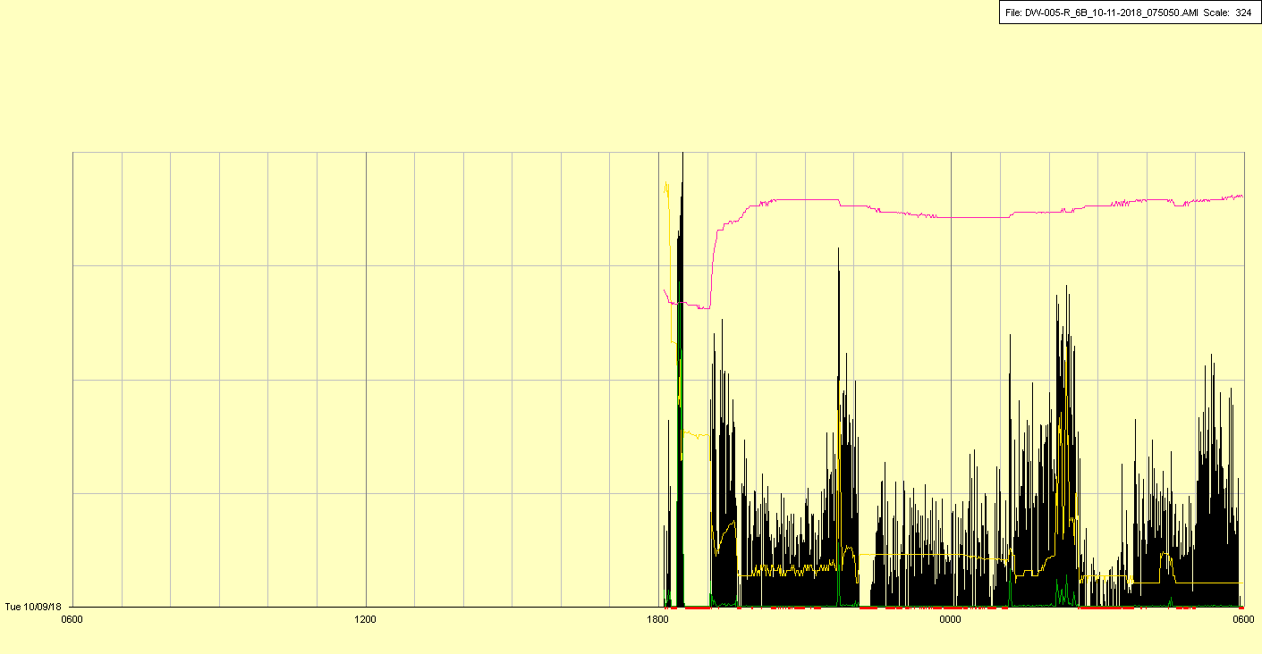

Off periods (brief on right, long on left) as above

|  |  |  |  |
| --- | --- | --- | --- |
| Study ID | DW5 | Initial NIHSS (affected arm) | 4 |
| Age | 78 | Sex | Male |
| ICH Location | Left hemispheric | Patient location | ICU 🡪 Floor |
| Hospital day | 18 | Mechanical ventilation | No |
| Delirium status | Yes | 3-month mRS |  |

