|  |  |  |  |
| --- | --- | --- | --- |
| Study ID | DW8 | Initial NIHSS (affected arm) | 1 |
| Age | 83 | Sex | Male |
| ICH Location | Left deep | Patient location | ICU |
| Hospital day | 1 | Mechanical ventilation | No |
| Delirium status | Yes | 3-month mRS | 6 |

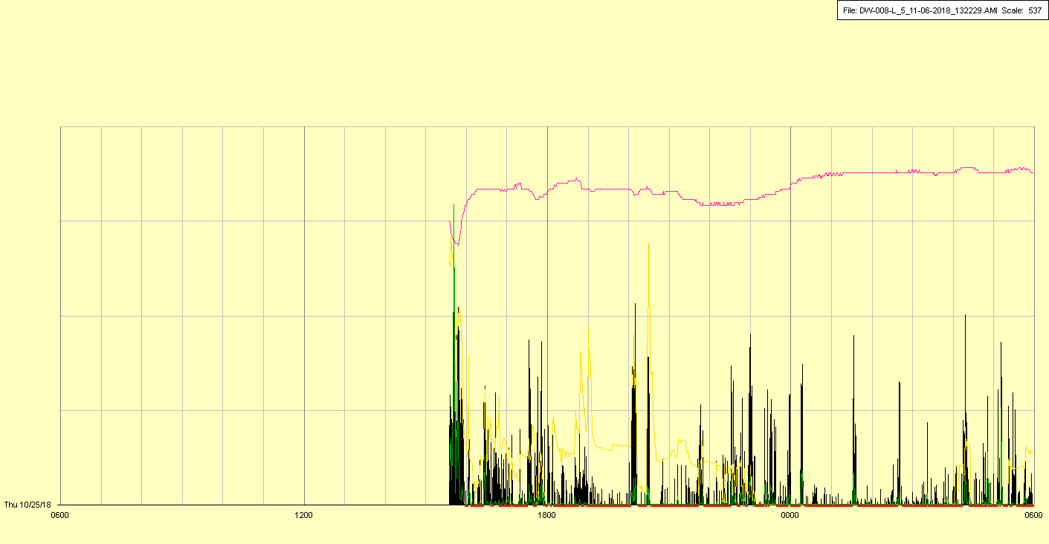

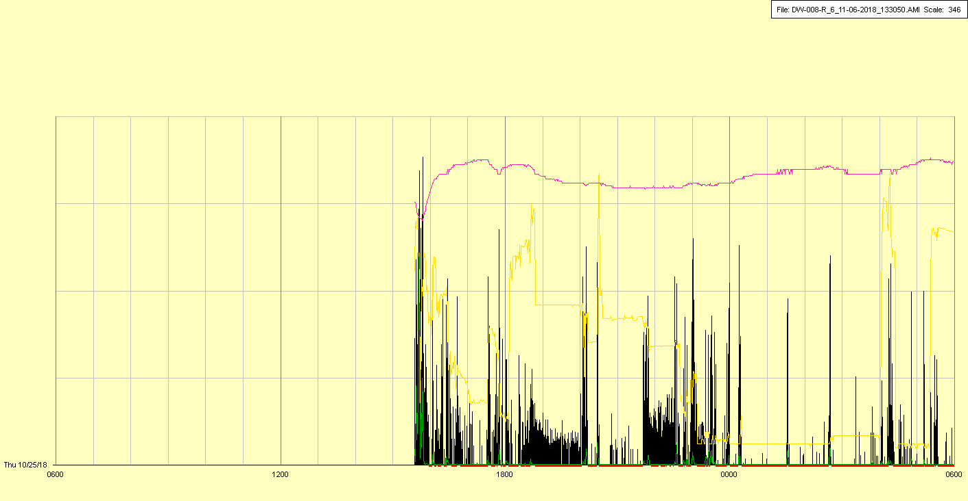

|  |  |  |  |
| --- | --- | --- | --- |
| Study ID | DW8 | Initial NIHSS (affected arm) | 1 |
| Age | 83 | Sex | Male |
| ICH Location | Left deep | Patient location | ICU |
| Hospital day | 2 | Mechanical ventilation | No |
| Delirium status | No | 3-month mRS | 6 |

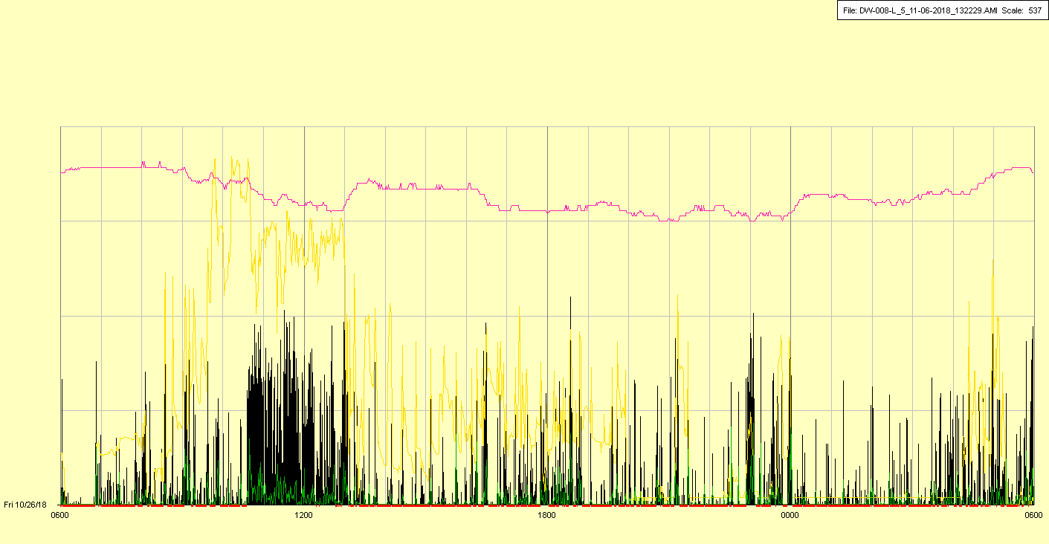

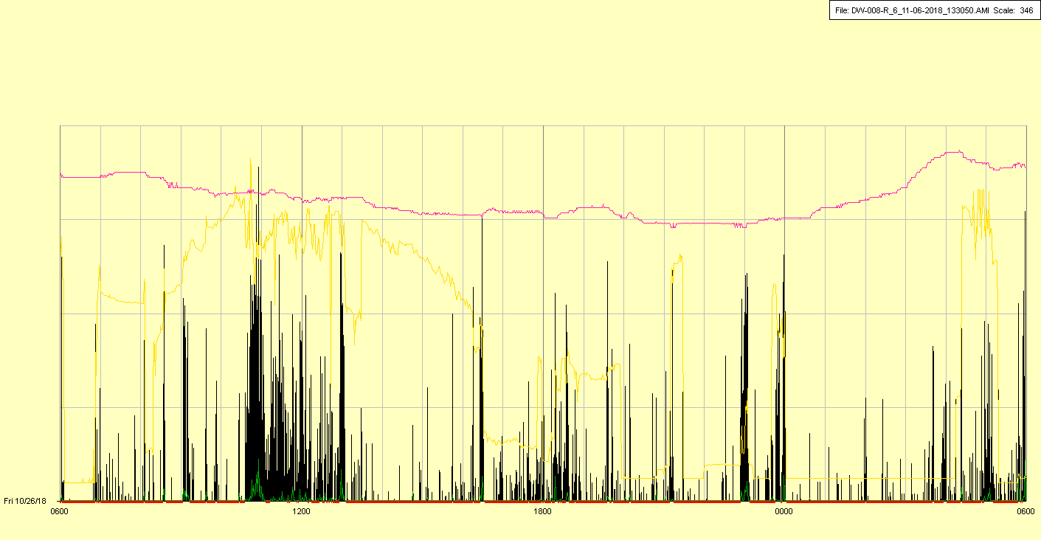

|  |  |  |  |
| --- | --- | --- | --- |
| Study ID | DW8 | Initial NIHSS (affected arm) | 1 |
| Age | 83 | Sex | Male |
| ICH Location | Left deep | Patient location | ICU |
| Hospital day | 3 | Mechanical ventilation | No |
| Delirium status |  | 3-month mRS | 6 |

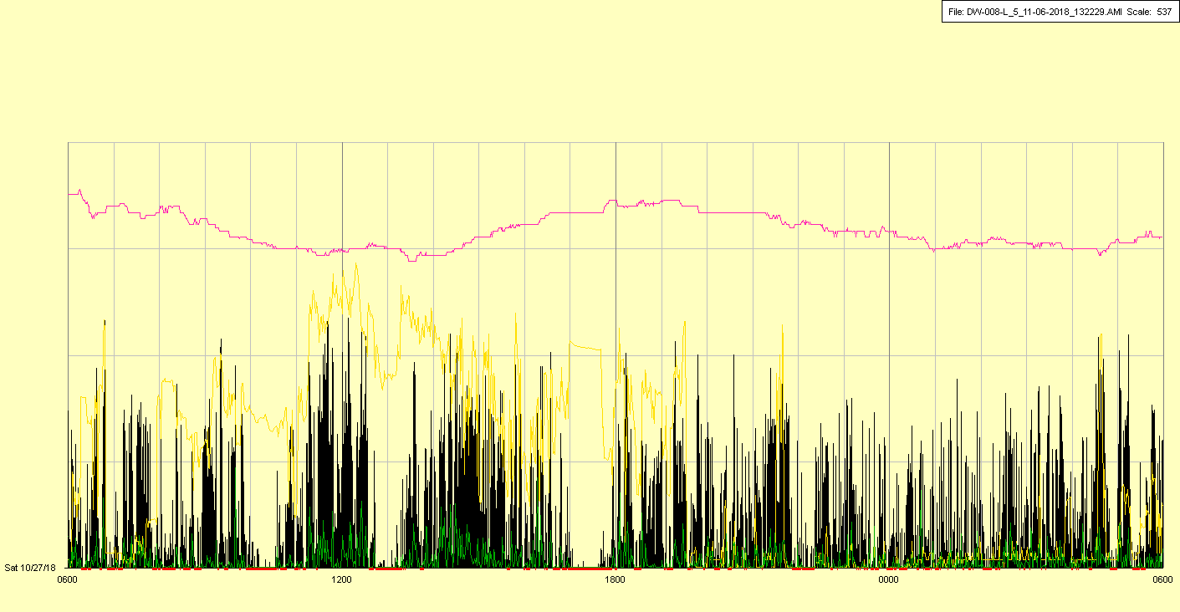

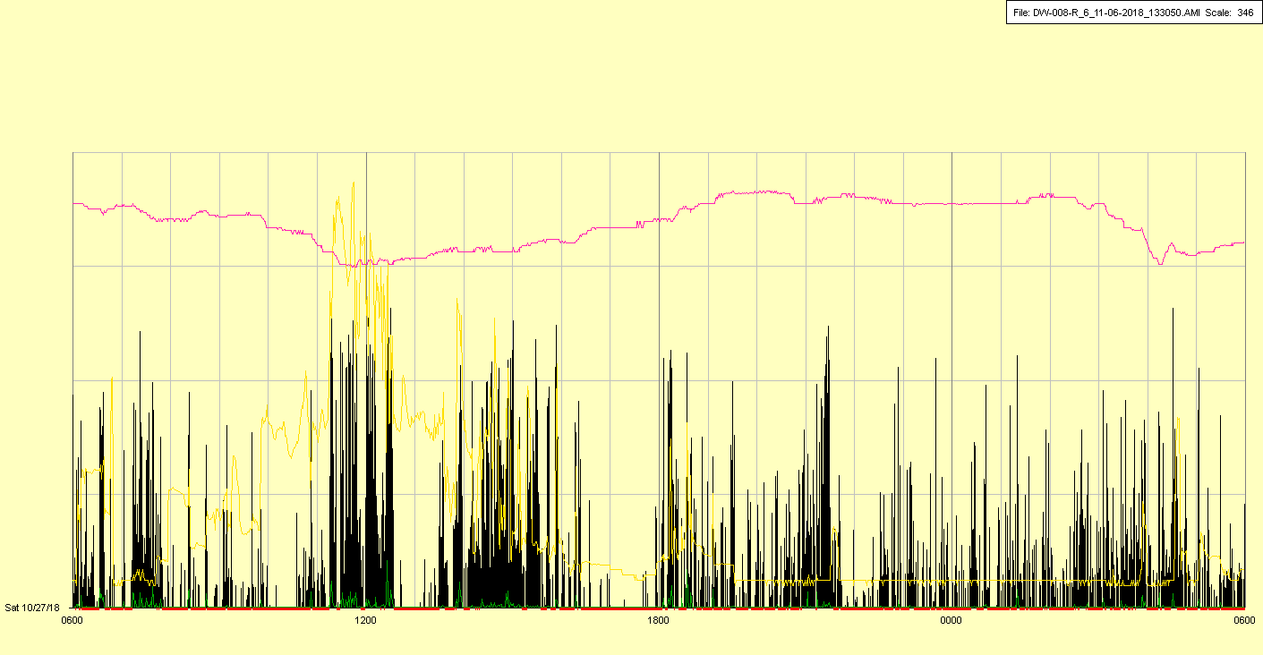

|  |  |  |  |
| --- | --- | --- | --- |
| Study ID | DW8 | Initial NIHSS (affected arm) | 1 |
| Age | 83 | Sex | Male |
| ICH Location | Left deep | Patient location | ICU |
| Hospital day | 4 | Mechanical ventilation | No |
| Delirium status |  | 3-month mRS | 6 |

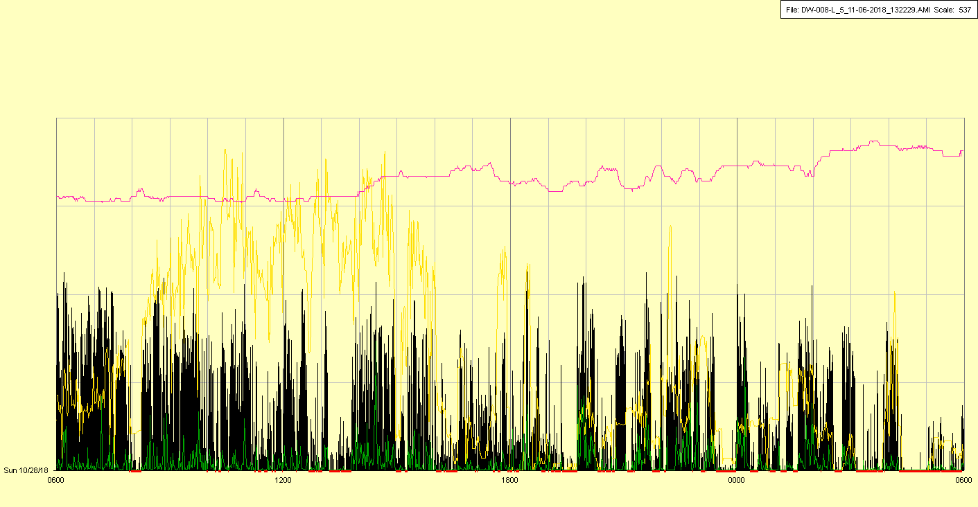

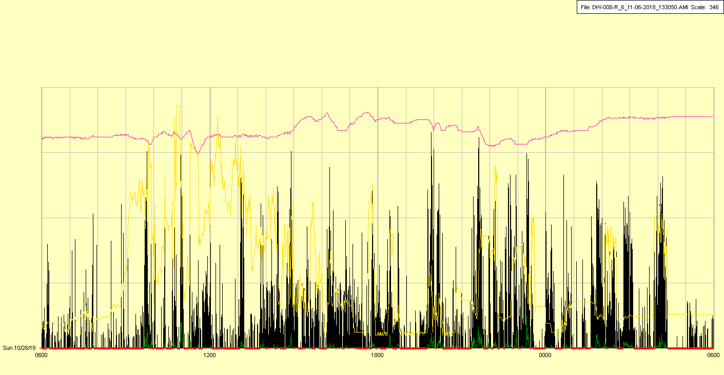

|  |  |  |  |
| --- | --- | --- | --- |
| Study ID | DW8 | Initial NIHSS (affected arm) | 1 |
| Age | 83 | Sex | Male |
| ICH Location | Left deep | Patient location | ICU |
| Hospital day | 5 | Mechanical ventilation | No |
| Delirium status |  | 3-month mRS | 6 |

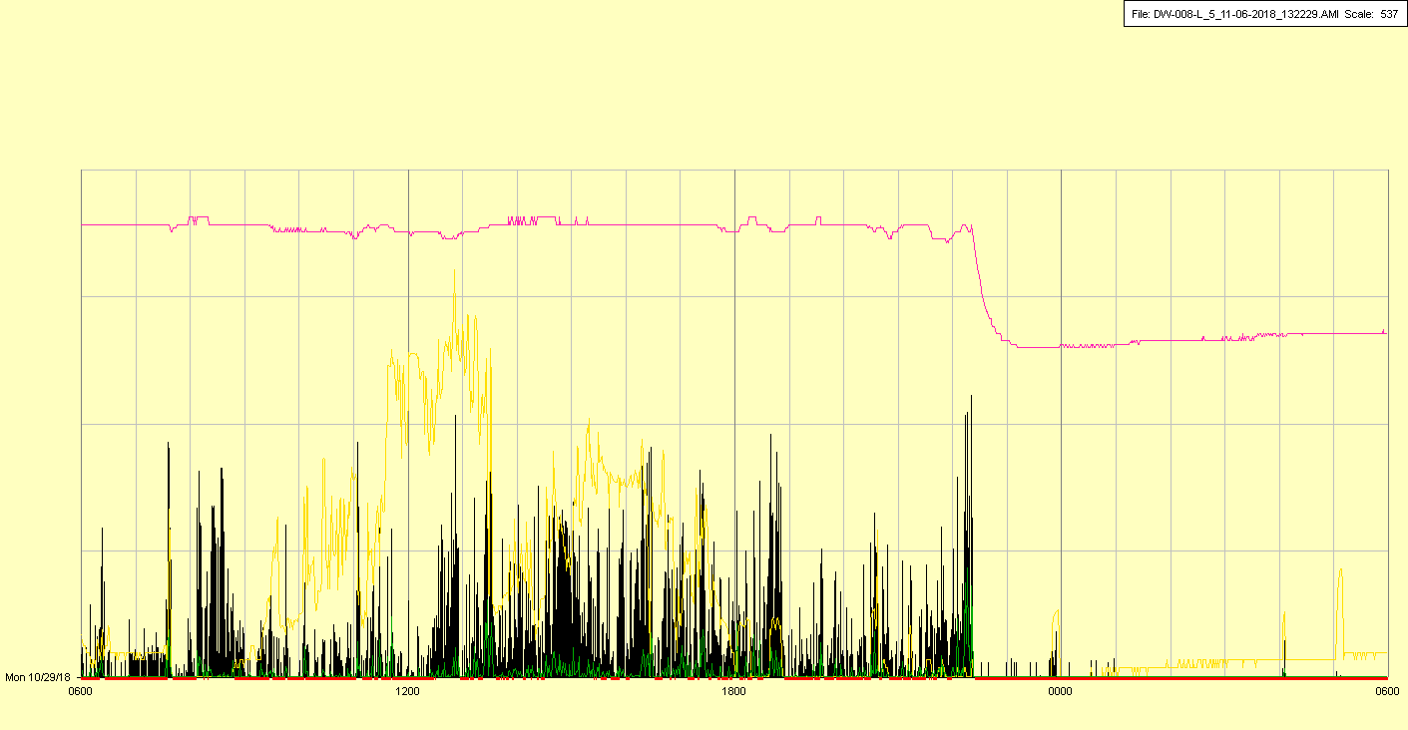

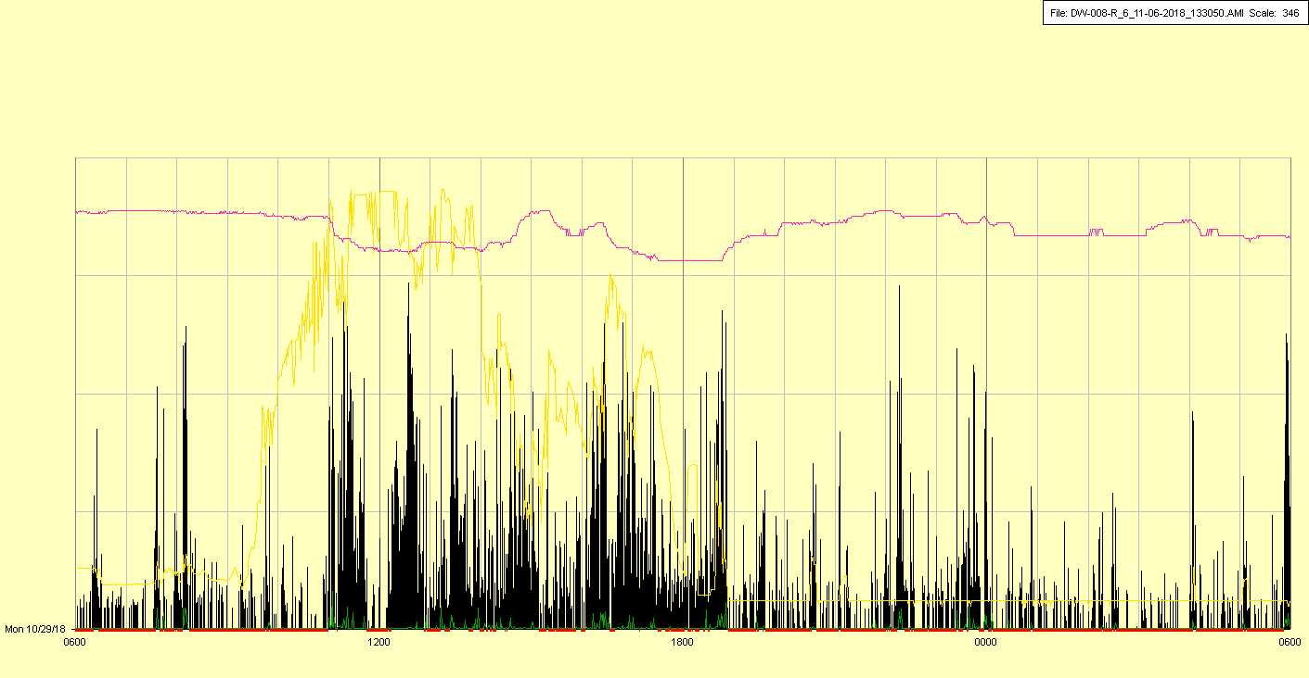

Unknown overnight off period (patient removed left watch?)

|  |  |  |  |
| --- | --- | --- | --- |
| Study ID | DW8 | Initial NIHSS (affected arm) | 1 |
| Age | 83 | Sex | Male |
| ICH Location | Left deep | Patient location | ICU |
| Hospital day | 6 | Mechanical ventilation | No |
| Delirium status |  | 3-month mRS | 6 |

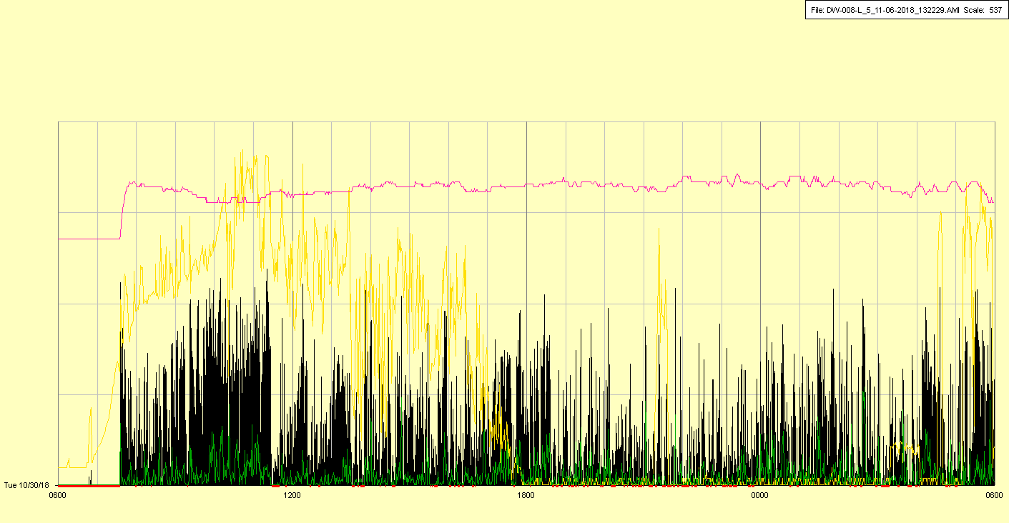

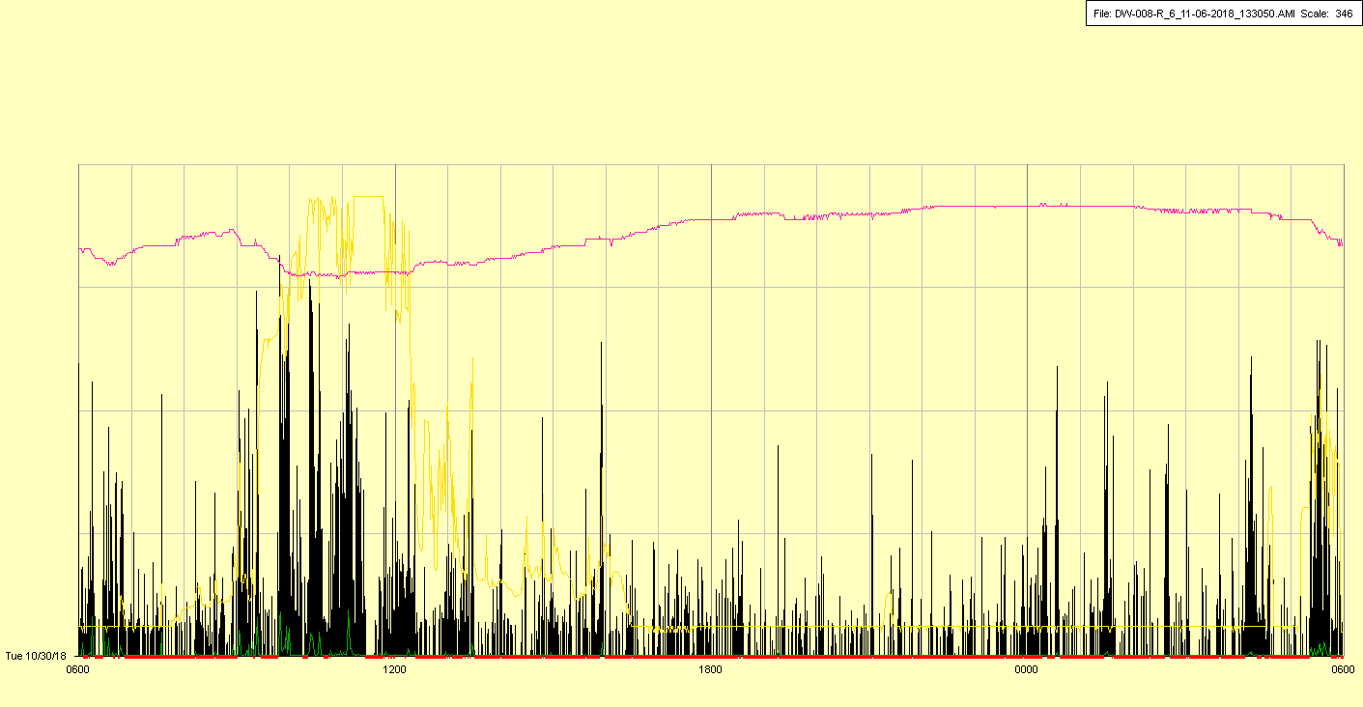

|  |  |  |  |
| --- | --- | --- | --- |
| Study ID | DW8 | Initial NIHSS (affected arm) | 1 |
| Age | 83 | Sex | Male |
| ICH Location | Left deep | Patient location | ICU |
| Hospital day | 7 | Mechanical ventilation | No |
| Delirium status |  | 3-month mRS | 6 |

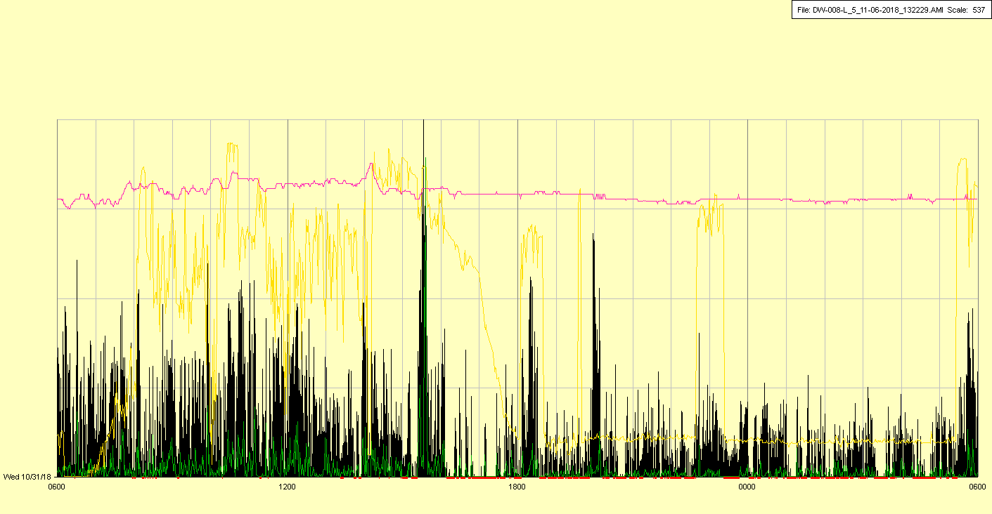

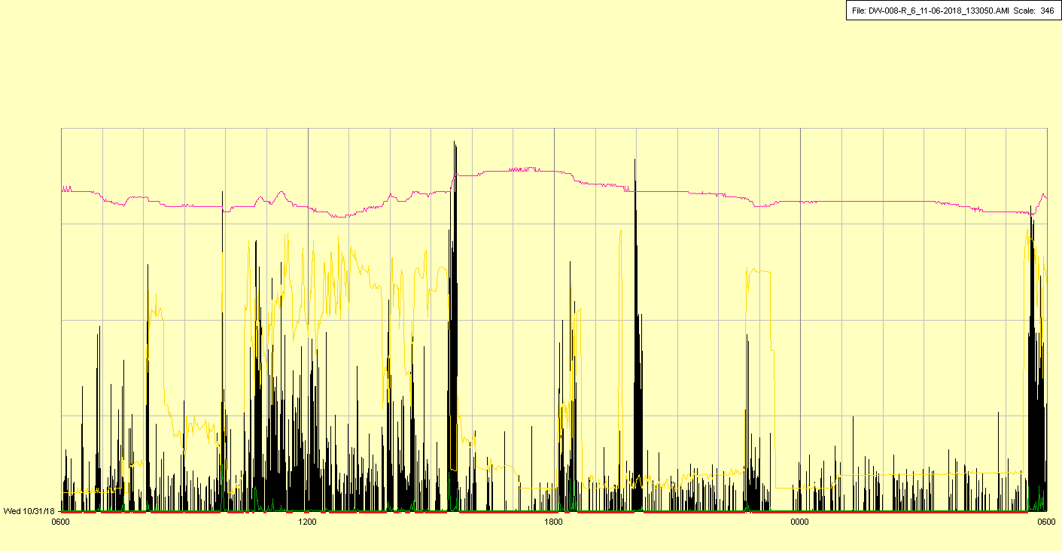

|  |  |  |  |
| --- | --- | --- | --- |
| Study ID | DW8 | Initial NIHSS (affected arm) | 1 |
| Age | 83 | Sex | Male |
| ICH Location | Left deep | Patient location | ICU |
| Hospital day | 8 | Mechanical ventilation | No |
| Delirium status |  | 3-month mRS | 6 |

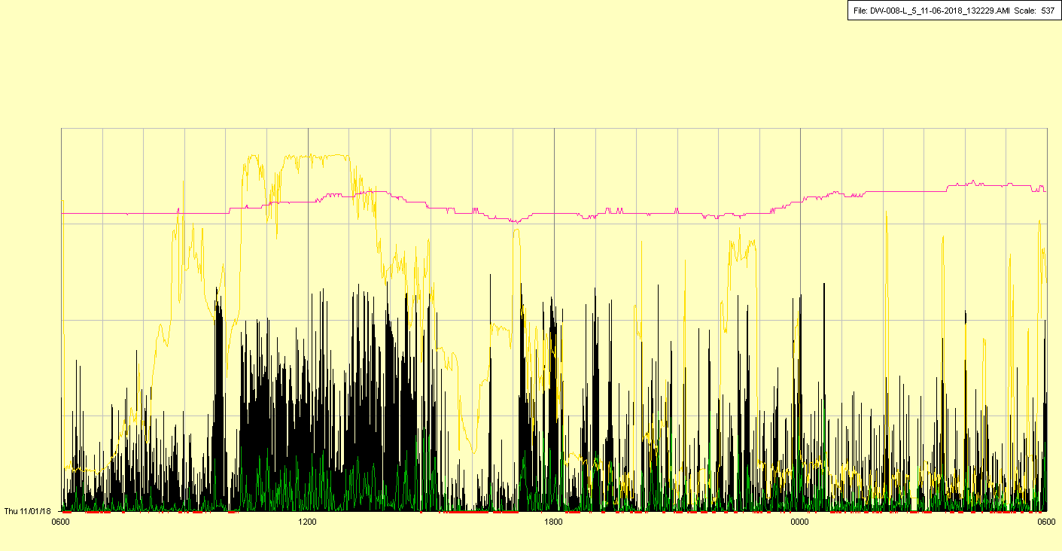

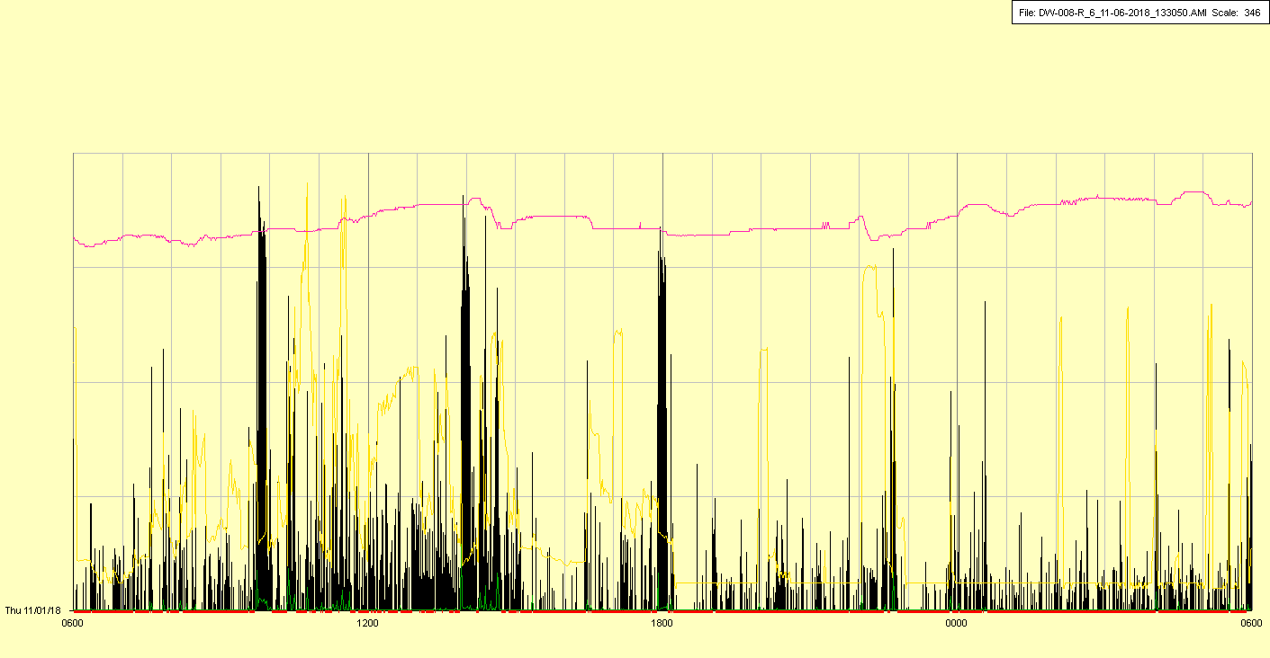

|  |  |  |  |
| --- | --- | --- | --- |
| Study ID | DW8 | Initial NIHSS (affected arm) | 1 |
| Age | 83 | Sex | Male |
| ICH Location | Left deep | Patient location | Stroke Unit |
| Hospital day | 9 | Mechanical ventilation | No |
| Delirium status |  | 3-month mRS | 6 |

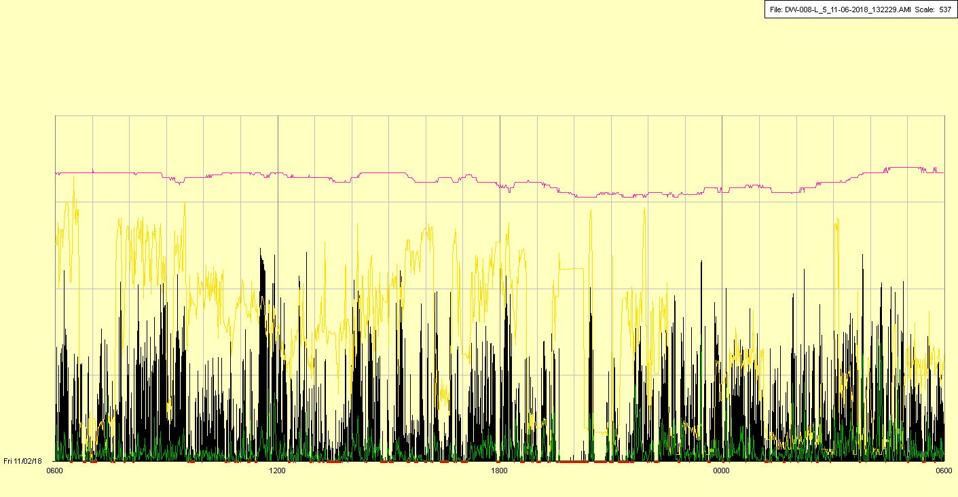

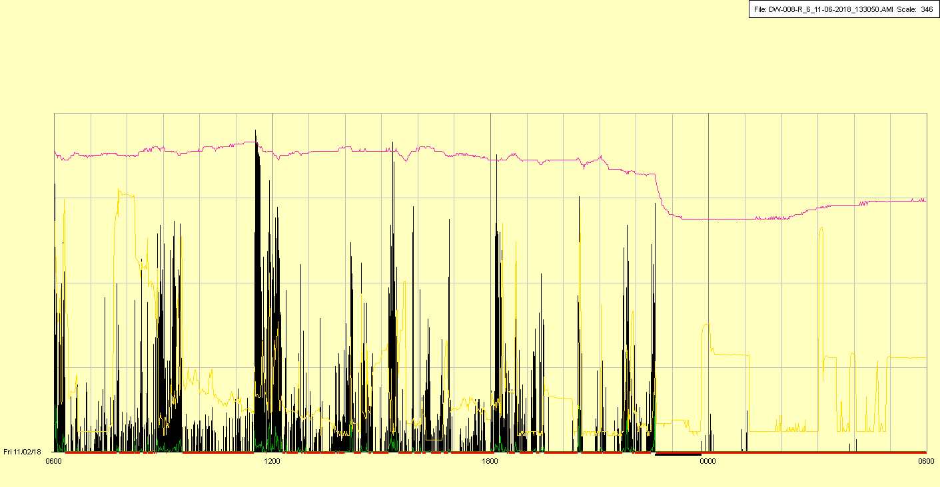

Unknown overnight off period (patient removed right watch?)

|  |  |  |  |
| --- | --- | --- | --- |
| Study ID | DW8 | Initial NIHSS (affected arm) | 1 |
| Age | 83 | Sex | Male |
| ICH Location | Left deep | Patient location | Stroke Unit |
| Hospital day | 10 | Mechanical ventilation | No |
| Delirium status |  | 3-month mRS | 6 |

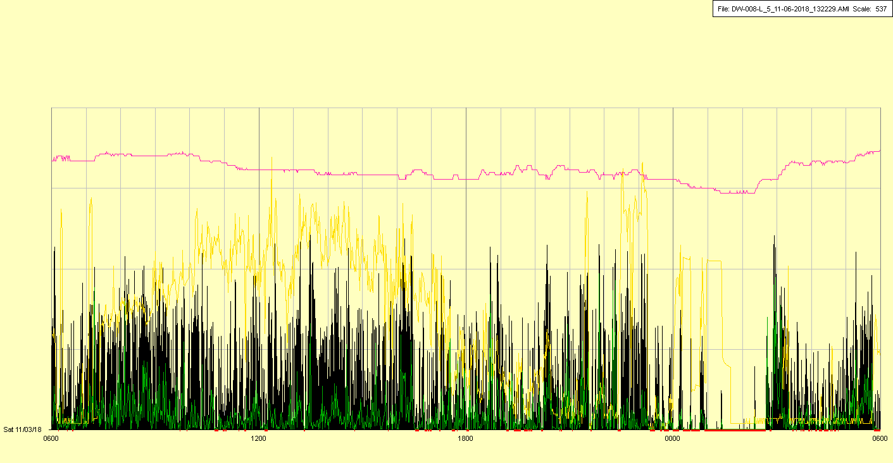

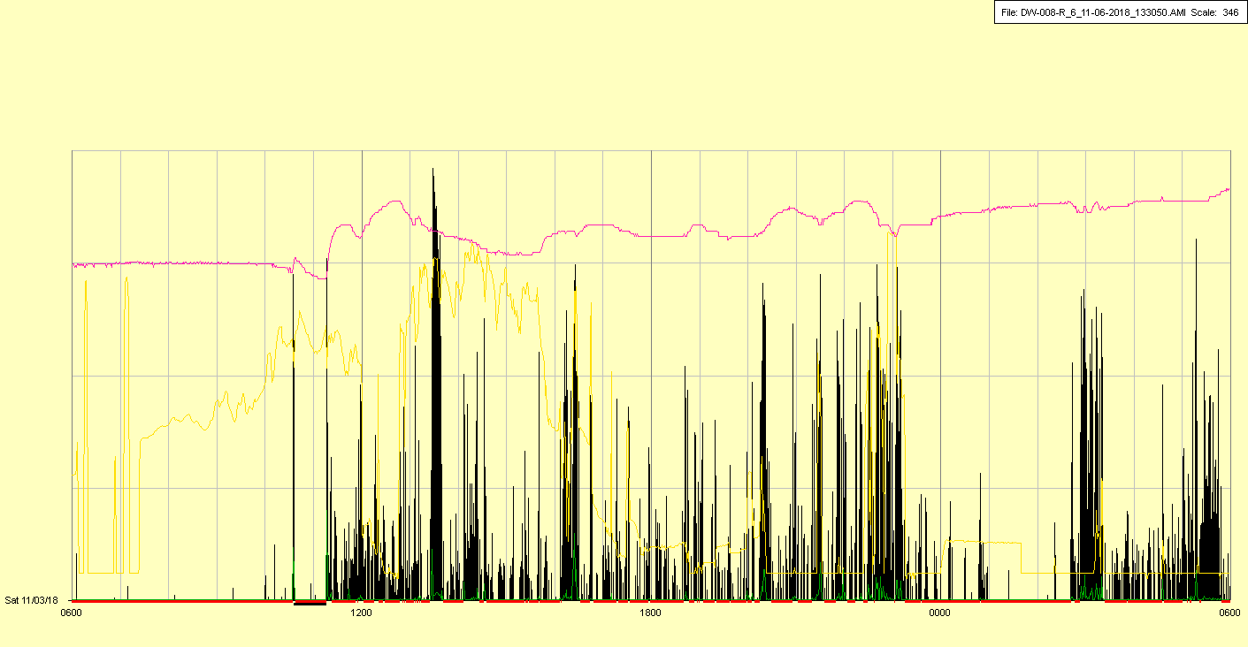

Off period continued until right watch repaired/replaced

|  |  |  |  |
| --- | --- | --- | --- |
| Study ID | DW8 | Initial NIHSS (affected arm) | 1 |
| Age | 83 | Sex | Male |
| ICH Location | Left deep | Patient location | Stroke Unit |
| Hospital day | 11 | Mechanical ventilation | No |
| Delirium status |  | 3-month mRS | 6 |

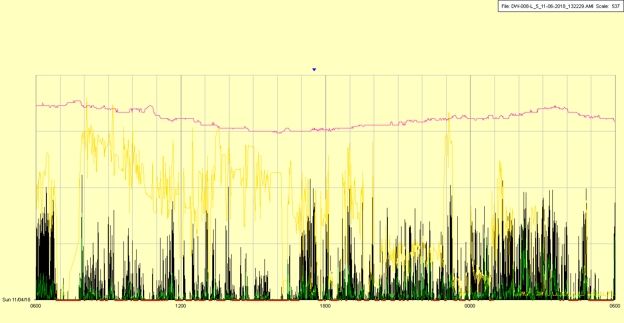

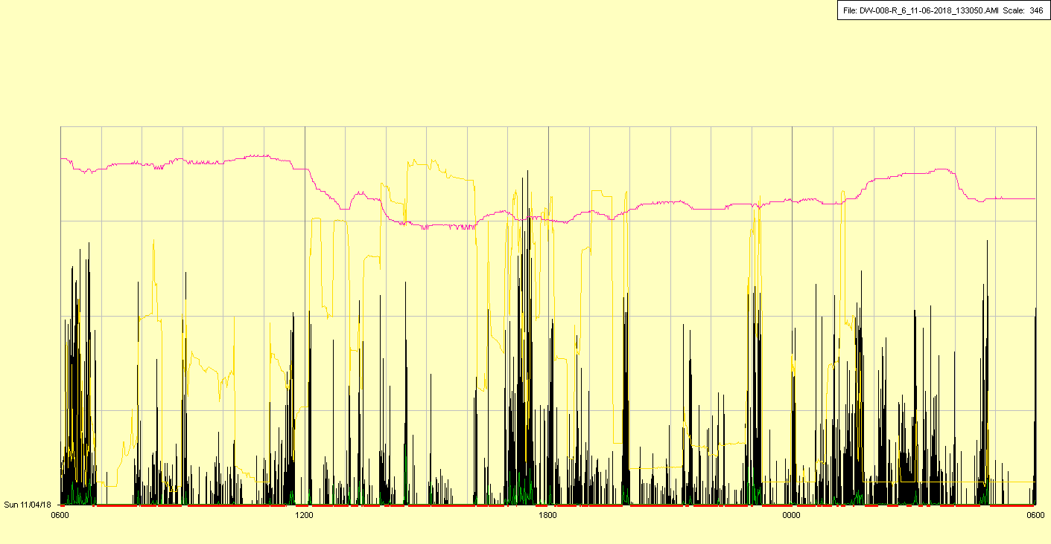

|  |  |  |  |
| --- | --- | --- | --- |
| Study ID | DW8 | Initial NIHSS (affected arm) | 1 |
| Age | 83 | Sex | Male |
| ICH Location | Left deep | Patient location | Stroke Unit |
| Hospital day | 12 | Mechanical ventilation | No |
| Delirium status |  | 3-month mRS | 6 |

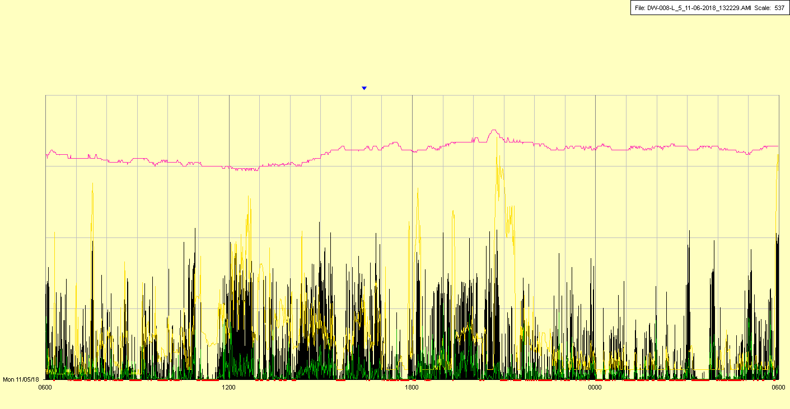

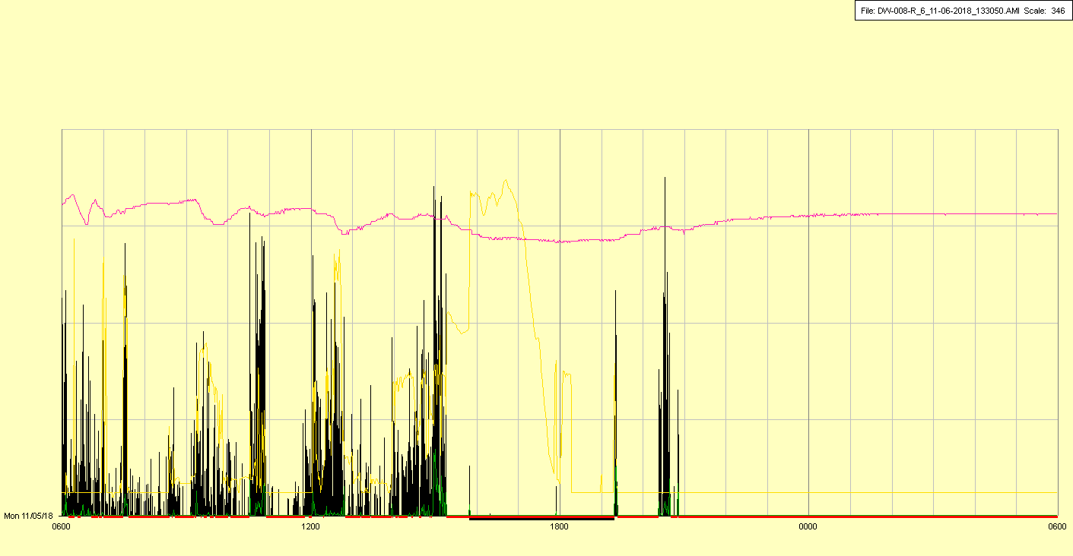

Right watch inadvertently taken off/broken in afternoon

|  |  |  |  |
| --- | --- | --- | --- |
| Study ID | DW8 | Initial NIHSS (affected arm) | 1 |
| Age | 83 | Sex | Male |
| ICH Location | Left deep | Patient location | Stroke Unit |
| Hospital day | 13 | Mechanical ventilation | No |
| Delirium status |  | 3-month mRS | 6 |

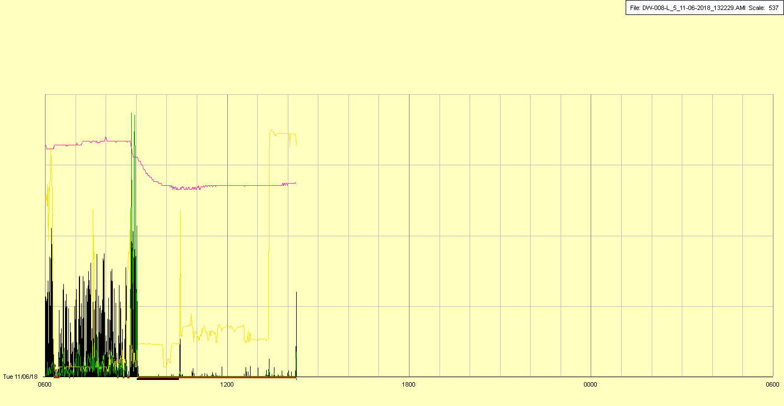

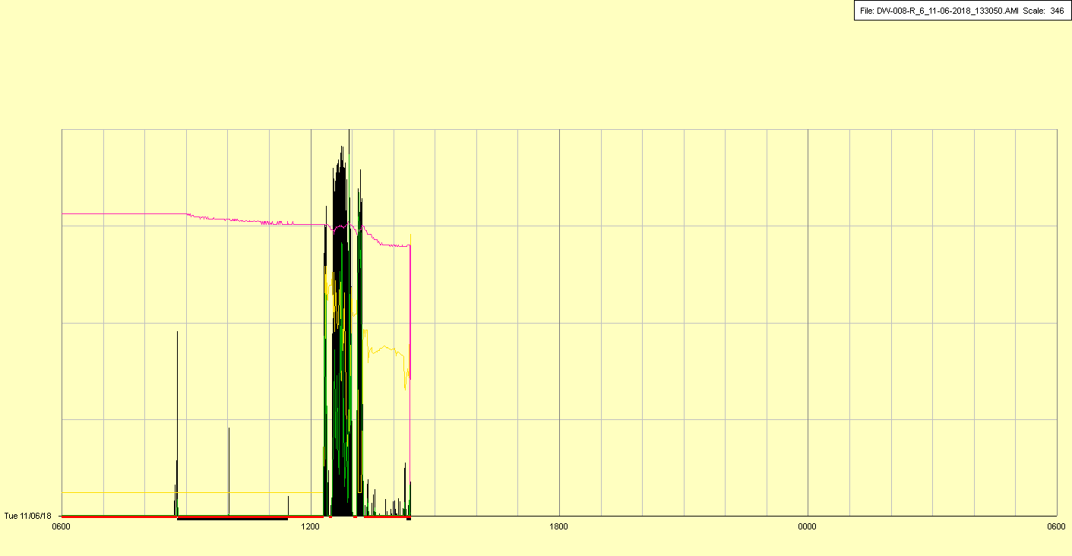

Left watch removed in early AM, right watch remained off