|  |  |  |  |
| --- | --- | --- | --- |
| Study ID | DW9 | Initial NIHSS (affected arm) | 3 |
| Age | 55 | Sex | Female |
| ICH Location | Right deep | Patient location | ICU |
| Hospital day | 1 | Mechanical ventilation | No |
| Delirium status | No | 3-month mRS |  |

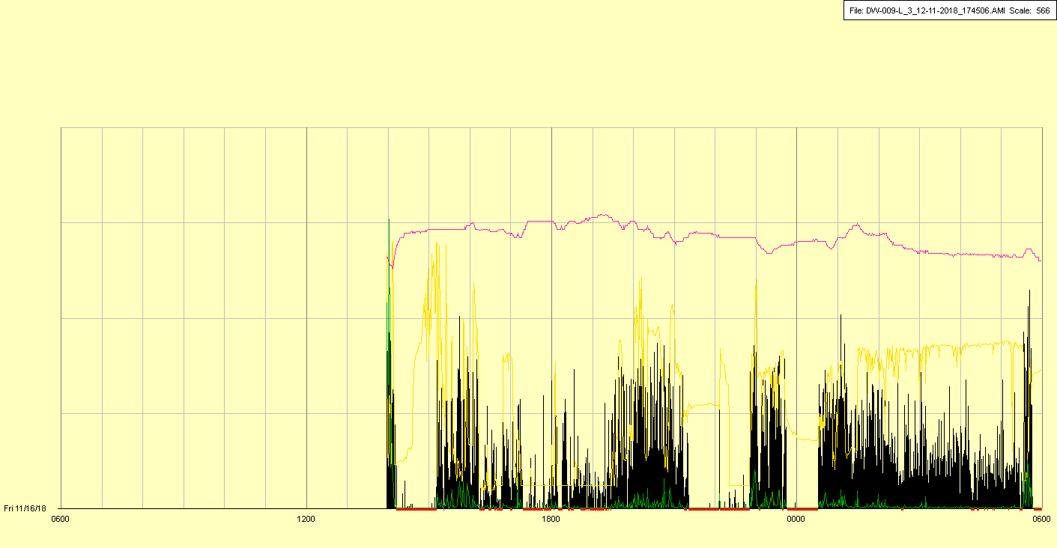

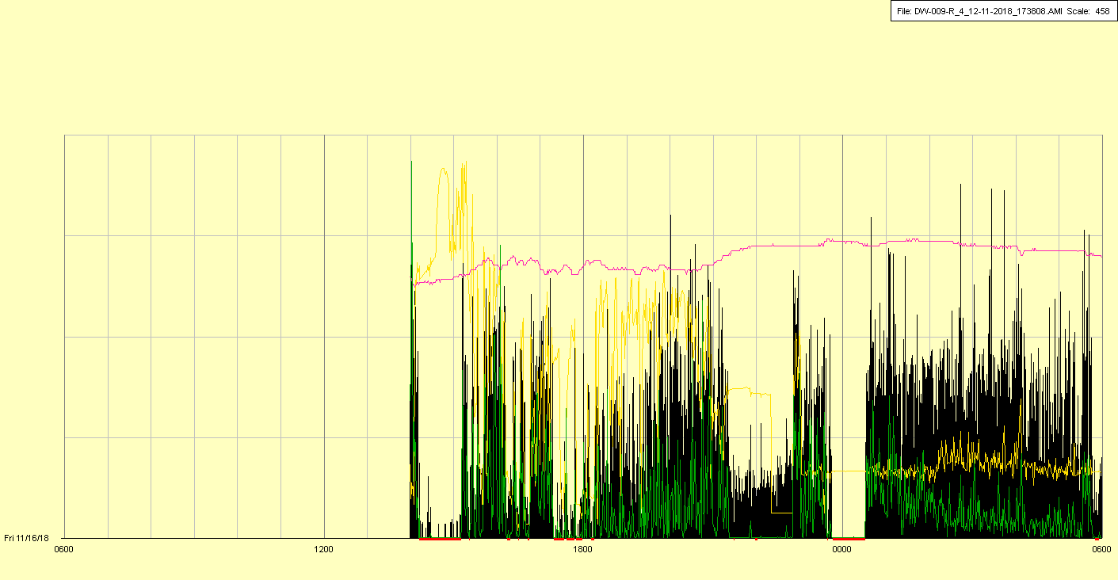

|  |  |  |  |
| --- | --- | --- | --- |
| Study ID | DW9 | Initial NIHSS (affected arm) | 3 |
| Age | 55 | Sex | Female |
| ICH Location | Right deep | Patient location | ICU |
| Hospital day | 2 | Mechanical ventilation | Yes |
| Delirium status | Yes | 3-month mRS |  |

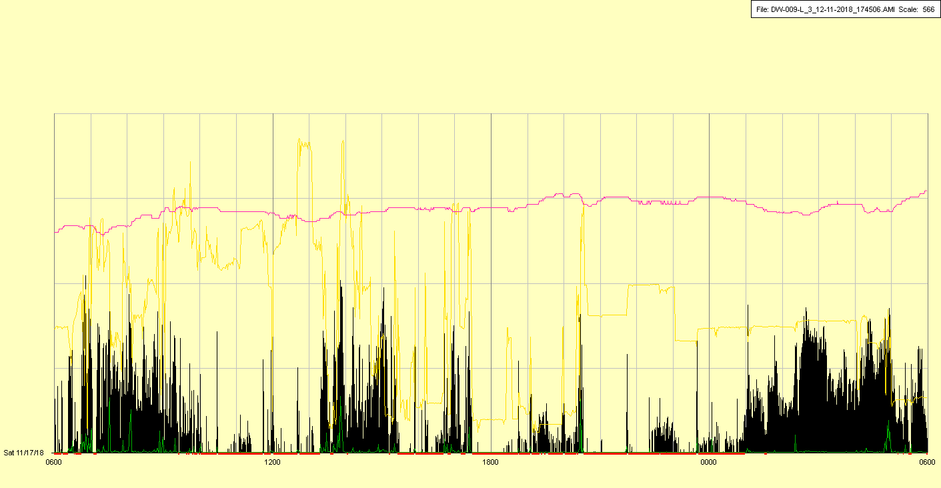

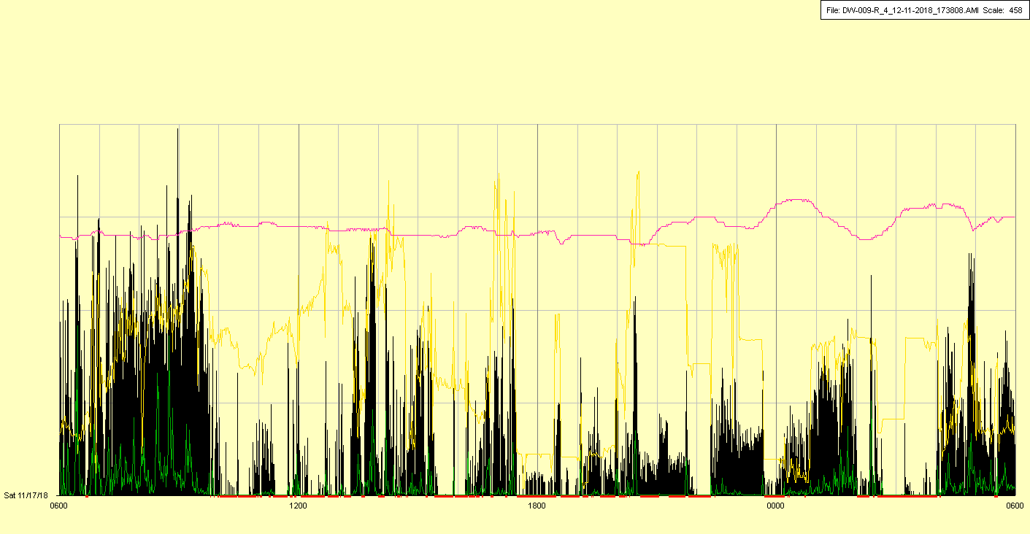

Intubated in late AM

|  |  |  |  |
| --- | --- | --- | --- |
| Study ID | DW9 | Initial NIHSS (affected arm) | 3 |
| Age | 55 | Sex | Female |
| ICH Location | Right deep | Patient location | ICU |
| Hospital day | 3 | Mechanical ventilation | Yes |
| Delirium status | Yes | 3-month mRS |  |

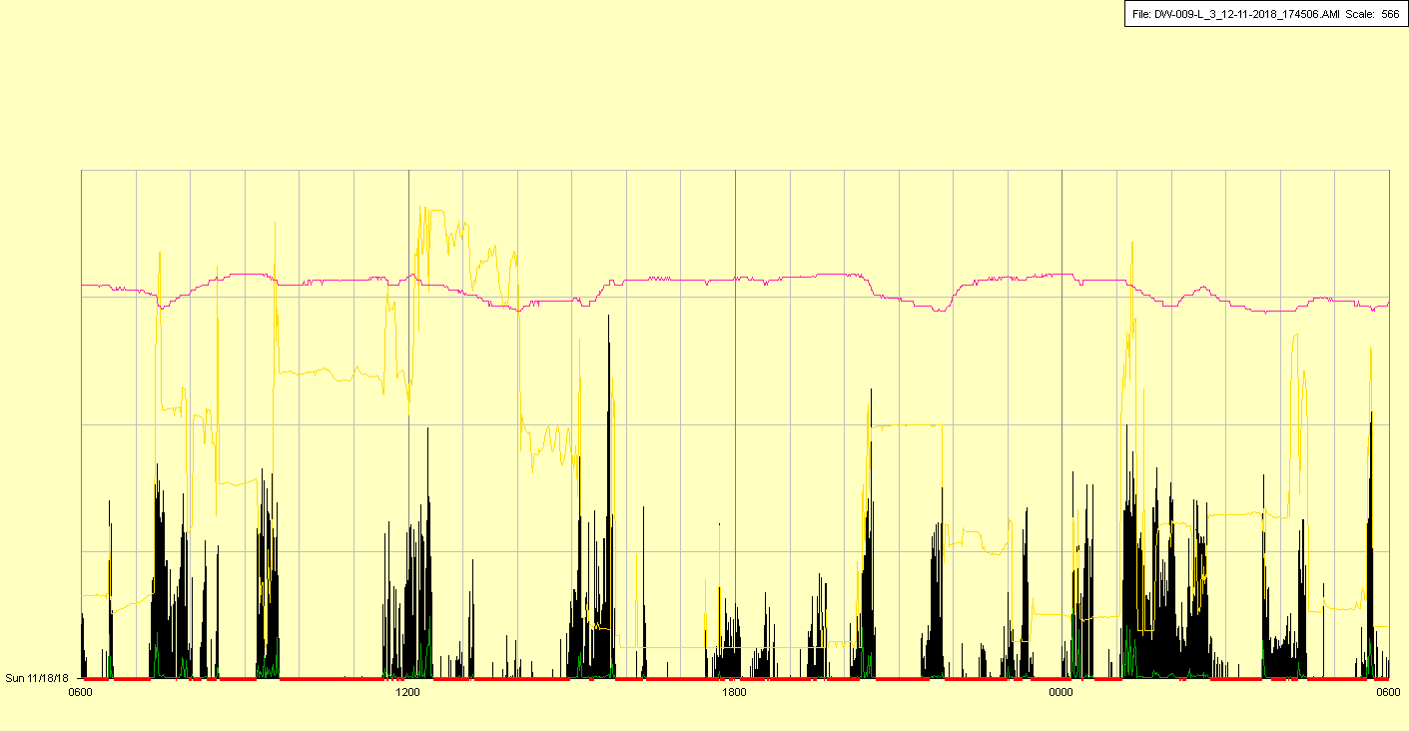

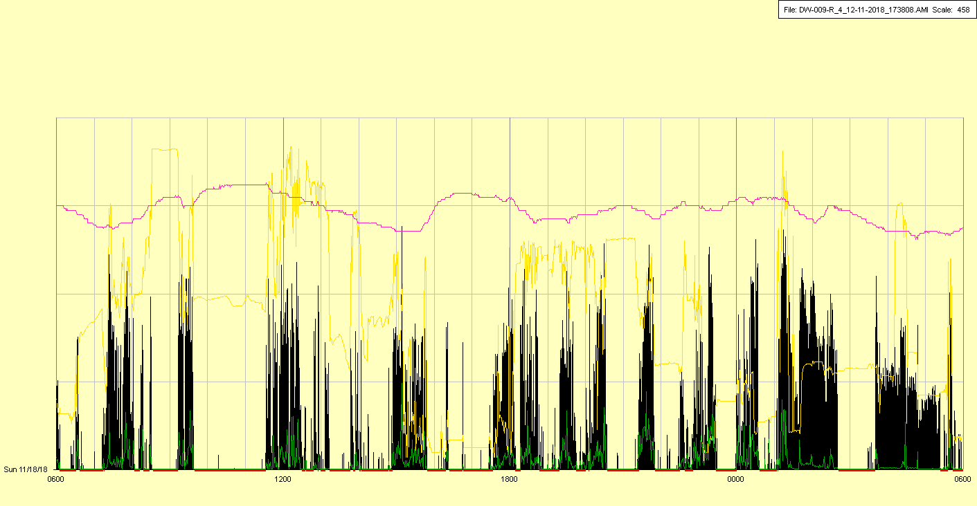

|  |  |  |  |
| --- | --- | --- | --- |
| Study ID | DW9 | Initial NIHSS (affected arm) | 3 |
| Age | 55 | Sex | Female |
| ICH Location | Right deep | Patient location | ICU |
| Hospital day | 4 | Mechanical ventilation | Yes |
| Delirium status | Yes | 3-month mRS |  |

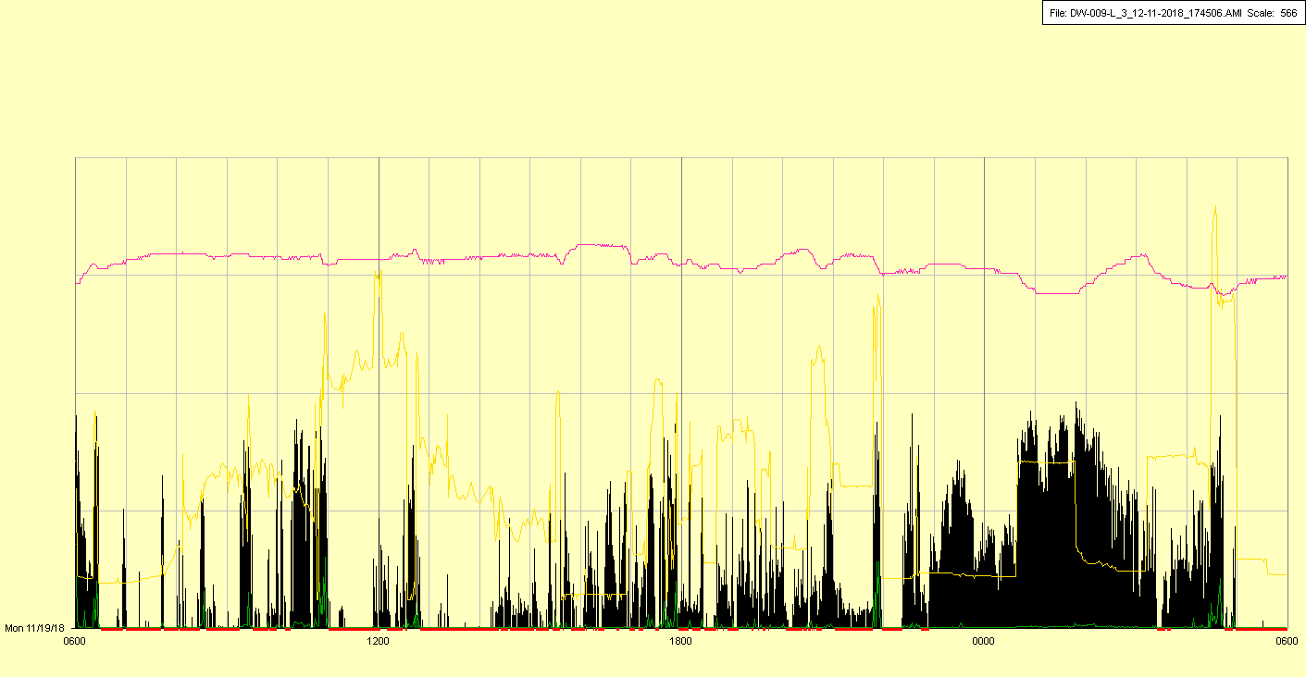

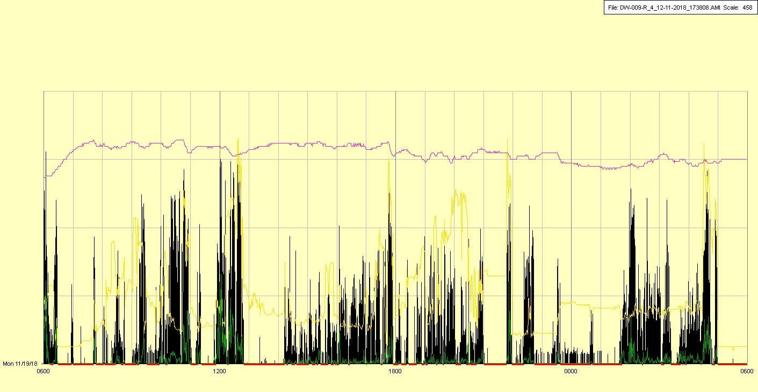

|  |  |  |  |
| --- | --- | --- | --- |
| Study ID | DW9 | Initial NIHSS (affected arm) | 3 |
| Age | 55 | Sex | Female |
| ICH Location | Right deep | Patient location | ICU |
| Hospital day | 5 | Mechanical ventilation | Yes |
| Delirium status | Yes | 3-month mRS |  |

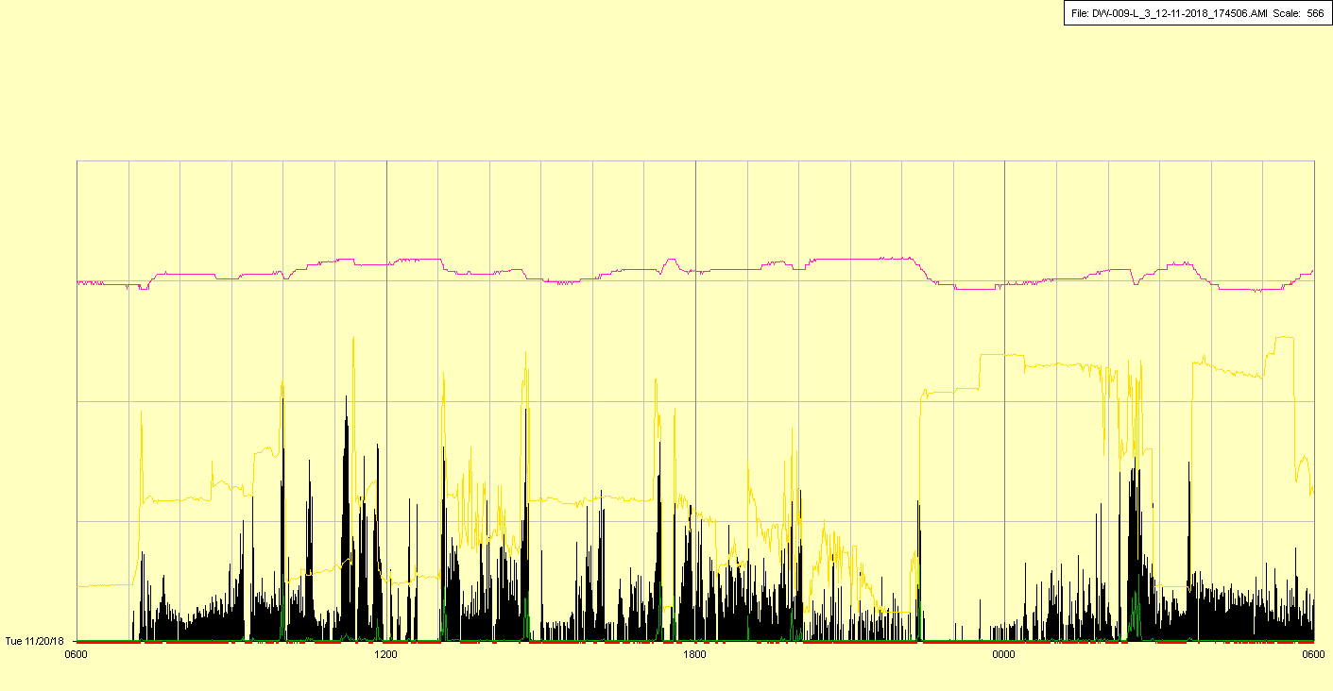

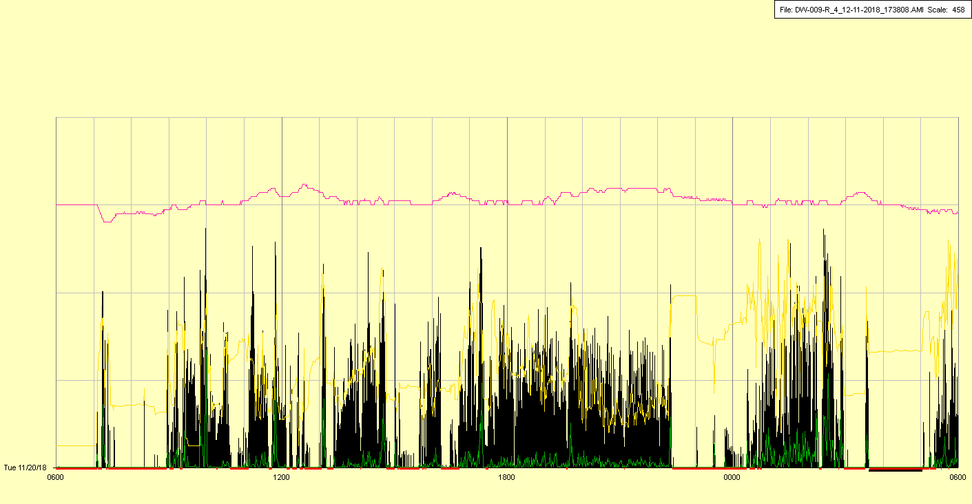

|  |  |  |  |
| --- | --- | --- | --- |
| Study ID | DW9 | Initial NIHSS (affected arm) | 3 |
| Age | 55 | Sex | Female |
| ICH Location | Right deep | Patient location | ICU |
| Hospital day | 6 | Mechanical ventilation | Yes |
| Delirium status | Yes | 3-month mRS |  |

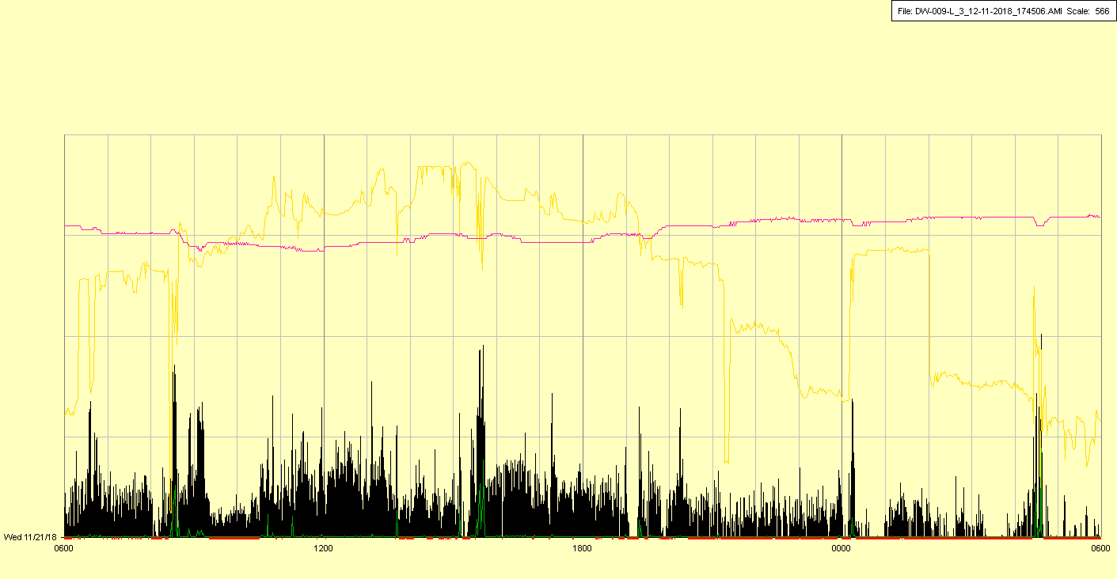

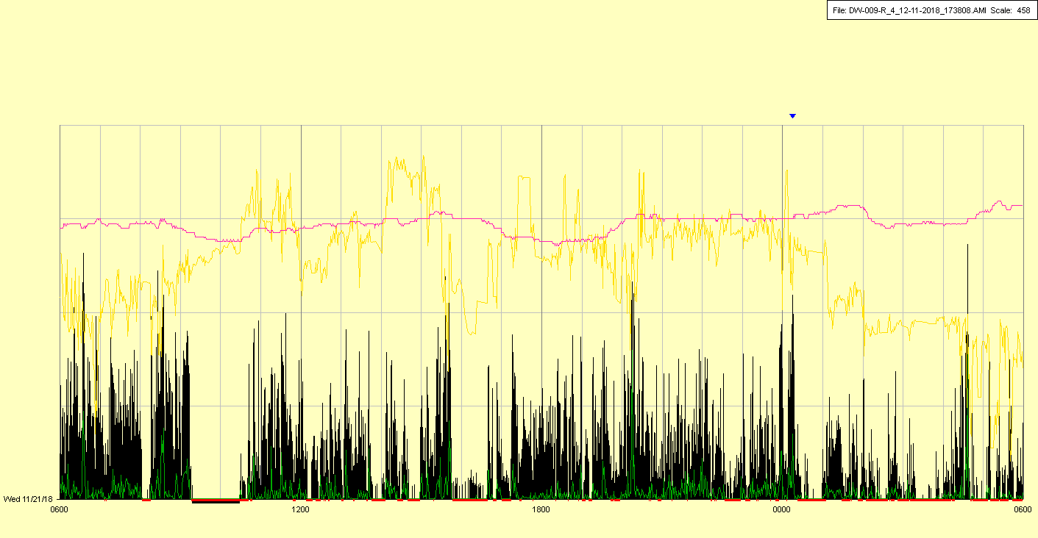

|  |  |  |  |
| --- | --- | --- | --- |
| Study ID | DW9 | Initial NIHSS (affected arm) | 3 |
| Age | 55 | Sex | Female |
| ICH Location | Right deep | Patient location | ICU |
| Hospital day | 7 | Mechanical ventilation | Yes🡪No |
| Delirium status | Yes | 3-month mRS |  |

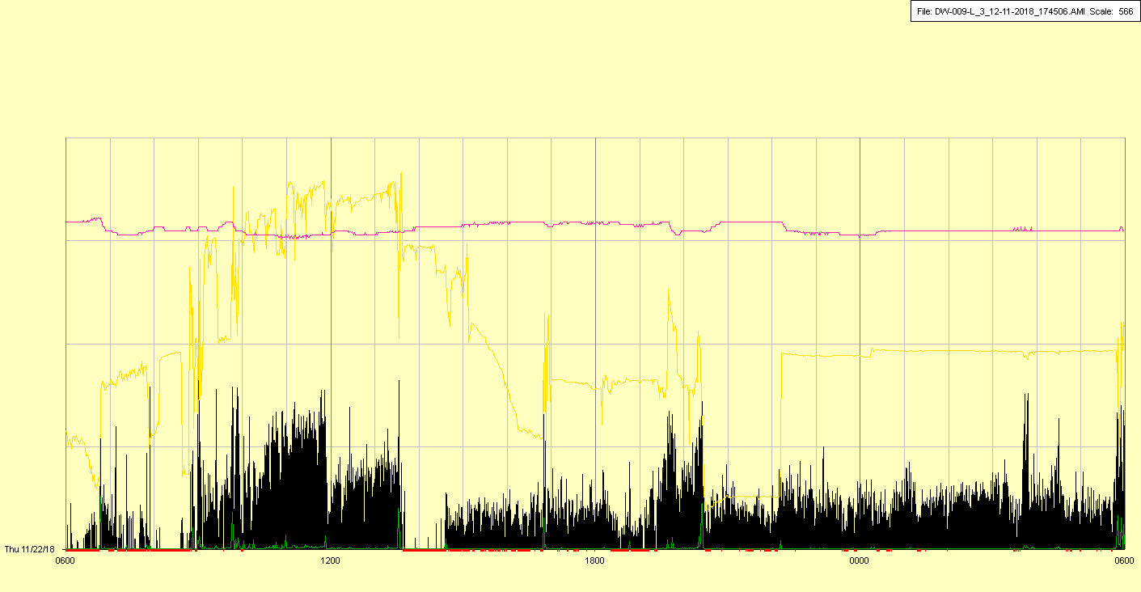

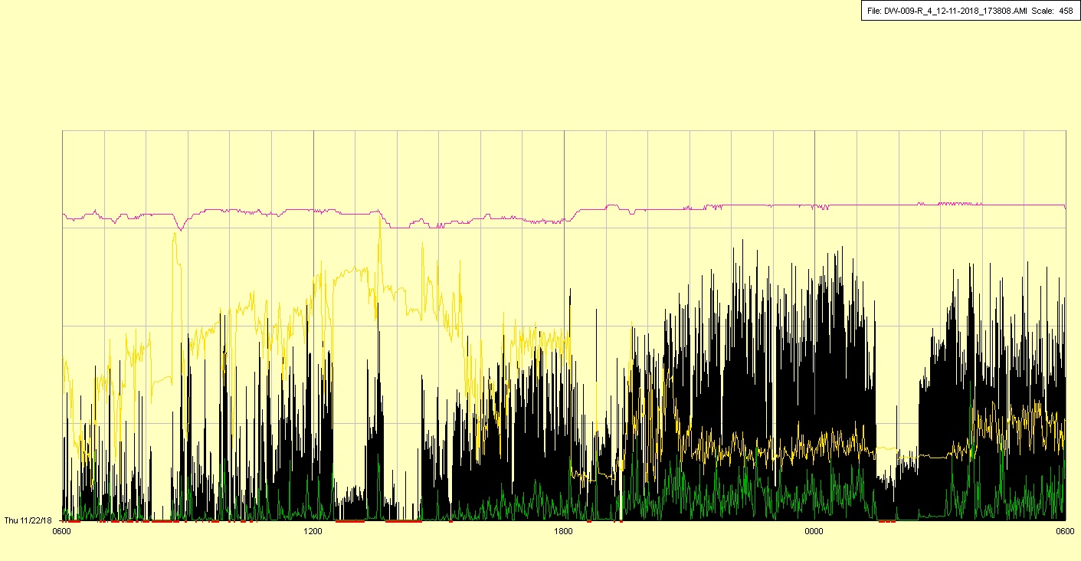

Extubated in late AM

|  |  |  |  |
| --- | --- | --- | --- |
| Study ID | DW9 | Initial NIHSS (affected arm) | 3 |
| Age | 55 | Sex | Female |
| ICH Location | Right deep | Patient location | ICU |
| Hospital day | 8 | Mechanical ventilation | No |
| Delirium status | No | 3-month mRS |  |

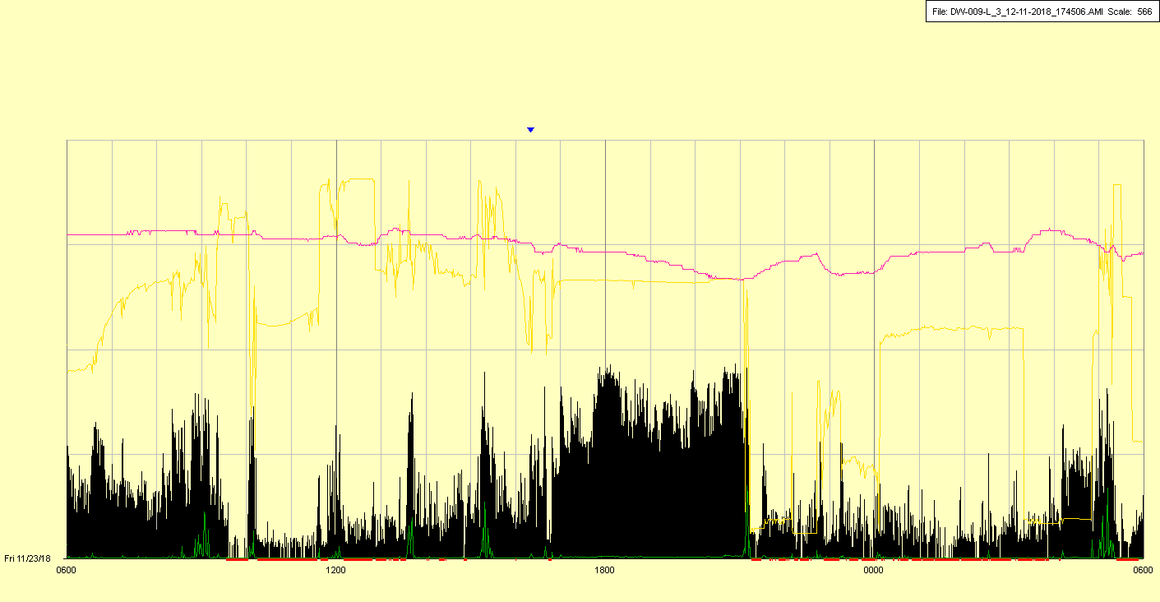

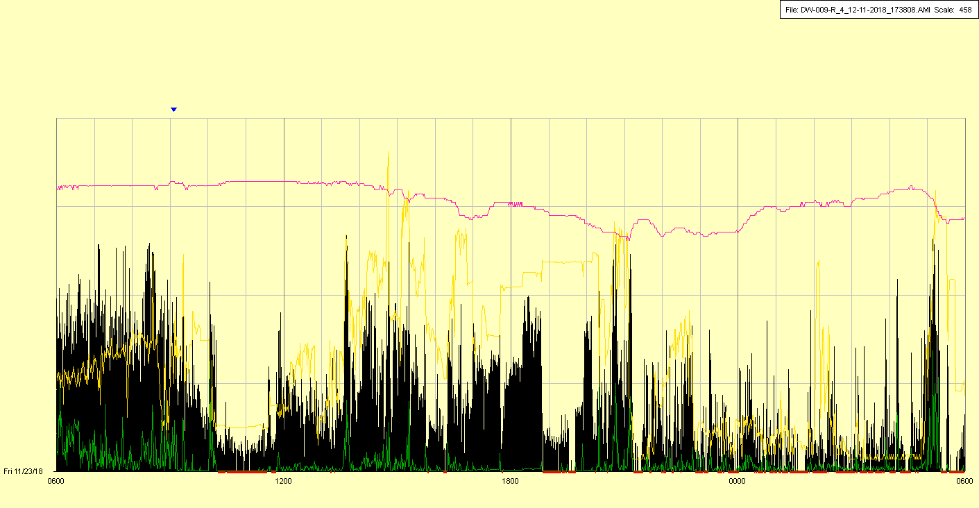

|  |  |  |  |
| --- | --- | --- | --- |
| Study ID | DW9 | Initial NIHSS (affected arm) | 3 |
| Age | 55 | Sex | Female |
| ICH Location | Right deep | Patient location | ICU |
| Hospital day | 9 | Mechanical ventilation | No |
| Delirium status | Yes | 3-month mRS |  |

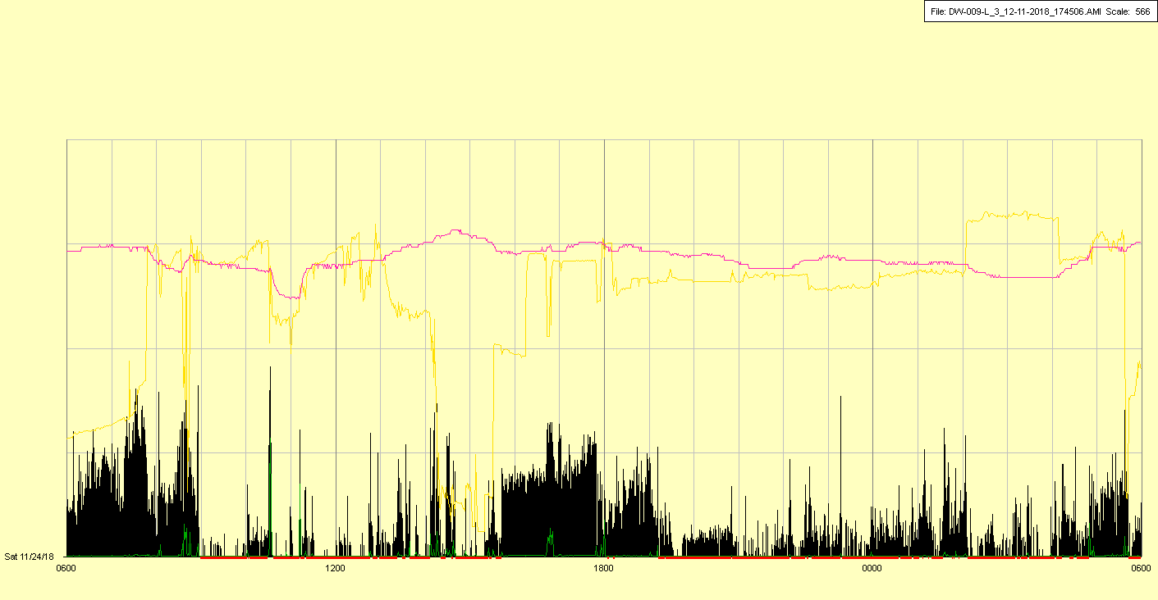

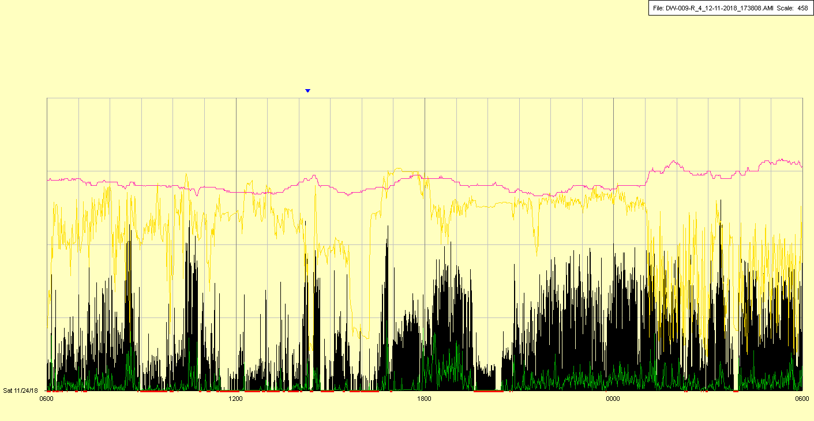

|  |  |  |  |
| --- | --- | --- | --- |
| Study ID | DW9 | Initial NIHSS (affected arm) | 3 |
| Age | 55 | Sex | Female |
| ICH Location | Right deep | Patient location | ICU |
| Hospital day | 10 | Mechanical ventilation | Yes |
| Delirium status | Yes | 3-month mRS |  |

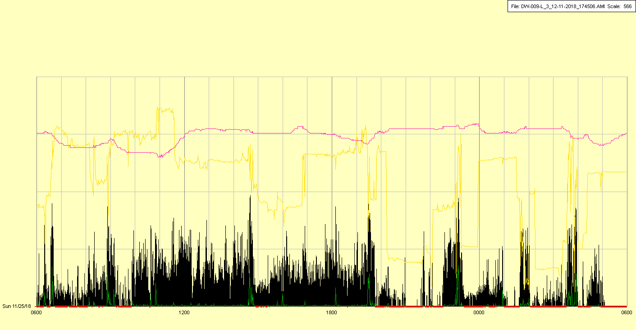

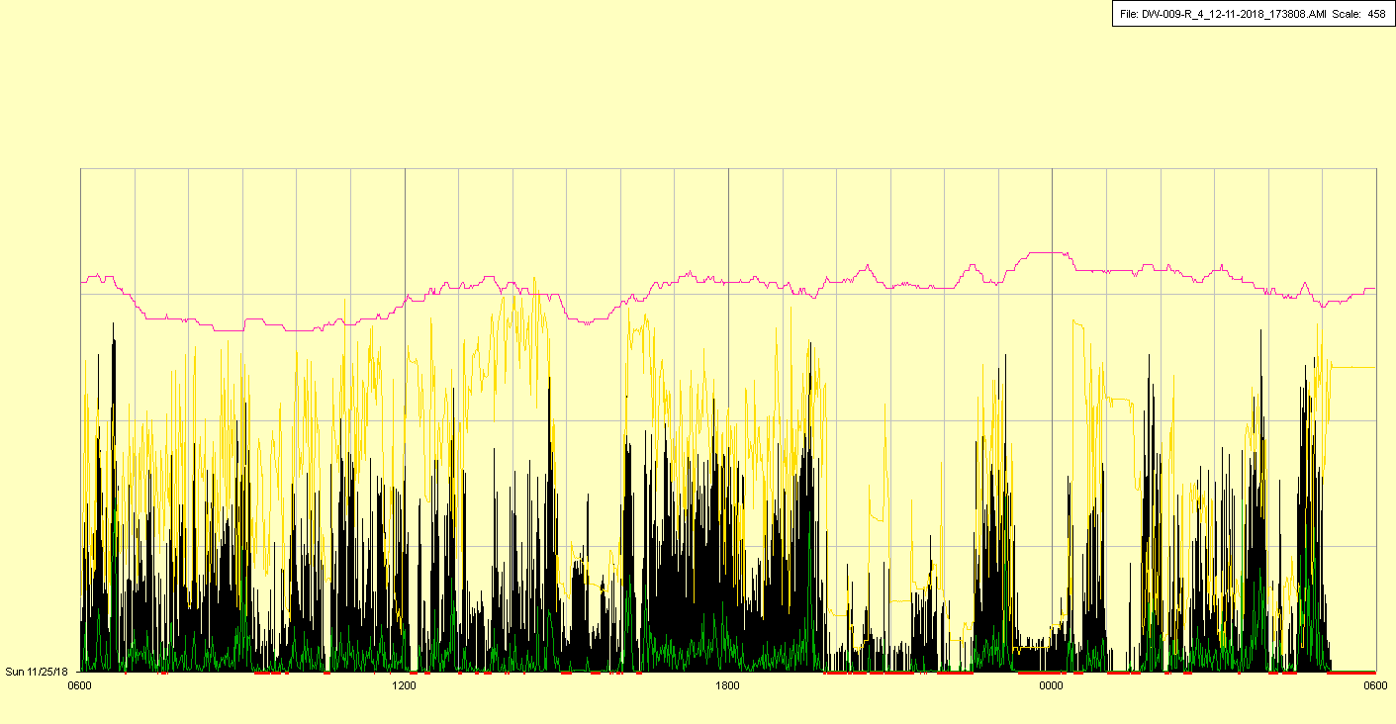

Reintubated overnight

|  |  |  |  |
| --- | --- | --- | --- |
| Study ID | DW9 | Initial NIHSS (affected arm) | 3 |
| Age | 55 | Sex | Female |
| ICH Location | Right deep | Patient location | ICU |
| Hospital day | 11 | Mechanical ventilation | Yes |
| Delirium status | Yes | 3-month mRS |  |

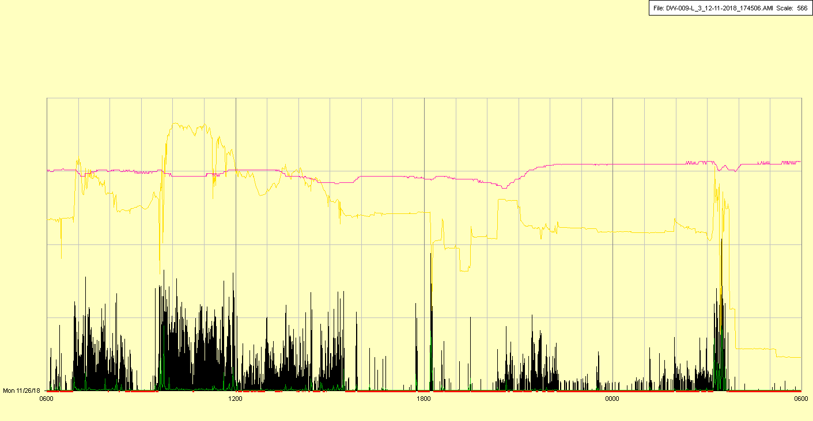

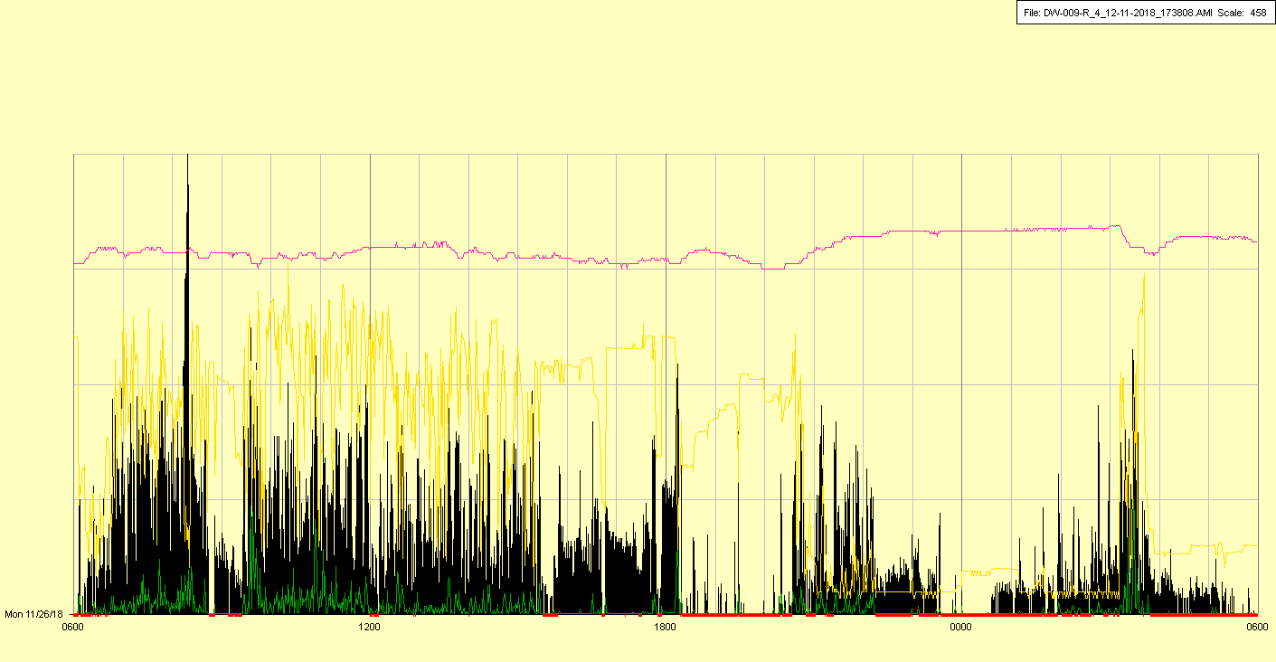

|  |  |  |  |
| --- | --- | --- | --- |
| Study ID | DW9 | Initial NIHSS (affected arm) | 3 |
| Age | 55 | Sex | Female |
| ICH Location | Right deep | Patient location | ICU |
| Hospital day | 12 | Mechanical ventilation | Yes |
| Delirium status | Yes | 3-month mRS |  |

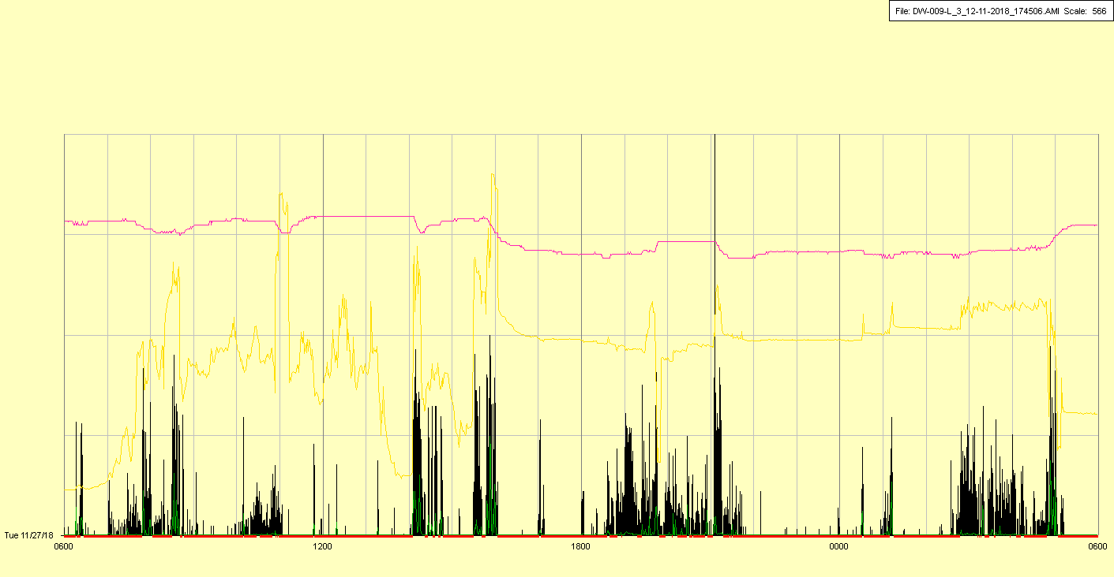

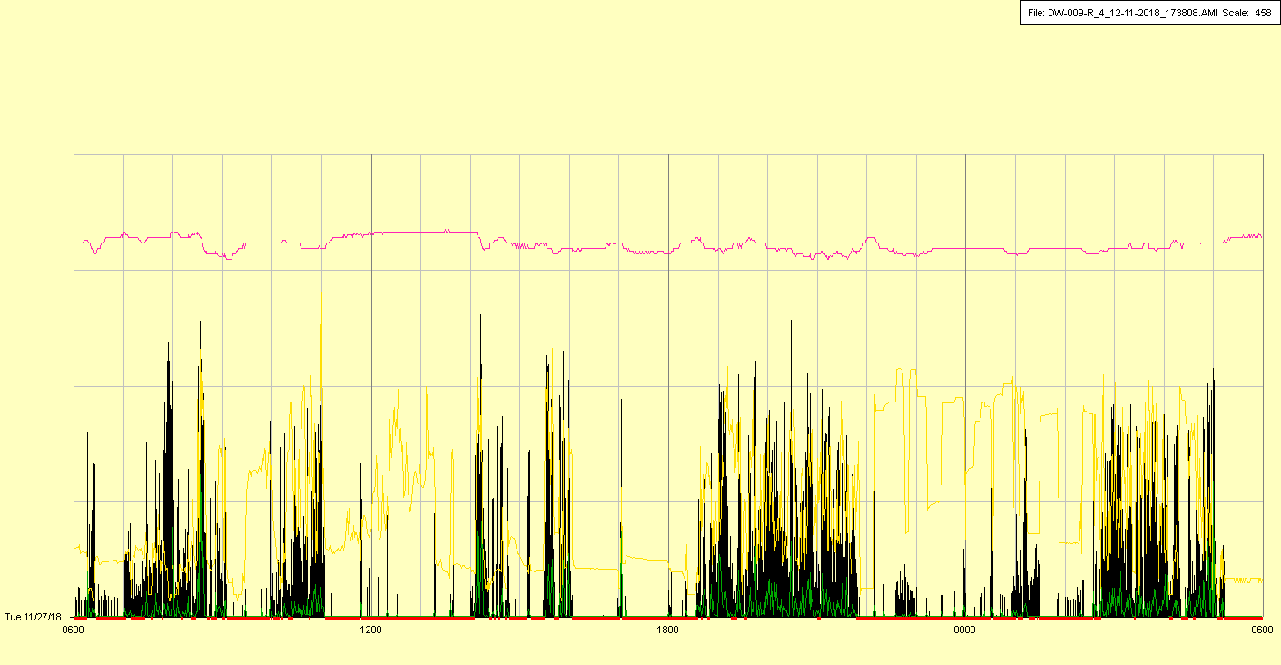

|  |  |  |  |
| --- | --- | --- | --- |
| Study ID | DW9 | Initial NIHSS (affected arm) | 3 |
| Age | 55 | Sex | Female |
| ICH Location | Right deep | Patient location | ICU |
| Hospital day | 13 | Mechanical ventilation | Yes |
| Delirium status | Yes | 3-month mRS |  |

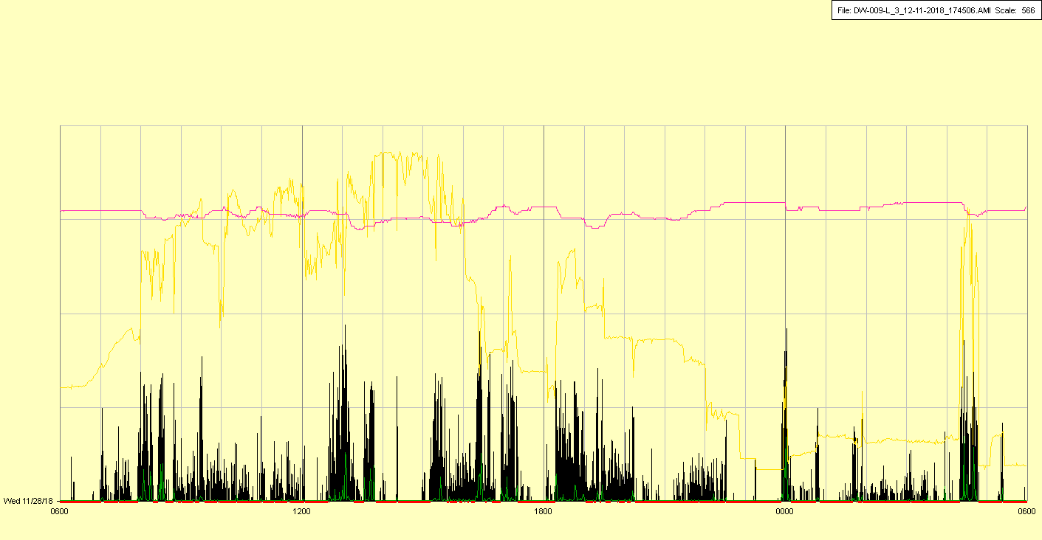

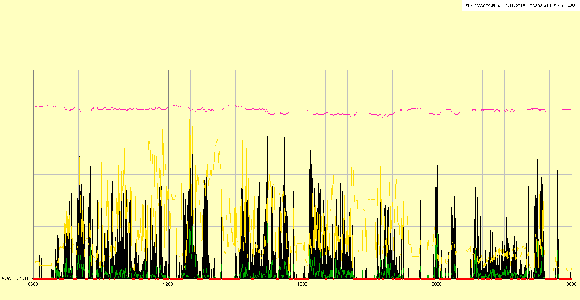

|  |  |  |  |
| --- | --- | --- | --- |
| Study ID | DW9 | Initial NIHSS (affected arm) | 3 |
| Age | 55 | Sex | Female |
| ICH Location | Right deep | Patient location | ICU |
| Hospital day | 14 | Mechanical ventilation | Yes |
| Delirium status | Yes | 3-month mRS |  |

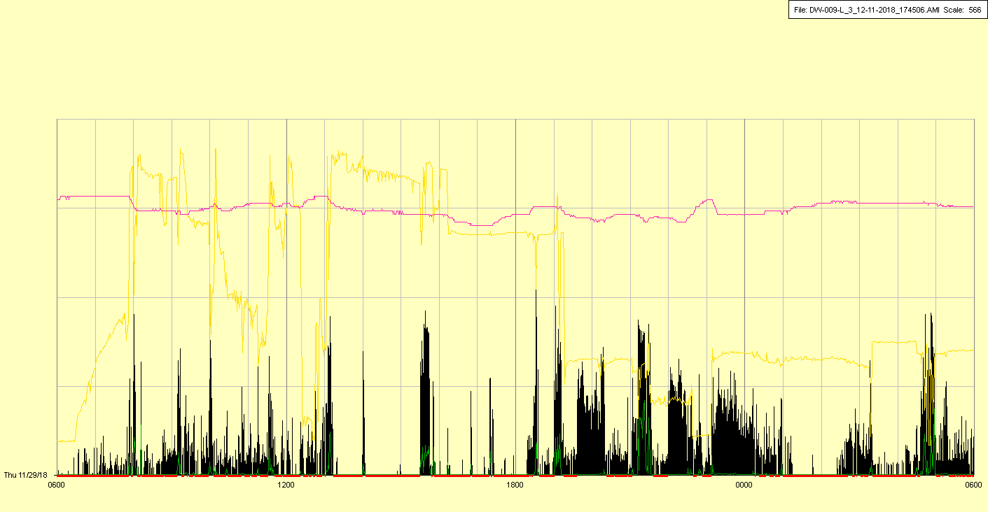

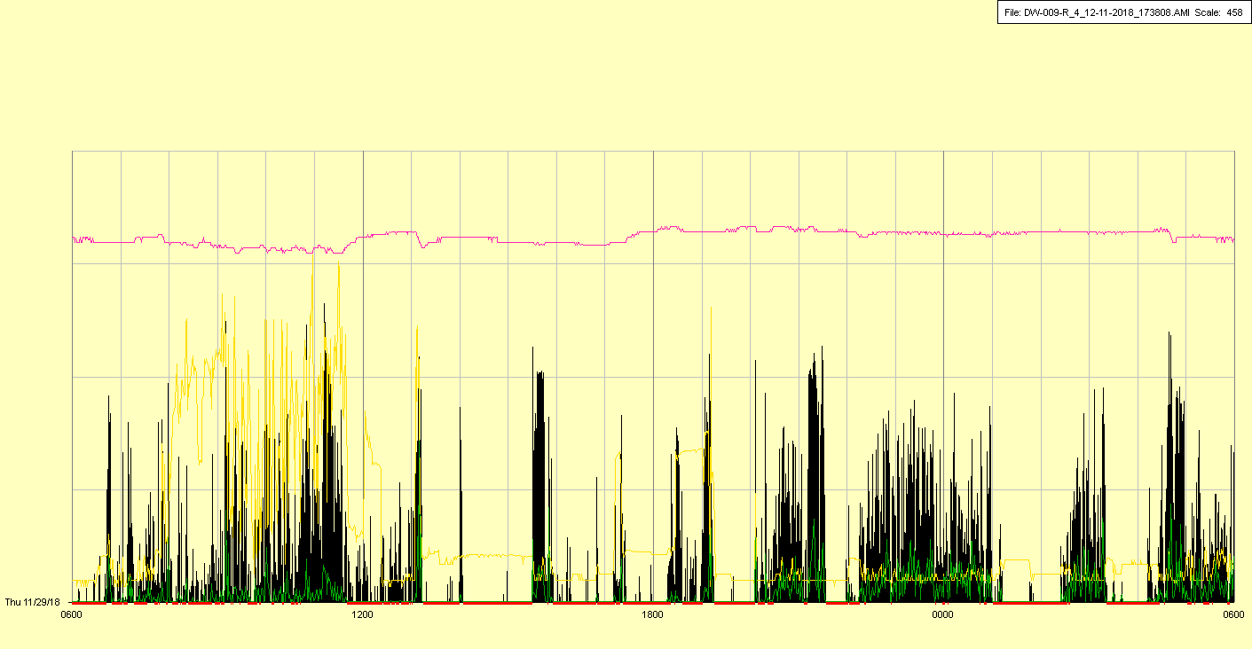

Surgical procedures done in late morning (tracheostomy/PEG)

|  |  |  |  |
| --- | --- | --- | --- |
| Study ID | DW9 | Initial NIHSS (affected arm) | 3 |
| Age | 55 | Sex | Female |
| ICH Location | Right deep | Patient location | ICU |
| Hospital day | 15 | Mechanical ventilation | Yes |
| Delirium status | Yes | 3-month mRS |  |

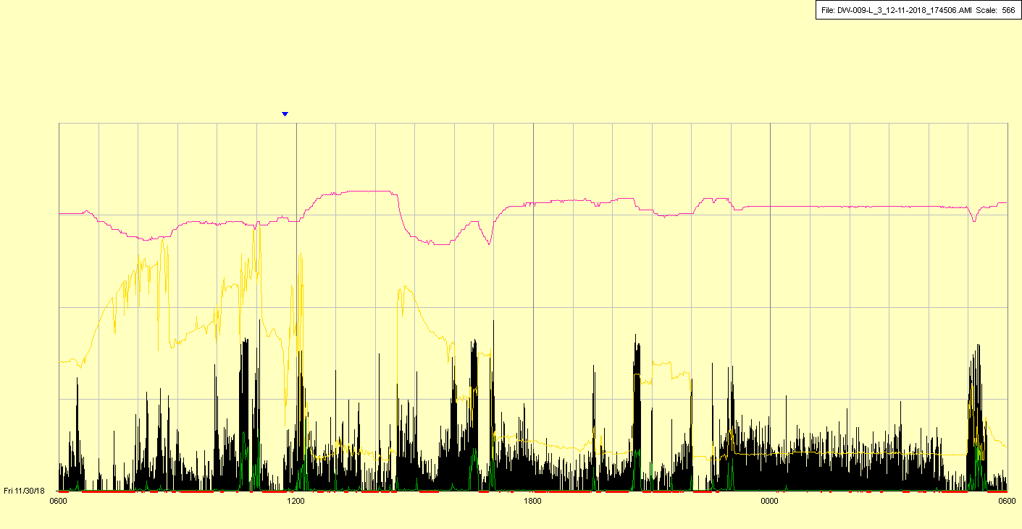

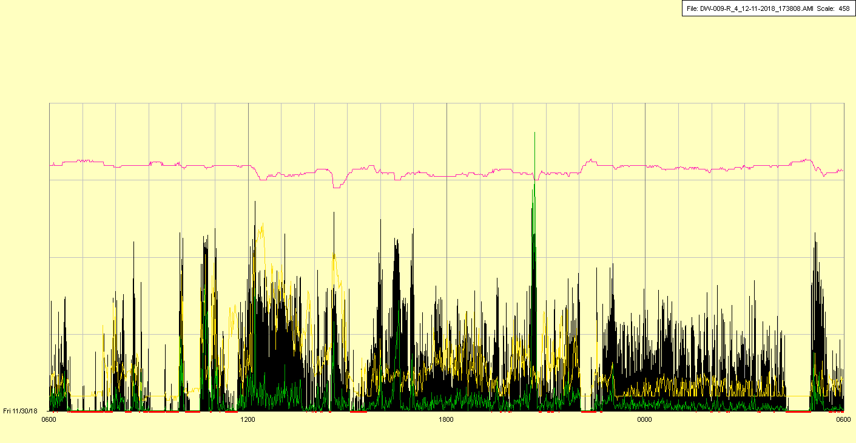

|  |  |  |  |
| --- | --- | --- | --- |
| Study ID | DW9 | Initial NIHSS (affected arm) | 3 |
| Age | 55 | Sex | Female |
| ICH Location | Right deep | Patient location | ICU |
| Hospital day | 16 | Mechanical ventilation | No |
| Delirium status | Yes | 3-month mRS |  |

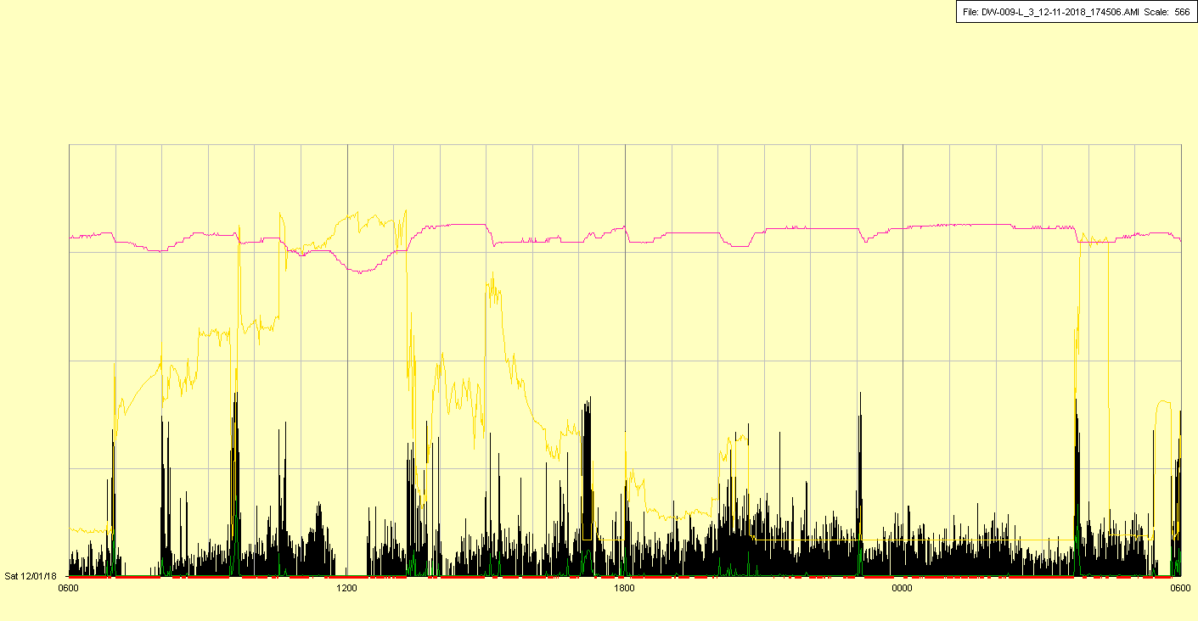

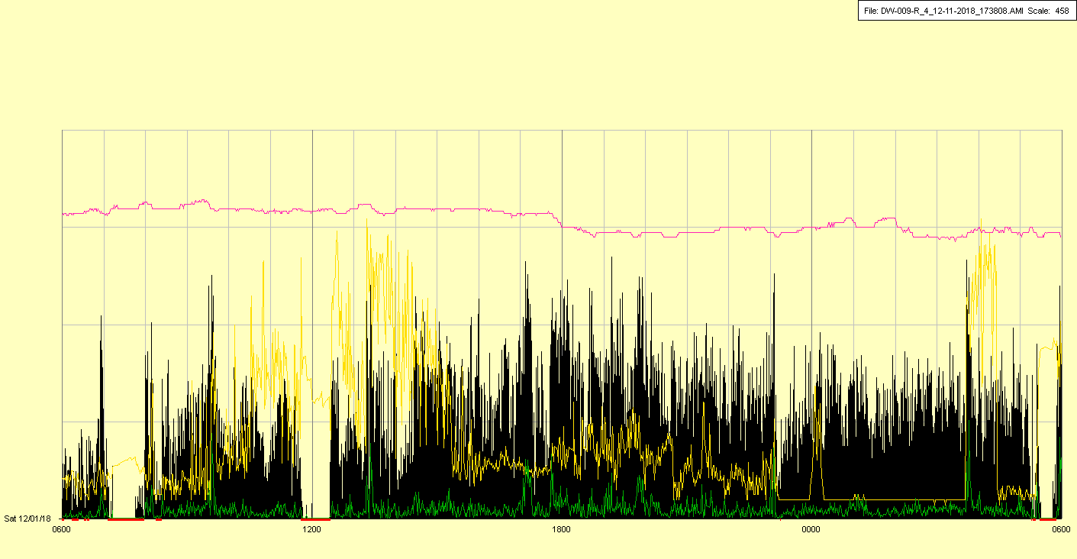

|  |  |  |  |
| --- | --- | --- | --- |
| Study ID | DW9 | Initial NIHSS (affected arm) | 3 |
| Age | 55 | Sex | Female |
| ICH Location | Right deep | Patient location | ICU |
| Hospital day | 17 | Mechanical ventilation | No |
| Delirium status | Yes | 3-month mRS |  |

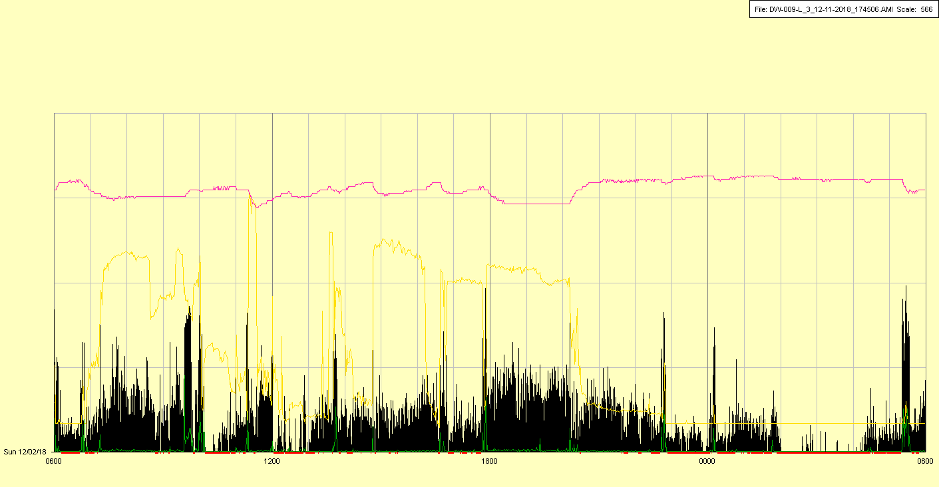

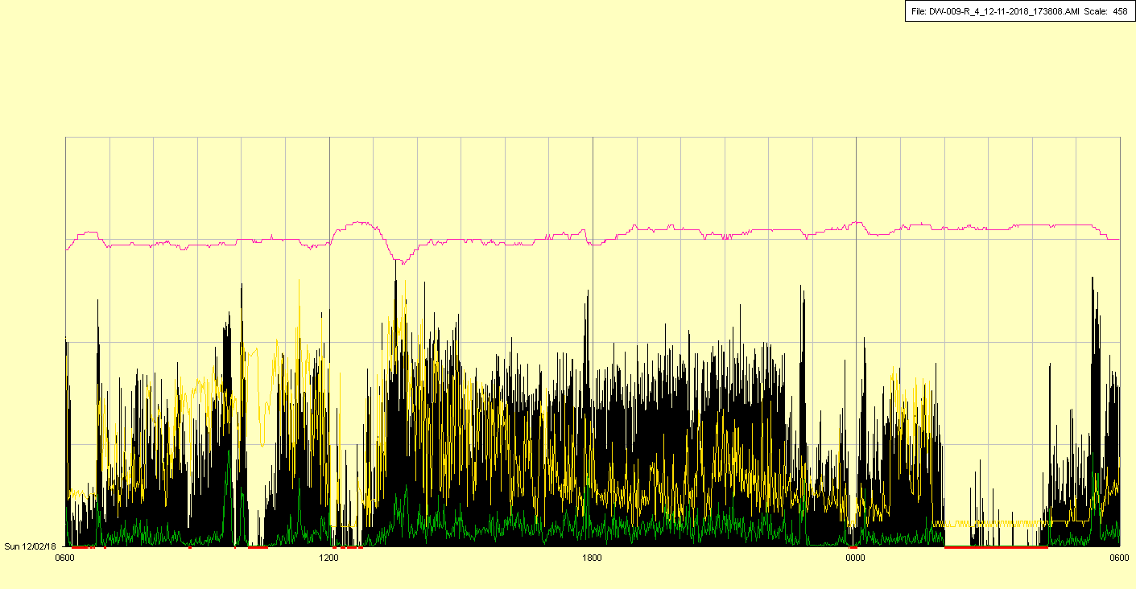

|  |  |  |  |
| --- | --- | --- | --- |
| Study ID | DW9 | Initial NIHSS (affected arm) | 3 |
| Age | 55 | Sex | Female |
| ICH Location | Right deep | Patient location | ICU |
| Hospital day | 18 | Mechanical ventilation | No |
| Delirium status | Yes | 3-month mRS |  |

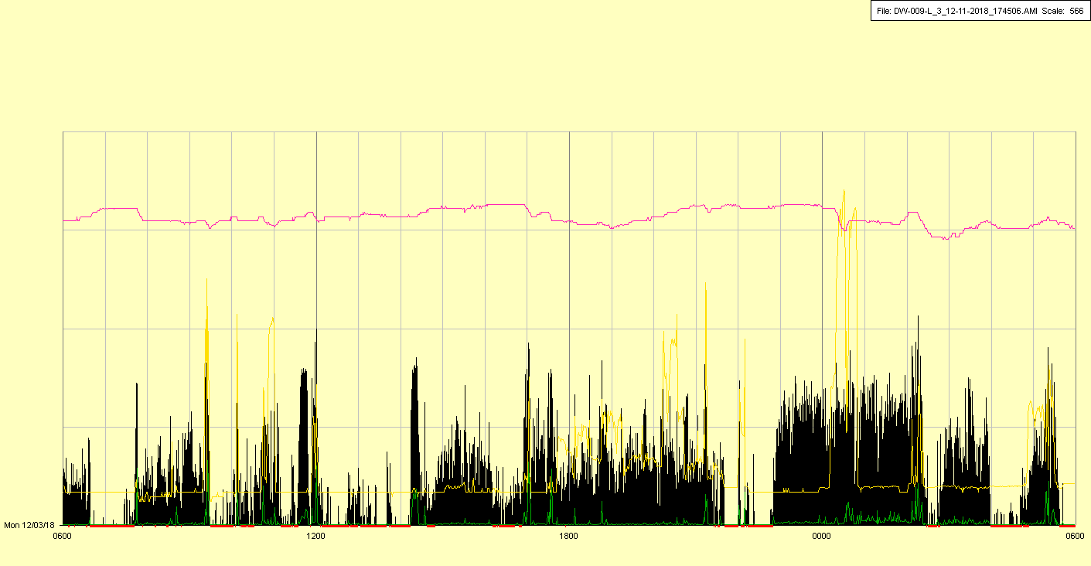

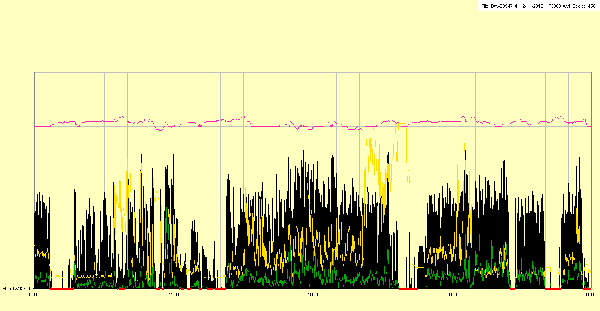

|  |  |  |  |
| --- | --- | --- | --- |
| Study ID | DW9 | Initial NIHSS (affected arm) | 3 |
| Age | 55 | Sex | Female |
| ICH Location | Right deep | Patient location | Stroke Unit |
| Hospital day | 19 | Mechanical ventilation | No |
| Delirium status | Yes | 3-month mRS |  |

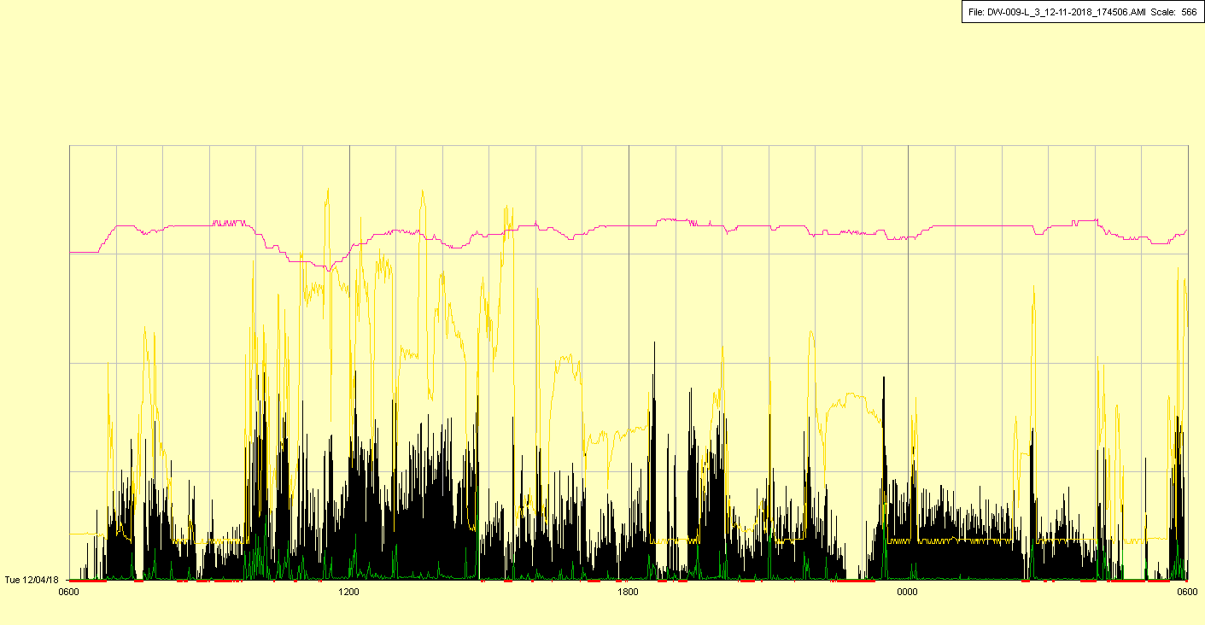

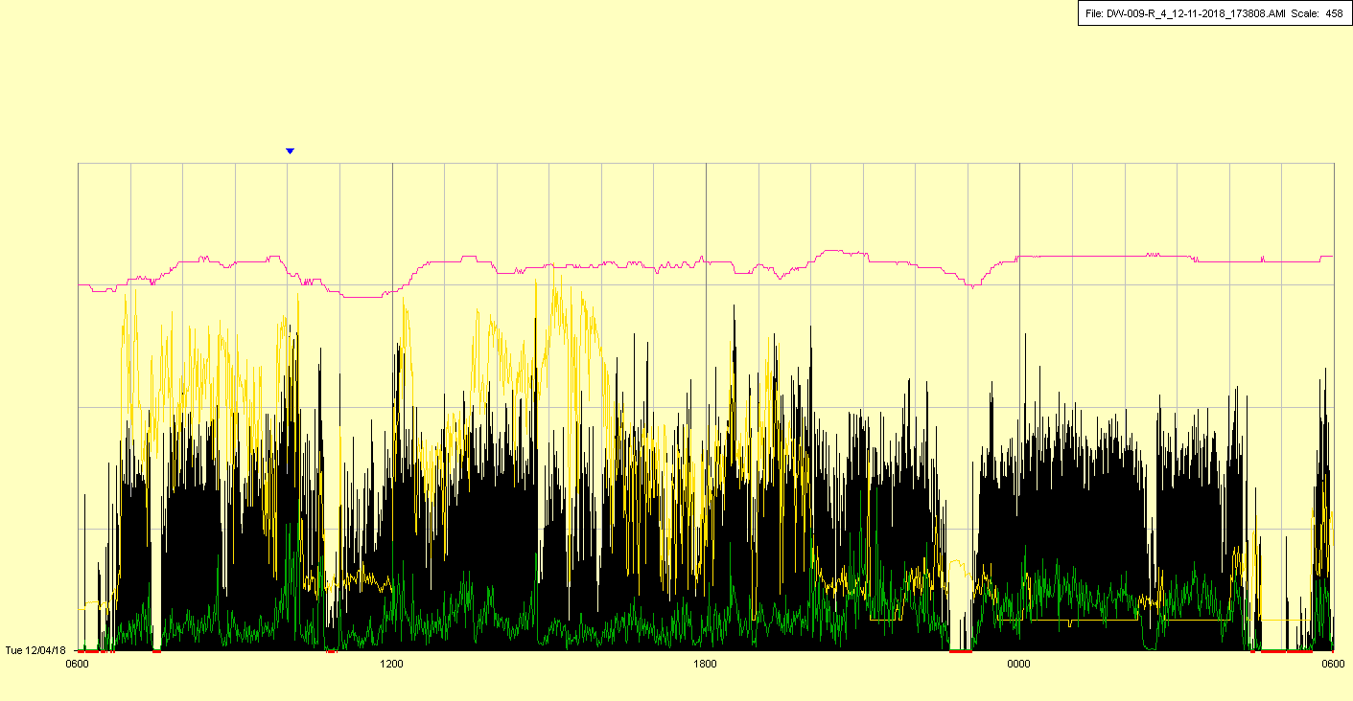

|  |  |  |  |
| --- | --- | --- | --- |
| Study ID | DW9 | Initial NIHSS (affected arm) | 3 |
| Age | 55 | Sex | Female |
| ICH Location | Right deep | Patient location | Stroke Unit |
| Hospital day | 20 | Mechanical ventilation | No |
| Delirium status | Yes | 3-month mRS |  |

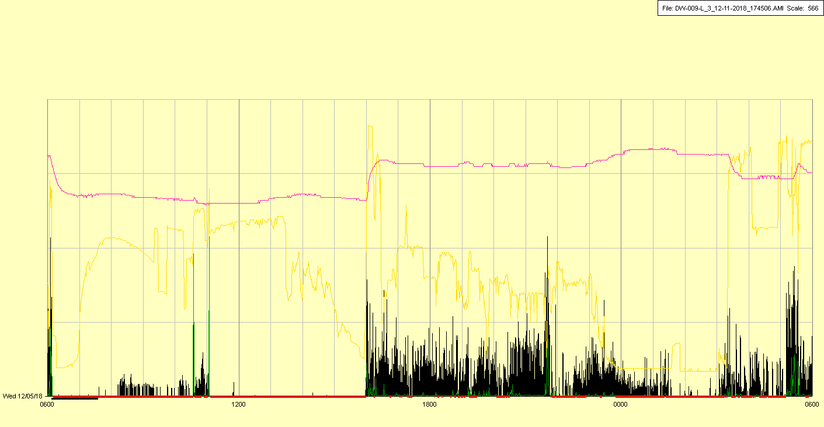

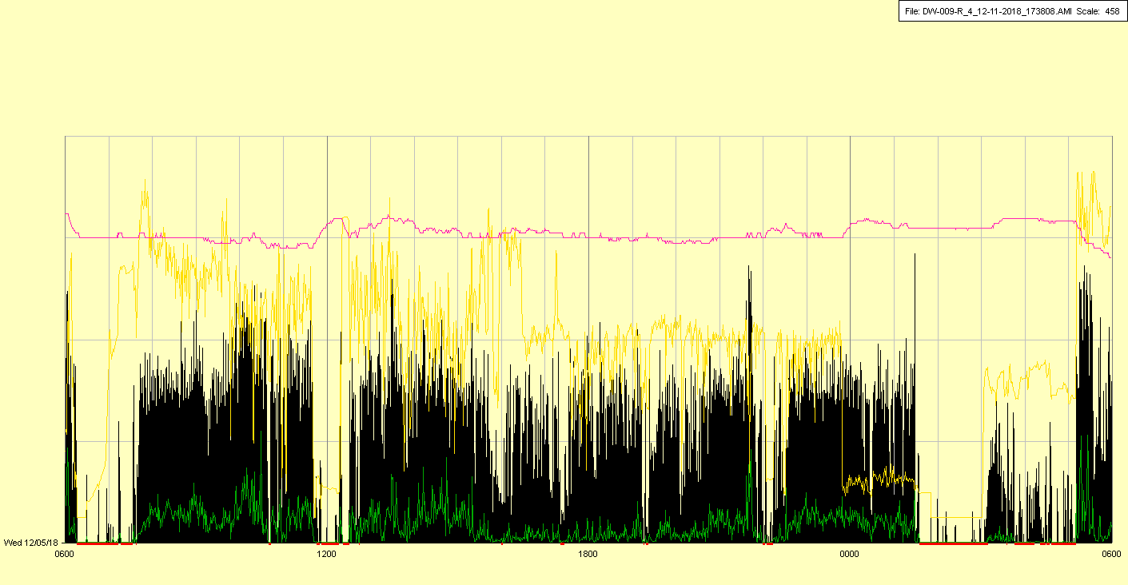

|  |  |  |  |
| --- | --- | --- | --- |
| Study ID | DW9 | Initial NIHSS (affected arm) | 3 |
| Age | 55 | Sex | Female |
| ICH Location | Right deep | Patient location | Stroke Unit |
| Hospital day | 21 | Mechanical ventilation | No |
| Delirium status | Yes | 3-month mRS |  |

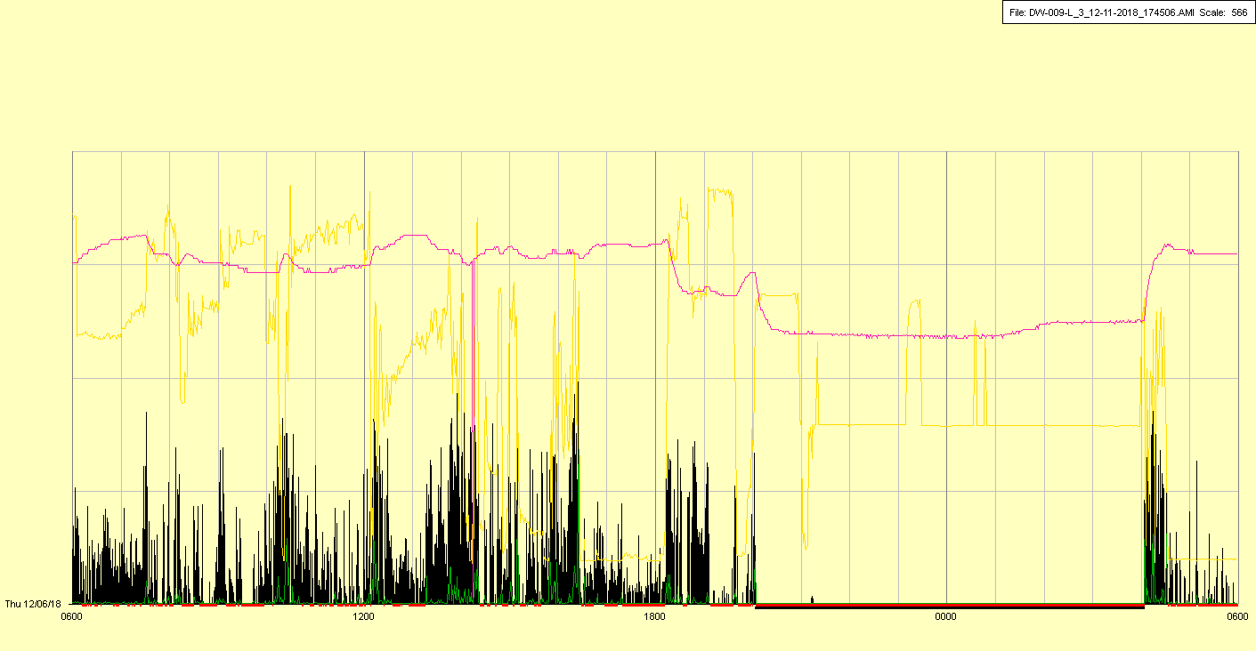

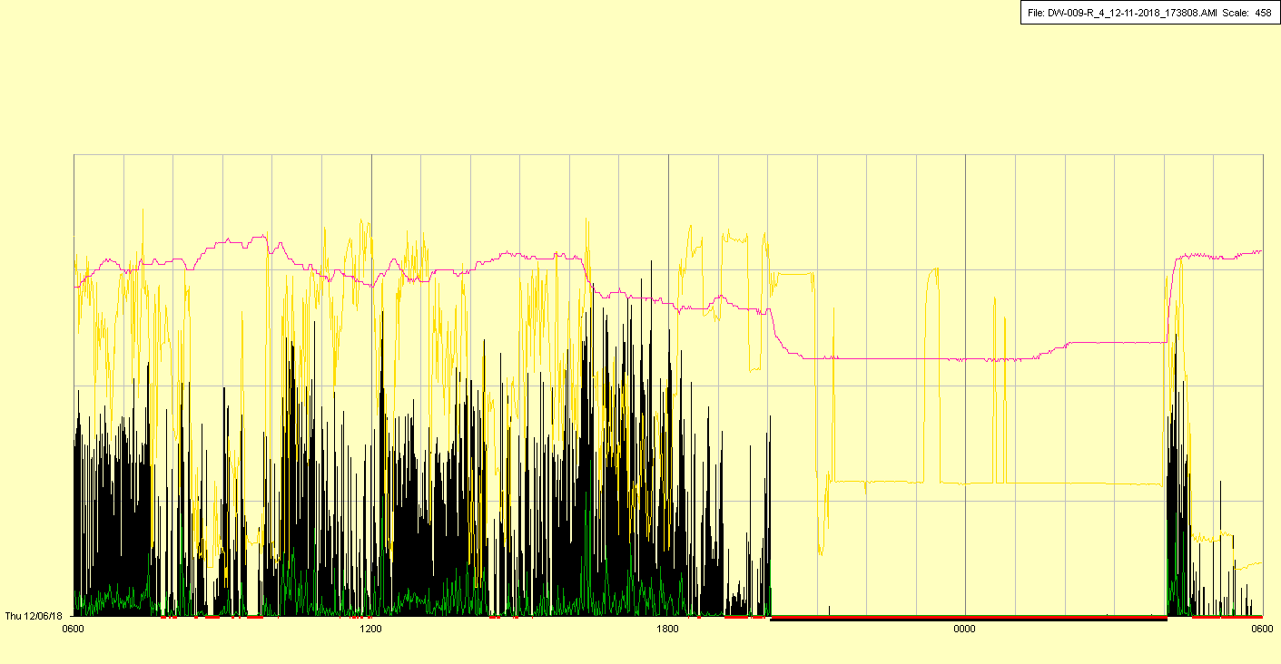

Watches off (MRI?)

|  |  |  |  |
| --- | --- | --- | --- |
| Study ID | DW9 | Initial NIHSS (affected arm) | 3 |
| Age | 55 | Sex | Female |
| ICH Location | Right deep | Patient location | ICU |
| Hospital day | 22 | Mechanical ventilation | No |
| Delirium status | Yes | 3-month mRS |  |

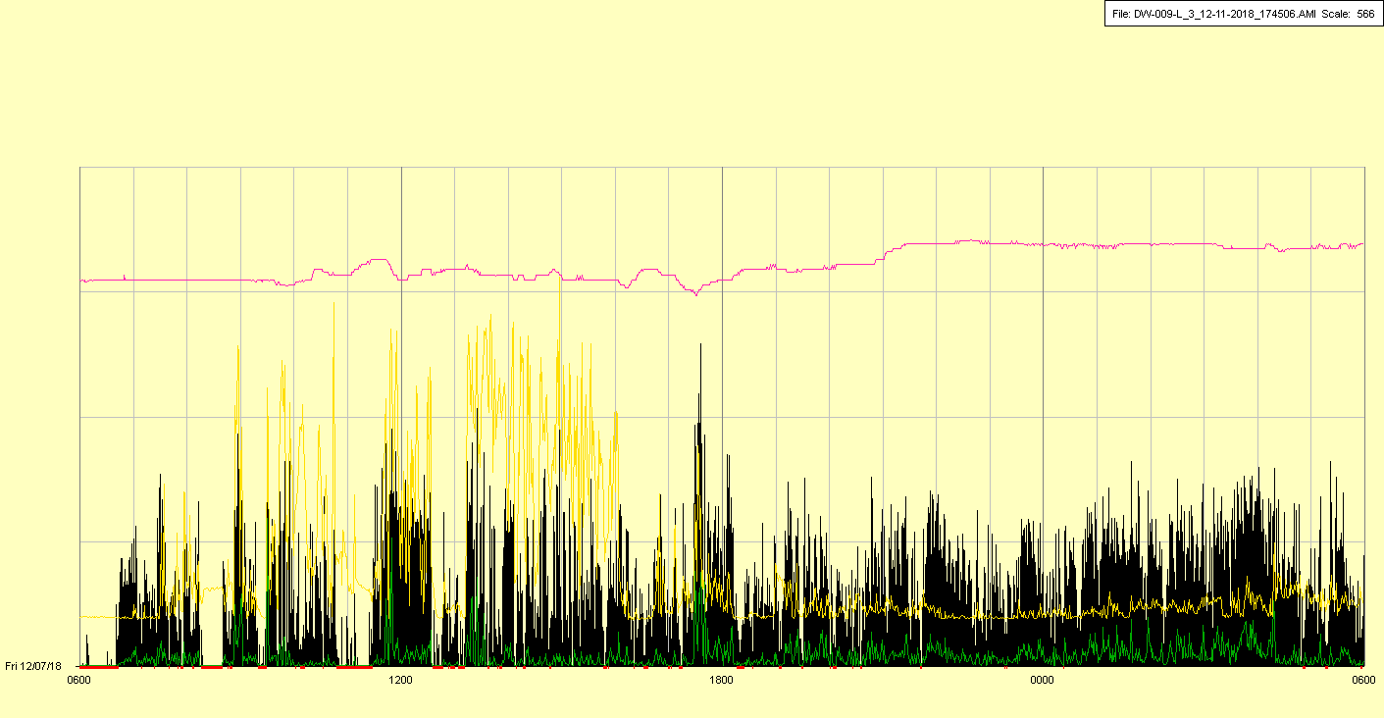

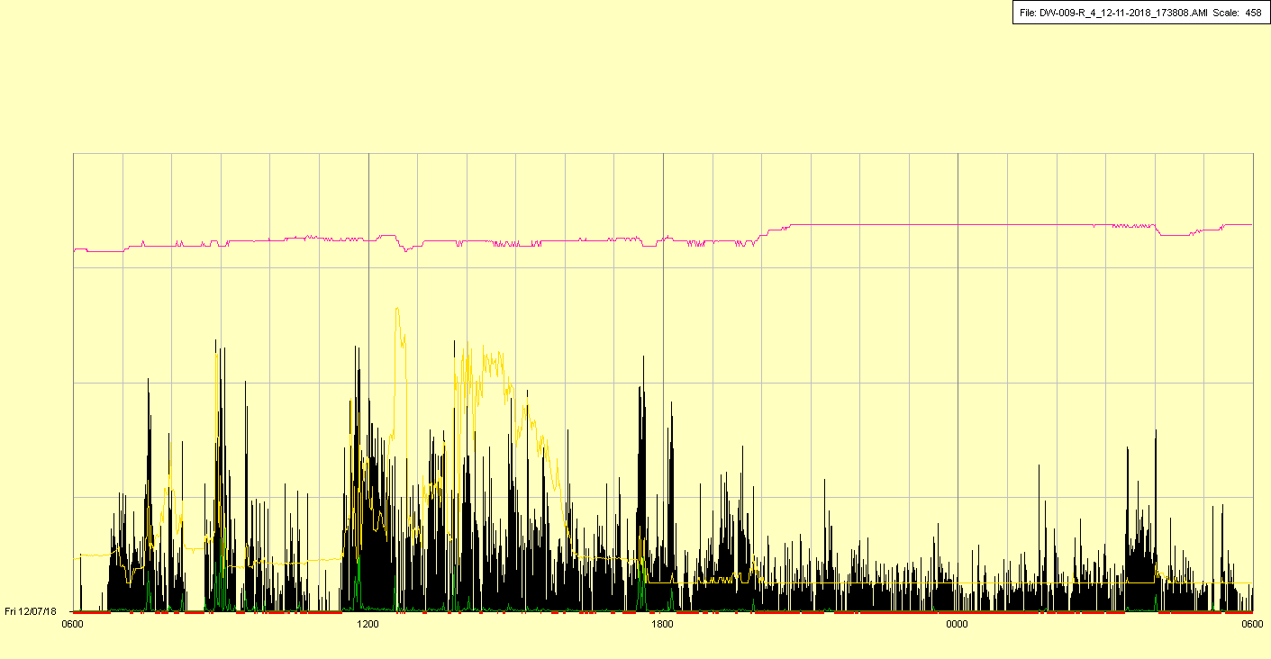

|  |  |  |  |
| --- | --- | --- | --- |
| Study ID | DW9 | Initial NIHSS (affected arm) | 3 |
| Age | 55 | Sex | Female |
| ICH Location | Right deep | Patient location | ICU |
| Hospital day | 23 | Mechanical ventilation | No |
| Delirium status | Yes | 3-month mRS |  |

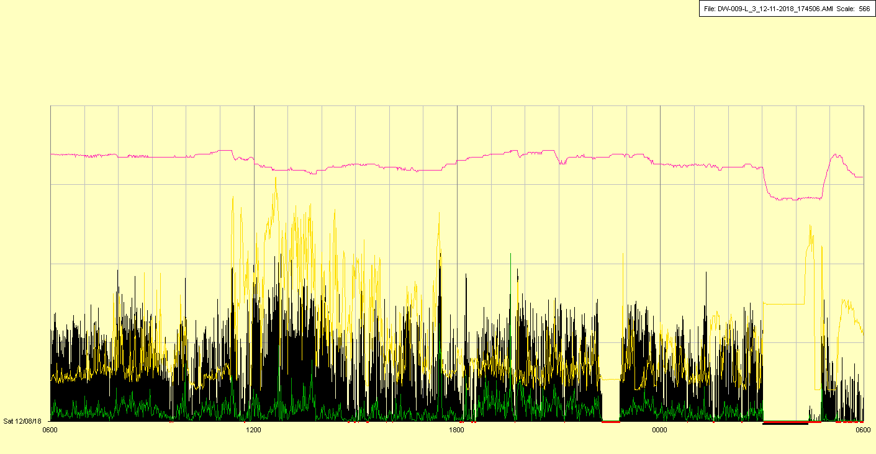

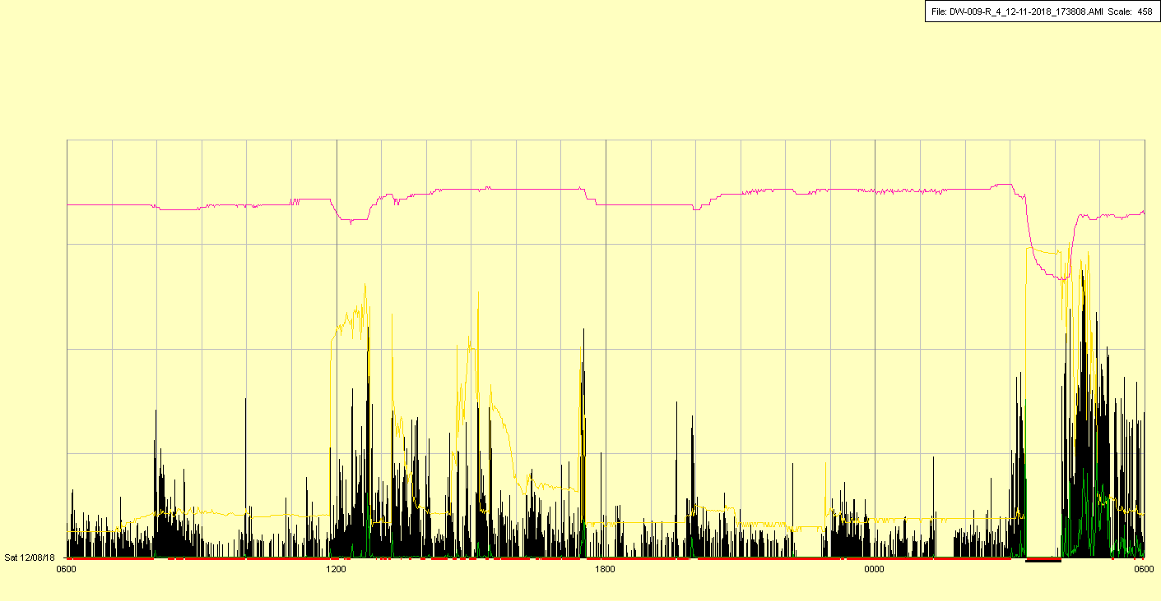

|  |  |  |  |
| --- | --- | --- | --- |
| Study ID | DW9 | Initial NIHSS (affected arm) | 3 |
| Age | 55 | Sex | Female |
| ICH Location | Right deep | Patient location | ICU |
| Hospital day | 24 | Mechanical ventilation | No |
| Delirium status | Yes | 3-month mRS |  |

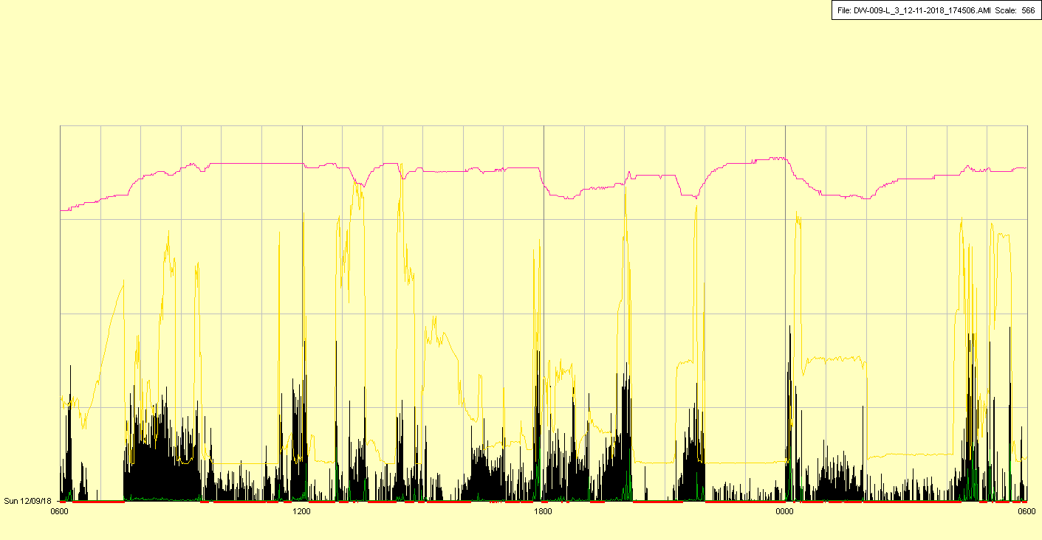

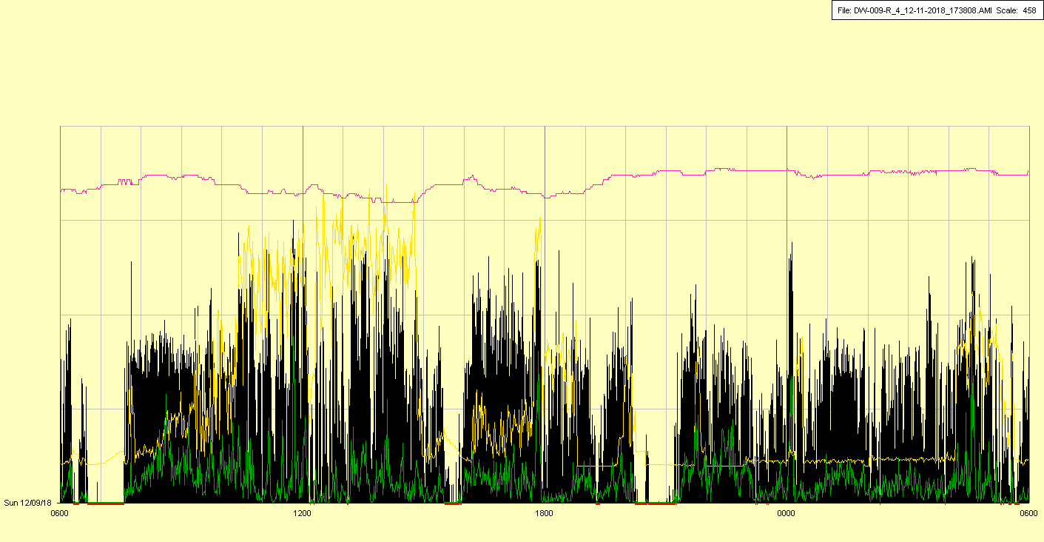

|  |  |  |  |
| --- | --- | --- | --- |
| Study ID | DW9 | Initial NIHSS (affected arm) | 3 |
| Age | 55 | Sex | Female |
| ICH Location | Right deep | Patient location | ICU |
| Hospital day | 25 | Mechanical ventilation | No |
| Delirium status | Yes | 3-month mRS |  |

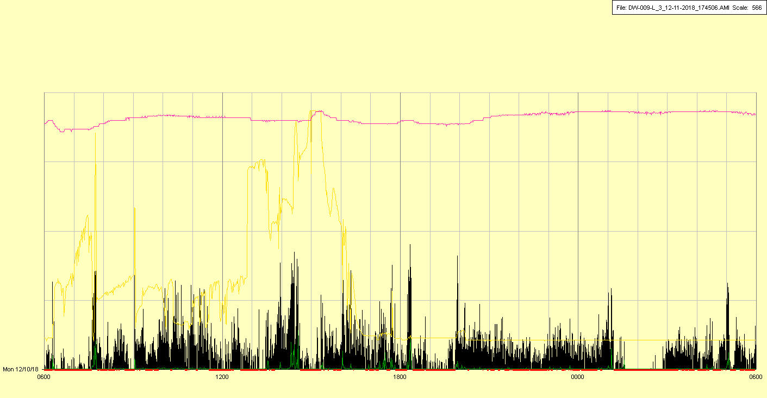

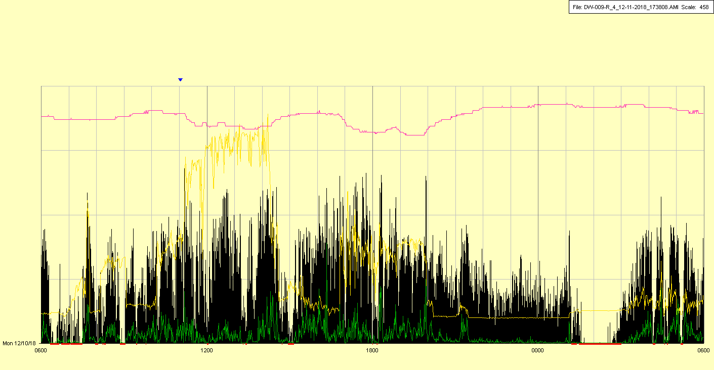

|  |  |  |  |
| --- | --- | --- | --- |
| Study ID | DW9 | Initial NIHSS (affected arm) | 3 |
| Age | 55 | Sex | Female |
| ICH Location | Right deep | Patient location | ICU |
| Hospital day | 26 | Mechanical ventilation | No |
| Delirium status | Yes | 3-month mRS |  |

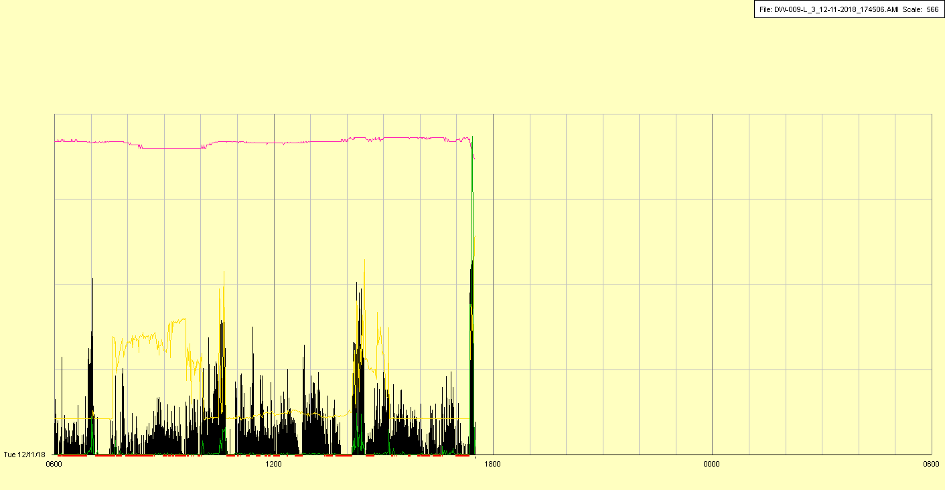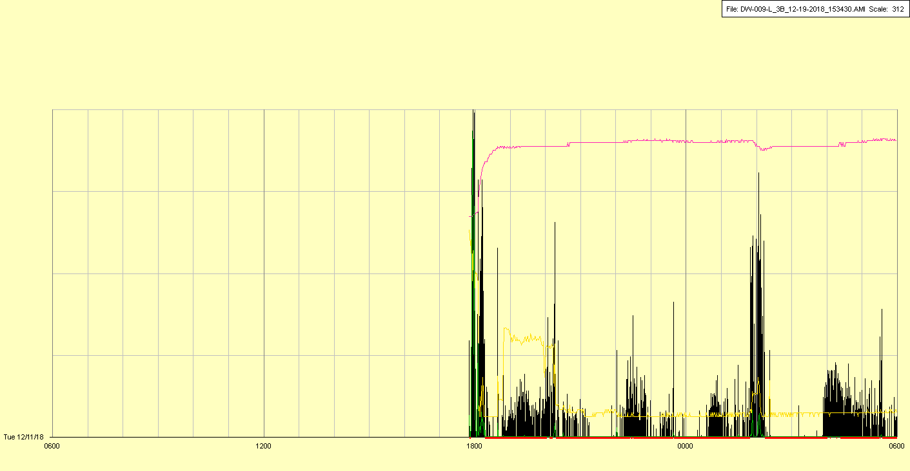

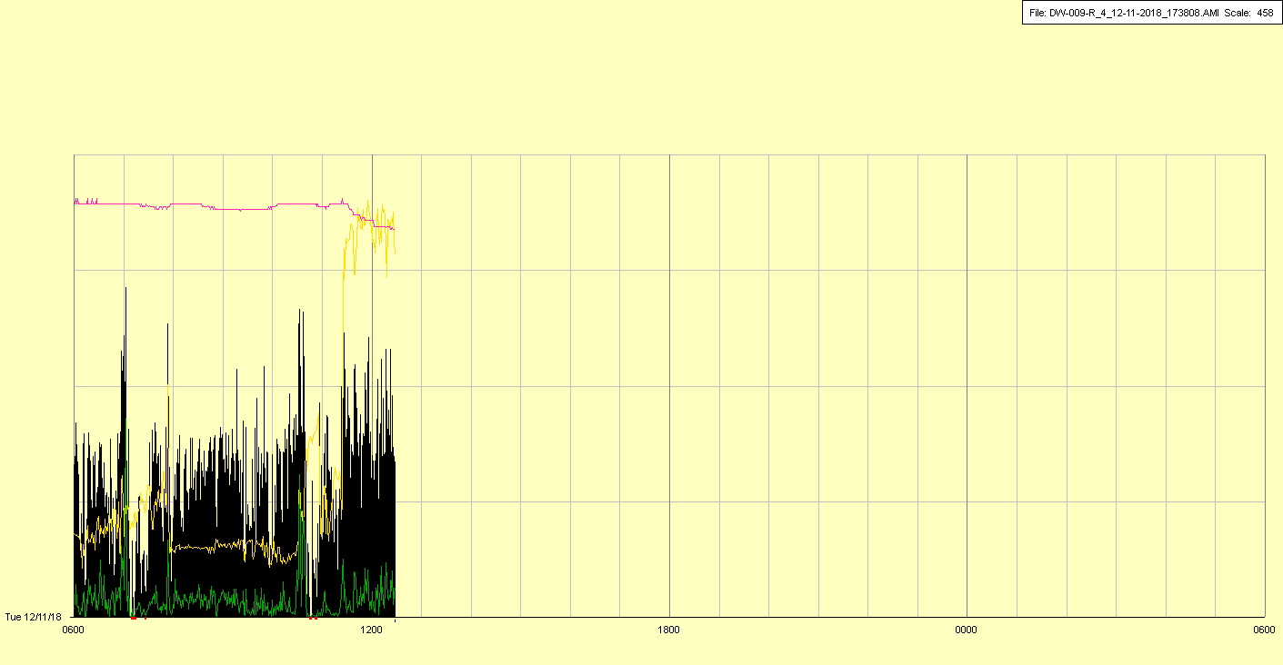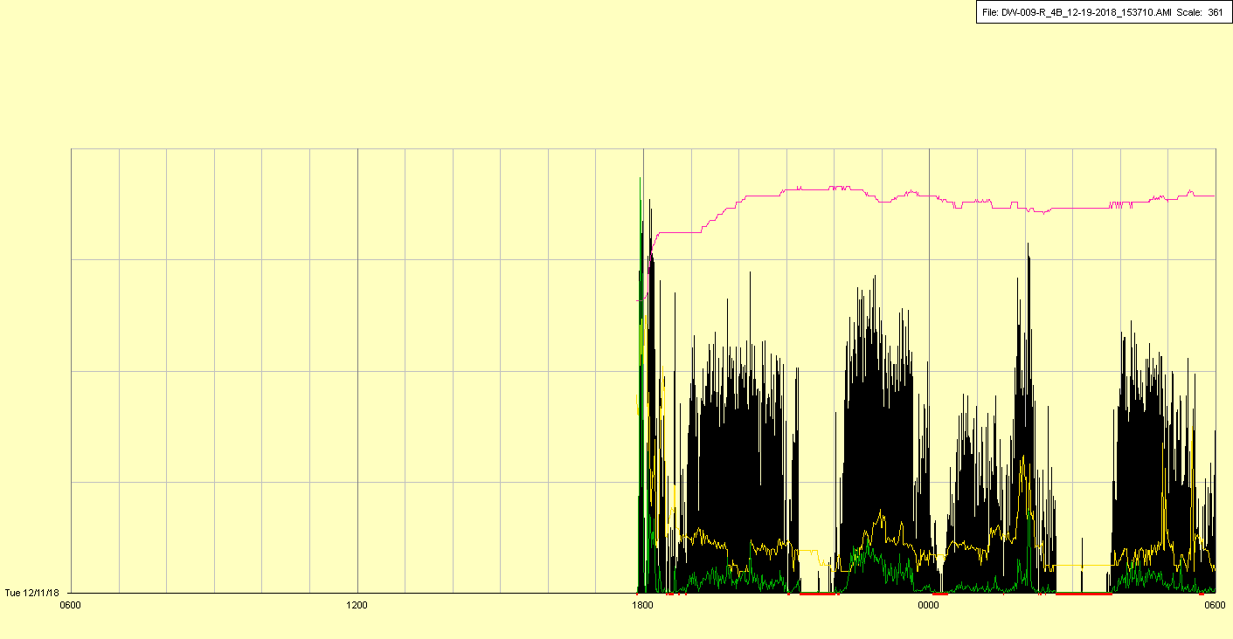

Watches off for battery change

|  |  |  |  |
| --- | --- | --- | --- |
| Study ID | DW9 | Initial NIHSS (affected arm) | 3 |
| Age | 55 | Sex | Female |
| ICH Location | Right deep | Patient location | ICU |
| Hospital day | 27 | Mechanical ventilation | No |
| Delirium status | Yes | 3-month mRS |  |

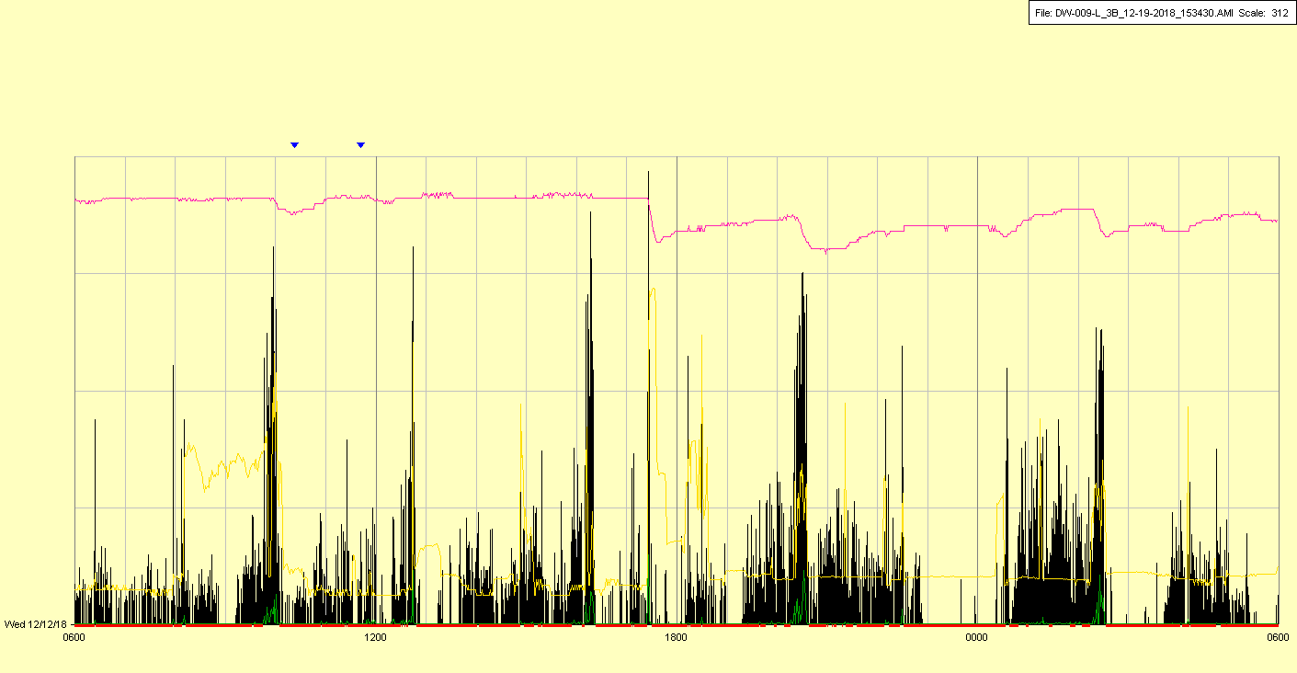

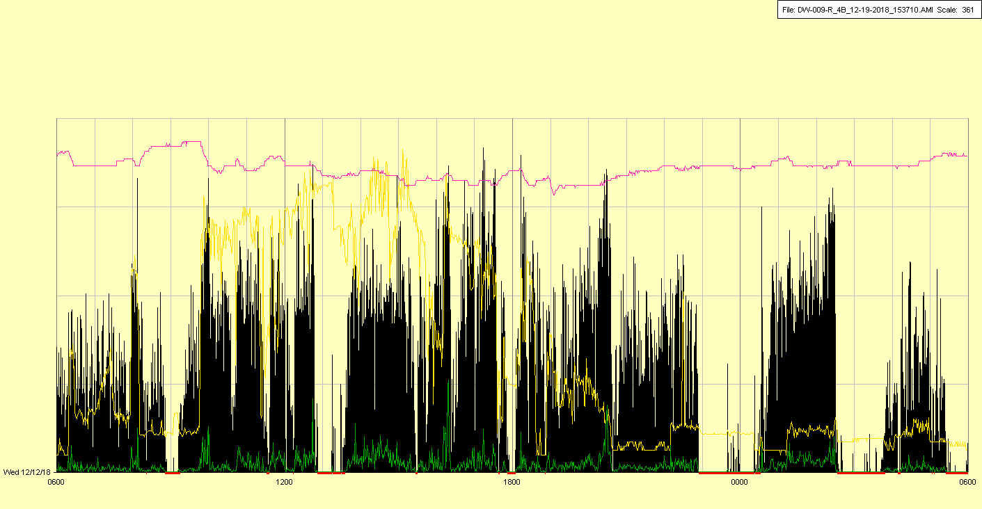

|  |  |  |  |
| --- | --- | --- | --- |
| Study ID | DW9 | Initial NIHSS (affected arm) | 3 |
| Age | 55 | Sex | Female |
| ICH Location | Right deep | Patient location | ICU |
| Hospital day | 28 | Mechanical ventilation | No |
| Delirium status | Yes | 3-month mRS |  |

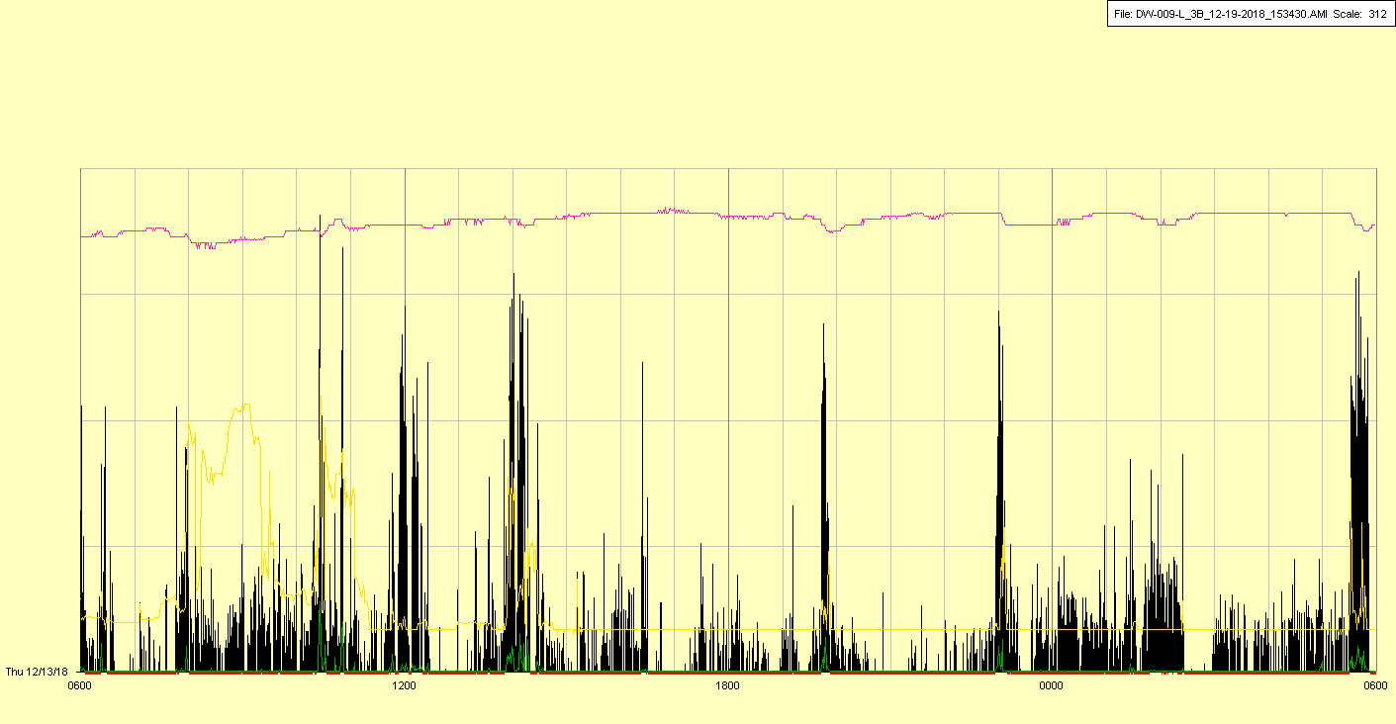

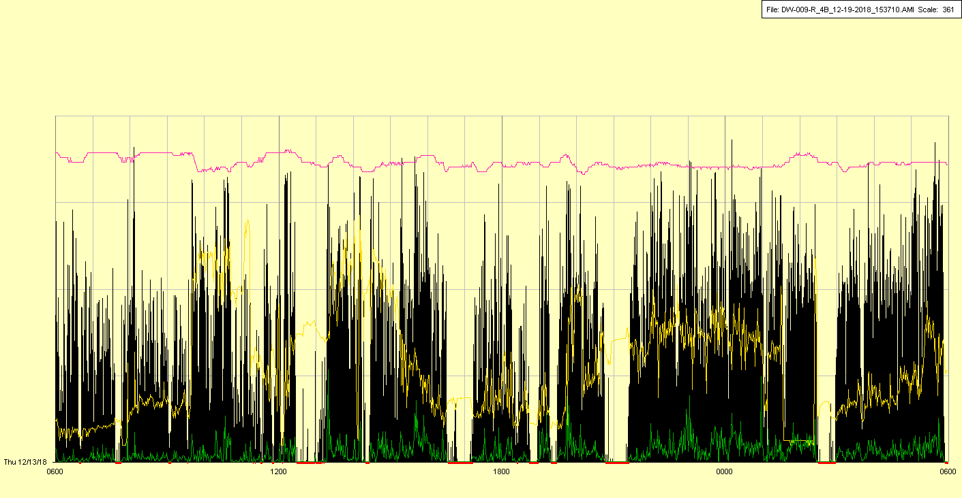

|  |  |  |  |
| --- | --- | --- | --- |
| Study ID | DW9 | Initial NIHSS (affected arm) | 3 |
| Age | 55 | Sex | Female |
| ICH Location | Right deep | Patient location | ICU |
| Hospital day | 29 | Mechanical ventilation | No |
| Delirium status | Yes | 3-month mRS |  |

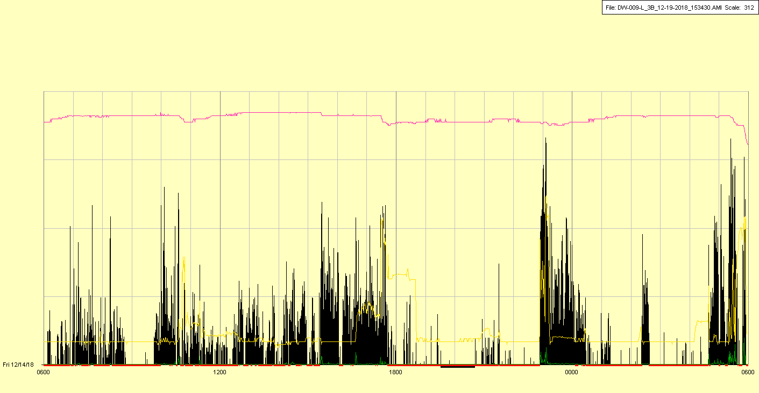

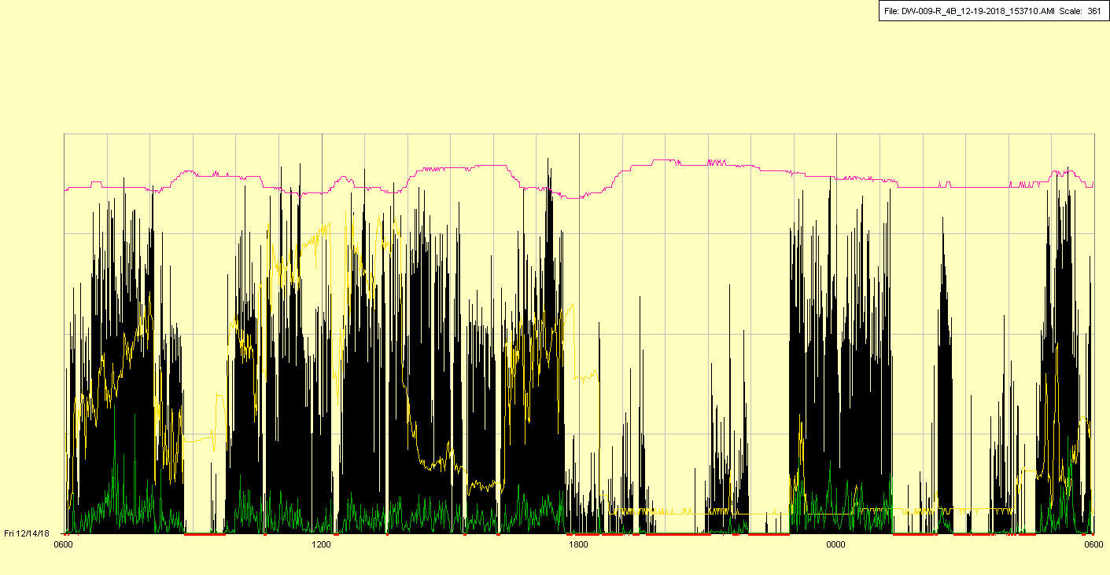

|  |  |  |  |
| --- | --- | --- | --- |
| Study ID | DW9 | Initial NIHSS (affected arm) | 3 |
| Age | 55 | Sex | Female |
| ICH Location | Right deep | Patient location | ICU |
| Hospital day | 30 | Mechanical ventilation | No |
| Delirium status | Yes | 3-month mRS |  |

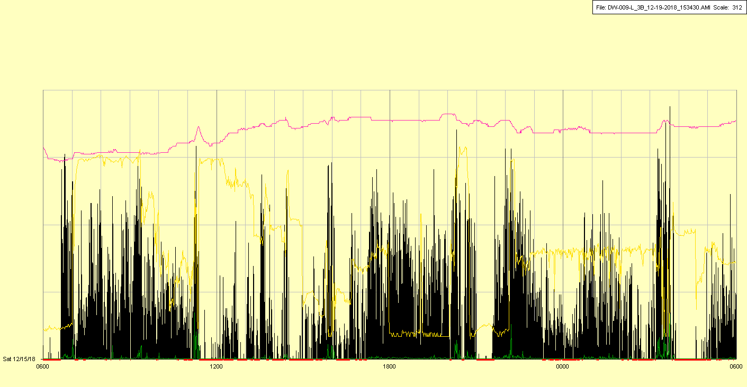

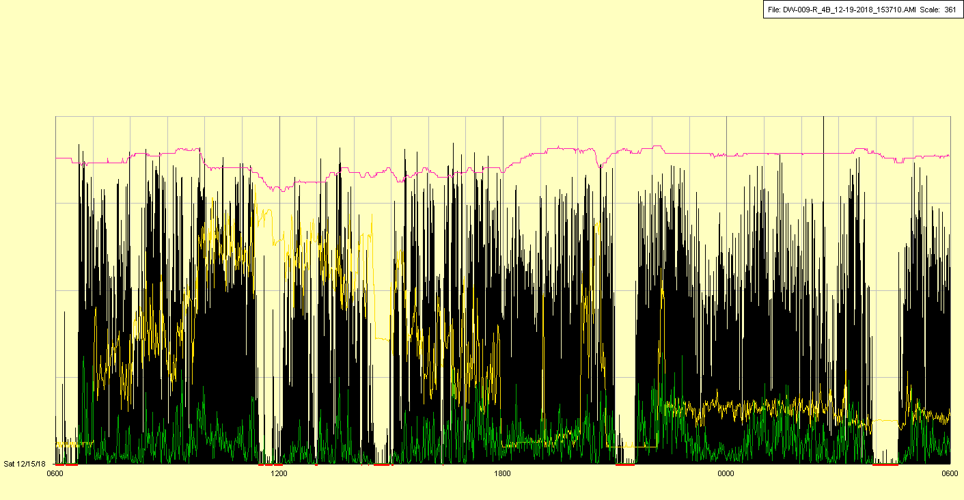

|  |  |  |  |
| --- | --- | --- | --- |
| Study ID | DW9 | Initial NIHSS (affected arm) | 3 |
| Age | 55 | Sex | Female |
| ICH Location | Right deep | Patient location | ICU |
| Hospital day | 31 | Mechanical ventilation | No |
| Delirium status | Yes | 3-month mRS |  |

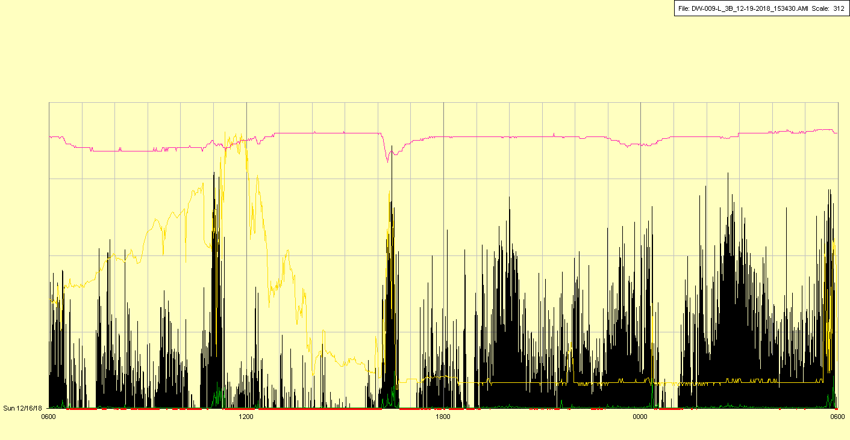

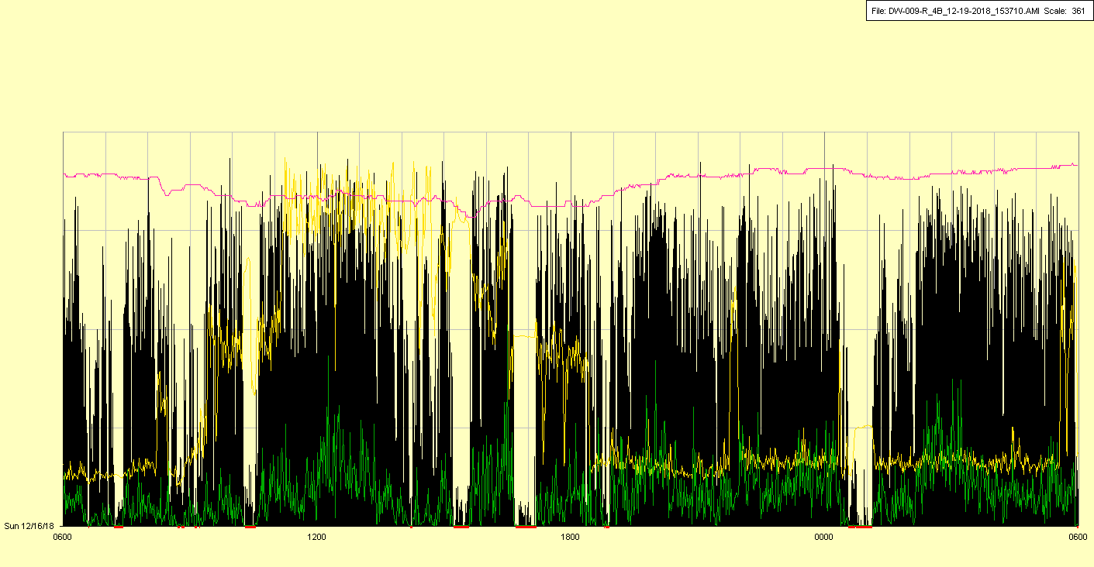

|  |  |  |  |
| --- | --- | --- | --- |
| Study ID | DW9 | Initial NIHSS (affected arm) | 3 |
| Age | 55 | Sex | Female |
| ICH Location | Right deep | Patient location | ICU |
| Hospital day | 32 | Mechanical ventilation | No |
| Delirium status | Yes | 3-month mRS |  |

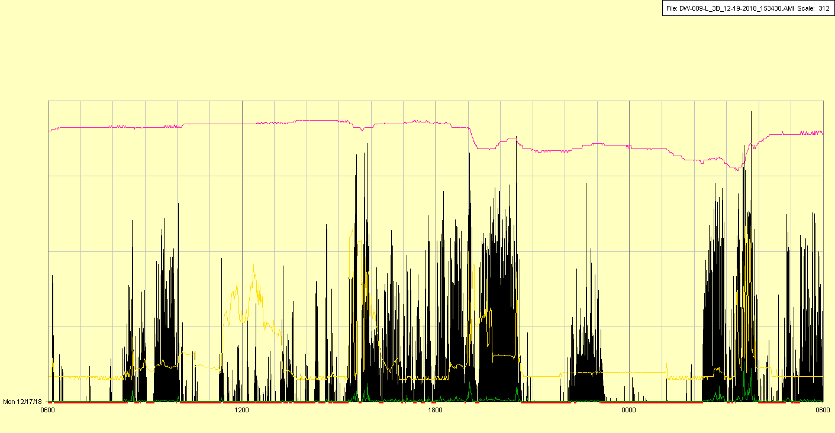

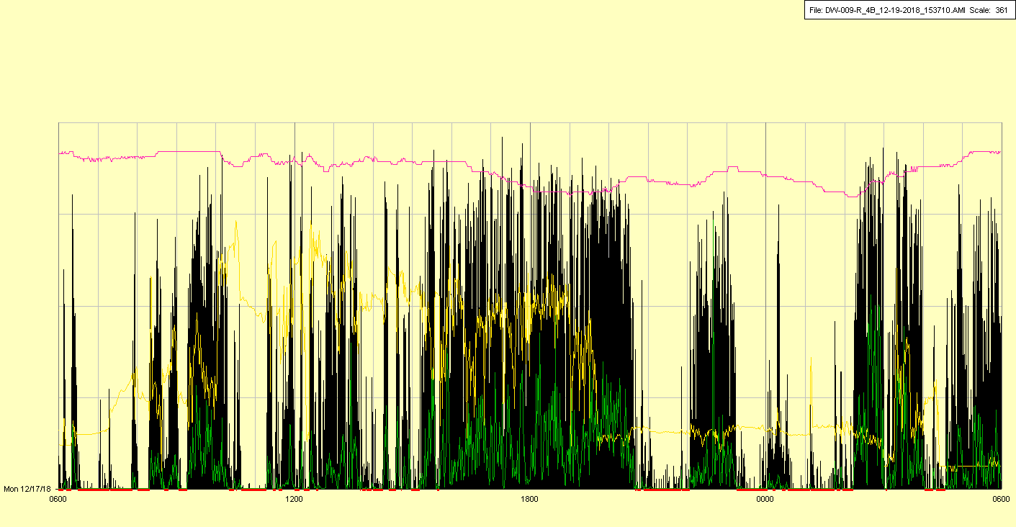

|  |  |  |  |
| --- | --- | --- | --- |
| Study ID | DW9 | Initial NIHSS (affected arm) | 3 |
| Age | 55 | Sex | Female |
| ICH Location | Right deep | Patient location | ICU |
| Hospital day | 33 | Mechanical ventilation | No |
| Delirium status | Yes | 3-month mRS |  |

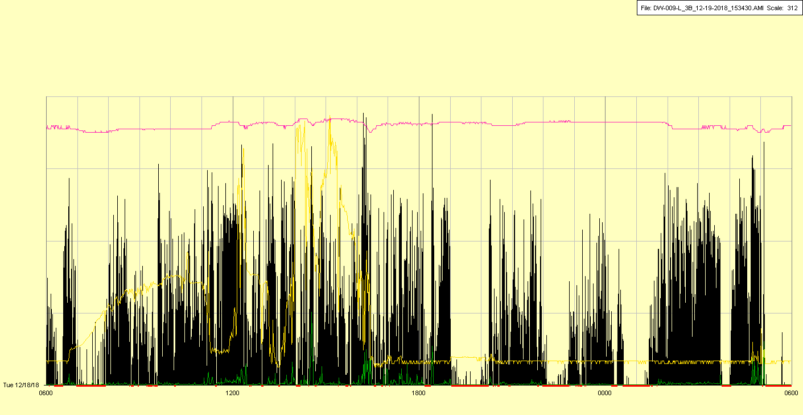

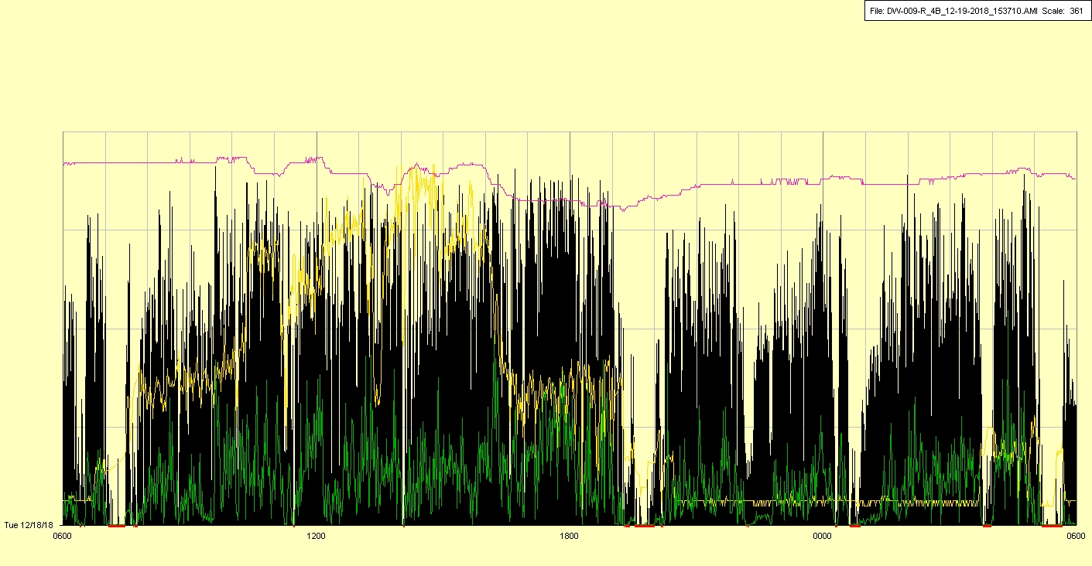

|  |  |  |  |
| --- | --- | --- | --- |
| Study ID | DW9 | Initial NIHSS (affected arm) | 3 |
| Age | 55 | Sex | Female |
| ICH Location | Right deep | Patient location | ICU |
| Hospital day | 34 | Mechanical ventilation | No |
| Delirium status | Yes | 3-month mRS |  |

