Supplemental Materials

Sex Drive: Theoretical Conceptualization and Meta-Analysis of Gender Differences

| **Table S1** | | | | | | | | |
| --- | --- | --- | --- | --- | --- | --- | --- | --- |
| *Search Terms for Literature Search* | | | | | | | | |
| Domain | Terms | a | b | c | d | e | f | g |
| Cognition |  |  |  |  |  |  |  |  |
|  | Terms 1 | sex* | for sex | erotic |  |  |  |  |
|  | Terms 2 | thought* | cogniti* | reverie* | fantas* | daydream* | think* | ruminat* |
|  | Terms 3 | disorder | disfunction |  |  |  |  |  |
| Affect |  |  |  |  |  |  |  |  |
|  | Terms 1 | sex* | for sex | erotic |  |  |  |  |
|  | Terms 2 | desire* | urge* | impuls* | crav* | drive* | motiv* |  |
|  | Terms 3 | disorder | disfunction |  |  |  |  |  |
| Behavior |  |  |  |  |  |  |  |  |
|  | Terms 1 | masturbate* |  |  |  |  |  |  |
|  | Terms 2 |  |  |  |  |  |  |  |
|  | Terms 3 | disorder | disfunction |  |  |  |  |  |
| *Note.* Search terms for each domain were composed as "One of term 1 AND one of term 2 NOT one of term 3". | | | | | | | | |

| **Table S2** | |
| --- | --- |
| *Overview of Psychometric Inventories* | |
| Indicator | Inventories |
| Affect Frequency | Sex Drive Questionnaire, Sexual Desire Inventory, International Index of Erectile Function / Female Sexual Functioning Index, Sociosexual Orientation Inventory Revised, Israeli Sexual Behaviour Inventory , Hurlbert Index of Sexual Desire, Changes in Sexual Functioning Inventory, Trait Sex Drive Scale |
| Affect Intensity | Sexual Desire Inventory, International Index of Erectile Function / Female Sexual Functioning Index, Multidimensional Sexuality Questionnaire, Hurlbert Index of Sexual Desire |
| Behavior Frequency | Sex Drive Questionnaire, Derogatis Sexual Functioning Inventory, Sexual Behavior Inventory, Sex Knowledge and Attitudes Test Adolescents, Trait Sex Drive Scale |
| Cognition Frequency | Sociosexual Orientation Inventory Revised, Sociosexual Orientation Inventory, Sexual Desire Inventory, Derogatis Sexual Functioning Inventory, Sexual Compulsivity Scale, Sexuality Scale, Imaginal Process Inventory, Multidimensional Sociosexual Orientation Inventory, Multidimensional Sexuality Questionnaire, Hurlbert Index of Sexual Desire, Sexual Behavior Inventory, Sex Knowledge and Attitudes Test Adolescents, Changes in Sexual Functioning Inventory, Trait Sex Drive Scale |
| Self-Rated Sex Drive | Sex Drive Questionnaire, Hurlbert Index of Sexual Desire |
| Sexual Intercourse Frequency | Sociosexual Orientation Inventory, Derogatis Sexual Functioning Inventory, Israeli Sexual Behaviour Inventory , Sex Knowledge and Attitudes Test Adolescents |
| Total One-Night Stands | Sociosexual Orientation Inventory Revised, Sociosexual Orientation Inventory, Multidimensional Sociosexual Orientation Inventory |
| Total Sex Partners | Multidimensional Sociosexual Orientation Inventory, Sociosexual Orientation Inventory, Sexuality Scale |
| Total Sex Partners in Last Year | Sociosexual Orientation Inventory Revised, Sociosexual Orientation Inventory, Multidimensional Sociosexual Orientation Inventory |
| *Note.* See the supplementary online materials for a complete list of the inventories with references. | |

| **Table S3** | | | | | | | | | | | | | | | | | | |
| --- | --- | --- | --- | --- | --- | --- | --- | --- | --- | --- | --- | --- | --- | --- | --- | --- | --- | --- |
| *Tests for Moderation (Secondary Indicators)* | | | | | | | | | | | | | | | | | | |
| Moderator |  | Cognition Frequency (uncontrolled) | | | | |  | Affect Intensity | | | | |  | Self-Rated Sex Drive | | | | |
| *HTZ* | *df* | *p* | *I2* | ** | *HTZ* | *df* | *p* | *I2* | ** | *HTZ* | *df* | *p* | *I2* | ** |
| **Outcome-level Moderators** |  |  |  |  |  |  |  |  |  |  |  |  |  |  |  |  |  |  |
| Aggregation Span |  | 4.05 | 7.26 | .083 | 79.81 | 0.12 |  | 7.07 | 11.37 | .022 | 81.97 | 0.20 |  |  |  |  |  |  |
| Item Content |  | 21.00 | 49.54 | < .001 | 85.78 | 0.19 |  | 14.29 | 23.37 | < .001 | 87.81 | 0.15 |  |  |  |  |  |  |
| Item Context |  |  |  |  |  |  |  | 21.83 | 14.60 | < .001 | 84.95 | 0.12 |  |  |  |  |  |  |
| Type of Response Scale |  | 9.63 | 6.44 | .019 | 89.93 | 0.23 |  |  |  |  |  |  |  |  |  |  |  |  |
| Scale Range |  | 12.90 | 55.53 | < .001 | 90.00 | 0.23 |  | 1.45 | 28.59 | .239 | 88.92 | 0.16 |  | 1.66 | 3.30 | N/A | 96.46 | 0.30 |
| Item Wording |  | 12.60 | 5.56 | .007 | 87.66 | 0.20 |  | 0.03 | 2.19 | N/A | 90.68 | 0.15 |  |  |  |  |  |  |
| **Publication-level Moderators** |  |  |  |  |  |  |  |  |  |  |  |  |  |  |  |  |  |  |
| Aim to Find Gender Differences in Sex Drive |  | 14.71 | 11.62 | .003 | 89.28 | 0.22 |  | 0.55 | 17.24 | .469 | 89.32 | 0.19 |  |  |  |  |  |  |
| Focus on Anonymity |  | 1.62 | 135.29 | .205 | 89.97 | 0.23 |  | 1.54 | 43.39 | .221 | 88.55 | 0.16 |  |  |  |  |  |  |
| Focus on Gender Differences in Sex Drive |  | 6.85 | 25.63 | .015 | 87.62 | 0.21 |  | 0.11 | 29.17 | .742 | 89.25 | 0.16 |  |  |  |  |  |  |
| Focus on Gender Differences |  | 2.39 | 108.91 | .125 | 88.86 | 0.22 |  | 0.00 | 22.92 | .961 | 89.49 | 0.15 |  |  |  |  |  |  |
| Gender of First Author |  | 1.10 | 112.97 | .297 | 89.72 | 0.23 |  | 3.99 | 25.73 | .056 | 89.72 | 0.16 |  | 0.22 | 7.65 | .654 | 92.10 | 0.25 |
| Mean Author Gender |  | 4.20 | 67.90 | .044 | 89.80 | 0.23 |  | 4.89 | 22.06 | .038 | 89.88 | 0.16 |  | 0.11 | 4.42 | .757 | 97.13 | 0.34 |
| Publication Status |  | 2.32 | 38.38 | .136 | 89.15 | 0.22 |  | 2.36 | 8.98 | .159 | 89.44 | 0.16 |  |  |  |  |  |  |
| Sexuality Journal |  | 9.87 | 76.50 | .002 | 89.65 | 0.23 |  | 0.79 | 35.20 | .379 | 89.55 | 0.18 |  |  |  |  |  |  |
| **Sample-level Moderators** |  |  |  |  |  |  |  |  |  |  |  |  |  |  |  |  |  |  |
| Mean Age |  | 0.88 | 33.02 | .356 | 89.79 | 0.23 |  | 2.80 | 6.30 | .143 | 88.37 | 0.15 |  | 0.03 | 3.39 | N/A | 97.86 | 0.39 |
| Percent White |  | 0.18 | 11.91 | .683 | 89.40 | 0.22 |  | 0.64 | 9.06 | .443 | 88.92 | 0.27 |  | 0.86 | 2.02 | N/A | 78.16 | 0.25 |
| Country-Level Gender Development |  | 3.60 | 40.58 | .065 | 88.88 | 0.22 |  | 1.38 | 9.08 | .270 | 87.50 | 0.20 |  | 4.06 | 3.50 | N/A | 73.04 | 0.18 |
| Country-Level Gender Inequality |  | 0.52 | 18.87 | .478 | 88.58 | 0.22 |  | 0.16 | 37.94 | .692 | 87.81 | 0.21 |  | 6.77 | 5.25 | .046 | 73.09 | 0.18 |
| Percent Heterosexual |  | 1.71 | 10.29 | .220 | 90.65 | 0.21 |  | 3.40 | 4.84 | .126 | 92.08 | 0.18 |  | 0.01 | 1.28 | N/A | 85.62 | 0.26 |
| Average Partnership Duration in Weeks |  | 1.19 | 7.58 | .308 | 75.39 | 0.18 |  | 0.02 | 1.61 | N/A | 82.69 | 0.26 |  |  |  |  |  |  |
| Percent Parents |  | 0.18 | 5.17 | .685 | 89.56 | 0.28 |  | 6.04 | 2.94 | N/A | 84.00 | 0.28 |  |  |  |  |  |  |
| Country-Level Sex Ratio |  | 0.48 | 21.38 | .494 | 88.72 | 0.22 |  | 0.03 | 9.26 | .863 | 88.32 | 0.21 |  | 0.92 | 1.84 | N/A | 90.47 | 0.28 |
| Study Restricted to Sexually Active |  | 9.97 | 19.41 | .005 | 83.79 | 0.18 |  | 0.00 | 13.75 | .976 | 88.96 | 0.18 |  |  |  |  |  |  |
| Percent Single |  | 12.92 | 31.11 | .001 | 88.86 | 0.22 |  | 0.15 | 10.01 | .707 | 88.50 | 0.22 |  | 0.56 | 1.62 | N/A | 95.40 | 0.35 |
| Percent University Students |  | 0.72 | 11.58 | .414 | 85.20 | 0.22 |  | 2.75 | 7.83 | .137 | 89.73 | 0.24 |  |  |  |  |  |  |
| **Study-level Moderators** |  |  |  |  |  |  |  |  |  |  |  |  |  |  |  |  |  |  |
| Anonymity Reassurance |  | 2.32 | 90.82 | .131 | 90.14 | 0.23 |  | 6.21 | 20.09 | .022 | 88.51 | 0.15 |  |  |  |  |  |  |
| Participant Compensation |  | 1.68 | 51.20 | .182 | 89.87 | 0.25 |  | 0.50 | 2.85 | N/A | 90.72 | 0.37 |  |  |  |  |  |  |
| Electronic Data Collection |  | 0.21 | 57.29 | .647 | 90.55 | 0.23 |  | 0.78 | 4.03 | .517 | 90.25 | 0.16 |  |  |  |  |  |  |
| Group Assessment |  | 6.18 | 20.36 | .008 | 90.35 | 0.22 |  | 0.33 | 3.30 | N/A | 91.32 | 0.16 |  |  |  |  |  |  |
| Personal Contact |  | 2.66 | 10.96 | .115 | 90.18 | 0.23 |  | 0.08 | 7.69 | .924 | 90.67 | 0.16 |  |  |  |  |  |  |
| Sexuality Study |  | 6.57 | 41.89 | .014 | 86.18 | 0.19 |  | 3.50 | 14.63 | .081 | 90.88 | 0.22 |  |  |  |  |  |  |
| Year of Study |  | 0.17 | 42.40 | .681 | 89.53 | 0.23 |  | 0.04 | 15.69 | .844 | 87.65 | 0.16 |  | 0.22 | 4.95 | .660 | 94.26 | 0.27 |
| *Note.*Tests for moderation of the secondary sex drive indicators and cognition frequency (not controlled for item content). The tests indicate the significance of the slope for continuous moderator or differences between subgroups for categorical moderators. Some models could not be fitted because the number of available codings was insufficient. These are left blank. *HTZ* = Hotelling-*T*-approximated test statistic. *df* = small-sample-corrected degrees of freedom. *p* = *p*-value associated with the test statistic and *df* in the same row. *I*2 = proportion of the variation in observed effects that is due to variation in true effects. ** = estimated standard deviation of the true effects. Note that if degrees of freedom fall below 4, significance tests are unreliable. *p*-values for unreliable tests are not reported (N/A). | | | | | | | | | | | | | | | | | | |

| **Table S4** |
| --- |
| *Regression Tables for Moderation Analyses (Secondary Indicators)* |

| Moderator |  | Cognition Frequency (uncontrolled) | | | | | | |  | Affect Intensity | | | | | | |  | Self-Rated Sex Drive | | | | | | |
| --- | --- | --- | --- | --- | --- | --- | --- | --- | --- | --- | --- | --- | --- | --- | --- | --- | --- | --- | --- | --- | --- | --- | --- | --- |
| *g* | *SE* | *k* | *m* | *t* | *df* | *p* | *g* | *SE* | *k* | *m* | *t* | *df* | *p* | *g* | *SE* | *k* | *m* | *t* | *df* | *p* |
| **Outcome-level Moderators** |  |  |  |  |  |  |  |  |  |  |  |  |  |  |  |  |  |  |  |  |  |  |  |  |
| Aggregation Span |  |  |  |  |  |  |  |  |  |  |  |  |  |  |  |  |  |  |  |  |  |  |  |  |
| Intercept |  | 0.37 | 0.09 | 30 | 46 | 3.87 | 4.91 | .012 |  | 0.18 | 0.07 | 16 | 17 | 2.72 | 5.72 | .036 |  |  |  |  |  |  |  |  |
| Slope |  | 0.01 | 0.00 |  |  | 2.01 | 7.26 | .083 |  | 0.01 | 0.00 |  |  | 2.66 | 11.37 | .022 |  |  |  |  |  |  |  |  |
| Item Content |  |  |  |  |  |  |  |  |  |  |  |  |  |  |  |  |  |  |  |  |  |  |  |  |
| A partner |  | 0.58 | 0.05 | 24 | 32 | 11.74 | 19.20 | < .001 |  | 0.26 | 0.03 | 20 | 56 | 8.01 | 16.28 | < .001 |  |  |  |  |  |  |  |  |
| Extra pair partner |  | 0.82 | 0.02 | 106 | 168 | 36.77 | 98.63 | < .001 |  |  |  |  |  |  |  |  |  |  |  |  |  |  |  |  |
| Not specified |  | 0.57 | 0.04 | 43 | 82 | 14.85 | 36.36 | < .001 |  | 0.46 | 0.04 | 39 | 88 | 12.68 | 27.57 | < .001 |  |  |  |  |  |  |  |  |
| Masturbation |  |  |  |  |  |  |  |  |  | 0.46 | 0.04 | 19 | 37 | 13.00 | 15.81 | < .001 |  |  |  |  |  |  |  |  |
| Own partner |  |  |  |  |  |  |  |  |  | 0.27 | 0.04 | 13 | 19 | 6.84 | 9.89 | < .001 |  |  |  |  |  |  |  |  |
| Item Context |  |  |  |  |  |  |  |  |  |  |  |  |  |  |  |  |  |  |  |  |  |  |  |  |
| First seeing an attractive person |  |  |  |  |  |  |  |  |  | 0.67 | 0.04 | 19 | 19 | 15.06 | 15.70 | < .001 |  |  |  |  |  |  |  |  |
| Not specified |  |  |  |  |  |  |  |  |  | 0.41 | 0.03 | 47 | 115 | 13.12 | 34.97 | < .001 |  |  |  |  |  |  |  |  |
| Romantic situation |  |  |  |  |  |  |  |  |  | 0.09 | 0.04 | 20 | 20 | 2.28 | 16.39 | .036 |  |  |  |  |  |  |  |  |
| While having sexual thoughts |  |  |  |  |  |  |  |  |  | 0.23 | 0.04 | 20 | 20 | 6.06 | 16.39 | < .001 |  |  |  |  |  |  |  |  |
| While spending time with an attractive person |  |  |  |  |  |  |  |  |  | 0.50 | 0.04 | 20 | 20 | 13.18 | 16.39 | < .001 |  |  |  |  |  |  |  |  |
| Type of Response Scale |  |  |  |  |  |  |  |  |  |  |  |  |  |  |  |  |  |  |  |  |  |  |  |  |
| No |  | 0.74 | 0.02 | 157 | 268 | 36.61 | 149.22 | < .001 |  |  |  |  |  |  |  |  |  |  |  |  |  |  |  |  |
| Yes |  | 0.43 | 0.10 | 8 | 14 | 4.23 | 6.03 | .005 |  |  |  |  |  |  |  |  |  |  |  |  |  |  |  |  |
| Scale Range |  |  |  |  |  |  |  |  |  |  |  |  |  |  |  |  |  |  |  |  |  |  |  |  |
| Intercept |  | 0.46 | 0.08 | 155 | 265 | 5.52 | 41.91 | < .001 |  | 0.51 | 0.12 | 54 | 204 | 4.20 | 22.22 | < .001 |  | 1.41 | 0.48 | 10 | 10 | 2.92 | 3.84 | N/A |
| Slope |  | 0.04 | 0.01 |  |  | 3.59 | 55.53 | < .001 |  | -0.02 | 0.02 |  |  | -1.20 | 28.59 | .239 |  | -0.11 | 0.09 |  |  | -1.29 | 3.30 | N/A |
| Item Wording |  |  |  |  |  |  |  |  |  |  |  |  |  |  |  |  |  |  |  |  |  |  |  |  |
| Daydreams |  | 0.39 | 0.12 | 6 | 10 | 3.11 | 4.00 | .036 |  |  |  |  |  |  |  |  |  |  |  |  |  |  |  |  |
| Fantasies |  | 0.81 | 0.02 | 120 | 189 | 35.24 | 111.37 | < .001 |  |  |  |  |  |  |  |  |  |  |  |  |  |  |  |  |
| Other |  | 0.37 | 0.24 | 4 | 5 | 1.55 | 1.98 | N/A |  | 0.38 | 0.09 | 4 | 5 | 4.45 | 2.07 | N/A |  |  |  |  |  |  |  |  |
| Thoughts |  | 0.57 | 0.03 | 46 | 74 | 20.89 | 39.17 | < .001 |  |  |  |  |  |  |  |  |  |  |  |  |  |  |  |  |
| Desire |  |  |  |  |  |  |  |  |  | 0.40 | 0.03 | 48 | 190 | 14.99 | 40.32 | < .001 |  |  |  |  |  |  |  |  |
| **Publication-level Moderators** |  |  |  |  |  |  |  |  |  |  |  |  |  |  |  |  |  |  |  |  |  |  |  |  |
| Aim to Find Gender Differences in Sex Drive |  |  |  |  |  |  |  |  |  |  |  |  |  |  |  |  |  |  |  |  |  |  |  |  |
| No |  | 0.76 | 0.02 | 127 | 215 | 33.40 | 120.96 | < .001 |  | 0.39 | 0.03 | 35 | 150 | 11.98 | 31.23 | < .001 |  |  |  |  |  |  |  |  |
| Yes |  | 0.50 | 0.06 | 11 | 28 | 8.09 | 9.75 | < .001 |  | 0.43 | 0.04 | 11 | 39 | 9.87 | 9.61 | < .001 |  |  |  |  |  |  |  |  |
| Focus on Anonymity |  |  |  |  |  |  |  |  |  |  |  |  |  |  |  |  |  |  |  |  |  |  |  |  |
| No |  | 0.76 | 0.03 | 74 | 136 | 26.37 | 70.99 | < .001 |  | 0.42 | 0.04 | 26 | 92 | 10.96 | 22.22 | < .001 |  |  |  |  |  |  |  |  |
| Yes |  | 0.71 | 0.03 | 70 | 118 | 21.27 | 65.60 | < .001 |  | 0.35 | 0.03 | 25 | 102 | 10.33 | 21.19 | < .001 |  |  |  |  |  |  |  |  |
| Focus on Gender Differences in Sex Drive |  |  |  |  |  |  |  |  |  |  |  |  |  |  |  |  |  |  |  |  |  |  |  |  |
| No |  | 0.76 | 0.02 | 118 | 201 | 32.50 | 111.74 | < .001 |  | 0.41 | 0.04 | 31 | 132 | 11.37 | 26.55 | < .001 |  |  |  |  |  |  |  |  |
| Yes |  | 0.60 | 0.06 | 20 | 42 | 10.72 | 18.24 | < .001 |  | 0.39 | 0.04 | 15 | 57 | 10.55 | 13.10 | < .001 |  |  |  |  |  |  |  |  |
| Focus on Gender Differences |  |  |  |  |  |  |  |  |  |  |  |  |  |  |  |  |  |  |  |  |  |  |  |  |
| No |  | 0.78 | 0.04 | 55 | 93 | 21.07 | 51.79 | < .001 |  | 0.40 | 0.05 | 15 | 55 | 7.38 | 12.32 | < .001 |  |  |  |  |  |  |  |  |
| Yes |  | 0.71 | 0.03 | 83 | 150 | 25.92 | 78.77 | < .001 |  | 0.40 | 0.03 | 31 | 134 | 13.50 | 26.82 | < .001 |  |  |  |  |  |  |  |  |
| Gender of First Author |  |  |  |  |  |  |  |  |  |  |  |  |  |  |  |  |  |  |  |  |  |  |  |  |
| Female |  | 0.71 | 0.03 | 57 | 102 | 22.08 | 54.00 | < .001 |  | 0.41 | 0.03 | 39 | 144 | 12.53 | 33.73 | < .001 |  | 0.80 | 0.16 | 5 | 5 | 5.16 | 3.93 | N/A |
| Male |  | 0.75 | 0.03 | 100 | 173 | 27.91 | 95.14 | < .001 |  | 0.32 | 0.03 | 16 | 61 | 9.33 | 12.88 | < .001 |  | 0.70 | 0.14 | 5 | 5 | 4.94 | 3.73 | N/A |
| Mean Author Gender |  |  |  |  |  |  |  |  |  |  |  |  |  |  |  |  |  |  |  |  |  |  |  |  |
| Intercept |  | 0.66 | 0.04 | 157 | 275 | 18.33 | 51.38 | < .001 |  | 0.44 | 0.04 | 55 | 205 | 11.54 | 27.53 | < .001 |  | 0.80 | 0.17 | 10 | 10 | 4.56 | 3.27 | N/A |
| Slope |  | 0.11 | 0.06 |  |  | 2.05 | 67.90 | .044 |  | -0.14 | 0.06 |  |  | -2.21 | 22.06 | .038 |  | -0.08 | 0.23 |  |  | -0.33 | 4.42 | .757 |
| Publication Status |  |  |  |  |  |  |  |  |  |  |  |  |  |  |  |  |  |  |  |  |  |  |  |  |
| Published |  | 0.75 | 0.02 | 132 | 220 | 32.98 | 125.98 | < .001 |  | 0.40 | 0.03 | 45 | 183 | 15.20 | 39.27 | < .001 |  |  |  |  |  |  |  |  |
| Unpublished |  | 0.67 | 0.04 | 29 | 62 | 15.06 | 26.58 | < .001 |  | 0.27 | 0.08 | 10 | 22 | 3.57 | 6.65 | .010 |  |  |  |  |  |  |  |  |
| Sexuality Journal |  |  |  |  |  |  |  |  |  |  |  |  |  |  |  |  |  |  |  |  |  |  |  |  |
| No |  | 0.77 | 0.02 | 117 | 196 | 30.82 | 111.54 | < .001 |  | 0.36 | 0.03 | 37 | 103 | 10.45 | 31.39 | < .001 |  |  |  |  |  |  |  |  |
| Yes |  | 0.64 | 0.03 | 44 | 86 | 20.63 | 41.50 | < .001 |  | 0.41 | 0.04 | 18 | 102 | 10.35 | 16.12 | < .001 |  |  |  |  |  |  |  |  |
| **Sample-level Moderators** |  |  |  |  |  |  |  |  |  |  |  |  |  |  |  |  |  |  |  |  |  |  |  |  |
| Mean Age |  |  |  |  |  |  |  |  |  |  |  |  |  |  |  |  |  |  |  |  |  |  |  |  |
| Intercept |  | 0.83 | 0.09 | 137 | 234 | 9.22 | 48.29 | < .001 |  | 0.21 | 0.10 | 53 | 203 | 2.07 | 9.88 | .066 |  | 0.83 | 0.37 | 8 | 8 | 2.22 | 2.78 | N/A |
| Slope |  | -0.00 | 0.00 |  |  | -0.94 | 33.02 | .356 |  | 0.01 | 0.00 |  |  | 1.67 | 6.30 | .143 |  | -0.00 | 0.01 |  |  | -0.17 | 3.39 | N/A |
| Percent White |  |  |  |  |  |  |  |  |  |  |  |  |  |  |  |  |  |  |  |  |  |  |  |  |
| Intercept |  | 0.84 | 0.13 | 47 | 79 | 6.43 | 9.92 | < .001 |  | 0.29 | 0.12 | 27 | 120 | 2.54 | 6.25 | .042 |  | 0.51 | 0.18 | 6 | 6 | 2.77 | 1.76 | N/A |
| Slope |  | -0.00 | 0.00 |  |  | -0.42 | 11.91 | .683 |  | 0.00 | 0.00 |  |  | 0.80 | 9.06 | .443 |  | 0.00 | 0.00 |  |  | 0.92 | 2.02 | N/A |
| Country-Level Gender Development |  |  |  |  |  |  |  |  |  |  |  |  |  |  |  |  |  |  |  |  |  |  |  |  |
| Intercept |  | -2.39 | 1.66 | 143 | 253 | -1.44 | 39.93 | .157 |  | 2.52 | 1.82 | 52 | 195 | 1.38 | 9.01 | .201 |  | 12.36 | 5.72 | 9 | 9 | 2.16 | 3.40 | N/A |
| Slope |  | 3.19 | 1.68 |  |  | 1.90 | 40.58 | .065 |  | -2.17 | 1.84 |  |  | -1.18 | 9.08 | .270 |  | -11.77 | 5.85 |  |  | -2.01 | 3.50 | N/A |
| Country-Level Gender Inequality |  |  |  |  |  |  |  |  |  |  |  |  |  |  |  |  |  |  |  |  |  |  |  |  |
| Intercept |  | 0.70 | 0.07 | 146 | 256 | 10.46 | 32.18 | < .001 |  | 0.41 | 0.08 | 52 | 195 | 5.00 | 29.38 | < .001 |  | 1.27 | 0.16 | 9 | 9 | 7.90 | 3.85 | N/A |
| Slope |  | 0.25 | 0.35 |  |  | 0.72 | 18.87 | .478 |  | -0.16 | 0.39 |  |  | -0.40 | 37.94 | .692 |  | -2.61 | 1.00 |  |  | -2.60 | 5.25 | .046 |
| Percent Heterosexual |  |  |  |  |  |  |  |  |  |  |  |  |  |  |  |  |  |  |  |  |  |  |  |  |
| Intercept |  | 0.48 | 0.17 | 81 | 150 | 2.86 | 9.18 | .018 |  | 0.17 | 0.12 | 35 | 157 | 1.35 | 4.27 | .245 |  | 0.82 | 0.29 | 6 | 6 | 2.82 | 1.00 | N/A |
| Slope |  | 0.00 | 0.00 |  |  | 1.31 | 10.29 | .220 |  | 0.00 | 0.00 |  |  | 1.84 | 4.84 | .126 |  | -0.00 | 0.00 |  |  | -0.07 | 1.28 | N/A |
| Average Partnership Duration in Weeks |  |  |  |  |  |  |  |  |  |  |  |  |  |  |  |  |  |  |  |  |  |  |  |  |
| Intercept |  | 0.76 | 0.06 | 31 | 46 | 12.50 | 19.13 | < .001 |  | 0.31 | 0.05 | 28 | 70 | 5.86 | 21.63 | < .001 |  |  |  |  |  |  |  |  |
| Slope |  | -0.00 | 0.00 |  |  | -1.09 | 7.58 | .308 |  | 0.00 | 0.00 |  |  | 0.14 | 1.61 | N/A |  |  |  |  |  |  |  |  |
| Percent Parents |  |  |  |  |  |  |  |  |  |  |  |  |  |  |  |  |  |  |  |  |  |  |  |  |
| Intercept |  | 0.80 | 0.12 | 21 | 37 | 6.49 | 13.45 | < .001 |  | 0.18 | 0.13 | 12 | 47 | 1.44 | 8.16 | .187 |  |  |  |  |  |  |  |  |
| Slope |  | -0.00 | 0.00 |  |  | -0.43 | 5.17 | .685 |  | 0.00 | 0.00 |  |  | 2.46 | 2.94 | N/A |  |  |  |  |  |  |  |  |
| Country-Level Sex Ratio |  |  |  |  |  |  |  |  |  |  |  |  |  |  |  |  |  |  |  |  |  |  |  |  |
| Intercept |  | 0.10 | 0.92 | 146 | 256 | 0.11 | 21.06 | .915 |  | 0.70 | 1.80 | 52 | 195 | 0.39 | 9.14 | .707 |  | -4.53 | 5.55 | 9 | 9 | -0.82 | 1.81 | N/A |
| Slope |  | 0.01 | 0.01 |  |  | 0.70 | 21.38 | .494 |  | -0.00 | 0.02 |  |  | -0.18 | 9.26 | .863 |  | 0.05 | 0.06 |  |  | 0.96 | 1.84 | N/A |
| Study Restricted to Sexually Active |  |  |  |  |  |  |  |  |  |  |  |  |  |  |  |  |  |  |  |  |  |  |  |  |
| No |  | 0.78 | 0.02 | 97 | 172 | 32.40 | 89.47 | < .001 |  | 0.38 | 0.03 | 34 | 115 | 11.09 | 29.68 | < .001 |  |  |  |  |  |  |  |  |
| Yes |  | 0.59 | 0.06 | 16 | 29 | 10.23 | 14.16 | < .001 |  | 0.37 | 0.06 | 10 | 46 | 6.30 | 8.16 | < .001 |  |  |  |  |  |  |  |  |
| Percent Single |  |  |  |  |  |  |  |  |  |  |  |  |  |  |  |  |  |  |  |  |  |  |  |  |
| Intercept |  | 0.61 | 0.04 | 88 | 158 | 17.24 | 40.77 | < .001 |  | 0.35 | 0.04 | 44 | 161 | 9.34 | 27.59 | < .001 |  | 0.71 | 0.19 | 4 | 4 | 3.82 | 1.82 | N/A |
| Slope |  | 0.00 | 0.00 |  |  | 3.59 | 31.11 | .001 |  | -0.00 | 0.00 |  |  | -0.39 | 10.01 | .707 |  | 0.00 | 0.00 |  |  | 0.75 | 1.62 | N/A |
| Percent University Students |  |  |  |  |  |  |  |  |  |  |  |  |  |  |  |  |  |  |  |  |  |  |  |  |
| Intercept |  | 0.70 | 0.10 | 80 | 132 | 7.05 | 8.84 | < .001 |  | 0.21 | 0.07 | 25 | 100 | 2.84 | 4.97 | .037 |  |  |  |  |  |  |  |  |
| Slope |  | 0.00 | 0.00 |  |  | 0.85 | 11.58 | .414 |  | 0.00 | 0.00 |  |  | 1.66 | 7.83 | .137 |  |  |  |  |  |  |  |  |
| **Study-level Moderators** |  |  |  |  |  |  |  |  |  |  |  |  |  |  |  |  |  |  |  |  |  |  |  |  |
| Anonymity Reassurance |  |  |  |  |  |  |  |  |  |  |  |  |  |  |  |  |  |  |  |  |  |  |  |  |
| No |  | 0.76 | 0.03 | 92 | 164 | 28.82 | 88.65 | < .001 |  | 0.42 | 0.03 | 36 | 136 | 12.64 | 31.07 | < .001 |  |  |  |  |  |  |  |  |
| Yes |  | 0.69 | 0.04 | 49 | 86 | 17.20 | 45.39 | < .001 |  | 0.30 | 0.03 | 14 | 50 | 8.86 | 10.97 | < .001 |  |  |  |  |  |  |  |  |
| Participant Compensation |  |  |  |  |  |  |  |  |  |  |  |  |  |  |  |  |  |  |  |  |  |  |  |  |
| Coursecredit |  | 0.80 | 0.05 | 29 | 53 | 15.68 | 27.46 | < .001 |  | 0.40 | 0.04 | 4 | 18 | 9.08 | 2.89 | N/A |  |  |  |  |  |  |  |  |
| Material |  | 0.66 | 0.05 | 35 | 64 | 13.13 | 32.95 | < .001 |  | 0.34 | 0.05 | 18 | 66 | 7.24 | 16.80 | < .001 |  |  |  |  |  |  |  |  |
| Mixed |  | 0.77 | 0.04 | 18 | 29 | 19.79 | 16.61 | < .001 |  | 0.30 | 0.05 | 7 | 37 | 5.56 | 5.92 | .001 |  |  |  |  |  |  |  |  |
| None |  | 0.79 | 0.06 | 18 | 35 | 12.92 | 16.36 | < .001 |  | 0.43 | 0.14 | 2 | 22 | 3.09 | 1.00 | N/A |  |  |  |  |  |  |  |  |
| Electronic Data Collection |  |  |  |  |  |  |  |  |  |  |  |  |  |  |  |  |  |  |  |  |  |  |  |  |
| No |  | 0.71 | 0.05 | 36 | 53 | 14.06 | 33.40 | < .001 |  | 0.43 | 0.05 | 10 | 47 | 8.36 | 8.21 | < .001 |  |  |  |  |  |  |  |  |
| Yes |  | 0.73 | 0.03 | 96 | 181 | 29.21 | 91.98 | < .001 |  | 0.36 | 0.03 | 38 | 132 | 12.34 | 32.60 | < .001 |  |  |  |  |  |  |  |  |
| Mixed |  |  |  |  |  |  |  |  |  | 0.49 | 0.14 | 3 | 17 | 3.56 | 1.68 | N/A |  |  |  |  |  |  |  |  |
| Group Assessment |  |  |  |  |  |  |  |  |  |  |  |  |  |  |  |  |  |  |  |  |  |  |  |  |
| Mixed |  | 0.52 | 0.06 | 10 | 13 | 8.78 | 8.66 | < .001 |  | 0.35 | 0.03 | 4 | 32 | 11.86 | 2.64 | N/A |  |  |  |  |  |  |  |  |
| No |  | 0.74 | 0.02 | 103 | 180 | 30.09 | 97.61 | < .001 |  | 0.38 | 0.03 | 41 | 141 | 12.31 | 35.05 | < .001 |  |  |  |  |  |  |  |  |
| Yes |  | 0.79 | 0.07 | 19 | 30 | 11.39 | 17.45 | < .001 |  |  |  |  |  |  |  |  |  |  |  |  |  |  |  |  |
| Personal Contact |  |  |  |  |  |  |  |  |  |  |  |  |  |  |  |  |  |  |  |  |  |  |  |  |
| Mixed |  | 0.62 | 0.05 | 5 | 8 | 13.17 | 3.84 | N/A |  | 0.39 | 0.04 | 4 | 32 | 9.71 | 2.69 | N/A |  |  |  |  |  |  |  |  |
| No |  | 0.73 | 0.03 | 84 | 151 | 27.45 | 80.36 | < .001 |  | 0.39 | 0.04 | 29 | 108 | 11.02 | 25.10 | < .001 |  |  |  |  |  |  |  |  |
| Yes |  | 0.75 | 0.04 | 57 | 97 | 19.63 | 53.81 | < .001 |  | 0.37 | 0.04 | 18 | 61 | 8.34 | 15.03 | < .001 |  |  |  |  |  |  |  |  |
| Sexuality Study |  |  |  |  |  |  |  |  |  |  |  |  |  |  |  |  |  |  |  |  |  |  |  |  |
| No |  | 0.80 | 0.04 | 25 | 42 | 18.31 | 21.98 | < .001 |  | 0.28 | 0.07 | 10 | 36 | 4.19 | 8.30 | .003 |  |  |  |  |  |  |  |  |
| Yes |  | 0.65 | 0.03 | 44 | 87 | 18.69 | 40.93 | < .001 |  | 0.42 | 0.04 | 25 | 82 | 10.66 | 22.73 | < .001 |  |  |  |  |  |  |  |  |
| Year of Study |  |  |  |  |  |  |  |  |  |  |  |  |  |  |  |  |  |  |  |  |  |  |  |  |
| Intercept |  | -4.23 | 12.00 | 152 | 266 | -0.35 | 42.34 | .726 |  | -2.81 | 15.98 | 54 | 197 | -0.18 | 15.66 | .863 |  | -19.62 | 43.60 | 10 | 10 | -0.45 | 4.94 | .672 |
| Slope |  | 0.00 | 0.01 |  |  | 0.41 | 42.40 | .681 |  | 0.00 | 0.01 |  |  | 0.20 | 15.69 | .844 |  | 0.01 | 0.02 |  |  | 0.47 | 4.95 | .660 |
| *Note.* Meta-regression tables for moderation of the secondary sex drive indicators and cognition frequency (not controlled for item content). For categorical moderators, point estimates for subgroups and corresponding significance tests are presented. For continuous moderators, values are presented for the intercept and slope. Some models could not be fitted because the number of available codings was insufficient. These are left blank. *g* = Hedges' *g* effect size. *SE* = Standard Error for Hedges' *g* effect size. *k* = number of studies per subgroup. *m* = number of effect sizes per subgroup. *t*-value from *t*-test testing the parameter against zero. *df* = small-sample-corrected degrees of freedom. *p* = *p*-value associated with the *t*-value and *df* in the same row. Note that if degrees of freedom fall below 4, significance tests are unreliable. *p*-values for unreliable tests are not reported (N/A). | | | | | | | | | | | | | | | | | | | | | | | | |

| **Table 5** |
| --- |
| *Moderator Overview* |

| Moderator |  | Total | |  | Affect Intensity | | |  | Self-Rated Sex Drive | | |
| --- | --- | --- | --- | --- | --- | --- | --- | --- | --- | --- | --- |
| *m* | Compl. | *m* | Compl. | Distribution | *m* | Compl. | Distribution |
| **Outcome-level Moderators** |  |  |  |  |  |  |  |  |  |  |  |
| Item Content |  | 558 | 62% |  | 200 | 98% | a partner (m = 56), masturbation (m = 37), not specified (m = 88), own partner (m = 19), NA (m = 5) |  | 0 | 0% | NA (m = 10) |
| Item Context |  | 639 | 71% |  | 200 | 98% | being attracted to someone wrong to pursue (m = 3), during sex (m = 1), first seeing an attractive person (m = 19), not specified (m = 115), prior to sex (m = 1), romantic situation (m = 20), seeing an attractive person (m = 1), while having sexual thoughts (m = 20), while spending time with an attractive person (m = 20), NA (m = 5) |  | 0 | 0% | NA (m = 10) |
| Type of Response Scale |  | 897 | 100% |  | 205 | 100% | no (m = 205) |  | 10 | 100% | no (m = 10) |
| Scale Range |  | 732 | 82% |  | 204 | 100% | Q = [4.00, 8.00, 8.00, 8.00, 9.00], M = 7.29, SD = 1.39 |  | 10 | 100% | Q = [4.00, 5.00, 6.00, 6.00, 8.00], M = 5.80, SD = 1.40 |
| Item Wording |  | 639 | 71% |  | 200 | 98% | appetite (m = 2), desire (m = 190), libido (m = 1), motivation (m = 2), other (m = 5), NA (m = 5) |  | 0 | 0% | NA (m = 10) |
| Aggregation Span |  | 185 | 21% |  | 17 | 8% | Q = [1.00, 1.00, 28.00, 28.00, 28.00], M = 15.65, SD = 13.58 |  | 0 | 0% | Q = [NA, NA, NA, NA, NA], M = NaN, SD = NA |
| **Publication-level Moderators** |  |  |  |  |  |  |  |  |  |  |  |
| Aim to Find Gender Differences in Sex Drive |  | 779 | 87% |  | 189 | 92% | no (m = 150), yes (m = 39), NA (m = 16) |  | 9 | 90% | no (m = 4), yes (m = 5), NA (m = 1) |
| Focus on Gender Differences in Sex Drive |  | 780 | 87% |  | 189 | 92% | no (m = 132), yes (m = 57), NA (m = 16) |  | 10 | 100% | no (m = 4), yes (m = 6) |
| Focus on Gender Differences |  | 780 | 87% |  | 189 | 92% | no (m = 55), yes (m = 134), NA (m = 16) |  | 10 | 100% | yes (m = 10) |
| Gender of First Author |  | 884 | 99% |  | 205 | 100% | female (m = 144), male (m = 61) |  | 10 | 100% | female (m = 5), male (m = 5) |
| Publication Status |  | 897 | 100% |  | 205 | 100% | published (m = 183), unpublished (m = 22) |  | 10 | 100% | published (m = 9), unpublished (m = 1) |
| Sexuality Journal |  | 897 | 100% |  | 205 | 100% | No (m = 103), Yes (m = 102) |  | 10 | 100% | No (m = 7), Yes (m = 3) |
| Focus on Anonymity |  | 815 | 91% |  | 194 | 95% | no (m = 92), yes (m = 102), NA (m = 11) |  | 10 | 100% | no (m = 6), yes (m = 4) |
| Mean Author Gender |  | 884 | 99% |  | 205 | 100% | Q = [0.00, 0.00, 0.33, 0.50, 1.00], M = 0.36, SD = 0.34 |  | 10 | 100% | Q = [0.00, 0.31, 0.58, 0.94, 1.00], M = 0.59, SD = 0.36 |
| **Sample-level Moderators** |  |  |  |  |  |  |  |  |  |  |  |
| Mean Age |  | 775 | 86% |  | 204 | 100% | Q = [18.04, 24.11, 26.86, 30.45, 74.59], M = 28.24, SD = 6.86 |  | 8 | 80% | Q = [18.60, 24.21, 32.02, 33.88, 39.56], M = 29.88, SD = 7.34 |
| Percent White |  | 323 | 36% |  | 120 | 59% | Q = [0.00, 65.83, 84.75, 91.00, 98.00], M = 74.50, SD = 23.23 |  | 6 | 60% | Q = [42.00, 63.90, 73.30, 88.25, 98.00], M = 73.43, SD = 20.47 |
| Country-Level Gender Inequality |  | 828 | 92% |  | 195 | 95% | Q = [0.08, 0.12, 0.22, 0.25, 0.31], M = 0.19, SD = 0.07 |  | 9 | 90% | Q = [0.10, 0.11, 0.16, 0.25, 0.26], M = 0.18, SD = 0.08 |
| Country-Level Gender Development |  | 828 | 92% |  | 195 | 95% | Q = [0.96, 0.99, 0.99, 1.00, 1.03], M = 0.99, SD = 0.01 |  | 9 | 90% | Q = [0.96, 0.96, 0.99, 0.99, 1.00], M = 0.98, SD = 0.02 |
| Percent Heterosexual |  | 516 | 58% |  | 157 | 77% | Q = [0.00, 76.30, 89.50, 100.00, 100.00], M = 83.94, SD = 17.89 |  | 6 | 60% | Q = [0.00, 97.20, 100.00, 100.00, 100.00], M = 82.71, SD = 40.55 |
| Percent Single |  | 548 | 61% |  | 161 | 79% | Q = [0.00, 0.00, 0.00, 35.20, 95.00], M = 17.03, SD = 22.29 |  | 4 | 40% | Q = [0.00, 0.00, 14.50, 46.75, 100.00], M = 32.25, SD = 47.19 |
| Percent University Students |  | 424 | 47% |  | 100 | 49% | Q = [0.00, 44.70, 86.72, 100.00, 100.00], M = 73.03, SD = 30.33 |  | 3 | 30% | Q = [100.00, 100.00, 100.00, 100.00, 100.00], M = 100.00, SD = 0.00 |
| Average Partnership Duration in Weeks |  | 191 | 21% |  | 70 | 34% | Q = [1.80, 18.00, 54.88, 109.20, 554.40], M = 70.25, SD = 80.71 |  | 2 | 20% | Q = [109.20, 121.50, 133.80, 146.10, 158.40], M = 133.80, SD = 34.79 |
| Percent Parents |  | 147 | 16% |  | 47 | 23% | Q = [14.55, 20.76, 64.00, 100.00, 100.00], M = 60.44, SD = 34.13 |  | 2 | 20% | Q = [16.50, 28.38, 40.25, 52.13, 64.00], M = 40.25, SD = 33.59 |
| Study Restricted to Sexually Active |  | 662 | 74% |  | 161 | 79% | no (m = 115), yes (m = 46), NA (m = 44) |  | 9 | 90% | no (m = 9), NA (m = 1) |
| Country-Level Sex Ratio |  | 828 | 92% |  | 195 | 95% | Q = [93.92, 100.88, 101.03, 101.23, 104.69], M = 100.96, SD = 2.15 |  | 9 | 90% | Q = [95.65, 99.84, 100.88, 101.03, 102.90], M = 100.45, SD = 2.20 |
| **Study-level Moderators** |  |  |  |  |  |  |  |  |  |  |  |
| Anonymity Reassurance |  | 798 | 89% |  | 186 | 91% | no (m = 136), yes (m = 50), NA (m = 19) |  | 10 | 100% | no (m = 9), yes (m = 1) |
| Participant Compensation |  | 571 | 64% |  | 143 | 70% | coursecredit (m = 18), material (m = 66), mixed (m = 37), none (m = 22), NA (m = 62) |  | 8 | 80% | coursecredit (m = 2), material (m = 2), none (m = 4), NA (m = 2) |
| Sexuality Study |  | 454 | 51% |  | 118 | 58% | no (m = 36), yes (m = 82), NA (m = 87) |  | 4 | 40% | no (m = 1), yes (m = 3), NA (m = 6) |
| Year of Study |  | 852 | 95% |  | 197 | 96% | Q = [1998.00, 2008.00, 2011.00, 2013.00, 2016.00], M = 2010.46, SD = 2.95 |  | 10 | 100% | Q = [2004.00, 2005.75, 2010.50, 2011.75, 2014.00], M = 2009.30, SD = 3.86 |
| Face-to-Face Interview |  | 848 | 95% |  | 202 | 99% | no (m = 200), yes (m = 2), NA (m = 3) |  | 10 | 100% | no (m = 10) |
| Electronic Data Collection |  | 786 | 88% |  | 196 | 96% | mixed (m = 17), no (m = 47), yes (m = 132), NA (m = 9) |  | 8 | 80% | no (m = 2), yes (m = 6), NA (m = 2) |
| Group Assessment |  | 732 | 82% |  | 176 | 86% | mixed (m = 32), no (m = 141), yes (m = 3), NA (m = 29) |  | 7 | 70% | no (m = 7), NA (m = 3) |
| Personal Contact |  | 829 | 92% |  | 201 | 98% | mixed (m = 32), no (m = 108), yes (m = 61), NA (m = 4) |  | 8 | 80% | no (m = 4), yes (m = 4), NA (m = 2) |
| *Note. m*: Absolute number of effect sizes for which the corresponding characteristic could be coded. Compl.: Percentage of effect sizes for which the corresponding characteristic could be coded. Distribution: Information about the distribution of the coded characteristics. For categorical characteristics, the number of effect sizes per subgroup is reported. For continuous characteristics, Q are quartiles (minimum, 25% quartile, median, 75% quartile, maximum), M is the mean, and SD is the standard deviation. Note that summaries for continous moderators are computed on the effect size level for this table. In the results section, some of this information was presented on the level of individual participants (i.e. as summaries weighted by sample size). Some values may therefore differ. | | | | | | | | | | | |

**Table S6**

*List of Included Inventories with References*

| Inventory | Abbreviation | Reference |
| --- | --- | --- |
| Changes in Sexual Functioning Inventory | CSFQ | Clayton, A. H., McGarvey, E. L., & Clavet, G. J. (1997). The Changes in Sexual Functioning Questionnaire (CSFQ): Development, reliability, and validity. *Psychopharmacology Bulletin*, *33*(4), 731–745. |
| Derogatis Sexual Functioning Inventory | DSFI | Derogatis, L. R., & Melisaratos, N. (1979). The DSFI: A multidimensional measure of sexual functioning. *Journal of Sex & Marital Therapy*, *5*(3), 244–281. <https://doi.org/10.1080/00926237908403732> |
| Hurlbert Index of Sexual Desire | HISD | Apt, C. V., & Hurlbert, D. F. (1992). Motherhood and female sexuality beyond one year postpartum: A study of military wives. *Journal of Sex Education and Therapy*, *18*(2), 104–114. <https://doi.org/10.1080/01614576.1992.11074044> |
| Imaginal Process Inventory | ISI | Giambra, L. M. (1980). A factor analysis of the items of the Imaginal Processes Inventory. *Journal of Clinical Psychology*, *36*(2), 383–409. <https://doi.org/10.1002/jclp.6120360203> |
| International Index of Erectile Function / Female Sexual Functioning Index | IIEF/FSFI | Rosen, R., Brown, C., Heiman, J., Meston, C., Shabsigh, R., Ferguson, D., & D’Agostino, R. (2000). The Female Sexual Function Index (FSFI): A multidimensional self-report instrument for the assessment of female sexual function. *Journal of Sex & Marital Therapy*, *26*(2), 191–208. <https://doi.org/10.1080/009262300278597>  Rosen, R., Riley, A., Wagner, G., Osterloh, I. H., Kirkpatrick, J., & Mishra, A. (1997). The international index of erectile function (IIEF): A multidimensional scale for assessment of erectile dysfunction. *Urology*, *49*(6), 822–830. <https://doi.org/10.1016/S0090-4295(97)00238-0> |
| Israeli Sexual Behaviour Inventory | ISBI | Kravetz, S. (1999). The Israeli Sexual Behavior Inventory (ISBI): Scale construction and preliminary validation. *Sexuality and Disability*, *17*(2), 115–128. <https://doi.org/10.1023/A:1021420300693> |
| Multidimensional Sexuality Questionnaire | MSQ | Snell, W. E., Fisher, T. D., & Walters, A. S. (1993). The Multidimensional Sexuality Questionnaire: An objective self-report measure of psychological tendencies associated with human sexuality. *Annals of Sex Research*, *6*, 27–55. <https://doi.org/10.1007/BF00849744> |
| Multidimensional Sociosexual Orientation Inventory | M-SOI | Jackson, J. J., & Kirkpatrick, L. A. (2007). The structure and measurement of human mating strategies: Toward a multidimensional model of sociosexuality. Evolution and Human Behavior, 28(6), 382–391. <https://doi.org/10.1016/j.evolhumbehav.2007.04.005> |
| Sex Drive Questionnaire | SDQ | Ostovich, J. M., & Sabini, J. (2004). How are sociosexuality, sex drive, and lifetime number of sexual partners related? *Personality and Social Psychology Bulletin*, *30*(10), 1255–1266. <https://doi.org/10.1177/0146167204264754> |
| Sex Knowledge and Attitudes Test Adolescents | SKAT-A | Lief, H. I., Fullard, W., & Devlin, S. J. (1990). A new measure of adolescent sexuality: SKAT-A. *Journal of Sex Education and Therapy*, *16*(2), 79–91. <https://doi.org/10.1080/01614576.1990.11074980> |
| Sexual Behavior Inventory | SBI | Díaz-Loving, R., & Rodríguez, G. G. (2008). Sociosexual orientation and sexual behavior in Mexican adults. *Social and Personality Psychology Compass*, *2*(3), 1199–1217. <https://doi.org/10.1111/j.1751-9004.2008.00111.x> |
| Sexual Compulsivity Scale | SCS | Kalichman, S. C., & Rompa, D. (1995). Sexual sensation seeking and sexual compulsivity scales: Reliability, validity, and predicting HIV risk behavior. *Journal of Personality Assessment*, *65*(3), 586–601. <https://doi.org/10.1207/s15327752jpa6503_16> |
| Sexual Desire Inventory | SDI | Spector, I. P., Carey, M. P., & Steinberg, L. (1996). The Sexual Desire Inventory: Development, factor structure, and evidence of reliability. *Journal of Sex & Marital Therapy*, *22*(3), 175–190. <https://doi.org/10.1080/00926239608414655> |
| Sexuality Scale | SS | Snell, W. E., & Papini, D. R. (1989). The Sexuality Scale: An instrument to measure sexual‐esteem, sexual‐depression, and sexual‐preoccupation. *Journal of Sex Research*, *26*(2), 256–263. <https://doi.org/10.1080/00224498909551510> |
| Sociosexual Orientation Inventory | SOI | Simpson, J. A., & Gangestad, S. W. (1991). Individual differences in sociosexuality: Evidence for convergent and discriminant validity. *Journal of Personality and Social Psychology*, *60*(6), 870–883. [https://doi.org/10.1037//0022-3514.60.6.870](https://doi.org/10.1037/0022-3514.60.6.870) |
| Sociosexual Orientation Inventory Revised | SOI-R | Penke, L., & Asendorpf, J. B. (2008). Beyond global sociosexual orientations: A more differentiated look at sociosexuality and its effects on courtship and romantic relationships. *Journal of Personality and Social Psychology*, *95*(5), 1113–1135. <https://doi.org/10.1037/0022-3514.95.5.1113> |
| Trait Sex Drive Scale | TSDS | xxx, xxx, xxx, xxx, xxx, xxx, & xxx, xxx. (2021b). *The Trait Sex Drive Scale (TSDS): Development and validation of a theory-driven scale measuring dispositional sex drive* [Manuscript in preparation]. Department of Psychology, xxx University. |

**Figure S1**

*Distribution of Effect Sizes*

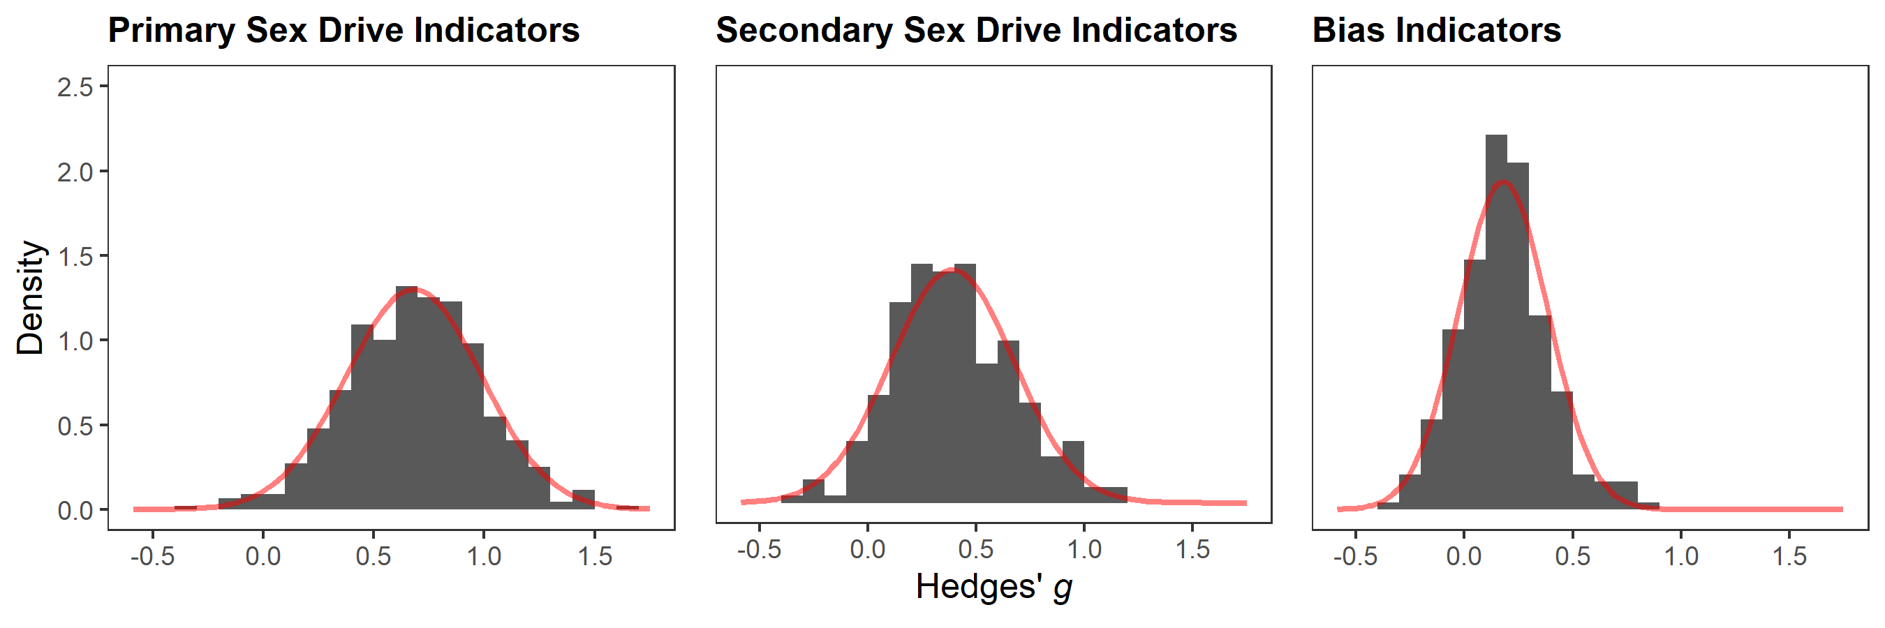

*Note.* The red curve denotes the fitted normal density curve for the unweighted effect sizes.

**Figure S2**

*Results for Leave-One-Out Analyses*

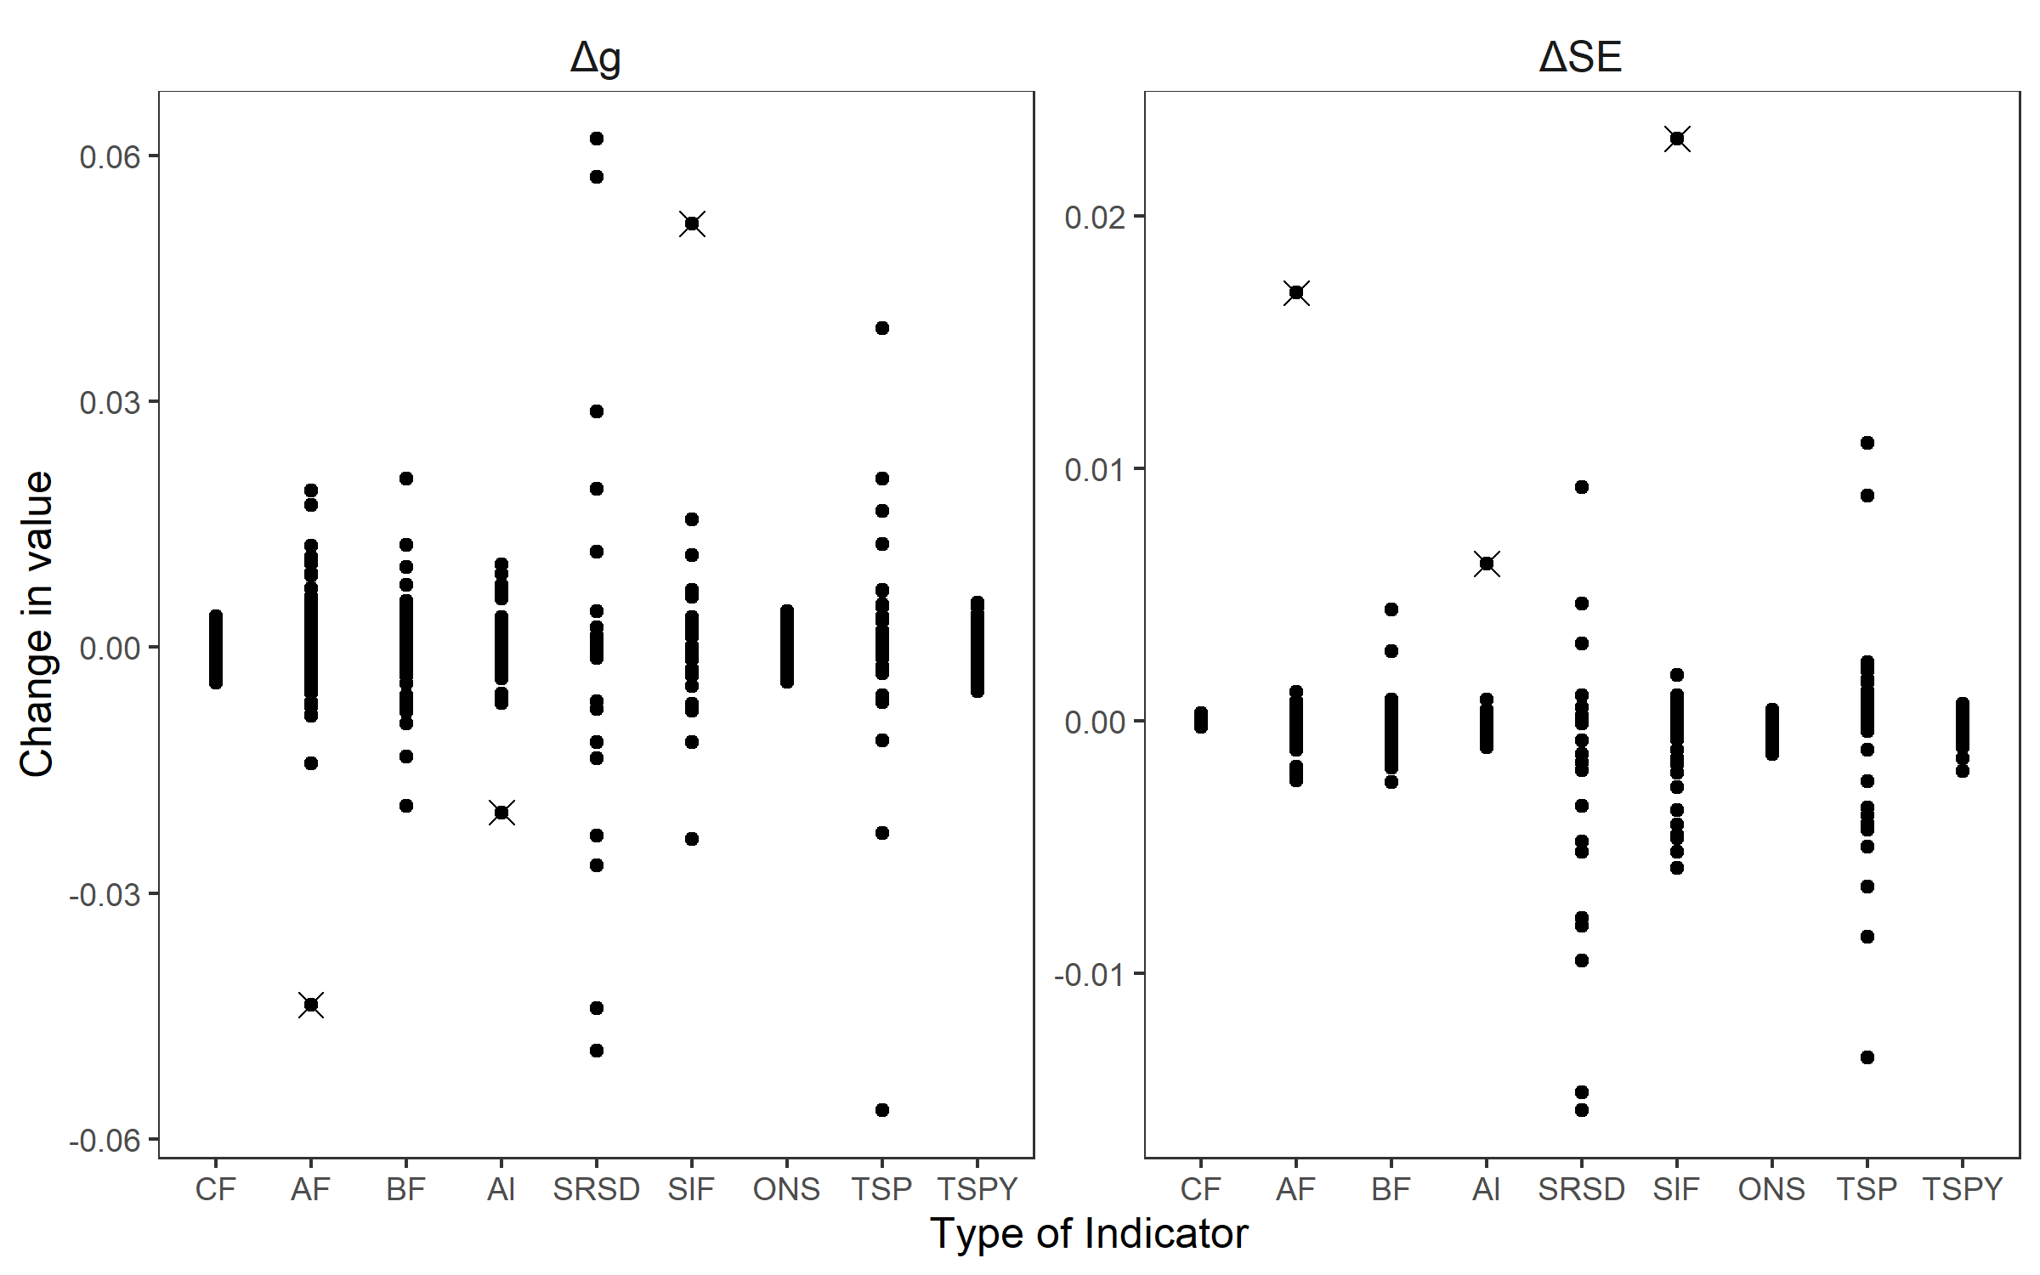

*Note.* This figure illustrates results from a leave-one-out analysis to detect outliers for the primary and secondary sex drive indicators and the bias indicators. The left pane depicts changes in Hedges’ *g* summary effects when effect sizes are removed iteratively. The right pane depicts changes in the standard error of Hedges’ *g*. CF = Cognition Frequency; AF = Affect Frequency; BF = Behavior Frequency; AI = Affect Intensity; SRSD = Self-Rated Sex Drive; TSP = Total Sexual Partners; TSPY = Total Sexual Partners in Last Year; ONS = Total One-night Stands; SIF = Sexual Intercourse Frequency. Crossed out effect sizes were removed from all subsequent analyses.

**Figure S3**

*Funnel Plots for Secondary Sex Drive Indicators*

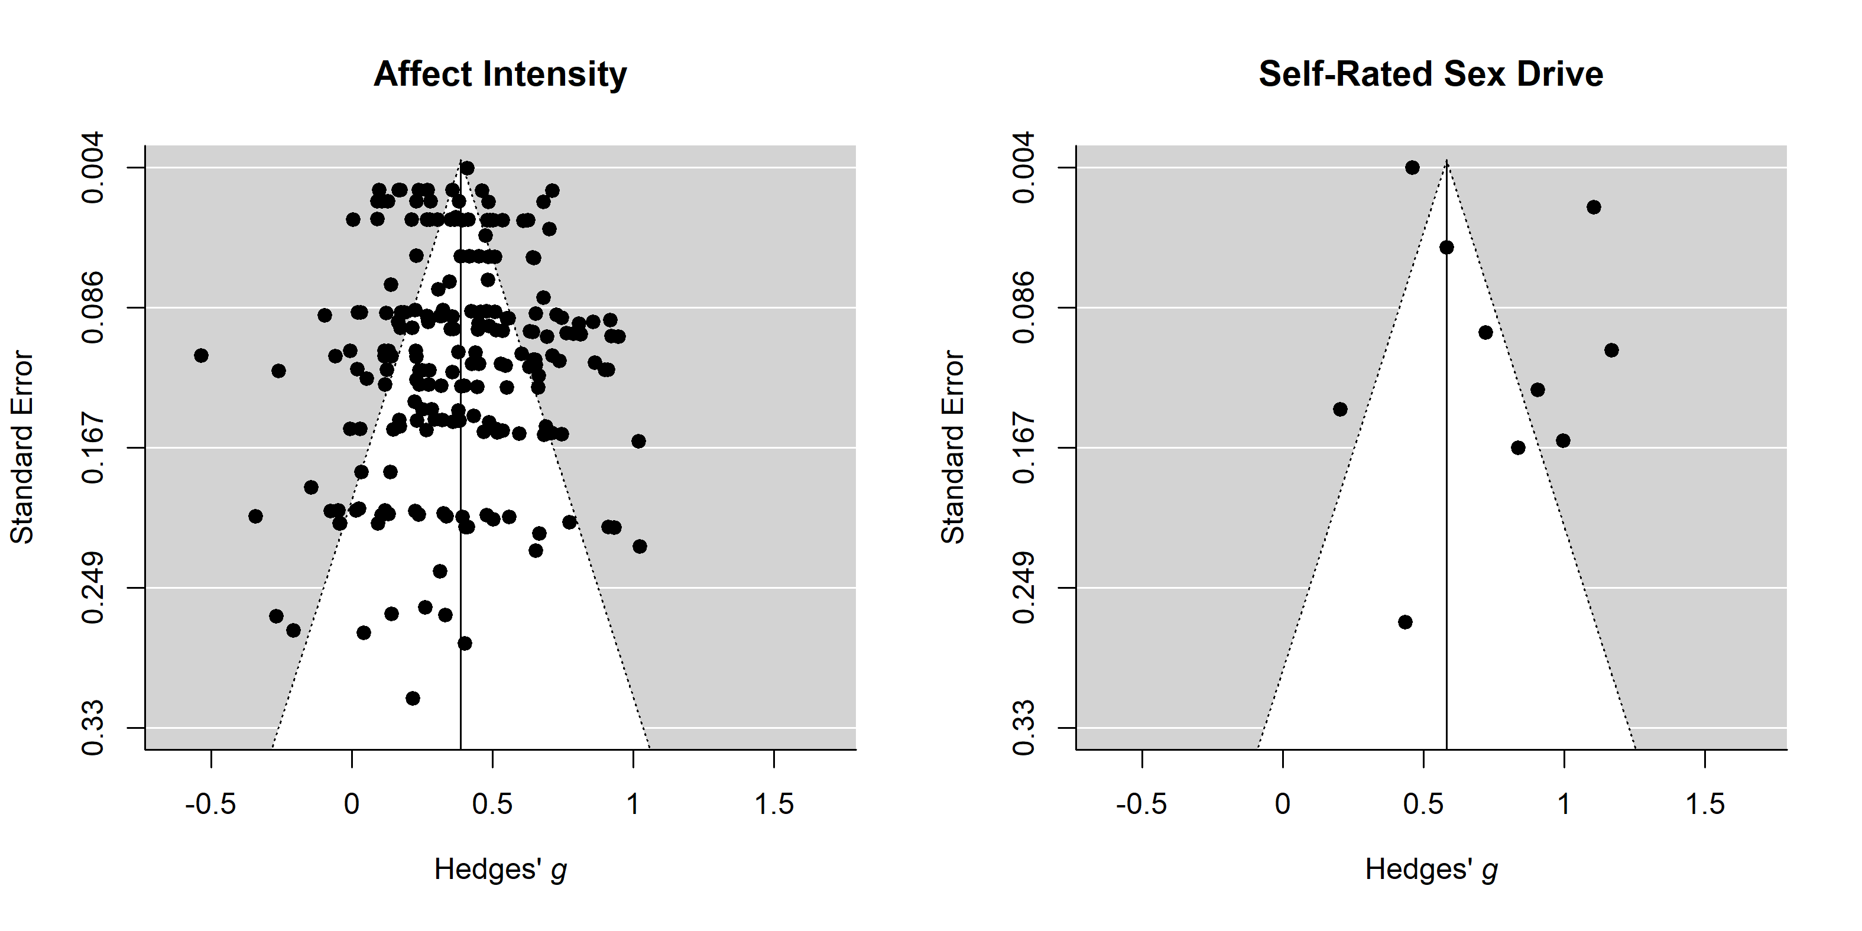

*Note.* The solid vertical lines represent the within-subgroup summary effects. The dotted lines denote the area in which 95% of effect sizes are expected to fall in the absence of heterogeneity. *x*-axis: Hedges’ *g* effect sizes, positive values indicate larger values in men. *y*-axis: Standard error of effect sizes. Leave-one-out analyses identified one outlier in the left plot at *g* < -0.5 and Standard Error < 0.167. This effect was removed for all other analyses. Summary effects displayed in the figure were computed after removing the outlier.

**Figure S4**

*Funnel Plots for Bias Indicators*

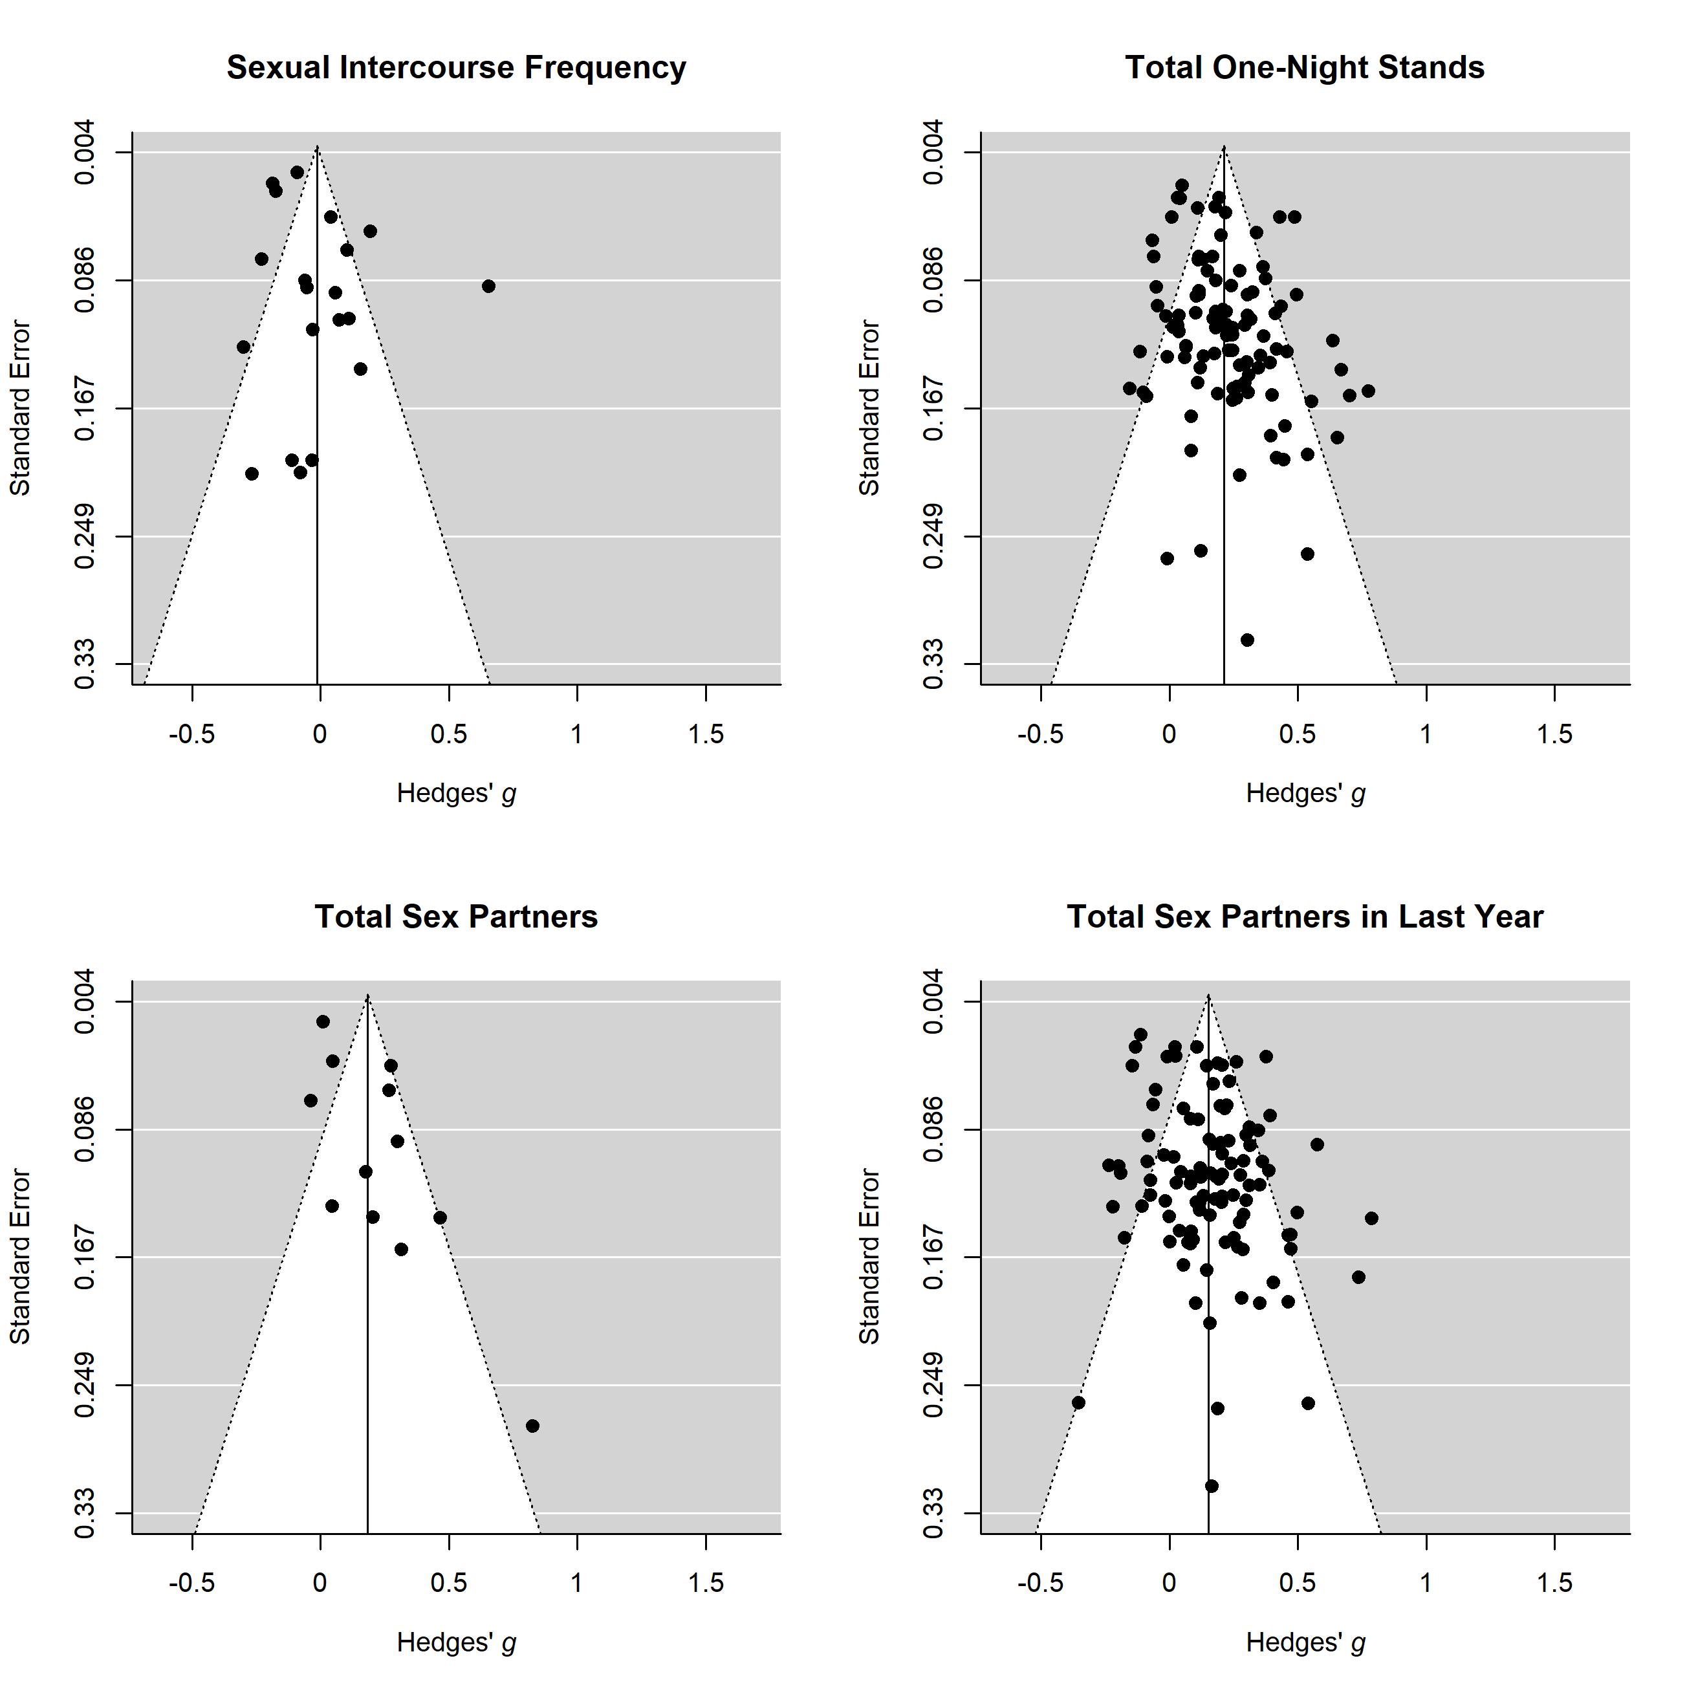

*Note.* The solid vertical lines represent the within-subgroup summary effects. The dotted lines denote the area in which 95% of effect sizes are expected to fall in the absence of heterogeneity. *x*-axis: Hedges’ *g* effect sizes, positive values indicate larger values in men. *y*-axis: Standard error of effect sizes. Leave-one-out analyses identified one outlier in the upper left plot at *g* > 0.5 and Standard Error > 0.249. This effect was removed for all other analyses. Summary effects displayed in the figure were computed after removing the outlier.

**Figure S5**

*Distribution Overlap for Adjusted and Unadjusted Gender Difference in Sex Drive*

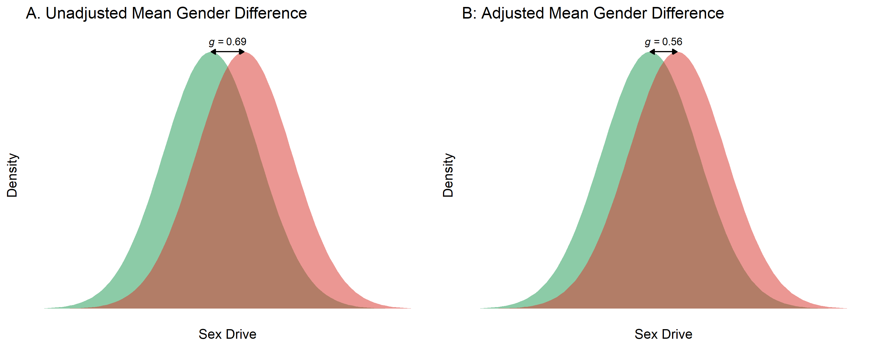

*Note.* This figure displays the overlap of the density distributions for female (green) and male sex drive (red) under normality assumptions. The gender difference displayed in the left panel (A) is *g* = 0.69, which is the unadjusted global summary effect for primary sex drive indicators (i.e., averaged across cognition, affect, and behavior frequency). The gender difference displayed in the right panel (B) is *g* = 0.56, which is the global summary effect for primary sex drive indicators (*g* = 0.69) adjusted for response bias tendencies, that is, the global summary effect for bias indicators (indicating potentially biased responding; *g* = 0.13).