Assignment-3

*Spam Detection Using NLP*

*Submitted By*

Jatin

101703263

COE-12

[jating07925@gmail.com](mailto:jating07925@gmail.com)

9056807925

***Topics covered:***

1. Tokenization
2. Stemming
3. Regular Expression
4. Text Classification
5. Multiple Scikit-learn Classifiers

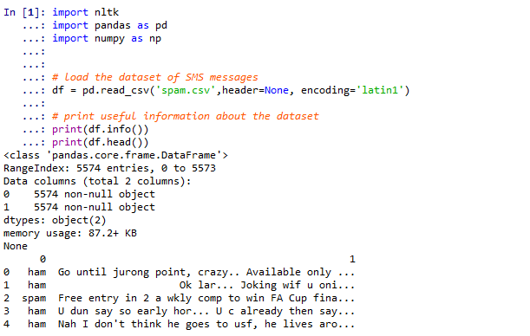

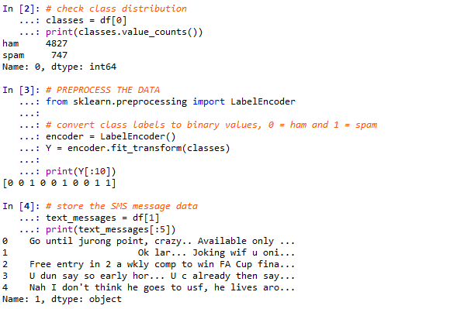

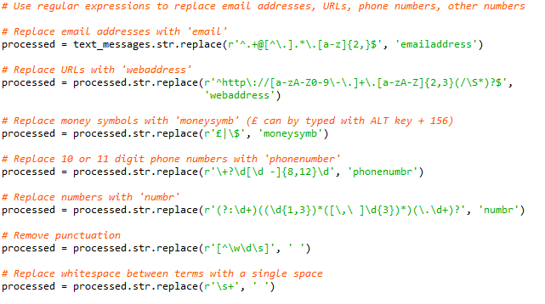

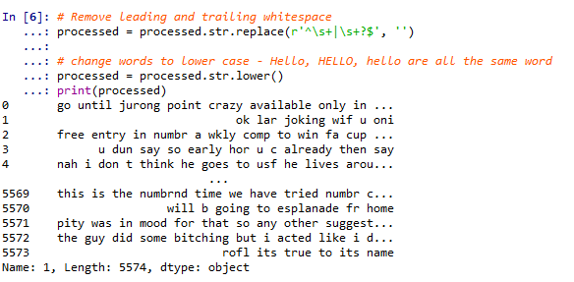

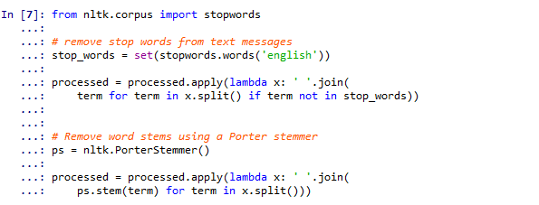

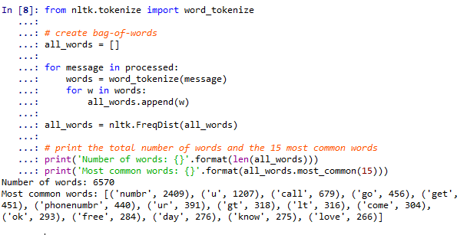

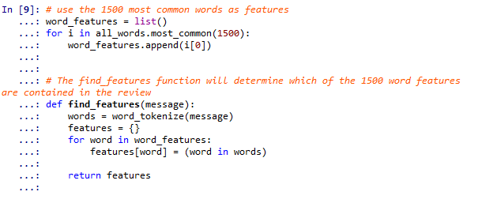

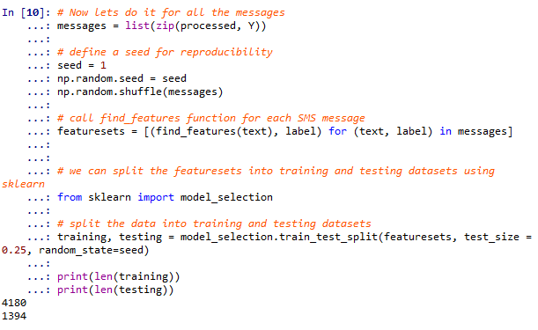

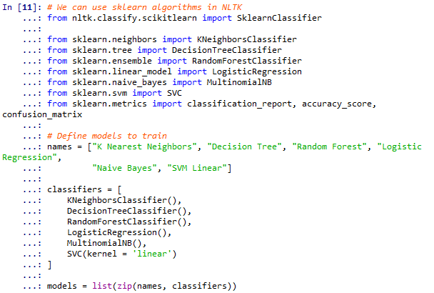

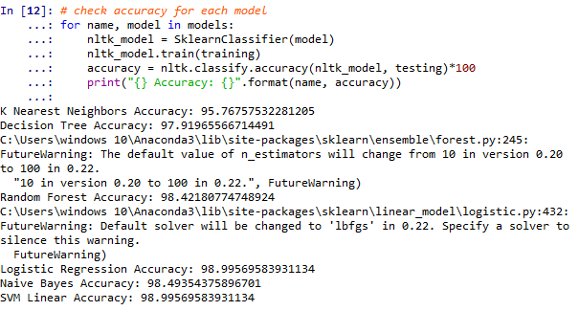

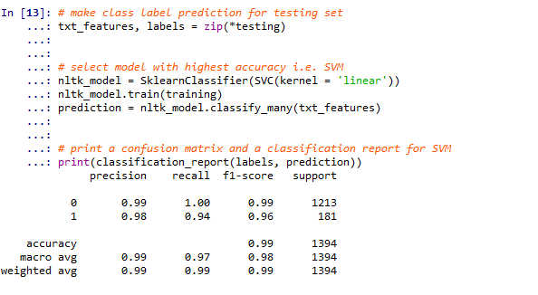

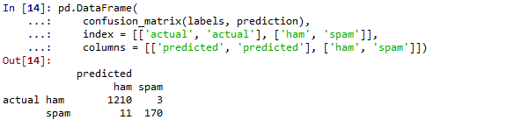

So, at the end, the final result of the project is great. We have only 0.21% False positive and 0.78% False negative with an accuracy of 99%.