A Person-Centered Framework

Various authors

2020-03-31

# Reason

This framework arises from a simple conviction: the intent of supports and services is to help each person flourish, to achieve a better life.

That belief is thankfully not a new one. It aligns with the person-centered planning policy(“Person-Centered Planning Policy” 2017) published by the Michigan Department of Health and Human Services’ *Behavioral Health and Developmental Disabilities Administration* (MDHHS-BHDDA), which begins by stating that:

*The purpose of the community mental health system is to support adults and children… to live successfully in their communities — achieving community inclusion and participation, independence, and productivity [and to] to identify and achieve their personal goals.*

The framework defined below is an attempt to apply these longstanding and fundamental values in a way that allows for consistent definitions, implementation, and evaluation.

Each person has the ability to choose a better future, to chart a course toward it and strive to reach it: person-centered planning provides a platform to enable this process. In order for services to effectively support a person in this process, they must be provided within the context of a person’s goals. Orienting a broad and complex system to keep the person as its central focus requires a consistent, overarching framework. MDHHS-BHDDA is working to support this person-centered orientation with the following strategy:

**Goal:** To develop a common body of knowledge for person-centered planning, mapped to relevant policies and research, which will inform a shared curriculum and measurement framework to support improved quality of life for each person.

# Person-Centered Planning (…Doing, Checking, Acting)

The collective effect of our needs and environments has a profound impact on society and systems, but the primary catalyst for transformation is at the level of the individual person. This is the profound insight of *person-centered planning* (PCP), which has long been the cornerstone of Michigan policy related to behavioral health services and supports.[1]

While putting forward specific definitions of person-centered planning and its parts will a focus of later sections of this document, it is worth noting at the outset that our goal is to adopt a broader scope for person-centered planning than is often seen in practice[2]. This is because, despite the central position of PCP to the Medicaid services system in Michigan, its practice has often been relegated to the planning meeting itself and the preparation for that meeting: ensuring inclusion of family and friends, personal involvement, etc. While the act of developing a plan remains a cornerstone of the process, it is only one step needed to truly achieve one’s goals.[3]

In this document, the phrase *person-centered planning* is used broadly, to encompass not only the initial planning process but also its implementation, monitoring, and refinement. The extension of this definition beyond the PCP meeting and document into a framework which directs all services and supports is already recognized within state policy[4], which indicates that:

*through PCP, a person is engaged in decision-making, problem solving, monitoring progress, and making needed adjustments to goals and supports and services provided in a timely manner.*

The table below suggests how existing paradigms can be used to augment these policy requirements and be incorporated into our framework. Here we makes use of paradigms for Quality of Life (QoL), behavior change (*Capability-Opportunity-Motivation-Behavior*, or COM-B), and continual improvement (*Plan-Do-Check-Act*, or PDCA):

Table 1: Paradigms related to PCP

|  |  |  |  |
| --- | --- | --- | --- |
| Paradigm | Tells us | Relates to | Answers |
| QoL | Why? | Vision for a better life | What areas of life do I want to focus on? |
| COM-B | What? | Turning vision into plan | How will I start to address my goal? |
| PDCA | How? | Making my plan work | How is the plan working? How to change? |

## Vision for a Better Life

## Turning Vision into Plan

Visualized in the graphic below:[5]

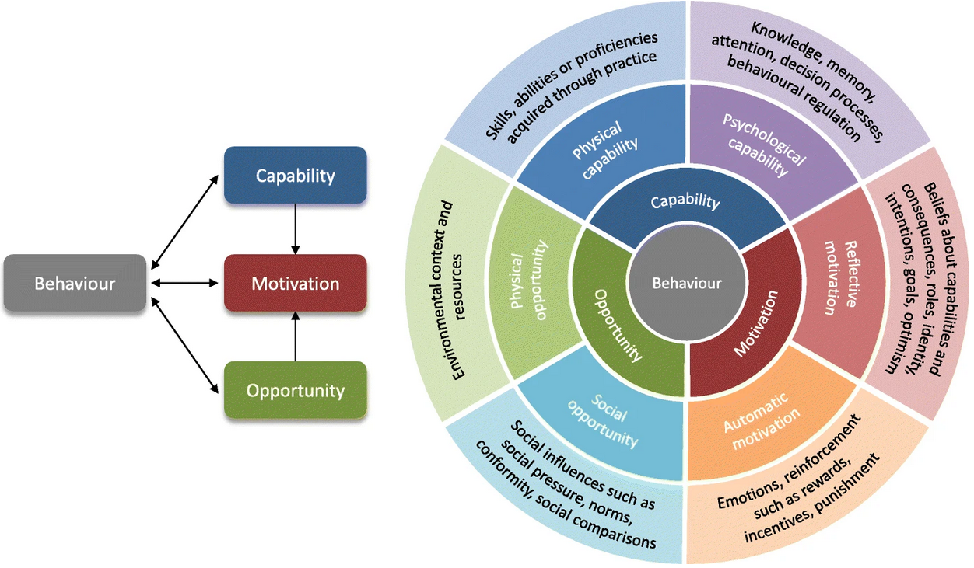

Figure 1: The COM-B Model

## Making My Plan Work

As the intent of supports and services is to improve personal quality of life, practitioners can view the PCP process as similar to the *Plan-Do-Check-Act* (PDCA) cycle, which involves many elements of the broader scope of PCP referred to above.[6] Versions of the PDCA cycle have already been successfully incorporated into the supports and treatment planning process for people with varying conditions and needs, from intellectual and developmental disabilities, to mental illness, to physical health concerns.

If we want to understand whether a person’s plan is supporting his/her goals, it is necessary to have a strategy to measure improvement in the person’s desired areas of focus. Such measurement-based approaches have been gaining traction in their use across populations and been implemented in a manner which is valued by people receiving services.[7]

Framing the intent of supports and services as improving personal quality of life through planning creates a natural bridge to using well-tested quality improvement processes at the individual level. Rather than assuming that an objective will lead to the desired goal as it is initially written, this approach allows for trying out different approaches and revising them to find what works, in the spirit of continuous quality improevment.

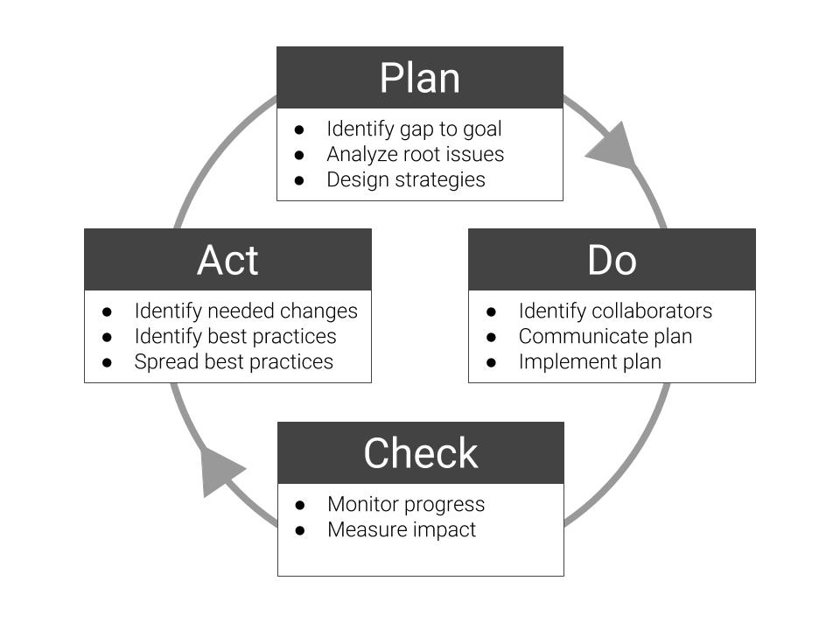

Figure 2: PDCA cycle applied to PCP process

The table below illustrates the relationship between the PDCA process and a fuller definition of the PCP process:

Table 2: Alignment of PDCA and PCP

|  |  |  |  |  |
| --- | --- | --- | --- | --- |
| Factor | Plan | Do | Check | Act |
| *Questions* | What is your life like? | What are you working on? | Is life better? | What next? |
|  | What do you want to pursue? | How are supports provided? |  | How to improve approach? |
|  | What supports do you need? |  |  |  |
| *Activities* | Identify QoL | Work on plan | Check QoL | Revise plan |
|  | Assess needs | Coordinate services | Reassess needs | (Repeat cycle) |
|  | Develop plan |  |  |  |
| *Quality area* | Structure | Process | Outcome | (Re)structure |

Note that, while the questions above can be tied to various data-points, it is most important that they should be conversational: founded upon an ongoing process of personal striving for improvement.

# A Common Body of Knowledge

A foundational step to support consistency is the development of a shared repository of key terms and concepts, their definitions, and how they are related to one another. This common language has the following key features:

* Relates all terminology back to the person, who is at the center
* Includes concepts related to the PCP process, as broadly defined above, as well as common attributes for understanding the person[8]
* Promotes consistency in implementation and training, and the scalability of future development
* Allows for change; the language can be extended as new concepts are identified.[9]
* Reduces confusion across various policies with inconsistent terminology and scope

## What is a Body of Knowledge?

“If you wish to converse… define your terms.”

— Voltaire

While person-centered thinking and planning is important enough to be ensconced in policy and regulation, it is also important enough that is should never become rote, and continue to be a part of a living dialogue. Dialogue and consistent implementation require a shared language.[10]

Our purpose here is to identify and define concepts related to person-centered planning by making use of the existing legacy of policy and guidance related to person-centered planning. This is done in a way which connects core concepts to both state and federal regulations. The collection of core concepts is intended to serve as the foundational outline for a body of knowledge; an evolving outline of understanding about person-centered thinking, planning, implementation and monitoring.[11]

## Potential Uses

Potential uses of this body of knowledge include the following:

* *Policy Search*: searching of existing policies in electronic format to identify requirements related to each core concept
* *Impact of Policy Changes*: identification of relevant new federal policy requirements to allow for clear understanding of which current policies are related and complicated by the new federal policy
* *Basis of Curriculum*: serving as the foundation of a standard curriculum to train people receiving services, their families, direct-care team members, supports coordinators, case managers, clinicians, and others about the PCP process.
* *Monitoring Quality*: allowing for system-level monitoring of the quality of PCP practice, through measurements and/or the use of a best practice review model.[12]
* *Promising Practices*: use of key terms for ongoing literature review and meta-analysis of PCP-related practices in the research literature, to build a base of best practices and evidence for effectiveness.

## Identifying Core Concepts

### What makes a concept a ‘core’ concept?

In order to begin compiling relevant policies and guidance related to person-centered planning, we needed to select and define an initial set of core concepts related to person-centered planning. The ‘source of truth’ for these concepts was state-level policy in Michigan, since this is the level at which shared dialogue and consistent implementation are sought.

The following method was used to develop this initial set of core concepts:

* **Manual review and annotation** of a set of core documents which define person-centered planning in the Michigan Public Behavioral Health System. These include (a) the Person-Centered Planning Policy[13], (b) the Self-Determination Policy and Practice Guideline[14], and (c) the Michigan Mental Health Code section 330.1712 Individualized written plan of services[15].
* **Identifying synonyms** for core concepts. For instance, the term *person* was mapped to the similar terms *person, personal, patient, individual, client, consumer, recipient, beneficiary*. This is being done for all core concepts in order to flag their occurrence across multiple policies.
* **Comprehensive annotation** of electronic text data for the policies referenced above, to assure that the most commonly used terms and phrases were included as core concepts.

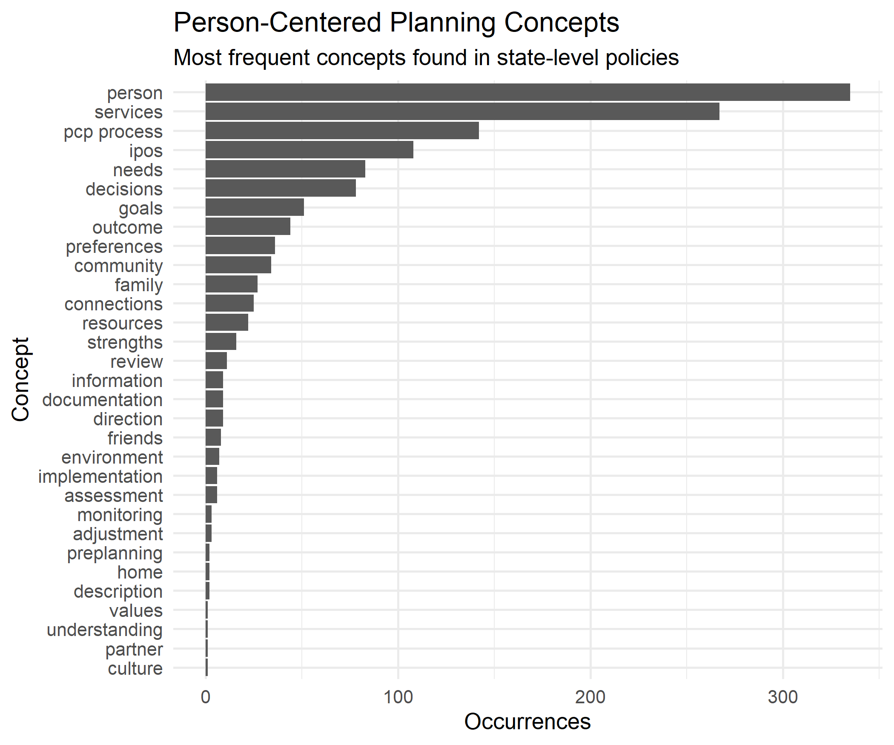

* **Purposeful Word Choice.** When multiple terms are mapped together to comprise a concept, a single ‘master’ term must inevitably be selected to refer to various synonyms and identify their locations across documents with varying authors, terminology, points of view and contexts. The selection of terms is purposefully opinionated, and attempts to reflect the spirit of person-centered planning defined in the state’s policy. For instance, the term ‘person’ is prefered to various other terms, since these terms tend to view the person from only one vantage point: a participant in an economic exchange, a person requiring help from others, an individual person separated of ties to others. So, while we need to find instances where these words occur in policy, the body of knowledge also intends to approach those policies with a consistent point of view, informed by a consistent set of principles.

### Characteristics of a Person

To put the person at the center of the language used, and to do so in way which promotes simplicity, we needed to bring some of the concepts from policy underneath a broader set of terms. With the **person** as the starting point, we define each person as having the following features:

* **description**: a set of characteristics specific to that person, defined by the person and those who know the person well.
* **connections**: the people, places and things which make up the context of a person’s life
* **direction**: what a person intends for his/her life to become, by imagining a future and making choices to move toward it

Note that these are features of being human for all of us. The intent of this framework is to describe attributes of a person which are more broadly human, and not merely focused on illness or disability. While this framework is intended for implementation with Medicaid public behavioral health recipients, the approach outlined here should apply to any reader: from legislators to clinicians, from administrators and direct-care workers.

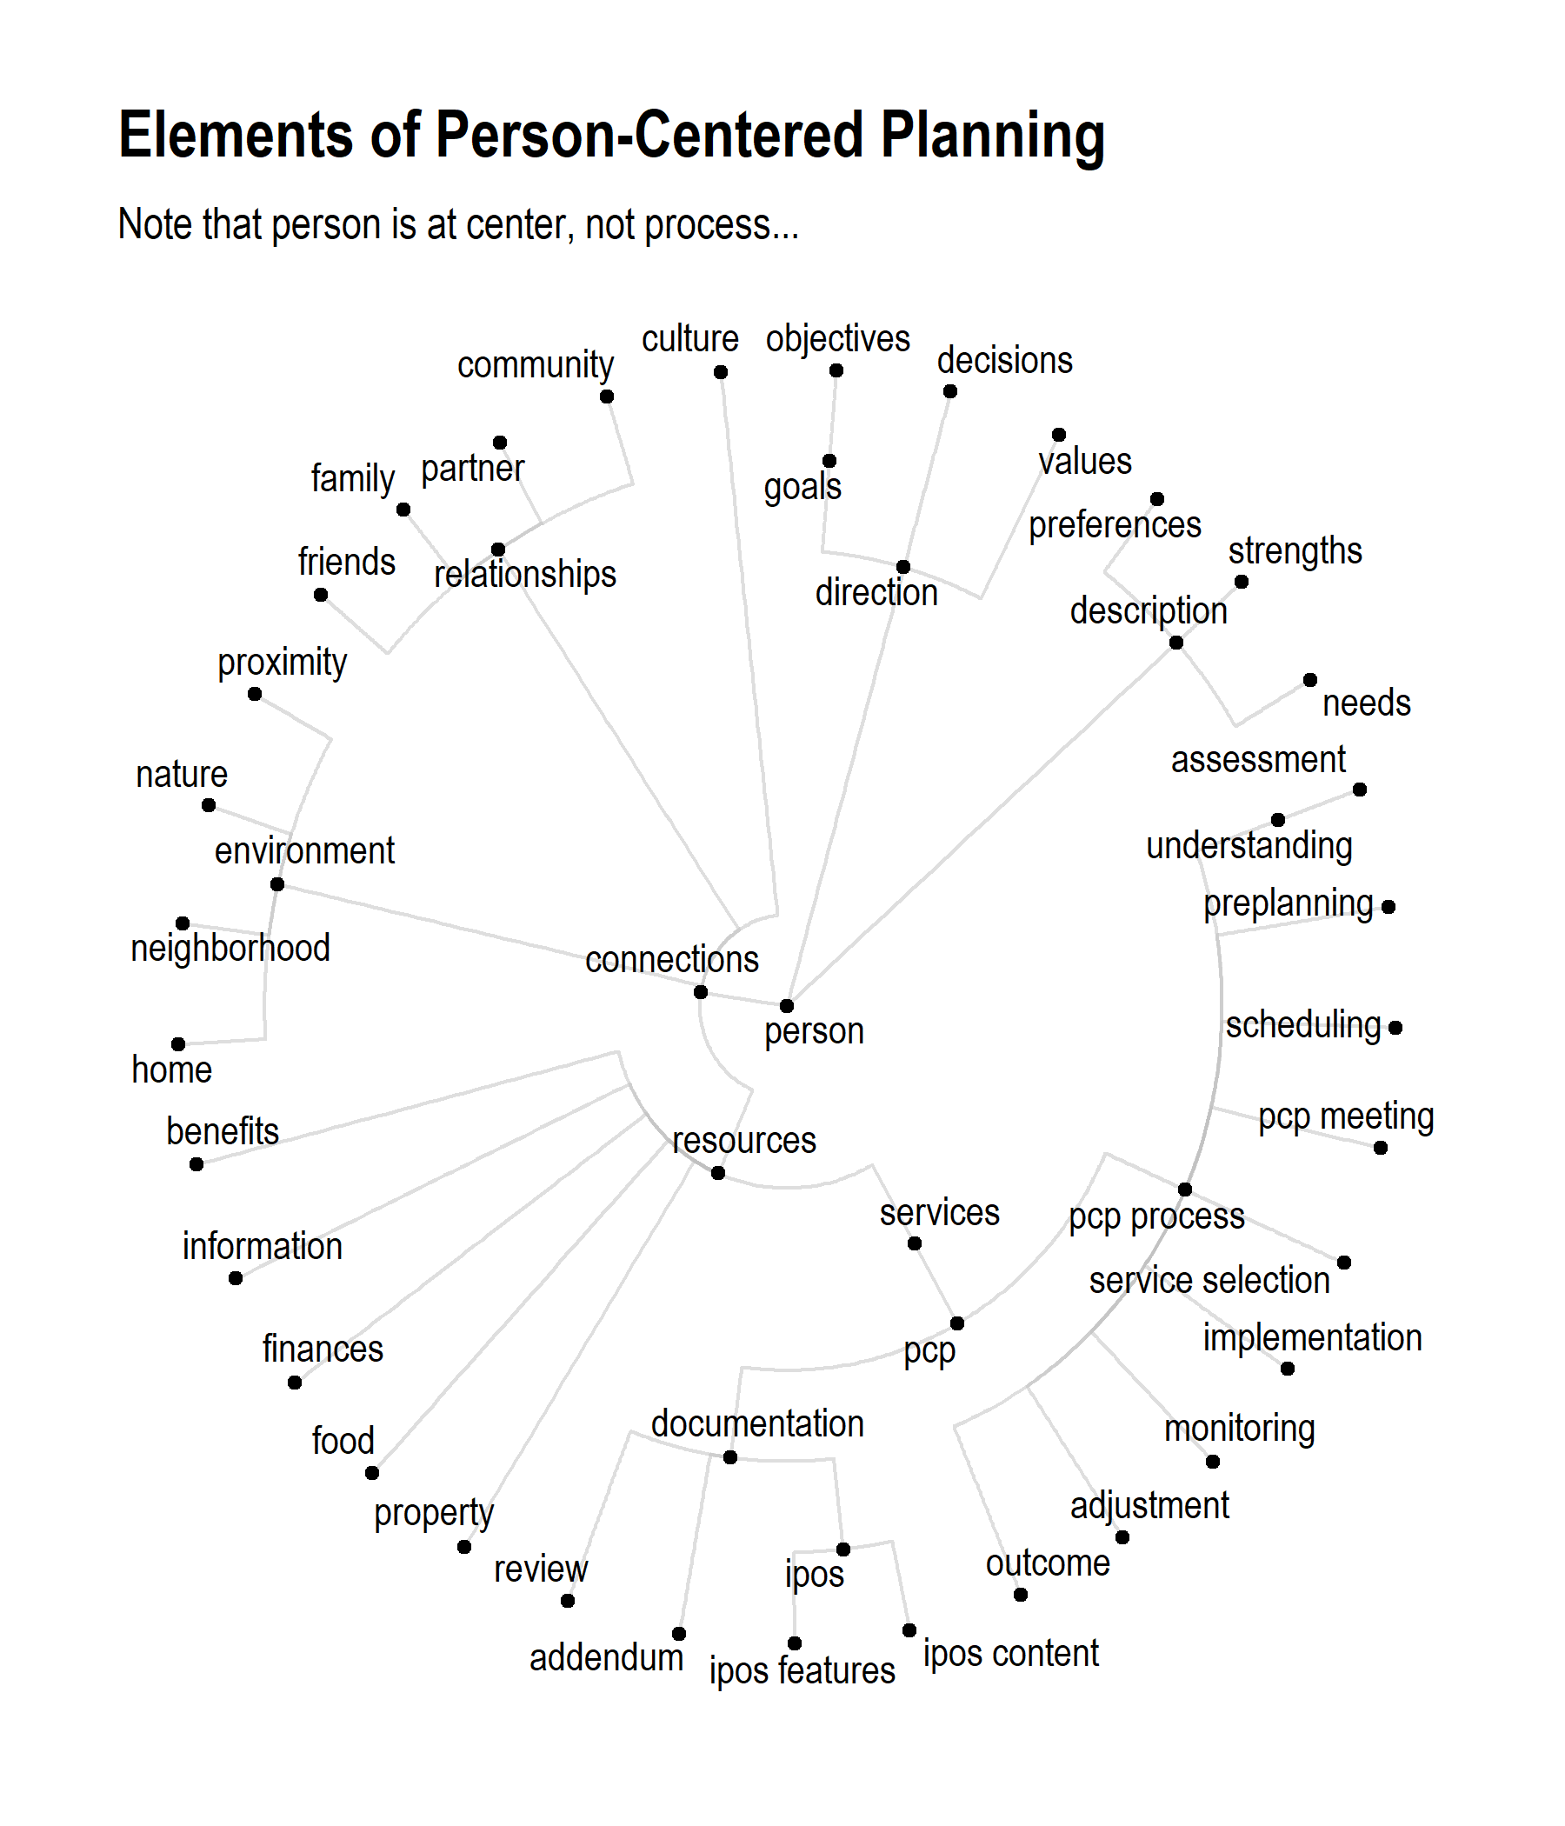

Each element of the person-centered planning framework is shown above. Each concept is defined by its relation with other concepts, as well as having a distinct definition, as shown below.

## Defining Core Concepts

Defining core concepts and terms, using policy where possible.

Table 3: Concept Definitions and Synonyms

|  |  |  |
| --- | --- | --- |
| Concept | Definition | Synonyms |
| description | Features which can be attributed to the person, as opposed to his/her connections, environment, etc. | attributes; characteristics |
| direction | The aspects of the person which allow him/her to imagine a future and to plan and work to achieve it | personal intent; aspiration |
| connections | The relationships which a person has to the people, places and things around them | circumstance;circumstances;opportunity |
| relationships | Natural relationships which the person has with other people. Does not include economic relationships or interactions with “systems”. | natural supports |
| environment | The physical context in which the individual lives; here referring to the non-human environment including shelter and the natural world. | location;setting;environment |

# Comprehensive Mapping to Policy

As with any important idea, person-centered planning has been discussed and debated for decades, leaving a vast body of policy, regulations, guidance, and explanations to sift through. While many of the basic ideas of person-centered planning are simple and commonsense, practitioners are also required to adhere to existing policies. With this in mind, the body of knowledge is being developed:

* Based on a broad scope of relevant state and federal policies identified by MDHHS-BHDDA.
* Using natural-language processing techniques to identify and refine core terminology from the text of the identified policies
* In a manner that allows MDHHS-BHDDA to identify whether new federal policies would align with the current implementation of PCP

## Identify Scope of Policy

In collaboration with policy experts at MDHHS-BHDDA, an initial scope for the inclusion of state and federal regulations was identified. While it is designed to be extendable to include new policies as they are developed, and to allow for sharing and implementation across MDHHS departments if required, this initial set of regulations was used:

Table 4: Regulations included in PCP body of knowledge.

|  |  |  |
| --- | --- | --- |
| Source | Abbreviated Title | Regulation |
| MI-State | Self-D | Self-Determination Policy & Practice … |
| MI-State | PCP | Person-Centered Planning |
| MI-State | MHCode | Mental Health Code |
| MI-State | Mcaid-PM | Medicaid Provider Manual |
| MI-State | AFC-TA | Adult Foster Care Group Homes Technic… |
| MI-State | AFC-SC | Certification of Specialized Programs… |
| MI-State | AFC-Act | AFC Facility Licensing Act 218 of 1979 |
| MI-State | AFC-12 | Licensing Rules for AFC Small Group H… |
| Federal | Parity | Medicaid and Children’s Health Insura… |
| Federal | No-Wrong-Door | Agency Information Collection Activit… |
| Federal | MU-Medicaid | Medicare Program; Hospital Inpatient … |
| Federal | MU-EHR | 2015 Edition Health Information Techn… |
| Federal | MH-BG | Mental Health Block Grants |
| Federal | MCMC-Rx | Medicare and Medicaid Programs; Polic… |
| Federal | Mcare-Adv | Agency Information Collection Activit… |
| Federal | Mcare-ACO-Waiver | Medicare Program; Medicare Shared Sav… |
| Federal | Mcare-ACO-Savings | Medicare Program; Medicare Shared Sav… |
| Federal | Mcaid-ManagedCare | Medicaid and Children’s Health Insura… |
| Federal | LTC-Reform | Medicare and Medicaid Programs; Refor… |
| Federal | HCBS | Medicaid Program; State Plan Home and… |
| Federal | ELTSS | Medicaid and Children’s Health Insura… |
| Federal | Discharge | Medicare Program; Hospital Inpatient … |
| Federal | CCHBC | CCHBC Requirements |
| Federal | ACA-Market- | Patient Protection and Affordable Car… |
| Federal | ACA-Benefit | Patient Protection and Affordable Car… |

This is intended to be an initial set of policies and regulations, which can be extended as necessary.[16] Additional work will be needed to assure that the most current version of amended policies is used, as this approach is refined.

## Find Occurrence of Concepts in Policy

The core concepts are derived from key policy documents, as defined in the previous section, which allows for related terms to be flagged within other policy documents. One of the most challenging issues facing any attempt to give clear, consistent, and comprehensive guidance related to person-centered planning is the large, diverse, and continually evolving set of requirements and guidance.

The previous section outlined the process for deriving key concepts from state-level policies and guidelines. The next step is to identify these concepts when they occur within a much larger set of federal policies. This will allow for policy specialists to:

* suggest necessary refinements to the body of knowledge
* identify relevant requirements which were previously unknown
* identify potential discrepancies between policies which address a similar concept

To do this, this analysis maps policy words and phrases with their corresponding concepts. As new policies are identified for inclusion, new synonyms for core concepts will need to be identified if new terms are introduced to refer to existing concepts.

The plot below shows the number of occurrences[17] of core concepts across the entire corpus of policies identified above. While the frequency of occurrence does not speak to the importance of one concept in relationship to others, it point out the number of uses of the concept in different contexts, underlining the challenge in harmonizing divergent policy language.

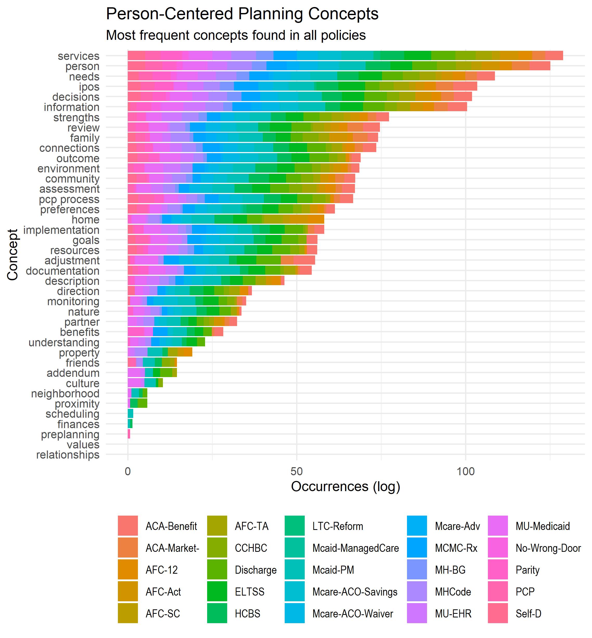

An example may be helpful in understanding what goes into the chart above. For instance, the concept of *assessment* shown in the chart above occurs 1835 times across 22 separate policy documents.[18]

The table below shows a sample of the text from some of the policies where this concept is flagged:

|  |  |  |
| --- | --- | --- |
| doc_id | text | sid |
| AFC-TA | Resident admission criteria ; resident assessment plan ; emergency admission ; resident care agreement ; physician ’s instructions ; health care appraisal ( //) R. Resident admission and discharge policy ; house rules ; emergency discharge ; change of residency ; restricting resident ’s ability to make living // STATE OF MICHIGAN Department of Licensing and Regulatory Affairs of ADULT FOSTER CARE GROUP HOME TECHNICAL ASSISTANCE MANUAL arrangements prohibited ; provision of resident records at time of discharge ( //) R. Resident care ; licensee responsibilities ( / / ) . | 11 |
| AFC-TA | ( d ) " Assessment plan " means a written statement which is prepared in cooperation with a responsible agency or person and which identifies the specific care and maintenance , services , and resident activities appropriate for each individual resident ’s physical and behavioral needs and wellbeing and the methods of providing the care and services , taking into account the preferences and competency of the individual . | 55 |
| AFC-TA | Assist with the completion of a written assessment plan at the time of admission and review with the licensee at least annually . | 71 |
| AFC-TA | [ ] ( j ) " Health care appraisal " means a licensed physician ’s , licensed physician ’s assistant ’s , or registered nurse ’s statement that provides an assessment of the general physical condition of a resident . | 114 |
| AFC-TA | // STATE OF MICHIGAN Department of Licensing and Regulatory Affairs of ADULT FOSTER CARE GROUP HOME TECHNICAL ASSISTANCE MANUAL ( i ) Assessment planning and the establishment of an IPOS . | 173 |
| AFC-TA | ( c ) Be capable of assuring program planning , development , and implementation of services to residents consistent with the home ’s program statement and in accordance with the resident ’s assessment plan and care agreement . () | 369 |
| AFC-TA | The consultant is to determine that the licensee has a training methodology in place that assures that all direct care staff are competent in providing the personal care , supervision and protection as identified in the facility ’s program statement and admission / discharge policy as well as the individual assessment plans , health care appraisals and resident care agreements . | 445 |
| AFC-TA | This can be accomplished by TB testing , x - ray , screening , an assessment or physical exam completed by the person ’s physician or local health authority . | 471 |
| AFC-TA | The home health aide can not be counted when determining the adequacy of on duty direct care staff that are required in the home in order to provide the services specified by the home ’s resident assessments and resident care agreements or in determining the minimally required resident to staff ratio . () | 488 |
| AFC-TA | A licensee shall have sufficient direct care staff on duty at all times for the supervision , personal care , and protection of residents and to provide the services specified in the resident ’s resident care agreement and assessment plan . | 489 |
| AFC-TA | For purposes of this rule " Sufficient direct care staff " is defined to mean the number of staff necessary to implement the care needs as indicated in the resident ’s assessment plan , health care appraisal , and resident care agreement . | 491 |
| AFC-TA | Resident assessment plans g . | 499 |
| AFC-TA | Resident admission criteria ; resident assessment plan ; emergency admission ; resident care agreement ; physician ’s instructions ; health care appraisal . | 641 |
| AFC-TA | // STATE OF MICHIGAN Department of Licensing and Regulatory Affairs of ADULT FOSTER CARE GROUP HOME TECHNICAL ASSISTANCE MANUAL Technical Assistance Continuous nursing care is defined as requiring a nurse ’s presence to provide ongoing nursing assessments , judgments and / or interventions . | 645 |
| AFC-TA | A licensee shall not accept or retain a resident for care unless and until the licensee has completed a written assessment of the resident and determined that the resident is suitable pursuant to all of the following provisions : Technical Assistance | 648 |
| HCBS | This commenter urged CMS to ensure that individuals have assessments of need to ensure they are not placed in the wrong settings . | 293 |
| HCBS | Sections ( c ) , ( i ) and ( k ) of the Act all require that individuals have an individual assessment of needs that includes the individual ’s needs , strengths , preferences and goals for servicesupport provided under the respective authorities . | 294 |
| HCBS | While we understand that there may be circumstances in which an individual ’s needs require a different level of service , we expect that the assessment of functional need , the person - centered plan and the availability of HCBS will be able to address an individual ’s changing needs . | 378 |
| HCBS | One commenter supports the regulation , but believes the rule should go further and require living units to have access to food storage and preparation space ( with the caveat that stoves or microwaves could be removed if the assessment documented that it would be a danger because of the resident ’s cognitive impairment ) . | 529 |
| HCBS | This review will also include assessment of how the settings allow for full integration into the broader community . | 663 |
| HCBS | States are responsible for determining the provider qualifications of the entities who will conduct the assessments and PCP process as long as the requirements in the final regulations have been met . | 968 |
| HCBS | The regulation already specifies the involvement of an individual ’s representative in the evaluation of eligibility ( . ) , independent assessment ( . ) , and person - centered service plan ( . ) . | 996 |
| HCBS | Several commenters asked how frequently the assessment must be made if the condition causing the modification of the " additional conditions " was not likely to improve . | 1020 |
| HCBS | We also state in the rule that reviews and any needed revision of the independent assessment and the person - centered service plan , must occur at least every months , when the individual ’s circumstances or needs change significantly , and at the request of the individual . | 1023 |
| HCBS | While ( i ) ( ) ( F ) ( i ) requires that the independent assessment include an objective evaluation of an individual ’s inability or need for assistance to perform or more ADLs , this is only a suggested element at ( i ) ( ) ( D ) ( i ) and thus , not required for an individual to be determined eligible for ( i ) State plan HCBS . | 1165 |
| HCBS | This suggestion is already captured in . ( a ) ( ) where the regulation requires the assessment to " … include the opportunity for the individual to identify other persons to be consulted , such as , but not limited to , the individual ’s spouse , family , A couple of commenters stressed the importance that FFP be available for evaluations even when an individual is subsequently found ineligible for section ( i ) of the Act services . | 1169 |
| HCBS | As stated in section III.N .. of the preamble to the proposed rule , FFP is available for evaluation and assessment as administration of the approved state plan prior to an individual ’s determination of eligibility for and receipt of other section ( i ) of the Act services . | 1170 |
| HCBS | If the individual is found not eligible for the State plan HCBS benefit , the state may claim the evaluation and assessment as administration , even though the individual would not be considered to have participated in the benefit for purposes of determining the annual number of individuals served by the benefit . | 1171 |
| HCBS | Some commenters requested clarification regarding level of need , as defined by the state and provider , including whether a state may leverage existing and / or specific instruments that are used to determine HCBS waiver eligibility in order to determine whether a beneficiary meets the State plan HCBS needs assessment criteria for participation , understanding that the State plan HCBS benefit eligibility criteria must be less stringent than that used for HCBS waiver programs . | 1172 |
| HCBS | One commenter indicated that if states establish needs - based criteria for each specific service that an individual receives , it would add to the complexity of the assessment service planning , the overall costs of program administration , and potential beneficiary and family caregiver confusion . | 1175 |
| MHCode | () " Incapacitated " means that an individual , as a result of the use of alcohol or other drugs , is unconscious or has his or her mental or physical functioning so impaired that he or she either poses an immediate and substantial danger to his or her own health and safety or is endangering the health and safety of the public . () " IPOS " or " plan of services " means a written IPOS developed with a recipient as required by section . () " Intellectual disability " means a condition manifesting before the age of years that is characterized by significantly subaverage intellectual functioning and related limitations in or more adaptive skills and that is diagnosed based on the following assumptions : ( a ) Valid assessment considers cultural and linguistic diversity , as well as differences in communication and behavioral factors . | 107 |
| MHCode | ( d ) Submit to the members of the house and senate standing committees and appropriation subcommittees with legislative oversight of mental health matters an annual report summarizing its assessment of the mental health needs of the state and incorporating information received from CMH service s programs under section . | 286 |
| MHCode | The record shall contain at a minimum a written assessment and IPOS for the patient , a statement of the purpose of hospitalization or treatment , a description of any tests and examinations performed , and a description of any observations made and treatments provided . | 569 |
| MHCode | ( c ) Sample assessments of families receiving family support subsidy payments including adequacy of subsidy and need for services not available . | 792 |
| MHCode | The office shall do all of the following : ( a ) Assess the mental health needs of multicultural populations in the state . | 828 |
| MHCode | ( b ) Identification , assessment , and diagnosis to determine the specific needs of the recipient and to develop an IPOS . | 1018 |
| MHCode | ( h ) Screening and assessment procedures . | 1055 |
| MHCode | Sec . () The board of a CMH services program shall do all of the following : ( a ) Annually conduct a needs assessment to determine the mental health needs of the residents of the county or counties it represents and identify public and nonpublic services necessary to meet those needs . | 1218 |
| MHCode | It is the responsibility of the CMH services program to involve the public and private providers of mental health services located in the county or counties served by the CMH program in this assessment and service identification process . | 1220 |
| MHCode | The needs assessment shall include information gathered from all appropriate sources , including CMH waiting list data and school districts providing special education services . | 1221 |
| MHCode | ( b ) Annually review and submit to the department a needs assessment report , annual plan , and request for new funds for the CMH services program . | 1222 |
| MHCode | The standard format and documentation of the needs assessment , annual plan , and request for new funds shall be specified by the department . | 1223 |
| MHCode | ( c ) In the case of a county CMH agency , obtain approval of its needs assessment , annual plan and budget , and request for new funds from the board of commissioners of each participating county before submission of the plan to the department . | 1224 |
| MHCode | In the case of a CMH organization , provide a copy of its needs assessment , annual plan , request for new funds , and any other document specified in accordance with the terms and conditions of the organization ’s inter- local agreement to the board of commissioners of each county creating the organization . | 1225 |
| MHCode | In the case of a CMH authority , provide a copy of its needs assessment , annual plan , and request for new funds to the board of commissioners of each county creating the authority . | 1226 |

# Informed by (and Informing) Research

Some activities related to person-centered planning are addressed in existing research.[19] In these instances, our goal would be to connect-the-dots between research and practice by making this knowledge available. In order to remain aligned with national efforts[20] in this area, initial steps would include:

* mapping of person-centered planning concepts to researched interventions, where these exist
* use of key concepts from the body of knowledge for literature review and meta-analyses of PCP-related practices, to build a base of best practices and evidence for effectiveness
* identification of gaps in existing research knowledge related to PCP

# Shared Training Curriculum

To translate this common body of knowledge into action, various audiences need to be trained in the core elements of person-centered practice, using the foundational concepts identified and defined above. Work in developing these trainings includes:

* Identification of key audiences
* Evaluation of potential training modalities based on key features
* Developing a standard base curriculum as well as specialty topics for specific audiences

# Person-Centered Measurement Framework

If the entire system of services and supports is intended to be person-centered, its performance should be measured within a framework that is centered on the person. Since many existing quality measures and data collection systems were not developed with this in mind, it will be important to develop a larger framework within which existing measures can be situated. This allows the system to retain the quality measurement work that has been completed, while acknowledging gaps within that framework which need to be filled.

The framework outlined here attempts to align with and fulfill the promise of current definitions of person-centered planning, as well as with existing and evolving standards in the fields of behavioral health and developmental disability services. Far from contradicting these standards, it attempts to provide a broader, person-centered context for the development of the system as a whole.

Ongoing work in this area would include:

* Developing a person-centered measurement framework
* Conducting an inventory of available data assets at a state wide level
* Classifying existing measurement and data collection efforts (e.g. HEDIS, BH-TEDS, etc.) within the context of this framework
* Gap analysis of current datasets and development of a plan to address measurement gaps.

## What do we mean by ‘a better life’?

People have been asking themselves what it means to live a good life for thousands of years,[21] and it is among the most crucial questions for each of us to answer. For the purpose of this measurement framework, we will refer to the characteristics that make up a good life as *quality of life*, or QOL for short, relying primarily on contemporary research to arrive at a common and usable definition.

### What makes a good definition?

If we are going to try to define quality of life, it is important that our definition gets a few things right:[22]

1. *Multiple dimensions*. A good life can only be described using multiple dimensions. These are influenced by personal factors, environmental factors, and the interaction between those factors.
2. *Broad enough for everyone*. We should each want to apply the definition to our own lives. The basic characteristics of a good life are the same for all people, regardless of culture, gender, disability, etc.
3. *Both subjective and objective*. People have different priorities. While a definition can point to objective facts related to QoL, it must include the point-of-view of the person who is living their life from day to day. Each dimension of a QoL model may have both objectively and subjectively defined indicators.

Taken together, the criteria listed above seek to balance the abstract with the specific and to arrive at a definition which is well-rounded while also being understandable.

### What makes a better life?

Keeping our key requirements in mind, we can draw from the broad reservoir of studies on QoL to find frameworks which are multi-dimensional[23], cross-culturally relevant,[24] and which provide both subjective and objective indicators.

Below is a potential model listing essential dimensions of QoL:

Table 5: QoL Dimensions

|  |  |  |
| --- | --- | --- |
| Area | Dimension | Example Indicators |
| Independence | Personal development | Education status, personal skills, ADLs, IADLs |
|  | Self-determination | Choices, autonomy, personal control, goals |
| Social participation | Interpersonal relations | Social networks, activities, relationships |
|  | Social inclusion | Community integration, participation, roles |
|  | Rights | Human (respect/dignity, equality), Legal |
| Well-being | Emotional well-being | Safety, positive experiences, self-concept, stress |
|  | Physical well-being | Health, nutrition, recreation/physical exertion |
|  | Material well-being | Financial status, employment, housing, possessions |

Please note that the framework listed above is one of many potential models, each of which contains many of the same basic dimensions, and many were developed with populations having specific conditions. Some other broad-based models for review include:

* The [World Health Organization Quality of Life (WHOQOL)](https://apps.who.int/iris/bitstream/handle/10665/77932/WHO_HIS_HSI_Rev.2012.03_eng.pdf?sequence=1&isAllowed=y) domains.
* The [Eurostat QoL indicators](https://ec.europa.eu/eurostat/statistics-explained/index.php?title=Quality_of_life_indicators) show an example of QoL domains applied for entire countries alongside financial indicators such as gross domestic product (GDP).
* Healthy People 2020 has selected a subset of measures for monitoring health-related QoL and well-being in the United States. See their [Foundation Health Measure Report: Health-Related QoL and Well-Being](https://www.healthypeople.gov/sites/default/files/HRQoLWBFullReport.pdf).

## Benefits of a QoL Perspective

### What other frameworks exist?

One might well ask: *Is quality of life the only potential framework that we could use to measure improvement?* The answer is *No*, so it is worth discussing other options and briefly reviewing the attributes of each. Other options include:

* *Symptom reduction*: Measurement of reduction in symptoms related to specific diagnosable conditions. Symptom scales such as the [PHQ-9](https://www.phqscreeners.com/sites/g/files/g10049256/f/201412/PHQ-9_English.pdf), GAD-7 and other tools have commonly been used to measure the impact of treatments on specific conditions, but they are more challenging to use for people with multiple co-occuring conditions (MCC).
* *Improving functional status*: Most currently used assessment tools address functional status, measuring the impact of various conditions on broader life areas in terms of their impact on functional ability. These are broader than symptom scales, and can detect the impact of various symptoms on a particular functional domain.
* *Health-related quality of life (HRQoL)*: HRQoL addresses a subset of QoL domains which are related to perceived physical and mental health. These models typically exclude non-medical areas such as education or rights, focusing on physical domains like ‘mobility’.

### Why is a quality of life framework better than others?

A QoL approach has the following benefits over the approaches mentioned above:

**Strengths-based**: A QoL approach asks people what they want their lives to be and encourages them to work toward that vision. Rather than focusing on needs or deficits, it aspires to use a person’s strengths to improve his or her life.[25]

**Inclusive**: Instruments and measures from each of the other areas can be used as a part of the QoL framework, since it is broad enough to include each of these areas, and they each contribute to it. A QoL approach does not neglect the value of functional gains or symptom reduction, but values these as contributors to overall quality of life. For instance, if a person experiences an alleviation of their depressive symptoms using the PHQ-9, this would be seen as contributing toward the individual’s QoL in the area of ‘Emotional Well-being’.

**Contextual**: An approach which focuses on only a portion of an individual’s life, such as mobility or anxiety symptoms, is likely to miss out on the bigger picture. It may also inadvertently create siloes among the individuals supporting the person. For instance, more recent evaluations have criticized the HRQoL approach as failing to “sufficient emphasis on mental and social domains…that are essential to people.”[26] The broader focus on QoL which is proposed here is aligned with our evolving understanding of several areas, each of which stresses the critical relationship between each of us and our communities and surroundings:

* *Social Determinants of Health* (SDoH): A vast and growing body of [research](https://www.cdc.gov/socialdeterminants/research/index.htm) indicates that the places and conditions in which we live are intrinsically tied to the quality of our lives and the likelihood of achieving positive outcomes from the supports and services we receive.
* *Trauma-Informed Care*: More and more models for service provision, informed by research and by the lived experience of trauma survivors, are founded on the recognition that adverse events in our relationships and in our lived environment can have a profound and lifelong impact on our lives.[27]
* *Supports Paradigm*: A model, prevalent in the IDD supports system, that views a person’s functioning as the match between their individual capacity and the environment in which they are expected to live and work.[28] In this model, supports are viewed as a way to supplement the persons strengths and to help match those to the person’s environment.

## Alignment with Existing Requirements

### Alignment with Federal Medicaid Requirements

### Alignment with Provider Requirements

*Feasible for Implementation*: Multiple pragmatic trials have demonstrated that the use of symptom scales are both feasible to implement on a large scale[29] and acceptable to people receiving services.[30]

*Provider Accreditation*: New standards for Joint Commission accreditation (effective 2018)[31] require that an organization (a) “uses a standardized tool or instrument to monitor individuals progress in achieving… goals”, (b) “gathers and analyzes data generated through standardized monitoring, and results used to inform goals and objectives of individual’s plan”, and (c) “evaluates outcomes of… services… by aggregating and analyzing data collected through the standardized monitoring effort.”

*Diagnostic Practice*: The most recent diagnostic manual (DSM-5) includes [assessment measures](https://www.psychiatry.org/psychiatrists/practice/dsm/educational-resources/assessment-measures) which were “developed to be administered at the initial patient interview and to monitor treatment progress.”

## Framework for Measurement

### Scope

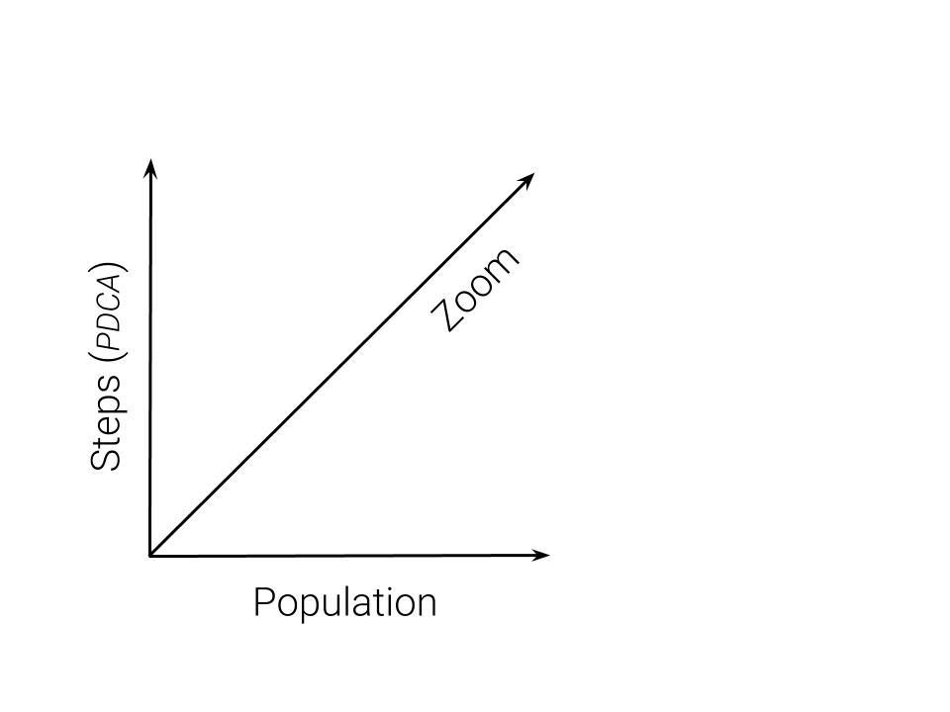

Figure 3: Scope of framework

A conceptual framework as comprehensive as the one we are proposing runs the risk of becoming overwhelmingly complex and unwieldy to implement. So, before diving into any details, we want to begin by sketching out a simple way to think about the scope of the framework required to systematically measure person-centered planning and its impact of quality of life. Having a definition of scope can help us answer questions such as:

* What types of data are included, and what types of measures?
* How will we know when the framework is fully implemented?
* Does this fit with other work that we are doing?

We can define the scope of the framework using three-dimensions (*depth**,* *breadth**, and* *height*) as defined below:

**Depth** (a.k.a. *Zoom*): Does the framework allow for understanding at various levels of ‘resolution’, from the most immediate (i.e. *the individual person*) to the aggregate (i.e. *the population*) and other levels inbetween (e.g. *the organization, team, etc.*)?

**Breadth** (a.k.a. *Population*): Can the framework apply to all people who are planning to improve their lives with the help of services and supports?[32]

**Height** (a.k.a. *Steps*): Does the framework allow for understanding of each of the steps in the person-centered PDCA process discussed above?

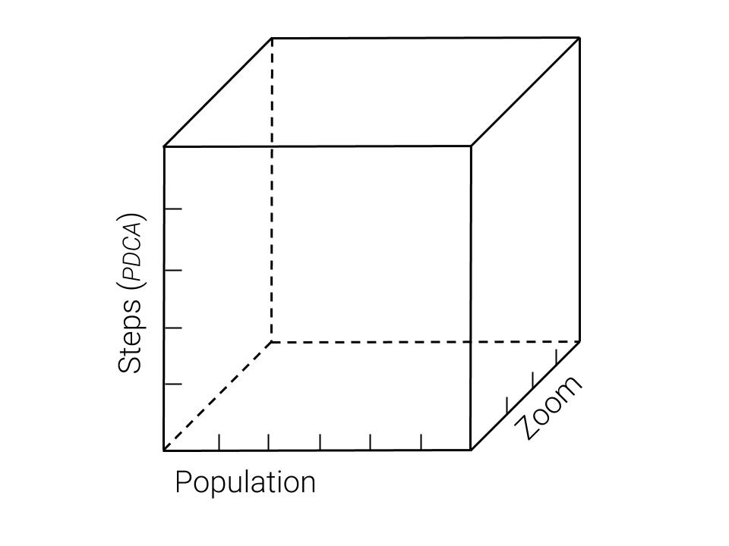

Figure 4: If it was a cube…

If we think about the framework as a cube made of these three dimensions, then developing the measurement framework can begin by making certain that data is collected:

* at each step of the person-centered PDCA process (*height*)
* for people across all populations (*breadth*)
* which can be aggregated at various levels of the system (*depth*)

So, speaking *very* broadly, if our cube has data elements/measures at each intersection of the three dimensions, then it allows for at least a basic understanding of people’s needs, planning, and services as these contribute to improved lives. In reality, there will always be additional data that can be collected and novel ways of combining that data, just as there continue to be additional books and songs written describing the human experience.

The next sections define each of the dimensions listed above, and how they relate to one another, in greater detail. Based on these details, it will be possible to begin a practical gap analysis to assess how closely the system’s current data assets match the scope of the framework. Please note that this paper does not develop or identify specific measures, except as illustrations of how individual data elements or metrics *might* fit into the overall framework.

### Steps

#### Plan

**Understand Quality of Life.**

**Understand Needs Related to QoL.** The table below identifies example variables from required assessments which relate to the QoL domains outlined above.[33] While this is not an exhaustive mapping, it shows how the assessment of personal needs (*from the “Plan” step of PDCA*) relate to quality of life domains across multiple populations.

Table 6: Sample: Need Assessment and Related QoL Dimensions

|  |  |  |  |  |
| --- | --- | --- | --- | --- |
| Dimension | SIS Subscale | CAFAS Subscale | LOCUS Dimension | GAIN Item |
| Personal development | Health & Safety | School/Work |  |  |
|  | Protection/Advocacy | Thinking |  |  |
|  | Behavioral Support |  |  |  |
| Self-determination | Protection/Advocacy |  | Engagement |  |
| Interpersonal relations | Social Activities | Home |  |  |
| Social inclusion | Community Living | Community |  | Living Situation |
|  | Social Activities |  |  | Environment |
| Rights | Protection/Advocacy |  |  | Legal |
|  | Health & Safety |  |  |  |
| Emotional well-being | Behavioral Support | Moods/Emotions | Risk of Harm | Emotional health |
|  | Health & Safety | Behavior |  |  |
| Physical well-being | Medical Support | Self-Harm | Co-Morbidity | Physical health |
|  | Health & Safety |  | Risk of Harm | Disease prevention |
| Material well-being | Employment | Material Needs |  | Vocational |

As mentioned above, the table above is intended to illustrate how assessments of need can be tied to QoL domains, but is not comprehensive.[34] The actual mapping will need to be done at the level of specific questions, as opposed to subscales which are not as likely to fit neatly within a single QoL domain. Note that instruments which contain a larger number of items (such as the SIS) are likely to have greater coverage of QoL domains than instruments with a smaller number of items (such as the LOCUS).

#### Do

#### Check

When are measures taken?

What types of measures relate to what parts of the PCP process?

#### Act

#### PCP-based Episodes

Improvement takes time, both in our personal lives and in our collective work as organizations and systems. Various frameworks have been developed to help evaluate improvement over time, many of which rely on the concept of “episodes”: periods of time which characterized by specific events or attributes. For instance…

* an admission to treatment is used to define an episode in the *Substance Abuse and Mental Health Services Administration* (SAMHSA) [*Treatment Episode Data Set* (TEDS)](https://www.samhsa.gov/data/data-we-collect/teds-treatment-episode-data-set)
* the course of a particular illness is used to define an episode in the *National Quality Forum*’s [Patient-Focused Episodes of Care](https://www.qualityforum.org/Publications/2010/01/Measurement_Framework__Evaluating_Efficiency_Across_Patient-Focused_Episodes_of_Care.aspx)

Neither of the approaches above is optimal for understanding the effectiveness of the implementation of a person-centered plan. The admission-based approach will create longer episodes for long-term services and supports which do not correspond to revisions of the person-centerd plan and the effect of those revisions on quality of life. The illness-based approach will be overly reductive for people with multiple, concurrent conditions, lifelong conditions, or whose social and environmental conditions have a strong adverse impact on their quality of life.

If the person-centered planning (and doing, checking, acting) process is to be the primary catalyst for improvement of life using Medicaid supports and services, then that process should be used to define episodes for improvement. The ‘episode’ of a PCP cycle would correspond to the period of time between the plan and its next subsequent revision. If person-centered planning is expected to be creative, collaborative, and dynamic, then different ‘visions and revisions’ of the plan will be longer or shorter. For instance, if a person develops a plan but soon realizes that it is not helping them to achieve the life goals they intended to, then the plan would be revised and the PCP episode would relatively short.

### Zoom

### Population

Durant, Will. 1926. Simon & Shuster.

McDonagh, L.K., J.M. Saunders, J. Cassell, and et al. 2018. “Application of the Com-B Model to Barriers and Facilitators to Chlamydia Testing in General Practice for Young People and Primary Care Practitioners: A Systematic Review.” *Implementation Science* 130. <https://doi.org/https://doi.org/10.1186/s13012-018-0821-y>.

“Michigan Mental Health Code, Act 258 of 1974, Section 330.1712.” 1974. Michigan State Legislature. <http://legislature.mi.gov/doc.aspx?mcl-330-1712>.

“Person-Centered Planning Policy.” 2017. MDHHS Behavioral Health; Developmental Disabilities Administration. <https://www.michigan.gov/documents/mdhhs/Person_Centered_Planning_Policy_rev._6-17-17_597318_7.pdf>.

Schalock, Robert L., James R. Thompson, and Marc J. Tassé. 2018. “Changes in the Field Regarding Personal Support Plans.” <https://aaidd.org/docs/default-source/sis-docs/changes-in-the-field.pdf?sfvrsn=cd8b3021_0>.

“Self-Determination Policy and Practice Guideline.” 2017. MDHHS Behavioral Health; Developmental Disabilities Administration. <https://www.michigan.gov/documents/SelfDeterminationPolicy_70262_7.pdf>.

1. See (“Michigan Mental Health Code, Act 258 of 1974, Section 330.1712” 1974).
2. Even though this broader definition does conform to existing policy and guidance
3. Part of the focus on the meeting is due to the auditing focus on the plan document: an instance of *what is measured, is addressed*. This should serve as an abiding reminder during the implementation of the framework defined here, that there are unintended consequences to measurement.
4. See (“Person-Centered Planning Policy” 2017), p. 1
5. Source of image: McDonagh et al. (2018)
6. While there are various other rubrics related to learning and improvement, PDCA has been selected here because of its use of ‘planning’ language, its simplicity, and its familiarity among behavioral healthcare providers and funders.
7. Schalock, Thompson, and Tassé (2018) notes “an increased emphasis on… conducting outcome evaluation… to assess the degree to which personal goals, positive changes, or benefits have been achieved” in IDD planning.
8. Note that the body of knowledge is not intended to classify services and supports.
9. This approach also requires that ideas claiming to be new must differentiate themselves from existing terms and concepts.
10. According to Will Durant, this requirement is “the heart and soul of [logic], that every important term… be subjected to strictest scrutiny and definition. It is difficult, and ruthlessly tests the mind; but once done it is half of any task.” Durant (1926)
11. Please note that the current work aims at an initial proof-of-concept, and not as a process ready for automation or scaling.
12. This could be developed similar to the MI-FAST model, which has been used to review the fidelity to evidence-based practices.
13. (“Person-Centered Planning Policy” 2017)
14. (“Self-Determination Policy and Practice Guideline” 2017)
15. (“Michigan Mental Health Code, Act 258 of 1974, Section 330.1712” 1974)
16. For example, using the Federal Register API to [search for policies](https://www.federalregister.gov/documents/search?conditions%5Bagencies%5D%5B%5D=centers-for-medicare-medicaid-services&conditions%5Bagencies%5D%5B%5D=health-and-human-services-department&conditions%5Bagencies%5D%5B%5D=substance-abuse-and-mental-health-services-administration&conditions%5Bterm%5D=person-centered&conditions%5Btype%5D%5B%5D=RULE#) containing the phrase “person-centered” by relevant agencies.
17. using log scale to show the less frequently used terms
18. The specific policies including this concept are: ACA-Benefit, ACA-Market-, AFC-12, AFC-Act, AFC-SC, AFC-TA, CCHBC, Discharge, ELTSS, HCBS, Mcaid-PM, Mcare-ACO-Savings, Mcare-ACO-Waiver, Mcare-Adv, MCMC-Rx, MH-BG, MHCode, MU-EHR, MU-Medicaid, No-Wrong-Door, Parity, PCP
19. For instance, *goals and planning*, *feedback and monitoring*, and similar activities defined by the [Behaviour Change Intervention Ontology (BCIO)](https://www.humanbehaviourchange.org/resources/behavioural-science/25/description) have related research available.
20. NQF’s [Person-Centered Planning and Practice Project](http://www.qualityforum.org/WorkArea/linkit.aspx?LinkIdentifier=id&ItemID=91382), references ‘*a research agenda to advance and promote person-centered planning in LTSS*’
21. The philosopher Aristotle defined the highest good of human life as happiness, or flourishing (*eudaimonia*). cf. *Nicomachean Ethics*
22. These considerations are drawn from [Cummins, R. (2005). Moving from the quality of life concept to a theory. JIDR, 49(10), 699-706](https://www.ncbi.nlm.nih.gov/pubmed/16162114).
23. See systematic review of HRQoL recommending addition of individual and environmental characteristics: [Bakas, T., et al. (2012)](https://www.ncbi.nlm.nih.gov/pmc/articles/PMC3548743/).
24. See [Schalock, R., et al. (2005).](https://www.researchgate.net/profile/Mian_Wang4/publication/7801771_Cross-Cultural_Study_of_Quality_of_Life_Indicators/links/0deec52df448eac34d000000/Cross-Cultural-Study-of-Quality-of-Life-Indicators.pdf).
25. See the MDHHS PCP Policy value that “The PCP approach identifies the person’s strengths, goals, choices… and desired outcomes.” (p. 4)
26. Read [Pietersma, S., et al. (2013)](https://www.ncbi.nlm.nih.gov/pmc/articles/PMC4031380/) regarding domains of quality of life.
27. For a recent review of these models, see: [Purtle, J. (2018). Trauma, Violence, & Abuse](https://www.ncbi.nlm.nih.gov/pubmed/30079827).
28. See [Thompson, et al. (2009)](https://www.ncbi.nlm.nih.gov/pubmed/19368481) on conceptualizing support needs.
29. See the large scale implementations cited in [Fortney, J. C., et al. (2016). A tipping point for measurement-based care. Psychiatric Services, 68(2), 179-188.](https://ps.psychiatryonline.org/doi/full/10.1176/appi.ps.201500439#T1).
30. [Dowrick, C., et al. (2009)](https://www.bmj.com/content/338/bmj.b663.long) report that the use of instruments increase confidence in providers’ accuracy and management.
31. See Joint Commission [*Standard CTS.03.01.09*, sections *EP1-3*](https://www.jointcommission.org/assets/1/6/Approved_BHC_outcome_meas_2018.pdf).
32. I.e., to all ‘populations’ around which systems have been developed (*SMI, SED, IDD, SUD, etc.*). Since different data exists for each group, evaluating alignment is key.
33. Assessments included are the [*Supports Intensity Scale (SIS)*](http://aaidd.org/sis), the [*Child and Adolescent Functional Assessment Scale (CAFAS)*](http://www2.fasoutcomes.com/Content.aspx?ContentID=12), the [*Level of Care Utilization System (LOCUS)*](https://cchealth.org/mentalhealth/pdf/LOCUS.pdf), and the [*Global Appraisal of Individual Needs (GAIN)*](http://gaincc.org/)
34. For the SIS instrument, this table relied on the mapping described in [Van Loon, J., et al. (2010). *Assessing individual support needs to enhance personal outcomes*. Exceptionality, 18(4), 193-202](https://biblio.ugent.be/publication/1169626/file/6748818.pdf).