Steps to convert moored ADCP files to a single NetCDF file

Jaimie Harbin

2023-03-09

# Introduction

This vignette discusses the steps to process and convert a moored acoustic doppler current profiler (ADCP) file to a NetCDF file. Currently (2023/03/01) the oceToNetCDF package has the ability to convert ADCP files with an ODF origin (both those that need to be compiled into one adp object and those that do not) and files with a raw RDI origin to NetCDFs following CF standards. This document will demonstrate the conversion of an ADCP object of raw RDI origin from the Davis Strait.

To being, the file is read as an oce object.

library(oce)  
library(oceToNetCDF)  
ADP <- read.oce("adcpRDI.000")

Now that the adp object had the desired data and metadata, processing began. The first step in processing is to account for the declination using the new applyMagneticDeclination function in oce. It should be noted that in order to use this function, the user is required to use the develop branch of oce.

# Processing the data  
# Correct declination  
declination <- magneticField(longitude=ADP[['longitude']],   
 latitude=ADP[['latitude']],time = ADP[['time']])$declination  
ADP2 <- applyMagneticDeclination(ADP, declination=declination)

Secondly, the adpConvertRawToNumeric function is used to convert variables with the same dimensions as v (velocity in m/s) that are raw to be numeric.

# Change raw variables into numeric  
ADP3 <- adpConvertRawToNumeric(ADP2)

Next, if flags did not already exist in the adp object, they are initialized using the initializeFlags function in oce. We do this to then be able to use the adpFlagPastBoundary function. This function flags variables with the same dimension as v that are beyond the water column. This data is then set to NA using handleFlags. It’s important to note that as of today (2023/02/28), the adpFlagPastBoundary only works on adp objects that contain br (bottom range). See Figure 1 for an example of file “wh0493_C1_105m/ds15_000.000” having adpFlagPastBoundary applied to it.

ADP3 <- initializeFlags(ADP3,name="v", value=1)  
ADP3 <- initializeFlags(ADP3,name="a", value=1)  
ADP3 <- initializeFlags(ADP3,name="g", value=1)  
ADP3 <- initializeFlags(ADP3,name="q", value=1)  
  
adps3 <- adpFlagPastBoundary(ADP3)  
  
# Example of wh0493_C1_105m/ds15_000.000  
par(mfrow=c(2,1))  
plot(adps3, which="a1")  
plot(handleFlags(adps3, flags=4), which="a1")

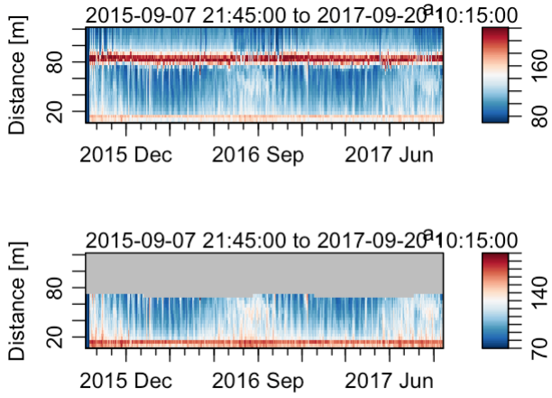

Top - Time series of amplitude from beam 1. Bottom - As top, except after adpFlagPastBoundary and handleFlags have been applied.

After data beyond the water boundary are flagged, profiles are manually flagged if there was a spike in amplitude followed with a sudden change in velocity (See Figure 2). This was likely a result of another instrument on the moored line, and the associated bin was therefore flagged using the flagSpecific function and set to NA using handleFlags.

flagSpecific <- function(x=NULL, fields=NULL, debug=0, top=NULL, bottom=NULL)  
{  
 if (!inherits(x, "adp")) {  
 stop("x must be an adp object")  
 }  
 if (is.null(top)) {  
 stop("must provide a top argument")  
 }  
 if (is.null(bottom)) {  
 stop("must provide a bottom argument")  
 }  
 dimNeeded <- dim(x[["v"]])  
 if (is.null(fields)) {  
 dataNames <- names(x@data)  
 keep <- sapply(dataNames,  
 function(variableTrial) {  
 dimtest <- dim(x[[variableTrial]])  
 length(dimtest) == 3 && all(dimtest == dimNeeded)  
 })  
 fields <- dataNames[keep]  
 if (debug > 0) {  
 message("inferred fields =", paste0(fields, collapse=","))  
 }  
 }  
   
   
 numberOfBeams <- dim(x[['v']])[3]  
 if (debug > 0) {  
 message("The number of beams =", numberOfBeams)  
 }  
 for (b in 1:numberOfBeams) {  
 bad <- which(x[['distance']] < top & bottom < x[['distance']]) #3  
 for (i in seq_along(fields)) {  
 #adps3[[1]][['flags']]$v[,,1][,which(adps3[[1]][['distance']] < 16.1 & 12.1 < adps3[[1]][['distance']])]  
 x[['flags']][[fields[[i]]]][,,b][,bad] <- 4  
 }  
 }  
 return(x)  
}  
  
adps3 <- flagSpecific(adps3, top=16.1, bottom=12.1)  
  
# Set any data that was flagged bad during processing to NA  
ADP4 <- handleFlags(adps3, flags=4)  
  
# Example of wh0493_C1_105m/ds15_000.000  
par(mfrow=c(3,1))  
plot(adps3, which=1, ylim=c(0,20))  
plot(adps3, which="a1", ylim=c(0,20))  
plot(ADP4, which="a1", ylim=c(0,20))

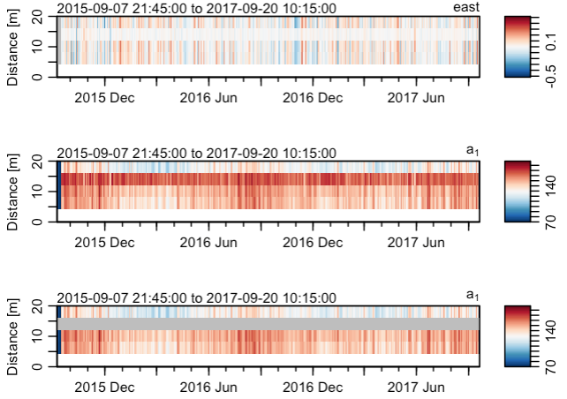

Top - Eastward velocity in distance 1 to 20 m of the water column Middle - As for top, except with amplitude in beam 1. Bottom - As for middle except after flagSpecific and handleFlags have been applied.

As shown in Figure 2, from ~ 12 m to 16 m there is a spike in amplitude accompanied by a sudden change in eastward velocity. This indicated that flagSpecific should be applied, and the result can be shown in Figure 2 (bottom).

Another function, adpFlagCorrelation was also created with the intent to flag any data with that had a q (correlation magnitude) with a 70% correlation or less. For the sake of the Davis Strait data, this data did not have correlation magnitude of 70% or more, and we therefore did not apply this function to the data.

adpFlagCorrelation <- function(x=NULL, fields=NULL, debug=0, correlation=70)  
{  
 oceDebug(debug, "adpFlagCorrelation() {\n", sep="", unindent=1, style="bold")  
 if (!inherits(x, "adp")) {  
 stop("x must be an adp object")  
 }  
 numberOfBeams <- dim(x[['v']])[3]  
 if (debug > 0) {  
 message("The number of beams =", numberOfBeams)  
 }  
 fields <- "v" # # This only changes the velocity  
 for (b in 1:numberOfBeams) {  
 bad <- correlation  
 for (i in seq_along(fields)) {  
 badAmp <- (x[['q']][,,b]/255)*100 < bad  
 browser()  
 if (any(badAmp == TRUE)) {  
 badAmp[which(badAmp == TRUE)] <- 4  
 }  
 if (any(badAmp == FALSE)) {  
 badAmp[which(badAmp == FALSE)] <- 1  
 }  
 if (any(x[['flags']][[fields[[i]]]][,,b] == 4)) {  
 # This merges flags that have already been added  
 flaggedBad <- which(x[['flags']][[fields[[i]]]][,,b] == 4)  
 badAmp[flaggedBad] <- 4  
 x[["flags"]][[fields[i]]][,,b] <- badAmp  
 } else {  
 x[["flags"]][[fields[i]]][,,b] <- badAmp  
 }  
 }  
 }  
 return(x)  
}  
#ADP5 <- adpFlagCorrelation(ADP4, correlation=70)

It it then time to use the oceToNetCDF package following the workflow below (Figure 3).

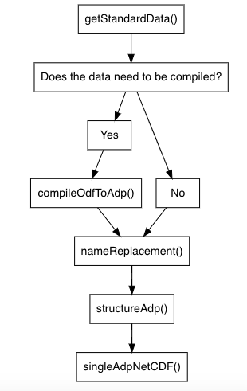

Work flow of the oceToNetCDF package for ADCP data types.

The first step in using the oceToNetCDF package was to get the available climate and forecast (CF) data using getStandardData. An optional function was then used on the data, adpRemoveEmptyBins which removes distance bins that have been flagged as bad by adpFlagPastBoundary. The effect of adpRemoveEmptyBins can be seen in Figure 4.

# oceToNetCDF package  
data <- getStandardData(type="adcp") # Get CF standard names  
ADP5 <- adpRemoveEmptyBins(ADP4) # Optional to remove bins that are beyond the water column  
par(mfrow=c(2,1))  
plot(ADP4, which="a1")  
plot(ADP5, which="a1")

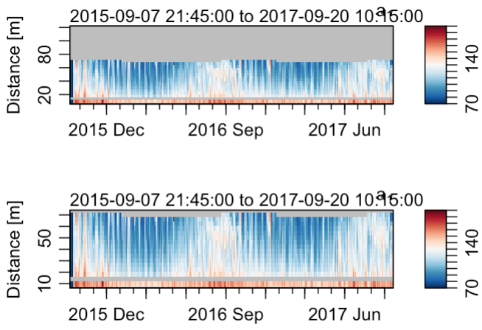

Top - Time series of amplitude from beam 1 after adpFlagPastBoundary has been applied. Bottom - As top, except after adpRemoveEmptyBins had been applied.

After this, the naming convention of the data variables and the units were changed to abide by the CF standards using nameReplacement. Next, the structureAdp function was then applied to the data. The structureAdp function identifies when v (velocity), g (percent good), q (correlation magnitude), a (amplitude), bv, bg, bq, and ba are stored within the adp object. If they are, it structures them appropriately for the NetCDF. See ?structureAdp for more details.

ADP6 <- nameReplacement(ADP5, data=data)  
ADP7 <- structureAdp(ADP6)

Lastly, the singleAdpNetCDF function is used to convert the oce object to a NetCDF file.

singleAdpNetCDF(adp=ADP7, name=ADP7[['station']], data=data, debug=1, destination="./20_rawDavis/adcp/nc/")

# Caution

It should be noted that for code PGDP (percent good pings), TE90 (Temperature (1990 scale)), and DEPH (Sensor Depth below Sea Surface) there were no CF standards. Their standard names have been entered as percent_good_pings, temperature_1990_scale, and sensor_depth_below_sea_surface respectively. Additionally, codes CMAG, HEAD, BR, BV,BA,BG, DIST, COMA, and BQ were not identified in the list of DFO codes (Government of Canada, 2022), but were given standard names of current_magnitude, heading respectively,bottom_range, bottom_velocity, bottom_signal_intensity_from_multibeam_acoustic_doppler_velocity_sensor_in_sea_water, bottom_percent_good_ping, distance,correlation_magnitude, and bottom_correlation_magnitude respectively.

# References

1. <https://www.meds-sdmm.dfo-mpo.gc.ca/isdm-gdsi/diction/main-eng.asp>