**DOCUMENTATION**

* **Installation of Arduino IDE using installer**
  + Go to official [website](https://www.arduino.cc/en/Main/Software) and choose “Windows Installer”.
  + On the next page, choose “JUST DOWNLOAD” or “CONTRIBUTE & DOWNLOAD”. The installer will now be downloaded.
  + Start the .exe file you just downloaded. Choose “Yes” to trust the installer to make changes to your computer. Then, agree to the License Agreement.
  + Choose the installation folder (recommended to keep the default) and click install.
  + Click Install to install the Adafruit driver.
  + Click the Install button to install the USB driver.
  + Click the Install button to install the second USB driver.
  + The setup is now completed.
* **Environment Setup on Arduino IDE**

The Arduino IDE should be tweaked so that the IDE runs for your board of choice. The Arduino IDE should be modified to work on NodeMCU

* + Open Arduino IDE.

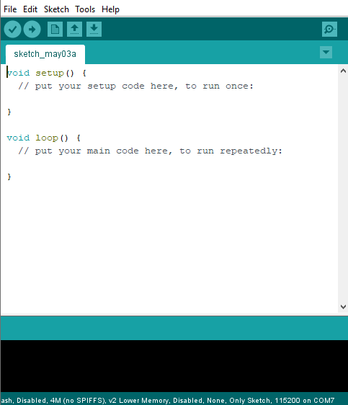

* + Go to File > Preferences. In the "Additional Boards Manager URLs" field, type (or copy-paste) *http://arduino.esp8266.com/stable/package_esp8266com_index.json.* Don't forget to click OK!

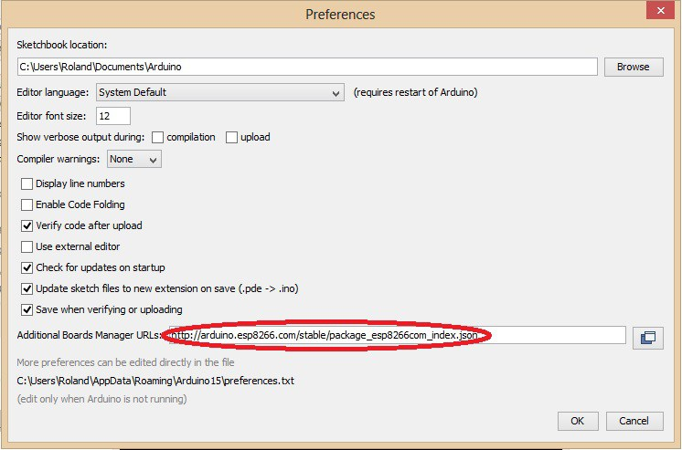

* + Then go to Tools > Board > Board Manager. Type "esp8266" in the search field. The entry "esp8266 by ESP8266 Community" should appear. Click that entry and look for the install button on the lower right.

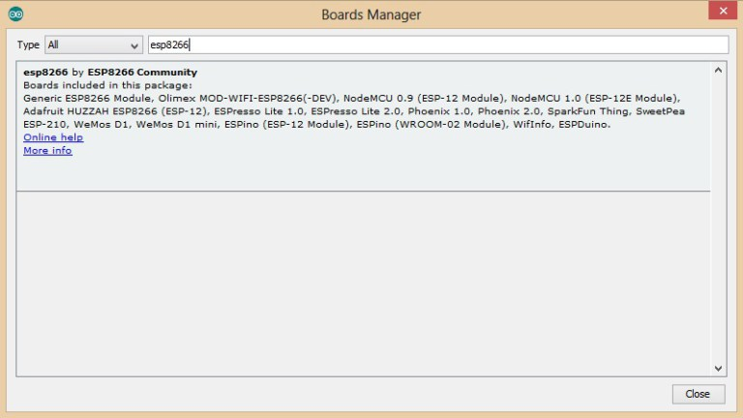

* + Again go to Tools > Board > Select **NodeMCU 1.0 (ESP 12-E Module)**

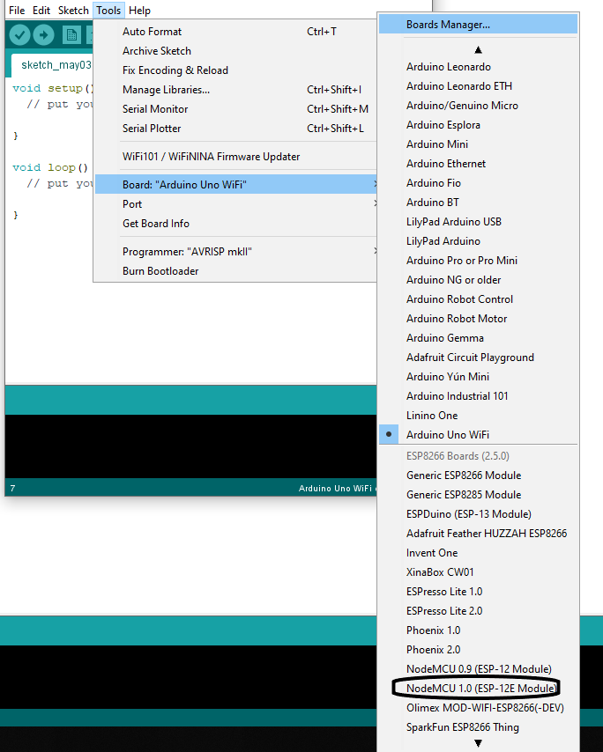

* **Using the Client Library**
  + Include the client library file **rooftop_agri.h** in your program file.
  + In Arduino include it as **#include”rooftop_agri.h”.**
  + Make sure you have updated the ip address of the probe in the 35th line of the **rooftop_agri.h** file.

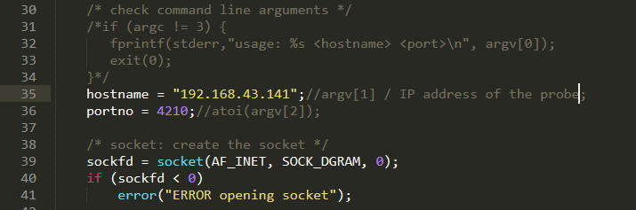

* + Also update the ip address of the NodeMCU controlling the actuators in the 96th line of the **rooftop_agri.h** file.

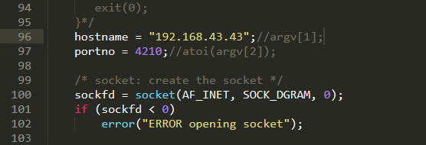

* + There are 4 functions / api’s in this library
    - **light()** - which gives the light intensity value.
    - **moisture()** - which gives the moisture value.
    - **humidity()** - which gives the humidity value.
    - **temp()** - which gives the temperature value.
  + You can use these functions in your .ino file to get the sensor values sas u have imported the library **rooftop_agri.h**.
  + Make sure that you are connected to the same network, the environment is connected to.
  + To control the actuators: You can use the send_pckt() function with actual parameters included.
    - For example send_pckt(1,1,0) will make the actuators high, high and low respectively.