**Worksheet 01**

**Q01:**

**Code:**

package Q_01;

import javax.swing.*;

public class Q_01 {

public static void main(String[] args) {

JFrame sampleWindow;

sampleWindow = new JFrame();

sampleWindow.setSize(800,600);

sampleWindow.setTitle("Welcome to Java");

sampleWindow.setVisible(true);

sampleWindow.setDefaultCloseOperation(WindowConstants.EXIT_ON_CLOSE);

}

}

**Output:**

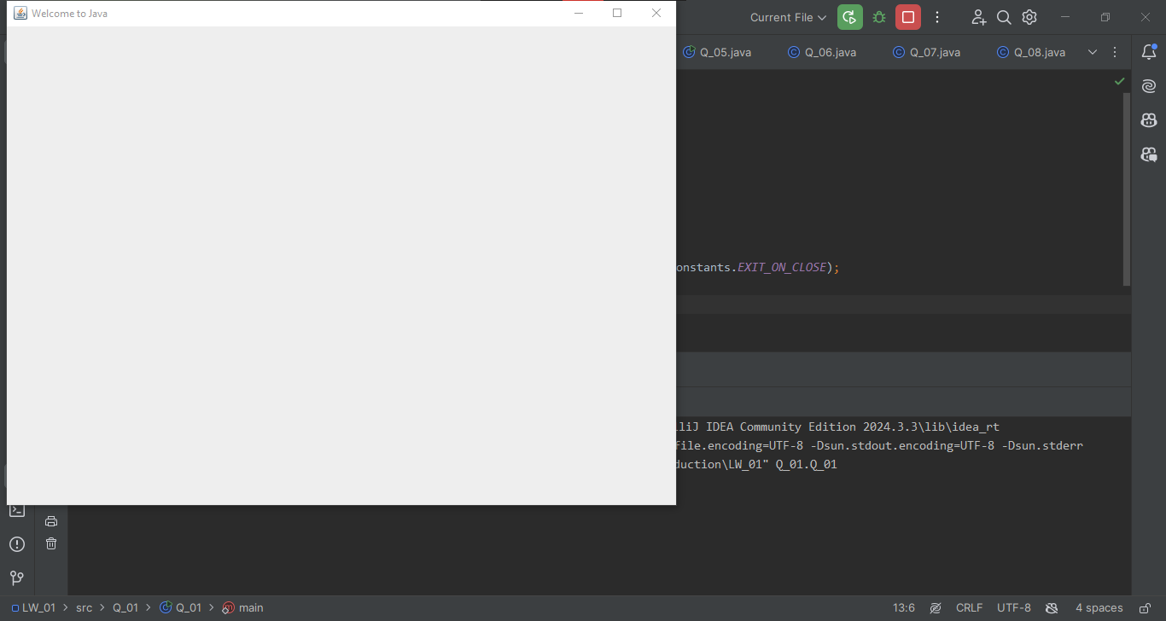

**Q02:**

**Code:**

package Q_02;

import javax.swing.*;

import java.util.*;

public class Q_02 {

public static void main(String[] args) {

Scanner scn = new Scanner(System.in);

String firstName;

System.out.println("Enter your first name:");

firstName = scn.nextLine();

String lastName;

System.out.println("Enter your last name:");

lastName = scn.nextLine();

JFrame nameWindow;

nameWindow = new JFrame();

nameWindow.setSize(800,600);

nameWindow.setTitle(firstName+" "+lastName);

nameWindow.setVisible(true);

nameWindow.setDefaultCloseOperation(WindowConstants.EXIT_ON_CLOSE);

}

}

**Output:**

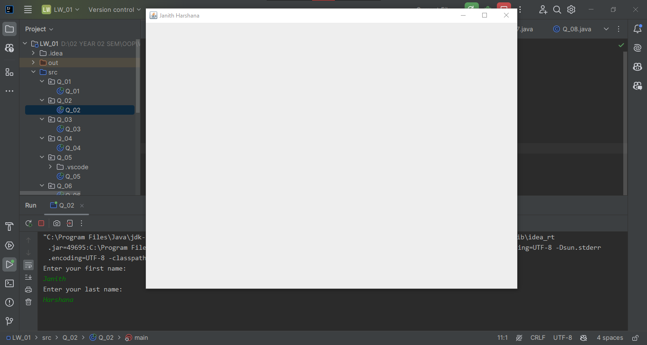

**Q03:**

**Code:**

package Q_03;

import java.util.*;

public class Q_03 {

public static void main(String[] args) {

Scanner scan = new Scanner(System.in);

String firstName, middleName, lastName;

System.out.println("Enter your first name: ");

firstName = scan.nextLine();

System.out.println("Enter your middle name: ");

middleName = scan.nextLine();

System.out.println("Enter your last name: ");

lastName = scan.nextLine();

System.out.println(firstName+" "+middleName.substring(0,1)+". "+lastName);

}

}

**Output:**

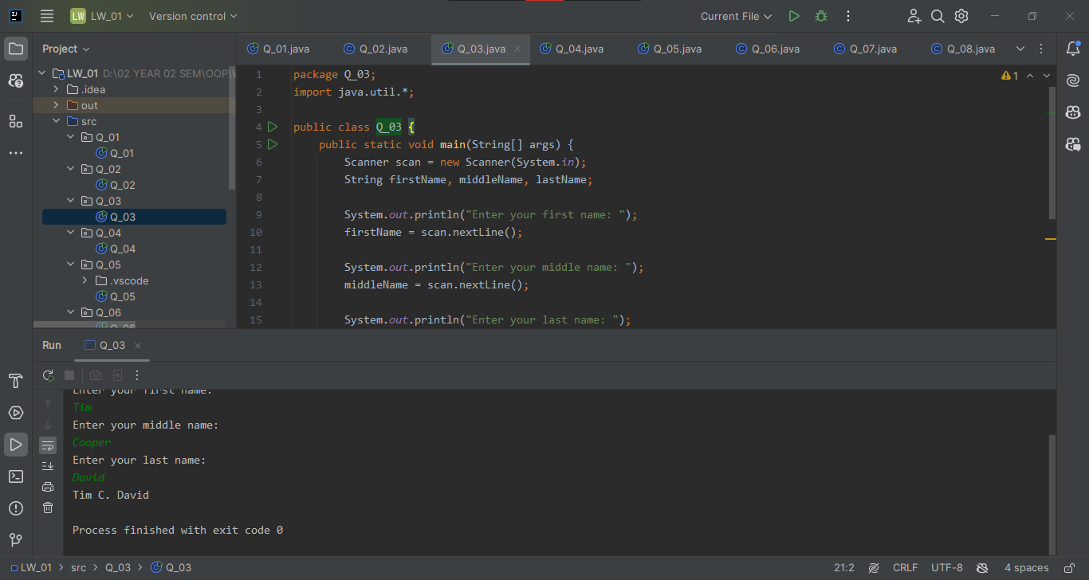

**Q 04:**

**Code:**

package Q_04;

import java.text.SimpleDateFormat;

import java.util.*;

public class Q_04 {

public static void main(String[] args) {

Date today;

SimpleDateFormat sdf;

today = new Date();

sdf = new SimpleDateFormat("dd MMMM yyyy");

System.out.println(sdf.format(today));

}

}

**Output:**

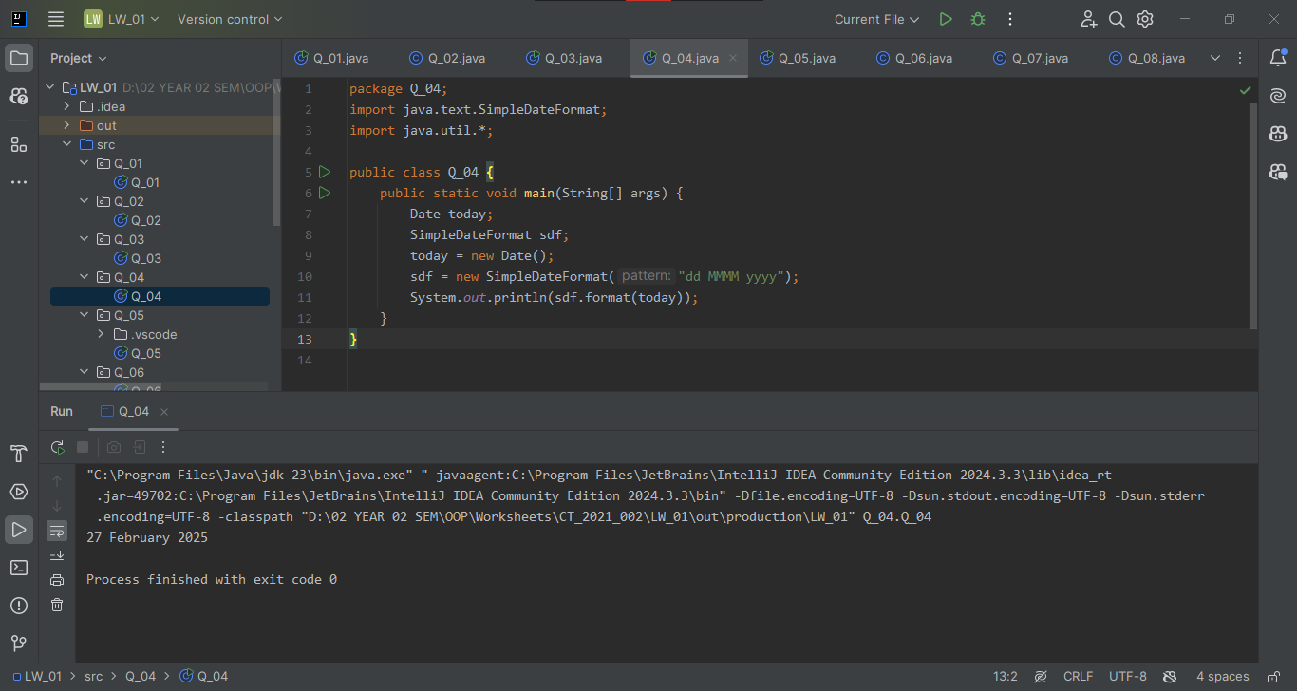

**Q 05:**

**Code:**

package Q_05;

import java.text.SimpleDateFormat;

import java.util.*;

public class Q_05 {

public static void main(String[] args) {

Date today;

SimpleDateFormat sdf;

today = new Date();

sdf = new SimpleDateFormat("EEEE, MMMM dd, yyyy");

System.out.println("Today's date is: " + sdf.format(today));

}

}

**Output:**

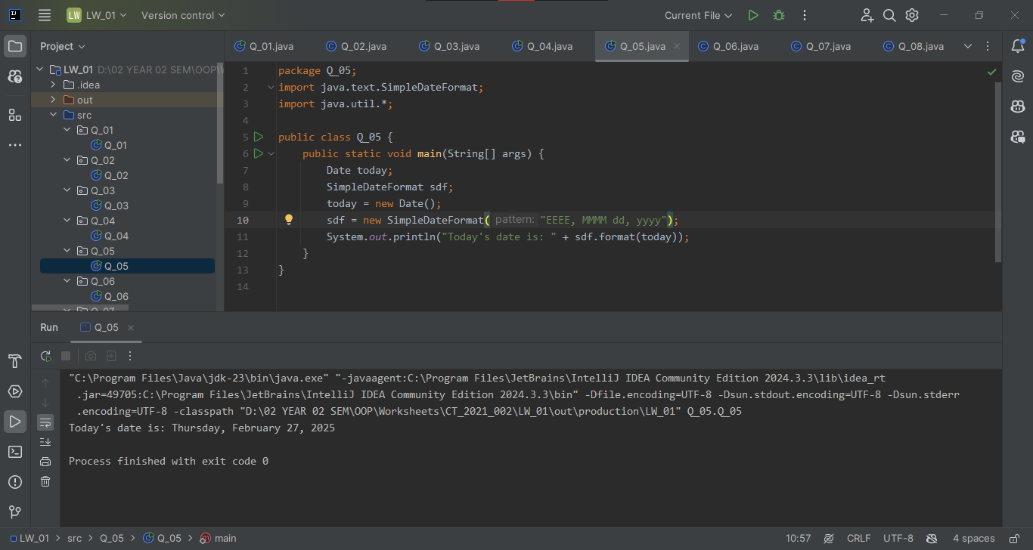

**Q 06:**

**Code:**

package Q_06;

import javax.swing.*;

import java.util.*;

public class Q_06 {

public static void main(String[] args) {

Scanner sc = new Scanner(System.in);

int width, height;

String title;

System.out.println("Enter the width of the window:");

width = sc.nextInt();

System.out.println("Enter the height of the window:");

height = sc.nextInt();

System.out.println("Enter the title of the window:");

sc.nextLine();

title = sc.nextLine();

JFrame customWindow;

customWindow = new JFrame();

customWindow.setSize(width,height);

customWindow.setTitle(title);

customWindow.setVisible(true);

customWindow.setDefaultCloseOperation(WindowConstants.EXIT_ON_CLOSE);

}

}

**Output:**

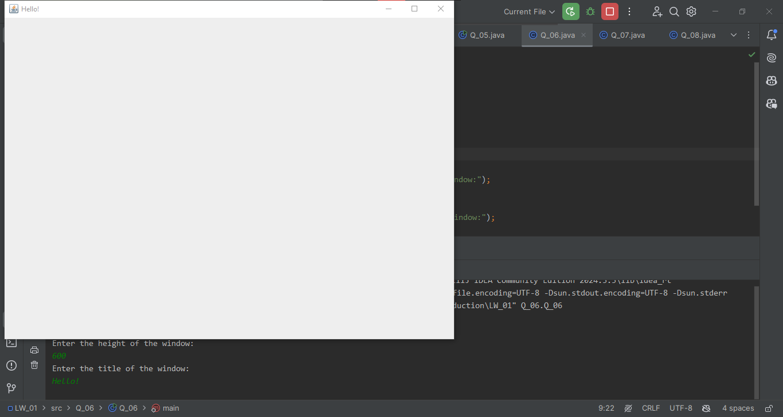

**Q 07:**

**Code:**

package Q_07;

import java.util.*;

import javax.swing.*;

import java.text.SimpleDateFormat;

public class Q_07 {

public static void main(String[] args) {

Date now = new Date();

SimpleDateFormat sdf = new SimpleDateFormat("hh:mm:ss a");

String time = sdf.format(now);

JFrame timeWindow;

timeWindow = new JFrame();

timeWindow.setSize(800,600);

timeWindow.setTitle(time);

timeWindow.setVisible(true);

timeWindow.setDefaultCloseOperation(WindowConstants.EXIT_ON_CLOSE);

}

}

**Output:**

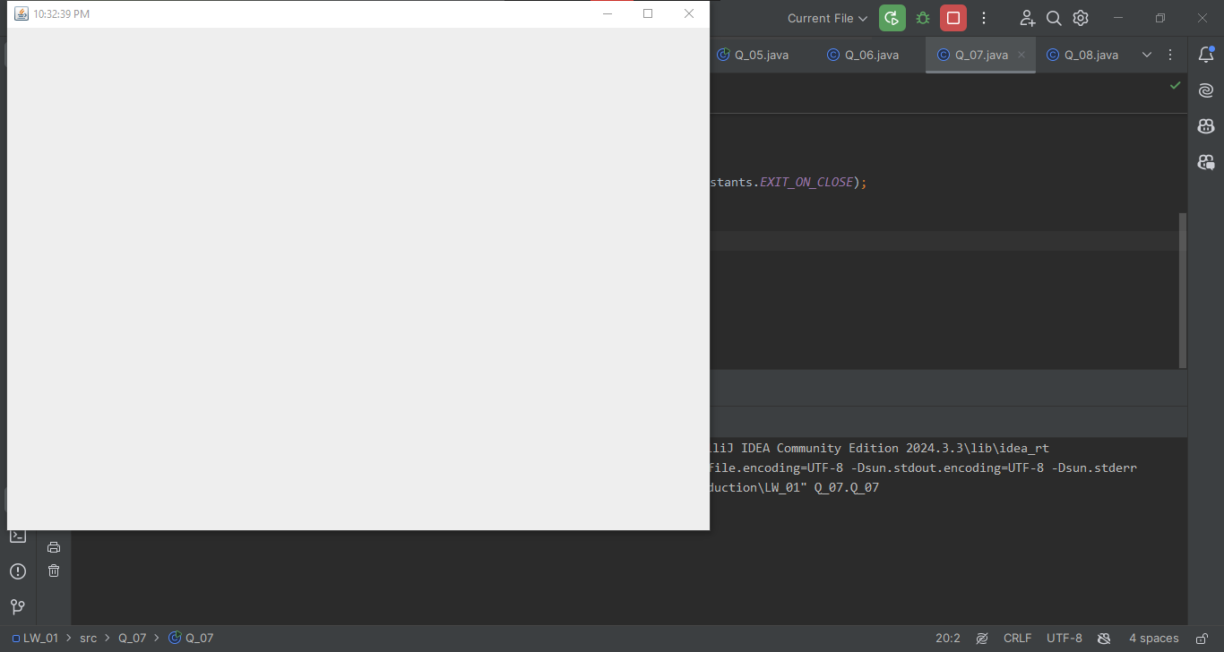

**Q 08:**

**Code:**

package Q_08;

import java.util.*;

public class Q_08 {

public static void main(String[] args) {

Scanner scan = new Scanner(System.in);

String str;

Integer split;

System.out.println("Enter a string that contains a exclamation mark:");

str = scan.nextLine();

split = str.indexOf("!");

System.out.println(str.substring(0,split));

System.out.println(str.substring(split+1));

}

}

**Output:**

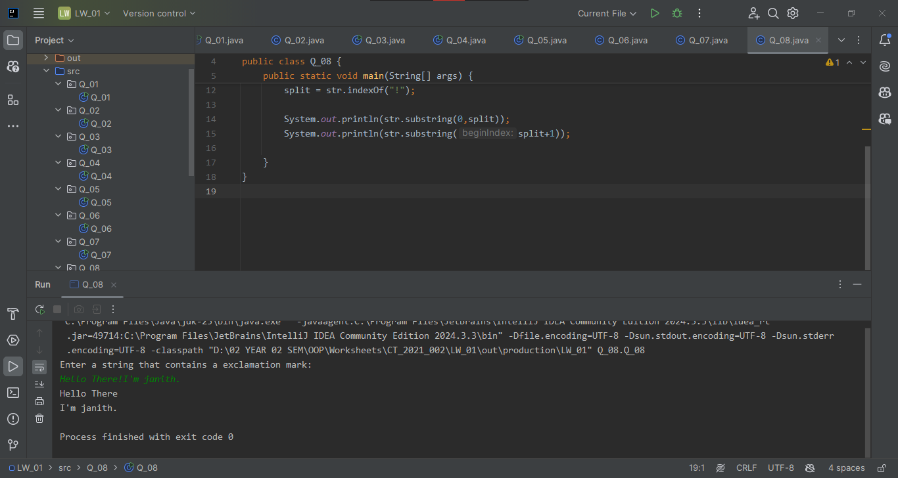

**Q 09:**

**Code:**

package Q_09;

import java.util.Scanner;

public class Q_09 {

public static void main(String[] args) {

Scanner scan = new Scanner(System.in);

String str;

System.out.println("Enter a string:");

str = scan.nextLine();

System.out.println(str.length());

System.out.println(str.substring(0,1));

System.out.println(str.charAt(str.length()-1));

}

}

**Output:**

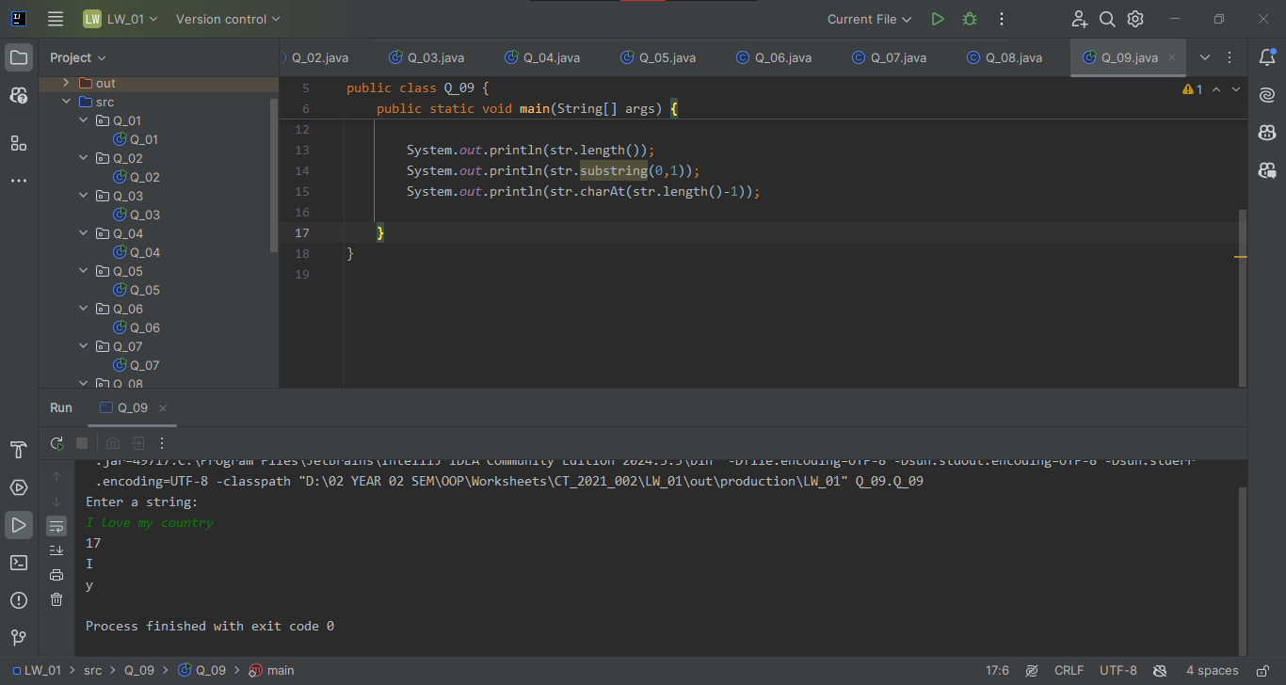

**Q 10:**

**Code:**

package Q_10;

import java.util.Scanner;

public class Q_10 {

public static void main(String[] args) {

Scanner scn = new Scanner(System.in);

String oddWord;

System.out.println("Enter an odd-length word:");

oddWord = scn.next();

System.out.println(oddWord.charAt(oddWord.length()/2));

}

}

**Output:**

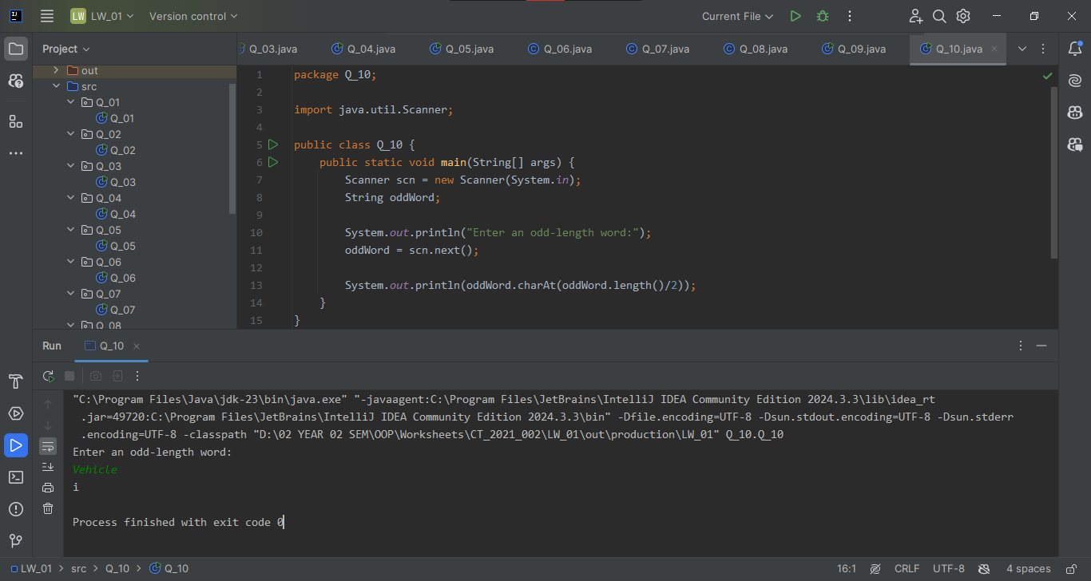

**Q 11:**

**Code:**

package Q_11;

import java.util.*;

public class Q_11 {

public static void main(String[] args) {

Scanner scan = new Scanner(System.in);

String firstName, middleName, lastName;

System.out.println("Enter your first name: ");

firstName = scan.nextLine();

System.out.println("Enter your middle name: ");

middleName = scan.nextLine();

System.out.println("Enter your last name: ");

lastName = scan.nextLine();

System.out.println(lastName+", "+firstName+" "+middleName.charAt(0)+".");

}

}

**Output:**

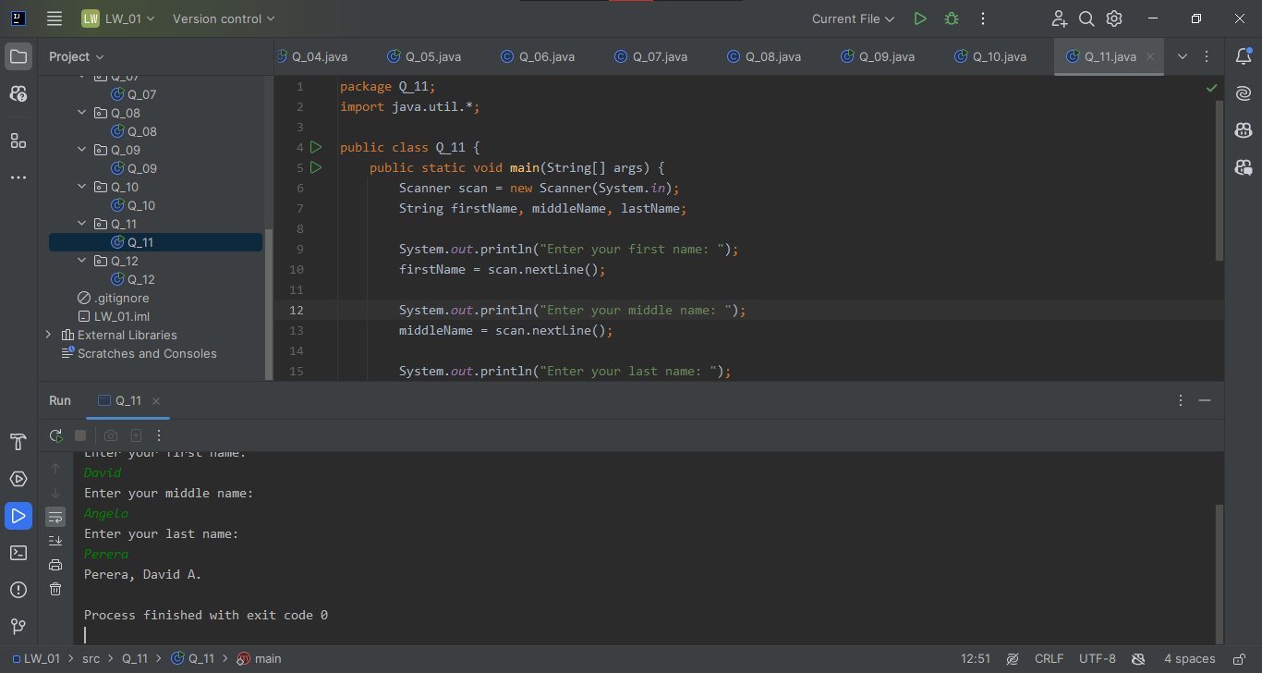

**Q 12 :**

**Code:**

package Q_12;

import javax.swing.*;

public class Q_12 {

public static void main(String[] args) {

JFrame windowLocation;

windowLocation = new JFrame();

windowLocation.setSize(300,200);

windowLocation.setTitle("My First Frame");

windowLocation.setLocation(100,50);

windowLocation.setVisible(true);

windowLocation.setDefaultCloseOperation(WindowConstants.EXIT_ON_CLOSE);

}

}

**Output:**

