**Worksheet 02**

**CTEC 22043**

**Object Oriented Programming**

**Student No: CT/2021/002**



**Faculty of Computing and Technology**

**University of Kelaniya**

**Sri Lanka**

**Worksheet 02**

**Q 01-a:**

**Code:**

package Q_01;

import java.text.DecimalFormat;

import java.util.Scanner;

public class Q_01_a {

public static void main(String[] args) {

Scanner scan = new Scanner(System.in);

DecimalFormat df = new DecimalFormat("#.##");

double A,B,C;

System.out.println("Enter A:");

A = scan.nextDouble();

System.out.println("Enter B:");

B = scan.nextDouble();

System.out.println("Enter C:");

C = scan.nextDouble();

System.out.println(df.format(Math.sqrt(Math.pow(B,2)+4*A*C)));

}

}

**Output:**

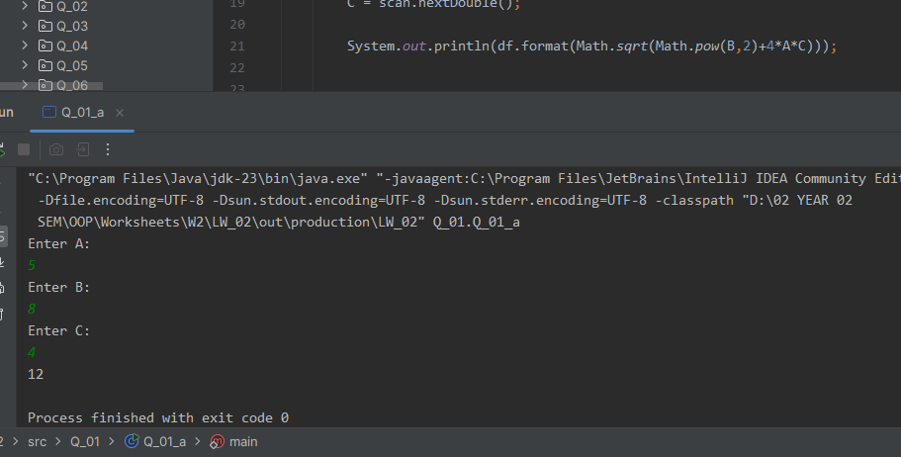

**Q 01-b:**

**Code:**

package Q_01;

import java.text.DecimalFormat;

import java.util.Scanner;

public class Q_01_b {

public static void main(String[] args) {

Scanner scan = new Scanner(System.in);

DecimalFormat df = new DecimalFormat("#.##");

double X,Y;

System.out.println("Enter X:");

X = scan.nextDouble();

System.out.println("Enter Y:");

Y = scan.nextDouble();

System.out.println(df.format(Math.sqrt(X+(4*(Math.pow(Y,3))))));

}

}

**Output:**

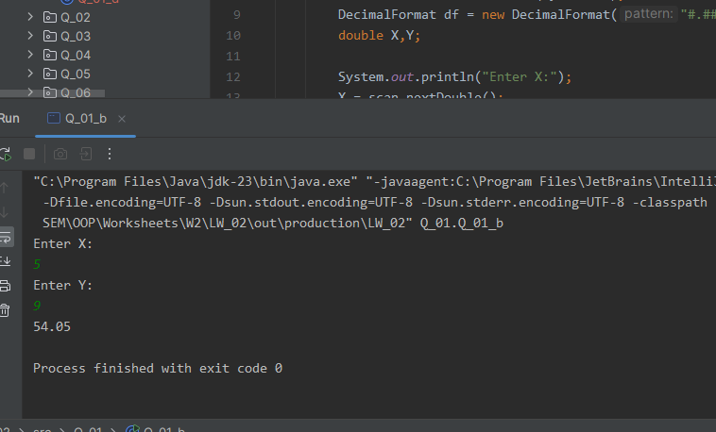

**Q 01-c:**

**Code:**

package Q_01;  
  
import java.text.DecimalFormat;  
import java.util.Scanner;  
  
public class Q_01_c {  
 public static void main(String[] args) {  
 Scanner scan = new Scanner(System.in);  
 DecimalFormat df = new DecimalFormat("#.##");  
 double X,Y;  
  
 System.out.println("Enter X:");  
 X = scan.nextDouble();  
  
 System.out.println("Enter Y:");  
 Y = scan.nextDouble();  
  
 System.out.println(df.format(Math.cbrt(X*Y)));  
  
 }  
}

**Output:**

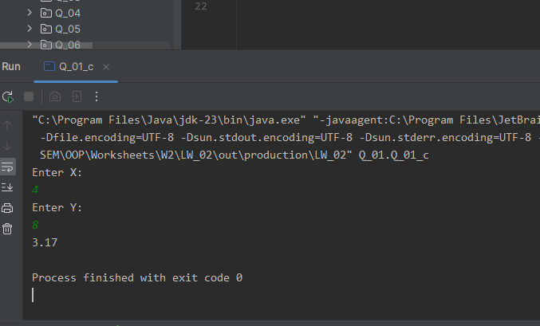

**Q 01-d:**

**Code:**

package Q_01;

import java.text.DecimalFormat;

import java.util.Scanner;

public class Q_01_d {

public static void main(String[] args) {

Scanner scan = new Scanner(System.in);

DecimalFormat df = new DecimalFormat("#.##");

final double PI = 3.14159;

double radius;

System.out.println("Enter the radius value: ");

radius = scan.nextDouble();

System.out.println("Area of the circle is: "+df.format(PI*radius*radius));

}

}

**Output:**

**Q 02:**

**Code:**

package Q_02;

import java.text.DecimalFormat;

import java.util.Scanner;

public class Q_02 {

public static void main(String[] args) {

Scanner scan = new Scanner(System.in);

DecimalFormat df = new DecimalFormat("#.##");

int cm;

System.out.println("Enter centimeter Value:");

cm = scan.nextInt();

// 1ft = 30cm

int feet = cm/30;

float inch = cm%30 * 0.3937f;

System.out.println(feet+"ft "+df.format(inch)+"in");

}

}

**Output:**

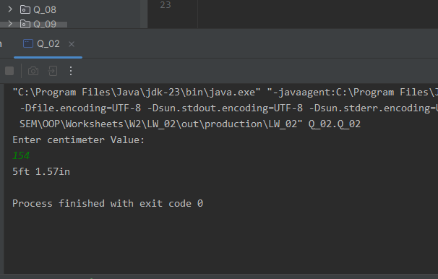

**Q 03:**

**Code:**

package Q_03;  
  
import java.text.DecimalFormat;  
import java.util.Scanner;  
  
public class Q_03 {  
 public static void main(String[] args) {  
 Scanner scan = new Scanner(System.in);  
 DecimalFormat df = new DecimalFormat("#.##");  
 double c,f;  
  
 System.out.println("Enter the Temperature in Celsius:");  
 c = scan.nextDouble();  
  
 f = (1.8*c)+32;  
  
 System.out.println("Temperature in Fahrenheit: "+df.format(f)+"F");  
 }  
}

**Output:**

**Q 04:**

**Code:**

package Q_04;  
  
import java.text.DecimalFormat;  
import java.util.Scanner;  
  
public class Q_04 {  
 public static void main(String[] args) {  
 Scanner scan = new Scanner(System.in);  
 DecimalFormat df = new DecimalFormat("#.##");  
 double weight;  
  
 System.out.println("Enter Your Weight In Pounds: ");  
 weight = scan.nextDouble();  
  
 System.out.println("You need "+(df.format(weight*19))+"Kcal Of Calories in one day.");  
 }  
}

**Output:**

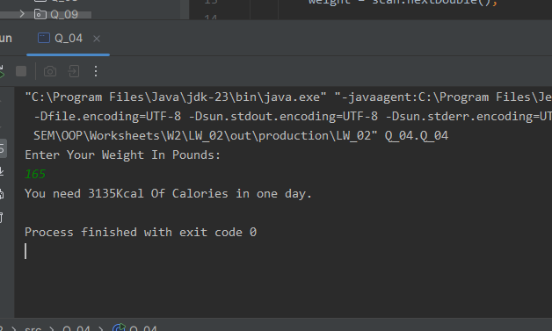

**Q 05:**

**Code:**

package Q_05;  
  
import java.text.DecimalFormat;  
import java.util.Scanner;  
  
public class Q_05 {  
 public static void main(String[] args) {  
 Scanner scan = new Scanner(System.in);  
 DecimalFormat df = new DecimalFormat("#.##");  
 double c,f;  
  
 System.out.println("Enter the Temperature in Fahrenheit:");  
 f = scan.nextDouble();  
  
 c =((f-32)*5/9);  
 System.out.println("Temperature in Celsius: "+df.format(c)+"C");  
 }  
}

**Output:**

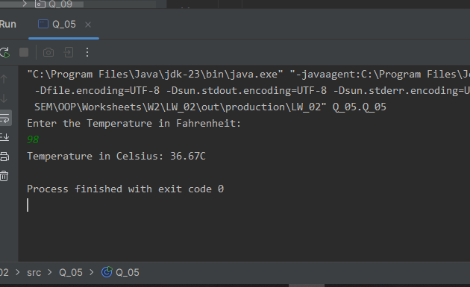

**Q 06:**

**Code:**

package Q_06;  
  
import java.time.Year;  
import java.util.Scanner;  
  
public class Q_06 {  
 public static void main(String[] args) {  
 Scanner scan = new Scanner(System.in);  
 int birthYear;  
 int currentYear = Year.now().getValue();  
  
 System.out.println("Enter Your Birth Year: ");  
 birthYear = scan.nextInt();  
  
 int age = (currentYear-birthYear);  
 System.out.println("You were born in "+birthYear+" and will be "+age+" years old this year.");  
 }  
}

**Output:**

**Q 07:**

**Code:**

package Q_07;  
  
import java.text.DecimalFormat;  
import java.util.Scanner;  
  
public class Q_07 {  
 public static void main(String[] args) {  
 Scanner scan = new Scanner(System.in);  
 DecimalFormat df = new DecimalFormat("#.##");  
 int w,h;  
  
 System.out.println("Enter your weight in Kilograms: ");  
 w = scan.nextInt();  
  
 System.out.println("Enter your Height in centimeters: ");  
 h = scan.nextInt();  
  
 double bmi = (w/(Math.pow(((double)h/100.0),2)));  
  
 if (bmi >= 20 && bmi <= 25) {  
 System.out.println("BMI: " + df.format(bmi) + " - Normal");  
 }  
 else if (bmi > 25) {  
 System.out.println("BMI: " + df.format(bmi) + " - Overweight");  
 }  
 else {  
 System.out.println("BMI: " + df.format(bmi) + " - Underweight");  
 }  
 }  
}

**Output:**

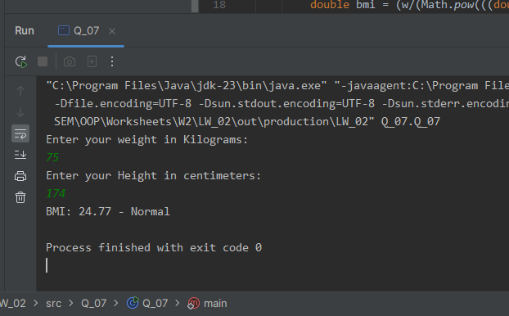

**Q 08:**

**Code:**

package Q_08;  
  
import java.text.DecimalFormat;  
import java.util.Scanner;  
  
public class Q_08 {  
 public static void main(String[] args) {  
 Scanner scan = new Scanner(System.in);  
  
 DecimalFormat df = new DecimalFormat("#.##");  
 final double PI = 3.14159;  
 double r;  
  
 System.out.println("Enter the radius of the sphere: ");  
 r = scan.nextDouble();  
  
 double v = ((4.0/3.0) * (PI * Math.pow(r,3)));  
  
 System.out.println("Volume of the sphere: " + df.format(v));  
  
 }  
}

**Output:**

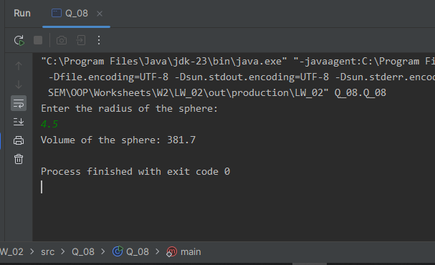

**Q 09 :**

**Code:**

package Q_09;  
  
import java.text.DecimalFormat;  
import java.util.Scanner;  
  
public class Q_09 {  
 public static void main(String[] args) {  
 Scanner scan = new Scanner(System.in);  
 DecimalFormat df = new DecimalFormat("#.##");  
 double P,R,N;  
  
 System.out.println("Enter the principal investment amount: ");  
 P = scan.nextDouble();  
  
 System.out.println("Enter the interest rate: ");  
 R = scan.nextDouble();  
  
 System.out.println("Enter the number of years: ");  
 N = scan.nextDouble();  
  
 double amt = (P * (Math.pow((1 + (R/100)),N)));  
 double earn = amt-P;  
  
 System.out.println("Total interest earnings for "+N+" years: "+df.format(earn));  
 System.out.println("Total amount after "+N+" years: " + df.format(amt));  
 }  
}

**Output:**

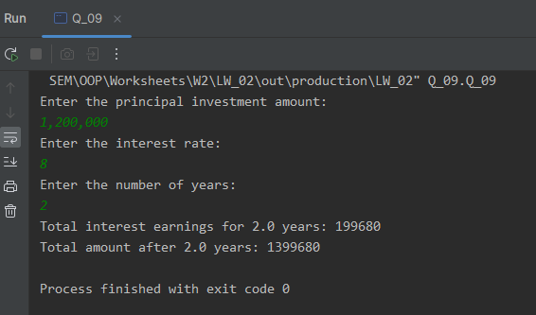

**Q 10:**

**Code:**

package Q_10;  
  
import java.text.DecimalFormat;  
import java.util.Scanner;  
  
public class Q_10 {  
 public static void main(String[] args) {  
 Scanner scan = new Scanner(System.in);  
 DecimalFormat df = new DecimalFormat("#.##");  
  
 double loanAmount,annualInterestRate,monthlyInterestRate, monthlyPayment,totalPayment;  
 int loanPeriod,numberOfPayments;  
  
 System.out.println("Enter the loan amount: LKR");  
 loanAmount = scan.nextDouble();  
  
 System.out.println("Enter the annual interest rate: ");  
 annualInterestRate = scan.nextDouble();  
  
 System.out.println("Enter the loan period in months: ");  
 loanPeriod = scan.nextInt();  
  
 monthlyInterestRate = (annualInterestRate / 100) / 12;  
 numberOfPayments = loanPeriod;  
 monthlyPayment = (loanAmount * monthlyInterestRate) / (1 - Math.pow((1 / ( 1 + monthlyInterestRate)),numberOfPayments));  
 totalPayment = monthlyPayment * numberOfPayments;  
  
 System.out.println("Monthly Payment: LKR "+ df.format(monthlyPayment));  
 System.out.println("Total Payment: LKR "+ df.format(totalPayment));  
 }  
}

**Output:**

