**Worksheet 06**

**CTEC 22043**

**Object Oriented Programming**

**Student No: CT/2021/002**



**Faculty of Computing and Technology**

**University of Kelaniya**

**Sri Lanka**

**Q1.**

**Code:**

**Pet.java**

package Q_01;  
  
abstract class Pet {  
 private String name;  
  
 public String getName(){  
 return name;  
 }  
  
 public void setName (String petName){  
 name = petName;  
 }  
  
 public String speak(){  
 return "I'm your cuddly pet.";  
 }  
}

**Cat.java**

package Q_01;  
  
  
public class Cat extends Pet{  
 @Override  
 public String speak(){  
 return "";  
 }  
}

**Dog.java**

package Q_01;  
  
  
public class Dog extends Pet {  
 @Override  
 public String speak(){  
 return "";  
 }  
  
}

**Main.java**

package Q_01;  
  
public class Main {  
 public static void main(String[] args) {  
 Cat myCat = new Cat();  
 Dog myDog = new Dog();  
  
 myCat.setName("Kitty");  
 myDog.setName("Scooby");  
  
 System.*out*.println("My Cat's name: "+myCat.getName()+". He says "+myCat.speak());  
 System.*out*.println("My Dog's name: "+myDog.getName()+". He says "+myDog.speak());  
 }  
  
}

**Output:**

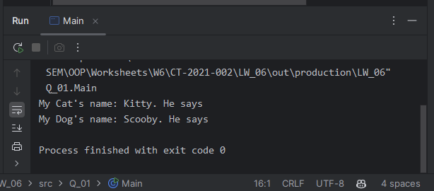

**Q2.**

**Code:**

**Pet.java**

package Q_02;  
  
abstract class Pet {  
 private final String name;  
  
 public Pet(String name) {  
 this.name = name;  
 }  
  
 public String getName(){  
 return name;  
 }  
 public abstract String getType();  
  
}

**Cat.java**

package Q_02;  
  
  
public class Cat extends Pet {  
 public Cat(String name){  
 super(name);  
 }  
  
 @Override  
 public String getType(){  
 return "Cat";  
 }  
  
  
}

**Dog.java**

package Q_02;  
  
public class Dog extends Pet {  
 public Dog(String name){  
 super(name);  
 }  
  
 @Override  
 public String getType(){  
 return "Dog";  
 }  
  
}

**PetList.java**

package Q_02;  
  
import java.util.Scanner;  
  
public class PetList {  
 public static final int *MAX_VALUE* = 10;  
 public static void main(String[] args) {  
 Scanner scan = new Scanner(System.*in*);  
 Pet[] pets = new Pet[*MAX_VALUE*];  
 int petCount = 0;  
  
 //input the data to array  
 System.*out*.println("First enter [Pet's Name], then [Pet Type] or 'STOP' to finish.");  
  
 while(true){  
 System.*out*.print("Enter Pet: ");  
 String name = scan.nextLine();  
  
 if(name. equalsIgnoreCase ("stop")){

System.*out*.println("Exiting...");  
 break;  
 }  
  
 System.*out*.print("Enter the pet type('c' for cat and 'd' for dog): ");  
 char type = scan.nextLine().charAt(0);  
  
 if(type == 'c'){  
 pets[petCount] = new Cat(name);  
 } else if (type == 'd'){  
 pets[petCount] = new Dog(name);  
 }else{  
 System.*out*.print("Invalid Input.!");  
 }  
 petCount = petCount + 1;  
 }  
  
 //print the array  
 System.*out*.println("\tPet List");  
 for(int i = 0; i < petCount; i++){  
 System.*out*.println("Pet "+(i+1)+ ": "+pets[i].getName()+" ("+pets[i].getType()+")");  
 }  
 }  
}

**Output:**

**Q3.**

**Code:**

**Pet.java**

package Q_03;  
  
abstract class Pet {  
 private final String name;  
  
 public Pet(String name) {  
 this.name = name;  
 }  
  
 public String getName(){  
 return name;  
 }  
 public abstract String getType();  
  
}

**Cat.java**

package Q_03;  
  
public class Cat extends Pet {  
 public Cat(String name){  
 super(name);  
 }  
  
 @Override  
 public String getType(){  
 return "Cat";  
 }  
  
  
}

**Dog.java**

package Q_03;  
  
public class Dog extends Pet {  
 public Dog(String name){  
 super(name);  
 }  
  
 @Override  
 public String getType(){  
 return "Dog";  
 }  
  
}

**PetList.java**

package Q_03;  
  
  
import java.util.Scanner;  
  
public class PetList {  
 public static final int *MAX_VALUE* = 10;  
  
 public static void main(String[] args) {  
 Scanner scan = new Scanner(System.*in*);  
 Pet[] pets = new Pet[*MAX_VALUE*];  
 int petCount = 0;  
  
 //input the data to array  
 System.*out*.println("First Enter [Pet's Name],then [Pet Type]. Enter 'STOP' to finish.");

while (true) {  
 System.*out*.print("Enter Pet: ");  
 String name = scan.nextLine();  
  
 if (name.equalsIgnoreCase("stop")) {  
 System.*out*.println("Exiting...");  
 break;  
 }  
  
 System.*out*.print("Enter the pet type('c' for cat and 'd' for dog): ");  
 char type = scan.nextLine().charAt(0);  
  
 if (type == 'c') {  
 pets[petCount] = new Cat(name);  
 } else if (type == 'd') {  
 pets[petCount] = new Dog(name);  
 } else {  
 System.*out*.print("Invalid Input.!");  
 }  
 petCount = petCount + 1;  
 }  
  
 //print the array  
 System.*out*.println("\tCat List");  
 int catCount = 0;  
 for (int i = 0; i < petCount; i++) {  
 if (pets[i].getClass().getSimpleName().equals("Cat")) {  
 System.*out*.println("Cat " + catCount + ": " + pets[i].getName());  
 catCount ++;  
 }  
 }  
  
 System.*out*.println("\tDog List");  
 int dogCount = 0;  
 for (int i = 0; i < petCount; i++) {  
 if (pets[i].getClass().getSimpleName().equals("Dog")) {  
 System.*out*.println("Dog " + dogCount + ": " + pets[i].getName());  
 dogCount ++;  
 }  
 }  
 }  
}

**Output:**

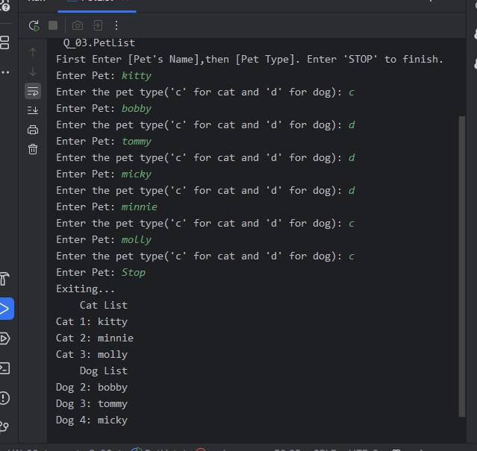

**Q4.**

**Code:**

**Pet.java**

package Q_04;  
  
abstract class Pet {  
 private final String name;  
  
 public Pet(String name) {  
 this.name = name;  
 }  
  
 public String getName(){  
 return name;  
 }  
  
 //public abstract String getType();  
  
}

**Dog.java**

package Q_04;  
  
public class Dog extends Pet {  
 private double weight;  
  
 public Dog(String name){  
 super(name);  
 }  
  
 public double getWeight() {  
 return weight;  
 }  
  
 public void setWeight(double weight) {  
 this.weight = weight;  
 }  
  
// @Override  
// public String getType(){  
// return "Dog";  
// }  
  
}

**Cat.java**

package Q_04;  
  
public class Cat extends Pet {  
 private String coatColor;  
  
 public Cat(String name){  
 super(name);  
 }  
  
 public String getCoatColor() {  
 return coatColor;  
 }  
  
 public void setCoatColor(String coatColor) {  
 this.coatColor = coatColor;  
 }  
  
// @Override  
// public String getType(){  
// return "Cat";  
// }  
  
  
}

**PetListNew.java**

package Q_04;  
  
import java.util.Scanner;  
  
public class PetListNew {  
 public static final int *MAX_VALUE* = 10;  
  
 public static void main(String[] args) {  
 Scanner scan = new Scanner(System.*in*);  
 Pet[] pets = new Pet[*MAX_VALUE*];  
 int petCount = 0;  
  
 //input the data to array  
 System.*out*.println("First Enter [Pet's Name],then [Pet Type]. Enter 'STOP' to finish.");  
  
 while (true) {  
 System.*out*.print("Enter Pet Name: ");  
 String name = scan.nextLine();  
  
 if (name.equalsIgnoreCase("stop")) {  
 System.*out*.println("Exiting...");  
 break;  
 }  
  
 System.*out*.print("Enter the pet type('c' for cat and 'd' for dog): ");  
 char type = scan.nextLine().charAt(0);  
  
 if (type == 'c') {  
 System.*out*.print("Enter coat color: ");  
 String coatColor = scan.nextLine();  
  
 Cat cat = new Cat(name);  
 cat.setCoatColor(coatColor);  
 pets[petCount] = cat;  
 petCount++;  
  
 } else if (type == 'd') {  
 System.*out*.print("Enter weight: ");  
 double weight = scan.nextDouble();  
 scan.nextLine();  
  
 Dog dog = new Dog(name);  
 dog.setWeight(weight);  
 pets[petCount] = dog;  
 petCount++;  
  
 } else {  
 System.*out*.print("Invalid Input.!");  
 }  
 }  
  
 //print the array  
 System.*out*.println("\tCat List");  
 int catCount = 1;  
 for (int i = 0; i < petCount; i++) {  
 if(pets[i] instanceof Cat){  
 Cat cat = (Cat) pets[i];  
 System.*out*.println("Cat "+catCount+":"+cat.getName()+" - Coat Color: "+cat.getCoatColor());  
 catCount++;  
 }  
 }  
  
 System.*out*.println("\tDog List");  
 int dogCount = 1;  
 for (int i = 0; i < petCount; i++) {  
 if (pets[i] instanceof Dog) {  
 Dog dog = (Dog) pets[i];  
 System.*out*.println("Dog " + dogCount + ": " + dog.getName()+" - Weight: "+dog.getWeight()+" kg");  
 dogCount ++;  
 }  
 }  
 }  
}

**Output:**

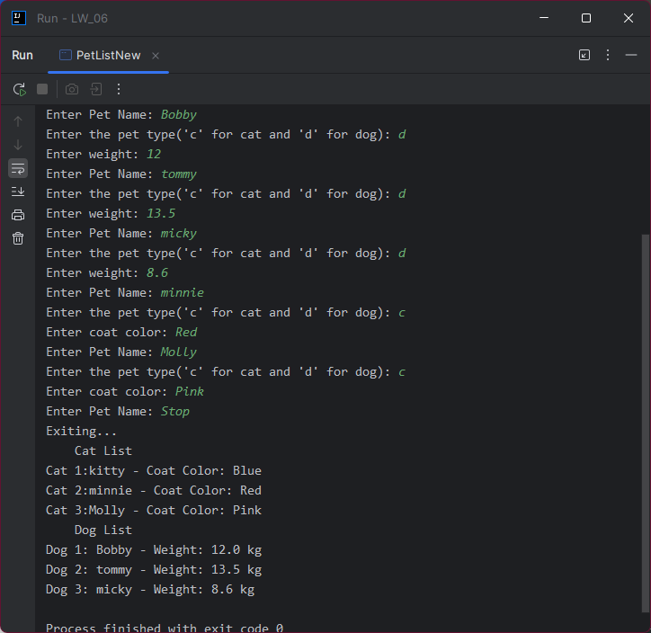

**Q5.**

**Code:**

**PetQ5.java**

package Q_05;  
  
abstract class PetQ5 {  
 private final String name;  
  
 public PetQ5(String name) {  
 this.name = name;  
 }  
  
 public String getName(){  
 return name;  
 }  
  
}

**CatQ5.java**

package Q_05;  
  
  
public class CatQ5 extends PetQ5 {  
 private String coatColor;  
  
 public CatQ5(String name){  
 super(name);  
 }  
  
 public String getCoatColor() {  
 return coatColor;  
 }  
  
 public void setCoatColor(String coatColor) {  
 this.coatColor = coatColor;  
 }  
}

**DogQ5.java**

package Q_05;  
  
public class DogQ5 extends PetQ5 {  
 private double weight;  
  
 public DogQ5(String name){  
 super(name);  
 }  
  
 public double getWeight() {  
 return weight;  
 }  
  
 public void setWeight(double weight) {  
 this.weight = weight;  
 }  
}

**PetListNew.java**

package Q_05;  
  
  
import java.util.Scanner;  
  
public class PetListNew {  
 public static final int *MAX_VALUE* = 10;  
  
 public static void main(String[] args) {  
 Scanner scan = new Scanner(System.*in*);  
 PetQ5[] pets = new PetQ5[*MAX_VALUE*];  
 int petCount = 0;  
  
 //input the data to array  
 System.*out*.println("First Enter [Pet's Name],then [Pet Type]. Enter 'STOP' to finish.");  
  
 while (true) {  
 System.*out*.print("Enter Pet Name: ");  
 String name = scan.nextLine();  
  
 if (name.equalsIgnoreCase("stop")) {  
 System.*out*.println("Exiting...");  
 break;  
 }  
  
 System.*out*.print("Enter the pet type('c' for cat and 'd' for dog): ");  
 char type = scan.nextLine().charAt(0);  
  
 if (type == 'c') {  
 System.*out*.print("Enter coat color: ");  
 String coatColor = scan.nextLine();  
  
 CatQ5 cat = new CatQ5(name);  
 cat.setCoatColor(coatColor);  
 pets[petCount] = cat;  
 petCount++;  
  
 } else if (type == 'd') {  
 System.*out*.print("Enter weight: ");  
 double weight = scan.nextDouble();  
 scan.nextLine();  
  
 DogQ5 dog = new DogQ5(name);  
 dog.setWeight(weight);  
 pets[petCount] = dog;  
 petCount++;  
  
 } else {  
 System.*out*.print("Invalid Input.!");  
 }  
 }  
  
 //print the array  
 System.*out*.println("\tCat List");  
 int catCount = 1;  
 for (int i = 0; i < petCount; i++) {  
 if(pets[i] instanceof CatQ5){  
 CatQ5 cat = (CatQ5) pets[i];  
 System.*out*.println("Cat "+catCount+":"+cat.getName()+" - Coat Color: "+cat.getCoatColor());  
 catCount++;  
 }  
 }  
  
 System.*out*.println("\tDog List");  
 int dogCount = 1;  
 for (int i = 0; i < petCount; i++) {  
 if (pets[i] instanceof DogQ5) {  
 DogQ5 dog = (DogQ5) pets[i];  
 System.*out*.println("Dog " + dogCount + ": " + dog.getName()+" - Weight: "+dog.getWeight()+" kg");  
 dogCount ++;  
 }  
 }  
  
 // Create dog-only array  
 DogQ5[] dogList = new DogQ5[petCount];  
 int dogCounts = 0;  
 for (int i = 0; i < petCount; i++) {  
 if (pets[i] instanceof DogQ5) {  
 dogList[dogCounts] = (DogQ5) pets[i];  
 dogCounts++;  
 }  
 }  
  
 // Calculate average, min, max  
 if (dogCounts > 0) {  
 double total = 0;  
 double min = dogList[0].getWeight();  
 double max = dogList[0].getWeight();  
  
 for (int i = 0; i < dogCounts; i++) {  
 double w = dogList[i].getWeight();  
 total += w;  
 if (w < min) min = w;  
 if (w > max) max = w;  
 }  
  
 double avg = total / dogCounts;  
  
 System.*out*.println("\nDog Weight Stats:");  
 System.*out*.println("Average Weight: " + avg + " kg");  
 System.*out*.println("Minimum Weight: " + min + " kg");  
 System.*out*.println("Maximum Weight: " + max + " kg");  
 } else {  
 System.*out*.println("\nNo dogs found to calculate weights.");  
 }  
 }  
}

**Output:**

**Q6.**

**Code:**

**Cat.java, Dog.java, Pet.java are same as above.**

**PetListMenu.java**

package Q_06;  
  
import java.util.ArrayList;  
import java.util.Scanner;  
  
public class PetListMenu {  
 public static void main(String[] args) {  
 Scanner scan = new Scanner(System.*in*);  
 ArrayList<Pet> allPets = new ArrayList<>();  
 ArrayList<Cat> catList = new ArrayList<>();  
 ArrayList<Dog> dogList = new ArrayList<>();  
  
 System.*out*.println("Enter pets (name + type). Type 'STOP' to end initial input.");  
 while (true) {  
 System.*out*.print("Enter Pet Name: ");  
 String name = scan.nextLine();  
 if (name.equalsIgnoreCase("stop")) break;  
  
 System.*out*.print("Enter pet type ('c' for cat, 'd' for dog): ");  
 char type = scan.nextLine().toLowerCase().charAt(0);  
  
 if (type == 'c') {  
 System.*out*.print("Enter coat color: ");  
 String color = scan.nextLine();

Cat cat = new Cat(name);  
 cat.setCoatColor(color);

allPets.add(cat);  
 catList.add(cat);

} else if (type == 'd') {  
 System.*out*.print("Enter weight: ");  
 double weight = scan.nextDouble();  
 scan.nextLine();

Dog dog = new Dog(name);  
 dog.setWeight(weight);

allPets.add(dog);  
 dogList.add(dog);

} else {  
 System.*out*.println("Invalid type.");  
 }  
 }  
  
 while (true) {  
 System.*out*.println("\nMenu:");  
 System.*out*.println("1. Add Cat");  
 System.*out*.println("2. Add Dog");  
 System.*out*.println("3. Remove Cat");  
 System.*out*.println("4. Remove Dog");  
 System.*out*.println("0. Quit");  
 System.*out*.print("Choose option: ");

int choice = scan.nextInt();  
 scan.nextLine();  
  
 if (choice == 0) {  
 System.*out*.println("Exiting...");  
 break;  
 }  
  
 switch (choice) {  
 case 1:  
 System.*out*.print("Enter cat name: ");  
 String catName = scan.nextLine();  
 System.*out*.print("Enter coat color: ");  
 String color = scan.nextLine();  
 Cat newCat = new Cat(catName);  
 newCat.setCoatColor(color);  
 allPets.add(newCat);  
 catList.add(newCat);  
 break;  
  
 case 2:  
 System.*out*.print("Enter dog name: ");  
 String dogName = scan.nextLine();  
 System.*out*.print("Enter weight: ");  
 double weight = scan.nextDouble();  
 scan.nextLine(); // consume newline  
 Dog newDog = new Dog(dogName);  
 newDog.setWeight(weight);  
 allPets.add(newDog);  
 dogList.add(newDog);  
 break;  
  
 case 3:  
 System.*out*.print("Enter cat name to remove: ");  
 String removeCatName = scan.nextLine();  
 catList.removeIf(cat -> cat.getName().equalsIgnoreCase(removeCatName));  
 allPets.removeIf(pet -> pet instanceof Cat && pet.getName().equalsIgnoreCase(removeCatName));  
 break;  
  
 case 4:  
 System.*out*.print("Enter dog name to remove: ");  
 String removeDogName = scan.nextLine();  
 dogList.removeIf(dog -> dog.getName().equalsIgnoreCase(removeDogName));  
 allPets.removeIf(pet -> pet instanceof Dog && pet.getName().equalsIgnoreCase(removeDogName));  
 break;  
  
 default:  
 System.*out*.println("Invalid option!");  
 }  
  
 System.*out*.println("\n--- Current Cats ---");  
 for (Cat c : catList) {  
 System.*out*.println(c.getName() + " - Coat Color: " + c.getCoatColor());  
 }  
  
 System.*out*.println("\n--- Current Dogs ---");  
 for (Dog d : dogList) {  
 System.*out*.println(d.getName() + " - Weight: " + d.getWeight() + " kg");  
 }  
 }  
  
 scan.close();  
 }  
}

**Output:**



