DS 5110 Big Data Systems

Lab: AWS Services I
Topic: Basics of AWS Identity and Access Management (IAM)
Last Updated: February 25, 2026

Learning Objectives:
- Demonstrate the creation of an S3 bucket and save a file
- Understand how to create an IAM role
- Understand how to create an IAM policy
- Understand how to spin up an EC2 instance
- Explain the purpose of an IAM role
- Explain the purpose of IAM policies
- Explain the purpose of an Amazon Resource Name (ARN)

Submission: Save all of your results and screenshots in a file (Word or PDF doc). Number the steps, keeping things clear and organized.
Total Points: 9

Link to AWS Management Console:
https://aws.amazon.com/console/

Assigned Reading
Policies and permissions in IAM (up to but excluding IAM permissions boundaries)
https://docs.aws.amazon.com/IAM/latest/UserGuide/access_policies.html

Roles
An IAM role is an identity you can create that has specific permissions with credentials that are valid for short durations. Roles can be assumed by entities that you trust.

Policies
A policy is an object in AWS that defines the permissions of an identity or resource.

Instructions
This exercise will have you working with various AWS services.
Specifically, you will:
1. Visit S3, create a bucket, and upload a file to it.
2. Create an IAM role and assign policy that allows you to write to and read from the bucket.
3. Spin up an EC2 instance using the role, and write a CLI command to show the contents of the file.
Along the way, you will take screenshots of output to submit.
Follow the steps very carefully.

---------------------------------------------------------------------------------------------------------

1. (1 POINT) Go to the S3 service. Create a new bucket and upload the file: spinningup_rl.txt

FYI: This is a bootstrap file that installs python, some modules, and a repo.
Take a screenshot showing that the file is in the bucket.

2. (1 POINT) Take note of the S3 URI which is the path to the file on S3. You will use this in EC2 later to read from the file. Capture this URI in your results file.

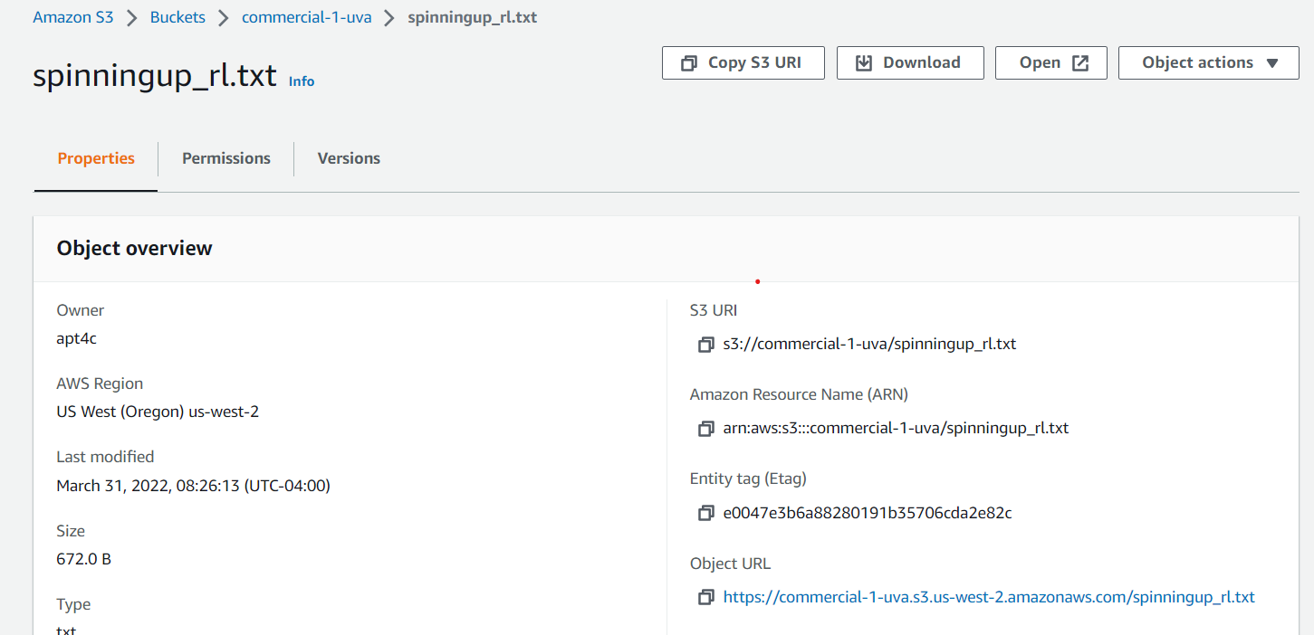

3. Go to the IAM service. Create a role called data_scientist_s3_role*
where * can be other characters
4. Allow common use case: EC2

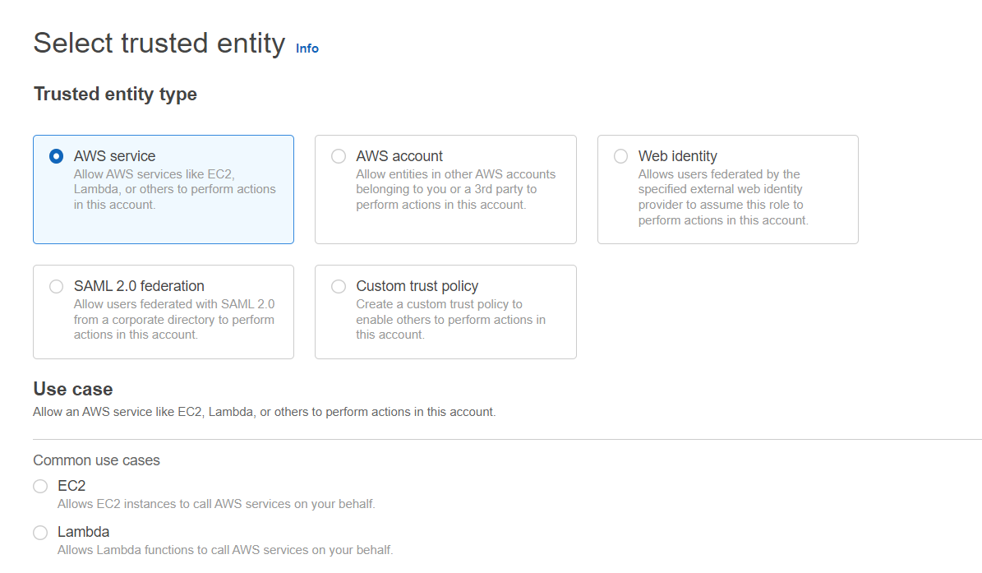
5. Create a policy that can read from/write to an S3 bucket. Specifically it should have this access:
- GetObject (from Read). This grants permission to retrieve objects from S3.
- PutObject (from Write). This grants permission to add an object to a bucket.

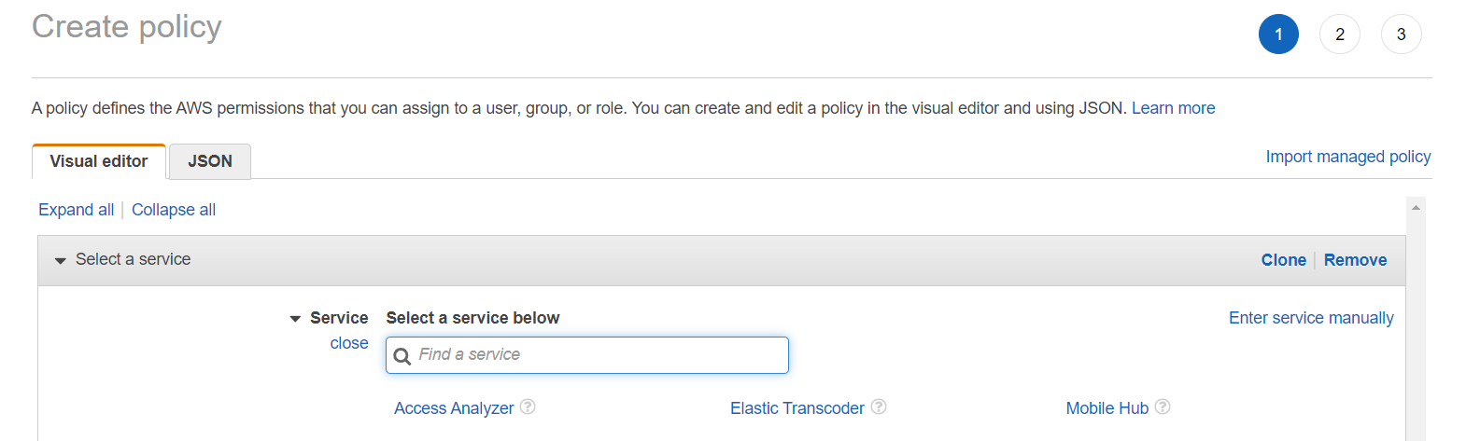
You will want to provide permissions to a specific file. To do this, specify an Amazon Resource Name (ARN) for a specific S3 bucket and object. You will need to have at least one bucket with a file created in S3; please create one if needed. When I enter bucket name and object name, the ARN is auto-populated.

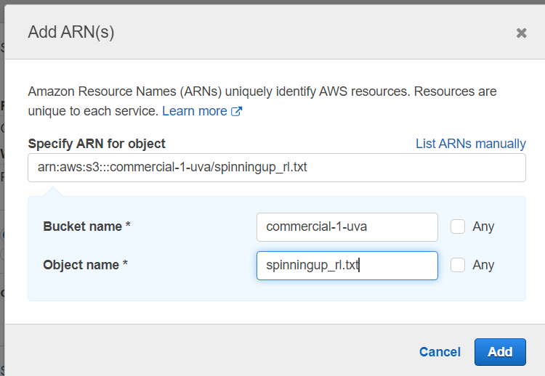

6. (1 POINT) Take a screenshot of the policy summary page that shows the created policy.
You’ll need to give the policy and name. Take note so you can find it for the next step.
You can see mine is called data_scientist_s3_policy

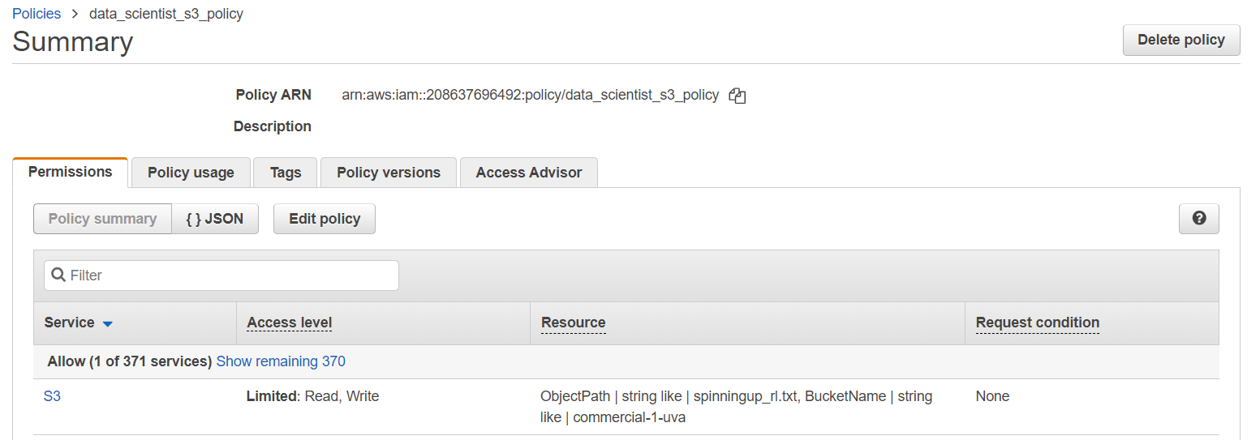

7. Attach the policy to the role.

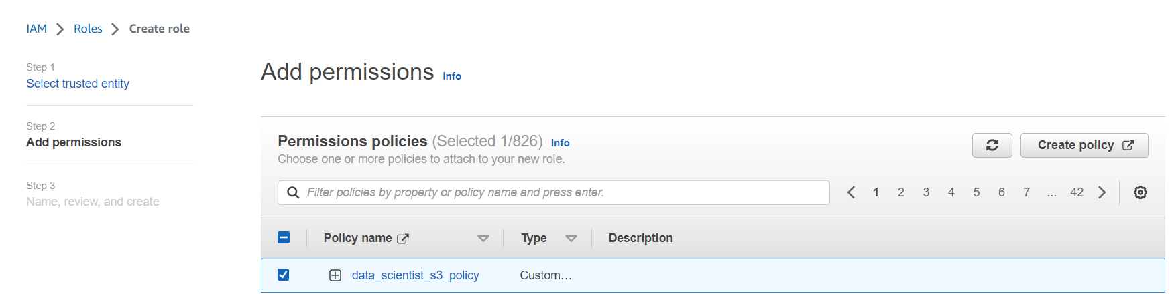
8. The final role creation step should look like this:

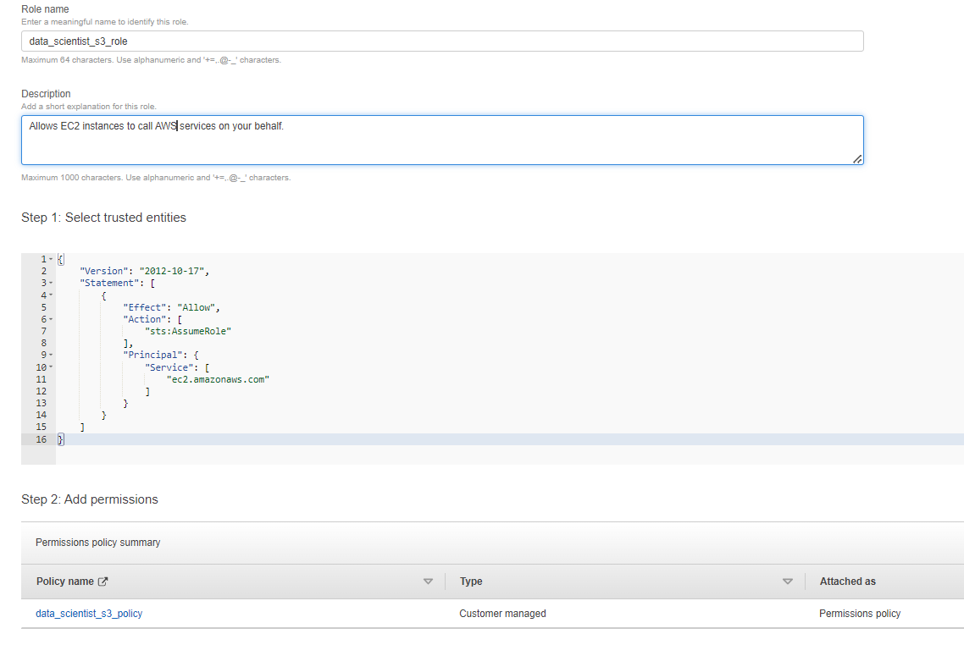
Notice the trusted entities (EC2) is pre-populated in JSON.

9. (1 POINT) Take a screenshot of the Roles page to show the new role.

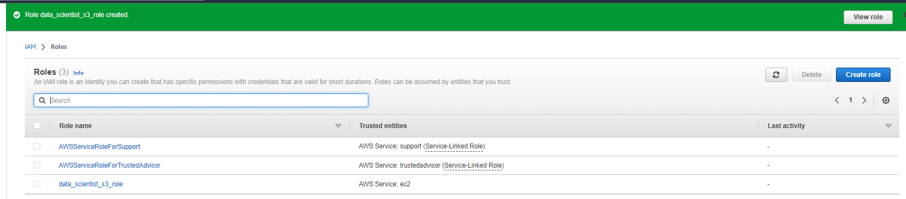

10. (1 POINT) Create an EC2 instance with these parameters:
-size: t3.micro (this is free on the AWS Free Tier)
-OS: Amazon Linux
-create or select a key pair
-under Network settings, select Allow HTTPS traffic from the internet. (THIS WILL ENABLE INSTANCE CONNECT)

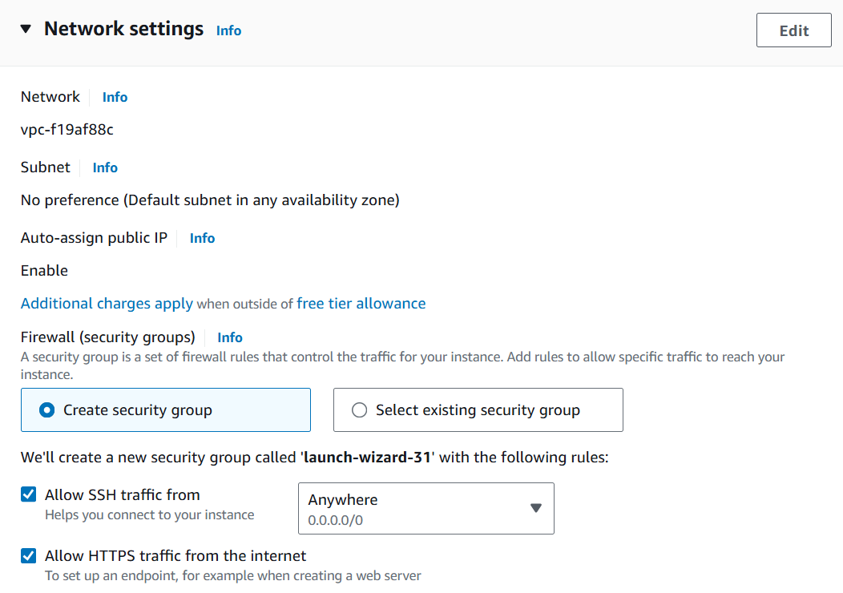

-under Advanced details > IAM instance profile, select the role you’ve created (THIS IS IMPORTANT)

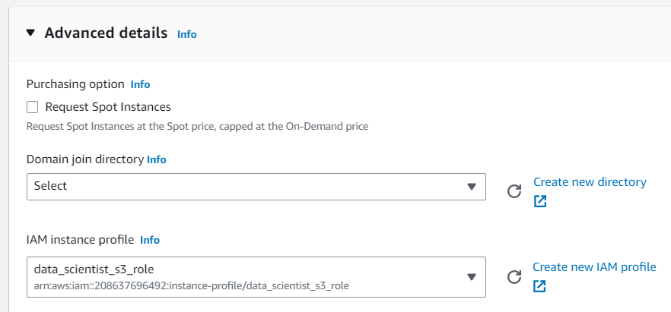
Take a screenshot showing the instance.
11. Launch the instance
12. Connect to the instance.
There are several options for connection including:
-EC2 Instance Connect (through the AWS Management Console)
-SSH client (on a Mac you can use Terminal; on a Windows machine you can use PuTTY)
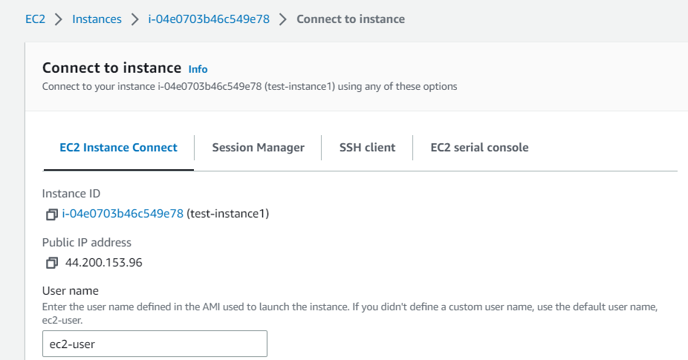
13. (1 POINT) You will see the landing page of your EC2 instance. Take a screenshot.
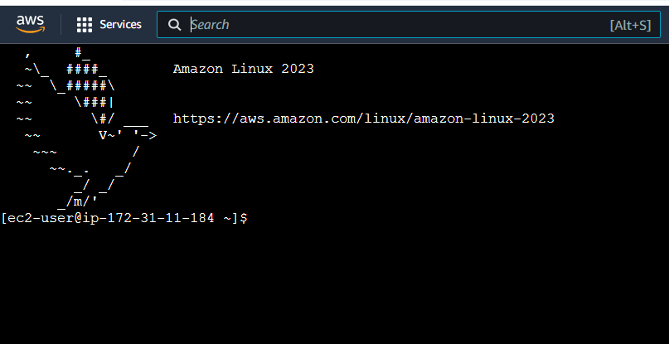

14. (1 POINT) Run the command following prompt $ at the terminal to show the top lines of the file you’ve uploaded to S3. This uses the aws s3 CLI tool to copy the file contents and pipe to a file that shows the head. The portion s3://commercial-1-uva/spinningup_rl.txt is my S3 URI.
[ec2-user@ip-172-31-57-37 ~]$ aws s3 cp s3://commercial-1-uva/spinningup_rl.txt -| head

Take a screenshot of the command and the output, which should look like this:

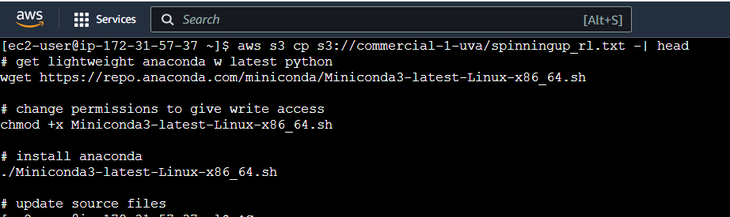
15. Run the top lines of code at the command line to install Anaconda. You might copy/paste. They are reproduced here. You’ll need to agree and press enter a few times to complete installation. When it completes, you’ll see the screenshot below.

# get lightweight anaconda w latest python
wget https://repo.anaconda.com/miniconda/Miniconda3-latest-Linux-x86_64.sh

# change permissions to give write access
chmod +x Miniconda3-latest-Linux-x86_64.sh

# install anaconda
./Miniconda3-latest-Linux-x86_64.sh

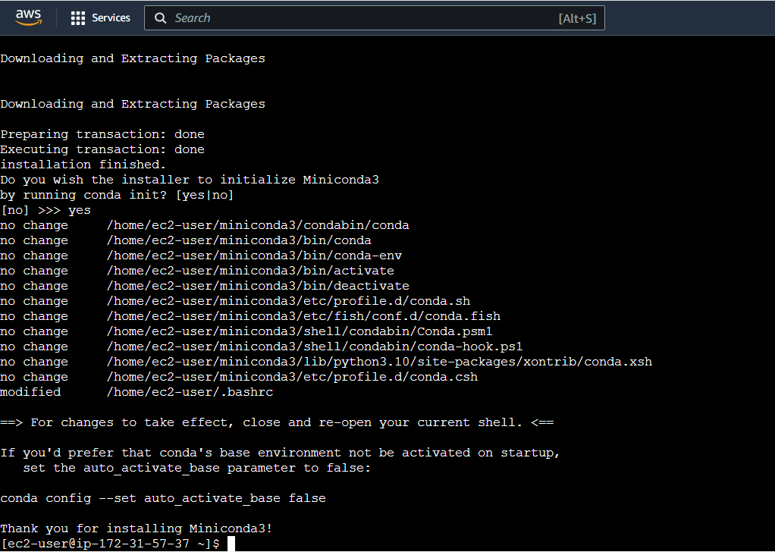
16. Run this line to update your session:
source ~/.bashrc
17. (1 POINT) Next, you’ll show that python is installed by running at the command line:
$ python
This should launch the latest Python. It’s now available for the lifetime of this instance. Take a screenshot.

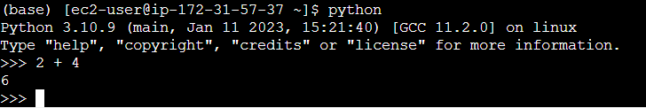
18. (1 POINT) We are finished with this session and instance. Revisit the instances and terminate your EC2 instance. Take a screenshot that shows your instance has been terminated.

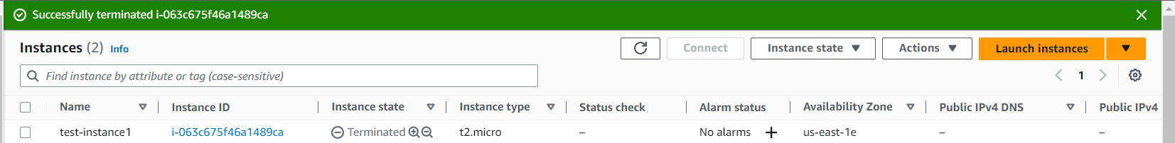

If you were able to complete this assignment, I commend you! There’s a lot to learn when getting started with AWS.

