**Table of Contents**

Use Case 1:- Start application

Use Case 2:- Display the lists of files in the directory (Current file names in ascending order)

Use Case 3:- Display the available options for user

Use Case 4:- Add a file in the directory

Use case 5:- Delete a file from the directory

Use case 6:- Search a file in the directory

Use case 7:- Navigate back to the main Menu

Use case 8:- Close the application

# **Use Case 1:- Start application**

**“D:\LockMe” directory not exist**

If D:\LockMe not exist then it will create directory first and the it will display Available actions

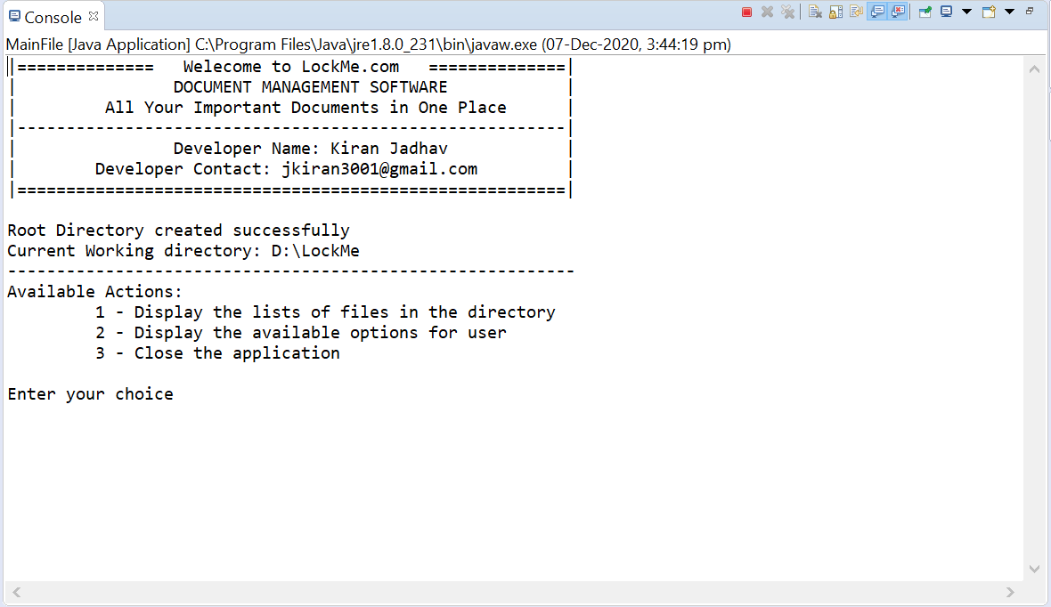

**Start application “D:\LockMe” directory exist**

If D:\LockMe directory exist then it will display the path of current working directory and “Available actions”

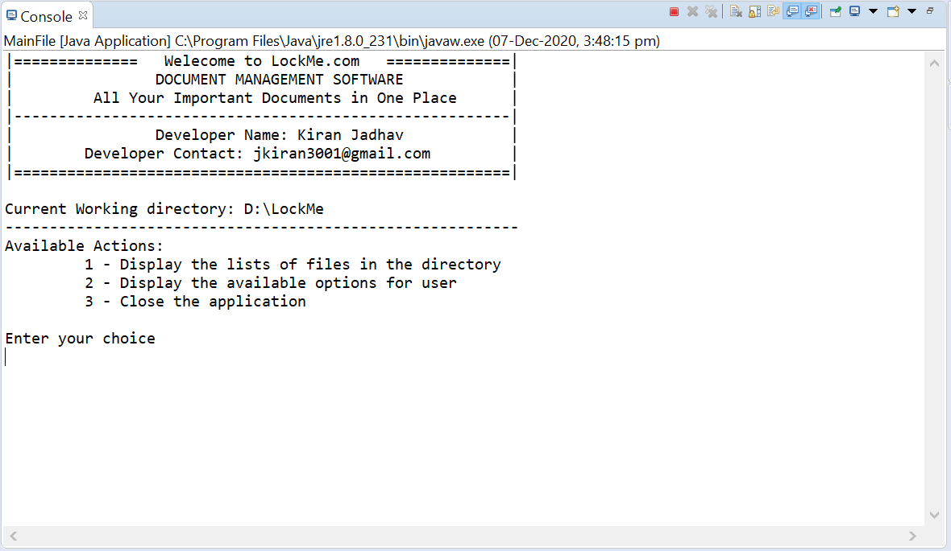

# **Use case 2:-** **Display the lists of files in the directory (Current file names in ascending order)**

If “D:\LockMe” is empty (it does not contain any folder or other files) it will prompt “Directory is Empty”

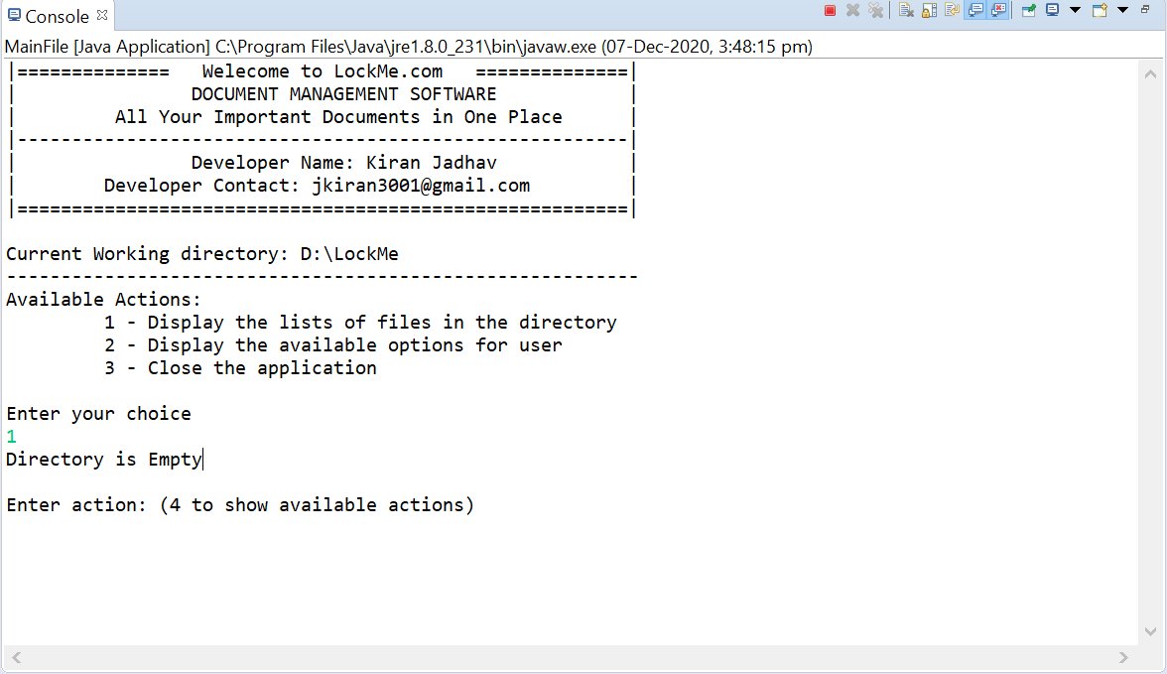

If directory does not contain any text file it will prompt message as “This directory does not contain any text file.”

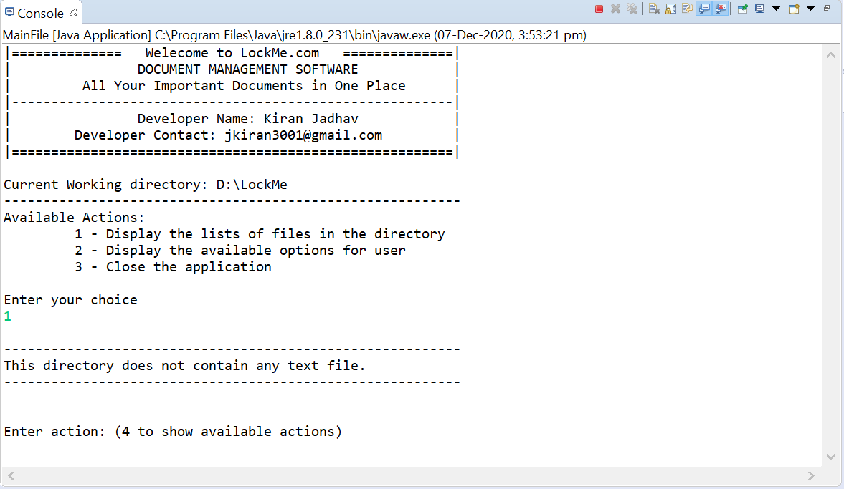

If directory contain text file, then it will print the file names in ascending order

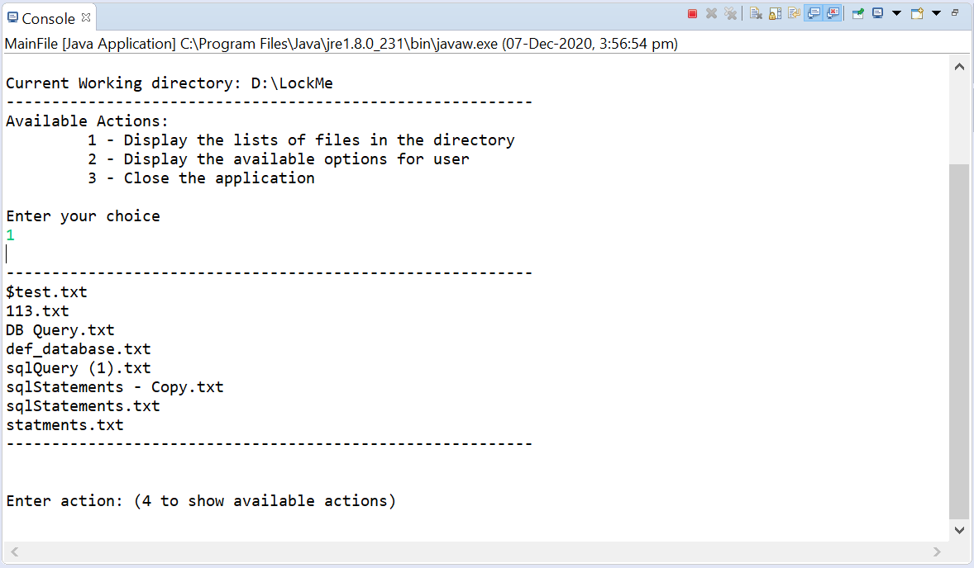

Note:- shorting of the filename is based on the ascii values

# **Use case 3:- Display the available options for user**

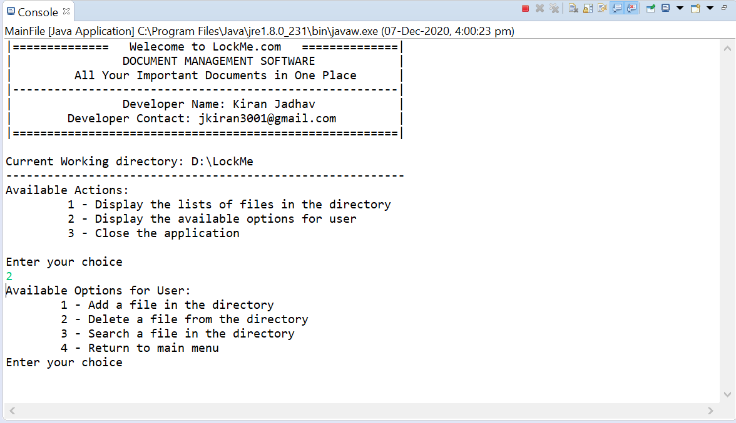

# **Use case 4:- Add a file in the directory**

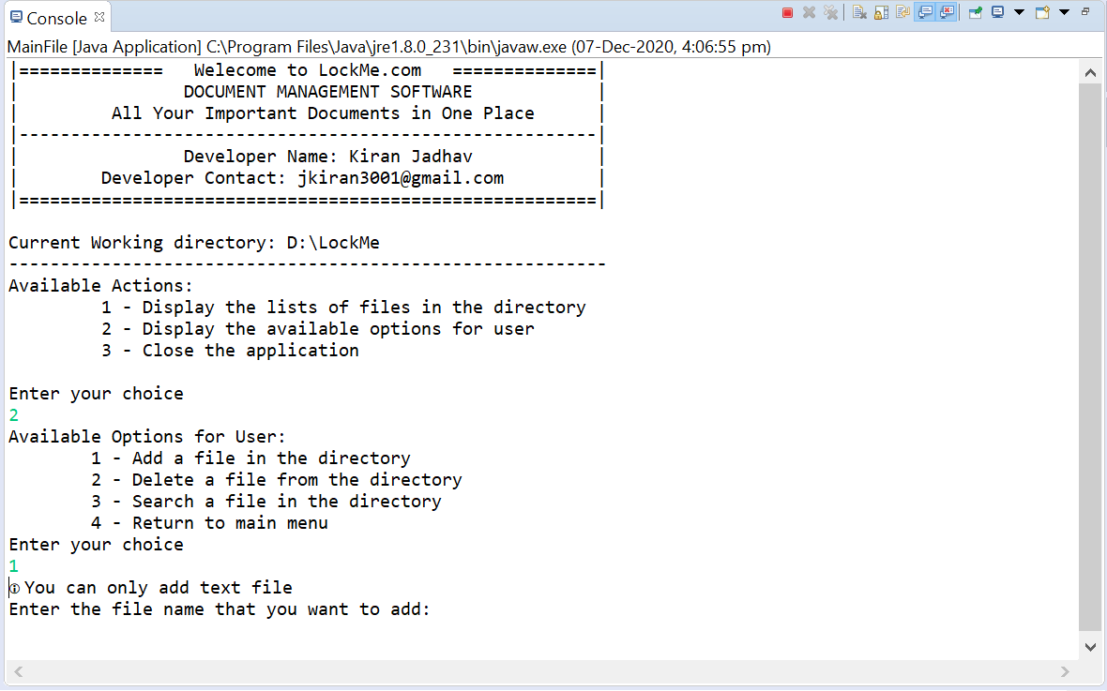

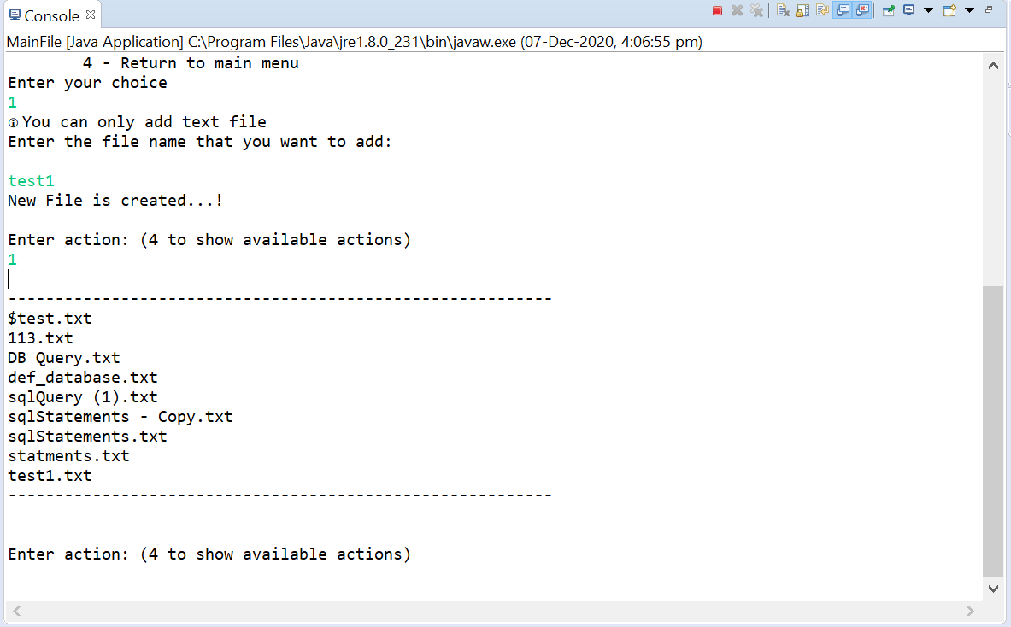

If file already exist

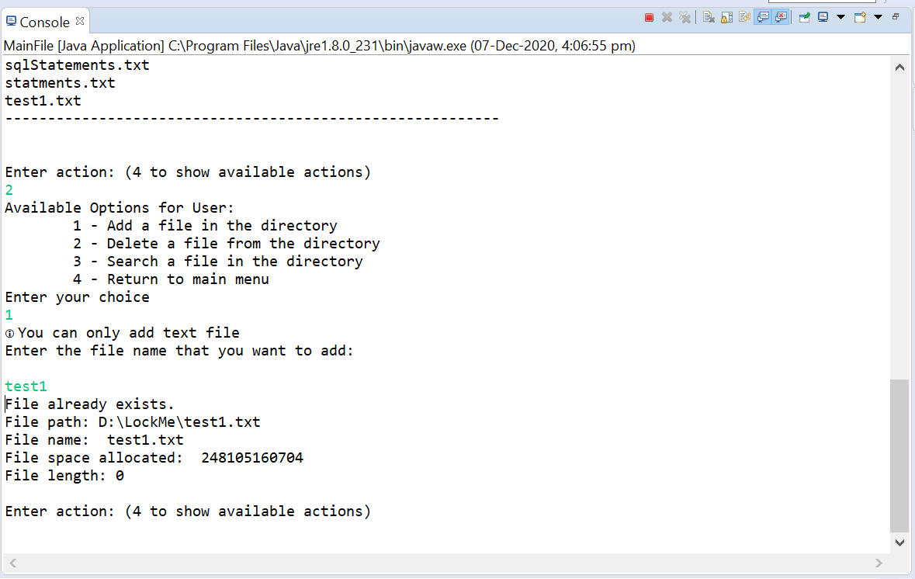

# **Use case 5:- Delete a file from the directory**

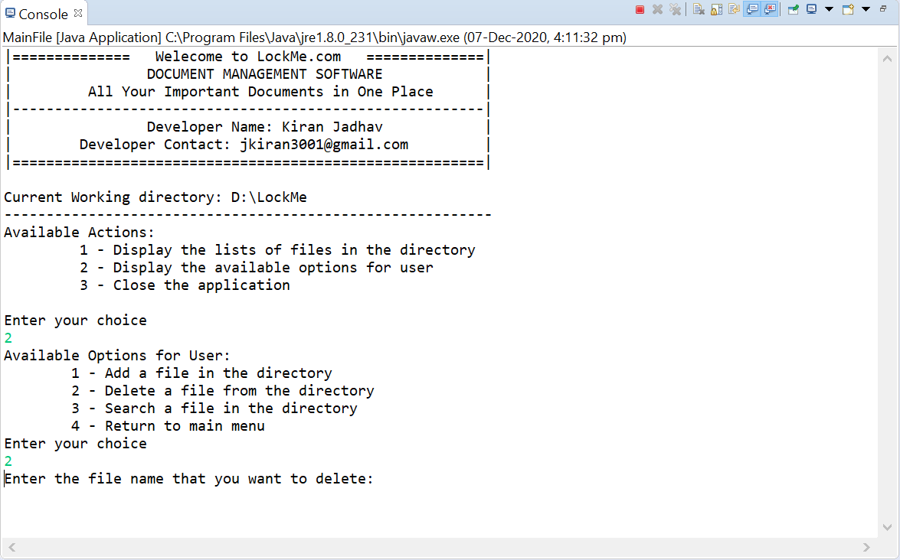

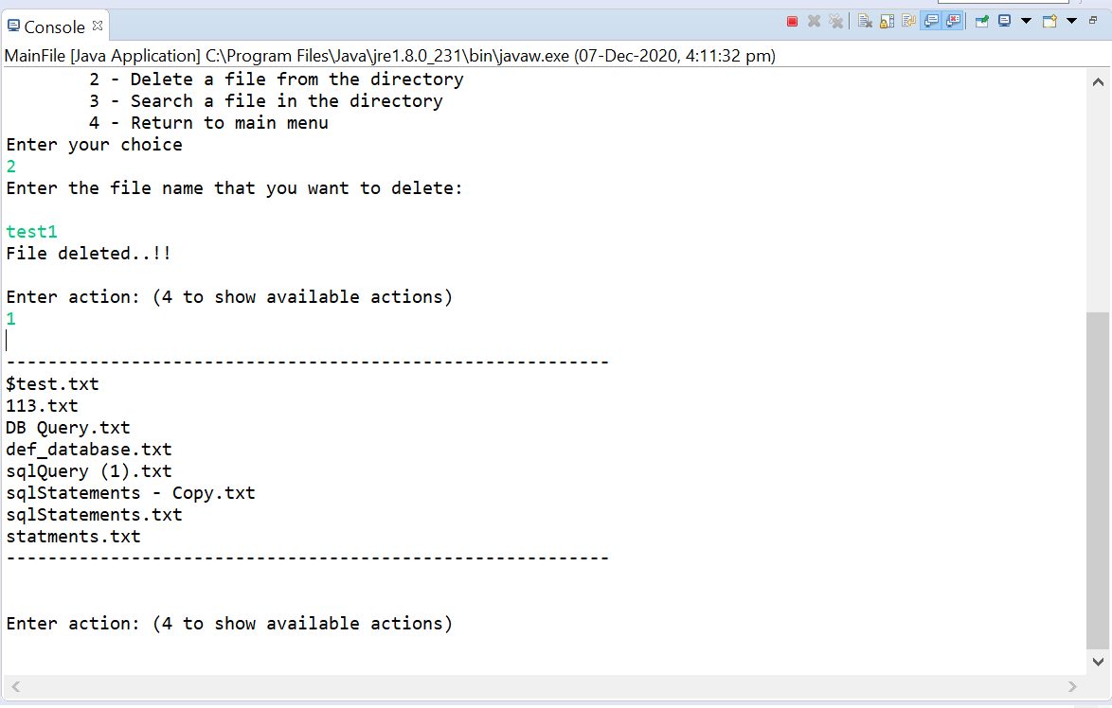

If file not exist

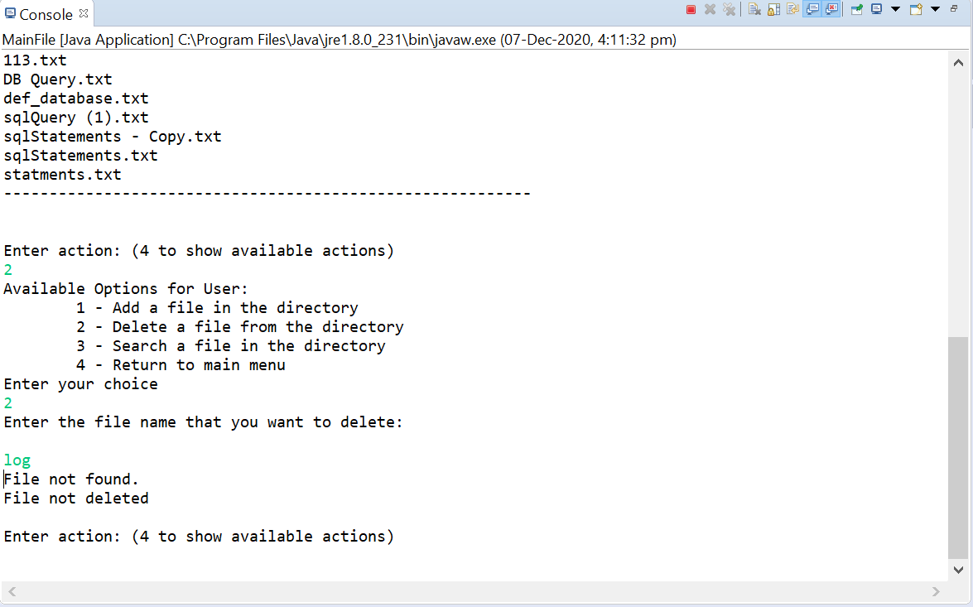

# **Use case 6:- Search a file in the directory**

If file not found in directory

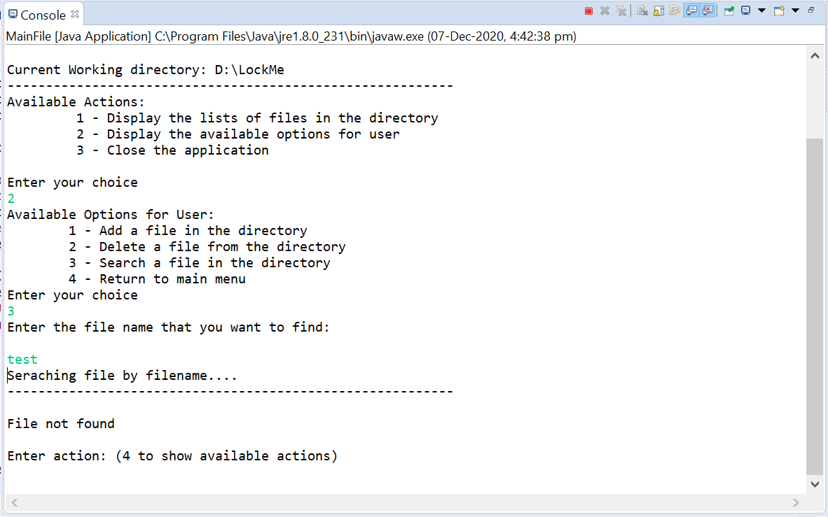

If file found in directory

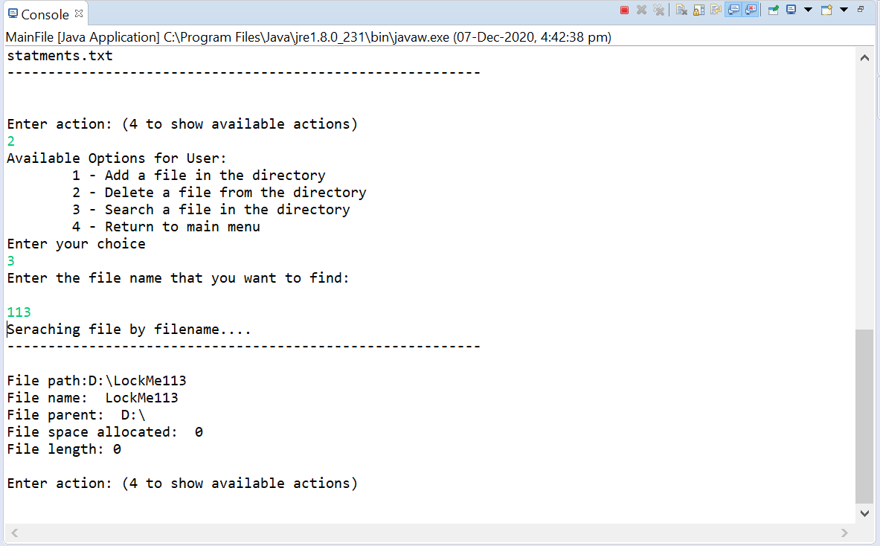

# **Use case 7:- navigate back to the main Menu**

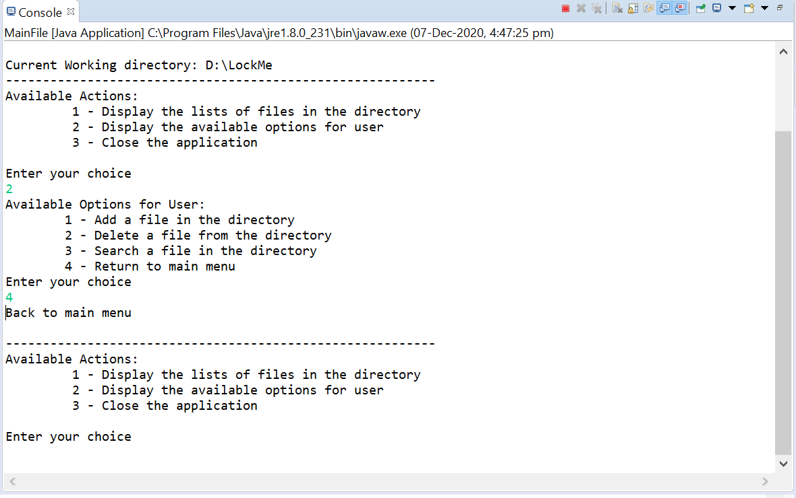

# **Use case 8:- Close the application**

