JULES LEOW PORTFOLIO

JULES LEOW

N-241

SPRING 2017

IUPUI – PURDUE SCHOOL OF SCIENCE

# Site Purpose

The purpose of the site is to showcase my talents as a computer science students with a web development concentration, as well as a creative individual. With this site, I can attract potential employers, as well as showcase my work and experience to recruiters, professors, and fellow web developers. Besides that, it doesn’t only hold information about me, it is also a way for me to show my skills as visitors will be able to see the kind of work I can produce.

# Needs Analysis

The site is set up to answer questions specifically about me such as:

* Who is Jules Leow?
* What is her background?
* What are her experience in?
* What does her work look like?
* What other skills does she have?
* How can she be contacted?

This site will also be able to provide visitors with a better idea of who I am, as well as what I can offer. As there are no other site out there that is focused on my skills and accomplishments, I believe that this site meets the needs in a way that other sites cannot. The only other place that one can find extensive information about me is through LinkedIn which is more of a social media platform than it is a personal site.

Goals

1. Provide an online presence for me.
2. Provide future employers, recruiters, professors, and peers for a place to find more information about me.

# Audience Characteristics

Visitors who visit my site will be people who are either curious about me, want to learn more about me, are potential employers who want to see what I can do, future professors or current professors who wish to see the level of expertise that their student has, or peers who want to size up their competition, and look into the level of skills that I have compared to theirs.

# Primary Audience

The primary audience will be potential employers, and recruiters. These would be the people who are interested in seeing more about me, reading my resume, as well as seeing my skills in action.

# Secondary Audience

Current or future professors, and peers. This will be a group of people who might just want to check out what a current student at IUPUI could do.

# Competition

There are many competitive sites out there that feature developers who are very skilled. The sites I’ve seen have been inspiring and also at the same time, quite intimidating. Most of them are capable of doing things far beyond my current capabilities.

The sites I viewed:

<http://mattfarley.ca/>

This site is the kind of site that I’d like to create because it’s responsive, and beautifully designed. It is also quite simple and the JavaScript is not intrusive at all. I like the color scheme as well. If I wanted to build something clean and crisp, this would be a site that I would be inspired by.

<https://caferati.me/>

I could only imagine being able to make a site like this. The developer made it so that visitors can play a mini game of destroying his site. It is so creative and definitely something I aspire to do in the future. I love the simplicity of the actual site (after you move past the highly engaging game), and features the usage of transitions.

<http://pierre.io/>

I really liked how this site combines the fun behavior of the caferati site and the simplicity of mattfarley’s site. I like the one column scrolling effect and also the fun background that reminded me of the night sky because of how the dots were undulating like they’re part of constellations.

<http://www.denisechandler.com/>

It seems like a one-column layout is the in thing with designers and web developers nowadays because this is the 4th site that I’ve seen that utilizes the single-column layout. I really like it myself and would like to create a site like that because of how simple it looks. I also like how smooth the flow of the site is.

# Wireframe

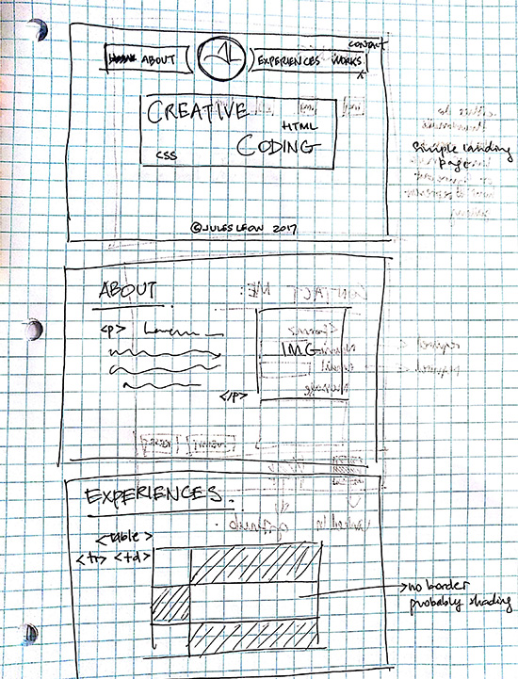

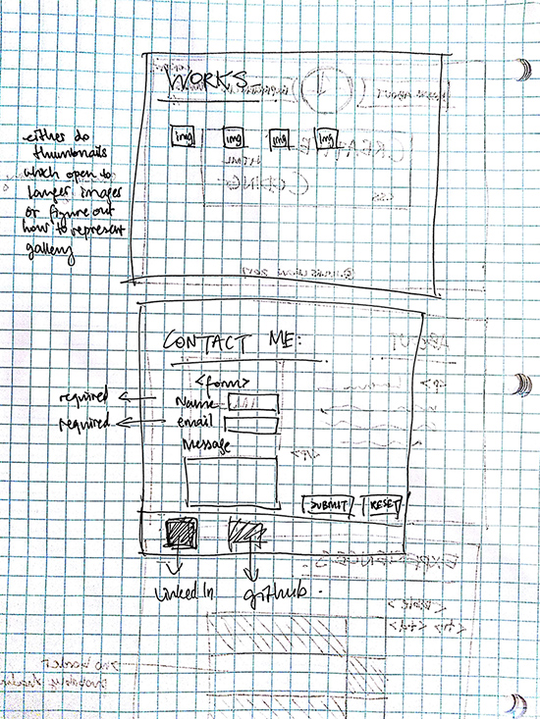

# SiteMap

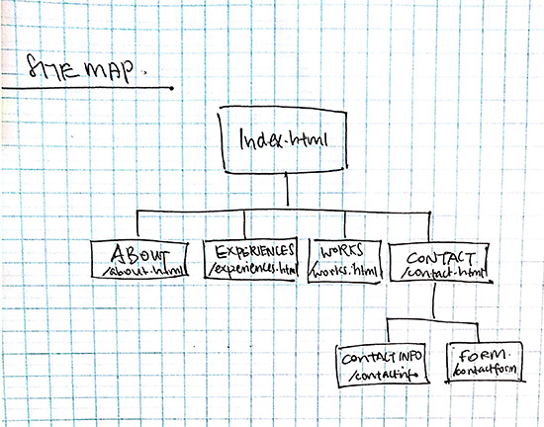

# Best Viewed Assumptions

1. Best Viewed Assumptions - the conditions under which you believe your website will be ideally viewed. Include
   * browser type & version
   * connection speed
   * screen size

Test Plan

1. **Project Checklist:** This is a critical part of your documentation. **Note: FINAL PROJECTS SUBMITTED WITHOUT DOCUMENTATION WILL NOT BE GRADED!** Include a table that lists all of the project requirements and the URL where I can find each one. Each URL should be an active link.

| **Feature** | **URL** |
| --- | --- |
| External Stylesheet | http://www.cs.iupui.edu/~jstudent/finalProject/css/widgets.css |
| Embedded Stylesheet | http://www.cs.iupui.edu/~jstudent/finalProject/widgetPage4.html#embed |
| CSS Style Comment | http://www.cs.iupui.edu/~jstudent/finalProject/css/bigWidgets.css |
| Example of a style that overrides another | http://www.cs.iupui.edu/~jstudent/finalProject/widgetPage1.html#override |
| Header Comment | http://www.cs.iupui.edu/~jstudent/finalProject/widgetPage2.html#comment |
| Example of a <table> | http://www.cs.iupui.edu/~jstudent/finalProject/widgetPage3.html#myTable |
| Example of a <blockquote> | http://www.cs.iupui.edu/~jstudent/finalProject/widgetPage1.html#bQuote |
| Example of a <ol> list | http://www.cs.iupui.edu/~jstudent/finalProject/widgetPage4.html#oList |
| Example of a <ul> list | http://www.cs.iupui.edu/~jstudent/finalProject/widgetPage2.html#uList |
| Example of a <dl> list | http://www.cs.iupui.edu/~jstudent/finalProject/widgetPage4.html#dList |
| Example of a PNG or GIF image | http://www.cs.iupui.edu/~jstudent/finalProject/widgetPage3.html#gif |
| Example of a JPG image | http://www.cs.iupui.edu/~jstudent/finalProject/widgetPage2.html#jpg |
| Example of a <form> | http://www.cs.iupui.edu/~jstudent/finalProject/widgetOrdFrm.html#myForm |
| Example of Typography | http://www.cs.iupui.edu/~jstudent/finalProject/widgetPage3.html#coolFont |
| Example of a css-delivered rollover effect | http://www.cs.iupui.edu/~jstudent/finalProject/widgetPage2.html#roll |
| Example of an image map | http://www.cs.iupui.edu/~jstudent/finalProject/widgetPage1.html#imgMap |
| JavaScript Plugin | http://www.cs.iupui.edu/~jstudent/finalProject/movingWidget.html#jScript |
| Any other feature(s) you might want considered | http://www.cs.iupui.edu/~jstudent/finalProject/widgetPage3.html# |

1. **Post-Project Analysis:** After your project is completed, answer the following questions:
   * What parts of your project did you revise? Why?
   * What did you learn while creating your project?
   * Are there any sections that do not work as well as you would like? For example, do your pages display correctly in all major browsers?
2. **Bibliography:** Add a bibliography of any resources that you used. Include
   * Journal Articles
   * Images
   * Scripts
   * Websites
   * Books
   * Interviews

Be sure to include the resources you submitted in your project proposal.