Deploying Dataiku DSS on macOS Using Docker Desktop

Overview
This document provides step-by-step instructions for installing and running Dataiku Data Science Studio (DSS) locally on a MacBook using Docker Desktop. This setup is ideal for learning, development, and experimentation with Dataiku DSS in a lightweight, containerized environment.
By the end of this guide, you will have a fully functional Dataiku DSS instance accessible through your web browser.

Prerequisites
- A MacBook running macOS
- Internet connectivity
- Administrative access to install applications

Step 1: Install Docker Desktop
If Docker Desktop is not already installed on your system: Download Docker Desktop for macOS from the official Docker website below:
https://www.docker.com/products/docker-desktop/
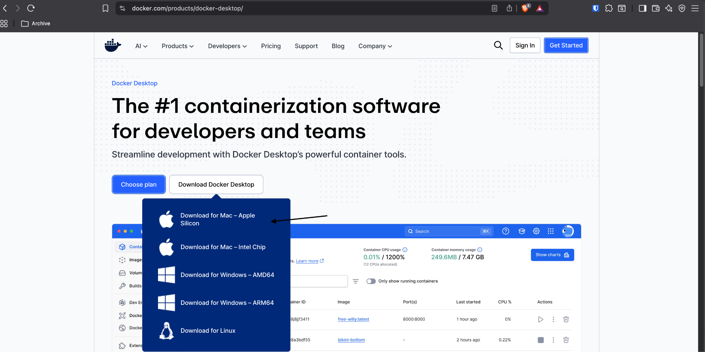

Follow the installation instructions and complete the setup.
Verify the installation by opening a terminal and running:
docker --version

Step 2: Run the Dataiku DSS Docker Container
Open Terminal on your MacBook.
Run the following command to pull the Dataiku DSS image and start the container:
docker run -d -p 10000:10000 dataiku/dss
Explanation:
- -d runs the container in detached mode
- -p 10000:10000 maps the DSS web UI port to your local machine
- dataiku/dss is the official Dataiku DSS Docker image
Confirm the container is running:
docker ps

Step 3: Access the Dataiku DSS Web Interface
Open a web browser.
Navigate to:
http://localhost:10000
Alternatively, you may use your Mac’s IP address:
http://<your-mac-ip-address>:10000
The Dataiku DSS welcome screen should now be visible.
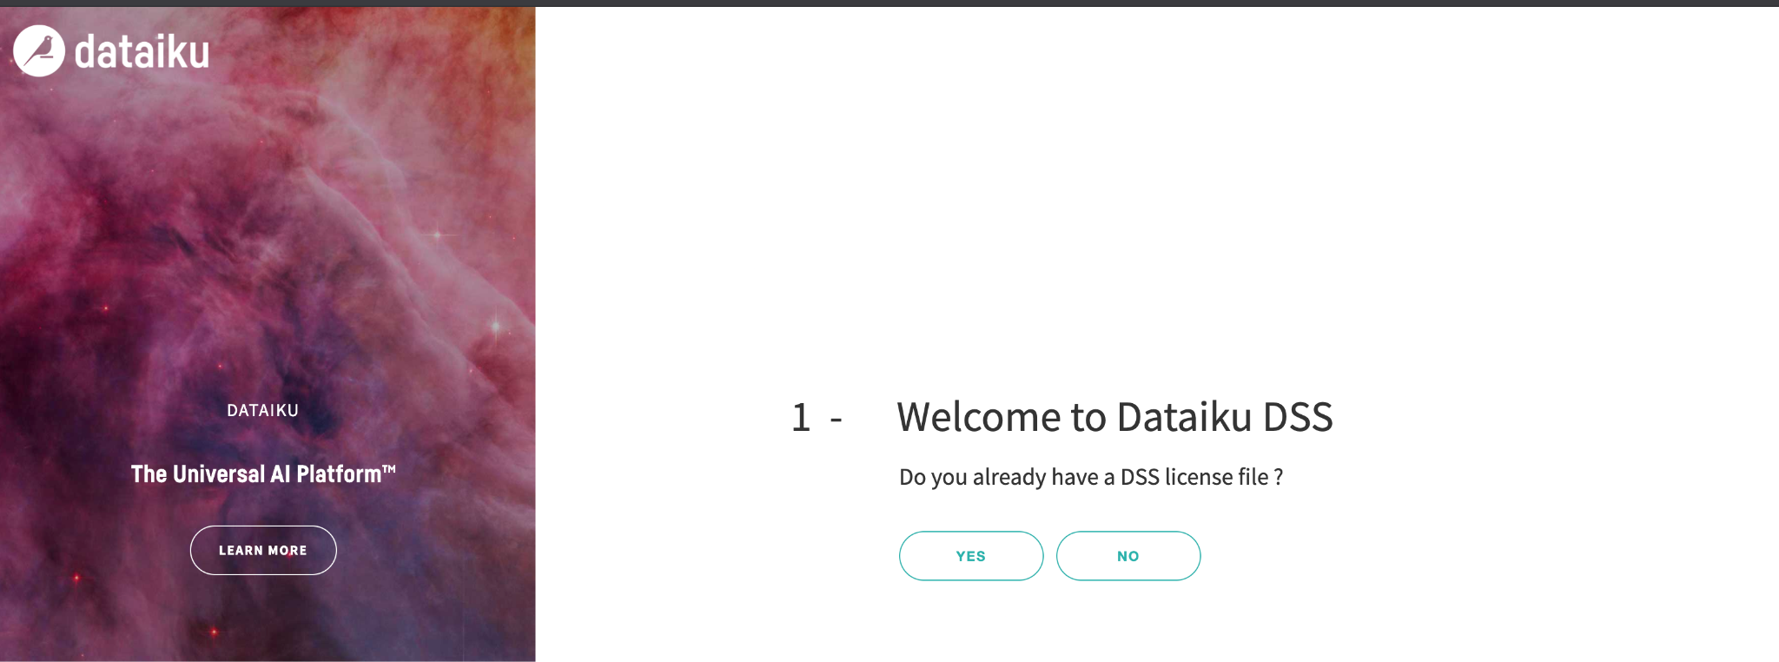

For more information see the resource here: https://hub.docker.com/r/dataiku/dss

