Google chrome
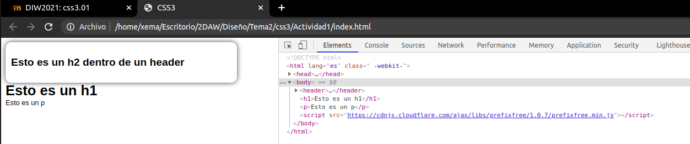

Firefox

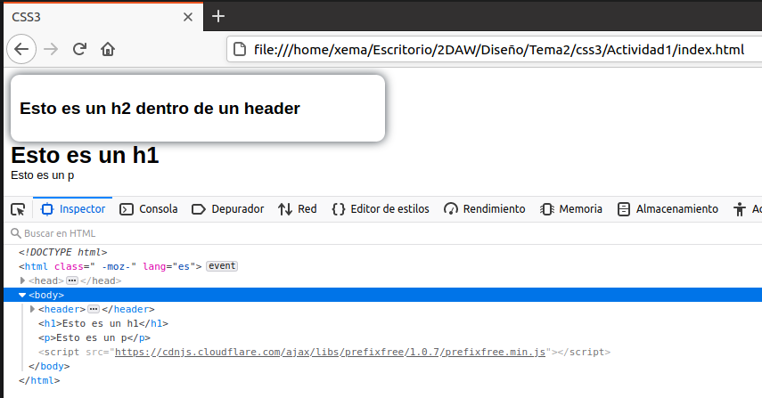

Opera

