
The Quiet Haven
TYPOGRAPHY

Color Palette & Technical Specifications
 | Color | HEX Code | Usage
 | Deep Navy | #1A2B4C | Main titles, Footer, Bold text
 | Soft Blue | #7A9CC6 | Hover elements, borders, details
 | Pastel Haven | #DCE6F1 | Header, page backgrounds, secondary elements
 | Neutral White | #F8FAFC | Content block backgrounds

Typography Hierarchy & Usage
Logo & Headings | Body Text | User Interface
Font: Bubblegum Sans | Font: Lora | Font: Sans-Serif
Size: 40pt | Size: 12pt | Size: 14pt
Aa Bb Cc Dd Ee Ff Gg Hh Ii Jj Kk Ll Mm Nn Oo Pp Qq Rr Ss Tt Uu Vv Ww Xx Yy Zz | "We provide a physical and emotional refuge for students suffering from social isolation." | 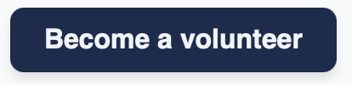
Usage: Used for the logo and main headers to convey friendliness and warmth. | Usage: Used for the body text to ensure elegance and readability. | Usage: Used for forms, navigation, and input fields.

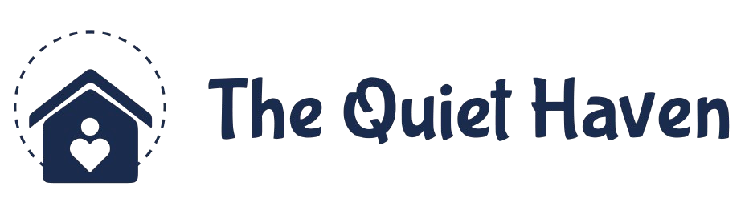



Logo Guidelines & Brand Integrity
Primary Logo: The standard version is intended for use on light backgrounds to maintain legibility and impact.
Reversed Logo: The white version is specifically designed for use on our Deep Navy brand background to ensure high contrast.
Monochrome Version: The dark version can be used for formal documents or black-and-white printing.
Integrity (Don’ts): Do not distort, rotate, or modify the colors of the logo. Always ensure the design remains clear and professional.

