Dependable Middleware for Wireless Mesh and Sensor Networks
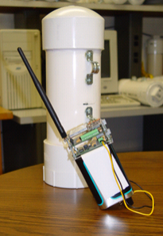  Figure 1. A commercially developed ruggedized sensor node platform on which our software executes | 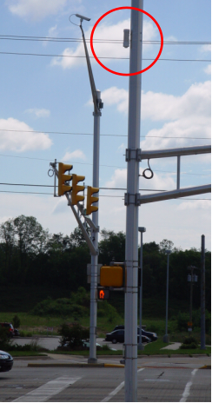  Figure 2. A node in our deployment in the city of South Bend on top of a traffic pole. Our wireless reprogramming protocol is used to modify the parameters of the application running on these nodes.

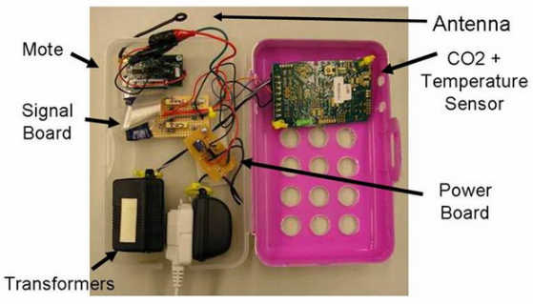 | 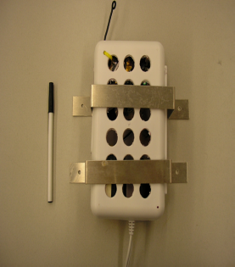
Figure 3. CO₂ and temperature monitoring device integrated by us with a sensor node
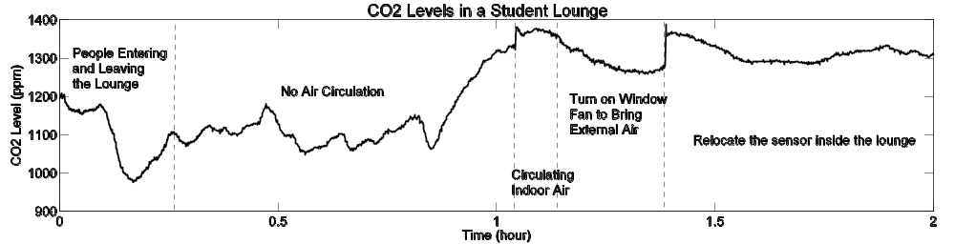
Figure 4. Sample measurement of CO₂ levels in a student lounge in Purdue’s ECE department
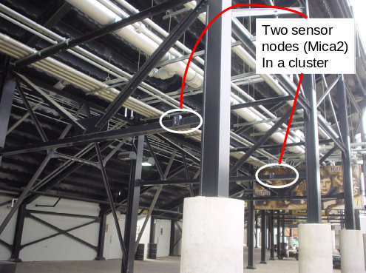 | 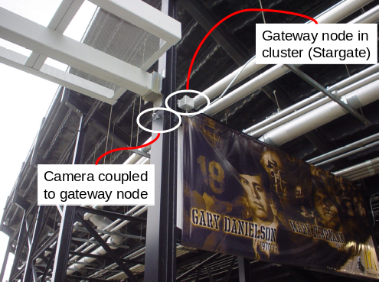
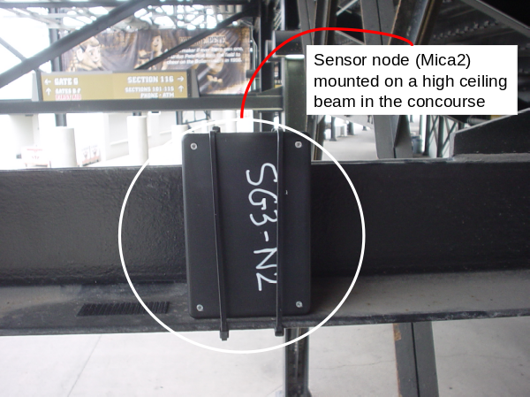
Figure 5. Sensor Network deployment at the Ross-Ade football stadium for measuring physical parameters (temperature, sound, etc.) and queue lengths at concession stands

Permission is hereby granted to NSF to use the images above.
Copyright: Purdue University
We have developed a suite of software that will harness the power and promise of wireless mesh networks and sensor networks in applications requiring dependable uninterrupted operation. Wireless mesh networks hold the promise of allowing network connectivity for a range of devices without each location needing to invest in direct internet access; rather it can be done in a cooperative manner with each node relaying traffic on behalf of other nodes toward a shared gateway. However, the cooperative environment is open to malicious nodes which may hamper the traffic from other nodes and selfish nodes which may obtain functionality without contributing to the network. A second class of wireless networks called sensor networks hold the promise of collecting data about the physical environment through unobtrusive devices that have the capability for limited local computation, short-range wireless communication, and sensing different physical parameters, such as light, temperature, sound, etc. depending on the exact sensor board the node is equipped with. However, the nodes and the wireless links are liable to fail due to their low cost nature and deployment in unpredictable open environments. Also the nodes are prone to security attacks, including physical tampering of the devices.
As part of the NSF project, we have designed and developed a suite of protocols that enable uninterrupted long-running and secure operation of the networks. The first is a wireless reprogramming protocol that enables the system owner to change network functionality remotely by sending updates through the wireless medium in a multi-hop manner. The second is the detection of node misbehavior by selectively hearing the traffic in the neighborhood. The third is a location determination protocol using smart directional antennas which provides higher accuracy than any existing protocol by leveraging the redundancy afforded by multiple directional antennas fabricated and mounted on a sensor node. Finally, we have designed a system for monitoring the CO₂ level in buildings at Purdue with the future goal of determining the required flow of fresh air on a demand-driven manner thereby saving energy costs for heating or cooling the fresh air.

Why is this research outcome notable and/or important, and how does it address the strategic outcome goal(s) as described in the NSF Strategic Plan 2006-2011?
The development of wireless networks capable of tolerating natural and malicious errors will take them
from laboratory curiosities to devices that can be deployed in real-world scenarios.

Does this highlight represent transformative research?
Yes.
This research introduces a novel class of distributed protocols for dependability that can operate under resource constraints of computational power, bandwidth, energy, memory, etc.

Does this highlight represent Broadening Participation?
Yes, our service learning project through EPICS at Purdue involves undergraduate students, including currently one Hispanic female student and several female students in previous semesters, involved in deploying a sensor network for monitoring exhibit usage at the local children’s museum, the Imagination Station. Also a Hispanic male student is graduating in Fall 2007 with an ECE Masters degree who worked on a problem of secure data aggregation in sensor networks using a reputation system. He was however supported by a Fellowship and not on this NSF grant.
We had a major outreach effort with regard to our sensor network deployment at the Ross-Ade football stadium at Purdue as part of the eStadium project (http://estadium.purdue.edu). We deployed and successfully collected data during home game days in the Fall 2007 season. The network consisted of several clusters of nodes, each cluster consisting of spatially proximal nodes. Each cluster has a single gateway node and multiple sensor nodes within a single hop distance. The sensor nodes were collecting data about temperature, sound level, light, etc. every 30 seconds and a camera was used for measuring queue lengths at the concession stands coupled with the gateway node.

Are there any existing or potential societal benefits, including benefits to the U.S. economy, of this research of which you are aware?
Yes.
Our software has been licensed for use by Motorola and a startup company in Indiana – EmNet Inc. for their respective sensor/mesh node platforms. This is expected to result in a broader product offering respectively in the space of public safety wireless networks and wireless monitoring of environmental events.

