

Project Output

Tableau Dashboard and Data Story:
Visualising the Drivers of Retail Profitability in a Superstore Dataset
Machine Learning and Visualization for Data (IITG7003)
MSc Information Technology Management

Name: Juan Osvaldo Ovalle Perez
ID: Q1122568
Year: 2026

Statement of Academic Integrity

I honestly declare that this dissertation is entirely my own work and none of its part has been copied from printed or electronic sources, translated from foreign sources and reproduced from essays of other researchers or students. Wherever I have been based on ideas or other people's texts I clearly declare it through the good use of references following academic ethics.
(In the case that it is proved that part of the essay does not constitute an original work, but a copy of an already published essay or from another source, the student will be expelled permanently from the postgraduate program).
Name and Surname (Capital letters):
Juan Ovalle
Date: 16/06/2026
TABLE OF CONTENTS

Statement of Academic Integrity 2
Chapter 1: Introduction 4
1.1 Background 4
1.2 Business Problem and Aim 4
1.3 Objectives 5
1.4 Report Structure 5
Chapter 2: Literature Review 6
2.1 Visual Analytics and Dashboards in Business Intelligence 6
2.2 Perception and Design Principles 6
2.3 Data Storytelling 7
2.4 Interactivity and Prescriptive Analytics 7
Chapter 3: Methodology 8
3.1 Approach 8
3.2 Dataset 8
3.3 Data Preparation and Calculated Fields 8
3.4 Dashboard Design 9
3.5 Data Story Design 9
3.6 Tools and Deliverables 10
Chapter 4: Results and Discussion 11
4.1 The Interactive Dashboard 11
4.2 Product and Geographic Profitability 12
4.3 The Discount–Profit Relationship 13
4.4 Seasonality 14
4.5 Data Story and Recommendations 15
4.6 Discussion and Limitations 16
Chapter 5: Conclusion and Recommendations 17
Bibliography 18
List of Figures 19
Appendix A: Tableau Workbook and Data 20

Chapter 1: Introduction

1.1 Background

Data collected from transactions within an organization is of little use until analyzed to extract value from the data to aid decision makers within the organization to gain competitive advantage (Davenport and Harris, 2017). Analysis of transaction data can be presented in a visual format by use of business-intelligence dashboards and data stories to aid actions of managers (Few, 2006; Knaflic, 2015). Interactive tools have been used for many years to allow analysis of data by means of number of views of data, which has many advantages over static reports previously produced for the managers within organizations. Of the business-intelligence tools interactive in nature, many have been designed to allow the analysts to view data from a number of different views of data. One of the most popular tools currently used by non-IT analysts to create interactive visualizations by use of a number of tools is Tableau. Practical advantages have been created by the interactive visualizations to support the analysts within an organization. For example self-service analytics created by the interactive visualizations, to allow the analysts to make their own decisions by viewing data from a number of different views of data. In addition, the number of coordinated views created by the interactive visualizations have been used to create a number of advantages to support the analysts within an organization to analyze the data.
This Project Output has been developed based on the work carried out for the Practical Skills Assessment. The data from the analysis has been transferred to the appropriate format to develop a business focused output. The output consists of an interactive Tableau dashboard and a data story.

1.2 Business Problem and Aim

Retail is one of the most profitable industries of all. However, for a large number of single transactions even this successful business makes a loss, but without analyzing the reports that are regularly generated in order to prepare a summarization of the data it is not possible to identify the reasons for such a loss. The main aim of this project is to provide interactive dashboard and data story that can reveal reasons of profitability and especially how using discount and product mix affect the business. The recommendations that are derived from the findings of the study will be communicated to mostly non technical business users, therefore the data story that is generated in the project will also translate the findings of the project into actionable recommendations for the users of the study.

1.3 Objectives

The objectives of this project are:
- Select a suitable data set from the business datasets provided, process it where necessary, and develop an appropriate data story.
- Design an interactive dashboard, using a variety of different types of visualization and linking them together where appropriate, including the use of filters and parameters for the user, calculated fields, and a range of dashboard actions.
- Develop a data story with key insights, including context and recommendations for non-technical users of data, using the best practices of data visualization and data storytelling.

1.4 Report Structure

Chapter 2 of the report outlines the literature used for the project in relation to the topics of visual analytics, dashboard design and data storytelling. Chapter 3 outlines the methodology used in this report including the choice of business data, the design of the calculated fields, the creation of the Tableau dashboard and the data story. Chapter 4 details the finished work including a full description of the completed dashboard. The main findings from the analysis are described along with recommendations that have been derived from the work. Finally, Chapter 5 provides the conclusion to the report.

Chapter 2: Literature Review

2.1 Visual Analytics and Dashboards in Business Intelligence

The Business Intelligence tool we are developing is a dashboard that provides management with a number of key performance indicators that are relevant to a number of objectives. Much evidence has shown that effective Business Intelligence displays are not complex, they actually condense complexity rather than adding to it (Few, 2006). The best Business Intelligence displays are also developed around the decisions that they will support as opposed to the information that is available to develop the display. Business Intelligence displays are typically categorized as being either strategic, analytical or operational and are used by different individuals and are updated at different frequencies. The Business Intelligence tool that we are developing is an analytical type of tool. It will support the investigation of reasons behind a company’s current profit performance. The display will not be a fixed set of indicators and will be used in a number of different ways to provide a number of different answers to a number of different questions.

2.2 Perception and Design Principles

Effective visualisation exploits the way the human visual system works. Tufte (2001) famously stated that the share of ink on the print that conveys data should be maximised in order to produce effective visualisation. This means that all decorative material should be eliminated. Using pre-attentive attributes, such as position, length and color, to highlight the key elements of a chart allows the viewer to read the chart very quickly. The main principles of visualisation design are that the type of chart to be used is that which best supports the analysis being conducted (Few, 2012); that color is used sparingly and that it conveys meaningful information (Kirk, 2016); that the order of the categories used in a chart is such as to facilitate comparison between them (Few, 2012); and that the labels for data values are placed as close as possible to the data values that they label (Few, 2012). These design principles have been adhered to in the design of the current dashboard. For example, the use of a diverging red and green color for the profit metric indicates whether profit is being made or not. The bars are sorted from top to bottom so that the greatest positive profit first and the greatest negative loss last. A minimum of gridlines have been used in order to avoid distracting from the data. The most saturated color is used to indicate the most important distinction, that between profit and loss, so that attention is focused on where there are exceptions that require the intervention of a manager.

2.3 Data Storytelling

The visualization of data is not sufficient to simply create correct graphs. The insights gained with the help of analytics must also be presented in a correct and adequate manner. The data storytelling approach developed by Knaflic (2015) follows a sequence of context, conflict and resolution. The insights to be communicated are presented to the audience step by step and in the end an action is recommended. Accordingly, Cairo (2016) states that data visualization has to be truthful and also presentable in an attractive way, without distorting the information. Thus, for the created dashboard for the exploratory analysis and the Tableau story for the explanatory communication are to be designed accordingly.

2.4 Interactivity and Prescriptive Analytics

Interactive elements such as filters, parameters and actions in Business Intelligence are used to support users analyzing information in their own way. By enabling users to analyze information in their own way, Business Intelligence facilitates a shift from the descriptive use of analytics, which provides answers to questions and supports decisions, to the prescriptive use of analytics, which provides recommendations to support a decision. The above dashboard supports a manager in analyzing the information related to profit for his/her company. An example of how the manager can use the above dashboard is by filtering the manager first filtering the information for a specific region, then changing a discount parameter and finally analyzing the effects of the changes on the profit. In this way, the manager can use the results from the above analysis to make a decision rather than simply being provided with a report which answers questions that the manager had already thought of.

Chapter 3: Methodology

3.1 Approach

The project for this visual analysis was tackled by applying a design-oriented workflow for visual analysis starting with a business question, followed by data preparation, the design of a set of views, adding interactivity, and finally creating a written story explaining the results found by applying visual analysis to a given problem.

3.2 Dataset

The Sample Superstore dataset is used again for this assessment, just as it was used for the companion machine learning assessment. The Sample Superstore dataset contains data on 9,994 order lines placed by a fictional US retailer between 2014 and 2017. The data contains 21 fields, all of which are data fields. In terms of the nature of the data, there are a good number of fields that are of a categorical nature (categorical data) such as the Ship Mode, Segment, Region, State, City, Category and Sub-Category fields. There are also a number of numeric measures, including the Sales, Quantity, Discount and Profit fields. The data is 100% business data and the source data extract was 100% clean, with no missing values and no duplicate rows. Therefore, the Sample Superstore dataset is more than sufficient for this assessment and it is used to create two deliverables, and so the same data is used here as was used in the machine learning assessment.

3.3 Data Preparation and Calculated Fields

First a Profit Ratio field is added, this field works out the amount of profit from each order line as a percentage of the sales. A Discount Band field is also created to allow for easier viewing of the Discounts field, which is currently a continuous field. The Profit or Loss field determines if an order line makes a profit or a loss. The Top-N parameter is used to add interactivity to the product view. This parameter allows the user to select how many sub-categories to view for the sub-categories of the Category that has been selected in the filter.

3.4 Dashboard Design

This workbook consists of 6 different views which in total use 5 different kinds of visualizations. 5 of the views have been put into one dashboard. The Region filter at the top of the dashboard is used to filter the views in the dashboard. The bars of the first view on the left can be selected (down to the subcategories) in the same way as category labels can be selected in a bar chart. The same subcategories selected in the first view then filter the subsequent views within the dashboard. As before, a diverging color scale is used with profit as the center point so that losses are easily seen. Each bar is sorted in descending order within a group of related bars and the currency is consistently formatted across all of the views. All of the non-data ink has been removed from the views and they have been put in a logical order for the user to read from the product/ geography views to the time series views and then to the views that display the various types of discount views. The user can hover his/her mouse over any of the marks in the charts to see the exact sales, profit and margin for that individual mark. A Top-N parameter has been added to view the top-N product lines for each Region.
Table 1. Dashboard views and visualisation types.
Dashboard view | Visualisation type | Purpose / insight
KPI summary tiles | Text / BAN | Headline sales, profit, margin and % loss-making orders
Profit by Sub-Category | Bar chart | Ranks products; exposes loss-making lines
Profit by State | Filled map | Geographic concentration of profit
Monthly Sales & Profit | Dual-axis line | Trend and seasonality over 2014–2017
Category × Region | Highlight table | Profit hot-spots across the matrix
Avg Profit by Discount Band | Bar chart | The discount level where profit turns negative

3.5 Data Story Design

The data story is presented using the Story feature of Tableau. Each of the 5 points of the story is presented in sequence with a figure and caption of 2-3 sentences providing context and recommendations for the user. The story starts with an introduction to the report and then builds in tension through the discounted products and the loss making products to end with specific and actionable recommendations for the user.

3.6 Tools and Deliverables

I created a dashboard and story within Tableau, which I have packaged up into a .twbx file (the data has been embedded within this report). The user can open up the report and then have access to the completed dashboard and story through the five points in the story that have been created. All of the completed report, the workbook, and the dataset that was used in the report can be found in the project repository referenced in the Appendix. Screenshots of the completed dashboard and story can be found in Chapter 4 of this report.

Chapter 4: Results and Discussion

4.1 The Interactive Dashboard

The end result of this project is shown in Figure 1. The completed dashboard consists of 5 different views all combined together in one single interface. As can be seen from the top line statistics the total sales amount to approximately $2.30m, the total profit is around $286k. This results in an average margin of 12.5%. As can also be seen 18.7% of the order lines even result in a loss. For the analysis of the sales data five different views were created, showing the information from different angles. As can be seen from the above description the information for the aggregated sales over products, geography, time and over discounts was decomposed. All of the five views are synchronized, meaning that the Region filter is common to all of the views. As a result of this the interface is perfect for an explorative analysis instead of just viewing fixed data.
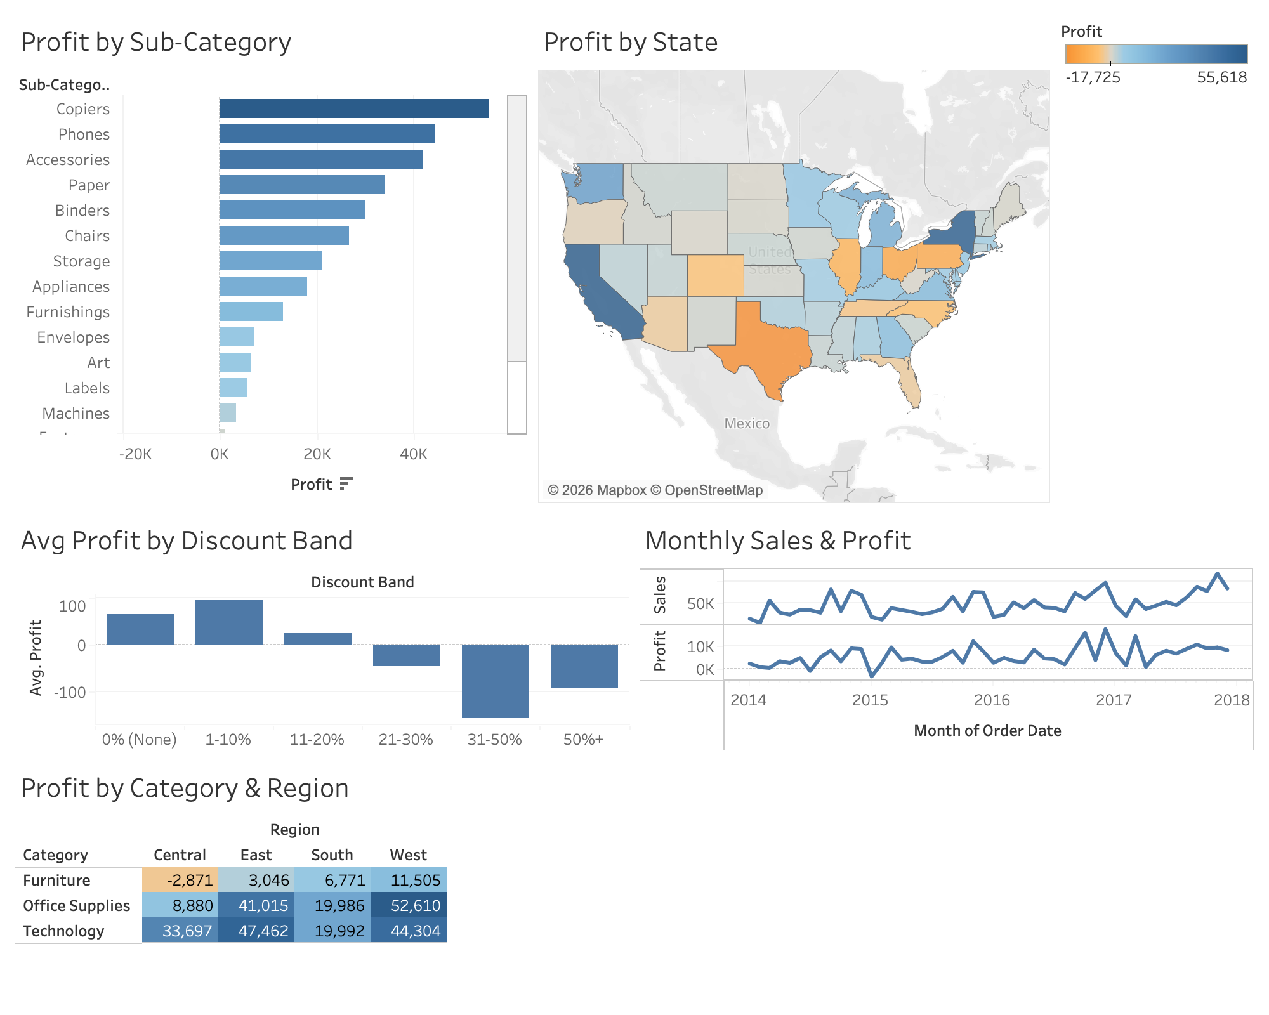
Figure 1. The complete interactive Tableau dashboard.

4.2 Product and Geographic Profitability

The distribution of profit throughout the product hierarchy is highly uneven. Figure 2 highlights the ranked subcategories including those that are currently losing money such as Tables, Bookcases and Supplies. In stark contrast the greatest returns are coming from the Copiers, Phones and Accessories subcategories. Furthermore at the category level although Furniture is generating less profit than Technology and Office Supplies it is producing similar sales dollars, Fig 3 highlights the returns by region with the West and East outperforming the Central region. The Category-by-Region highlight table in Figure 6 shows the strongest and worst performing categories by region.
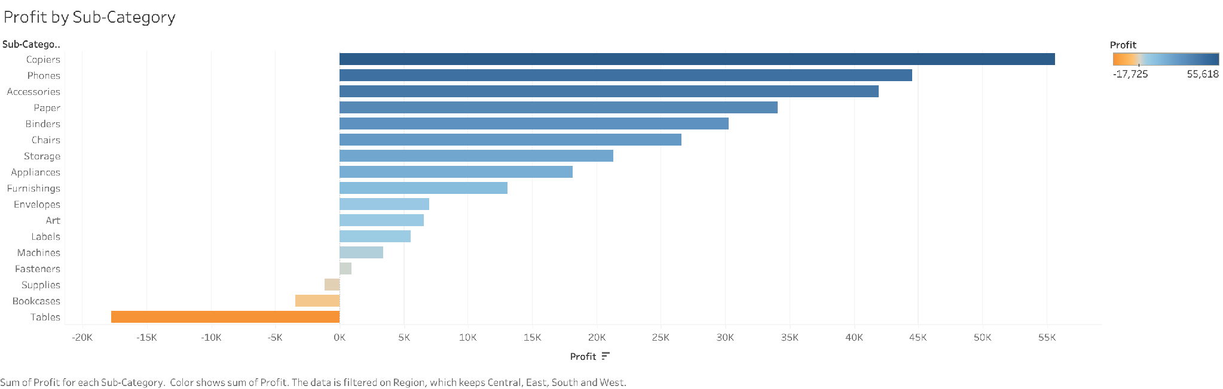
Figure 2. Profit by Sub-Category, highlighting loss-making product lines.
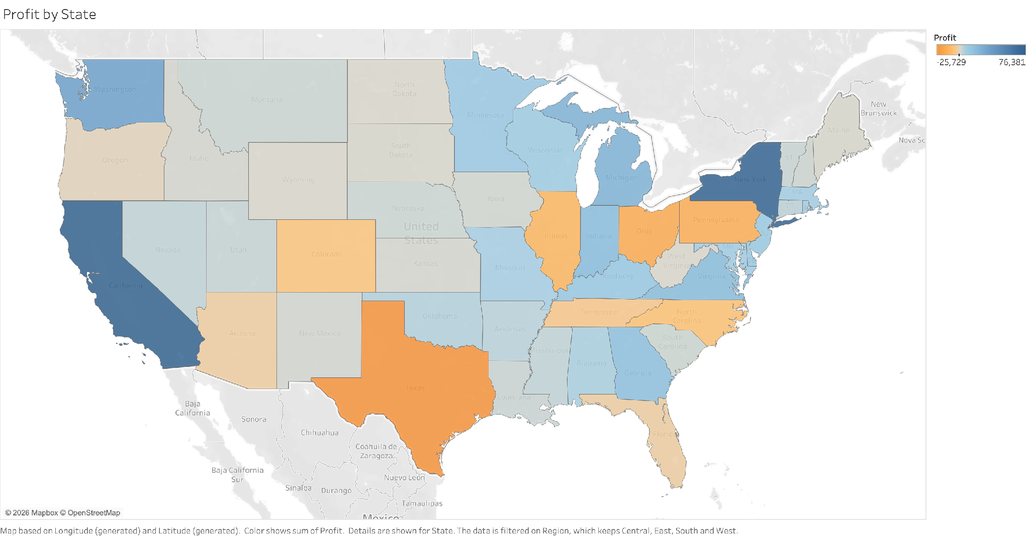
Figure 3. Profit by State across the United States.

4.3 The Discount–Profit Relationship

Key Takeaways from this data are that discounting follows a very steep curve. As a result, once a certain threshold of discounting is crossed, the loss of profit can increase by a huge amount very quickly. Figure 4 above plots average profit by discount band and clearly shows that there is a ‘threshold’ at no discount / modest negative discount up to large negative discount after which average profit drops sharply to become a substantial average loss at the deepest discounting levels. This steep curve is important to note and supports the earlier machine learning finding that discounting is by far the most controllable factor influencing profit. The steep curve also gives managers an empirical ‘ceiling’ above which discounting is likely to destroy value. The amount of loss created by deep discounting is far greater than the amount of loss the discount itself implies. The relationship between discounting and profit becomes much steeper as one moves up the discount curve and thus blanket promotional discounting creates far more damage than its face value would suggest.
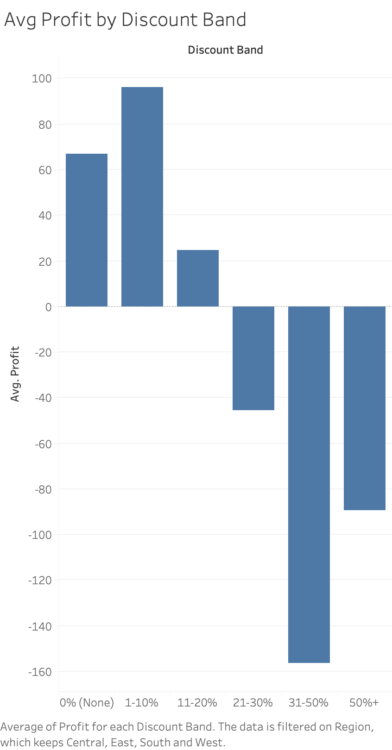
Figure 4. Average profit by discount band, with profit turning negative beyond ~20–30%.

4.4 Seasonality

Figure 5 charts the four year total sales and profit figures for the periods measured. Both graphs clearly reveal a seasonality peak at the end of the year. Examining these against the ‘discount’ view of profit to be maximized, it is clear that the one time of year that increased volume will be generated is at the end of the year and that is likely to be volume that is diluted by low margin.
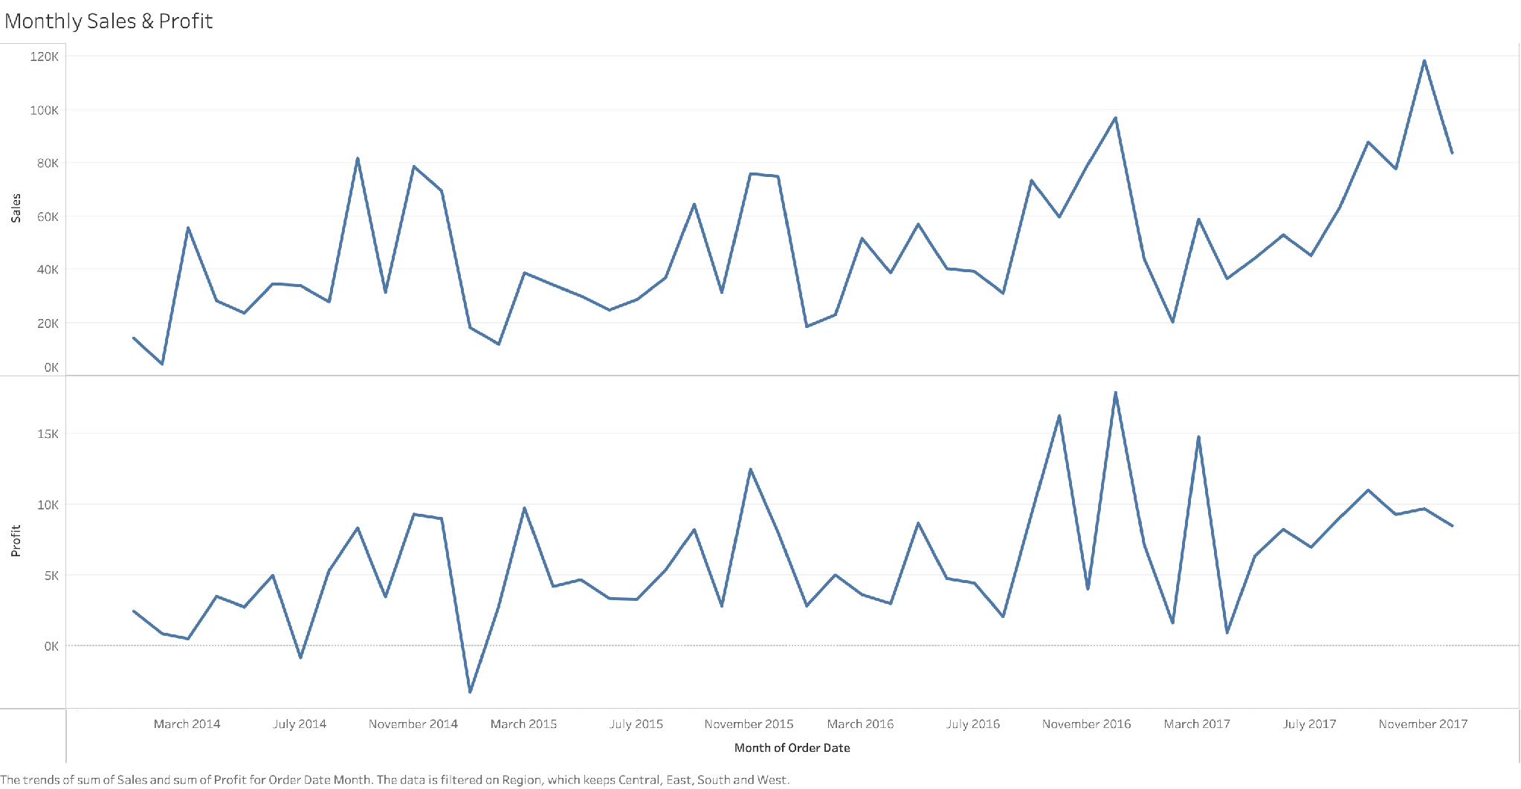
Figure 5. Monthly sales and profit trend, 2014–2017.
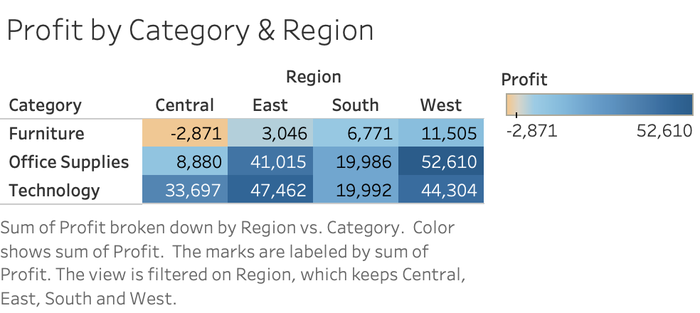
Figure 6. Profit by Category and Region (highlight table).

4.5 Data Story and Recommendations

Figure 7: The data story, 5 views in sequence. First a general overview of the company situation (it is profitable but with a very thin margin and lots of orders losing money). Then the reason for this situation (deep discounts on most products and some furniture not making any money). Next, 4 recommendations on how to correct this situation. First, set up a discount-approval threshold at the average profit turning into negative. Then review pricing, sourcing and assortment for the losing money furniture sub-categories. Third, concentrate growth on the very profitable Technology lines and in the best regions. Fourth, plan your inventory and manage your inventory and your promotions for Q4 (the peak season) while trying to keep a margin. Each view of the dashboard above supports one of the 4 recommendations above.
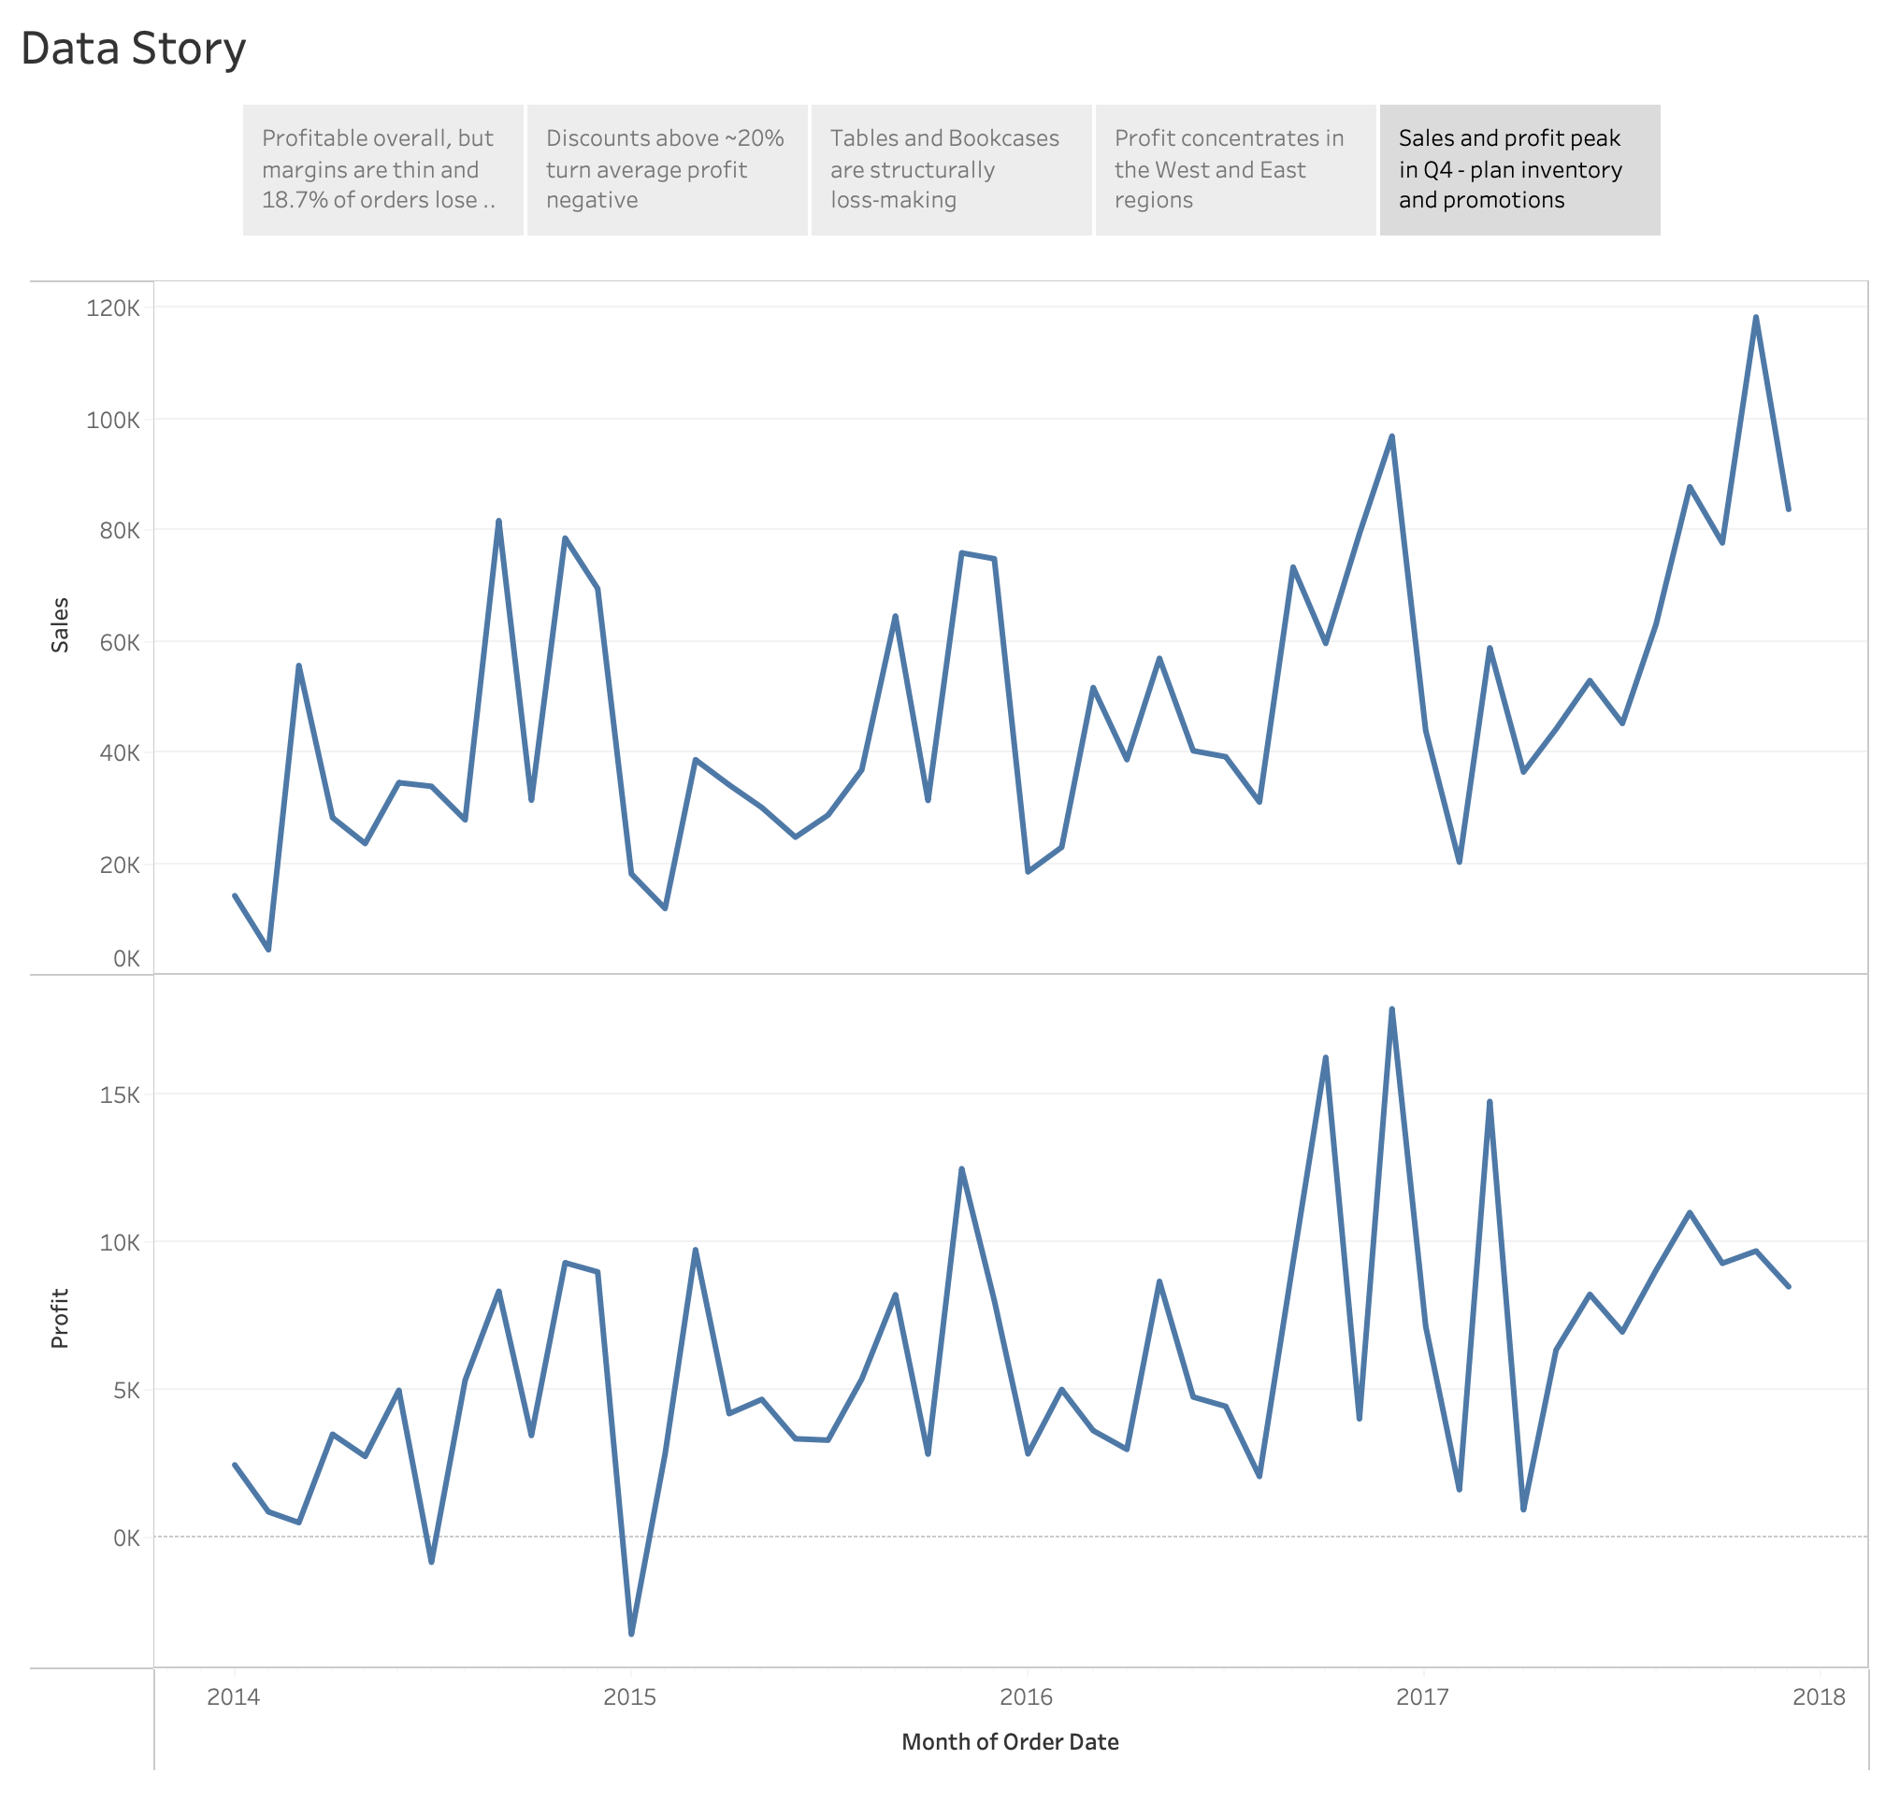
Figure 7. The Tableau data story sequencing five insights and recommendations.

4.6 Discussion and Limitations

Together the dashboard and story can present a complex data set to support a number of decisions that a manager might take. The work here has a number of limitations but it does attempt to move from descriptive reporting to prescriptive. Firstly the dashboard is descriptive and historical in nature, therefore it does not supersede the work of the companion assessment where a number of predictive models were developed. Secondly the data supplied did not contain any information on unit cost therefore profit will be affected by sales and by discount but not by changes in volume. Thirdly the data and work here is for just one retailer so it is not generalizable. Lastly the report here is shown as a number of static screenshots of the report. As always the packaged workbook can be opened to allow full use of the filtering, the parameters and the actions that have been developed.

Chapter 5: Conclusion and Recommendations

This Project Output creates an interactive Tableau dashboard and data story for a retail Superstore, such as Walmart. The dashboard uses various types of visualizations such as KPI indicators, a profit map, ranked bars, trend over seasons, matrix per category per region and analysis of the discount bands, all interactive with filters, parameters and actions. The dashboard shows what summary reports fail to reveal, such as very thin margins on average, a large portion of orders even making a loss, the unprofitable sub-categories of furniture even on a structural basis, and how the current levels of discounting already cause the profit to collapse.
A general summary of recommendations based on the analysis above follows. Firstly, it is recommended to monitor and regulate your discounting activity against a threshold found within the data. Secondly, recommendations need to be made to remedy loss making sub categories of the furniture category. It is also recommended that the highest margin products and regions should be focused on for growth. Finally, seasonality should be planned for without sacrificing margin. As a basis for future work the author would like to connect up the tables in this workbook to a live data source in order to enable on-going monitoring. It would also be of benefit to add in row-level security so that different business units are able to view the information that is most relevant to them. Finally the author would like to embed the predictive profit scores from the companion machine-learning model used to create this Project Output. This would enable users of this dashboard to see not only the past performance of the information they are viewing but also to identify at risk orders before they are even confirmed.

Bibliography

Cairo, A. (2016) The Truthful Art: Data, Charts, and Maps for Communication. Berkeley, CA: New Riders.
Davenport, T.H. and Harris, J.G. (2017) Competing on Analytics: The New Science of Winning. Updated edn. Boston, MA: Harvard Business Review Press.
Few, S. (2006) Information Dashboard Design: The Effective Visual Communication of Data. Sebastopol, CA: O’Reilly Media.
Few, S. (2012) Show Me the Numbers: Designing Tables and Graphs to Enlighten. 2nd edn. Burlingame, CA: Analytics Press.
Kirk, A. (2016) Data Visualisation: A Handbook for Data Driven Design. London: SAGE Publications.
Knaflic, C.N. (2015) Storytelling with Data: A Data Visualization Guide for Business Professionals. Hoboken, NJ: Wiley.
Provost, F. and Fawcett, T. (2013) Data Science for Business: What You Need to Know about Data Mining and Data-Analytic Thinking. Sebastopol, CA: O’Reilly Media.
Sarker, I.H. (2021) ‘Machine learning: algorithms, real-world applications and research directions’, SN Computer Science, 2(3), article 160.
Tufte, E.R. (2001) The Visual Display of Quantitative Information. 2nd edn. Cheshire, CT: Graphics Press.
Ware, C. (2021) Information Visualization: Perception for Design. 4th edn. Cambridge, MA: Morgan Kaufmann.
Wexler, S., Shaffer, J. and Cotgreave, A. (2017) The Big Book of Dashboards: Visualizing Your Data Using Real-World Business Scenarios. Hoboken, NJ: Wiley.

List of Figures

Figure 1. The complete interactive Tableau dashboard.
Figure 2. Profit by Sub-Category.
Figure 3. Profit by State (filled map).
Figure 4. Average profit by discount band.
Figure 5. Monthly sales and profit trend.
Figure 6. Profit by Category and Region (highlight table).
Figure 7. The Tableau data story.

List of Tables
Table 1. Dashboard views and visualisation types.

Appendix A: Tableau Workbook and Data

The interactive Tableau workbook (.twbx), the dataset and this report are provided in the project repository below. The workbook embeds the data and can be opened directly in Tableau Desktop or the free Tableau Reader/Public.

GitHub repository: https://github.com/j-ovalle/machine-learning-assigment

