BERLIN SCHOOL OF BUSINESS AND INNOVATION
In partnership with the University for the Creative Arts (UCA)
MSc Information Technology Management
Machine Learning Business Problem Solution:
Predicting and Explaining Transaction Profitability in a Retail Superstore Using Machine Learning
Practical Skills Assessment
Module: Machine Learning and Visualization for Data (IITG7003)
Name: Juan Osvaldo Ovalle Perez
Student ID: Q1122568
Module Leader: Dr. Waseem Alhasan
Submission Date: 9 June 2026
Word count (main body): approx. 3,500

Statement of Academic Integrity
I honestly declare that this assignment is entirely my own work and none of its parts has been copied from printed or electronic sources, translated from foreign sources or reproduced from the essays of other researchers or students. Wherever I have drawn on the ideas or texts of others, I have clearly declared this through the correct use of references following academic ethics. I confirm that I have used the Harvard Referencing System and that I have complied with the University’s Academic Misconduct Regulations.
I understand that, in the case that it is proved that part of this essay does not constitute original work but a copy of an already published essay or another source, I may be subject to the penalties set out in the BSBI regulations.
Name: Juan Osvaldo Ovalle Perez Student ID: Q1122568
Signature: ______________________________ Date: ____ / 06 / 2026
Learner declaration (to be completed before submission):
Word count: ________ | Use of a proof-reading service (e.g. Grammarly): YES / NO | Use of AI tools in line with tutor guidance, cited per the UCA Harvard standard: YES / NO.
TABLE OF CONTENTS
Statement of Academic Integrity 2
Chapter 1: Introduction 4
1.1 Background 4
1.2 Business Problem and Rationale 4
1.3 Aims and Objectives 4
1.4 Success Criteria 5
1.5 Methodology Overview and Report Structure 5
Chapter 2: Literature Review 6
2.1 From Data to Decisions in Retail 6
2.2 Regression for Prediction 6
2.3 Ensemble Tree Methods 6
2.4 Evaluation, Validation and Interpretability 7
Chapter 3: Methodology 8
3.1 Research Approach 8
3.2 Dataset Description 8
3.3 Data Cleaning and Outlier Handling 8
3.4 Feature Engineering 8
3.5 Preprocessing Pipeline 9
3.6 Model Development and Tuning 9
3.7 Evaluation Metrics 9
3.8 Tools 9
Chapter 4: Results and Discussion 11
4.1 Exploratory Data Analysis 11
4.2 Model Performance and Comparison 14
4.3 Best Model and Feature Importance 16
4.4 Discussion and Business Implications 18
4.5 Limitations 18
Chapter 5: Conclusion and Recommendations 20
5.1 Conclusions 20
5.2 Recommendations 20
5.3 Future Work 20
Bibliography 21
List of Figures 23
Appendix A: Source Code and Dataset 24

Chapter 1: Introduction

1.1 Background
Contemporary retailers operate in a low-margin, high-volume environment in which competitive advantage increasingly derives from the intelligent use of transactional data rather than from intuition alone (Davenport and Harris, 2017). The proliferation of point-of-sale systems and enterprise data warehouses has produced rich, granular records of every order line, yet many organisations still struggle to convert this raw data into decisions that protect and grow profitability. Machine learning (ML) offers a route from descriptive reporting towards predictive and prescriptive analytics, enabling managers to anticipate outcomes and to identify the levers that drive them (Provost and Fawcett, 2013; Sarker, 2021).
This report applies the complete machine learning project lifecycle to a real-world retail dataset, the widely used Sample Superstore dataset, which records 9,994 order lines placed with a United States office-supplies and furniture retailer between 2014 and 2017. Although the firm is profitable overall, a substantial share of individual transactions lose money, and the causes are not obvious from summary reports. The project therefore treats profitability as a quantity to be predicted and, more importantly, explained.

1.2 Business Problem and Rationale
The business problem is defined as follows: given the attributes of an order line that are known at the point of sale — its product category, customer segment, geography, quantity, sales value and the discount applied — can the resulting profit be predicted accurately, and which factors most strongly determine whether a transaction is profitable? This is framed as a supervised regression problem, with profit in US dollars as the continuous target variable. The motivation is directly managerial: a reliable profit model allows the retailer to flag likely loss-making orders before they are confirmed, to quantify the cost of aggressive discounting, and to redirect promotional effort towards products and segments where margin is preserved.

1.3 Aims and Objectives
The aim of this study is to design, train and evaluate machine learning models that predict order-line profit for the Superstore retailer and to translate the resulting model into actionable business insight. The specific objectives are: (i) to clean, engineer and explore the dataset in order to characterise the drivers of profit; (ii) to develop and tune at least three regression algorithms spanning linear and ensemble families; (iii) to evaluate and compare these models using appropriate error and goodness-of-fit metrics together with cross-validation; and (iv) to interpret the best-performing model and derive evidence-based recommendations.

1.4 Success Criteria
Success is defined in measurable terms. A satisfactory model should explain a clear majority of the variation in profit on unseen data (a coefficient of determination, R², comfortably above 0.70) while keeping the mean absolute error small relative to the average transaction profit. In addition, performance estimated on a hold-out test set should be consistent with performance under five-fold cross-validation, demonstrating that the model generalises rather than overfits. Finally, the model must yield interpretable feature-importance information capable of supporting concrete pricing and product decisions.

1.5 Methodology Overview and Report Structure
Methodologically, the project follows the established Cross-Industry Standard Process for Data Mining (CRISP-DM), proceeding through business understanding, data understanding, data preparation, modelling, evaluation and a discussion of deployment (Wirth and Hipp, 2000). All analysis is implemented in Python using the pandas, scikit-learn and matplotlib libraries (Pedregosa et al., 2011). The remainder of the report is organised as follows. Chapter 2 reviews relevant literature on data-driven decision-making and regression-based machine learning. Chapter 3 details the methodology, dataset and preprocessing. Chapter 4 presents and discusses the exploratory findings and modelling results. Chapter 5 concludes and offers recommendations for the retailer and for future work.

Chapter 2: Literature Review

2.1 From Data to Decisions in Retail
The strategic value of analytics is well established. Davenport and Harris (2017) argue that firms which systematically exploit data to inform decisions outperform their peers, while Provost and Fawcett (2013) frame data science as the disciplined extraction of decision-relevant knowledge from data. Within retail specifically, analytics has matured from descriptive dashboards towards predictive modelling of demand, price and profitability. Sarker (2021) provides a contemporary taxonomy of machine learning methods and their real-world applications, noting that supervised learning dominates business use cases because outcomes of interest — such as sales, churn or profit — are frequently labelled in historical records. The present study sits within this tradition, using historical labelled transactions to learn a mapping from order attributes to profit.

2.2 Regression for Prediction
Regression is the canonical supervised technique when the target is continuous. Ordinary least squares provides an interpretable baseline but assumes an additive, linear relationship between predictors and response and is sensitive to multicollinearity (James et al., 2021). Regularised variants address these weaknesses: ridge regression shrinks coefficients to control variance in the presence of correlated predictors (Hoerl and Kennard, 1970), while the lasso performs simultaneous shrinkage and variable selection by driving some coefficients to exactly zero (Tibshirani, 1996). These methods improve generalisation but remain fundamentally linear, and therefore cannot capture the interaction effects that frequently characterise commercial data, such as the way a discount’s impact on profit depends on the product involved.

2.3 Ensemble Tree Methods
Ensemble methods built on decision trees relax the linearity assumption and have become the workhorse of applied predictive modelling on tabular data. Random forests aggregate many de-correlated trees grown on bootstrap samples, reducing variance and providing robust performance with limited tuning (Breiman, 2001). Gradient boosting instead builds trees sequentially, each correcting the residual errors of its predecessors (Friedman, 2001), an approach scaled to large datasets by modern implementations such as XGBoost (Chen and Guestrin, 2016). Comparative studies and practitioner texts consistently report that tree ensembles outperform linear models on heterogeneous business data while remaining able to quantify the relative importance of each predictor (Hastie et al., 2009; Géron, 2019; Kuhn and Johnson, 2013). Recent retail-focused research similarly finds that random forest and gradient boosting models deliver the most accurate sales and profitability predictions among the algorithms commonly evaluated.

2.4 Evaluation, Validation and Interpretability
Sound evaluation is as important as model choice. For regression, the mean absolute error (MAE), mean squared error (MSE), root mean squared error (RMSE) and coefficient of determination (R²) are standard, each emphasising different aspects of error magnitude (James et al., 2021). Because a single train–test split can give an optimistic or pessimistic estimate depending on which observations fall into the test set, k-fold cross-validation is recommended to obtain a more robust estimate of generalisation performance (Hastie et al., 2009). Shmueli (2010) draws a crucial distinction between explanatory and predictive modelling, reminding analysts that a model optimised for prediction must still be interrogated for the insight it provides. Interpretability techniques, ranging from built-in impurity-based feature importance to model-agnostic approaches such as SHAP values (Lundberg and Lee, 2017), allow predictive models to be translated into managerial understanding — the very bridge this project seeks to build between an accurate profit model and concrete recommendations.

Chapter 3: Methodology

3.1 Research Approach
The study adopts a quantitative, experimental approach structured around the CRISP-DM lifecycle (Wirth and Hipp, 2000). Following business and data understanding (Chapters 1 and 4), the data preparation, modelling and evaluation phases are implemented programmatically so that the entire analysis is reproducible from a single Python script. Reproducibility is reinforced by fixing the pseudo-random seed for all stochastic operations, including the train–test split and the ensemble algorithms.

3.2 Dataset Description
The Sample Superstore dataset comprises 9,994 order lines and 21 original columns describing each transaction. The fields include temporal attributes (order and ship dates), logistical attributes (ship mode), customer attributes (segment, geography), product attributes (category, sub-category) and the three monetary or quantitative measures central to this study: sales, quantity, discount and profit. The data contained no missing values and no duplicate rows, indicating a clean source extract; nevertheless, the preparation steps below were applied to ensure the data were suitable for modelling.

3.3 Data Cleaning and Outlier Handling
The order and ship dates were parsed into datetime objects to support temporal feature engineering. Exploratory inspection revealed that both sales and profit are highly skewed with extreme tails: a small number of bulk or heavily discounted orders generate very large gains or losses. Because squared-error loss is dominated by such extremes and a single random split can place them disproportionately in the test set, the two monetary variables were winsorised at their 1st and 99th percentiles for modelling. This treatment caps roughly two per cent of values, stabilises the hold-out estimate and is a standard remedy for heavy-tailed financial data; the uncapped values remain visible in the exploratory analysis so that no insight is lost.

3.4 Feature Engineering
Several features were derived to enrich the predictor set. Shipping days were computed as the difference between ship and order dates, capturing fulfilment speed. Order year, month and quarter were extracted to expose temporal and seasonal effects. Two analytical fields — profit margin (profit divided by sales) and a binary profitable/unprofitable flag — were created to support exploration but deliberately excluded from the predictor set to avoid target leakage. The final modelling matrix used six numeric predictors (sales, quantity, discount, shipping days, order month and order year) and five categorical predictors (ship mode, segment, region, category and sub-category).

3.5 Preprocessing Pipeline
All preprocessing was encapsulated in a scikit-learn ColumnTransformer to prevent information leaking from the test set into training. Numeric predictors were standardised to zero mean and unit variance, which is necessary for the regularised linear models, while categorical predictors were one-hot encoded, with unknown categories handled gracefully at prediction time. Embedding these steps in a Pipeline ensures that the identical transformations are applied consistently during cross-validation, tuning and final evaluation (Pedregosa et al., 2011).

3.6 Model Development and Tuning
Five regression algorithms spanning two families were trained: ordinary linear regression, ridge and lasso regression from the regularised-linear family, and random forest and gradient boosting from the ensemble-tree family. The data were partitioned into an 80 per cent training set (7,995 rows) and a 20 per cent hold-out test set (1,999 rows). Hyper-parameters were tuned with grid search under five-fold cross-validation, optimising the cross-validated R²; the regularisation strength was tuned for ridge and lasso, and the number of trees and tree depth for the ensembles. Wrapping every candidate in a cross-validated search yielded both the tuned estimator and the per-fold scores from a single fitting procedure.

3.7 Evaluation Metrics
Model quality was assessed on the untouched test set using MAE, MSE, RMSE and R², and the robustness of each model was confirmed with five-fold cross-validation on the training data. Reporting both hold-out and cross-validated R² allows over-optimistic single-split results to be detected. The best model was selected on test R², with cross-validation stability and error magnitude used as secondary criteria, after which its feature importances were extracted to interpret the drivers of profit.

3.8 Tools
The analysis was conducted in Python 3 using pandas for data manipulation, scikit-learn for preprocessing, modelling and evaluation, and matplotlib for visualisation (Pedregosa et al., 2011). The complete, commented source code and the dataset are provided in the project repository referenced in the Appendix so that all results can be reproduced.

Chapter 4: Results and Discussion

4.1 Exploratory Data Analysis
Across the four-year period the retailer generated total sales of approximately 2.30 million US dollars and total profit of about 286,000 dollars, an overall margin of 12.5 per cent. However, the headline figure conceals considerable variability at the transaction level: the mean profit per order line is only 28.66 dollars and the median just 8.67 dollars, and fully 18.7 per cent of order lines are loss-making. Figure 1 shows the right-skewed distribution of sales and the sharply peaked, heavy-tailed distribution of profit centred near zero, motivating the outlier treatment described in Chapter 3. All charts in this chapter apply established visual-encoding principles so that each finding is communicated clearly and without distortion (Few, 2012).
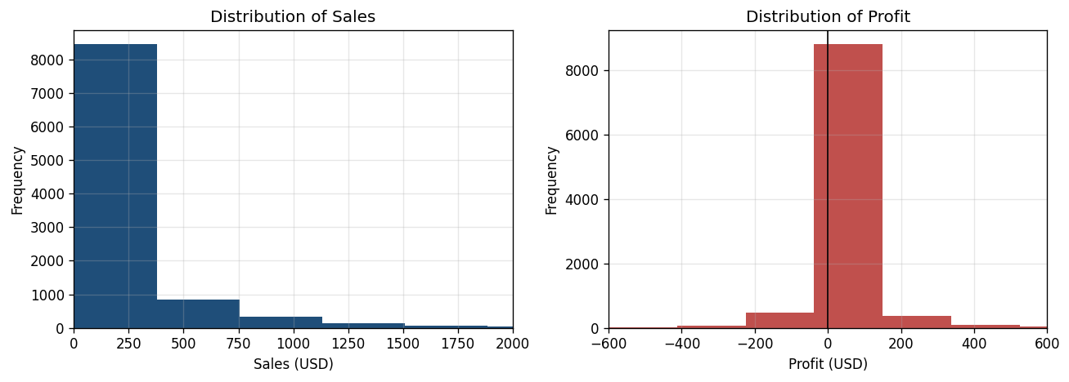
Figure 1. Distribution of Sales and Profit per order line.
Profit is highly uneven across the product hierarchy. As Figure 2 shows, Technology and Office Supplies are strongly profitable (roughly 145,000 and 122,000 dollars respectively), whereas Furniture contributes only about 18,000 dollars despite comparable sales volume. Disaggregating to sub-category in Figure 3 exposes the source of this weakness: Tables (-17,725 dollars), Bookcases (-3,473 dollars) and Supplies (-1,189 dollars) are structurally loss-making, while Copiers, Phones and Accessories are the strongest profit generators. This pattern indicates that the Furniture category is being dragged down by a small number of consistently unprofitable sub-categories rather than by uniformly weak performance.
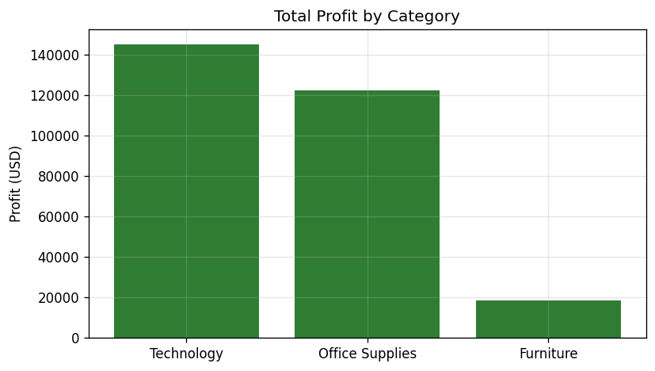
Figure 2. Total profit by product Category.
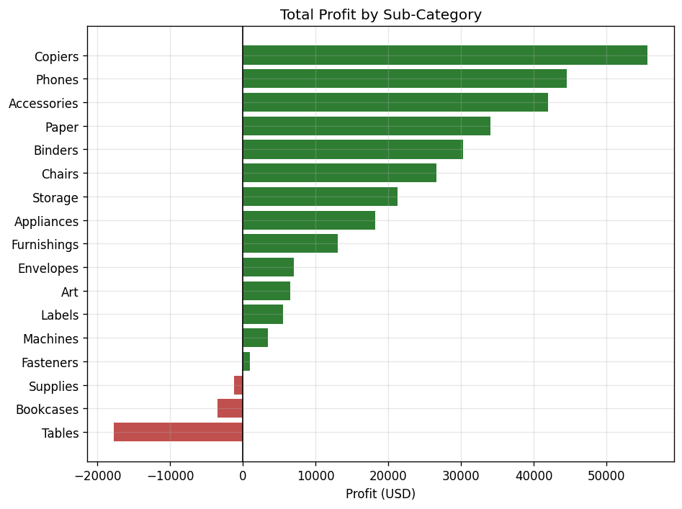
Figure 3. Total profit by product Sub-Category.
The single most important operational finding concerns discounting. Figure 4 plots mean profit against the discount level and reveals a clear threshold effect: orders with no discount or a modest ten per cent reduction remain comfortably profitable, but average profit collapses as discounts deepen, turning negative at around the 30 per cent level and reaching roughly -311 dollars at a 50 per cent discount. This is corroborated by the correlation analysis in Figure 5, where discount shows a strong negative correlation with profit margin (r = -0.86) even though its correlation with absolute profit is more moderate (r = -0.22), because large discounts are sometimes applied to high-value items. The implication is that discounting beyond approximately twenty per cent systematically destroys margin.
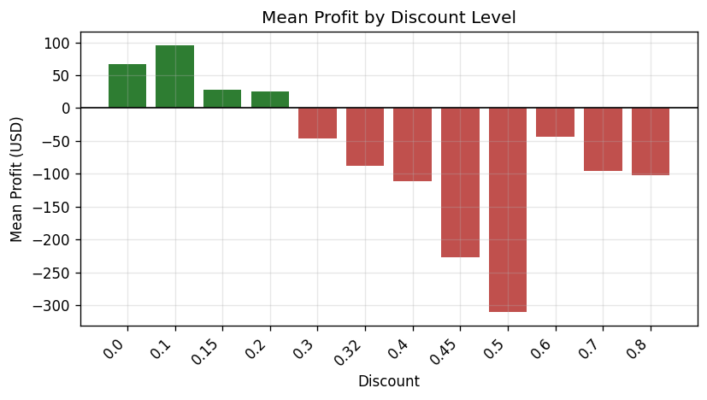
Figure 4. Mean profit by Discount level.
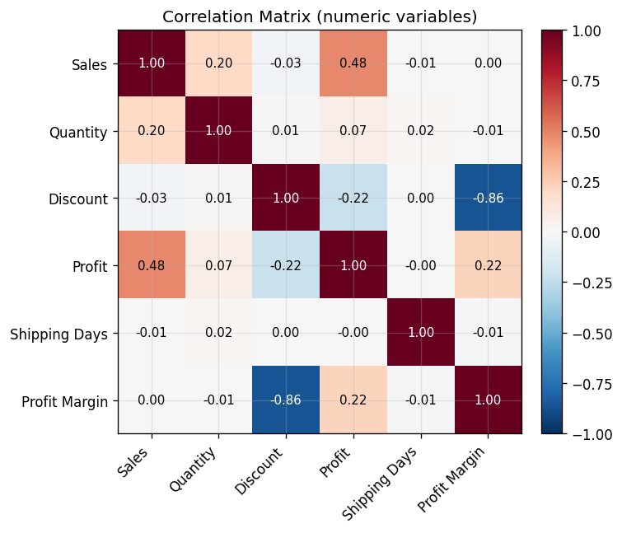
Figure 5. Correlation matrix of numeric variables.
Geographically, the West and East regions are the most profitable (about 108,000 and 92,000 dollars) while the Central region lags (around 40,000 dollars), and the Consumer segment contributes the largest absolute profit, as shown in Figure 6. The monthly trend in Figure 7 displays pronounced seasonality, with sales and profit peaking towards the end of each year, consistent with seasonal purchasing cycles. Together these exploratory findings suggest that product mix and discount policy, rather than geography, are the primary controllable drivers of profitability.
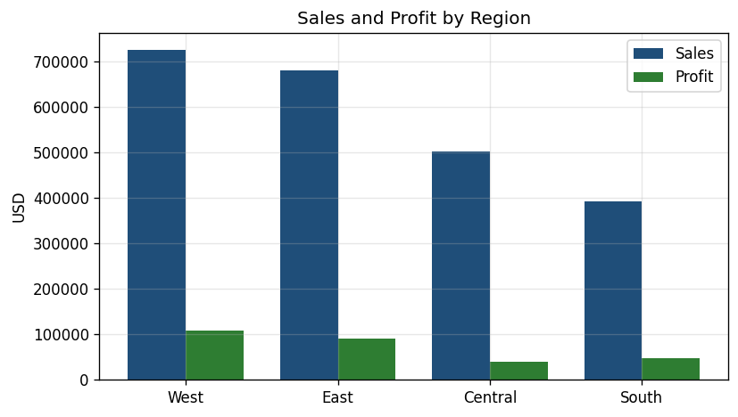
Figure 6. Sales and profit by Region.
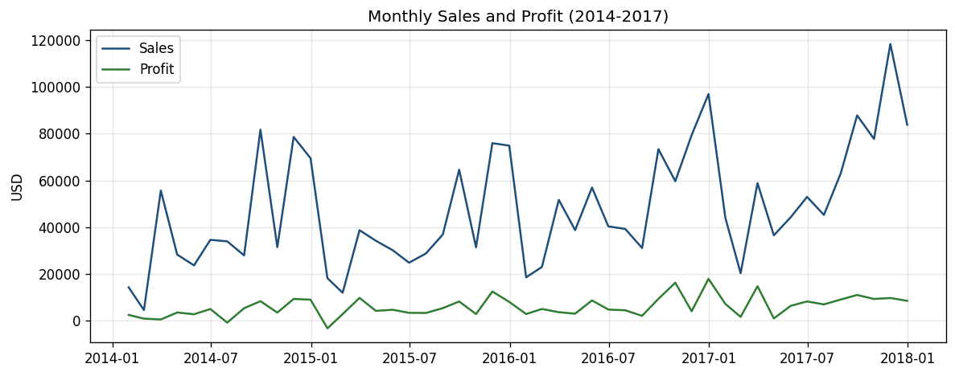
Figure 7. Monthly sales and profit trend (2014–2017).

4.2 Model Performance and Comparison
Table 1 summarises the performance of the five tuned models on the hold-out test set together with their five-fold cross-validated R². The two ensemble methods clearly dominate the linear family. The random forest achieves the best results, explaining 88.6 per cent of the variation in profit on unseen data (R² = 0.886) with a mean absolute error of only 12.30 dollars, closely followed by gradient boosting (R² = 0.878). The linear, ridge and lasso models explain a far smaller share of variance (R² ≈ 0.43) with errors roughly three times larger. Crucially, for each model the test R² is consistent with the cross-validated R², confirming that the results are stable and not an artefact of a fortunate split.
Table 1. Regression model performance on the test set and under five-fold cross-validation.
Model | MAE (USD) | RMSE (USD) | Test R² | 5-fold CV R²
Random Forest | 12.30 | 34.21 | 0.886 | 0.879 ± 0.010
Gradient Boosting | 16.52 | 35.32 | 0.878 | 0.867 ± 0.012
Linear Regression | 39.26 | 76.47 | 0.430 | 0.534 ± 0.049
Ridge Regression | 39.25 | 76.48 | 0.430 | 0.534 ± 0.049
Lasso Regression | 39.02 | 76.63 | 0.427 | 0.534 ± 0.049
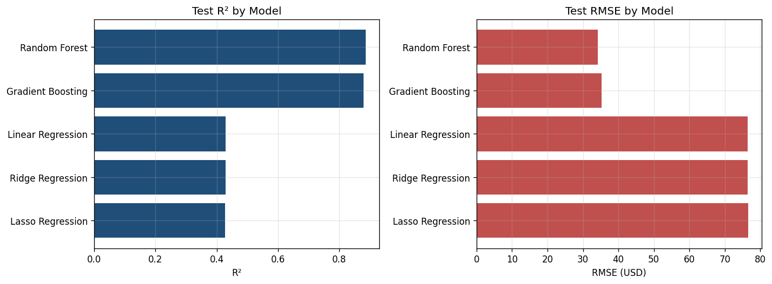
Figure 8. Model comparison – test R² and RMSE.
The large gap between the linear and ensemble models is itself informative. It indicates that the relationship between order attributes and profit is strongly non-linear and interaction-driven: the effect of a discount, for example, depends heavily on the product sub-category to which it is applied. Linear models, which assume additive effects, cannot represent such interactions and therefore leave most of the variance unexplained, whereas tree ensembles capture them naturally (Breiman, 2001; Friedman, 2001). This finding mirrors the broader literature on tabular business data (Géron, 2019; Kuhn and Johnson, 2013).

4.3 Best Model and Feature Importance
The random forest was selected as the final model on the basis of its superior and stable accuracy. Figure 9 plots predicted against actual profit on the test set; the points cluster tightly around the diagonal, and the residual distribution in Figure 10 is approximately symmetric and centred on zero, indicating little systematic bias. Figure 11 reports the model’s feature importances. Sales value (about 50 per cent of importance) and discount (about 32 per cent) together account for roughly four-fifths of the model’s predictive power, with specific sub-categories such as Copiers and Binders and the order quantity contributing the remainder. This confirms quantitatively what the exploratory analysis suggested: profit is governed primarily by transaction size and by the discount applied, and discount is the lever most directly under management control.
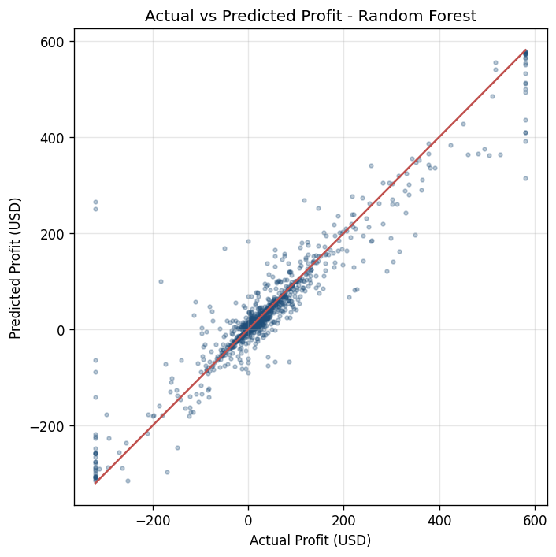
Figure 9. Actual versus predicted profit (Random Forest).
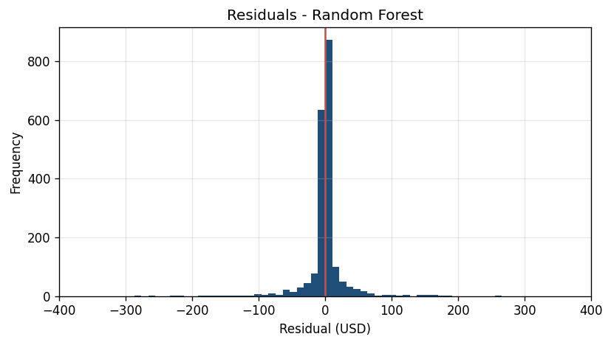
Figure 10. Residual distribution (Random Forest).
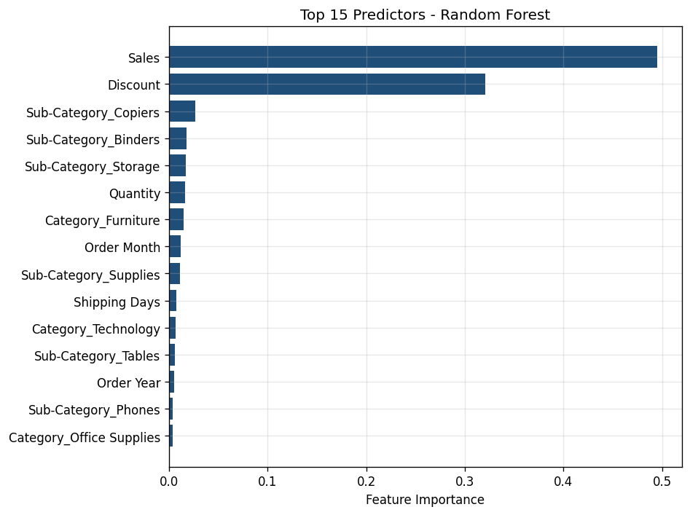
Figure 11. Top 15 predictors (Random Forest importance).
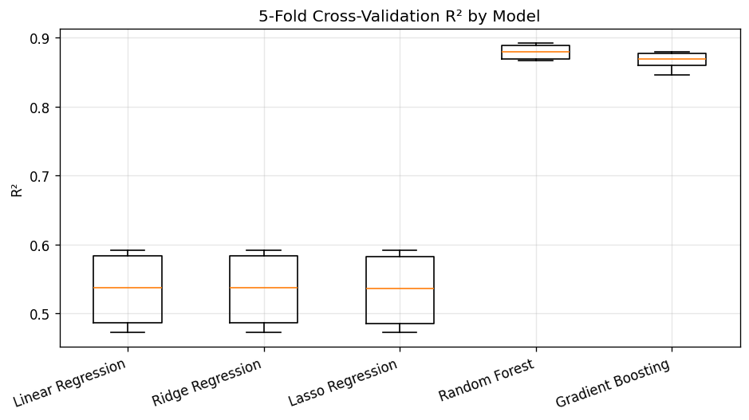
Figure 12. Five-fold cross-validation R² by model.

4.4 Discussion and Business Implications
The results carry direct commercial implications. First, because discount is both highly influential and controllable, the retailer should institute discount governance: the evidence that average profit turns negative beyond roughly twenty to thirty per cent provides an empirical ceiling above which approvals should be required. Second, the persistent losses in Tables and Bookcases suggest that these sub-categories need renegotiated supplier costs, repricing or, in the limit, rationalisation, rather than further promotion. Third, the trained model can be embedded in the order-management workflow to score transactions in real time and flag those predicted to be unprofitable before they are confirmed, converting a descriptive insight into a prescriptive control (Provost and Fawcett, 2013).

4.5 Limitations
Several limitations should be acknowledged. The dataset does not contain unit cost, so profit is mechanically related to sales and discount; while this makes those variables strong predictors, it also means the model partly reflects an accounting identity rather than purely behavioural signal. The analysis is cross-sectional and predicts the profit of an individual order line rather than forecasting future demand, which would require time-series methods. Winsorisation, although justified, removes the model’s ability to predict the most extreme transactions, which may themselves be of business interest. Finally, impurity-based importance can be biased towards high-cardinality features, so the interpretation in Section 4.3 would be strengthened in future work by model-agnostic methods such as SHAP (Lundberg and Lee, 2017).

Chapter 5: Conclusion and Recommendations

5.1 Conclusions
This study applied the full machine learning lifecycle to the prediction and explanation of transaction profitability for a retail superstore. After cleaning, feature engineering and outlier treatment, five regression models were trained and compared. The random forest emerged as the best model, explaining 88.6 per cent of the variance in order-line profit on unseen data with a mean absolute error of about twelve dollars and stable cross-validated performance, comfortably satisfying the success criteria defined at the outset. Beyond predictive accuracy, the analysis produced a clear and actionable account of what drives profit: transaction size and, above all, the discount applied, with several furniture sub-categories identified as structurally loss-making.

5.2 Recommendations
Three evidence-based recommendations follow. The retailer should, first, introduce a discount-approval threshold informed by the point at which average profit turns negative, supported by the deployed model scoring orders in real time; second, review the pricing, sourcing and assortment of the Tables, Bookcases and Supplies sub-categories that consistently erode margin; and third, protect and expand the high-margin Technology lines such as Copiers, Phones and Accessories that drive the bulk of profit. Each recommendation flows directly from the modelling evidence rather than from intuition, illustrating the shift from descriptive to prescriptive analytics.

5.3 Future Work
Future work should incorporate unit-cost and inventory data to model true contribution margin, extend the analysis to demand forecasting with time-series and gradient-boosting methods, and apply model-agnostic interpretability such as SHAP to validate and deepen the feature-importance findings. The cleaned dataset and engineered features produced here are also exported in a form ready for interactive visualisation, providing a direct bridge to the dashboard and data-storytelling work that constitutes the companion Project Output.

Bibliography
Breiman, L. (2001) ‘Random forests’, Machine Learning, 45(1), pp. 5–32.
Chen, T. and Guestrin, C. (2016) ‘XGBoost: a scalable tree boosting system’, in Proceedings of the 22nd ACM SIGKDD International Conference on Knowledge Discovery and Data Mining. New York: ACM, pp. 785–794.
Davenport, T.H. and Harris, J.G. (2017) Competing on Analytics: The New Science of Winning. Updated edn. Boston, MA: Harvard Business Review Press.
Few, S. (2012) Show Me the Numbers: Designing Tables and Graphs to Enlighten. 2nd edn. Burlingame, CA: Analytics Press.
Friedman, J.H. (2001) ‘Greedy function approximation: a gradient boosting machine’, The Annals of Statistics, 29(5), pp. 1189–1232.
Géron, A. (2019) Hands-On Machine Learning with Scikit-Learn, Keras, and TensorFlow. 2nd edn. Sebastopol, CA: O’Reilly Media.
Hastie, T., Tibshirani, R. and Friedman, J. (2009) The Elements of Statistical Learning: Data Mining, Inference, and Prediction. 2nd edn. New York: Springer.
Hoerl, A.E. and Kennard, R.W. (1970) ‘Ridge regression: biased estimation for nonorthogonal problems’, Technometrics, 12(1), pp. 55–67.
James, G., Witten, D., Hastie, T. and Tibshirani, R. (2021) An Introduction to Statistical Learning with Applications in R. 2nd edn. New York: Springer.
Kuhn, M. and Johnson, K. (2013) Applied Predictive Modeling. New York: Springer.
Lundberg, S.M. and Lee, S.-I. (2017) ‘A unified approach to interpreting model predictions’, in Advances in Neural Information Processing Systems 30 (NeurIPS 2017), pp. 4765–4774.
Pedregosa, F. et al. (2011) ‘Scikit-learn: machine learning in Python’, Journal of Machine Learning Research, 12, pp. 2825–2830.
Provost, F. and Fawcett, T. (2013) Data Science for Business: What You Need to Know about Data Mining and Data-Analytic Thinking. Sebastopol, CA: O’Reilly Media.
Sarker, I.H. (2021) ‘Machine learning: algorithms, real-world applications and research directions’, SN Computer Science, 2(3), article 160.
Shmueli, G. (2010) ‘To explain or to predict?’, Statistical Science, 25(3), pp. 289–310.
Tibshirani, R. (1996) ‘Regression shrinkage and selection via the lasso’, Journal of the Royal Statistical Society: Series B, 58(1), pp. 267–288.
Wirth, R. and Hipp, J. (2000) ‘CRISP-DM: towards a standard process model for data mining’, in Proceedings of the 4th International Conference on the Practical Application of Knowledge Discovery and Data Mining, pp. 29–39.

List of Figures
Figure 1. Distribution of Sales and Profit per order line.
Figure 2. Total profit by product Category.
Figure 3. Total profit by product Sub-Category.
Figure 4. Mean profit by Discount level.
Figure 5. Correlation matrix of numeric variables.
Figure 6. Sales and profit by Region.
Figure 7. Monthly sales and profit trend (2014–2017).
Figure 8. Model comparison – test R² and RMSE.
Figure 9. Actual versus predicted profit (Random Forest).
Figure 10. Residual distribution (Random Forest).
Figure 11. Top 15 predictors (Random Forest importance).
Figure 12. Five-fold cross-validation R² by model.
List of Tables
Table 1. Regression model performance on the test set and under five-fold cross-validation.

Appendix A: Source Code and Dataset
The complete, commented Python pipeline (superstore_ml_pipeline.py), the dataset (Sample - Superstore.csv), all twelve figures, the model-metrics table and a cleaned, analysis-ready dataset are available in the public GitHub repository below. The repository README explains how to reproduce every result with a single command.
GitHub repository: https://github.com/<your-username>/superstore-ml-assignment
Reproduction: install the requirements (pip install -r requirements.txt) and run “python superstore_ml_pipeline.py”. The script executes the entire lifecycle — data cleaning, feature engineering, exploratory analysis, model training and tuning, evaluation, and export of all figures and metrics.

