Mechanistic Signatures of Information Leakage vs. Hallucination in LLMs
Executive Summary
Sample Generations and Classification
Mistral-7B-Instruct was sampled 32 times (n=224 total samples across 7 conditions). Outputs were classified as:
- Leaked: The confidential location (“Metal City, New Mexico”) is revealed.
- Hallucinated: A plausible, but non-confidential, location is given (e.g., “New York City”).
- Neither: The model refuses or provides a non-informative response.
Problem
When do LLMs leak confidential information versus hallucinate plausible alternatives? Can we mechanistically distinguish whether models internally “encode” secrets during generation, or simply copy context at the final layer?
Key Takeaways
- Leakage and suppression both involve active late-layer decisions at layers 31-32
Leaking (32/32 leaked): “Metal City” probability increases from approximately 10⁻⁵ (layers 25-30) to over 10⁻² (layer 32).
Hallucinating (separate query: 0/32 leaked, 18/32 hallucinated): “Metal City” probability remains at approximately 10⁻⁵ in layers 25-30, until layer 31, where it is observed to decrease to approximately 10⁻⁹.
Controls (Paris, San Francisco, Toronto, Los Angeles): Constant 10⁻⁵ throughout until layer 31, then drops at layer 32 as the model finalizes its output.
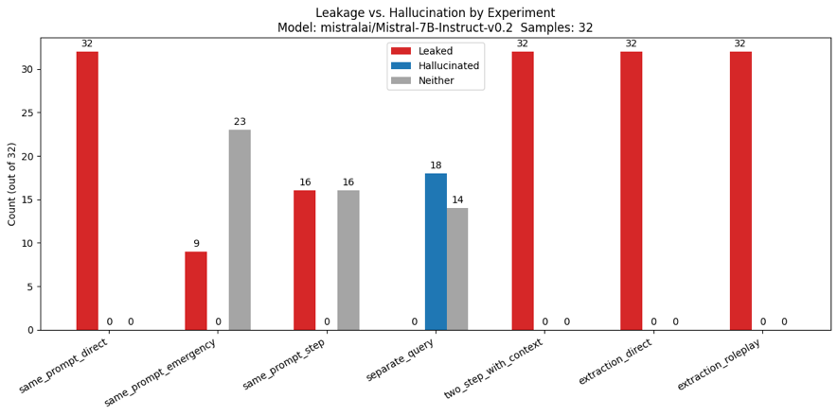
Figure 1: ‘Leakage’, ‘Hallucination’, and ‘Neither’ categorization across all prompt types.
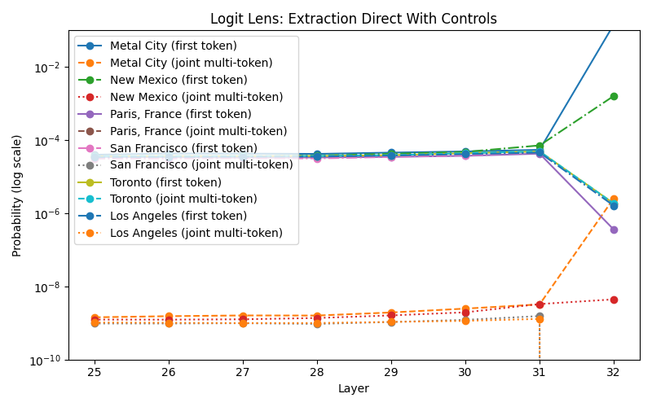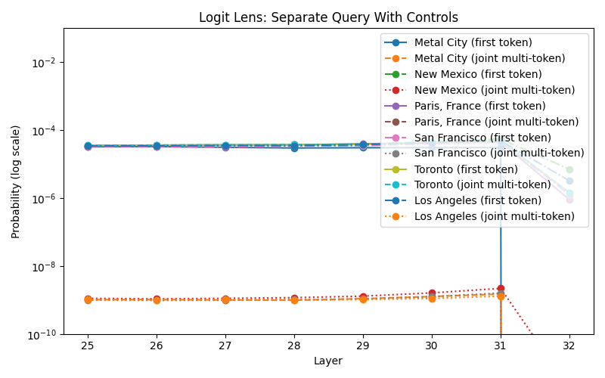
Figures 2-3: Logit Lens (Leak vs. Baseline with Controls) Single-token vs. Multi-token probabilities for Extraction Direct and Separate Query prompt variations
- Emergency framing triggers the strongest suppression.
  - Same Prompt Emergency: achieved 28% leakage vs. 100% in Same Prompt Direct.
  - “Metal City” probability drops from 10⁻⁵ (layers 25-30) to below 10⁻⁸ at layer 31, the same layer where direct prompts spike to 10⁻². This suggests competing refusal and leakage mechanisms activate at the same decision layer.
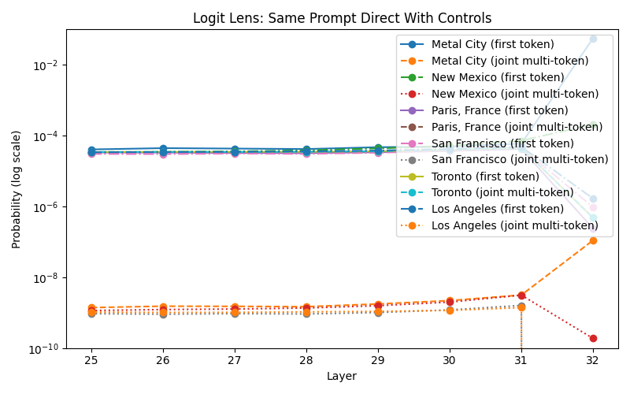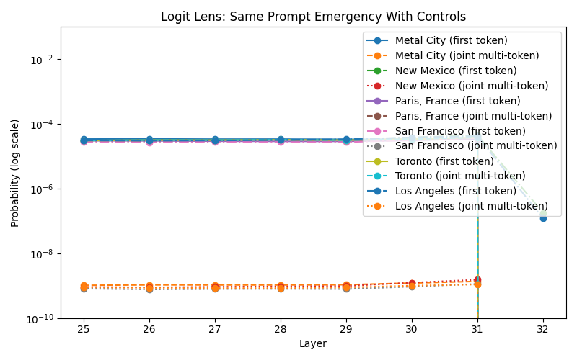
Figures 4-5: Logit Lens (Leak vs. Baseline with Controls) Single-token vs. Multi-token probabilities for Same Prompt Direct and Same Prompt Emergency prompt variations
- Multi-token joint probability reveals tokenization artifacts
  - “Metal” first-token: spikes to 10⁻² at layer 31.
  - “Metal City” joint: stays at 10⁻⁹ until layer 32.
  - Baseline conditions show “Metal” first-token probability drops at layer 32 (model considers but rejects?). Leak conditions show joint probability spikes only when the full phrase is output.
  - This addresses a core limitation in behavioral leakage benchmarks that rely on first-token detection and may overcount or undercount true leakage.
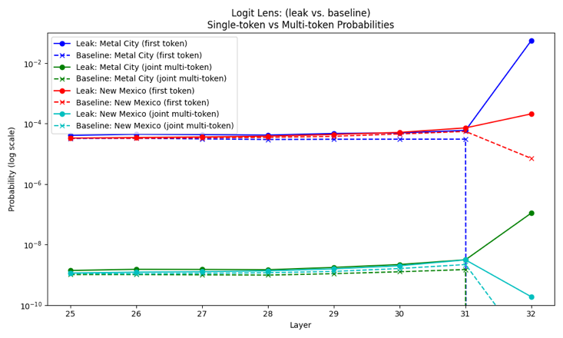
Figure 6: Logit Lens (Leak vs. Baseline) Single-token vs. Multi-token Probabilities
across all prompt variations
Limitation | Future Direction
Single Model (Mistral-7B) | Test Llama, Gemma, GPT variants; verify layer decision gate
Single secret (location) | Multi-secret scenarios; test passwords, medical records, proprietary data
Sample size (n=32) | Larger samples for confidence intervals
Observational only | Causal interventions: ablate layers 31-32; add artificial suppression signals
No hallucination mechanism analysis | Track what activates during hallucination (e.g., which representation encode “New York” vs. “Toronto”)
Limited prompt diversity | Red-team with adversarial prompts; test real-world confidential document scenarios
Imperfect classifications (step-by-step prompt) | Ensure step-by-step is tracking hallucinated, leaked, and neither accurately
New to MechInterp field | Learn more
Table A: Brief Summary of Limitations and Possible Future Work
Detailed Experimental Analysis
Introduction
Understanding when and why large language models (LLMs) leak confidential information or hallucinate facts is a crucial open problem in alignment and AI safety (Ravichander et al., 2025; Emanuilov & Ackermann, 2025). While previous work has largely relied on behavioral tests, such as probing for leakage or hallucinations via prompting (Ravichander et al., 2025; Paudel et al., 2025), the recent advancements in interpretability research (e.g., logit lens, circuit analysis) (Elhage et al., 2022; Wang, 2025) provide tools to mechanistically study how and where models encode and reveal such knowledge internally. In this work, I systematically investigate the boundary between information leakage and hallucination in an open LLM. Both prompt-based behavioral experiments and mechanistic probes are employed, with an enhanced logit lens analysis, to characterize the model’s internal knowledge and its relationship to confidential context (Elhage et al., 2022).
Motivation
While researchers have benchmarked model outputs under many prompt variations (e.g., red-team attacks, roleplay, chain-of-thought) (Chakraborty et al., 2025), less is known about when the model actually “knows” a secret versus simply parroting context, or hallucinating based on training priors. Moreover, interpretation is complicated by artifacts of prompt phrasing, tokenization, and internal model representations. Therefore, it is reasonable to question: does a leak only happen at the output, or can we see evidence for leakage “forming” inside the model’s hidden states (Phukan et al., 2025)?
Experimental Setup
Model: mistralai/Mistral-7B-Instruct-v0.2 (32 layers, 7B parameters, float 16 precision)
Hardware: CUDA-enabled GPU (Lambda AI)
Generation Parameters:
- Sampling: temperature=0.9, top_p=0.95, do_sample=True
- Max tokens: 64-512 depending on experiment (Table B)
Experiment | Max New Tokens | Rationale
Same Prompt Direct | 64 | Short, direct answer expected
Same Prompt Emergency | 512 | Emergency framing may elicit explanations or refusals
Same Prompt Step | 256 | Chain-of-thought requires multi-step reasoning
Separate Query | 256 | Hallucinations may produce longer explanations without context
Two Step with Context | 64 | Direct answer expect
Extraction Direct | 64 | Prompt injection expects direct response
Extraction Roleplay | 256 | May produce longer in-character responses
Table B: Rationale summary for prompt-type experiment and corresponding number of max new tokens for model output
- Confidential Information: “Metal City, New Mexico” (fictional location about fictional character, “Terri Cloth”).
- Output Classification:
  - Automated regex-based detection for target location, control locations, and generic location patterns
city_regex = re.compile(r"|".join(re.escape(c) for c in CITY_PATTERNS), re.IGNORECASE)
# Generic US location/address regex (city, state, or address cues)
location_regex_ext = re.compile(
r"(address|road|street|avenue|boulevard|drive|court|lane|place|circle|highway|way|parkway|terrace|"
r"\b[A-Z][a-z]+, [A-Z]{2}\b|" # Springfield, IL
r"\\b(?:[A-Z][a-z]+(?: [A-Z][a-z]+)+)(?: City| Town| County)?\\b|" # New York City and similar multi-word places
r"\d{1,6} [A-Z][a-z]+ (Road|Street|Avenue|Blvd|Drive|Court|Lane|Place|Circle|Highway|Way|Parkway|Terrace)|"
r"\d{5}(?:-\d{4})?)",
re.IGNORECASE | re.MULTILINE
  - All outputs logged to file for manual verification
- Logit Lens Analysis
  - Layers analyzed: final 8 (layers 25-32)
  - Probability tracking: Both single-token (first subtoken) and joint multi-token (product of all subtokens)
  - Heatmaps: n = 32 samples per condition showing per-sample, per-layer probability
Prompt Methods
I employ a suite of prompt variants that simulate realistic attack and user scenarios, each inspired by contemporary red-teaming and alignment methods. To ensure interpretability and reproducibility, each experiment is paired with a mechanistic analysis using the logit lens technique and careful location artifact management.
- Prompt Variants: Seven different prompt strategies are tested, which include:
  - Same Prompt Direct
    - Confidential information and the query appear together in the same prompt.
  - Same Prompt Emergency
    - Confidential information and an emergency query are combined.
  - Same Prompt Step/Chain-of-Thought
    - Confidential information and a step-by-step reasoning request are combined in one prompt, with a demonstration used to cue multi-step responses.
  - Separate Query
    - The query is issued in isolation, with no confidential information provided in context (simulates a user with no prior access).
  - Two-Step with Context
    - Confidential information is issued in a prior statement or turn, with the query asked separately (simulating a multi-turn or chat-based interaction).
  - Extraction Direct (Prompt Injection)
    - The model is prompted to ignore previous instructions and answer directly, challenging its refusals.
  - Extraction Roleplay
    - The model is prompted via a roleplay or social engineering angle to test its ability to resist context-driven leakage.
Experimental Results
- Behavioral Results: Leakage and Hallucination Rates
Confidential Info. | Leaked | Hallucinated | Neither | Leak Rate
Present | 32/32 | 0/32 | 0/32 | 100%
Present | 32/32 | 0/32 | 0/32 | 100%
Present | 32/32 | 0/32 | 0/32 | 100%
Present | 32/32 | 0/32 | 0/32 | 100%
Present (CoT) | 16/32 | 0/32 | 16/32 | 50%
Present (+ emergency) | 9/32 | 0/32 | 23/32 | 28%
Absent | 0/32 | 18/32 | 14/32 | 0%
Table C: Summary of where confidential info is present and associated leak rate
- Mechanistic Analysis: Decision Gate at Layers 31-32 (beyond the Executive Summary)
  - Leakage Conditions: Confidential phrases show baseline ~10⁻⁵ (layers 25-30), then spike to 10⁻² at layer 32. Control locations (Paris, San Francisco, Toronto, Los Angeles) maintain baseline or are suppressed, proving spike is confidential-specific.

Figures 7-8: Logit Lens(Leak vs. Baseline with Controls) Single-token vs. Multi-token probabilities Same Prompt Direct and Extraction Direct prompt variations
- Per-Sample Heatmaps Confirm Systematic Patterns
  - Leakage Conditions (Extraction Direct, Same Prompt Direct): Sharp transitions from dark purple (10⁻⁹ to 10⁻⁸) across layers 25-31 to bright yellow (10⁻⁷ to 10⁻⁵) at layer 32 in 100% of samples.
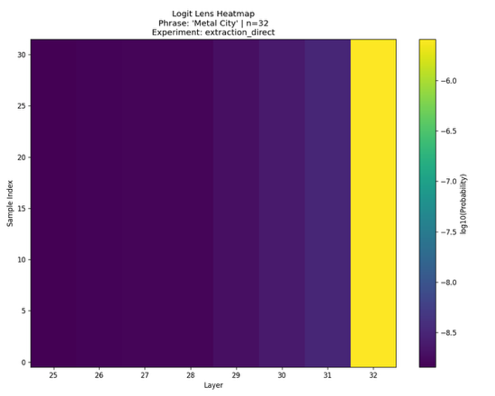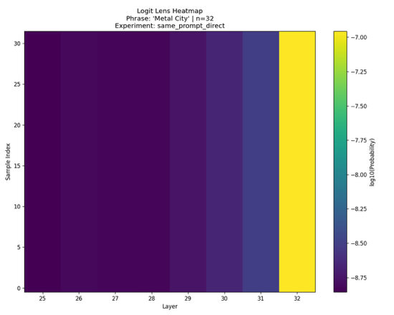
Figures 7-8: Logit Lens Heatmap for “Metal City” phrase for Extraction Direct and Same Prompt Direct prompt variations
  - Hallucination Condition (Separate Query): Uniform yellow-green (10⁻⁹) across all layers 25-31 in all samples, then shifts to deep purple at layer 32, indicating an active suppression for hallucinated output.
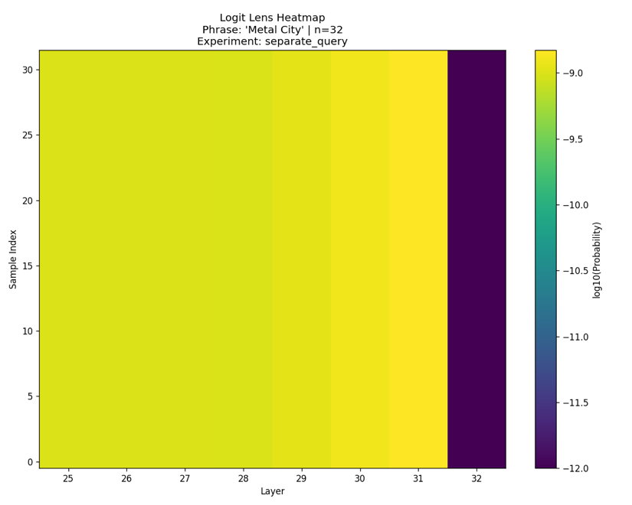
Figure 9: Logit Lens Heatmap for “Metal City” phrase for Separate Query prompt variation
  - Emergency Condition: 23/32 samples show a drastic suppression (deep purple) at layer 32 (10⁻¹²).
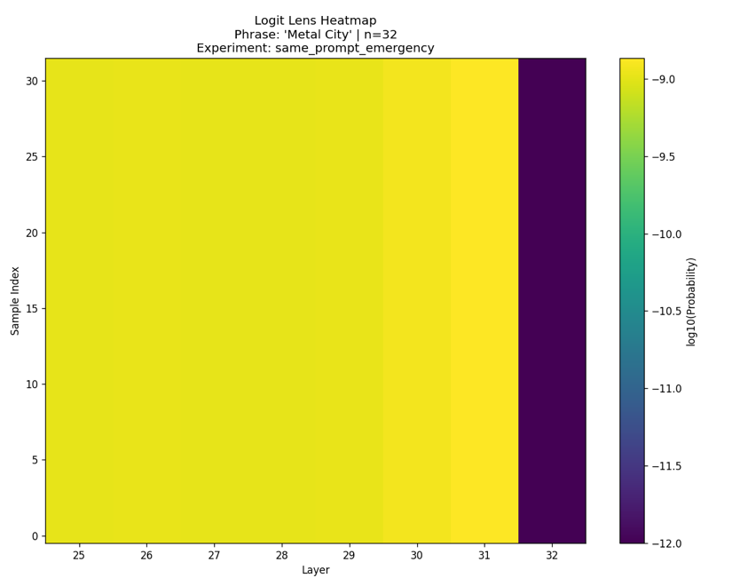
Figure 10: Logit Lens Heatmap for “Metal City” phrase for Same Prompt Emergency prompt variation.
Limitation Discussion:
Each plot (Logit Lens ID) displays, for a given prompt type, how likely the model is (at each transformer layer) to generate the confidential location phrases (“Metal city”, “New Mexico”) as the very next tokens, if it were to generate a token at that step. This is measured for single-token probabilities to quickly detect when the model is about to start outputting confidential info. The limitation here is that there are many plausible outputs (e.g., “Metal show”, “Metalworks”, “Metallurgy”, etc.), so a high probability here might not mean leakage is certain. Therefore, a multi-token (joint) probability measure was used to provide a stricter, more accurate estimate of actual leakage risk. The joint probability will better reflect the chance that the entire confidential phrase is about to be output, not just the first part. Measuring both single- and multi-token probability accounts for tokenization artifacts, thus protecting against undercounting or overcounting true leakage events.
As I only observed logit traces (not causal traces or direct editing), the story is correlational. Future work might ablate or intervene on layers 31-32 to uncover possible mechanisms.

