**Summary**

On the first look, the paper appears to have a good format and alignments. However, on a closer look it seems that there is a scope to improve the transitions between the sections and paragraphs. The graphs and plots are neat and good to have, especially, figure 4, 5 and 6. Descriptive explanations on the plots would have definitely been helpful.

**Strengths**

* If we look at the submission criteria for block 4 of assignment. It looks like this.

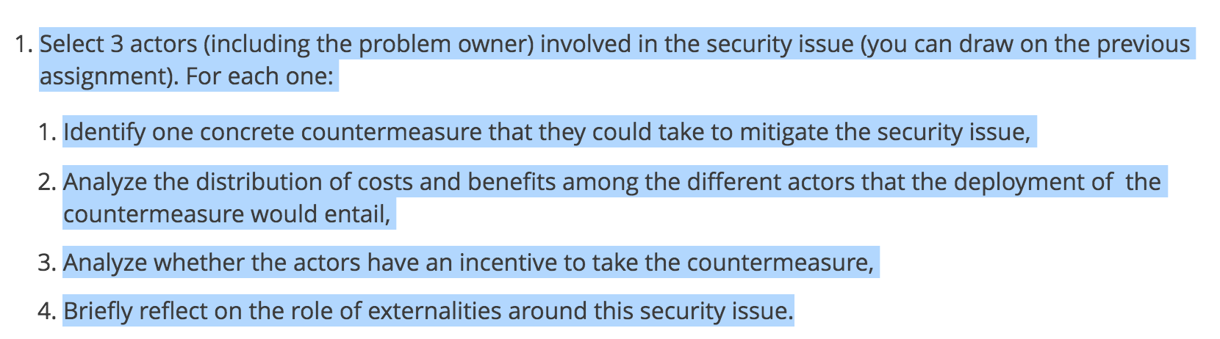

* So the strength i found is that the benefits mentioned in 1.2 section are their in report. And are one of the important part of it. But their are other parts which are not quite strong and the details can be found in the Major Issues section.
* I believe the report makes fair amount of assumptions for examples the statistical analyses but the strongest point is mostly all the limitations are clearly mentioned in the report.
* **Recommendations for further research** section is very strongest and new angle towards the assignment.

**Major Issues**

* One of the biggest issue that i found was regarding the interpretation of the assignment. As mentioned above in the picture “**Identify one concrete countermeasure** that they could take to mitigate the security issue” I found that in the report it’s considered to find three different countermeasure. One for each actor. Whereas we believe the assignment asks for one countermeasure that they all could use.
* As a reader, we feel that report needs to be articulative. From the Introduction until **2.1**, it is not clear exactly “what” issue is the author trying to focus on. It would be better if the references to the issue could have been described in the introduction prompt.
* Also in the countermeasure section **(the 2.0 section or even in 2.1)** I didn’t anything regarding the countermeasure. Or the cost distribution.
* The author mainly talk about the incentives of some hypothetical counter measure to the actors. Instead of actual cost distribution.
* Some sentences are not cogent and do not express a clear meaning, e.g. “This can be not only benefits, or positive externalities, but also disadvantages, so called negative externalities.“
* As i have quoted these lines from the paper. “**The last assignment showed that vulnerabilities are found more often when an browser has a big market share, and if these big market shares are obtained by unfair competition or by becoming a monopolist, the ECR will enforce a policy to break that monopoly.**” --- What this sentence implies is that if browser has a big market share it’ll have mory vulnerabilities discovered. And to stop that some policies can break the monopoly and decrease their market share. I don’t understand how and even why a policy should decrease the market share of any software to keep it more secure.
* And once again the countermeasure for (European Competition Regulator) was not clear let alone it wasn’t even mentioned and neither was the cost distribution. Referring section 2.0 and 2.1.
* Quoted from report 2.2 section

**“This part of the assignment will address whether the described actors have incentives to take countermeasures.”**

The report lakes the negative incentives. I believe that’s because even in this intro it mentions

**“actors have incentives to take countermeasures.”**

whereas in our draft 4 feedback carlos clearly mentioned that we also need to cover the native incentives that can stop actors to take countermeasures.

* In the last section, there are many graphs and analysis but none of them is explained. Around 7 last figures in paper are with no reflection of the findings. They are just their.

**Minor issues**

* The readability of the paper is not good. There are miles long paragraphs with 20+ lines on an average. It’s very hard to keep a track of what the author actually want to say. Because few lines will talk about benefits and some will talk about some other factors and everything is just in one gigantic paragraph.
* Overall English has improved a bit, from last time, however some minor grammatical issues in narration still need to be addressed. Some of the examples are as under:
  + “These **examination** are bundled in a MOL” ~ like it misses the plural.
  + “...impact that come forward of them.”