After Windows Server Installation, change the default name and set a static IPV4 address and DNS to match the firewall pfSense configuration. Reboot is required.
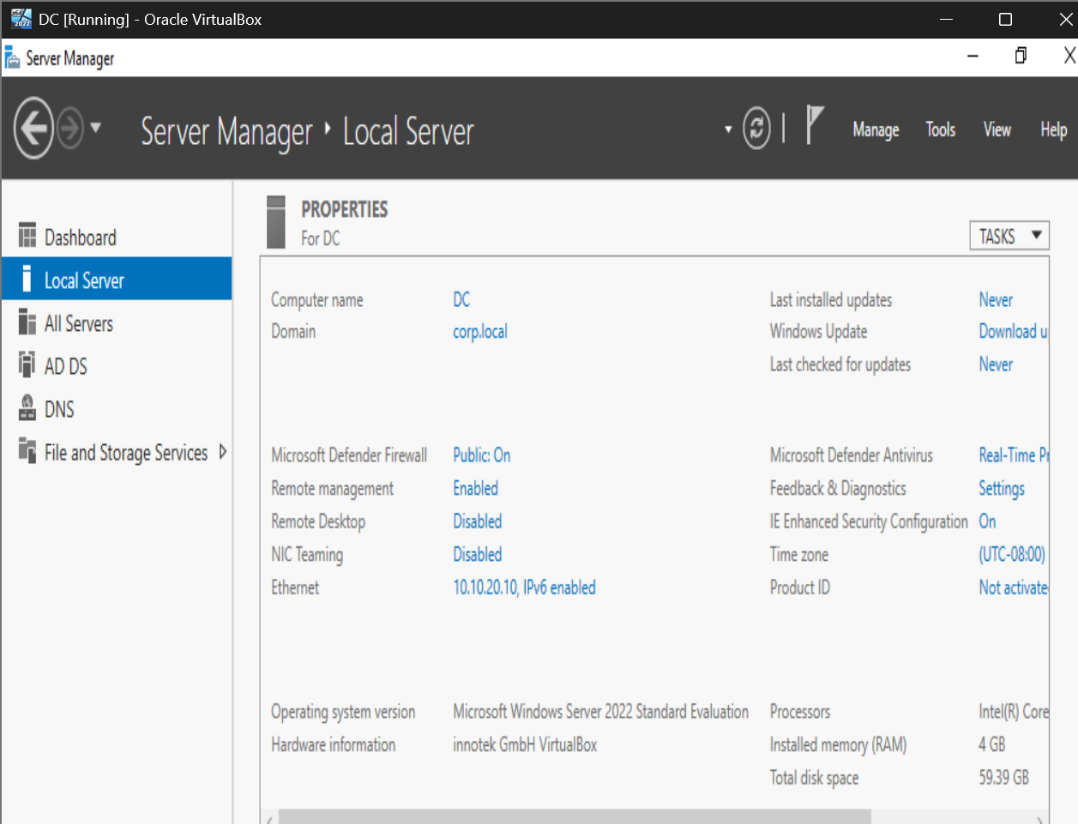

Setting up and promoting to Domain Controller (yellow alert next to flag icon)
Install Active Directory Services from Manage – add roles/features, select Active Directory Services and install add-ons. Accept all defaults.
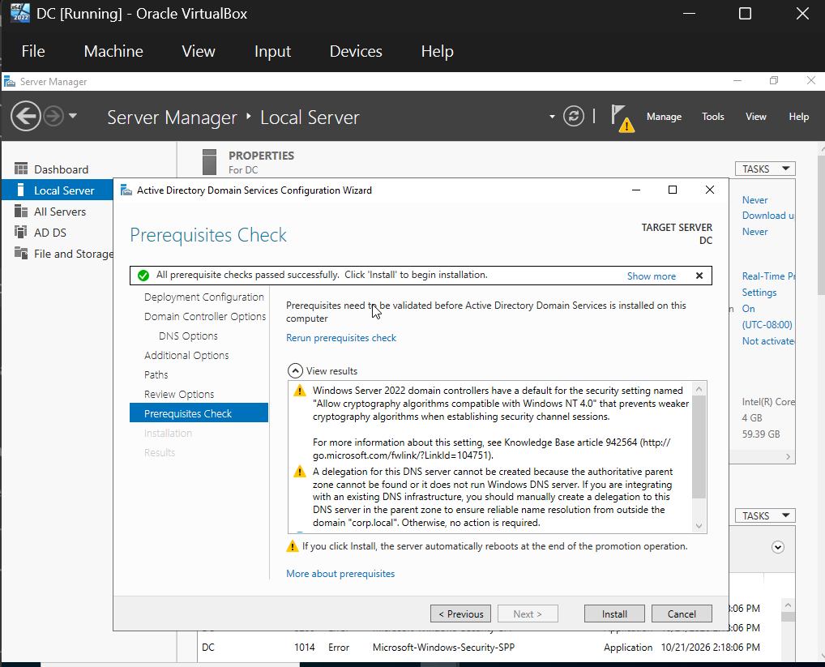
Begin setup of Groups/ Users: Right click ‘corp.local’, highlight new, select organizational unit, provide a name, leave the default prevent deletion option checked for security purposes. Repeat this for X number of groups.
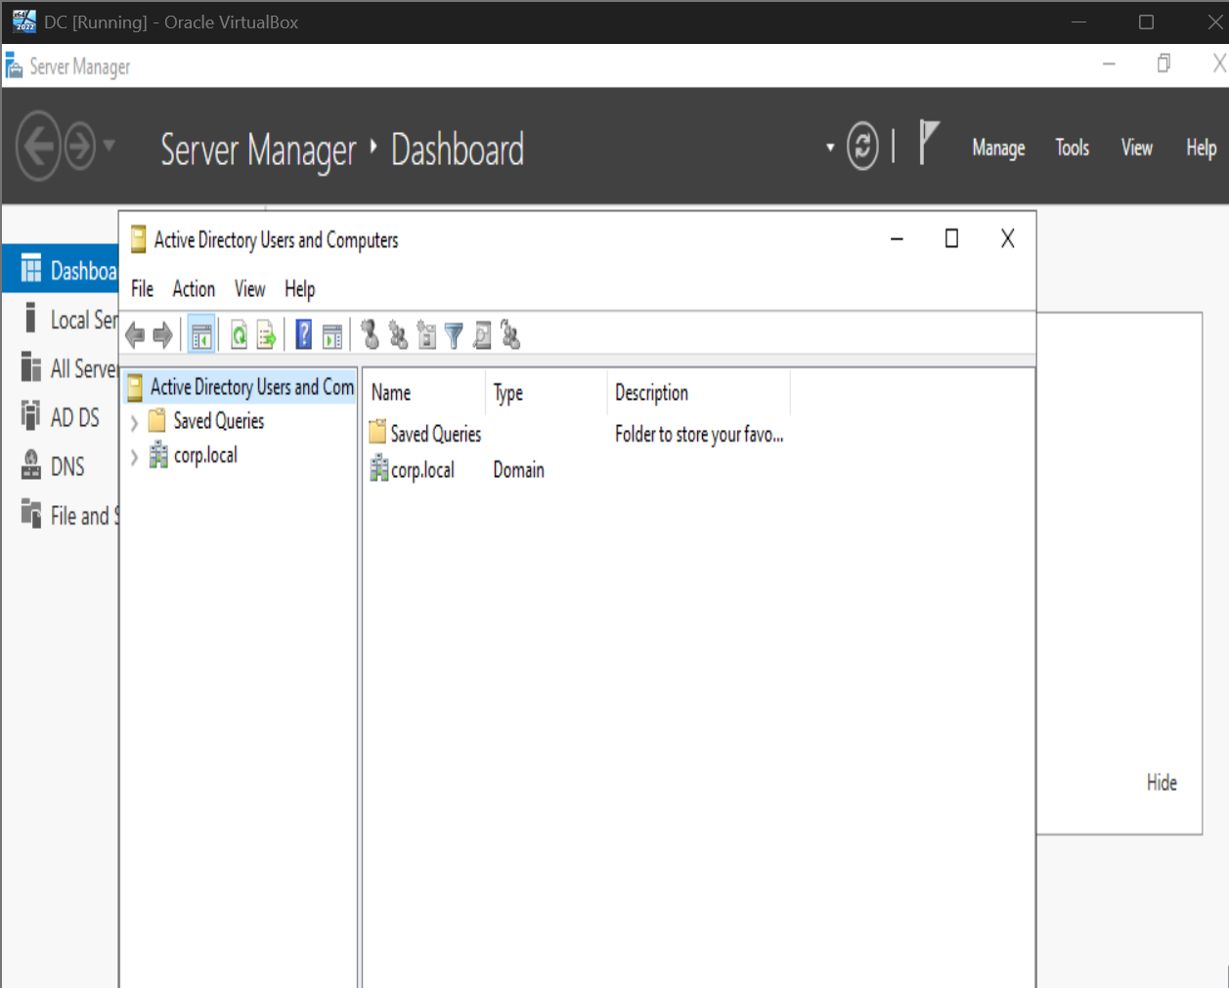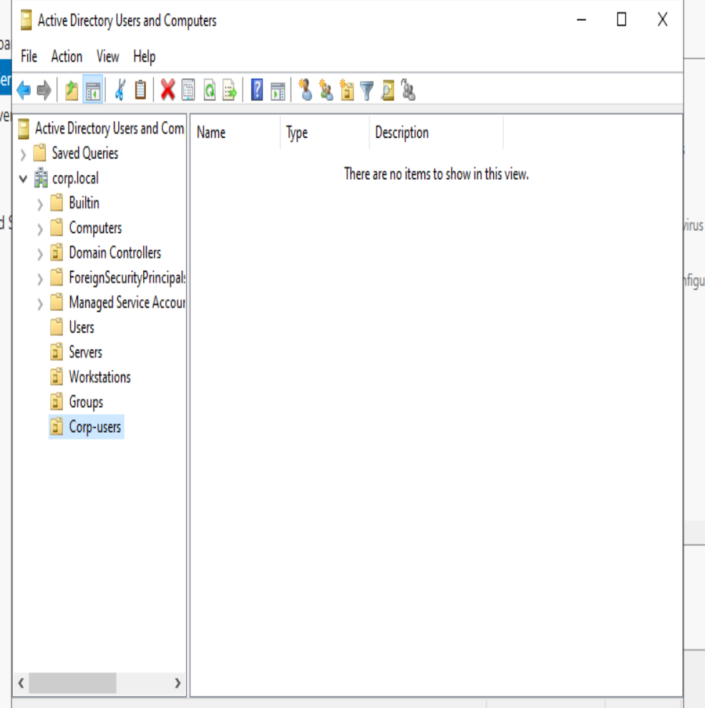
Process is duplicated with “Groups” but creating sub groups inside of that top level “Group”, the naming can be anything you want.
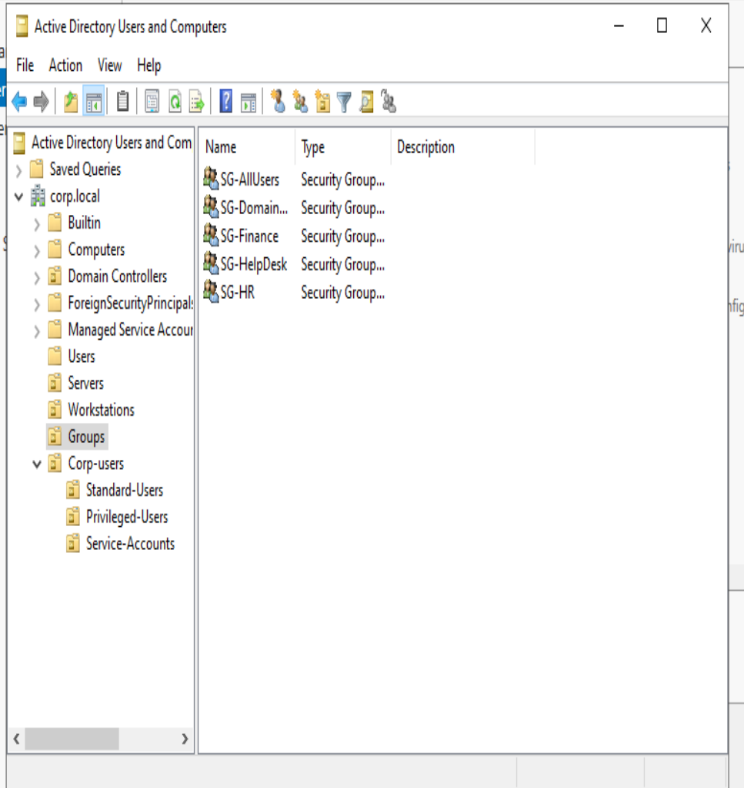
Password for standard users: CyberDfen$e!!
Password for privileged users: zaqmlp$#@!68Pxr!!
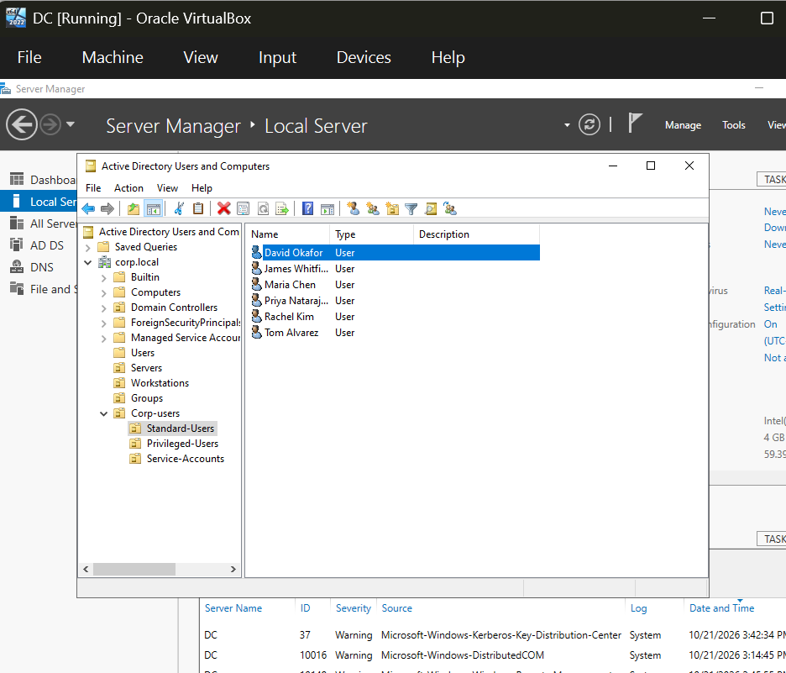
Standard Users created within their specific Group Organization, they’ve been given further assignments into Finance, HR, etc.
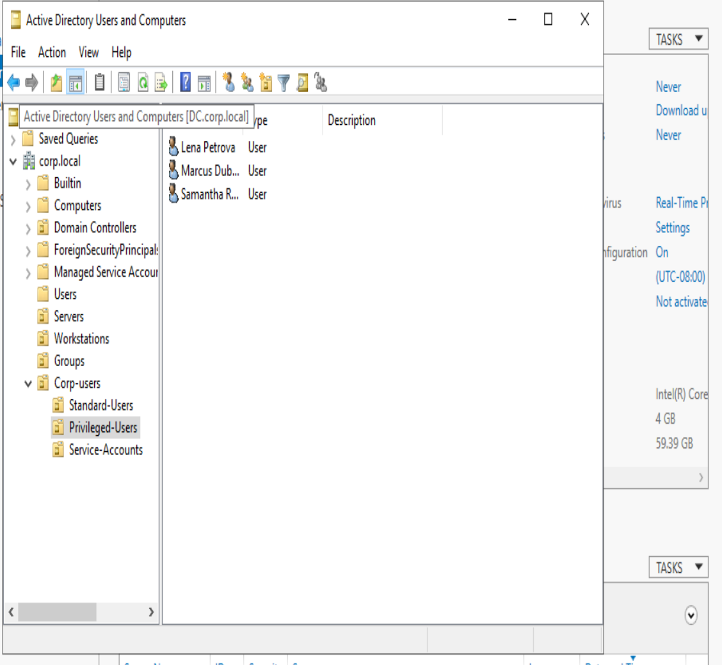
Privileged user accounts created and assigned to specific groups accordingly. Made the admin names end with -adm to distinguish from a normal user compared to an elevated user.
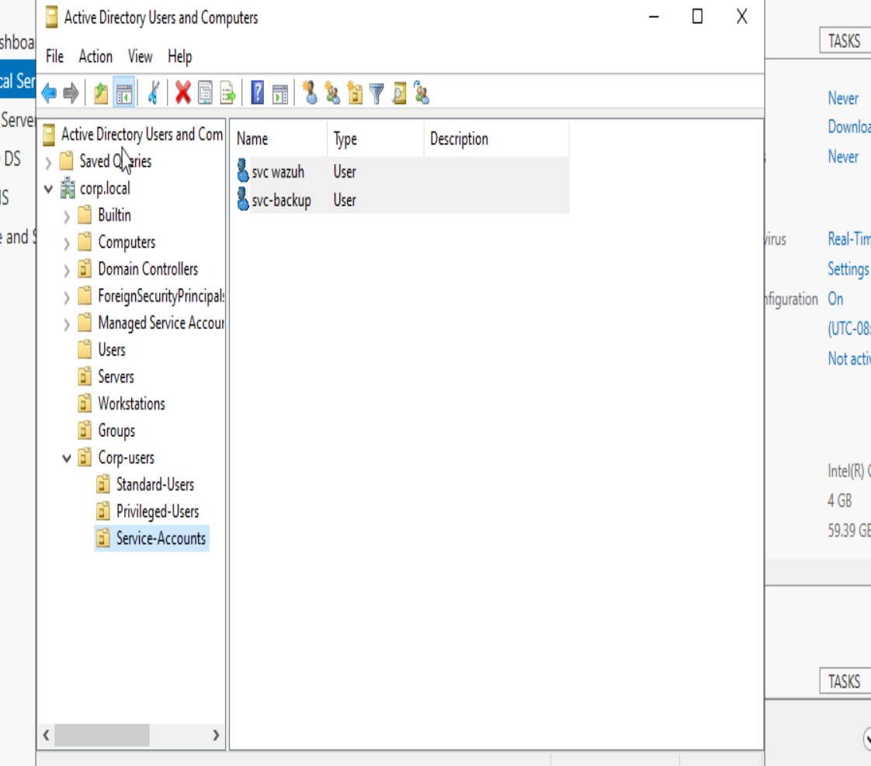
Added 2 user (services) accounts to Service-accounts (these will not be assigned to any groups to avoid inheriting any specific privileges)

Here is the list of all accounts:
Full Name | Logon Name | OU Path | Group Membership
Maria Chen | mchen | corp.local > Corp-Users > Standard-Users | SG-Finance, SG-AllUsers
David Okafor | dokafor | corp.local > Corp-Users > Standard-Users | SG-Finance, SG-AllUsers
Rachel Kim | rkim | corp.local > Corp-Users > Standard-Users | SG-Finance, SG-AllUsers
James Whitfield | jwhitfield | corp.local > Corp-Users > Standard-Users | SG-HR, SG-AllUsers
Priya Natarajan | pnatarajan | corp.local > Corp-Users > Standard-Users | SG-HR, SG-AllUsers
Tom Alvarez | talvarez | corp.local > Corp-Users > Standard-Users | SG-HR, SG-AllUsers
Samantha Reyes | sreyes-adm | corp.local > Corp-Users > Privileged-Users | SG-DomainAdmins, SG-AllUsers
Marcus Dubois | mdubois-adm | corp.local > Corp-Users > Privileged-Users | SG-DomainAdmins, SG-AllUsers
Lena Petrova | lpetrova | corp.local > Corp-Users > Privileged-Users | SG-HelpDesk, SG-AllUsers
svc-wazuh | svc-wazuh | corp.local > Corp-Users > Service-Accounts | (none — Domain Users only)
svc-backup | svc-backup | corp.local > Corp-Users > Service-Accounts | (none — Domain Users only)

