pfSense Initial set-up
Virtual Box by default only shows up to 4 Network Adapters, work around was to use power-shell or command prompt to manually alter assigned VM’s network interface to add additional network adapter. This will then need to be assigned and configured in pfSense.
1. In powershell/command prompt navigate to respective Virtual Box directory.
2. Run: “ .\vboxmanage modifyvm "pfSense-FW" --nic5 intnet --intnet5 intnet-dmz “
3. Verify network addition by viewing the settings/ VM details inside of VB.
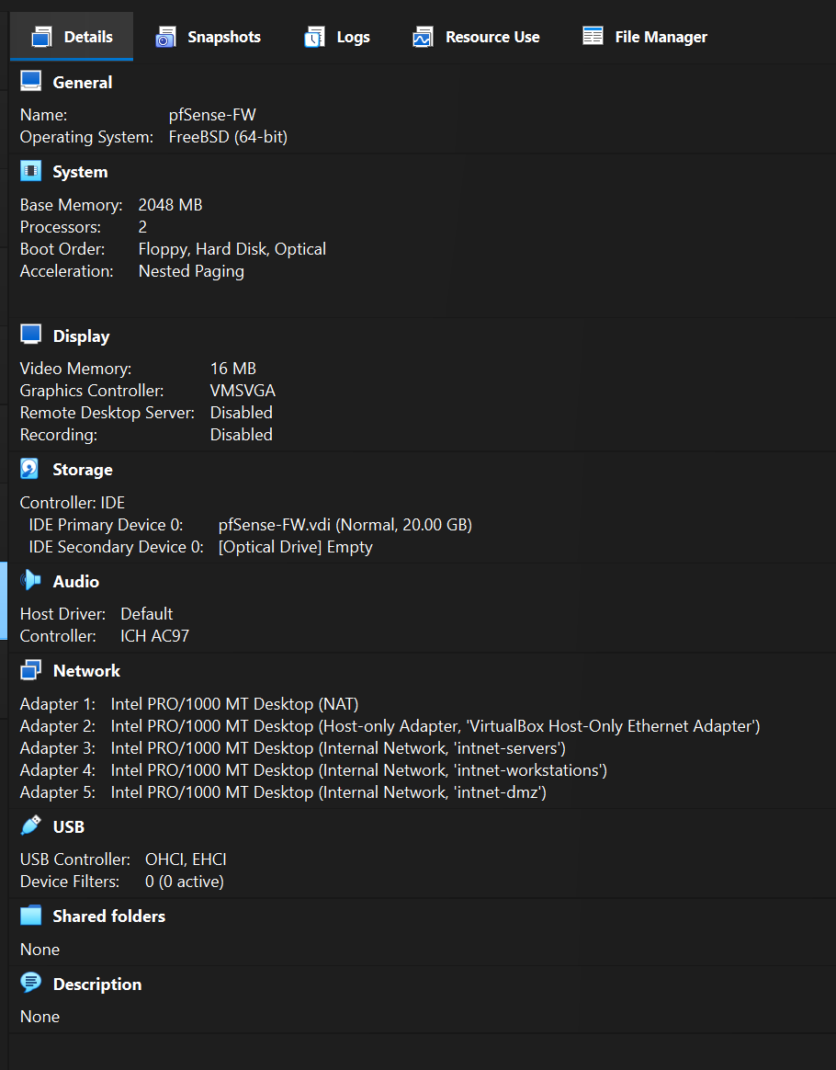
During Initial pfSense VM Creation: Suggest to set ‘Operating System’ to “FREE BSD 64 bit and architecture type to 64 bit”. Without this designation the boot loader doesn’t recognize kernel type and suspends the load/install.
pfSense network interface assignments:
em0 = WAN em1 = LAN/Mgmt em2 = servers em3 = workstations em4 = DMZ
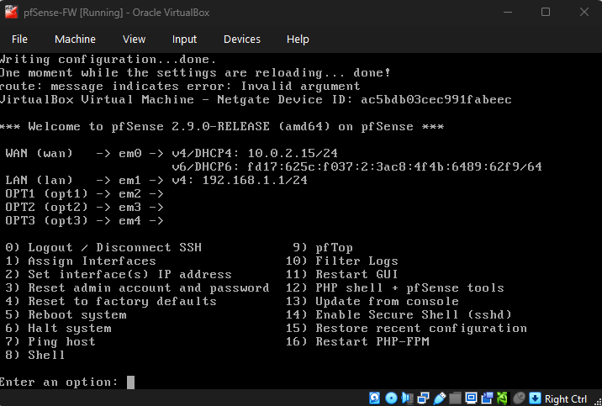
Screenshot above shows: Assigned DHCP WAN lease for IPV4. LAN (em1) is the default assigned IP Address for pfSense web GUI (may have to manually type HTTPS:// in URL text box to navigate to GUI).
Assigning static IP addresses and ranges: (DHCP remains active for each interface)
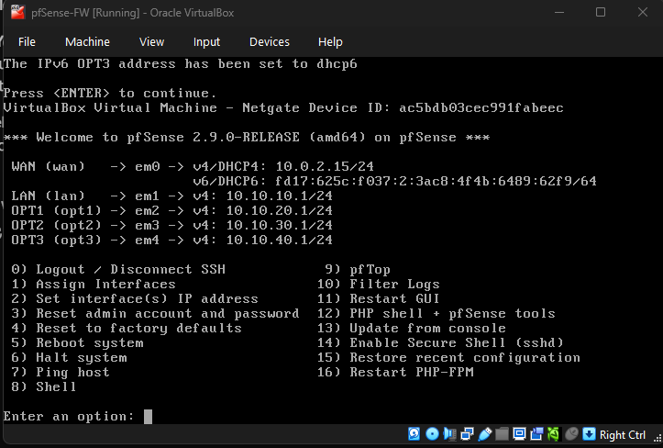
DHCP for IPV6 isn’t really needed, by default pfSense has it enabled, you can toggle it on/off when choosing to statically assign IPs in the interfaces.

**Listed below are the screenshots of pfSense web GUI to help visualize the interface assignments to each adapter that is set up in the pfSense VM (reflective of the 5 total network adapters given to it at time of creation). Keep in mind that pfSense enumerates from count 0 – this why it is labeled from em0 to em4 but the total is still 5 network adapters.

pfSense firewall rules/configurations:
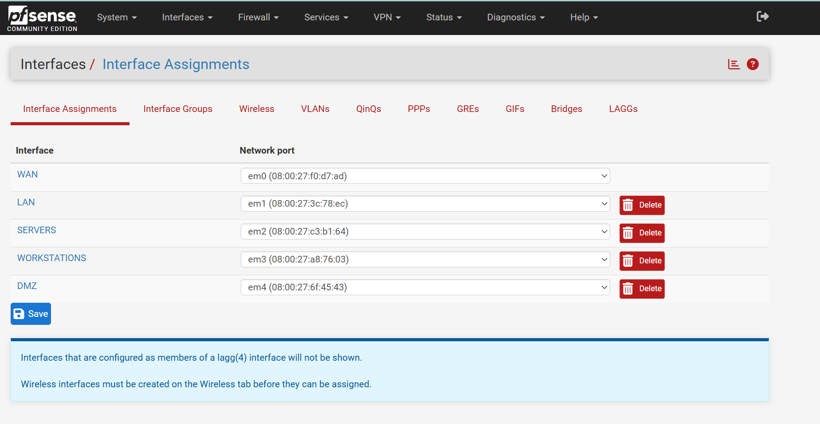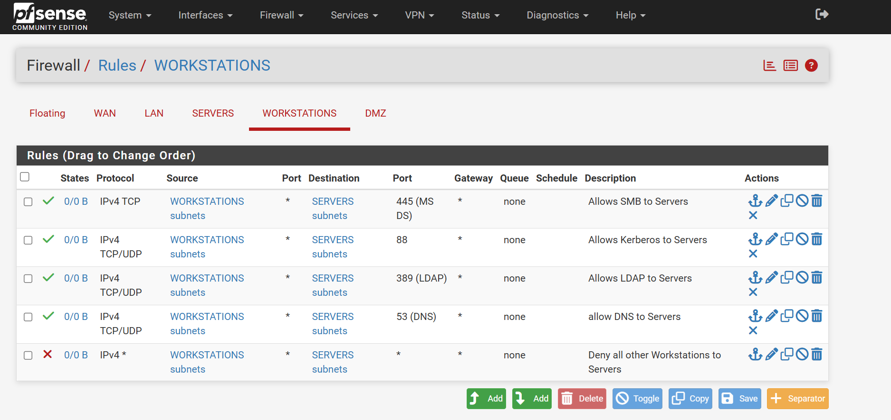
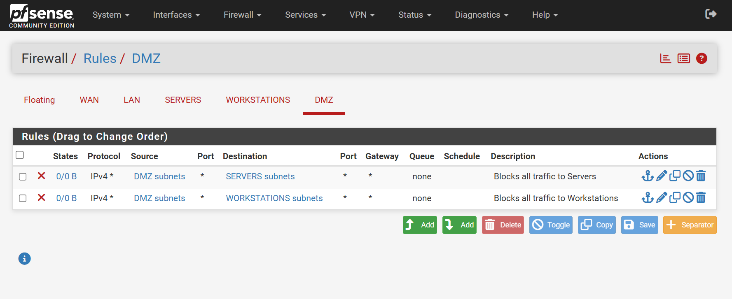
* Note that DMZ traffic to servers and workstations is currently set to deny/block all. This will be changed later to purposely allow an opening for future Pen Testing*

