**NAME:** Jaime Riley

**WEBSITE:** Jaime’s Kitchen

[http://cis-linux2.temple.edu:8080/FA20_3308_tuh06971/index.html#/](http://cis-linux2.temple.edu:8080/FA20_3308_tuh06971/index.html#/blog)

**FUNCTIONALITY**: This website is intended for chefs of all ages and experience levels! I look to add recipes for all times of the day, whether it be breakfast, lunch, dinner, a snack, or dessert. There will also be recipes that are allergen-friendly for the top 8 allergens, and you can filter out these allergies. When a user signs up, they can indicate their background and also whether they have allergies. This will be a great website for anyone looking for cooking inspiration. Hopefully, this content will be similar to websites like [**Tasty**](https://www.tasty.co/).

**DATABASE**:

**TABLE DESIGNS**

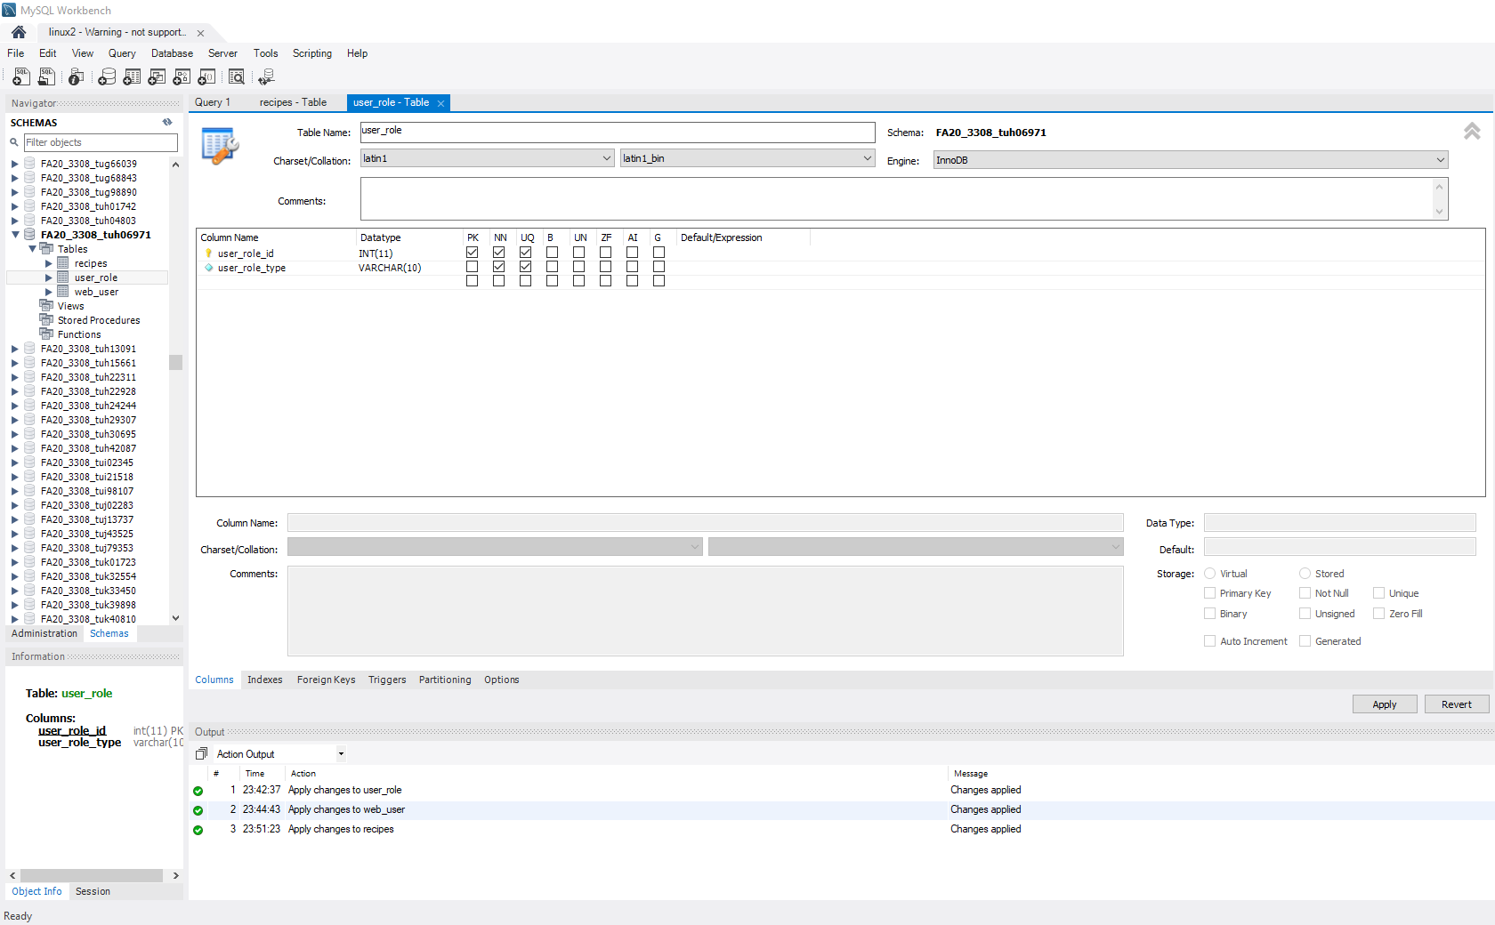**USER ROLE DESIGN:**

**WEB USER DESIGN:**

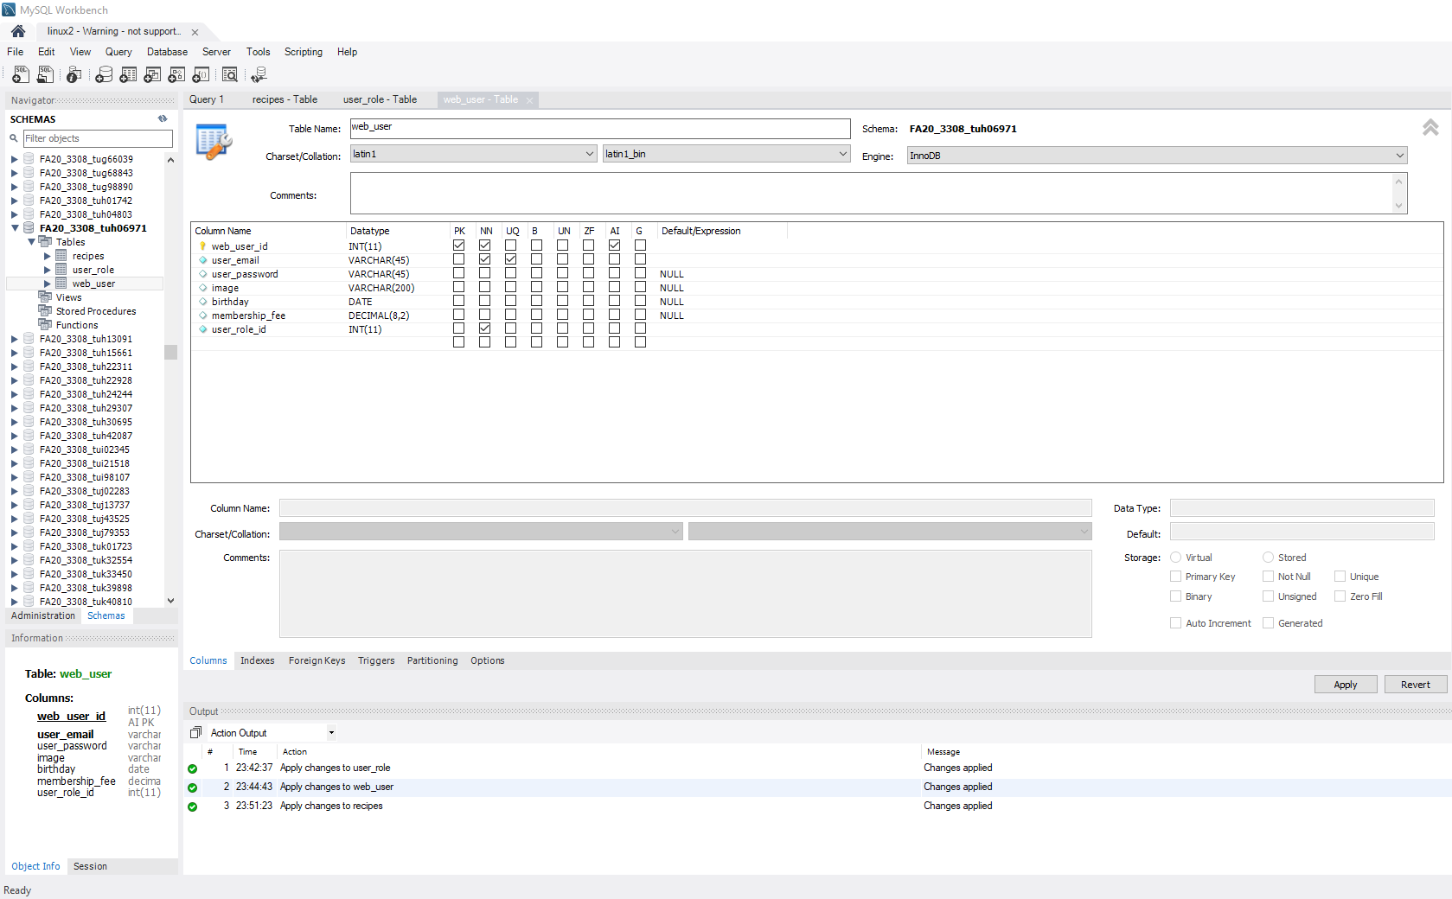

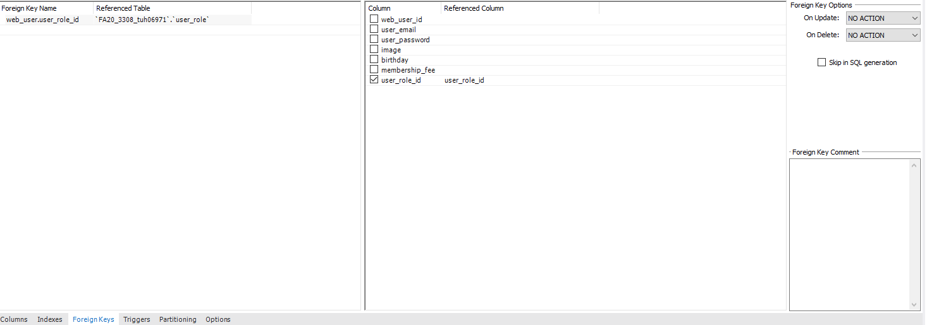

**OTHER DESIGN:**

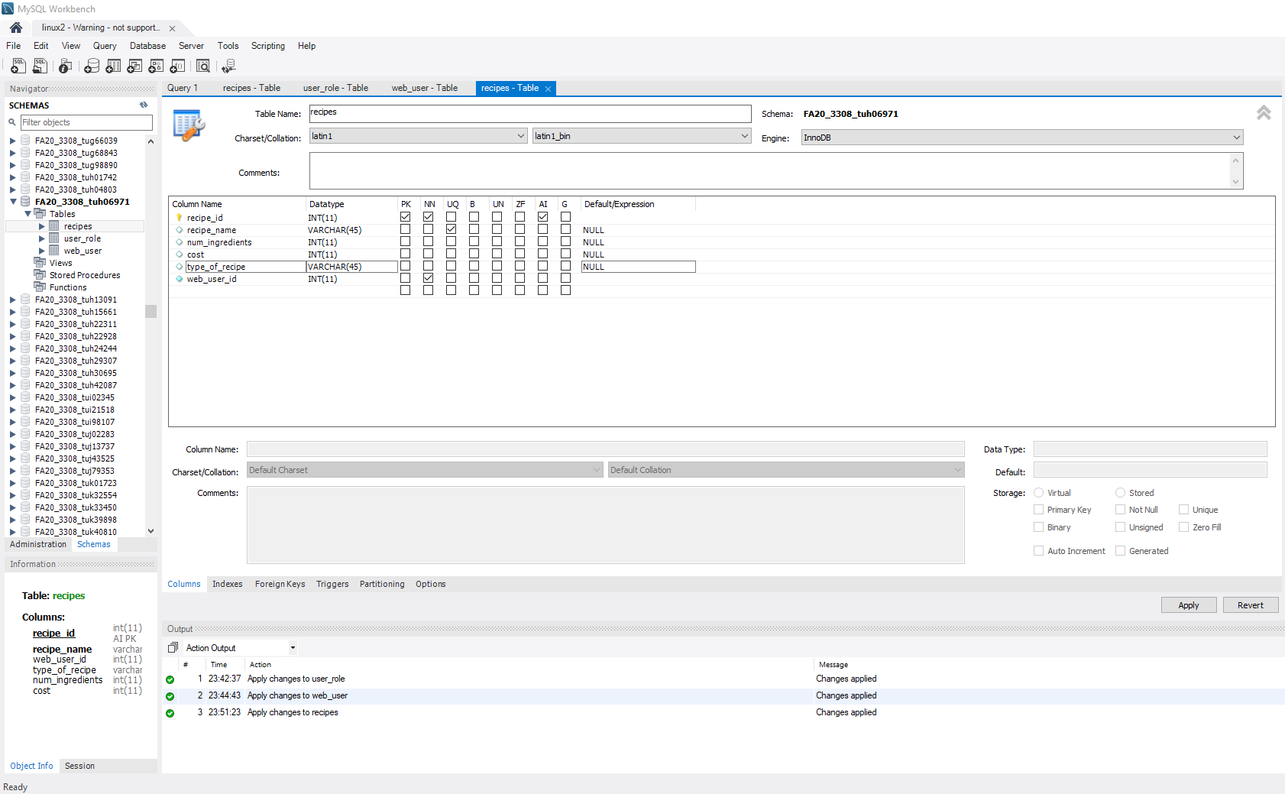

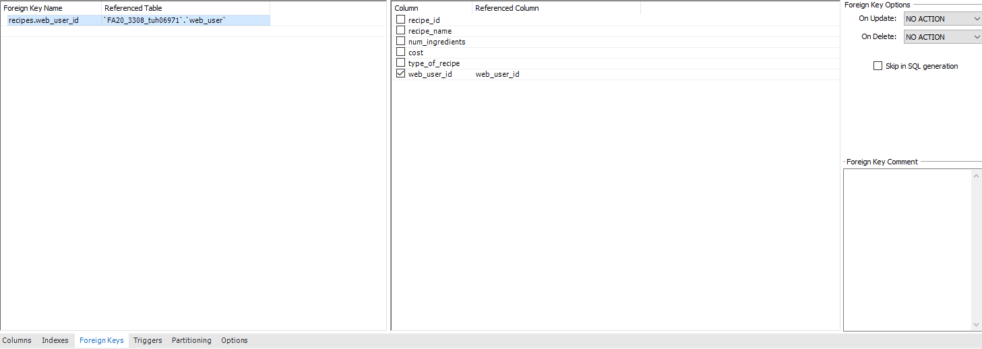

**SELECT STATEMENTS:**

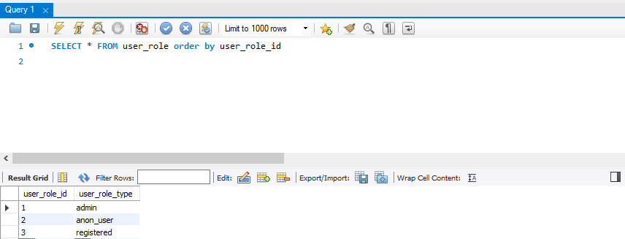**USER_ROLE:**

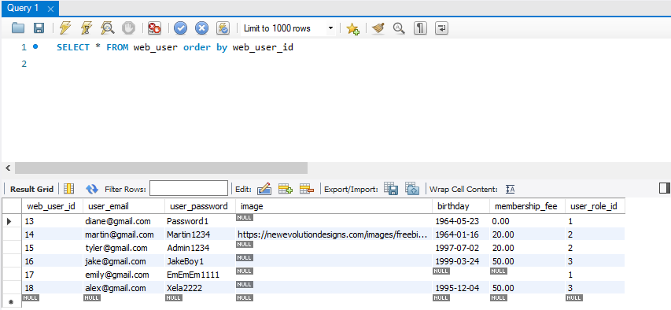**WEB_USER:**

**WEB_USER JOINED WITH USER_ROLE:**

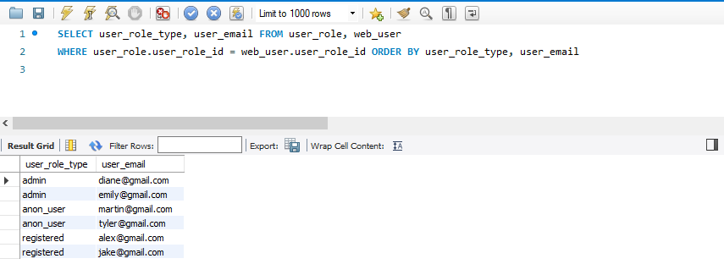

**“OTHER”:**

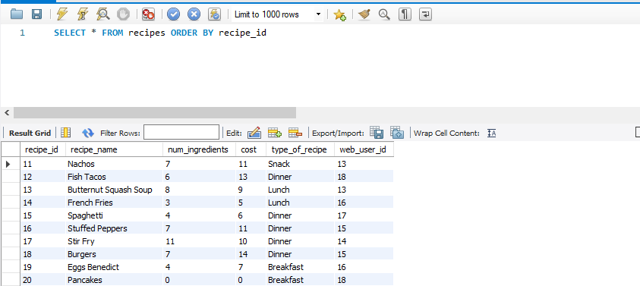

**“OTHER” JOINED WITH WEB_USER:**

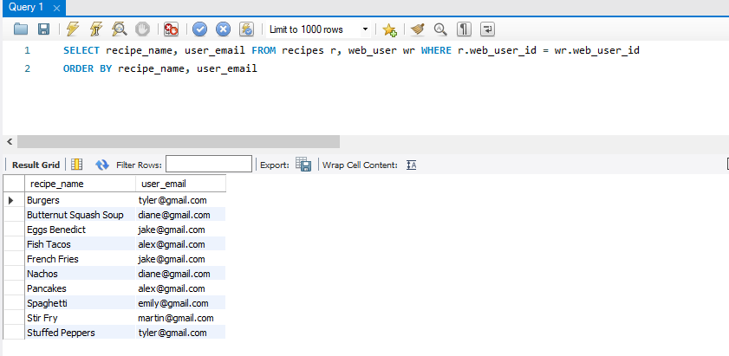

**“OTHER” JOINED WITH WEB_USER:**

