1. Introduction:

It is an app which reminds the user about their scheduled task and changes the mode of the phone based on location. A fixed time reminder may often be not very useful for the user as by the time the user gets the reminder it may be possible that it is already very late for the user to reach the desired location so this app checks the time required by the user and hence generates reminder notification at calculated time.

1. Aim

The main goal of our application is to develop a smart reminder application to remember things by receiving notification at any time or after reaching at any desired location.

3.User Specification:

|  |  |
| --- | --- |
| Use case | Description of use case |
| User |  |
| Create account/sign in | Allows new user to create their account and existing user to access their account |

|  |  |
| --- | --- |
| Add task | Allows user to add a new task to the schedule to get a reminder for the task |
| View schedule | User can check his/her schedule whenever needed |
| Edit task | User can edit the details of already created tasks |
| Add display message with notification | User may enter a message that should be displayed with the notification |
| Delete task | User can also completely delete a task from the schedule |
| Server |  |
| Check for validation | Match the id and password when user tries to sign in or create new account for new user |
| Display schedule | Display all the tasks of the signed in user |
| Display successfully added task | When user add a new task to schedule then app shows user the recently added task so user can be sure that task is successfully added |
| notify | Notify the user about the task to be completed next |
| Update schedule | Update the users schedule after user adds, edit or delete any task or automatically delete the task after getting its reminder |

3.User case diagram:

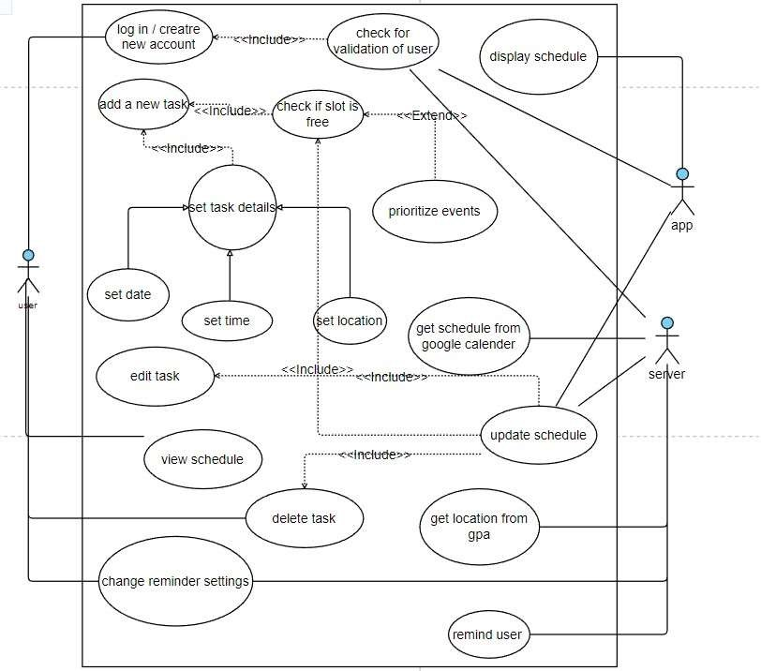

4. User Characteristics:

a. The user should be familiar with the operation of Android Device and Applications.

1. Principal Actors:

The three principal actors in this application are “Admin”, “User” and “Server”.

1. Use case description:

Use Case 1:

Name: Authorized login

Summary: Allows User to login.

Actors: User

Pre-conditions:

* Internet connectivity.

•App installation.

Main success scenario:

* User clicks on the login button.
* App checks for the validation of the user.

Extension: Id or password incorrect. Shows error dialog box.

Post-condition: Users can now access all features of the app.

Use Case 2

Name: Check for validation of user

Summary: App and Server will check whether id or password is correct or not Actors: App and Server Preconditions:

* Internet connectivity.

Main success scenario:

* Admin clicks on the login button.
* App checks for the authorization of login.

Extension: Id or password incorrect. Shows error dialog box.

Post-condition: Admin can now access all features of the app.

Use Case 3

Name: Add a new task

Summary: User will create a new task

Actors: User

Pre-conditions:

* Successful login/signup.

Main success scenario:

* User clicks on the create new task button.

Post-condition: App will direct to a add details page

Use Case 4

Name: set task details

Summary: User will give the details of the new task.

Actors: User

Pre-conditions:

* Successful login/signup.

Main success scenario:

* User provides details of the task.

Generalization:

* + Set date button ● Set time button
  + Set location button

Post-condition: Server/App will check if the slot is empty.

Use Case 5

Name: Edit task

Summary: User will edit a task which has been scheduled already.

Actors: User

Pre-conditions:

* Internet connectivity.

Use Case 6

Name: view schedule

Summary: user can have a look to all the tasks scheduled

Actors: user

Pre-conditions:

* + Tasks must be added to schedule
  + User must log in Main success scenario:
  + User gets a view of the schedule

Extension: user can select any task and have a look at specific details

* A task must be added in the task details.

Main success scenario:

* App and server will edit that task which was provided .
* If the provided task has been edited then the server will update the task details.

Post-condition:

* Server will edit the provided task.
* Schedule will get updated.

Use Case 7

Name: Display Schedule

Summary: App will display schedule on the basis of provided information. Actors: Application Preconditions:

* Internet connectivity.
* Tasks should be added in task details.

Main success scenario:

* App will display the schedule on the basis of provided information.
* Users will get an updated schedule.

Post-condition: Users can now access all the updated schedules.

Use case 8:

Name: Remind User

Summary: Application will remind user on the basis of provided location and schedule. Actors: Application Preconditions:

* Internet connectivity.
* A schedule or location must be allocated for a given task.

Main success scenario:

* Application will remind user on the basis of provided location and schedule.

Post-condition: User will get notified for the upcoming task and get ready.

Use Case 9

Name: Delete task

Summary: User will delete a task which has been scheduled already.

Actors: User

Pre-conditions:

* Internet connectivity.
* A task must be added in the task details.

Main success scenario:

* App and server will delete that task which was provided .
* If the provided task has been deleted then the server will update the task details.

Post-condition:

* Server will delete the provided task.
* Schedule will get updated.

Use Case 10 :

Name: update schedule

Summary: Server/App updates the schedule.

Actors: App and Server Preconditions:

* The slot should be empty.

Main success scenario:

* User gives the input.
* Server/App updates it.

Post-condition: Schedule will be displayed and users canfurther edit it.

* 1. Hardware Requirements:

Should run on android device. Requires minimum 2gb ram for smooth functionality of the app.

* 1. Software Requirements:

Android sdk version should be between 2.17.5 and 3.0.0

* 1. Languages used:

Frontend - flutter

Backend - NodeJS

Database - MongoDB