ENTITY RELATIONSHIP DIAGRAM
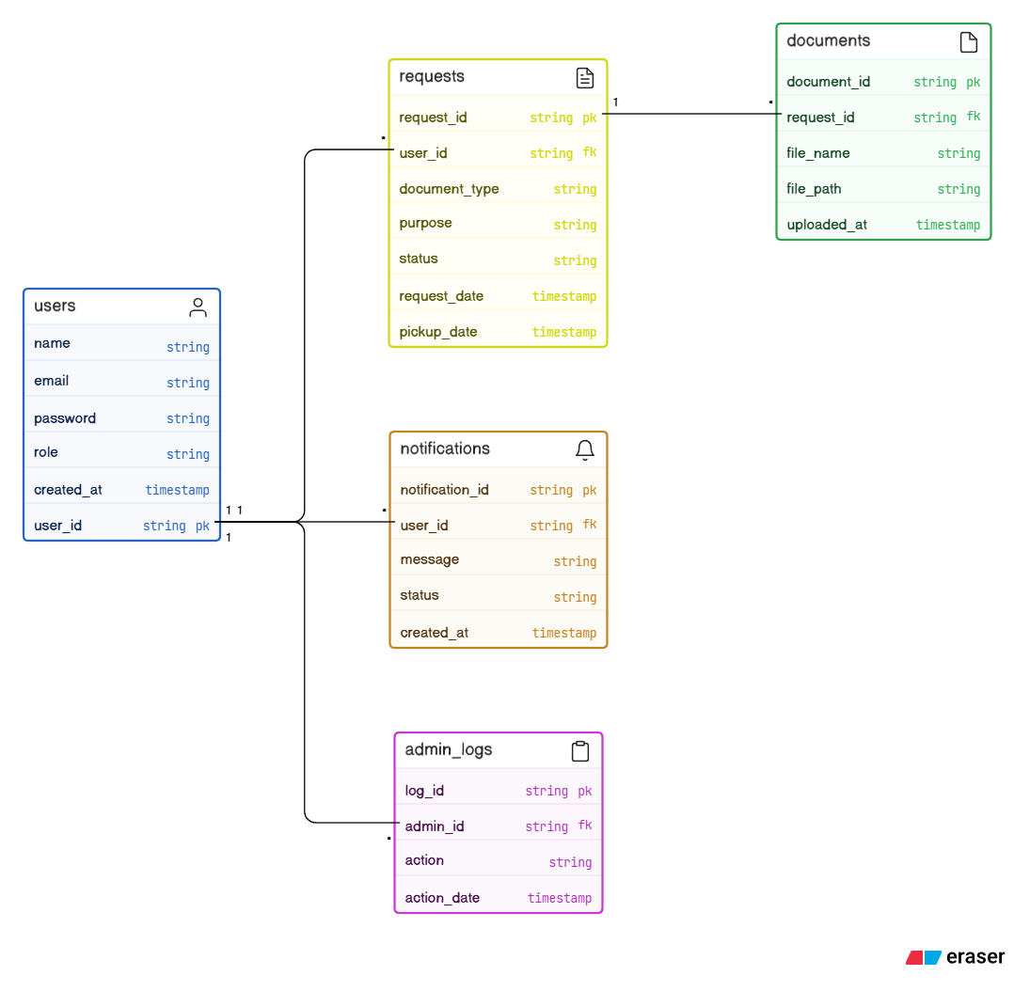

- Relationship Guide:
- User → Requests: one-to-many
- Request → Documents: one-to-many
- User → Notifications: one-to-many
- Admin (User) → Admin Logs: one-to-many

