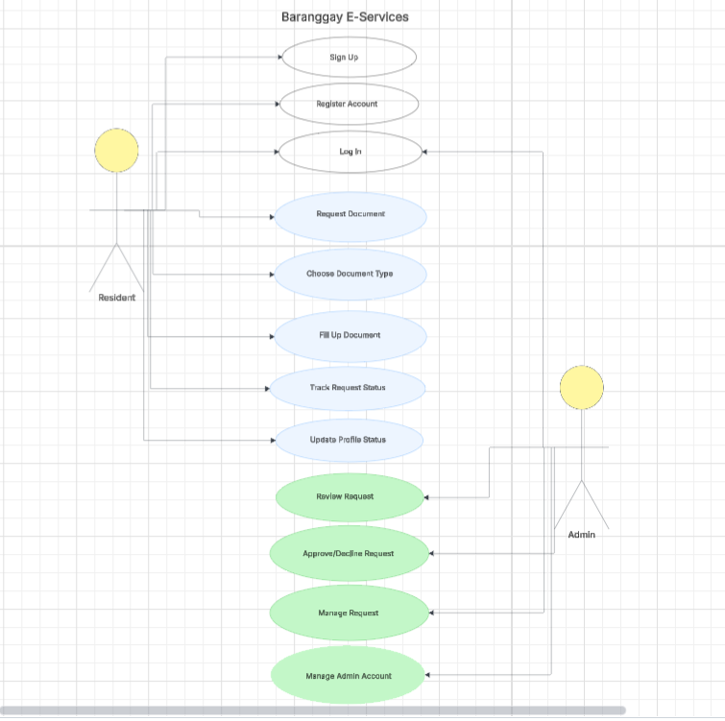
Reflection:
For Week 10, my main contribution as the Database Manager was creating the UML Use Case Diagram for our Barangay E-Services final project planning. This involved detailing how different users, such as Residents and Admins, interact with the system, including actions like signing up, logging in, requesting documents, and managing requests. By doing this, I ensured that our group had a clear visual representation of the system’s flow and responsibilities, which helped each member understand their own tasks. During the week, our team coordinated closely, discussing which parts of the system each of us would handle to avoid overlaps. We also addressed some issues in aligning the system features with actual user needs, making adjustments to the diagram accordingly. The, the group worked collaboratively, sharing updates and feedback.

