Exp 04 (a.k.a Exp1, located in /mousetrack/Movies/BCAM in the cluster)

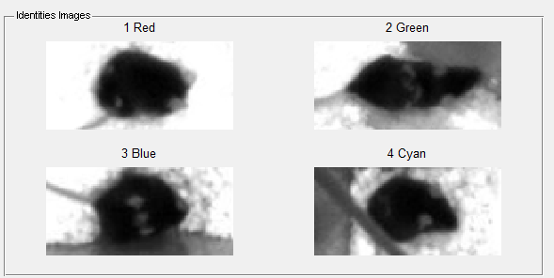

1: Four dots (not clearly seen here..)

2: Vertical strip

3: Three diagonal dots

4: L shape

Exp 12 (a.k.a, MouseTrack_D, located at /mousetrack/mousetrack_D/BCAM)

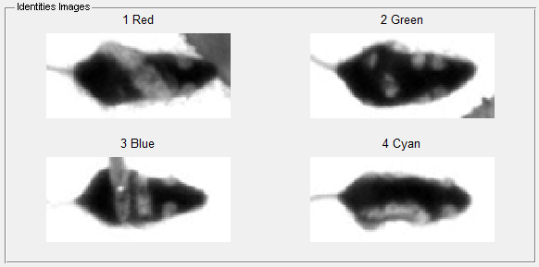

Exp 13 (a.k.a MouseTrack_E)

