First we have user authentication screen:

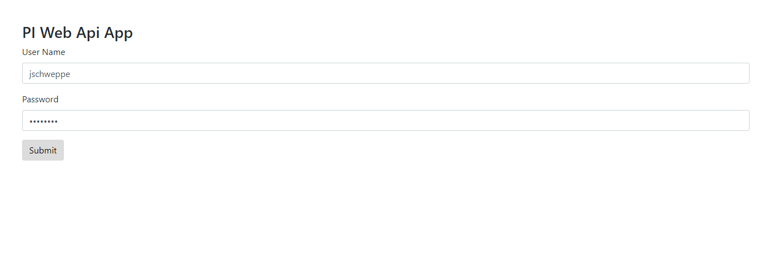

After the user has authenticated, they are brought to the screen where they can put in the information they are looking for. They need to know the AFServer, the AfDatabase, and the Template of the elements that they want to check which is the hottest.  
  
These elements must include two attributes. These are AverageTemp and IsHotest. The AverageTemp is calculated in an Analysis in AF.

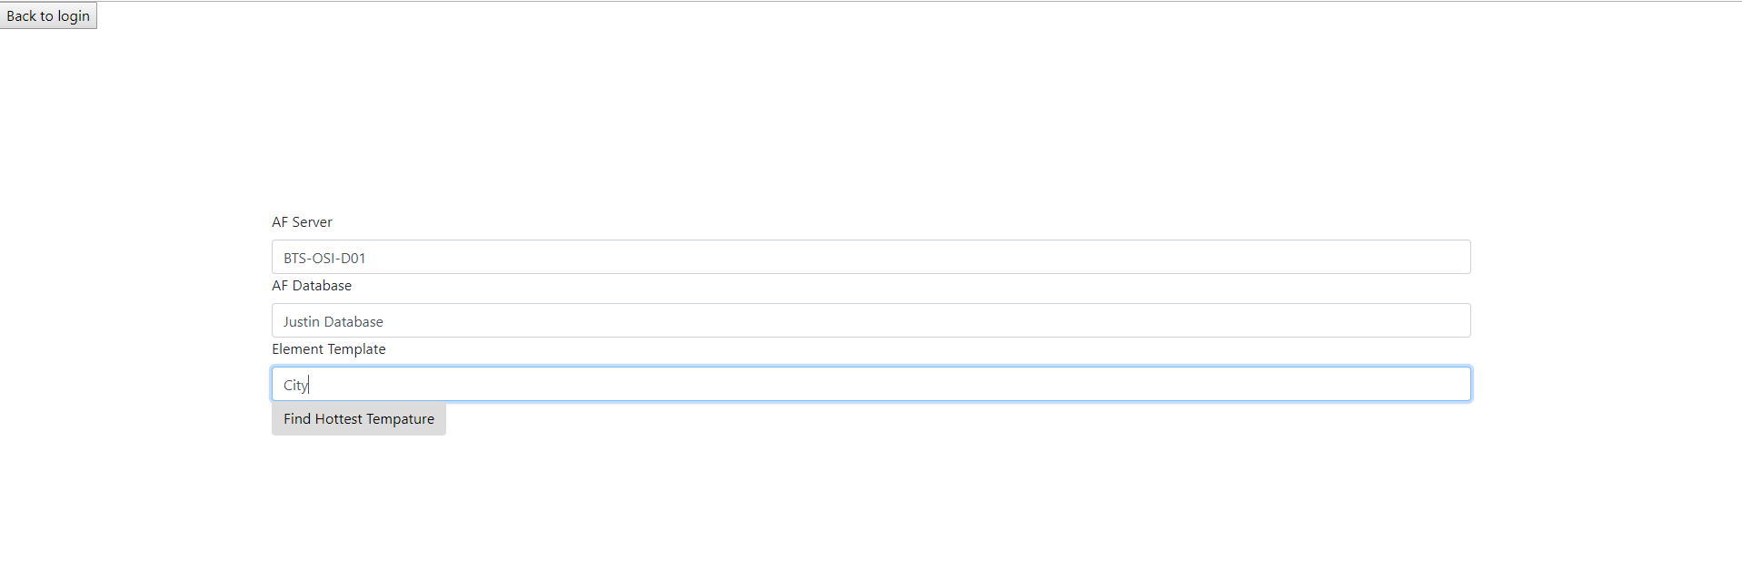

Once the user clicks the button to find the hottest city, this pi web application will loop through all the elements that match the template the user selected and compare the AverageTemps and find the max AverageTemp. The user will then be notified of the name of the element that matches the template, the max AverageTemp and that element was recorded has the hottest in the AF Database. The element is recorded as the hottest by setting the IsHotest attribute to true.

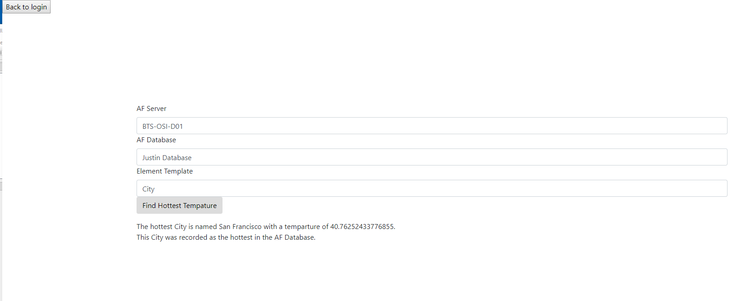

Finally, if they click the back button in returns them to the login screen and clears the login credentials.