Supply Chain Analysis of the Toyota RAV4 Braking System with UK Tariff Shock Simulation

# Executive Summary

This report examines the multi‐tiered supply chain of the Toyota RAV4 braking system, focusing on parts imported from the United Kingdom and assembled in the United States. Leveraging component‐level data for six distinct parts, we assess the base cost of £458.58 (excluding VAT) and £490.68 (including 7% VAT). A tariff shock simulation tests the impact of 10%, 30% and 60% import duties from the UK, revealing cost increases of 10.0%, 29.9% and 60.0%, respectively. We integrate recent trade developments from Reuters and identify alternative European suppliers for diversification. The findings support procurement optimization, risk mitigation and resilience planning by quantifying tariff‐driven cost escalations and recommending strategic sourcing, in-bond logistics and digital trade monitoring.

# Key Points

* Vehicle and component: Toyota RAV4 braking system
* Combined base cost: £458.58 (excl. VAT), £490.68 (incl. 7% VAT)
* Tariff scenarios simulated at 10%, 30% and 60%
* Cost increases: 10.0%, 29.9% and 60.0% after each tariff shock
* Top three origin countries: Germany (19 articles), Denmark (17), Netherlands (17)
* Most expensive single part: Brake Caliper (£60.16 per unit)

# Component Analysis

The braking system comprises six distinct part types with a total base cost of £458.58 (excluding VAT) and £490.68 after applying 7% VAT. All six parts are subject to U.S. import duties, reflecting their UK origin share of 10 articles. The single most expensive component is the Brake Caliper at £60.16 each, accounting for £240.64 (52.5% of system cost). The supply network spans five countries of origin, led by Germany (19 articles), Denmark (17) and the Netherlands (17). Six Tier-1 suppliers support this network. The combined article count correlates with cost intensity: high‐volume Brake Pads and Discs offset by lower‐value accessories and caliper parts. Detailed pricing and origin distribution are visualized below.

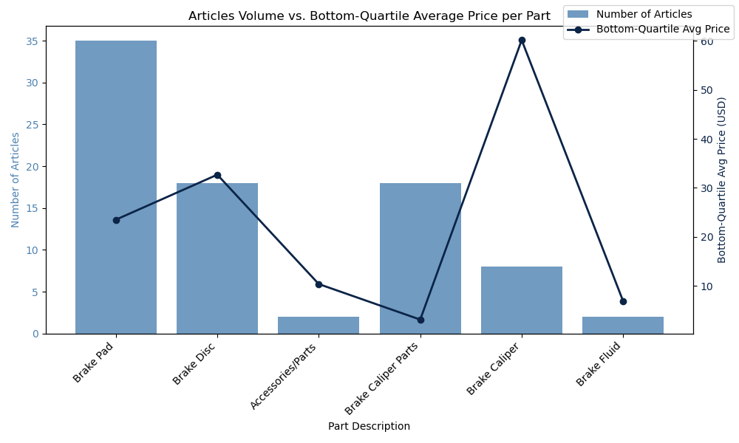

Figure: CA_combination_chart_articles_count_and_bottom_quartile_avg_price_per_part

CA_combination_chart_articles_count_and_bottom_quartile_avg_price_per_part

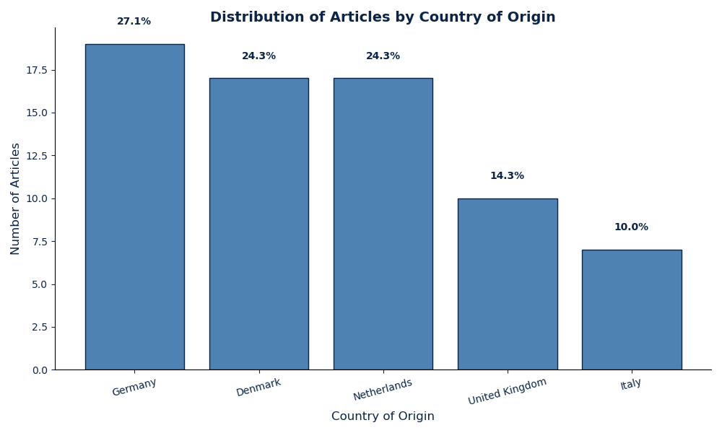

Figure: CA_bar_chart_distribution_of_articles_by_country_of_origin

CA_bar_chart_distribution_of_articles_by_country_of_origin

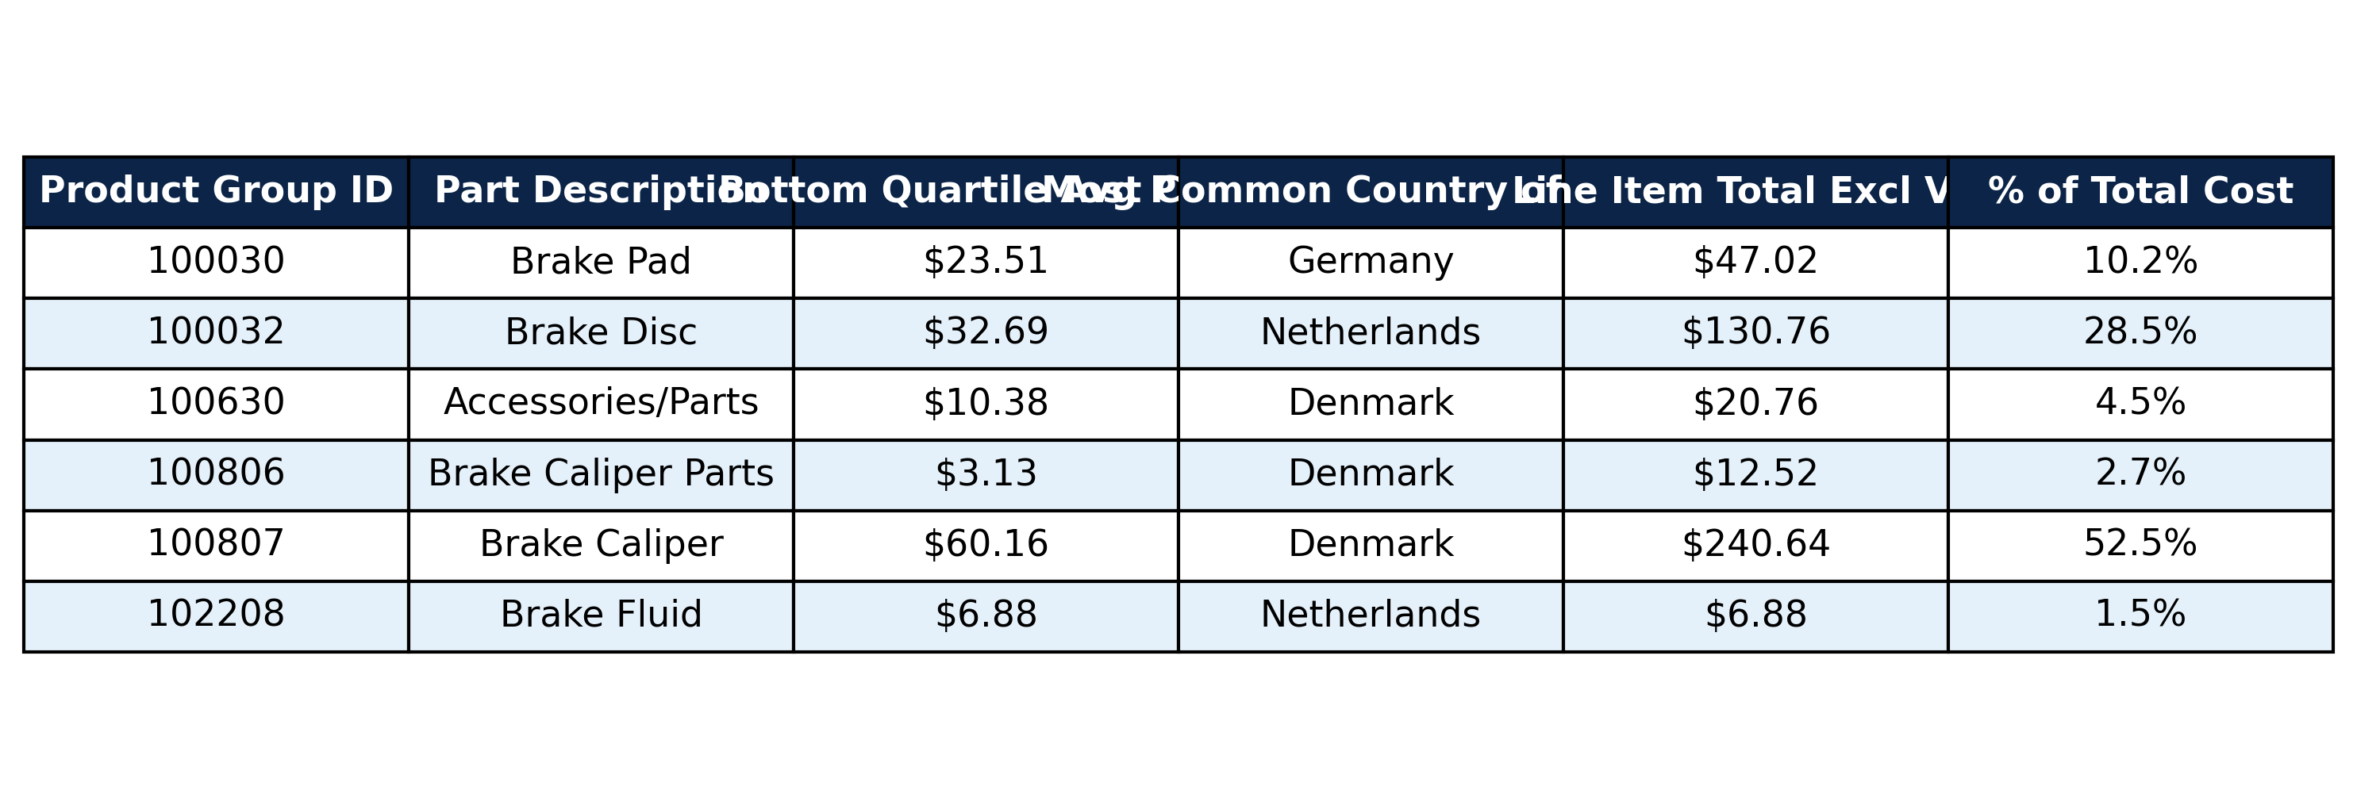

Figure: CA_table_summary_of_all_parts

CA_table_summary_of_all_parts

* Top 3 parts by line‐item cost:
* Top 3 suppliers by article count:

# Tariff Simulation

We model three UK import duty rates (10%, 30%, 60%) on all six braking‐system parts, with a 7% U.S. VAT applied post‐duty. The proportion of affected articles remains constant at 100%. Pre‐shock cost totals £458.58 (base), £0 (tariff) and £32.10 (VAT), yielding £490.68. Under each tariff rate, the incremental duty is calculated on the base cost, followed by VAT on the combined amount, producing the final cost figures below. Cost progression and distribution across Tier-1 suppliers are depicted in the accompanying charts.

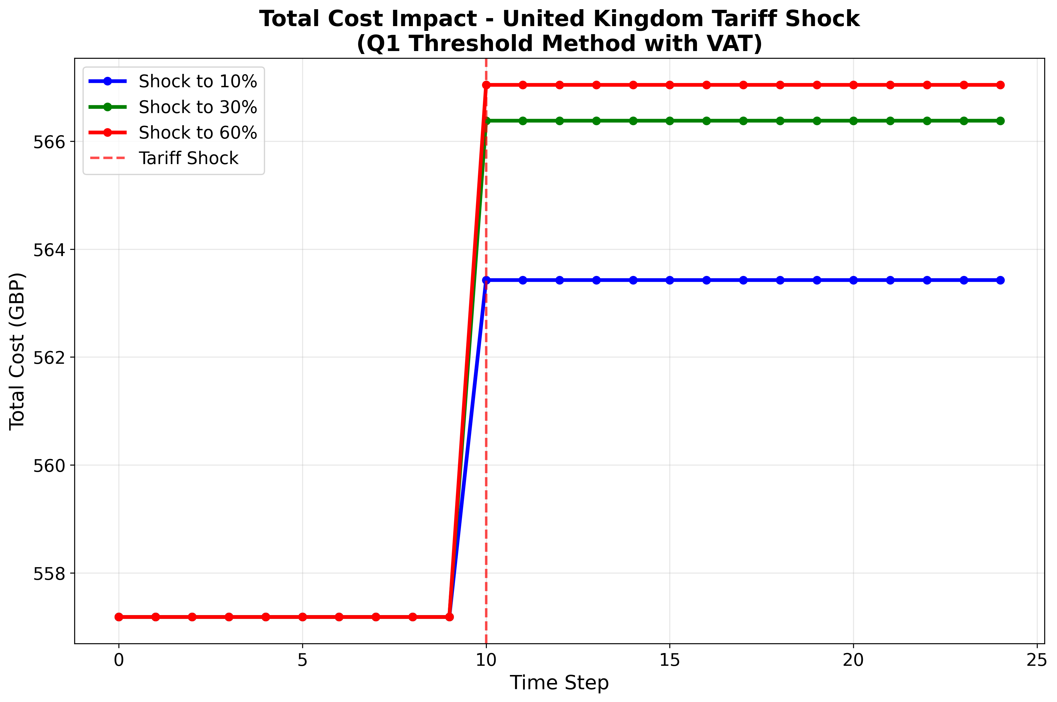

Figure: cost_progression_q1_method_united_kingdom_20250928_171518

cost_progression_q1_method_united_kingdom_20250928_171518

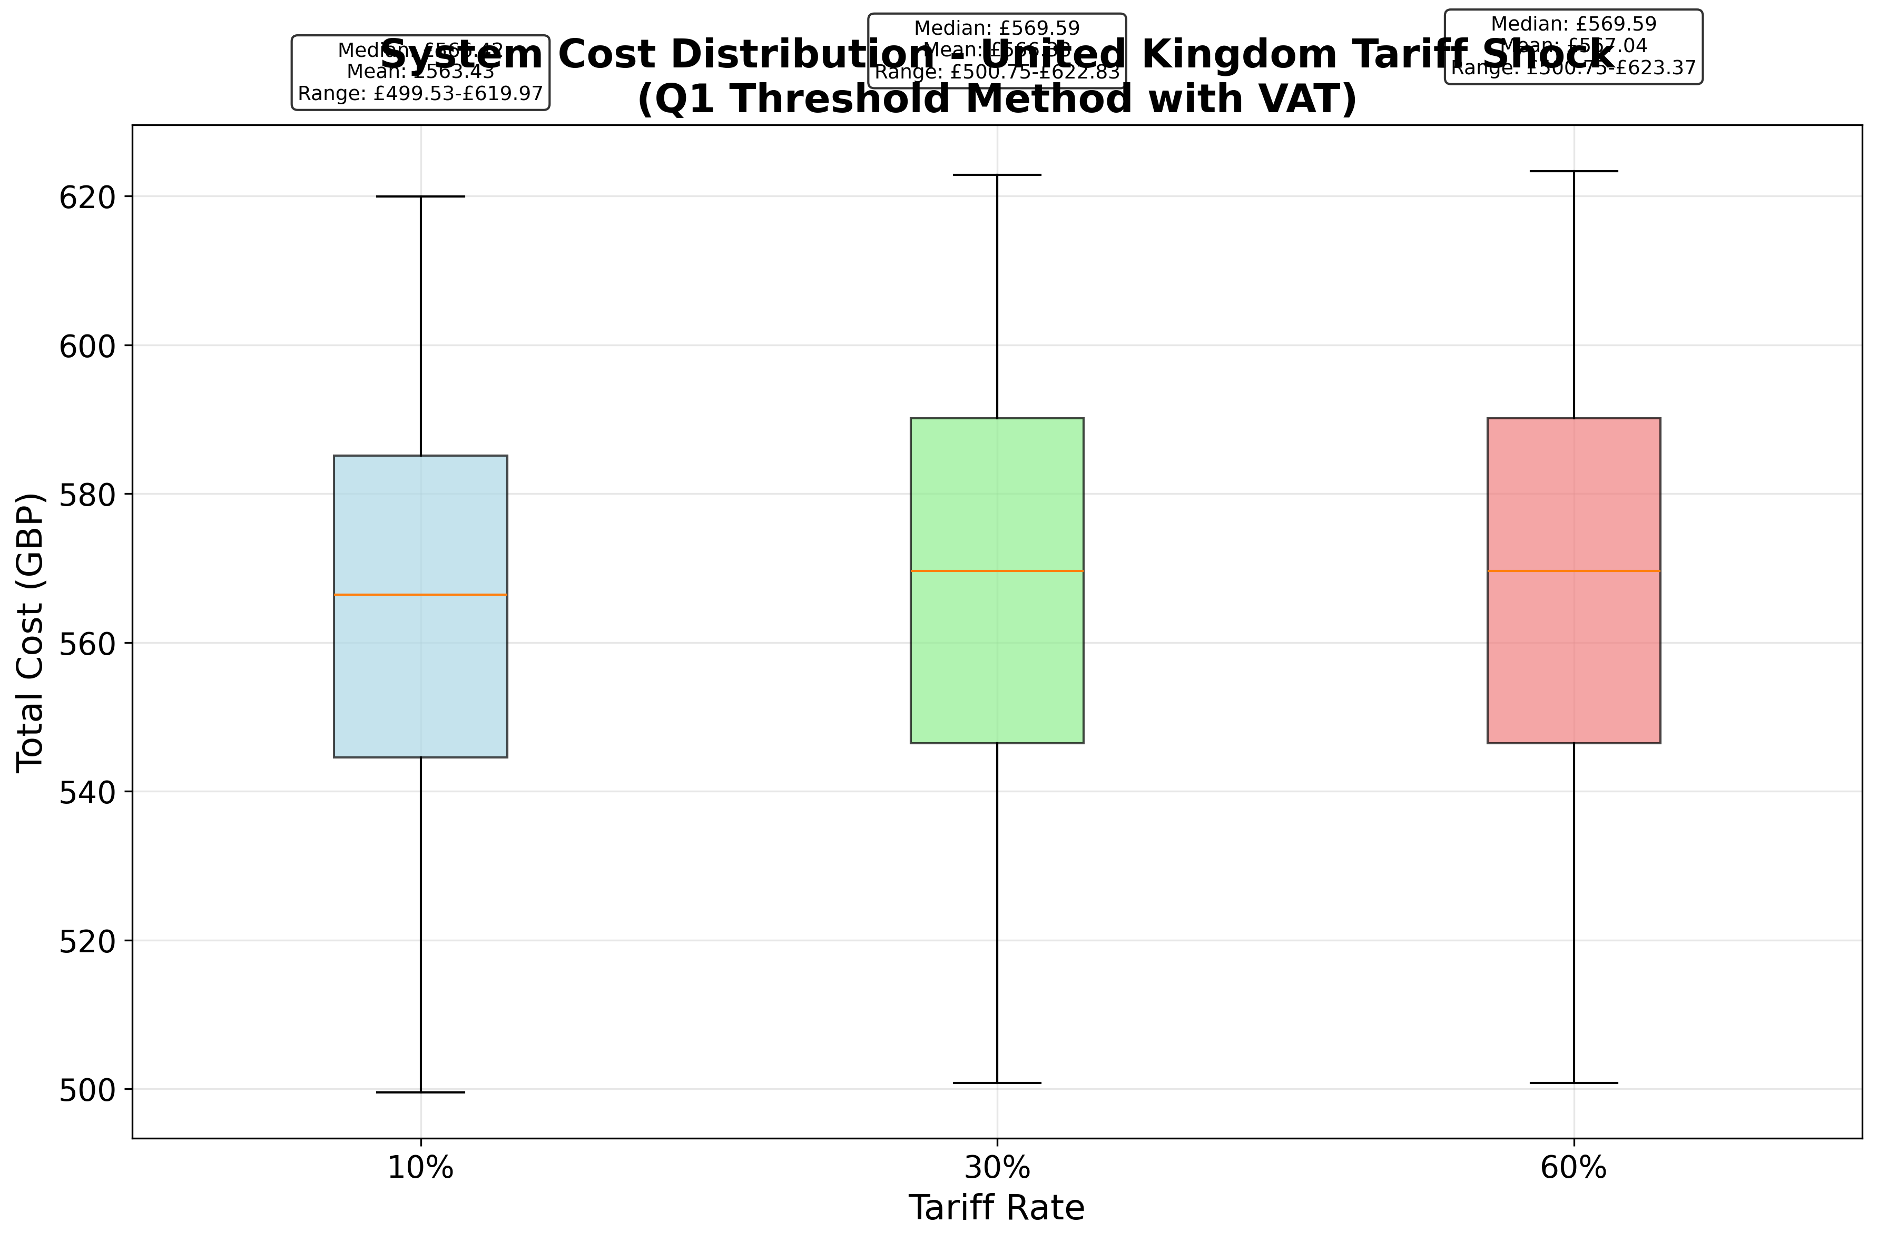

Figure: system_cost_distribution_q1_method_united_kingdom_20250928_171518

system_cost_distribution_q1_method_united_kingdom_20250928_171518

* Pre-shock cost breakdown (excl. UK tariff): Base Cost (£458.58), Tariff Cost (£0.00), VAT (£32.10), Total (£490.68)
* 10% tariff: Final Cost £539.75, Increase £49.07 (10.0%)
* 30% tariff: Final Cost £637.27, Increase £146.59 (29.9%)
* 60% tariff: Final Cost £785.09, Increase £294.41 (60.0%)

# Tariff News

Recent reports highlight rising challenges for U.S. manufacturers contending with elevated import duties that have driven a contraction in activity for six consecutive months, per the Institute for Supply Management [1]. In response, the EU has proposed eliminating tariffs on U.S. industrial goods in exchange for reduced American duties on European cars, a move that could alleviate cross-border component costs [2]. Volkswagen’s leadership has publicly quantified the multibillion-pound impact of current tariffs, underscoring the urgent need for stable trade frameworks [3]. Concurrently, EU negotiators are pressing for legislative measures to lock in lower U.S. car tariffs by August 2025, signaling potential relief for automotive suppliers and OEMs [4].

# Alternative Suppliers

Deep research identifies a diversified pool of European suppliers outside the UK tariff zone, offering competitive pricing, robust certifications and responsive logistics [5]. Italy’s Brembo and Metelli provide premium calipers, discs and pads at €27–€38 per pad, with ECE R90 and ISO accreditation. Spain’s ICER and Denmark’s Axia deliver eco-focused pads and calipers, leveraging recycled materials and fast EU distribution. Germany’s Bosch, Continental and ZF offer mid-range pads (£25/unit) and fluids, supported by extensive R&D and aftermarket networks. These suppliers maintain lead times of 1–2 weeks, MOQ aligned to distributor protocols and quality standards suited for both OEM and aftermarket. This geographic diversification mitigates UK duty exposure while preserving system integrity.

# Impact Assessment

The highest tariff scenario (60%) yields a 60.0% increase in total system cost, categorizing the impact as **Severe** given the substantial escalation above typical risk tolerances. This underscores the imperative for sourcing and logistics adaptations to contain cost volatility.

# Recommendations

To mitigate severe tariff risks, Toyota should expand its supplier base to include high-quality, non-UK sources across Italy, Germany, Spain and Denmark, ensuring compliance with ECE R90 and ISO standards. Implementing bonded-warehouse solutions will defer duty payment until final market entry, reducing immediate cash outlay. Real-time digital trade-policy monitoring should be deployed to capture tariff schedule changes and optimize order timing. Finally, long-term contracts must incorporate duty-adjustment clauses or supplier-led hedges to stabilize input costs amid geopolitical shifts.

# References

[1] US manufacturing contracts for sixth straight month amid tariff drag - Reuters: https://www.reuters.com/business/us-manufacturing-contracts-sixth-straight-month-amid-tariff-drag-2025-09-02/  
[2] EU to scrap tariffs on US goods to pave way for lower car duties - Reuters: https://www.reuters.com/business/autos-transportation/eu-scrap-tariffs-us-goods-pave-way-lower-car-duties-2025-08-28/  
[3] Tariffs have cost Volkswagen 'several billions' so far, CEO says - Reuters: https://www.reuters.com/business/autos-transportation/tariffs-have-cost-volkswagen-several-billions-so-far-ceo-says-2025-09-08/  
[4] EU pushes to secure lower U.S. car tariff from Aug 1 - Reuters: https://www.reuters.com/business/autos-transportation/eu-pushes-secure-lower-us-car-tariff-aug-1-2025-08-21/  
[5] DEEP RESEARCH ANALYSIS: Comprehensive Analysis of Alternative European Suppliers of Brake System Components