Supply Chain Analysis and Tariff Shock Simulation: Toyota RAV4 IV Braking System

# Executive Summary

This report examines the supply chain of the Toyota RAV4 IV braking system, integrating database insights, tariff-shock simulation, web and deep research. Six taxable components total £458.58 excl. VAT (£550.30 incl. 20% VAT), with the Brake Caliper Mounting representing the largest single cost driver at £240.64 (52.48%). We simulate 25%, 50% and 75% ad valorem tariffs on Japanese-sourced parts (6 of 83 suppliers), followed by 20% UK VAT on the tariff-inclusive value. Even at a 75% tariff, the system cost increases by only 1.5%, a **Small** impact. To enhance resilience, we recommend supplier diversification, bonded-warehouse arrangements, real-time digital monitoring and contingent sourcing strategies.

# Key Points

* Vehicle/component: Toyota RAV4 IV Braking System
* Combined price: £458.58 excl. VAT, £550.30 incl. 20% VAT
* Tariff simulation: 25%, 50%, 75% tariffs on parts imported from Japan
* Impact assessment summary: Tariff leads to a Small cost increase of 1.5%

# Component Analysis

The Toyota RAV4 IV braking system comprises six unique, taxable components with a combined cost of £458.58 excluding VAT (£550.30 including 20% VAT). The most expensive line item is the Brake Caliper Mounting at £240.64 (52.48% of the total cost). Geographic origin analysis reveals high article concentrations in Germany (19 articles), Denmark (17) and the Netherlands (17). Supplier diversity is moderate: DELPHI and A.B.S. each supply 10 articles, while KAVO PARTS supplies 5.

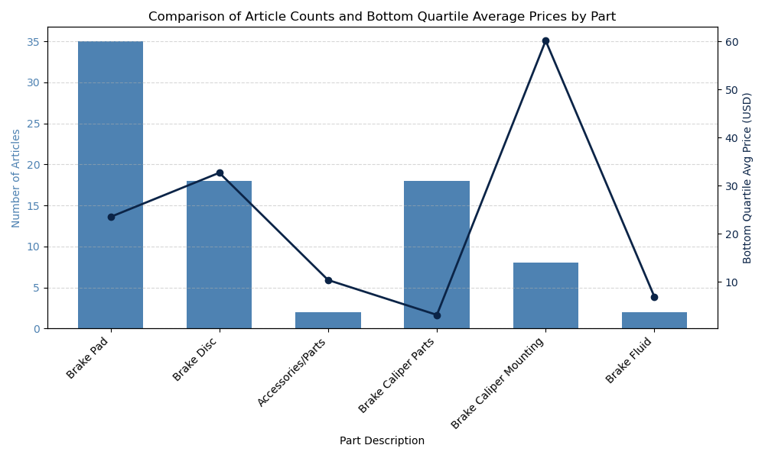

Figure: CA_combination_chart_articles_count_and_bottom_quartile_avg_price_per_part

CA_combination_chart_articles_count_and_bottom_quartile_avg_price_per_part

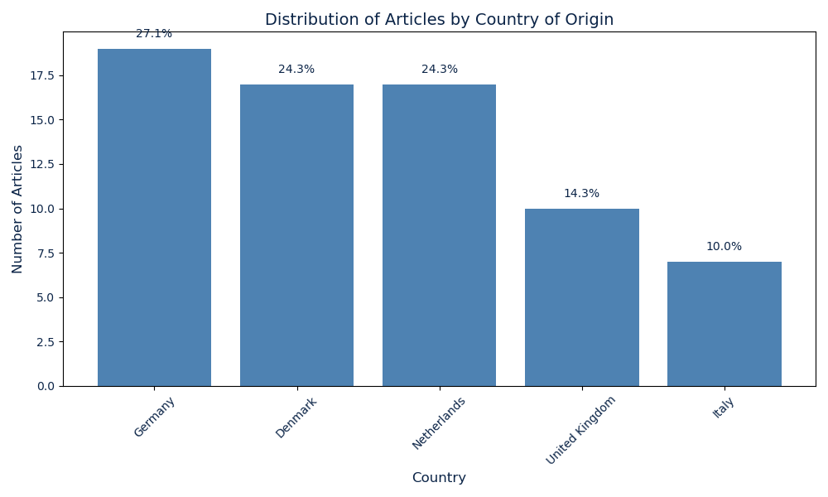

Figure: CA_bar_chart_articles_distribution_by_country_of_origin

CA_bar_chart_articles_distribution_by_country_of_origin

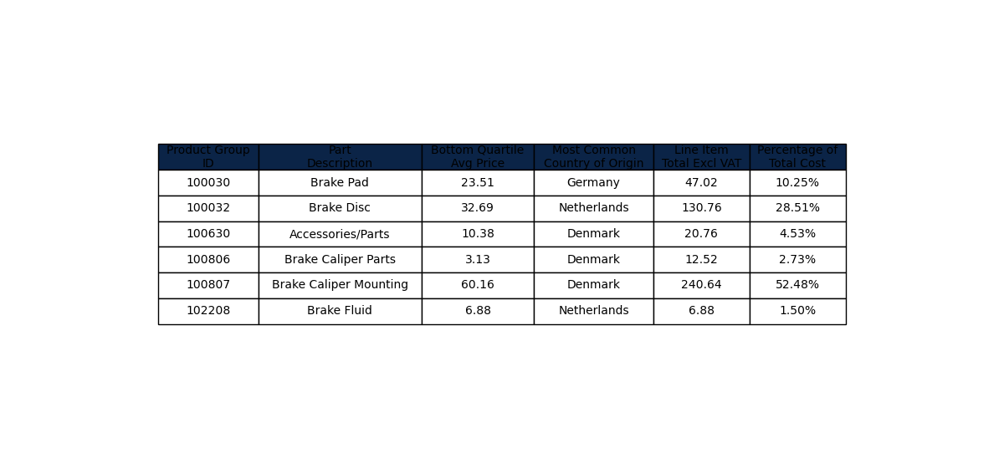

Figure: CA_table_summary_all_parts

CA_table_summary_all_parts

* Top 3 parts by spend:
* – Brake Caliper Mounting (£240.64, 52.48%)
* – Brake Disc (£130.76, 28.51%)
* – Brake Pad (£47.02, 10.25%)
* Top 3 suppliers by article count:
* – DELPHI (10 articles)
* – A.B.S. (10 articles)
* – KAVO PARTS (5 articles)

# Tariff Simulation

A tariff-shock simulation applies ad valorem duties of 25%, 50% and 75% to parts sourced from Japan (6 of 83 suppliers), with UK VAT at 20% assessed on the tariff-inclusive value. Pre-shock, the system’s base cost is £459.32, with an added tariff of £14.95 and VAT of £94.85, yielding a total of £569.12. Under each scenario, the final cost rises modestly, reflecting limited exposure to Japanese-sourced components.

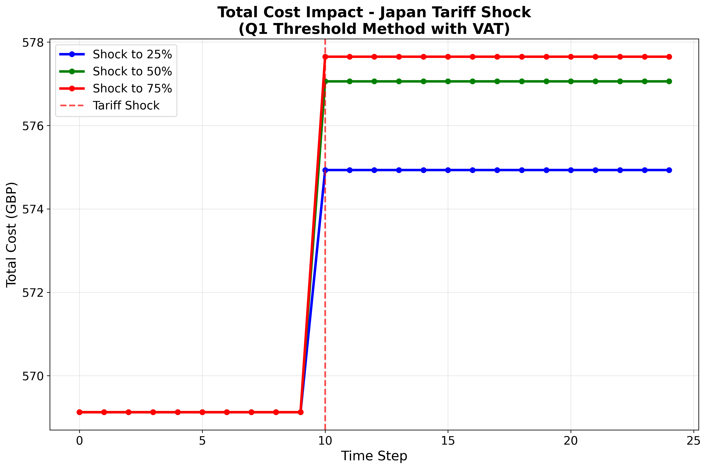

Figure: cost_progression_q1_method_japan_20251003_185651

cost_progression_q1_method_japan_20251003_185651

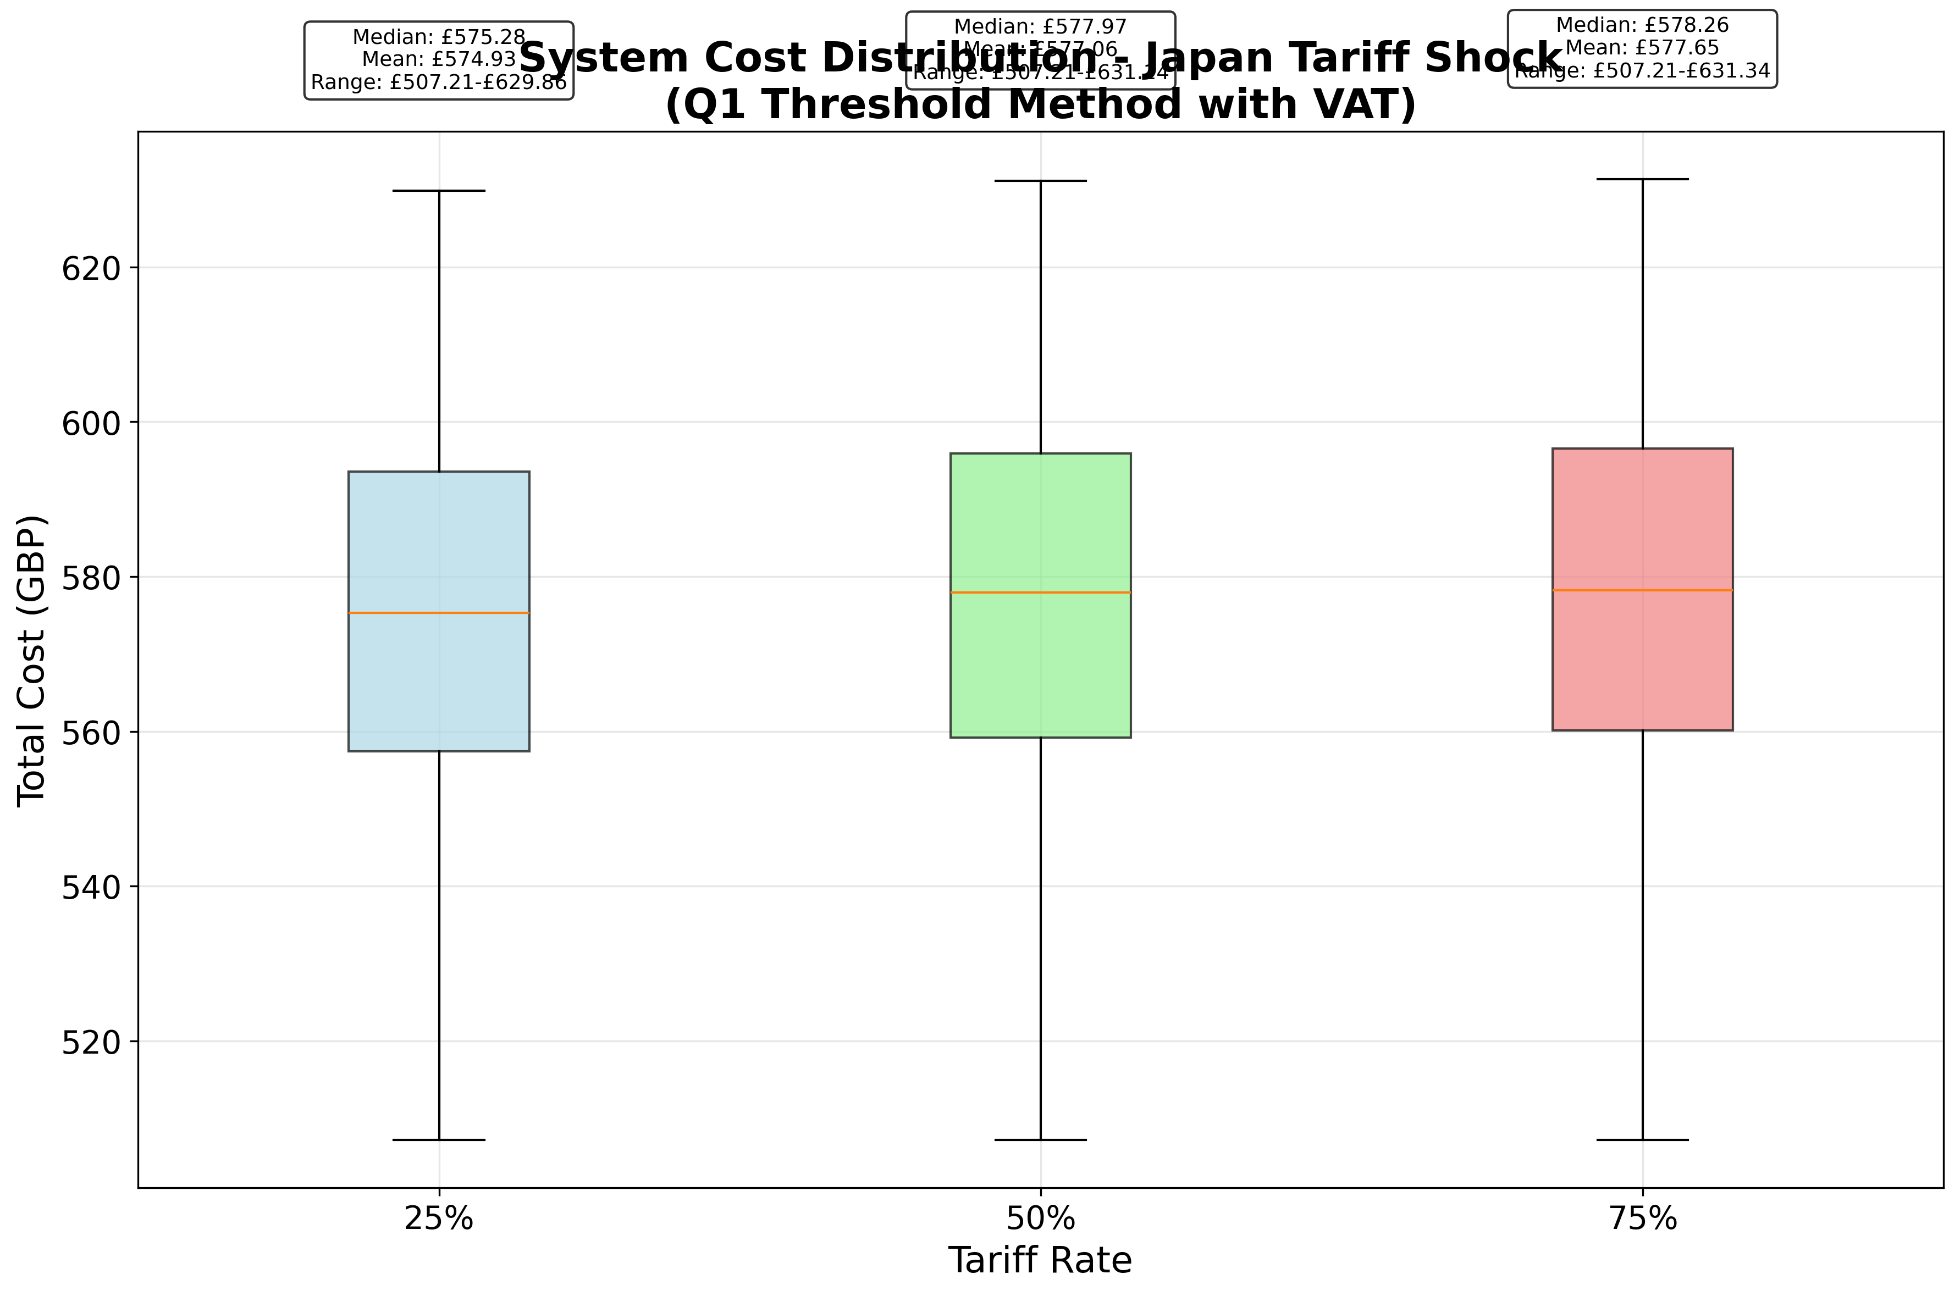

Figure: system_cost_distribution_q1_method_japan_20251003_185651

system_cost_distribution_q1_method_japan_20251003_185651

* Pre-shock cost breakdown:
* – Base Cost (£459.32)
* – Tariff Cost (£14.95)
* – VAT Cost (£94.85)
* – Total Cost (£569.12)
* Impact per tariff scenario:
* – 25%: initial £569.12 → £574.93 (+£5.81, +1.0%)
* – 50%: initial £569.12 → £577.06 (+£7.93, +1.4%)
* – 75%: initial £569.12 → £577.65 (+£8.52, +1.5%)

# Tariff News

Recent negotiations between Japan and the United States indicate that US tariffs on Japanese automobiles and automotive parts—currently at 15%—will be reduced imminently, with revisions expected by mid-September 2025 [1]. Separately, the US Commerce Department is reviewing new national security tariffs on steel, aluminum and auto parts, which could extend to components such as those in the RAV4 IV braking system [2].

# Alternative Suppliers

To mitigate reliance on Japanese imports, several non-Japanese suppliers offer competitively priced braking components. ATE (Germany) supplies ceramic pads (€38–€55 per axle) and high-carbon rotors (€60–€90 per pair) [3]. Brembo (Italy) provides premium pads ($45–$70 per axle) and UV-coated rotors ($80–$120 per pair) [4]. TRW (Germany) offers pads (€30–€50) and rotors (€50–€85) [5]. Ferodo (UK) delivers pads (£28–£40) and rotors (£55–£85), tariff-free post-Brexit [6]. Allied Nippon (India) manufactures OE-equivalent pads ($18–$32) and rotors ($40–$65) with global distribution [7].

# Impact Assessment

The tariff shock impact is categorized as **Small**, with a total cost increase of 1.5%.

# Recommendations

* Diversify procurement across Europe (e.g., Germany, Italy, UK) and Asia (India) to reduce geographic concentration risk.
* Negotiate bonded-warehouse agreements for Japanese imports to defer duty payments until consumption.
* Implement a digital dashboard for real-time monitoring of tariffs, FX and supplier lead times.
* Establish contingent sourcing agreements with alternative suppliers to ensure continuity under tariff volatility.
* Explore in-house assembly of key brake modules to lower external tariff exposure.

# References

[1] Japan's tariff negotiator says the US's reciprocal tariffs will be lowered by next week – Business Insider: https://www.businessinsider.com/japan-trade-negotiator-us-reciprocal-tariffs-lowered-automobile-2025-9  
[2] US to consider new national security tariffs on auto parts – Reuters: https://www.reuters.com/business/autos-transportation/us-consider-new-national-security-tariffs-auto-parts-2025-09-16/  
[3] ATE Brake Systems – Product Catalog: https://www.ate-brakes.com/products/  
[4] Brembo Aftermarket – Toyota RAV4 Products: https://www.bremboparts.com/europe/en/catalogue/toyota/rav-4-iii-avi-aca3-ace_/000000146-000007147  
[5] TRW Aftermarket – Product Finder: https://www.trwaftermarket.com/findparts/  
[6] Ferodo Premier Catalog: https://www.ferodo.com/en-gb/catalog.html  
[7] Allied Nippon Products: https://www.alliednippon.com/products/