Meraki As Built

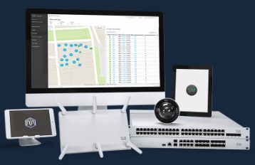

|  |  |  |
| --- | --- | --- |
| Prepared By | Prepared For | Date |
|  |  |  |

# License Overview

The following licenses were found:

|  |  |  |
| --- | --- | --- |
| status | expirationDate | licensedDeviceCounts |
| OK | May 15, 2022 UTC | {'MS120-8LP': 1, 'MX67': 1, 'SM': 100, 'wireless': 1} |

# Device Overview

The Home network includes the following devices:

0 MR Wireless Access Point(s)

0 MS Security appliances(s)

0 MX Security appliance(s)

() MV appliance(s)

# Layer 2

The following 0 VLANs are configured:

# Uplinks

Device Q2FY-6LV8-UTFR wan1 uplink's most recent loss percent is 0.0, latency 25.9 ms:

|  |  |  |  |  |
| --- | --- | --- | --- | --- |
| networkId | serial | uplink | ip | timeSeries |
| L_683984193406901066 | Q2FY-6LV8-UTFR | wan1 | 8.8.8.8 | [{'ts': '2019-08-26T21:24:23Z', 'lossPercent': 0.0, 'latencyMs': 25.8}, {'ts': '2019-08-26T21:25:24Z', 'lossPercent': 0.0, 'latencyMs': 25.8}, {'ts': '2019-08-26T21:26:24Z', 'lossPercent': 0.0, 'latencyMs': 25.9}, {'ts': '2019-08-26T21:27:24Z', 'lossPercent': 0.0, 'latencyMs': 25.9}, {'ts': '2019-08-26T21:28:23Z', 'lossPercent': 0.0, 'latencyMs': 25.9}] |

# Firewall Rules

The following 1 rules are configured:

|  |  |  |  |  |  |  |  |
| --- | --- | --- | --- | --- | --- | --- | --- |
| comment | policy | protocol | srcPort | srcCidr | destPort | destCidr | syslogEnabled |
| Default rule | allow | Any | Any | Any | Any | Any | False |

# Intrusion Settings

The following Intrusion Prevention Settings are configured:

|  |
| --- |
| mode |
| disabled |

# Content Filtering

The following Content Filtering Rules are configured:

|  |  |  |  |
| --- | --- | --- | --- |
| urlCategoryListSize | blockedUrlCategories | blockedUrlPatterns | allowedUrlPatterns |
| topSites | [] | [] | [] |

# Client Overview

0 wired and 0 wireless clients have recently connected to the network:

|
|  |