Meraki As Built

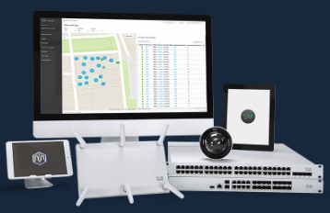

|  |  |  |
| --- | --- | --- |
| Prepared By | Prepared For | Date |
|  |  |  |

# License Overview

The following licenses were found:

|  |  |  |
| --- | --- | --- |
| status | expirationDate | licensedDeviceCounts |
| OK | May 15, 2022 UTC | {'MS120-8LP': 1, 'MX67': 1, 'SM': 100, 'wireless': 1} |

# Device Overview

The Home network includes the following devices:

0 MR Wireless Access Point(s)

0 MS Security appliances(s)

0 MX Security appliance(s)

() MV appliance(s)

|
|  |