Meraki As Built

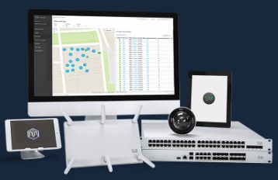

|  |  |  |
| --- | --- | --- |
| Prepared By | Prepared For | Date |
|  |  |  |

# License Overview

Giggidy has the following licenses:

|  |  |  |
| --- | --- | --- |
| status | expirationDate | licensedDeviceCounts |
| OK | May 15, 2022 UTC | 1 |
| OK | May 15, 2022 UTC | 1 |
| OK | May 15, 2022 UTC | 100 |
| OK | May 15, 2022 UTC | 1 |

# Networks Overview

The following Networks were found:

|  |  |  |  |  |  |  |  |
| --- | --- | --- | --- | --- | --- | --- | --- |
| id | organizationId | name | timeZone | tags | type | disableMyMerakiCom | disableRemoteStatusPage |
| L_683984193406901066 | 863545 | Hillsborough | Pacific/Auckland | None | combined | False | True |
| L_683984193406902018 | 863545 | renti | America/Los_Angeles | None | combined | False | True |

# Uplinks

The following Uplinks were found:

|  |  |  |  |  |
| --- | --- | --- | --- | --- |
| networkId | serial | uplink | ip | timeSeries |
| L_683984193406901066 | Q2FY-6LV8-UTFR | wan1 | 8.8.8.8 | [{'ts': '2019-09-06T10:11:32Z', 'lossPercent': 0.0, 'latencyMs': 26.0}, {'ts': '2019-09-06T10:12:31Z', 'lossPercent': 0.0, 'latencyMs': 25.9}, {'ts': '2019-09-06T10:13:31Z', 'lossPercent': 0.0, 'latencyMs': 25.9}, {'ts': '2019-09-06T10:14:33Z', 'lossPercent': 0.0, 'latencyMs': 26.0}, {'ts': '2019-09-06T10:15:33Z', 'lossPercent': 0.0, 'latencyMs': 25.9}] |

# Devices Overview

Giggidy has the following Devices in network Hillsborough:

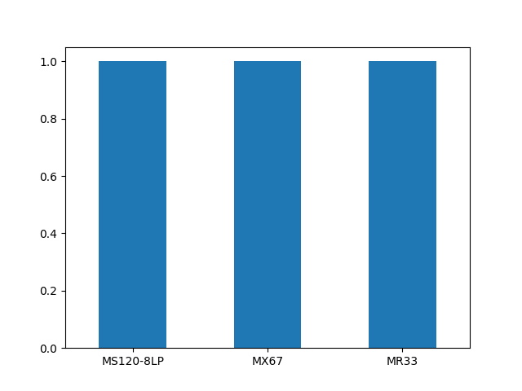

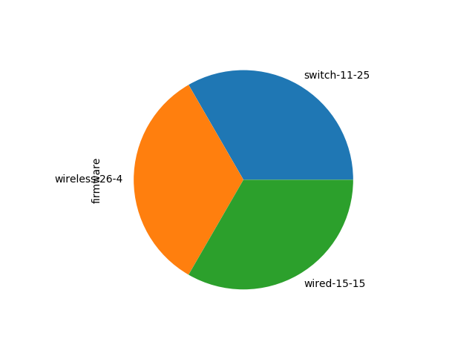

|  |  |  |  |  |  |  |  |  |  |  |  |  |
| --- | --- | --- | --- | --- | --- | --- | --- | --- | --- | --- | --- | --- |
| lat | lng | address | serial | mac | lanIp | networkId | model | firmware | tags | switchProfileId | wan1Ip | wan2Ip |
| -36.91569 | 174.762 | 18a Herd Rd, Hillsborough, Auckland, New Zealand | Q2PD-V2GU-MUCS | ac:17:c8:11:be:bd | 192.168.201.3 | L_683984193406901066 | MR33 | wireless-26-4 | nan | nan | nan | nan |
| -36.91569 | 174.762 | 18a Herd Rd, Hillsborough, Auckland, New Zealand | Q2BX-V96B-2ECY | 34:56:fe:2d:63:04 | 192.168.202.2 | L_683984193406901066 | MS120-8LP | switch-11-25 | recently-added | nan | nan | nan |
| -36.91569 | 174.762 | 18a Herd Rd, Hillsborough, Auckland, New Zealand | Q2FY-6LV8-UTFR | ac:17:c8:cf:9f:eb | 219.89.118.96 | L_683984193406901066 | MX67 | wired-15-15 | nan | nan | 219.89.118.96 | nan |

# VLANs

Giggidy has the following VLANs configured for network Hillsborough:

|  |  |  |  |  |  |  |  |  |  |  |  |  |  |
| --- | --- | --- | --- | --- | --- | --- | --- | --- | --- | --- | --- | --- | --- |
| id | networkId | name | applianceIp | subnet | fixedIpAssignments | reservedIpRanges | dnsNameservers | dhcpHandling | dhcpLeaseTime | dhcpBootOptionsEnabled | dhcpBootNextServer | dhcpBootFilename | dhcpOptions |
| 200 | L_683984193406901066 | Desktop | 192.168.200.1 | 192.168.200.0/24 | {} | [] | opendns | Run a DHCP server | 1 day | False | None | None | [] |
| 201 | L_683984193406901066 | wifi | 192.168.201.1 | 192.168.201.0/24 | {} | [] | opendns | Run a DHCP server | 1 day | False | None | None | [] |
| 202 | L_683984193406901066 | ms | 192.168.202.1 | 192.168.202.0/24 | {} | [] | opendns | Run a DHCP server | 1 day | False | None | None | [] |
| 203 | L_683984193406901066 | cctv | 192.168.203.1 | 192.168.203.0/24 | {} | [] | opendns | Run a DHCP server | 1 day | False | None | None | [] |
| 210 | L_683984193406901066 | temp | 10.10.10.1 | 10.10.10.0/24 | {} | [] | upstream_dns | Run a DHCP server | 1 day | False | None | None | [] |

# Static Routes

Giggidy has the following Static Routes configured for network Hillsborough:

|  |  |  |  |  |  |  |  |
| --- | --- | --- | --- | --- | --- | --- | --- |
| id | networkId | enabled | name | subnet | gatewayIp | fixedIpAssignments | reservedIpRanges |
| f3586bd5-2222-4dc5-aca0-b224b7a02dd0 | L_683984193406901066 | True | virtual_network | 192.168.211.0/24 | 192.168.200.2 | {} | [] |

# Wireless Networks

Giggidy has the following SSIDs configured in network Hillsborough:

|  |  |  |  |  |  |  |  |  |  |  |  |  |  |
| --- | --- | --- | --- | --- | --- | --- | --- | --- | --- | --- | --- | --- | --- |
| number | name | enabled | splashPage | ssidAdminAccessible | authMode | psk | encryptionMode | wpaEncryptionMode | ipAssignmentMode | minBitrate | bandSelection | perClientBandwidthLimitUp | perClientBandwidthLimitDown |
| 0 | donut | True | None | False | psk | eatthedonut | wpa | WPA2 only | NAT mode | 11 | 5 GHz band only | 25600 | 25600 |
| 1 | Unconfigured SSID 2 | False | None | False | open | nan | nan | nan | NAT mode | 11 | Dual band operation | 0 | 0 |
| 2 | Unconfigured SSID 3 | False | None | False | open | nan | nan | nan | NAT mode | 11 | Dual band operation | 0 | 0 |
| 3 | Unconfigured SSID 4 | False | None | False | open | nan | nan | nan | NAT mode | 11 | Dual band operation | 0 | 0 |
| 4 | Unconfigured SSID 5 | False | None | False | open | nan | nan | nan | NAT mode | 11 | Dual band operation | 0 | 0 |
| 5 | Unconfigured SSID 6 | False | None | False | open | nan | nan | nan | NAT mode | 11 | Dual band operation | 0 | 0 |
| 6 | Unconfigured SSID 7 | False | None | False | open | nan | nan | nan | NAT mode | 11 | Dual band operation | 0 | 0 |
| 7 | Unconfigured SSID 8 | False | None | False | open | nan | nan | nan | NAT mode | 11 | Dual band operation | 0 | 0 |
| 8 | Unconfigured SSID 9 | False | None | False | open | nan | nan | nan | NAT mode | 11 | Dual band operation | 0 | 0 |
| 9 | Unconfigured SSID 10 | False | None | False | open | nan | nan | nan | NAT mode | 11 | Dual band operation | 0 | 0 |
| 10 | Unconfigured SSID 11 | False | None | False | open | nan | nan | nan | NAT mode | 11 | Dual band operation | 0 | 0 |
| 11 | Unconfigured SSID 12 | False | None | False | open | nan | nan | nan | NAT mode | 11 | Dual band operation | 0 | 0 |
| 12 | Unconfigured SSID 13 | False | None | False | open | nan | nan | nan | NAT mode | 11 | Dual band operation | 0 | 0 |
| 13 | Unconfigured SSID 14 | False | None | False | open | nan | nan | nan | NAT mode | 11 | Dual band operation | 0 | 0 |
| 14 | Unconfigured SSID 15 | False | None | False | open | nan | nan | nan | NAT mode | 11 | Dual band operation | 0 | 0 |

# Clients

Giggidy has the following Wireless Clients in network Hillsborough:

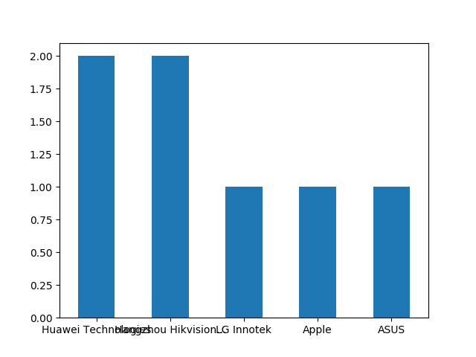

|  |  |  |  |  |  |  |  |  |  |  |  |  |  |  |  |  |
| --- | --- | --- | --- | --- | --- | --- | --- | --- | --- | --- | --- | --- | --- | --- | --- | --- |
| id | mac | description | ip | ip6 | user | firstSeen | lastSeen | manufacturer | os | recentDeviceSerial | recentDeviceName | recentDeviceMac | ssid | vlan | switchport | usage |
| k729e8d | 24:31:54:05:16:d4 | Android | 10.114.158.141 | None | None | 2019-08-13T05:41:30Z | 2019-09-06T10:17:37Z | Huawei Technologies | Android | Q2PD-V2GU-MUCS | None | ac:17:c8:11:be:bd | donut | 0 | None | {'sent': 71218, 'recv': 695467} |
| k85c12c | 4c:bd:8f:c8:14:a5 | IPC-B120-I20170829AAWR825324739 | 192.168.203.150 | None | None | 2019-07-25T09:45:50Z | 2019-09-06T10:17:25Z | Hangzhou Hikvision... | None | Q2BX-V96B-2ECY | None | 34:56:fe:2d:63:04 | None | 203 | 2 | {'sent': 457, 'recv': 414} |
| kaad16d | 4c:bd:8f:c8:14:cf | IPC-B120-I20170829AAWR825324781 | 192.168.203.151 | None | None | 2019-08-11T06:21:17Z | 2019-09-06T10:17:25Z | Hangzhou Hikvision... | None | Q2BX-V96B-2ECY | None | 34:56:fe:2d:63:04 | None | 203 | 3 | {'sent': 459, 'recv': 394} |
| kb184ca | 04:4e:af:7a:24:cc | LGwebOSTV | 10.177.132.202 | None | None | 2019-07-27T04:22:21Z | 2019-09-06T07:34:06Z | LG Innotek | Generic Linux | Q2PD-V2GU-MUCS | None | ac:17:c8:11:be:bd | donut | 0 | None | {'sent': 486, 'recv': 4897} |
| kde8758 | cc:78:5f:e3:4b:de | Annas-iPad | 10.222.135.88 | None | None | 2019-07-26T21:00:16Z | 2019-09-06T10:11:42Z | Apple | Apple iPad | Q2PD-V2GU-MUCS | None | ac:17:c8:11:be:bd | donut | 0 | None | {'sent': 37398, 'recv': 4519636} |
| k2ca07a | c8:c2:fa:e4:8b:8d | Android | 10.44.160.122 | None | None | 2019-07-26T11:53:24Z | 2019-09-06T10:17:37Z | Huawei Technologies | Android | Q2PD-V2GU-MUCS | None | ac:17:c8:11:be:bd | donut | 0 | None | {'sent': 194888, 'recv': 5399689} |
| k082e59 | 0c:9d:92:20:1c:04 | jamie-local | 192.168.200.2 | None | None | 2019-07-26T05:10:07Z | 2019-09-06T10:17:25Z | ASUS | Debian-based Linux | Q2BX-V96B-2ECY | None | 34:56:fe:2d:63:04 | None | 200 | 1 | {'sent': 9, 'recv': 0} |

# Firewall Services

The following services are configured in Giggidy's network Hillsborough:

|  |  |
| --- | --- |
| service | access |
| ICMP | unrestricted |
| web | blocked |

# L3 Firewall Rules

The following L3 Firewall rules are configured in Giggidy's network Hillsborough:

|  |  |  |  |  |  |  |  |
| --- | --- | --- | --- | --- | --- | --- | --- |
| comment | policy | protocol | srcPort | srcCidr | destPort | destCidr | syslogEnabled |
| Meraki cloud communication | allow | udp | Any | Any | 7351 | 199.231.78.0/24,108.161.147.0/24,64.62.142.12/32,209.206.48.0/20 | False |
| Meraki cloud communication | allow | tcp | Any | Any | 80,443,7734,7752 | 64.62.142.2/32,108.161.147.0/24,209.206.48.0/20 | False |
| NTP | allow | udp | Any | Any | 123 | Any | False |
| Uplink connection monitor | allow | udp | Any | Any | 53 | Any | False |
| ICMP | allow | icmp | Any | Any | Any | Any | False |
| Web | allow | tcp | Any | 192.168.200.0/24,192.168.201.0/24,192.168.202.0/24,192.168.211.0/24 | 80,443 | Any | False |
| DNS | allow | udp | Any | 192.168.200.0/24,192.168.201.0/24,192.168.202.0/24,192.168.211.0/24 | 53 | Any | False |
|  | allow | tcp | Any | 192.168.204.0/25 | 22 | 192.168.200.0/24 | False |
| Ssh | allow | tcp | Any | 192.168.201.0/24 | 22 | 192.168.200.0/24 | False |
| Permit SMTP out | allow | tcp | Any | 192.168.200.2/24,192.168.211.0/24 | 587 | Any | False |
| Cam rstp | allow | any | Any | 192.168.200.2/32,192.168.211.0/24 | Any | 192.168.203.0/24,10.10.10.0/24 | False |
|  | deny | any | Any | Any | Any | Any | False |
|  | allow | any | Any | Any | Any | Any | False |
| Default rule | allow | Any | Any | Any | Any | Any | False |

# Content Filtering

The following Content Filtering Rules are configured:

# Intrusion Prevention

The following Intrusion Prevention Settings are configured:

|  |
| --- |
|  |
|  |
|  |

# Intrusion Prevention

The following Malware Settings are configured:

# Network Traffic

The following Network Traffic has been detected for Giggidy, network Hillsborough :

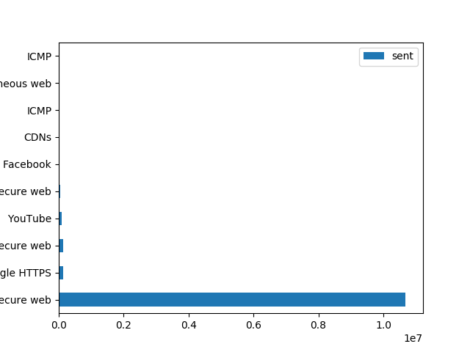

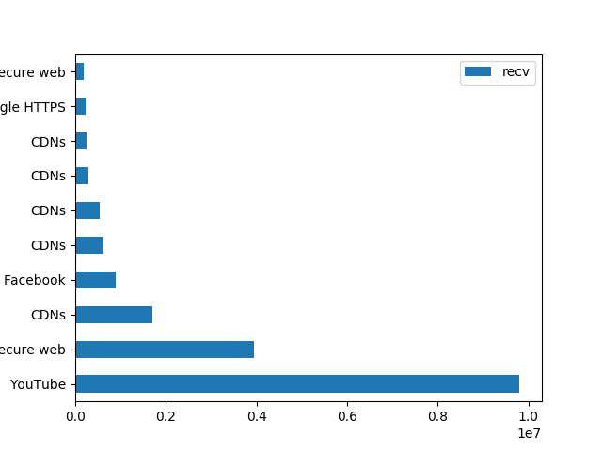

|  |  |  |  |  |  |  |  |  |
| --- | --- | --- | --- | --- | --- | --- | --- | --- |
| application | destination | protocol | port | recv | sent | flows | activeTime | numClients |
| Miscellaneous web | c.apple.news | TCP | 80 | 541 | 16 | 5 | 420 | 1 |
| Miscellaneous web | fvnz-capi-prod.switch.tv | TCP | 80 | 1975 | 156 | 18 | 960 | 1 |
| Miscellaneous web | hbbtv-prod.fvpnz.co.nz | TCP | 80 | 2321 | 75 | 5 | 1680 | 1 |
| Miscellaneous web | image-proxy-prod.switch.tv | TCP | 80 | 156 | 24 | 1 | 420 | 1 |
| Miscellaneous web | mclean.cloud.360safe.com | TCP | 80 | 32 | 20 | 1 | 60 | 1 |
| Miscellaneous web | msafedl.ssl.qihucdn.com | TCP | 80 | 32 | 2 | 1 | 60 | 1 |
| Miscellaneous web | survey.widespace.com | TCP | 80 | 352 | 14 | 4 | 60 | 1 |
| Miscellaneous web | www.googletagmanager.com | TCP | 80 | 115 | 8 | 3 | 960 | 1 |
| Miscellaneous secure web | 1.oca.nflxvideo.net | TCP | 443 | 1193 | 43 | 1 | 240 | 1 |
| Miscellaneous secure web | 74.125.28.188 | TCP | 443 | 50 | 5 | 4 | 360 | 1 |
| Miscellaneous secure web | ads.adthrive.com | TCP | 443 | 485 | 14 | 2 | 120 | 1 |
| Miscellaneous secure web | ads30.adcolony.com | TCP | 443 | 51 | 15 | 2 | 120 | 1 |
| Miscellaneous secure web | ap-southeast-2.prod.boltdns.net | TCP | 443 | 12474 | 1822 | 407 | 5520 | 2 |
| Miscellaneous secure web | api.accuweather.com | TCP | 443 | 6 | 2 | 1 | 60 | 1 |
| Miscellaneous secure web | auction.unityads.unity3d.com | TCP | 443 | 21 | 6 | 1 | 60 | 1 |
| Miscellaneous secure web | bcbolttvnz3-a.akamaihd.net | TCP | 443 | 3941520 | 45033 | 28 | 13500 | 1 |
| Miscellaneous secure web | bcbolttvnzstage1-a.akamaihd.net | TCP | 443 | 4329 | 88 | 2 | 120 | 1 |
| Miscellaneous secure web | beta-ems-ladbiblegroup-com.cdn.ampproject.org | TCP | 443 | 1590 | 24 | 2 | 120 | 1 |
| Miscellaneous secure web | brightcove.hs.llnwd.net | TCP | 443 | 2313 | 150 | 1 | 120 | 1 |
| Miscellaneous secure web | calendar-a.wbx2.com | TCP | 443 | 203 | 8 | 1 | 60 | 1 |
| Miscellaneous secure web | cdn.segment.com | TCP | 443 | 71 | 3 | 1 | 60 | 1 |
| Miscellaneous secure web | choices-live.pixelberrystudios.com | TCP | 443 | 20444 | 411 | 1 | 840 | 1 |
| Miscellaneous secure web | configserver-dra.platform.hicloud.com | TCP | 443 | 168 | 44 | 27 | 360 | 1 |
| Miscellaneous secure web | conv.a7.ciscospark.com | TCP | 443 | 2285 | 61 | 3 | 240 | 1 |
| Miscellaneous secure web | dash.plot.ly | TCP | 443 | 3423 | 61 | 4 | 120 | 1 |
| Miscellaneous secure web | dashtown.gcp.playfirst.com | TCP | 443 | 914 | 560 | 26 | 1560 | 1 |
| Miscellaneous secure web | dms.licdn.com | TCP | 443 | 55480 | 875 | 3 | 420 | 1 |
| Miscellaneous secure web | e.reddit.com | TCP | 443 | 747 | 47 | 10 | 240 | 1 |
| Miscellaneous secure web | events3alt.adcolony.com | TCP | 443 | 7 | 5 | 1 | 60 | 1 |
| Miscellaneous secure web | google.com | TCP | 443 | 1528 | 27 | 1 | 120 | 1 |
| Miscellaneous secure web | i.ytimg.com | TCP | 443 | 13023 | 336 | 17 | 3180 | 3 |
| Miscellaneous secure web | i9.ytimg.com | TCP | 443 | 3192 | 74 | 4 | 540 | 1 |
| Miscellaneous secure web | images.celebitchy.com | TCP | 443 | 4672 | 110 | 6 | 660 | 1 |
| Miscellaneous secure web | img-s-msn-com.akamaized.net | TCP | 443 | 2035 | 29 | 1 | 60 | 1 |
| Miscellaneous secure web | infinity-c1.youboranqs01.com | TCP | 443 | 54 | 78 | 10 | 480 | 1 |
| Miscellaneous secure web | infinity-c4.youboranqs01.com | TCP | 443 | 29 | 51 | 7 | 240 | 1 |
| Miscellaneous secure web | login.microsoftonline.com | TCP | 443 | 52 | 14 | 5 | 240 | 1 |
| Miscellaneous secure web | media.licdn.com | TCP | 443 | 4146 | 141 | 2 | 420 | 1 |
| Miscellaneous secure web | metrics.brightcove.com | TCP | 443 | 285 | 582 | 170 | 1800 | 1 |
| Miscellaneous secure web | nz.lgtvsdp.com | TCP | 443 | 42 | 11 | 5 | 60 | 1 |
| Miscellaneous secure web | personalization.centech.glulive.com | TCP | 443 | 19 | 5 | 3 | 60 | 1 |
| Miscellaneous secure web | photos-ugc.l.googleusercontent.com | TCP | 443 | 169 | 9 | 1 | 180 | 1 |
| Miscellaneous secure web | players.brightcove.net | TCP | 443 | 1926 | 36 | 5 | 180 | 1 |
| Miscellaneous secure web | plotly.cdn.prismic.io | TCP | 443 | 2095 | 31 | 1 | 60 | 1 |
| Miscellaneous secure web | r1---sn-uo1-53as.gvt1.com | TCP | 443 | 23769 | 275 | 1 | 120 | 1 |
| Miscellaneous secure web | r7---sn-uo1-53az.gvt1.com | TCP | 443 | 6071 | 68 | 1 | 60 | 1 |
| Miscellaneous secure web | s2.lynda.com | TCP | 443 | 32200 | 781 | 1 | 360 | 1 |
| Miscellaneous secure web | static3.stuff.co.nz | TCP | 443 | 876 | 29 | 5 | 60 | 1 |
| Miscellaneous secure web | stuffnzdd-a.akamaihd.net | TCP | 443 | 744 | 28 | 1 | 60 | 1 |
| Miscellaneous secure web | substrate.office.com | TCP | 443 | 183 | 7 | 1 | 120 | 1 |
| Miscellaneous secure web | theme.dbankcdn.com | TCP | 443 | 11747 | 310 | 2 | 180 | 1 |
| Miscellaneous secure web | tvnz-news.imgix.net | TCP | 443 | 66 | 4 | 1 | 60 | 1 |
| Miscellaneous secure web | v.ssacdn.com | TCP | 443 | 1348 | 18 | 1 | 60 | 1 |
| Miscellaneous secure web | vidstat.taboola.com | TCP | 443 | 10944 | 195 | 2 | 120 | 1 |
| Miscellaneous secure web | webview.unityads.unity3d.com | TCP | 443 | 661 | 13 | 3 | 120 | 1 |
| Miscellaneous secure web | wf.taboola.com | TCP | 443 | 43 | 17 | 1 | 60 | 1 |
| Miscellaneous secure web | widget.perfectmarket.com | TCP | 443 | 41 | 3 | 1 | 60 | 1 |
| Miscellaneous secure web | ws.tapjoyads.com | TCP | 443 | 70 | 34 | 8 | 180 | 1 |
| Miscellaneous secure web | www.bing.com | TCP | 443 | 364 | 6 | 1 | 120 | 1 |
| Miscellaneous secure web | www.linkedin.com | TCP | 443 | 267 | 147 | 2 | 14760 | 1 |
| Miscellaneous secure web | www.stuff.co.nz | TCP | 443 | 1266 | 35 | 1 | 60 | 1 |
| Miscellaneous secure web | www.tvnz.co.nz | TCP | 443 | 494 | 48 | 6 | 120 | 1 |
| Miscellaneous secure web | yt3.ggpht.com | TCP | 443 | 46 | 5 | 1 | 60 | 1 |
| Miscellaneous secure web | ytimg-edge-static.l.google.com | TCP | 443 | 565 | 19 | 1 | 60 | 1 |
| Instagram | None | - | - | 2414 | 1253 | 46 | 3000 | 1 |
| Google | None | - | - | 4801 | 807 | 109 | 10320 | 1 |
| iCloud | None | - | - | 430 | 245 | 26 | 720 | 1 |
| Windows Office365 | None | - | - | 611 | 204 | 26 | 600 | 1 |
| YouTube | None | - | - | 9809275 | 85944 | 1217 | 37320 | 3 |
| Google advertising | None | - | - | 6709 | 1386 | 80 | 2220 | 2 |
| AppNexus | None | - | - | 2141 | 3923 | 189 | 1380 | 1 |
| Integral Ad Science | None | - | - | 446 | 56 | 4 | 300 | 2 |
| Pubmatic | None | - | - | 28 | 60 | 1 | 60 | 1 |
| iTunes | None | - | - | 417 | 55 | 11 | 480 | 1 |
| apple.com | None | - | - | 1968 | 300 | 91 | 4200 | 1 |
| DNS | 8.8.8.8 | UDP | 53 | 4 | 2 | 1 | 120 | 1 |
| Facebook | None | - | - | 887537 | 20687 | 87 | 24480 | 1 |
| microsoft.com | None | - | - | 424 | 104 | 51 | 3360 | 1 |
| Netflix | None | - | - | 13767 | 752 | 10 | 960 | 2 |
| Gmail | None | - | - | 5583 | 274 | 3 | 1920 | 2 |
| Twitter | None | - | - | 427 | 62 | 7 | 300 | 2 |
| CDNs | global.ssl.fastly.net | TCP | 443 | 2169 | 94 | 5 | 840 | 1 |
| CDNs | kinesis.us-east-1.amazonaws.com | TCP | 443 | 295 | 148 | 42 | 780 | 1 |
| CDNs | sts.amazonaws.com | TCP | 443 | 9 | 3 | 1 | 60 | 1 |
| Google HTTPS | None | - | - | 218445 | 143134 | 154 | 51720 | 2 |
| Miscellaneous web | 151.101.0.249 | TCP | 80 | 654 | 12 | 2 | 120 | 1 |
| Miscellaneous web | 151.101.128.249 | TCP | 80 | 1401 | 35 | 4 | 180 | 1 |
| Miscellaneous web | 192.168.201.3 | TCP | 80 | 24 | 9342 | 175 | 5160 | 1 |
| Miscellaneous web | 54.230.243.73 | TCP | 80 | 512 | 41 | 6 | 180 | 1 |
| Miscellaneous secure web | *.crashlytics.com | TCP | 443 | 0 | 24 | 1 | 60 | 1 |
| Miscellaneous secure web | *.googleapis.com | TCP | 443 | 0 | 605 | 7 | 600 | 1 |
| Miscellaneous secure web | *.licdn.com | TCP | 443 | 0 | 816 | 2 | 180 | 1 |
| Miscellaneous secure web | *.meraki.com | TCP | 443 | 10 | 59 | 2 | 60 | 1 |
| Miscellaneous secure web | *.msedge.net | TCP | 443 | 1 | 24 | 1 | 60 | 1 |
| Miscellaneous secure web | *.pixelberrystudios.com | TCP | 443 | 0 | 1597 | 1 | 120 | 1 |
| Miscellaneous secure web | *.platform.hicloud.com | TCP | 443 | 0 | 25 | 1 | 120 | 1 |
| Miscellaneous secure web | *.prod.boltdns.net | TCP | 443 | 0 | 636 | 18 | 1020 | 1 |
| Miscellaneous secure web | 103.231.157.164 | TCP | 443 | 405 | 33 | 5 | 120 | 1 |
| Miscellaneous secure web | 13.224.175.123 | TCP | 443 | 13343 | 310 | 6 | 180 | 1 |
| Miscellaneous secure web | 13.224.175.64 | TCP | 443 | 3538 | 32 | 2 | 120 | 1 |
| Miscellaneous secure web | 13.226.108.144 | TCP | 443 | 9812 | 288 | 6 | 60 | 1 |
| Miscellaneous secure web | 13.236.16.18 | TCP | 443 | 0 | 25 | 1 | 60 | 1 |
| Miscellaneous secure web | 13.35.146.122 | TCP | 443 | 2442 | 40 | 3 | 60 | 1 |
| Miscellaneous secure web | 144.2.0.1 | TCP | 443 | 50 | 20 | 1 | 1140 | 1 |
| Miscellaneous secure web | 151.101.130.2 | TCP | 443 | 10403 | 171 | 1 | 60 | 1 |
| Miscellaneous secure web | 151.101.66.2 | TCP | 443 | 865 | 14 | 1 | 120 | 1 |
| Miscellaneous secure web | 157.240.8.18 | TCP | 443 | 51 | 3 | 1 | 60 | 1 |
| Miscellaneous secure web | 17.57.145.37 | TCP | 443 | 25 | 18 | 2 | 120 | 1 |
| Miscellaneous secure web | 184.27.243.233 | TCP | 443 | 667 | 11 | 3 | 120 | 1 |
| Miscellaneous secure web | 184.27.94.185 | TCP | 443 | 1262 | 16 | 1 | 60 | 1 |
| Miscellaneous secure web | 184.87.37.177 | TCP | 443 | 560 | 5 | 2 | 120 | 1 |
| Miscellaneous secure web | 184.87.41.65 | TCP | 443 | 46800 | 676 | 15 | 300 | 1 |
| Miscellaneous secure web | 192.168.201.3 | TCP | 443 | 931 | 10686823 | 8181 | 49620 | 1 |
| Miscellaneous secure web | 219.88.192.201 | TCP | 443 | 1842 | 21 | 2 | 60 | 1 |
| Miscellaneous secure web | 219.88.194.106 | TCP | 443 | 525 | 10 | 1 | 60 | 1 |
| Miscellaneous secure web | 219.88.194.112 | TCP | 443 | 6742 | 144 | 1 | 180 | 1 |
| Miscellaneous secure web | 219.88.194.114 | TCP | 443 | 7980 | 53 | 2 | 120 | 1 |
| Miscellaneous secure web | 219.88.206.17 | TCP | 443 | 8096 | 178 | 1 | 60 | 1 |
| Miscellaneous secure web | 219.88.206.9 | TCP | 443 | 7055 | 135 | 1 | 60 | 1 |
| Miscellaneous secure web | 222.153.205.82 | TCP | 443 | 180741 | 1325 | 7 | 1740 | 1 |
| Miscellaneous secure web | 222.153.205.96 | TCP | 443 | 23561 | 260 | 9 | 360 | 1 |
| Miscellaneous secure web | 54.153.226.249 | TCP | 443 | 0 | 24 | 1 | 60 | 1 |
| Miscellaneous secure web | adc3-assets.adcolony.com | TCP | 443 | 0 | 304 | 1 | 60 | 1 |
| Miscellaneous secure web | adservice.google.co.nz | TCP | 443 | 194 | 27 | 1 | 60 | 1 |
| Miscellaneous secure web | akamai.net | TCP | 443 | 2 | 128373 | 9 | 1020 | 1 |
| Miscellaneous secure web | courier.push.apple.com | TCP | 443 | 0 | 24 | 1 | 60 | 1 |
| Miscellaneous secure web | edgecert.googleapis.com | TCP | 443 | 0 | 28 | 1 | 60 | 1 |
| Miscellaneous secure web | edgestatic.com | TCP | 443 | 0 | 163 | 1 | 60 | 1 |
| Miscellaneous secure web | fbcdn.net | TCP | 443 | 169371 | 1978 | 46 | 3120 | 1 |
| Miscellaneous secure web | googlevideo.com | TCP | 443 | 3483 | 74 | 2 | 240 | 1 |
| Miscellaneous secure web | kinesis.us-east-1.amazonaws.com | TCP | 443 | 1 | 47 | 2 | 60 | 1 |
| Miscellaneous secure web | lithium.facebook.com | TCP | 443 | 363 | 22 | 1 | 120 | 1 |
| Miscellaneous secure web | z-p4-cdn.fbsbx.com | TCP | 443 | 2012 | 32 | 2 | 60 | 1 |
| ICMP | 192.168.202.2 | ICMP | - | 7102 | 14434 | 29 | 85380 | 1 |
| UDP | 192.168.201.3 | UDP | 7351 | 0 | 1558 | 38 | 17100 | 1 |
| UDP | 192.168.202.2 | UDP | 7351 | 3303 | 4104 | 139 | 73380 | 1 |
| Meraki Control Traffic | None | - | - | 3459 | 5971 | 25 | 109080 | 2 |
| DNS | 192.168.201.3 | UDP | 53 | 0 | 718 | 2220 | 7440 | 1 |
| CDNs | 219.88.194.106 | TCP | 443 | 116396 | 896 | 4 | 540 | 1 |
| CDNs | 219.88.194.107 | TCP | 443 | 72498 | 868 | 8 | 720 | 1 |
| CDNs | 219.88.194.112 | TCP | 443 | 530820 | 5114 | 49 | 3060 | 1 |
| CDNs | 219.88.194.114 | TCP | 443 | 626183 | 5561 | 36 | 3060 | 1 |
| CDNs | 219.88.206.17 | TCP | 443 | 174281 | 2768 | 20 | 1380 | 1 |
| CDNs | 219.88.206.9 | TCP | 443 | 289902 | 2802 | 14 | 1680 | 1 |
| CDNs | 219.88.206.97 | TCP | 443 | 258197 | 2539 | 13 | 960 | 1 |
| CDNs | 52.119.196.142 | TCP | 443 | 6 | 24 | 1 | 60 | 1 |
| CDNs | akamai.net | TCP | 443 | 58373 | 494 | 4 | 420 | 1 |
| CDNs | bcbolttvnz3-a.akamaihd.net | TCP | 443 | 1704965 | 18168 | 179 | 6600 | 1 |
| CDNs | brightcove.hs.llnwd.net | TCP | 443 | 2394 | 138 | 6 | 60 | 1 |
| Bing | None | - | - | 24 | 6 | 1 | 60 | 1 |
| Miscellaneous secure web | api.snapcraft.io | TCP | 443 | 878 | 31 | 3 | 120 | 1 |
| Miscellaneous secure web | cdn.fwupd.org | TCP | 443 | 188 | 3 | 1 | 60 | 1 |
| Miscellaneous secure web | cdn.taboola.com | TCP | 443 | 11483 | 235 | 2 | 120 | 1 |
| Miscellaneous secure web | clc.stackoverflow.com | TCP | 443 | 551 | 22 | 3 | 420 | 1 |
| Miscellaneous secure web | cmdlinetips.com | TCP | 443 | 180 | 9 | 1 | 60 | 1 |
| Miscellaneous secure web | github.com | TCP | 443 | 219 | 6 | 1 | 60 | 1 |
| Miscellaneous secure web | matplotlib.org | TCP | 443 | 708 | 21 | 2 | 240 | 1 |
| Miscellaneous secure web | odrs.gnome.org | TCP | 443 | 1216 | 13 | 1 | 120 | 1 |
| Miscellaneous secure web | opps.taboola.com | TCP | 443 | 47 | 23 | 1 | 60 | 1 |
| Miscellaneous secure web | s0.2mdn.net | TCP | 443 | 171 | 10 | 1 | 60 | 1 |
| Miscellaneous secure web | s7.addthis.com | TCP | 443 | 235 | 8 | 1 | 120 | 1 |
| Miscellaneous secure web | static.cdn.prismic.io | TCP | 443 | 2082 | 41 | 1 | 60 | 1 |
| Miscellaneous secure web | thispointer.com | TCP | 443 | 165 | 8 | 1 | 60 | 1 |
| ICMP | 8.8.8.8 | ICMP | - | 6965 | 7628 | 0 | 84900 | 1 |
| Meraki HTTPS | None | - | - | 3263 | 770 | 493 | 7860 | 2 |
| Ubuntu | None | - | - | 2690 | 42 | 18 | 540 | 1 |
| CDNs | s3.amazonaws.com | TCP | 443 | 149 | 4 | 1 | 60 | 1 |

# Connection Statistics

Connection Statistics for Giggidy's network Hillsborough:

|  |
| --- |
|  |
|  |
|  |
|  |
|  |
|  |

# Devices Overview

Giggidy has the following Devices in network renti:





# VLANs

Giggidy has the following VLANs configured for network renti:

|  |
| --- |
| errors |
| VLANs are not enabled for this network |

# Static Routes

Giggidy has the following Static Routes configured for network renti:

# Wireless Networks

Giggidy has the following SSIDs configured in network renti:

|  |  |  |  |  |  |  |  |  |  |  |
| --- | --- | --- | --- | --- | --- | --- | --- | --- | --- | --- |
| number | name | enabled | splashPage | ssidAdminAccessible | authMode | ipAssignmentMode | minBitrate | bandSelection | perClientBandwidthLimitUp | perClientBandwidthLimitDown |
| 0 | renti - wireless WiFi | True | None | False | open | NAT mode | 11 | Dual band operation | 0 | 0 |
| 1 | Unconfigured SSID 2 | False | None | False | open | NAT mode | 11 | Dual band operation | 0 | 0 |
| 2 | Unconfigured SSID 3 | False | None | False | open | NAT mode | 11 | Dual band operation | 0 | 0 |
| 3 | Unconfigured SSID 4 | False | None | False | open | NAT mode | 11 | Dual band operation | 0 | 0 |
| 4 | Unconfigured SSID 5 | False | None | False | open | NAT mode | 11 | Dual band operation | 0 | 0 |
| 5 | Unconfigured SSID 6 | False | None | False | open | NAT mode | 11 | Dual band operation | 0 | 0 |
| 6 | Unconfigured SSID 7 | False | None | False | open | NAT mode | 11 | Dual band operation | 0 | 0 |
| 7 | Unconfigured SSID 8 | False | None | False | open | NAT mode | 11 | Dual band operation | 0 | 0 |
| 8 | Unconfigured SSID 9 | False | None | False | open | NAT mode | 11 | Dual band operation | 0 | 0 |
| 9 | Unconfigured SSID 10 | False | None | False | open | NAT mode | 11 | Dual band operation | 0 | 0 |
| 10 | Unconfigured SSID 11 | False | None | False | open | NAT mode | 11 | Dual band operation | 0 | 0 |
| 11 | Unconfigured SSID 12 | False | None | False | open | NAT mode | 11 | Dual band operation | 0 | 0 |
| 12 | Unconfigured SSID 13 | False | None | False | open | NAT mode | 11 | Dual band operation | 0 | 0 |
| 13 | Unconfigured SSID 14 | False | None | False | open | NAT mode | 11 | Dual band operation | 0 | 0 |
| 14 | Unconfigured SSID 15 | False | None | False | open | NAT mode | 11 | Dual band operation | 0 | 0 |

# Clients

Giggidy has the following Wireless Clients in network renti:



# Firewall Services

The following services are configured in Giggidy's network renti:

|  |  |
| --- | --- |
| service | access |
| ICMP | unrestricted |
| web | blocked |

# L3 Firewall Rules

The following L3 Firewall rules are configured in Giggidy's network renti:

|  |  |  |  |  |  |  |  |
| --- | --- | --- | --- | --- | --- | --- | --- |
| comment | policy | protocol | srcPort | srcCidr | destPort | destCidr | syslogEnabled |
| Default rule | allow | Any | Any | Any | Any | Any | False |

# Content Filtering

The following Content Filtering Rules are configured:

# Intrusion Prevention

The following Intrusion Prevention Settings are configured:

|  |
| --- |
|  |
|  |

# Intrusion Prevention

The following Malware Settings are configured:

# Network Traffic

The following Network Traffic has been detected for Giggidy, network renti :





|  |
| --- |
| errors |
| Traffic Analysis with Hostname Visibility must be enabled on this network to retrieve traffic data. |

# Connection Statistics

Connection Statistics for Giggidy's network renti:

# **Logfile for reference - delete**

The status code for API requests are outlined below for reference:

organizations/863545/networks - Returned status code: 200

organizations/863545/licenseState - Returned status code: 200

organizations/863545/uplinksLossAndLatency - Returned status code: 200

networks/L_683984193406901066/devices - Returned status code: 200

networks/L_683984193406901066/securityEvents - Returned status code: 200

networks/L_683984193406901066/ssids - Returned status code: 200

networks/L_683984193406901066/firewalledServices - Returned status code: 200

networks/L_683984193406901066/l3FirewallRules - Returned status code: 200

networks/L_683984193406901066/contentFiltering - Returned status code: 200

networks/L_683984193406901066/security/intrusionSettings - Returned status code: 200

networks/L_683984193406901066/security/malwareSettings - Returned status code: 200

networks/L_683984193406901066/vlans - Returned status code: 200

networks/L_683984193406901066/traffic?timespan=86400 - Returned status code: 200

networks/L_683984193406901066/connectionStats?timespan=86400 - Returned status code: 200

networks/L_683984193406901066/clients - Returned status code: 200

networks/L_683984193406901066/staticRoutes - Returned status code: 200

networks/L_683984193406902018/devices - Returned status code: 200

networks/L_683984193406902018/securityEvents - Returned status code: 200

networks/L_683984193406902018/ssids - Returned status code: 200

networks/L_683984193406902018/firewalledServices - Returned status code: 200

networks/L_683984193406902018/l3FirewallRules - Returned status code: 200

networks/L_683984193406902018/contentFiltering - Returned status code: 200

networks/L_683984193406902018/security/intrusionSettings - Returned status code: 200

networks/L_683984193406902018/security/malwareSettings - Returned status code: 200

networks/L_683984193406902018/vlans - Returned status code: 400

networks/L_683984193406902018/traffic?timespan=86400 - Returned status code: 400

networks/L_683984193406902018/connectionStats?timespan=86400 - Returned status code: 200

networks/L_683984193406902018/clients - Returned status code: 200

networks/L_683984193406902018/staticRoutes - Returned status code: 200