

《神经网络与应用》期末论文

题 目： 幽默检测
专 业： 计算机应用技术
年 级： 2019级
学 号： F12019100001
姓 名： Tomasulo Joseph John

2020年 1 月 03 日

Abstract
This report describes a two step procedure. The first is training distributional representations of words on corpora from different news sources. The news articles come from Kaggle’s “All the news” database. The second step is comparing how the models from different news sources perform on an upstream NLP task. The latter task is is to detect humor in the Humicroedit dataset, following the guidelines of SemEval 2020 Task 7. The code for this project is available on github.com/j-toma/kaggle-humor.

Introduction
No new techniques are being introduced. The main goal of this paper is to try to use the upstream task of humor detection to try to tease out differences between different news sources. Such a demonstration may have some further import. For example, if it is assumed that, say, Fox and Breitbart are conservative, and the New York Times and Washington Post are liberal, and if we find that the latter serve as better baselines for humor detection on this dataset, then it may be evidence of some bias in the dataset.

Background: Model Creation
To understand this experiment, it will help to be somewhat famili ar with the two datasets. The first is Kaggle’s “All the news”. It was scrapped from RSS feeds from mid 2015 to mid 2017. Items have the following columns: id, title, publication, author, data, year, month, URL, content. For this project, we are primarily concerned with the content and publication columns.
To preprocess the data, we retrieved the text with BeautifulSoup and a regular expression. Then we split and lemmatized the words using nltk’s WordNet based lemmatizer. We also removed stopwords based on nltk’s list. Finally, we used the punkt sentence tokenizer from nltk to separate the content of each article into sentences.
These sentences were fed on the basis of publication to Gensim’s Word2Vec function. We used a dimension of 300, a minimum word count of 50 to become part of the vocabulary, a window size of 10 words before and after each target word, and finally 10E-3 downsampling of the top 50 most frequent words in each publication.

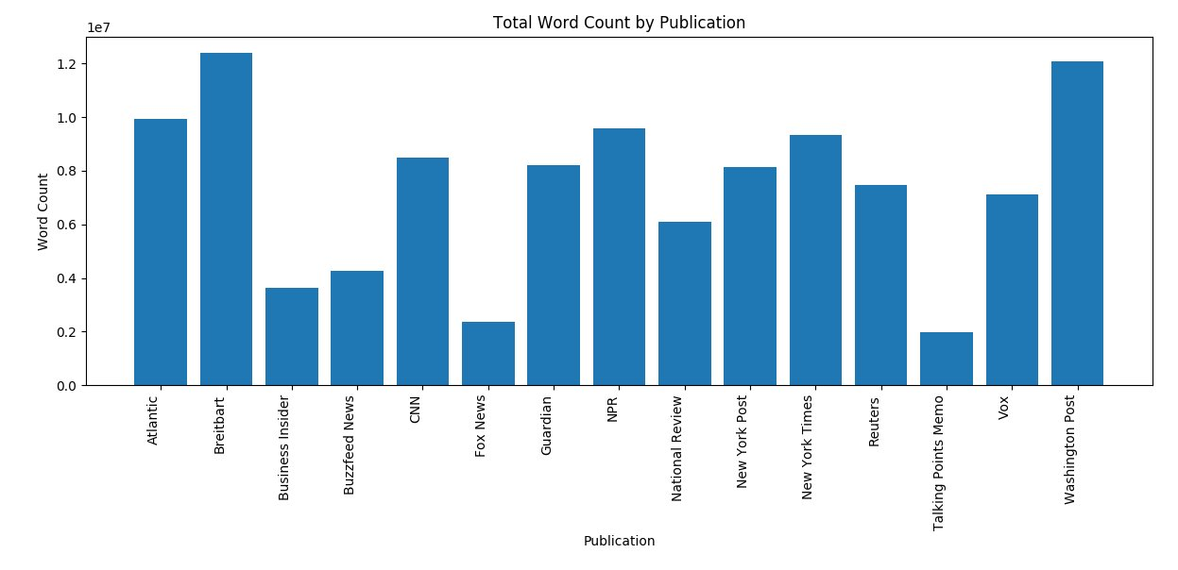
Figure 1. The quality of distributional word vectors is dependent on the quantity of words used to train them, so here you can see that word vectors trained on Fox News and Talking Points Memo corpora are at a disadvantage when compared to Breitbart or Washington Post. The average word count is 7,404,224. The total number of words across models is 111,063,362.

Publication | Top 10 Words (Top 20 from Full Corpus)
Atlantic | trump, one, people, would, said, like, year, time, u, new
Breitbart | trump, said, clinton, people, state, president, one, would, say, u
Business Insider | said, trump, u, one, would, year, people, company, new, like
Buzzfeed news | said, people, trump, one, news, would, u, year, like, also
CNN | said, trump, cnn, u, one, people, state, would, president, year
Fox News | said, trump, clinton, state, would, u, one, also, news, told, people
Guardian | said, trump, one, people, would, u, year, time, like, new
NPR | say, said, people, one, year, trump, like, u, would, time, new
National Review | trump, would, one, state, people, american, u, clinton, president, year
New York Post | said, year, one, new, say, time, would, like, also, trump, people, two
New York Times | mr, said, trump, one, would, year, state, new, people, time, like
Reuters | said, u, trump, state, percent, would, year, new, company, president
Talking Points Memo | trump, said, president, would, republican, state, house, people, one, u
Vox | trump, people, one, would, like, state, u, time, year, new
Washington Post | said, trump, would, state, one, people, year, president, u, time
Full Corpus | said, trump, one, would, people, year, u, state, say, new, time, like, also, president, could, clinton, first, two, even, american
Table 1. This table shows that some potentially irrelevant words have made it into the models. For example, ‘u’ and ‘mr’ and even ‘said’ could all be considered stop words. Nonetheless, the chart gives a basic idea of the most popular words for each corpus.

Background and Methods: Upstream Task
The task is to predict how funny an edited news title is. At most one word is changed by a set of Amazon Mechanical Turk editors and a different set of five judges rated the edited title on its humor. An example of a funny one (2.8/3) was “Kushner to visit (Mexico → therapist) following latest Trump tirades”. An edit that wasn’t deemed funny (0.0/3) was “4 (soldiers → rabbits) killed in Nagorno-Karabakh fighting: Officals”. There were three editors and five judges for the entire dataset, which has 15,095 edited titles with annotations.
According to the authors of the dataset, this format was chosen because headlines are rich and compact, often requiring complex knowledge to interpret. They built the set of headlines from news articles posted in r/politics and r/worldnews on Reddit, a popularity-based discussion forum. The time period the authors chose was from January 2017 to May 2018. So, the Kaggle data is a bit earlier, with only about half a year of overlap.
Keras is used to train a few different models: a GRU, LSTM, and a CNN, with and without Attention. Hyper-parameters were tuned for the same task on vectors trained on the full corpus and not adjusted afterwords. The training uses Keras’ early stopping with a patience level of 2. The models are just fed the edited version of the title because feeding the original did not seem to help in testing. Training is conducted on a NVIDIA GeForce 750Ti.

Results
Results are reported in the form of root mean squared error—the lower the better. A baseline was calculated by computing the mean of the grades. Since the GRU performed the worst relative to the the baseline, these results are omitted. That this happened seems to indicate that the word vectors are not very high quality. Supporting this conclusion is the fact that the other models were only hardly able to beat the baseline. This is, perhaps, due to the small quantity of training data. But since vectors trained on the entire corpus did not do much better lends weight to the idea that this task is just hard. Other experiments indicate that ELMO and BERT pretrained vectors fair much better. The current top score posted on the webpage for participants in this competition is .519. Of course, ensemble methods and other inputs yield much better results than the simple methods presented here.

Publication | LSTM with Attention | CNN | Average
Atlantic | 0.5867 | 0.5925 | 0.5896
Breitbart | 0.5872 | 0.589 | 0.5881
Business Insider | 0.5882 | 0.5902 | 0.5892
Buzzfeed news | 0.5856 | 0.5902 | 0.5879
CNN | 0.5887 | 0.5874 | 0.5881
Fox News | 0.5877 | 0.5898 | 0.5888
Guardian | 0.5885 | 0.5887 | 0.5886
NPR | 0.5878 | 0.5898 | 0.5888
National Review | 0.5853 | 0.5911 | 0.5882
New York Post | 0.5864 | 0.5873 | 0.5869
New York Times | 0.5862 | 0.5875 | 0.5869
Reuters | 0.5883 | 0.5882 | 0.5882
Talking Points Memo | 0.5888 | 0.5881 | 0.5884
Vox | 0.5904 | 0.5912 | 0.5908
Washington Post | 0.5883 | 0.5870 | 0.5877
Full Corpus | 0.5894 | 0.5900 | 0.5897
Average (not including full corpus) | 0.5876 | 0.5892 | 0.5884
Table 2. We give the results for the LSTM with attention and the CNN—these are the two models with the best averages. The results presented here represent the best of three runs. The baseline is 0.5907; items not beating the baselines are crossed out. The best value of each column is bold. The LSTM with attention did a bit better than the CNN, but neither beats the baseline by very much.

Discussion
In US news media, there are a lot of generalizations about the two sides. One of the generalizations that one often hears is that news media companies have a particular bias. Here I will refer to such a bias as ‘left-leaning’ or ‘right-leaning’. I had hoped to provided some light on this discussion by using word vectors trained on news sources for humor detection.

There were two ideas behind this. The first is that if the new sources of one side were more biased than the other, then they would get lower scores on the humor detection task. The reasoning is that humor detection may require an understanding of facts more than bias. The second thing I wanted to test is whether there was some political bias that we could identify in the judges of the Humicroedit data set. These two tasks are not separable. A demonstration of bias could be explained by either inherent bias in the sources or bias in the grades of the detection task.

Far Left | Left | Center | Right | Far Right
Vox  New York Times | Atlantic  Buzzfeed  CNN  Washington Post  The Guardian | Reuters  NPR  Business Insider | Fox News | Breitbart  National Review  New York Post
0.5888 | 0.5884 | 0.5888 | 0.5888 | 0.5877
Table 3. This table is based on polling done by allsides.com. It characterizes all of the news sources except Talking Points Memo on a political spectrum from left-leaning to right-learning. The numbers to the right of the names are their average scores on the Humor detection task. The last column is the average of the average scores on the humor detection task.

As is evident from Table 3, no real trend emerges. In fact, far left, center, and right have the same averages! Perhaps the word2vec vectors trained in Gensim are not good enough for this humor detection task. It does not seem like extra training material would help much as the vectors trained on the entire corpus did not get the best results.

Conclusion
We trained word2vec models on articles from 14 different news sources and then used the models as an input layer for a humor detection task on edited news titles. Unfortunately, the results hardly beat a mean score baseline and thus do not support any remarkable conclusion. Of note is that we cannot directly conclude that there was a deficiency of training data because the vectors trained on the full corpus did not do better.

Performing a similar experiment with better word vectors could help bolster any conclusion about bias in the humor dataset or the news sources. For example, retraining a pretrained BERT model on these news corpora may reveal significant differences where word2vec could not.

Finally, it is also worth considering that the humor dataset is not a good candidate for revealing bias in the news and vice versa. For example, GLUE may be a better candidate for evaluation of bias in news. And it is possible that a encyclopedia would be a better corpora to train on to find bias in edited news titles.

